KWAME NKRUMAH UNIVERSITY OF SCIENCE AND TECHNOLOGY COLLEGE OF ART AND BUILT ENVIRONMENT

ARTISTIC ELEMENTS IN THE FESTIVALS OF THE
EFFUTUS-GHANA

BY
IMPRAIM – SWANZY ENOCK
(B.ED ART)

A thesis submitted to the Graduate School, Kwame Nkrumah University of
Science & Technology, Kumasi
In partial fulfillment of the requirements for the degree of
MASTER OF PHILOSOPHY
(AFRICAN ART AND CULTURE)

Faculty of Art
College of Art and Built Environment

JULY, 2015
©2015, Department Of General Art Studies

DECLARATION
I hereby declare that this is my own work towards the M.Phil African Art and Culture degree and that, to the best of my knowledge, it contains no material previously published by another person nor material which has been accepted for the award of any other degree of the University, except where due acknowledgement has been made in the text.
……………………………. ………………………. …………………………..
Impraim-Swanzy Enock (20287589) Signature Date (Students Name & ID No.)

Certified by:
…………………………… ………………………… ……………………………
Dr. (Mrs.) N.A.P. Arthur Signature Date
(Supervisor’s Name)

Certified by:
………………………… …………………………. ………………………….
Dr. Steve Kquofi Signature Date
(Head of Department’s Name)

ABSTRACT
Although the arts in Effutu festivals make a particularly vibrant and far-reaching contribution to their culture, little or no attention has been given to it. The energetic and enthusiastic characteristics associated with the involvement of these arts in the festivals play functional, economic and aesthetic roles which are indispensable to their culture. The Aboakyer festival involves two Asafo cohorts and they use different artworks for the celebration which widens the artistic scope of the festival. These art works involved in the festival have direct link with the culture, history and traditions of the Effutus, making them requisite for the celebration. Since these art works have a direct link with the culture there is the need to document them for cultural perpetuation. The Akomase festival, which is the second festival for this study has received less attention by writers due to the low patronage also needs a scholarly documentation. The study made use of the qualitative research which employed the descriptive and narrative design for data presentation. The study concluded that the artistic elements in the festivals of the Effutus are enormous especially the Aboakyer festival. However, it is recommended that Effutu Traditional Council should have a museum or gallery for keeping the artworks used in their festivals and train personnel to educate people about the roles they play in the festival and artistic elements in relation to their culture.

ACKNOWLEDEMENTS
I will like to thank God Almighty for taking me through this study successfully. Indeed He has been merciful and gracious to me. My sincere gratitude goes to my supervisor Dr. (Mrs.) Nana Ama Pokuaa Arthur of the Department of General Art Studies – African Art and Culture section for her time and impact in making this work come to a successful end.
I am also indebted to Dr Mariama Ross, Dr Eric Appau Asante, Dr Joe Adu-Agyem and all the lecturers of the Department of General Art Studies for their encouragements and supports throughout the program.
I will also like to thank my parents Papa Kodwo Owranye and Comfort Yeboaba Mensah and my siblings for their prayers and supports. I say “ayekoo” to all of them and may God richly bless them.
I am most grateful to my respondents especially Neenyi Ghartey VII, the paramount chief of the Effutu Traditional Area, Nana Quansah Panyin, the P.R.O. of Effutu Youth Association, Supis of the Asafo Companies and all the respondents for their countless efforts towards the success of the study.
Finally, my sincere gratitude goes to all my friends especially Miss Rashida Nyarkoh, Mr Prince.
Bessah Sam and Mr Humphrey Dautey of the Language Department (Ahantaman Girls’ Senior High School) for editing the work despite their busy schedule. May God smile at them and enlarge their coast.

TABLE OF CONTENTS
Title Page
Declaration Page ii
Abstract iii
Acknowledgements iv
Table of Contents v
List of Tables vi
List of Plates ix
CHAPTER ONE - INTRODUCTION 1
1.1 Overview 1
1.2 Background to the Study 1
1.3 Statement of the Problem 3
1.4 Objectives of the Study 4
1.5 Justification of Objectives 5
1.6 Research Questions 5
1.7 Delimitation 5
1.8 Definition of Terms 5
1.9 Importance of the Study 7
1.10 Sources of Information 7
1.11 Facilities Available 8
1.12 Acronyms and Abbreviations 8
1.13 Ethnographic Background 9
1.14 The Origin of the Effutus 11
1.15 Arrangement of the rest of the text 15

CHAPTER TWO - REVIEW OF RELATED LITERATURE 16
Overview 16
2.1 Involvement of arts in Ghanaian festivals 16
2.2 The role of arts in Ghanaian festivals 19
2.3 Importance of festivals in socio – economic development of the nation 21
2.4 The significance of art in festivals 24
2.5 The celebration of festivals in Africa 26
2.6 The Origin of the Aboakyer Festival 28
2.7 The Origin of Akomase Festival 30

CHAPTER THREE - METHODOLOGY 32
Overview 32
3.1.1 Research Design 32
3.1.2 Descriptive Method 33
3.1.3 Narrative Method 33
3.2 Library Research 34
3.3 Population 34
3.3.1 Sample design 35
3.4 Data Collection Instruments 36
3.4.1 Observation 36
3.4.2 Interviews conducted 37
3.4.3 Transcribing of Audio and Video files 38
3.5 Types of Data 38
3.5.1 Primary data 38
3.5.2 Secondary data 39
3.6 Administering of instruments 39
3.7 Data Analysis Plan 39

CHAPTER FOUR - PRESENTATION AND DISCUSSION OF FINDING 41
Overview 41
4.1 The Aboakyer festival of the Effutus 41
4.2 The Akomase festival of the Effutus 55
4.3.0 The Artistic Elements in the festivals of the Effutus 59
4.3. Visual arts in the Aboakyer festival 59
4.3.1 Beads (jewellery) 60
“Nsise” and “Ehuma” 60
4.3.2 Textiles (costume) 62
Iron Helmet 65
Fokyw 67
4.4.3 Body Arts 69
Body Painting 70 Hairdo (Coiffure) 72
Mporba hair 73
4.3.4 Sculpture 75
Ceremonial seat of Oma Odefe 76
Palanquin of Oma Odefe of Effutu Traditional Area 76
Wooden horse 77
Wooden ship (steamer) 80
Stools 83
Umbrella tops 84
Spokesman staff 86
Sword (Akonfena) 94
Drums 95
Rings 97
“Abosomba” statue 98
Canoe 100
Rattle (kakrade) 101
Dawur-nta (gong gong) 102
Bells (Nkodwo) 103
4.3.5 Graphic Design 103
Union Jack (British flag) 104
Asafo flags 105
Buntings 106
Printed T-shirts 107
Banner 108
4.3.6 Leather work 109
Whips of office (Asafo Abɛe) 109
Traditional sandals 111
4.3.7 Pottery/ceramics 112
4.4. Performing arts in the Aboakyer festival 113
4.4.1 Music 113
4.4.2 Drama 116
4.4.3 Drumming 117
4.4.4 Dance 119
4.4.5 Verbal art 121 4.5 Visual Arts in the Akomase festival 123
“Apɔnpowa” (Flat Wooden Tray/Panel) 123
Ceramic pot 124 Earthenware bowl 124
Matchet/cutlass 125
4.6 Performing arts in the Akomase festival 126
4.6.1. Music 126
4.6.2 Drama 126

CHAPTER FIVE - SUMMARY, CONCLUSIONS AND RECOMMENDATIONS 128
Overview 128
5.1 Summary 128
5.2 Conclusion 129
5.3 Recommendations 130 REFERENCES 132
APPENDIX I 136
The interview guide used by the researcher during the data collection 136
APPENDIX II 139
The observation guide used by the researcher during the data collection 139

LIST OF TABLES
Table1. Target Population, Accessible Population and Sample Population 35 showing various respondents for the study

LIST OF PLATES
Plate 1.1.1Aerial view of Winneba 9
Plate 1.1.2Map of Winneba 10
Plate 1.1.3Emblem of the Effutu state 11
Plate 4.1.1 The Dentsefo No.2 youths in their red t-shirt during the tug of peace 43
Plate 4.1.2 The Tuafo No. 1 youths in their blue t-shirt during the tug of peace 43
Plate 4.1.3 Canoe race (regatta) between the Dentsefo youths and Tuafo youths 44
Plate 4.1.4 A youth of the Tuafo No. 1 carrying the “Nsambon” deity 45
Plate 4.1.5 The Dentsefo No. 2 youths outdooring “Basabasa” deity 47
Plate 4.1.6 Tuafo No. 1 Asafo Company outdoor their deity “Gyemisi” on a wooden board 48 Plate 4.1.7 Dentsefo No.2 Asafo Company outdoor their deity “Asikama” 48
Plate 4.1.8 Traditional priest sprinkle “akom mu nsu” (concussion from the shrine) on the Asafo 49
On their way to the hunting grounds
Plate 4.1.9 Dentsefo No. 2 on their way to the hunting grounds 50
Plate 4.1.10 Tuafo No. 1 on their way to the hunting grounds 50 Plate 4.1.11 Procession of chiefs, queen mothers, traditional priests and priestesses to 50 the durbar grounds.
Plate 4.1.12 The Dentsefo No.2 with a catch at the durbar grounds 51 Plate 4.1.13 The deer laid on a mat made with twigs and tied with twines being carried 52 to the shrine by a man from Akyeampon ano
Plate 4.1.14 Apa Sekum shrine where the deer is fed to their war god 53
Plate 4.2.1 Penkye Otu’s yam being cooked 56
Plate 4.2.2 Preparation of food to feed families during the Akomase festival 57
Plate 4.2.3 Members of the seven Prama carrying the garbage to the site 58
Plate 4.3.1 “Ehuma” beads used by the Tuafo No.1 Asafo group for identification 60
Plate 4.3.2 Dentsefo Asafo youths wearing “Nsise” beads for identification 60
Plate 4.3.3 Beads (Jewellery) worn by chiefs and queen mothers during Aboakyer 61
Plate 4.3.4 The Tuafo No. 1 female and male groups in their costumes 62
Plate 4.3.5 The Dentsefo No.2 female and male groups in their costume 63
Plate 4.3.6 The Tuafo No. 1 Supis in their costume during the afternoon procession 63
Plate 4.3.7 The Dentsefo No.2 Supis in their costume during the afternoon procession 63
Plate 4.3.8 Tuafo No.1 “Nmbo” (amulet) worn during the festival. 64
Plate 4.3.9 Dentsefo No.2 roman helmet worn during the festival. 64
Plate 4.3.10 Dentsefo No. 2 Asao men wearing “Fokyɛw” during the afternoon procession 66
Plate 4.3.11 Dentsefo youths painted with yellow pigments for the hunting body 67
Plate 4.3.12 Dentsefo youths painted with “Ntwema” solution for hunting 67
Plate 4.3.13 Tuafo No. 1 youths painted with white clay and blue pigment for hunting. 68
Plate 4.3.14 Body markings seen on the priestesses during the Aboakyer. 68
Plate 4.3.15 Hairdo seen during the Aboakyer festival. 69
Plate 4.3.16 “Mporba” hairstyle of Okomfo Ansa (chief priestess) 70 during the Aboakyer festival
Plate 4.3.17 “Mporba” hairstyle used by the priesthood during the Aboakyer festival 71

Plate 4.3.18 The Ceremonial seat of Oma Odefee. 72 Plate 4.3.19 Oma Odefee sit and dance in a palanquin during the afternoon 73 procession through the principal streets.
Plate 4.3.20 A captain of Tuafo No.1 Asafo company (Safohen) riding on 74 a wooden horse during the celebration of the festival.
Plate 4.3.21 A captain of Dentsefo No.2 Asafo Company (Safohen) being 75 carried in a wooden ship (Steamer) during the festivals.
Plate 4.3.22 Some stools used during the Aboakyer festival 76 Plate 4.3.23 “Anᴐna Ebusua” umbrella top seen during the procession of 78
chiefs to the durbar grounds
Plate 4.3.24 “Twidan Ebusua” umbrella top seen during the Aboakyer festival 79 Plate 4.3.25 Tufuhen’s umbrella top seen during the procession of chiefs at 79 the Aboakyer festival
Plate 4.3.26 Spokesperson holding “Nkyidmhen’s” staff during the 81 Aboakyer festival
Plate 4.3.27 The linguists holding “Nsna” Ebusua (family) staff during the 82 procession of chiefs at the Aboakyer festival
Plate 4.3.28 Edwinadze Ebusua staff seen during the Aboakyer festival 83
Plate 4.3.29 Okyeame holding Oma Odefe’s staff during the procession 84 to the durbar grounds
Plate 4.3.30 The linguist holding Tufuhen’s staff during the Aboakyer festival 85
Plate 4.3.31 The linguist holding the Apofohen’s staff during the procession 86 of chiefs to the durbar grounds
Plate 4.3.32 The Akonfena (Sword) used during the Aboakyer festival 87 Plate 4.3.33 Drum played by the sub groups of the Asafo Companies 88 for communication.
Plate 4.3.34 The Fromtomfrom drum played during the Aboakyer festival 89 Plate 4.3.35 Rings worn by the chiefs and queen mothers during the 90 Aboakyer festival.
Plate 4.3. 36 Abosomba statue seen during the Aboakyer festival 91
Plate 4.3.37 Canoe used for a race during the Aboakyer festival. 92
Plate 4.3.38 A rattle used by the Tuafo No.1 during the Aboakyer festival 92
Plate 4.3.39 Dawur-nta (gong gong) used during the Aboakyer festival. 93
Plate 4.3.40 Bell (nkodwo) used by the Dentsefo during the Aboakyer. 94
Plate 4.3.41 Union Jack (British flag) seen during the Aboakyer festival. 95 Plate 4.3.42 Asafo flags for Dentsefo No.2 company seen during the festival. 96
Plate 4.3.43 Asafo flags for Tuafo No.1 group during the Aboakyer festival. 97
Plate 4.3.44 Buntings used during the Aboakyer festival. 97 Plate 4.3.45 Printed T-shirt identifying the Dentsefo and Tuafo Asafo Company. 98
Plate 4.3.46 Banner displayed during the Aboakyer festival. 99
Plate 4.3.47 Supis from the Dentsefo Asafo company with their whips of office 100
Plate 4.3.48 Supis from the Tuafo Asafo company with their whips of office 100

Plate 4.3.49 Examples of traditional sandals seen during the Aboakyer festival. 101
Plate 4.3.50 Ceramic pot used for the Ebisatsir on Aboakyer Sunday. 102 Plate 4.4.1 The youth singing and making merry after a successful catch. 104 Plate 4.4.2 Horn blower using the Akoben to sing praises to the chiefs 104 during the festival

Plate 4.4.3 The Dentsefo women singing their native songs (Adzewa music) 105 during the afternoon procession
Plate 4.4.4 The Tuafo women singing their native songs (Adzewa music) 105 during the afternoon procession.

Plate 4.4.5 Drama performance at the durbar grounds 106
Plate 4.4.6 Dentsefo No. 2 Asafo drumming as a medium of communication 108 Plate 4.4.7 Tuafo No. 1 asafo drumming as a medium of communication 108 Plate 4.4.8 Drumming by the cultural troupe at the durbar grounds 108
Plate 4.4.9 The Tuafo asafo dancing the Akosuadontoba during the afternoon procession 110
Plate 4.4.10 The Dentsefo asafo dancing the Owombir during the afternoon procession 110
Plate 4.4.11 The cultural group at the durbar grounds during the Aboakyer festival 110 Plate 4.4.12 The priest of Acheampong Ano making libation prayer to receive the deer 111
Abosomba
Plate 4.5.1 “Apnpowa” (flat wooden tray/panel) used to carry garbage from 112
Penkye Otu’s shrine and the seven paternal homes to the garbage site during the Akomase festival
Plate 4.5.2 Ceramic pots for cooking Penkye Otu’s meal and other gods 113 during the Akomase festival
Plate 4.5.3 Cutlass used by the priest to clear the path to the garbage site during the 114
Akomase festival.
Plate 4.5.4 Earthenware bowl used for dishing out Penkye Otu’s meal during the 115 Akomase Yam feasting.
Plate 4.6.1 The priest swinging cutlass left right clearing the path to the garbage site. 116

CHAPTER ONE INTRODUCTION

1.1 Overview
This thesis gives an account of Artistic Elements in the Festivals of the Effutus in the Central Region of Ghana. It highlights on the Background to the Study, Statement of the Problem,
Objectives of the Study, Research Questions to be answered, Delimitation, Limitation to the Study,
Definition of Terms, Importance of the Study, Ethnographic Background of the Effutus and Arrangement of the Rest of Text in the thesis.

1.2 Background to the Study
Art is used in series of performances or other cultural events such as festivals, normally held at frequent intervals, often in one place. The arts used include the visual or environmental arts, verbal arts and the performing arts. Art and culture have been intertwined and cannot be separated. They are closely linked and cut across cultures of different people.
Festivals are rituals which recur at regular intervals, and which have as their purpose, the expression of beliefs held by a particular community. There is also the conscious expectation that certain very specific ends will come about as a result of the performance of the festivals and the performance is motivated by the desire to gain some form of satisfaction and this is expected to be effected. Festivals take place at special times set aside by a community in order to commemorate some events of historical, cultural or religious significance and by the performance of certain rituals, such events are re-enacted, giving both individuals and the communities a sense for meaning and cohesiveness (Akintan, 2013).
Winneba is a town and the capital of Effutu Municipal District in the Central Region of Southern Ghana. Winneba has a population of 60,331. Winneba, traditionally known as Simpa, is an historic fishing port in Southern Ghana, lying on the South Coast, 90 miles (140 km) East of Cape Coast (http://en.wikipedia.org/wiki/Winneba).
Effutu Municipal area is one of the 170 districts in Ghana and one of the 17 districts in the Central Region. It was extracted from the then Awutu – Effutu – Senya – District Assembly in 2007 by L 11860 and it covers a total area of about 64 square kilometers.
The people of Winneba were part of the large family of Guan speaking people who migrated out of Timbuktu, proudly referred to as Tumutu by the natives, between 1100 – 1200. Some of the tribes among this group were the Gonja, Kyerepon, Larteh, Nkonya, Krakyi and the Awutus. Those who eventually settled at Winneba belonged to the latter group or family; generally referred to as Awutuabe (Awutufo in Akan) and they speak a distinct version of Awutu called Effutu. Many choose to call them ‘Effutufo’ (Effutu people) after this dialect. Fishing is the major occupation of the indigenes and few enter into farming and animal husbandry (Brown , 2005).
The Effutus have three major festivals thus colourful Masquerading festival, supported by brass band music and held on January 1 each year at Advance Park (formerly known as Humphrey’s Park) near the South Campus of the University of Education, Winneba; Aboakyer festival also held during the first week of May each year coupled with a lot of activities.
The third festival is the Akomase, a ritual festival celebrated in August that involves sacrificing domestic animals to the lesser gods of Winneba. All of these festivals are dominated by music and art forms close to the heart of the Effutufo (Brown, 2005).
There are other festivals of the Effutus which are not as popular as the ones mentioned above. These are Tuafo Fida (Twins Yam Feasting), Dentsefo Memenda, Fantse Fantse Firing of Musketry (Petu), Eyipey Otu Yam Feasting and Ash Wednesday (festival of the gourd).
Festivals in the Effutu Traditional Area reveal profound information about arts, culture, customs and traditions and serve as means to remember their ancestors and seek for protection and purification. To them, the festivals are opportunity given by their forefathers to showcase their rich culture, history and art forms. The arts in the Effutu festivals play essential roles and significance towards the celebration and this affect the economic and socio - cultural aspects of their lives. The artistic elements have contributed immensely towards the success of the Effutu festivals. Nevertheless the arts involved in the festival are enormous, it appears there has been little chronicling on them; creating a vacuum in the involvement of these arts in the culture of the Effutus.

1.3 Statement of the Problem
Although arts play a pivotal role in the celebration of the festivals of the Effutus, a study of the literature on the festivals revealed that the artistic aspects of the festivals have not been adequately and extensively treated by authors and there has been less attention given to the Akomase festival. The oral records that are passed onto generations are losing certain components in the festival gradually and very soon the festival will die off just as some of the festivals of the Effutus.
Okae –Anti (2010) wrote on the Educational Significance of the Visual Arts in the Aboakyer Festival of the Effutu People of Winneba. Walden (2012) also wrote extensively on the SocioCultural Significance of Canoe Decoration among the people of the Effutu Traditional Area in the
Central Region of Ghana. Brown (2005) wrote on the Social Conflicts of the Festivals of the Effutus and Safo - Ankama (2006) also wrote on the Philosophical and Artistic Inclination of the Winneba Masquerade Festival.
Aboakyer on the other hand involves two Asafo companies and these companies use different artworks during the celebration hence increasing the number of artistic elements. The arts in the festivals have direct link to the culture, canons and history of the people. Majority of the artistic elements are not documented in relation to their culture and there has been some recent additions in the festival which needs a scholarly documentation. There are lots of loop holes that need to be filled as far as the festivals are concerned. The arts they use are distinct and peculiar to the Effutus that needs to be treated as such. The arts differentiate them from the traditions of the Akans, Fantes and Agona people since they are the only Guans found in the midst of Akans.
For instance, the royal regalia of an Effutu Chief might be similar to that of Mankessim Chief but what makes him (Effutu Chief) different is a special bead called the “EHUMA or NSISE”. The bead classifies the chief as a descendant of the Tuafo No. 1 Asafo Company or the Dentsefo No. 2 Asafo Company. This is peculiar to the Effutus and it is missing in the previous works of the writers. There are so many artistic elements that are used in the Effutu festivals which are not documented making them look ordinary among the other ethnic groups. The study therefore sought to describe the festivals of the Effutus with the view to discuss the roles and significance of the various artistic elements in them in relation to their culture.
1.4 Objectives of the Study The purpose of this study is:
- To find out and describe the Aboakyer and Akomase festival.
- To discuss the roles and significance of the artistic elements in the Effutu festivals.

1.5 Justification of Objectives
- Finding out and description of the Aboakyer and Akomase festival of the Effutus will help in documentation and also highlight the recent additions in their celebrations.
- Discussing the roles and significance of the artistic elements in relation to their culture will bring to bear the art forms, reveal certain history, meaning and origin of art forms in festivals.

1.6 Research Questions
- How do the Effutus celebrate the Aboakyer and Akomase festival?
- What are the roles and significance of the artistic elements in relation to the culture of the
Effutus?

1.7 Delimitation
This study was limited to the Effutu Traditional Area (Simpa/Winneba) in the Central Region of Ghana and only two of their festivals were highlighted upon, thus the Aboakyer Festival and Akomase Festival.

1.8 Definition of Terms
Art: The process of creating beautiful items to satisfy human needs.
Artefacts: Works of art.
Ancestors: The spirits of the dead in the society who led exemplary lives.
Celebration: An occasion of giving joy
Festival: Religious or other celebrations
Awutu abe (Awutufo in Akan): The indigenes of Winneba
Oma Odefe: paramount chief of the Effutus
Wansan: refers to the deer caught during the Aboakyer.
Supi: a title conferred on the head of the Asafo Company
Safohen: the chief of the Asafo group
Kobae: the group that support the Safohen
Penkye: is the ancestral home of the Effutus precisely the first place of settlement.
Penkye Otu: it is the deity that foretells the future events likely to happen during the Ebisatsir (casting of lot).
Prama: refers to paternal home/ house of the Effutus.
Apa Sekum: a deity that takes the deer as a way of protecting the citizenry against unwanted future occurrences. (War god of the Effutus)
Mpar: the thread used to tie the animal (deer) before it is carried to the Apa Sekum’s shrine.
Creative milieu: a street, place or area to generate a flow of ideas and inventions.
Piece: refers to sculpture works
Neenyi: the title for chiefs in the Effutu Traditional Area
Mfoba: musical instrument used by women for the adzewa music

1.9 Importance of the Study
This work is important because, it serves as a platform for preserving and propagating Ghanaian culture and art in general. It will add up to the body of knowledge already existing. The results of this study will help the citizens (indigenes) of Winneba as well as the entire nation to identify and understand some aspects of their culture.
The findings of the study will supply useful information about the culture and festivals of Effutus to researchers, historians, students, lecturers, tourists, policy makers, stakeholders, educators, archaeologists and many others.

1.10 Sources of Information
- Internet
- Journals
- Books
- Articles
- Chiefs
- Queen mothers
- Supis
- Elders
- Youths
- Senior citizens of Winneba
- Expert in the field of festivals and culture

1.11 Facilities Available
- The College of Art Library, KNUST, Kumasi

- Social Science Library, KNUST, Kumasi

- Main Library, KNUST, Kumasi

- Effutu Traditional Council

- E – Resource Center KNUST

- UCC Main Library

- Takoradi Polytechnic Library
- UEW Library North and South Campus
- Palace of the Chief of Winneba (Simpa)
- University of Ghana Library

1.12 Acronyms & Abbreviations
KNUST-Kwame Nkrumah University of Science and Technology
UCC-University of Cape Coast
UEW-University of Education, Winneba
T-POLY –Takoradi Polytechnic
UG – University of Ghana
PRO – Public Relations Officer
OAS – Organization of American States
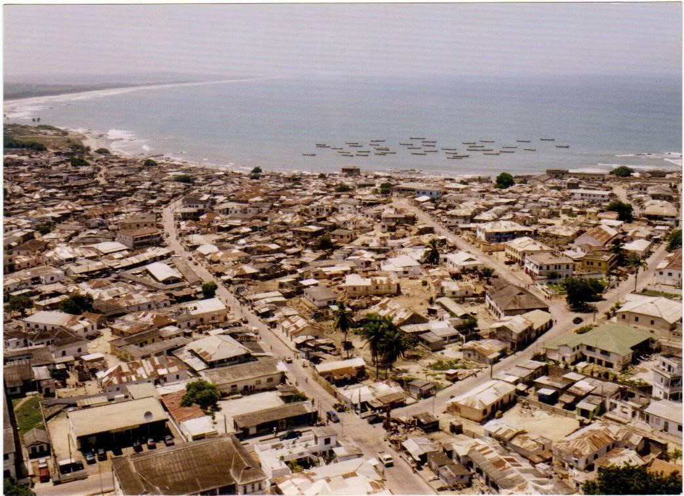
Plate 1: Aerial view of Winneba
Source: Palace of Oma Odefe

1.13 Ethnographic Background
The Effutu State comprises sixteen traditional structure, namely: Gyangyanadze (Krontir
Division), Gyahadze (Gyase Division), Essuekyir (Kyidom Division), Effutu Atekyedo, Effutu Osubonpanyin, Effutu Tuansa, Ekroful, Ateitu, Sankor, Ansaful, Bombito Obae, Ntakorfa, Abasraba, Worabeba, Akosua Village and Eyipey. These traditional set - ups are intertwined in terms of culture, tradition and socio economic orientation. These locations have certain things in common thus language, food, customs and traditions. Their location determines their source of livelihood, thus those close to the sea have fishing as their major occupation and those far from the sea have farming and animal husbandry as their occupation or source of livelihood.
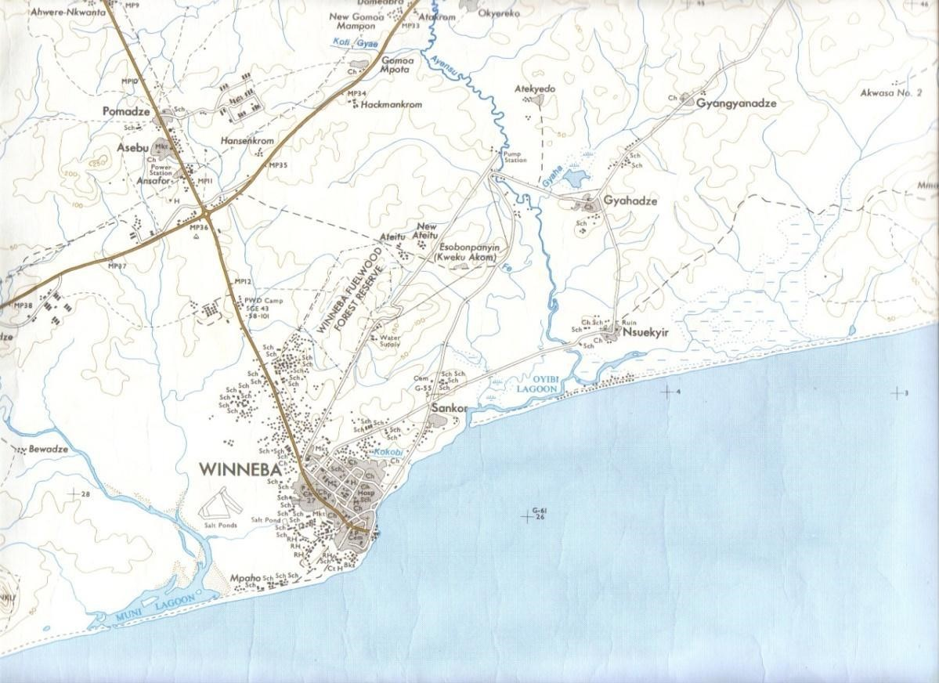
Plate 2: Map of Winneba Source: Palace of Oma Odefe

The state emblem of the Effutus is made up of a stool, two royal swords and the ‘wansan’ (deer).
The totem of the people is the ‘wansan’ which is the animal hunted for and used to propitiate the deity, Apa Sekum. The royal swords tell of the two asafo companies and the stool is the black stool at Otuano on which the paramount chief of the people is installed. The interpretation of the arrangement, with the stool sitting on the animal is that, the stool representing the deity is propitiated with that animal. And this is the religious custom of the Effutus of Winneba.
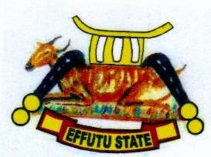
Plate 3: Emblem of the Effutu State Source: Palace of Oma Odefe

1.14 The Origin of the Effutus
According to Ackom (2005) the Effutu State was founded by Nana Tumpa around AD 1335.The state was named after him. The founding father of the state Nana Tumpa, popularly called Osimpa and his chief traditional priest Bonzie – Ebi and his people brought along with them a war god called APA – SEKUM who helped the people in diverse ways.
Brown (2005) also states that around 1200 CE, a large community of Guan speaking people migrated from Timbuktu towards the south. Among them were the Kyerepon, Gonja, Larteh, Krakyi and the Effutu (present Winneba). He further stated that the reason for migrating was attributed to strife; frequent wars and shortage of food supplies due to famine or low production resulting from the wars. The customs and beliefs, art, way of life and social organization of the
Effutus are deeply rooted in their history.
Neenyi Ghartey VII (Oma Odefe) explains that oral records single out one fearless warrior Kwamena Gharteh Ayirebi – Gyan. He was not only an ordinary leader but also a spiritual leader. He took care of the deity Otu and other gods including Apa, Sekum, Osipi, Dawa and Bassaw and the ancestral black stool all through their journey. He is considered the first priest – king. His extreme spiritual powers enabled him to deal with the exigencies of this arduous journey. He was succeeded by his son Gyarteh Sisii. At Tekyiman, this Guan group split into several cohort with Kwamena Gyarteh Ayirebi Gyan leading his people south by the Western Corridor. It is reported that, from Tekyiman this group made another camp at a location presently called Effutu near Jukwaa on the Cape Coast road (Personal communication, April 29, 2014)
Ackom (2005) further explained that Effutu did not become a permanent settlement. Something very impressive happened at Effutu. It is certain that Kwamena Gyarteh Ayirebi Gyan who always wore a hat had a third eye and therefore never removed it. That he was the god
“Tuwaenyiwanyiwa” personified as a myth yet to be unravelled. This god according to Effutu mythology had multiple eyes on the head. The people arranged with his wife to uncover the mystery. She removed the hat as he was resting under his favourite tree and realizing his secret was now open to the people, he sunk into the ground. The people dug him out but to no avail. He was immortalized by the forming of two cannon earth balls (from the earth) dug from the spot he sunk and these balls directed them in search of a permanent resident. It is this cannon, “Akwa Tubu” that is used to perform the “Ebisatsir” (casting of lots) after the sacrifice during the Aboakyer Festival.
Kwamena Gyarteh changed residence by moving his people forward and founded another settlement, Amanforo which has become Oguaa, (Cape Coast). From there they moved along the coast eastwards and saw something that looked like a settlement. Coming closer, it was rather a hill, which derived its name from ‘yaeomako’ meaning see a settlement and hence mount Manko (Mungo). They then came to Dwomma (now Mumford). It is not very clear who first settled at Dwomma. There are two sides to the naming of this settlement. Both relate to the advanced movement of the people for a more suitable area to live. It is said that life on the hills of Dwomma was not that very convenient to their aspiration. Their leader, in his very advanced age requested the eldest son, Osimpam Bondzeabe to search further for a more suitable place. The search party came first in contact with a lagoon which was salty and said ‘boni’ meaning hard water. The name of this lagoon has been derived from this and as it was found on a Wednesday, it is today called Kweku Muni Lagoon. They moved eastwards and eventually met fresh water which after tasting was sweet and they exclaimed ‘aninyansu’, meaning we’ve got water, hence the derived name - Ayensu River.
Upon return, the entire group decided to move down to the new site but Prince Edwey, the youngest son, refused to join the party and was left there as the head of his settlement. In the Effutu dialect, ‘dwomba’ derived from ‘dwomemaaba’ means I will be back, wait for me. Whereas some believe that it was the name of Edwe that gave Mumford its name, others have it that the area left behind was named so because it was the area left in waiting for a better settlement.
Kwamena Gyarteh Ayirebi Gyan led his people down to the new settlement and had to come back to Dwomma annually to perform propitiatory rites to the deity Otu and other gods as they belonged to both parties. However, due to skillful machinations, he was able to dislodge them to their new settlement. Till today, the clay used in consecrating the gods are still fetched from Dwomma.
Kwamena Gyarteh and his people arrived on the new site by sea. The new settlement was at the shore. This suburb today derives its name from the phrase, ‘to land’ in the Effutu language ‘Prekye’ and hence Penkye. The deity Otu is affectionately called Penkye Otu. It is placed together with the other gods and all its effigies into a shrine, where they lived and for it, they propitiated with fresh human blood annually. One of the cannon earth balls they prepared from Efutu was planted under the Osenkyew tree at their residence, Otuano and the other became Akwatubu used to forecast the future after the annual sacrifice at the shrine.

Not long after their settlement was founded, Osimpam Bondeabe who succeeded his father Gyarteh Sisii died. He was the first king to die there and the settlement Simpa, was named after him.
Simpa was christened Winneba. Some claim its description as a windy bay earned it this shortened form; - Winneba. Others claim it originated from “win de bar” but all related to the calm breezy environment created by its bay shoreline.
The descendants of Kwamena Gyarteh Ayirebi Gyan founded Winneba, they established a house and was called Otuano after the deity Otu. The state they founded was based on the Guan tradition of patrilineal system of inheritance, hence Osimpa Bondze Abe’s recognition as the first king who was succeeded by his third son; Bondze Enyinman. It was during Bondze Enyinman’s reign, (1495 – 1560) that the non-Guan and non-Akan group joined them and were permitted to settle here on condition that they help protect the settlement. These were the Eyipey people whose custom was much closer to the Islamic culture and were patrilineal. Till date, these people are still there residing in the Zongo community at the back of the Effutu Municipal office.

1.15 Arrangement of the Rest of the Text
The report consist of five chapters. Chapter One which is basically the Introduction of the report deals with the Background to the Study, Statement of the Problem, Objectives of the Study, Justifications of the Objectives, Research Questions, Importance of the Study, Definition of Terms and Facilities Available. Chapter Two deals with the Review of Related Literature which highlights brief Introduction of the Chapter and supporting facts from experts in the field of festivals. Chapter Three which caters for the Research Methodology is made up of a brief Introduction of the Chapter, Research Design, and Population for the Study, Sampling Design, Data Collection, Research Tools, Library Research and a Summary of Discussion. Chapter Four talks about the Analysis and Discussion of Data ; Analysis of Results for Interview and the
Observational Approach, a Summary of Discussion and Presentation of the Main Findings.
Chapter five comprises Summary, Conclusions, Recommendations, Appendix, Glossary and References.

CHAPTER TWO REVIEW OF RELATED LITERATURE Overview
This chapter reviews literature from different sources related to the topic. It looks at the involvement of arts in Ghanaian festivals, the role of arts in Ghanaian festivals, importance of festivals in the socio – economic development of a nation, the significance of art in festivals, the celebration of festivals in Africa, the origin of Akomase festival and the origin of Aboakyer
festival.

2.1 Involvement of Arts in Ghanaian Festivals
Ghana as a nation is made up of different ethnic groups. Every ethnic group has a culture, and festivals form part of the elements of culture. These groups and settlements have annual events and celebrations (festivals) to pacify their gods, purify themselves and in remembrance of their ancestors. Ghana has many local festivals that are dated back to the time before the arrival of the major religions, and are still occasions for masquerade, arts, drumming, singing and dancing. The local festivals entail a massive scope of events: harvest festivals, commemorative festivals, masquerade festivals and betrothal festivals to the installation of a new chief and funerals. Examples of festivals in Ghana are the Hogbetsotso by the Ewes, Fetu Afahye by the people of
Cape Coast, Bakatue by the people of Elmina, Homowo by the Ga, Odwira by the Akwiapims, Aboakyer by the Effutus, Yaw Yam festival of the people of Atebubu, Kundum by the Nzemas and Ahantas, Akwambo by Gomoa (the people of Esuehyia, Gomoa Mando and other Gomoa towns), Swedru and other Agona Towns and Mankessim (Fantes).
Festivals are special events in every human culture and bring together people from all walks of life, be it the living or the dead (ancestors). A festival is defined as a celebration, with a public theme, where the social and symbolic meaning of the events are closely related to series of overt values that the community recognize as essential to its ideology and world view, to its social identity, historical continuity and to its physical survival (Hall, 2000).
Festivals in modern times still serve to inform communities about their culture and their traditions. They give continuity to the customs and traditions of the people. They are important elements in cultural development: they foster unity, social cohesion and promote diversity and mutual understanding ( Kiwewa, n.d.).
A festival may last a day or a week, but it unfolds over time set aside from the daily round. It cannot be momentary or static, but rather a rhythmic series of events flowing together toward climax and resolution. Cole (1974) submits that people activate this time, rendering it extraordinary by their own unusual actions and looks. He further points out that these people match in processions and crowds, they dance and pray and gesticulate, carrying art and becoming art forms themselves. Cole (1975) writes: Multitudes of objects, decorated people, dances, skits and sacrifices transform a once quiet space into an arena of colour, sound and motion. The festival embraces the community, raising both people and place onto a plane marked by aesthetics, spiritual and social values.
Kemevor (2004), Nortey (2009) and Gbadegbe (2013) wrote on festivals in Ghana and agreed to the fact that festivals are celebrated with the arts. These arts are seen from the beginning of the celebration till the end. These arts are symbolic and identify the people, their culture, canons, customs, traditions and history. Arts dominate in the celebration of festivals and the popularity of a festival is attributed to the artistic elements involved.

Okai-Anti (2010) also wrote that “Festivals rely on art forms like sculpture, dance, ritual objects, drums, etc. to preserve and impress their key beliefs, ideas, and values in the mind of successive generations of society”.
From this, art is a reservoir for festivals in Ghana. It is manifested through the offering of sacrifices, incantations, Asafo companies’ parade, processions and the durbar. These activities are made up of sections. For instance, the procession is made of the chiefs, priesthood, Asafo groups, etc. which in one way or the other exhibit different forms of arts. The unit of festival is art and this is showcased in the form of visual or environmental, verbal art, body arts and performing arts.
Some art forms used in the celebrations of festivals in Ghana run through certain ethnic groups and others differ due to history, beliefs and tradition. For instance southern chiefs sit in palanquins during processions whiles chiefs in the northern parts sit on horses. The nature of festivals also influence the choice of art forms used in the celebration.
Ododo (2001) stated in his abstract that festivals are arts with functional responsibilities to the society. To him, festival in its entirety is art and does not concentrate on only the artistic elements found in it but considered the whole celebration as art.
Gbadegbe (2009) in his work about the role of art in Asogli Yam Festival also pointed out that it has even been argued that a festival in itself is art, because it starts at a point and ends at another point, which is a clear display of aesthetics.
Artistic programs such as festivals are grassroots organizational displays that attempt to use the arts as a tool for human or material development (Costello, 1998). Community arts programs almost universally involve community members in a creative activity leading to a public performance or exhibit (Guetzkow, 2002).

2.2 The Role of Arts in Ghanaian Festivals
Arts and festivals in Ghana are intertwined. They move together as a unit and separating them will be a hard nut to crack. The inclusion of art is a necessity rather than liability in Ghanaian culture irrespective of the ethnic group or location. This is as a result of man trying to live comfortably in his domain since the genesis of creation. Man found ways and means of living thereby improvising tools and materials. These tools and materials were used to create simple designs and forms which made life comfortable and the end product is what we see in our celebrations today. Art became a necessary commodity in human existence throughout the rites of passage of mankind. Therefore the role of art in festivals cannot be overemphasized.

Asihene (1978) said art plays a pivotal role in all the acts of veneration intended to cleanse or purify the people during festivals. The role arts play reflects on the social, political, religious and economical lives of Ghanaians. This is also seen in the rites of passage and other customary rites.
Vrettos (2006) also wrote that: “ festival is enhanced with more forms of art such as plastic arts and a broader content of visual & performing arts (digital videos, slam poetry, etc.)”. To Vrettos, arts in festivals enrich and improve the celebration. It makes the celebration more colourful and appealing for public consumption and satisfaction.

Ododo (2001) also pointed out the functionalities of art in festivals even though he considered the festival as art in its entirety. The arts in the festivals are functional thus “art for life sake”. This falls under the instrumentalist theory of aesthetics which sees art as something that aids someone to do something easier or perform a specific task aside the beauty or taste. This bears out that in the history of African arts, functionality was a hallmark of every work of art they produced; tracing it down to prehistoric arts where images or works of art were created for magical or spiritual purposes.
There are certain beliefs, traditions, myth, wise sayings and history embedded in the works of art in the celebration of festivals in Ghana and these are used as a form of keeping records, history and maintaining the tradition of the people or passing it on to generations. For example, the Union Jack used by the Dentsefo No. 2 Asafo Company of the Effutus attests to the fact that the British in history colonized Gold Coast, now Ghana, and the flag was used as a prize for the eventual winners who will be the first group to catch the deer and return to the durbar grounds. This is a confirmation of history and up to date, the Asafo Company still uses the Union Jack.
Agbodo (2001) as cited in Gbadegbe (2009) revealed that festivals are days set aside for communal merry-making and that the day is marked with artefacts, chieftaincy regalia, cultural displays and other tourist attractions. According to him, chiefs and other traditional leaders attached significance to their art forms and amongst the Akan people for example, leadership regalia and prestige items for royals and others of high status represent an important area of artistic activity. He emphasized that festivals in Ghana are characterized by intensive use of art forms. Examples of art forms he listed are stools, skins, linguist staffs, amulets bracelets, gold rings, special kente cloths, masks, decorative local weapons like bows and arrows, shields, palanquins and the performing arts such as the various traditional drumming, dances, masqueraders and music.

2.3 Importance of Festivals in Socio-economic Development of the Nation
Festivals are perhaps one of the least considered options, when talking about the economy.
Festivals not only act as cultural and social events but also as generators of income and employment in local economies. The knowledge of this impact by those who manage the festivals, is crucial when accessing public resources, which are given in the form of grants, and private financing which are obtained in the form of sponsorship ( Duran, Mejia, &Valbuena, 2014).
In this regard the OAS’ (2007) American Committee on Culture states that culture is a strategic resource available in developing countries to meet the challenges of the new economic and social needs of the 21st century. Festivals form part of the elements of culture of a group of people. This means that certain social and economic needs in the society are met after celebrating festivals (Duran et al., 2014).
Festivals bring people from all walks of life to a destination. Where do they come from? How do they get to the event? What do they spend their money on, where do they sleep and where do they buy from? All these questions show how the socio-economic state of a country improves due to the celebration. It boost the local businesses in the area and serves as a trading center for goods and services.
Also, festivals are one of the fastest growing forms of tourism. It is becoming increasingly popular in rural areas as a means to revitalize local economies. Advancing technologies and changing weather patterns (i.e. increase in droughts and floods/storms) have brought about the need for diversification of industry in areas previously reliant on traditional industries such as farming, or narrowly focused tourism industries. Events and festivals have been used with great success in many such areas as a means to draw people to regions that traditionally have a seasonal tourist appeal (Janeczko, Mules, & Ritchie, n.d.).
There is a form of media awareness through the press both international and local. Television, radio, social media and certain websites broadcast the celebration which in turn invites people to the celebration and also generates revenue for companies in the country.
Festivals help provide positive relationships between tourist, visitors and indigenes including media relations. They identify local partners and supporters and offer an opportunity to recognize those relationships. It identifies the events as a player in the local economy and in the community as a whole. Festivals open the door for future fund-raising projects and may support efforts to work more closely with financial institutions (Moore, 2012).
Festivals in Ghana offer the visitors the artistic scope from theatre to dance, fine art to craft art, indigenous Ghanaian music to contemporary music, sightseeing, wine tasting, beach visit, wildlife viewing, history and relaxing in some Ghanaian beautiful spot. All these generate some amount of revenue for the nation and also promote tourist attraction and the hospitality industries (Ediagbonya, 2011).
The former Central Regional Minister, Mr. E.K.T. Addo, on the 5th of May, 2014 appealed to the chiefs and people of Winneba to resolve the perennial skirmishes that have characterized the celebration of the Aboakyer festival in order to boost tourism in the area (www.peacefmonline.com).
He further explained that the festival is one of the notable carnivals that brought tourists to the country leading to the earning of foreign exchange. He agrees to the fact that the festival, in one way or the other, helps boost the economy of the state and the people in it.
Gbadegbe and Mensah (2013), point out that festivals are not mere occasions of enjoyment and merry-making, but they are also platforms for social, religious and economic development of the society in which they are celebrated.
From this, we understand it affects the various aspects of human life positively, thereby providing spiritual purification, releasing of stress, bringing happiness and satisfaction, increasing wallet of indigenes and also for networking purposes.
The exhibitions and mini fairs organized during festivals are means of buying and selling of products. There is a lot of buying and selling during the celebration. These organizations whose products and services are exhibited pay royalties to the organizers of the festival.
In view of this, certain ethnic groups readjust their celebration date to the beginning of the month or ending of the month with the assurance that working class indigenes and visitors will be paid at that time of the month to enable them travel back home and also have enough to spend and give out as gift during the celebration. A typical example is that of the Effutus’ Aboakyer Festival. It was rescheduled to the first week of May every year and it has been like that for some years now.
The chiefs’ regalia for processions and the items used by the Asafo companies are all made up of art works which in one way or the other help promote Made in Ghana products and help in generating income for the individuals, community and the nation at large.
The arts in festivals serve as a source of employments and ready markets for the artists who produce them. The artists earn a living from the returns made after selling the artefacts. These returns are reinvested in the raw materials used in the production of the works which give some revenue to the state.
Festivals build community identity and pride leading to positive community norms, such as diversity, tolerance and free expression. They increase sense of collective identity and usefulness to the community thereby giving the people a great sense of belonging. People come together who might not otherwise come into contact with each other. Festivals put together social capital by getting people involved, by connecting organizations to each other and by giving participants experience in organizing and working with local government and non-profit organizations (Guetzkow, 2002).
Again, they improve community image and status thereby increasing attractiveness of the area to tourists, businesses, people (esp. high- skill workers) and investments. Festivals foster a “creative milieu” that spurs economic growth in creative industries. It makes the place a center to generate a flow of ideas and inventions.

2.4 The Significance of Art in Festivals
Art is a distinctive expression of ideas, beliefs, experiences and feelings presented in a welldesigned visual or audio format. Quantifying the worth of art in the celebration of festival will not be a difficult mantle. This is because it is so glaring and obvious during festivals in Ghana, Africa and the world at large. Festivals with fewer arts are not as popular as the ones with lots of arts dominating the celebration.
Festivals are important cultural activities in Ghana and they are very substantial and aboriginal to the very people who celebrate them. It is an event that presents the traditional leader of the community to give accounts of the past year and plans for the future (Gbadegbe & Mensah, 2013).
Art in festivals serves as a mirror for traditions and culture of the people. The way of life of the people, canons and philosophies are inculcated in their arts and these arts are seen throughout the celebration of a festival. The arts are used to sell the identity and culture of the people to the rest of the world.
The use of arts in festivals is important in the educational sector of a country. Since the use of art in festivals is very immense, it serves as teaching aids (teaching and learning materials) to facilitate the teaching and learning of arts, history and social studies.
The artistic elements in festivals serve as a source of reference to certain festivals that are not celebrated any more thereby serving as evidence of the existence of the events. They aid in record keeping. These records are seen in museums, cultural centers, traditional council offices, palaces and archives of the nation.
It is the art in festivals that attract people from all over the world to a destination. Festivals with little or no art forms suffer patronage. There is nothing persuasive about such events and makes the celebration unattractive to visitors and indigenes.
Furthermore, when a chief goes out with his retinue, whether in a procession or sitting in state, there is an act of drama and also, an art exhibition of his regalia: “for these clothing, stools, swords, drums, rings, staffs etc. were not limited to function, they were also meant to express the emotion and ideas of beauty and ugliness (Kukah, 1977). In view of this, without the arts the chiefs will look ordinary in the eyes of people. The arts give them class, status and identity thus royalty comes with the arts whether visual or environmental, verbal and performing arts.

2.5 The Celebration of Festivals in Africa
Although civilization started in Africa, there is no specific date to show when festivals began in Africa. This is as a result of lack of documentation and proper means of record keeping in the prehistoric era. Africans celebrate festivals whose roots are traced to their fore - fathers and ancestors. In the African tradition, festivals are classified as harvest festivals, hunting festivals, planting festivals, fishing festivals, commemorative festivals, festival for the gods, victory festivals, masquerade festivals, festivals for the ancestors and coronation or accession festivals. Examples of harvest festivals in Africa are; Homowo festival of Ga people of Ghana, Asogli yam festival of the people of Ho – Ghana, Adaa-Kuya festival of the people of Bolgatanga - Ghana, Hunting festivals; Aboakyer festival of the Effutus – Ghana, masquerade festivals; Eyo and Igbo festival of masquerade Nigeria, masquerade festival of Winneba, Saltpond and Sekondi – Ghana, fishing festivals; Argungu fishing festival – Nigeria, commemorative festival; Akwasidae festival of the Ashantis– Ghana, dance festival; Bwaba dancing mask festival of Burkina Faso, festival of the gods; EpeEkpe in Glidji– Togo, festival for the ancestors; Akomase festival of the Effutus - Ghana etc. It has been one of the elements of culture or events in Africa that has stood the test of time, right from the pre-colonial era, colonial and post-colonial era.

Art in Africa is contextual, thus a manifestation to be understood only in the light of its cultural origins. It may be appreciated for its formal qualities but the formal qualities tell us nothing about the artist, culture he/she worked in or its effectiveness as useful powerful object (Chanda, 1991).
In order to understand and appreciate African arts in festivals, people in general must understand that: (a) taste is a product of culture; (b) it is necessary to be familiar with the canons and philosophies underpinning non – western creations for it are the canons and philosophies which give the object their form. E.g. Building calves in the case of the Baule of the Cote d’ivoire or large eyes in the case of the Yoruba of Nigeria and (c) accept, respect and embrace differences as positives (Chanda, 1991).
Festivals in Africa are celebrated annually in different locations at different times. The time of celebration is determined by the calendar system of the ethnic group, thus whether they are using the lunar calendar system (moon), solar calendar system (sun) or Luna - solar calendar system (combination of the moon and sun).
Masquerade festival celebrated in the southern part of Ghana during Christmas is also celebrated in Nigeria around that same time. The youth in their twenties and thirties dress in colourful costumes and wear masks. In Nigeria, they are used to honour their ancestral spirits whereas Ghana there is no form of spirituality attached to it.
Some festivals in Africa are also in a form of competition. Examples are the Argungu Fishing Festival – Nigeria; and the Aboakyer Festival – Ghana. The Argungu Festival is held on the Sokoto River in February or March with thousands of fishermen equipped with only nets to compete to catch the largest fish. The Aboakyer Festival in Ghana is also a form of competition between two Asafo companies over the catch of a live deer to feed their war god Apa Sekum. It is held in the first week of May every year.
There are other attractions attached to the festival and these include dance, music, sporting activities, exhibition of arts and crafts and procession of Chiefs.
Some festivals in Africa are celebrated to inquire from the gods what is in store for them in the coming year. Example is the EpeEkpe festival of Togo and the casting of lots (Ebisatsir) on Sunday during the Aboakyer festival of the Effutus in Ghana. The highlight of the EpeEkpe festival is the sacred stone, sought by a priest within a sacred walled-in forest. The stone's colour portends the fortunes of the coming year. The blue stone announcing a year of rain and abundant harvests, if red, it will be a year of war, meanwhile the black stone presages of famine, disease and devastating rain. Finally, the white stone indicates that the year will be blessed with luck and abundance (http://www.transafrica.biz/en/tour).
In recent times, festivals in Africa are celebrated with a theme. These themes are agreed upon by the planning committee in consultation with the Paramount Chief. They range from unity, conflict resolution, development, education and so on.
All the authors aforementioned in this chapter of the study agree through their missive that the festivals in Africa irrespective of tribe or location contains certain amount of arts whether visual or environmental, verbal arts and performing arts. Arts and festivals are bonded in one spirit and goal thus they are intertwined. In all, festivals are the parade of artistic elements.

2.6 The Origin of the Aboakyer Festival
The natives of Simpa (Effutus) love deeply and hold in high esteem their deity, Penkye Otu, their war god, Apa Sekum and other deities, for leading their ancestors through the arduous journey from Timbuktu to their present settlement. Oral records indicate that all along this route, the leaders of this migrating group conciliated the deity for all forms of protection against the numerous challenges that confronted them including diseases and feeding. At their present location, the annual rites were performed by the elders of the Otuano Royal House who established Simpa (Winneba). Penkye Otu and its sons (lesser gods) did enjoy human sacrifices in the beginning but this had to be changed with the dawning of civilization and human rights laws.
Slaves were kept for this purpose but the gruesomeness of the process because of increasing intimacy between slaves and masters and the dawning of civilization created a social concern that led to consultations with the deity for a more suitable alternative. The alternative, a leopard, was found to be more difficult to obtain as the capture of a single animal resulted in the loss of many more lives than the sacrifice of a single slave. It was also noted that by then, the “able-bodied men” and fearless among the leadership of the Gyarteh family were gone. Eventually, the
“Wansan” (the deer) became a practicable and most acceptable substitute probably before or during the reign of King Bondze Enyinam.
A school of thought says the Aboakyer festival is the major festival of all the citizenry of the Effutus and relates the celebration to the occasion to feeding the deity Penkye Otu. To them, the capture of a live “Wansan”, like the leopard, required many more hands than the members of the royal family could find. The additional hands required were solicited from the local militia as a service to the stool. It was this change in form; the involvement of the local militia, that the annual consecration and appeasement of the deity became a public affair. This gave birth to the “Aboakyer” festival initially named the Deer Hunt Festival by the early European writers, who witnessed it. Indeed, observing the hunt for the first time on Mount Mungo, de Marees (1620) cited in Ephirim-Donkor (2009) wrote:
“four miles below lies the high mount Mungo, on which the blacks sacrificed to the Devil. The design of the Effutu State emblem tells this story; the black stool at Otuano on which the King is installed sits on the wansan. This festival is an important ceremony for the stool, its occupant and the royal stool house family. It is a religious duty and an obligation for the general citizenry to ensure its celebration annually to ensure a prosperous life for all”.

Another school of thought also says that the Aboakyer festival is a festival for the Asafo Company thus the Dentsefo and Tuafo and the live deer is given to their war god Apa Sekum. From the early days, there was only one Asafo Company thus the Dentsefo. The Tuafo was born from the Dentsefo. First borns of the Dentsefo were sent to the scout to be trained as the junior militia. During the early day celebrations, the Tuafo take the lead to the hunting grounds before the seniors will follow thus the Dentsefo. Because of this arrangement, the early writers wrote about the festival and brought about the No.1 and No. 2. They saw the Tuafo leave first to the hunting grounds and called them No.1 followed by the Dentsefo and called them No. 2.

2.7 The Origin of Akomase Festival
Supi Donsu, Safohen Tagoe, Supi Kojo Sekyi and Safohen Dampson (2014), attest to the fact that
Akomase festival is a festival for the entire citizenry. Akomase literally means “ k m asa” (end of hunger). The festival is celebrated to remember the dead. Every household in one way or the other has lost family members through death and a festival is celebrated to remember the dead aside the funeral rites performed for them. The festival is celebrated on the first or second week of August annually. It has been in existence since the Effutus migrated from Timbuktu to their present location, Simpa (Winneba).
Penkye Otu (god for the entire citizens of the town) is fed with a sheep and yam after the Akomase festival and the significance is for protection of the citizens. Other gods are also fed during the Akomase and the garbage and left - over are kept for the garbage procession to the garbage site at Donkoryiem.
There is a general weeping at dawn throughout the town on the day of the festival to remember their ancestors. Sumptuous meals are prepared in every household to dine with the departed family members and the living. Family heads pour libation prayers and make observations to invite the ancestors before the feasting. Garbage and left over are kept for the garbage procession to the garbage site.
Neenyi Ghartey VII in an interview revealed that the festival has lost its popularity and involvement due to the introduction of other religions, such as Christianity, Islam, Buddhism and so on and so forth. There are limited artistic elements in the celebration which has contributed to the low patronage and involvements. People do not see the need to remember the dead by libation prayer, offering of sacrifices to gods and weeping at dawn. The citizens converted into Christianity see it as fetish and do not go down well with their new found faith.
The literature gathered from the authors cited in this research demonstrates that information with regards to celebrating festivals in Ghana are enormous. But none of the secondary findings presented data on the Akomase festival and also the artistic elements in the festivals are not dealt with extensively. This research seeks to fill in all the loop holes left in the artistic aspect of the festivals celebrated by the Effutus of Ghana.

CHAPTER THREE METHODOLOGY Overview
This chapter of the research details how the study was carried out. It encompasses the various approaches or techniques employed to gather the required data thereby contributing to the artistic elements in the festivals of the Effutus – Ghana. It discusses the research design, the population of the study, instruments for data collection and the procedures for the collection.

3.1 Research Design
According to Creswell (2008), research designs are plans and routine for research that span the choices from wide assumptions to detailed methods of data collection and analysis. The research design allows the researcher acquire answers to the questions posed.
Considering the festivals of the Effutus, describing them and discussing the role and significance of the artistic elements in the celebration, the research problem was ace answered by a qualitative research method. This happened in a natural setting such as the fishing beach where the tug of peace and regatta (canoe race) took place, the outdooring of the deities through the principal street of the town, procession of the chiefs to the durbar grounds, afternoon procession, preparation of the ancestral meals, and procession to the garbage site and casting of lots. The researcher also conducted library research and produced a descriptive and narrative report.

Qualitative research is a means for exploring and understanding the meaning individuals or groups ascribe to a social or human problem. The process of research involves emerging questions and procedures, data typically collected in the participant’s setting, data analysis inductively building from particulars to general themes, and the researcher making interpretations of the meaning of the data. The final written report has a flexible structure. Those who engage in this form of inquiry support a way of looking at research that honours an inductive style, a focus on individual meaning, and the importance of rendering the complexity of a situation (Creswell, 2008).

3.1.1 Descriptive Method
A descriptive study was adopted by the researcher to describe and interpret events. Descriptive research method is a form of research that specifies, describes or reports the nature of a particular situation or phenomenon (Turkson, 2011). This was used to throw light extensively on the various phases of the festival as well as the artistic elements seen during the celebration.

3.1.2 Narrative Method
Clandinin and Connely (2000, p. 20) define narrative research as “a way of understanding experience” involving “collaboration between researcher and participants, over time, in a place or series of places, and in social interaction with milieus”. The most common narrative research can be described as a methodology which consists of gathering stories about a certain theme where the researcher will find out information about a specific phenomenon.
The study used narrative method to show the composition of the deity of Dentsefo No. 2 and Tuafo
No. 1 youths (“Basabasa” and “Nsambon”) and also the origin of certain art works used during the Aboakyer festival. Example is the “foky w” used by the Dentsefo No. 2 Asafo Company.

3.2 Library Research
In achieving the objectives of the study, the researcher visited the following libraries; Department of General Art Studies library, College of Art and Social Sciences library, main library all of KNUST. The Osagyefo library of the University of Education, Winneba south campus and north campus, Art Education library , University of Cape Coast main library and Takoradi Polytechnic library. The library research was gainful because it served as a source for data collection. Both primary and secondary data were collected from literature from experts in the form of books, publications, catalogues, journals, articles, e – books and unpublished theses. These data collected from the libraries served as the secondary data for the study.

3.3. Population
The chiefs, traditional priests and priestesses, spokesmen, Supis, Asafohen, Asafo companies, clan leaders, elders, queen mothers, the youths, senior citizens, elite indigenes and sub - chiefs in Effutu Traditional Area constitute the target population for this study. The target population in terms of numbers is represented as four hundred and seventy (470) people, the accessible population is represented as one hundred and twenty nine (129) people and the sample for the study is also represented as thirty three (33) people. The Table 1 below represents the target population, accessible population and sample population of the respondents.

Table1. Target Population, Accessible Population and Sample Population showing various respondents for the study

 | Target Population | Accessible Population | Sample Design
Chiefs | 22 | 10 | 2
Spokesmen | 22 | 10 | 3
Queen mothers | 22 | 8 | 2
Traditional priests//priestess | 20 | 6 | 3
Asafohen | 16 | 7 | 2
Supis | 20 | 12 | 4
Elders | 30 | 10 | 6
The youth | 200 | 50 | 5
Effutu traditional council members | 20 | 6 | 2
Senior citizens | 98 | 10 | 4
Total | 470 | 129 | 33

3.3.1 Sample Design
A sample is “a smaller (but hopefully representative) collection of units from a population used to determine truths about that population” (Field, 2005). The researcher chose purposive sampling technique to get the various respondents for the study. The researcher handpicked the respondents to be included in the sample on the basis of their judgements on the phenomenon under study. It was used to access “knowledgeable people” i.e. those with in – depth knowledge about the festivals of the Effutus and the artistic elements used in the celebration. The sample in terms of number is represented by thirty three (33) people.

3.4 Data Collection Instruments
The data gathered for the research were made possible by conducting interviews, the participant observations, transcribing of video and audio files into textual facts and taking of photographs. These instruments were necessary due to the nature of the study as it involves series of activities within a week coupled with visual or environmental arts and performing arts.

3.4.1 Observation
Robson (2002: 310) says, “what people do may differ from what they say, they do and observation provides a reality check”. It enabled the researcher look afresh at everyday behaviour that otherwise might be taken for granted, expected or go unnoticed (Cooper & Schindler 2001: 374).
Observing the activities during the celebration of the festivals form fundamental part of this study. Observation took place at the fishing beach during the regatta (canoe race) and tug of peace, at the shrine, through the principal street when the deities were being outdoored, the durbar ground, and the procession of chiefs, Akosuadontoba and Owombir dance, preparation of ancestral meals, general weeping at dawn and procession to the garbage site. The researcher did not only observe but also went through a deep philosophical thought to get a deeper understanding and also test the authenticity of the answers obtained during the interview. On the other hand, it gave the researcher the probability to actually come into contact with the artefacts used during the celebration of the Aboakyer festival and Akomase festival. Observation was useful to the researcher for recording non – verbal behaviour, behaviour in natural or contrived settings (Baileys 1994: 244).

3.4.2 Interviews Conducted
Kvale (1996:14) defines interview as an interchange of views between two or more people on a topic of mutual interest, sees the centrality of human interaction for knowledge production, and emphasizes the social situatedness of research data. It is an intercommunication in which oral questions are posed by the interviewer to bring out oral feedback from the interviewee. It became necessary when the researcher felt the need to meet face – to – face with the individuals to interact and generate ideas in relation to the Aboakyer and Akomase festival and the artistic elements involved. The choice of interview was because some correspondents were illiterate and could not answer questionnaires appropriately. The researcher also realized the respondent will be more comfortable and prefer verbal conversation than writing. The researcher made use of both the structured and unstructured interviews to gather data from the respondent. The interview was conducted in English and Fantse language, responses were recorded in a form of audio files and also written in a book where necessary. The paramount chief (Oma Odefe), supis, queen mothers, PRO of Effutu Youth Association, senior citizens and others were interviewed and their names were mentioned in Chapter Four of this thesis.

Interview was a flexible tool for data collection, enabling multi – sensory channels to be used: verbal, non – verbal, spoken and heard (Cohen, Manion & Morrison 2008).

3.4.3 Transcribing of Audio and Video Files
The researcher bought videos of previous celebrations and watched it repeatedly to get a clearer view as to the art forms used during the celebration of the festivals. The artworks differ from time to time due to chieftaincy conflicts, rivalry and also choice of designs taken to the chief’s court for endorsement. These videos were transcribed into textual facts to describe the festivals and also the artefacts seen during the festival.
Data recorded from the verbal intercommunication with respondents were also transcribed thereby converting the speech sound into text as accurately as possible.

3.5 Types of Data

3.5.1 Primary Data
This is a first-hand information gotten from the series of interviews conducted and the observation made by the researcher. The researcher interviewed the paramount chief of the Effutu Traditional Area (Oma Odefe) Neenyi Ghartey VII, Supis, elders and senior citizens in the town who have witness the festivals over a period of time. He also interviewed the youth (PRO of the Effutu Youth
Association) since they are familiar with the artefacts used during the celebration of Aboakyer and Akomase festival. It gave the respondent the free will and urge to express themselves freely thereby giving their views and opinions about activities and artefacts used. This was recorded with a camera and mobile phone. The camera was used for the photographs and the mobile phone for recording audio/verbal intercommunication with the respondents.

3.5.2 Secondary Data
The library served as a reservoir for data from experts in the field of festivals and artistic elements used thereby supporting the researcher in the Chapter Two of this thesis. Sources including books, articles, journals, publications, e – books, unpublished theses and other open educational resources available online were also used.

3.6 Administering of Instruments
The researcher used personal interviews with Oma Odefe of Effutu Traditional Area, Queen mothers, Supis, Asafohen, elders, senior citizens and the youths to collect data for the research. The channel of expression was in Fantse and English. The researcher arranged meetings with the respondents at different times and was not difficult to get them on board since the researcher is a native of the town and knew the respondents personally. The interview sessions were recorded with a smart phone and some phrases were written in the form of notes.
The researcher through series of observations was able to witness all the activities that took place during the celebration of the festivals. These were examined physically and photographs taken for documentation. The researcher bought videos of past celebrations till present to get a wider coverage of all the art forms used during the celebration of the festivals. These videos were transcribed into textual facts which were useful in the chapter two and four of the study.

3.7 Data Analysis Plan
In a nutshell, the interviews, personal observations, photographs and recordings made, the information gathered from the sample was organized using the descriptive and narrative research method. Both primary and secondary sources of information on the festivals of the Effutus and the artistic elements used in the celebration: their role and significance. Conclusions were drawn and recommendations were made to determine the future of the artistic element in the festivals of the Effutus - Ghana.
The diverse data collection methods and tools were reliably employed to gather and expound data. Several efforts were therefore made by the researcher to collate data essential for the study. The next chapter thus Chapter Four discusses the analyses, evaluation and interpretation of the data that have been collected using the research methods and tools discussed earlier in this chapter.

CHAPTER FOUR PRESENTATION AND DISCUSSION OF FINDINGS

Overview
The identity and culture of the Effutus are expressed through arts. Festivals as part of the elements of culture are also celebrated with the arts. The Effutus have variety of festivals they celebrate annually. Some of the festivals they celebrate are the Aboakyer Festival, Akomase, Masquerading
Festival (Fancy Dress), Tuafo Fida, Dentsefo Memenda, Fantse Fantse Firing of Musketry (Petu), Eyipey Otu Yam Feasting and Ash Wednesday (Festival of the Gourd).

The Aboakyer festival and the Akomase festival of the Effutus like any other festival is rich in visual and performing arts. This research seeks to unearth the various artistic elements in the festivals of the Effutus, their roles and significance in relation to their culture. The information gathered from the employment of the instruments are presented and analysed in this chapter.
Interviews, the participant observations and transcribing of video and audio files into textual facts were used by researcher to collect data from the sample population. A critical analysis and interpretation of data collected on Aboakyer and Akomase using the tools of research has been presented below:

4.1 The Aboakyer Festival of the Effutus
The ever popular Aboakyer Festival (Deer Hunt Festival) begins with several activities before the catch on Saturday. Active preparation towards the festival starts soon after the Easter holidays.
Long before then the youth begin to learn Asafo songs from their elders. They assemble on canoes along the fish landing beaches and at times open parks to learn the art of performing Asafo songs. This is done in secret for the other group not to see or hear what they are doing or the songs to be sang during the festival. Around the same time preparations towards the festival also start at the Otuano house with rituals aimed at eventual consecration of the deity. However, two weeks to the due date, a special offering of a ram is performed that signifies the opening of the doors of the deity for the festival; this door remains open until a week after the festival.
A week before the festival, the Asafo companies consult their shrines for clearance, protection and early catch. Tuafo invoke the gods Eku and Katawer on Wednesday and Thursday respectively.
According to history, Ekusebo was brought in by the Akomfor while Katawer was brought in by
Kyeremfo. Dentsefo invoke Sakagya, Efirim (meaning to be released or to free one’s self) and Kofi during the week. These gods are invoked indoors between noon and sunset (Personal conversation with Neenyi Ghartey VII, April 29, 2014).
The Monday before the hunt is set aside for a football gala between the youth of the town at the Adansi Park close to the old post office. Prize package and awards are allocated for the winners of the competition through sponsorship from individuals and co-operate bodies. The gala is full of excitement, music and noise from the soccer fans.
On the Tuesday preceding the hunt, there is a tag of peace between the two Asafo Companies thus the Dentsefo No. 2 and Tuafo No. 1 between 1:00pm to 3:00pm. This happens between the male group and the female group in the form of a competition, thereby sending a signal for a peaceful celebration. The activity takes place at the fishing beach near the Winneba prisons yard. The
Dentsefo No. 2 group put on a red and yellow t – shirts, shorts or trousers and “Nsise” beads as a form of identification. The Tuafo No. 1 group also put on blue or white t – shirts, shorts and the “Ehuma” beads as a form of identification and differentiation from the other party.
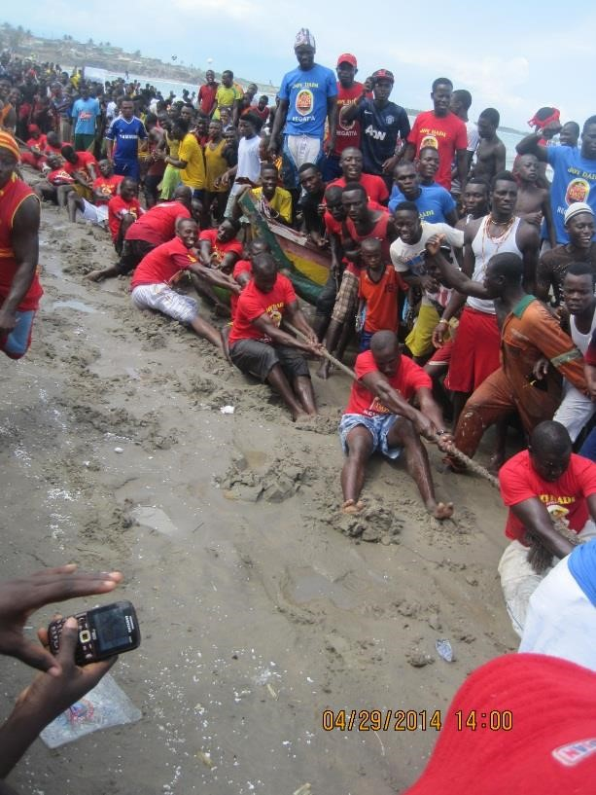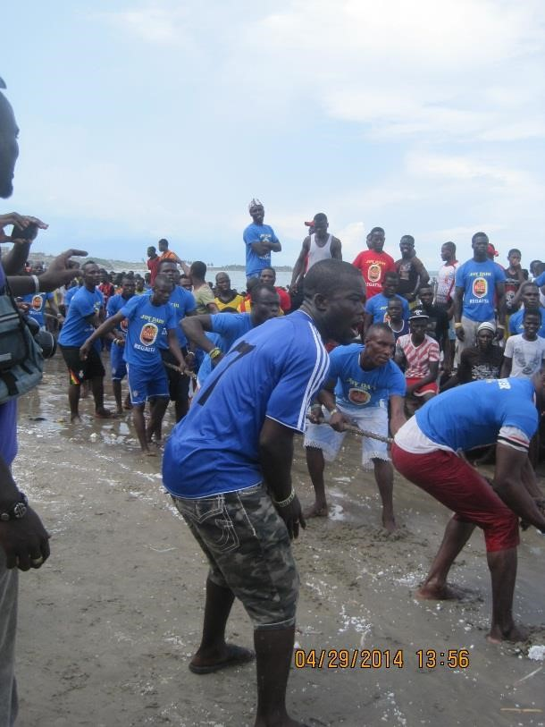

Plate 4.1.1 The Dentsefo No. 2 youths Plate 4.1.2 The Tuafo No. 1 youths in in their Red t – shirt during the tug of their Blue t – shirt during the tug of peace peace

Source: photograph by researcher Source: photograph by researcher
On that same day, immediately after the tug of peace, there is a canoe race (regatta) between the two groups. The umpires or referees take the lead with a canoe onto the sea. They locate a spot where the two groups respectively will go and turn around the spot and the group that will be able to turn and get back to the shore first are the winners of the race. There is also a prize package for the participating members and the eventual winners. All these activity goes on as a warm up to the major event on the Saturday. Immediately after the tug of peace and the canoe race (regatta), the Tuafo Asafo No. 1 youths outdoor their deity “Nsambon” through selected routes in the town. This is seen in Plate 4.1.4 as the deity is outdoored.
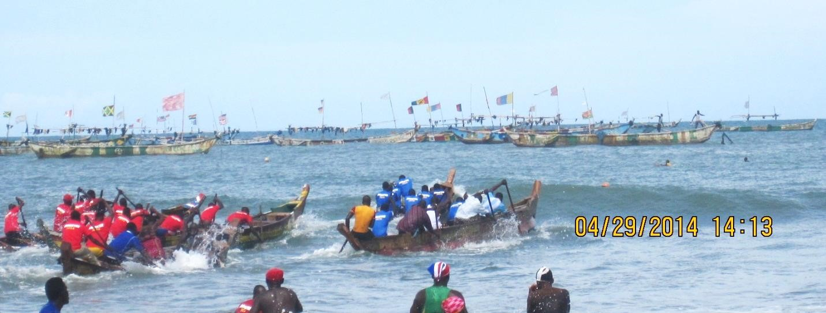
Plate 4.1.3 Canoe Race (regatta) between the Dentsefo youths and Tuafo youths

Source: photograph by researcher

“Nsambon” (Deity of Tuafo No. 1 Youths)
“Nsambon” is a deity of the Tuafo No. 1 youths. The spirit invoked in the deity brought about the name “Nsambon”. It is made up of six flowers, powder and traditional drink covered with calico. A mirror is pasted on the front and back of the deity. It is believed that the mirror enables them to see spiritual things or serves as a link between the natural world and spiritual world (metaphysics) thus beyond physical. Certain observations and rituals are made before outdooring the Nsambon deity on the Tuesday afternoon immediately after the tag of peace and regatta. The deity is outdoored for purification of the youths and also for protection against the other party and any form of attack both physically and spiritually.
(Nana Kwansah Panyin PRO of Winneba Youth Association, personal communication 14th June, 2014)
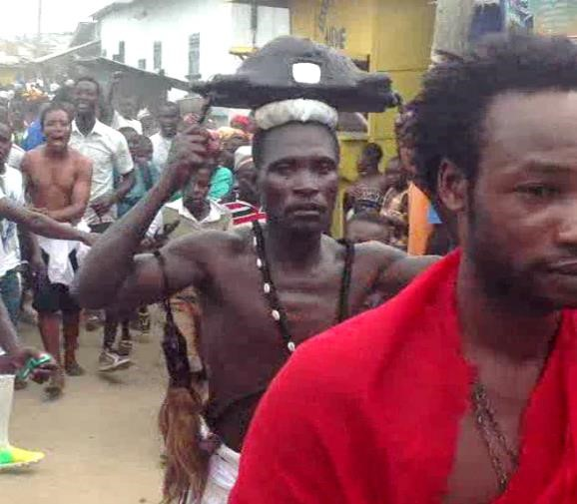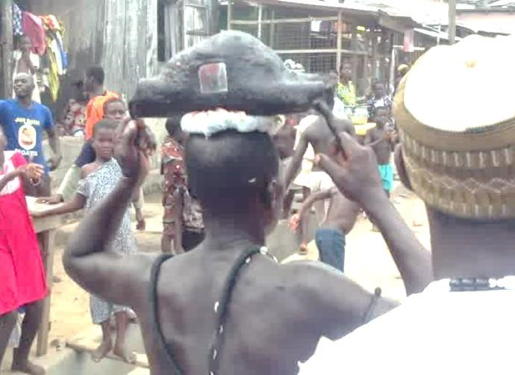

Plate 4.1.4 A youth of the Tuafo No. 1 carrying the “Nsambon” deity
Source: photograph by researcher

Wednesday is set aside for observations, rituals and the consultation of the deities by both Asafo groups (Dentsefo and Tuafo) and this is done indoors because wednesday is a day for no noise making in the town during the Aboakyer festival (a ban is placed on noise making). It is believed that Wednesday is the day the Effutus arrived in their present location (Winneba) and came across the Monyi lagoon so they hold this day very sacred. They met Monyi lagoon on wednesday, the Ayensu on friday and settled at Penkye on a saturday.
On the thursday preceding the hunt, the Dentsefo No. 2 youths perform certain rituals and observations to their deity “Basabasa” and outdoor the deity in the afternoon through the selected routes of the town.

“Basabasa” (Deity of Dentsefo No. 2 Youths)
“Basabasa” is a deity of the Dentsefo No. 2 Asafo youths. The ontology behind this was that the youths of the time outdoored certain things during the festival for fun. This continued yearly till a day the bearer became possessed after passing through Mfantse Mfantse where the major shrine is. They got terrified and contacted the chief priest for rituals and observations to be made before the possessed youth was freed. There were consultations with the gods and they were taught the actual procedures to follow.
The spirit invoked in the deity brought about the name “Basabasa”. It is made up of the “nkanto” tree, cola, six flowers, blood from a dog and covered with calico. The colour turned brownish black due to ageing and also the blood being poured on it during rituals and observations. The “nkanto” is a sacred tree in the forest and is cut without breathing. It is believed the tree speaks and possesses certain spirit. The spirit can possess or take dominion over the person cutting when talking whiles cutting.
The bearer of the “Basabasa” deity hang a “bodua”(tail of a horse or donkey) with mirror on their arm as they parade through the selected route in the town during the festival. This serves as a third eye which enables them communicate with the spirit world and also see what the opposing group is planning against them. “Basabasa” is outdoored on the thursday before the catch. Time is allocated for the outdooring of the various deities of the Asafo companies to avoid rivalry and conflicts. The deity is outdoored for purification and also offer protection to the youth of Dentsefo No. 2 Asafo Company. The “Basabasa” deity is shown in the picture below:
(Nana Kwansah Panyin PRO of Winneba Youth Association, personal communication 14th June, 2014)

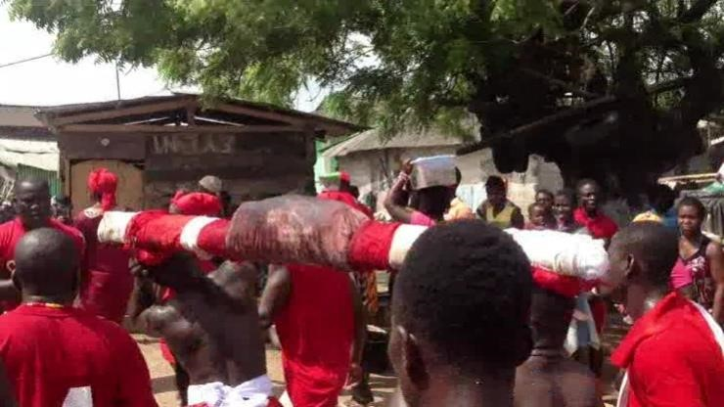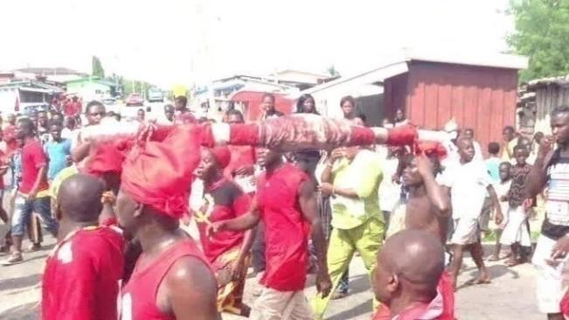

Plate 4.1.5 The Dentsefo No. 2 youths outdooring “Basabasa” deity
Source: photograph by researcher

The introduction of the youth deities in the celebration of the Aboakyer festival is a recent addition to the festival and is contributing immensely in the celebration. It pulls along massive crowd when outdoored and adds lot of excitements, enthusiasm and colour to the carnival.
The Friday preceding the hunt is spectacular for Aboakyer; Tuafo invoke and outdoor Gye mesi (meaning restore, protect), while Dentsefo come out with “Asikama”. These are paraded along selected routes in town and in turn so as to prevent a clash or conflict. Tuafo are supposed to come out between noon and three in the afternoon and then Dentsefo follow. These outdoor
performances by the Asafo are really exciting as their respective head priests carry their idols in a trance amidst shouts and chanting of Asafo war songs and led by one person playing a pair of special oval shaped handmade bells –“nkodwo”. The Asafo members disperse at the end of the day to prepare for the actual hunt the following day. There is no Asafo drumming during this parading of gods.
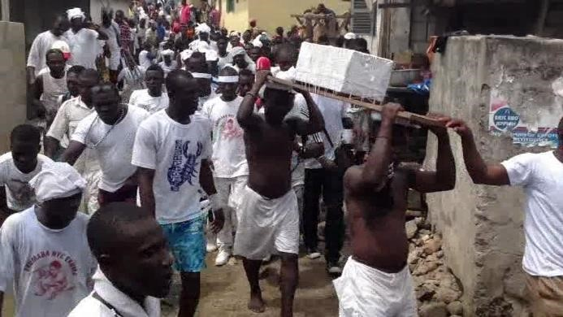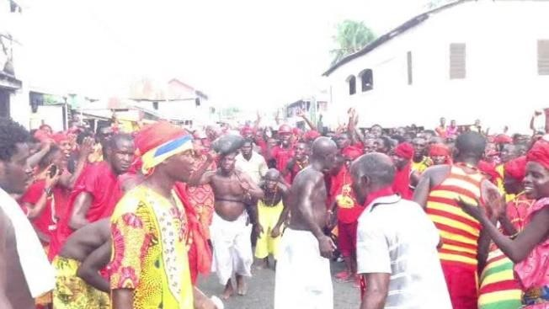
Plate 4.1.6 Tuafo No. 1 Asafo Company Plate 4.1.7 Dentsefo No. 2 Asafo outdoor their deity “Gyemisi” on a wooden Company outdoor their deity “Asikama” board
Source: photograph by researcher Source: photograph by researcher
Scouts are sent to respective hunting grounds to observe the movements of animals and thereby secure the best hunting site. They are followed by an advance party at dawn and the main body at day break.
By 4.00 am on the hunting day, Saturday, Asafo members are awakened by the sounding of drums, bugle, rattles and bells to start trooping to their respective meeting places. Supis, Asafohenfo and Kobae are escorted from their homes to their respective Asafo bases. While this goes on, Asafo youth groups parade the streets in readiness for a final departure command. The singing and playing of Asafo musical instruments awaken everyone to come to the road sides as they begin moving out of town to the hunting grounds. This movement is gradual until at the appointed time, 5.30 am for Tuafo and 6.00am for Dentsefo, (because of the distant location of the former’s hunting grounds) the head Supi of each Asafo gives the command for the groups to move out. The Asafo depart in groups according to age and all pass in front of the Chief’s palace where the Chief and his elders and state linguist are assembled to offer them a final blessing.

Just after Abosomba, the priestesses and priests of Otuano, Dawur prama and others sprinkle water from a concussion (“akom mu nsu” –water from the shrine) on them also to offer another level of protection for a safe and successful hunt. The significance of this is to bind the animals from the Asafo except the deer to enable them have a successful catch devoid of snake bites and other attacks. The “akom mu nsu” is also sprinkled on the chiefs, queen mothers, linguists as they process
to the durbar grounds for protection as well.
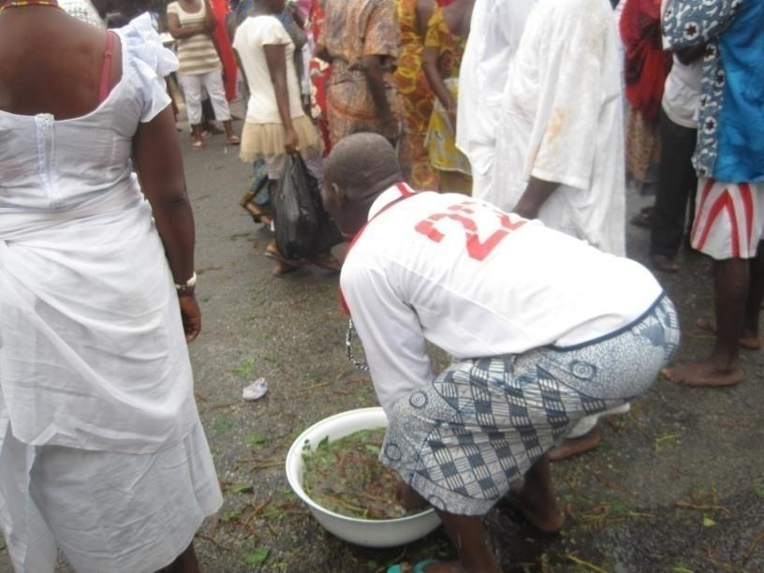
Plate 4.1.8 Traditional priest sprinkle “akom mu nsu” (concussion
from the shrine) on the Asafo groups on their way to the hunting grounds

Source: photograph by researcher

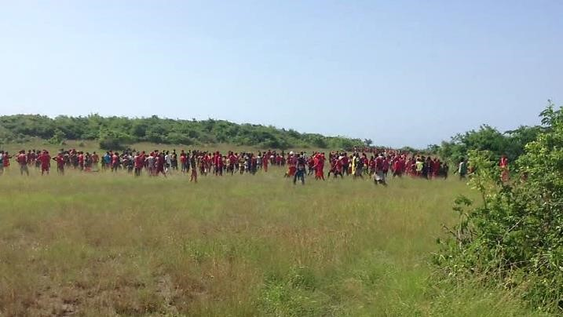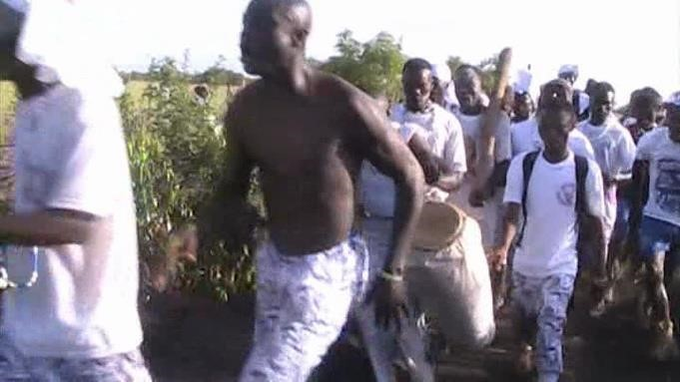

Plate 4.1.9 Dentsefo no. 2 group on their Plate 4.1.10 Tuafo no. 1 group on their way way to the hunting grounds to the hunting grounds
Source: photograph by researcher Source: photograph by researcher

Soon after their departure, the paramount chief, divisional chiefs, sub-chiefs, linguists, traditional priests and priestesses leave the palace in a long procession to the durbar grounds to wait for the arrival of the first catch. This procession is done with all available royal drumming: fontomfrom or bombae, mpintsin, mmensuon and aprede.
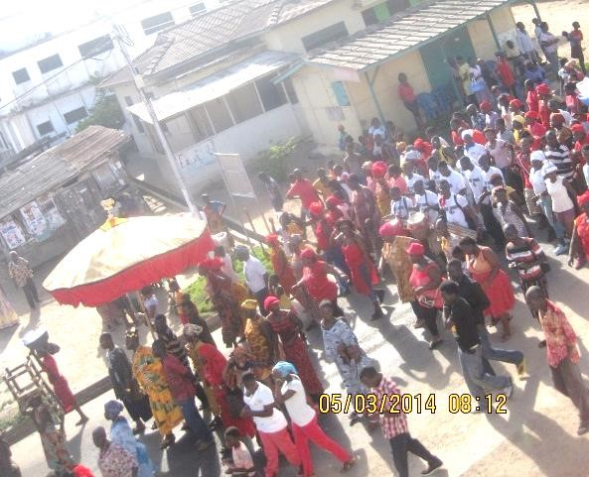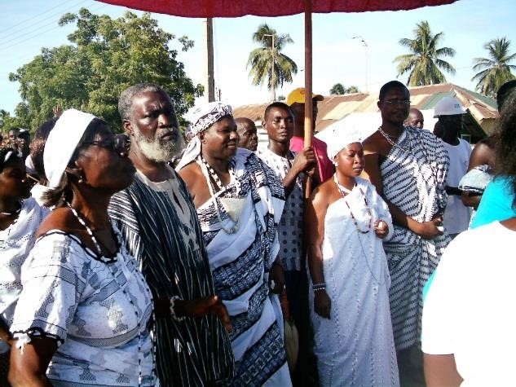

Plate 4.1.11 Procession of Chiefs, Queen Mothers, Traditional Priests and Priestess to the

durbar grounds
Source: photograph by researcher and palace of Oma Odefe

When a catch is made, message gets to the people in town within minutes and this turns the people into jubilation. The Dentsefo Asafo Company send some members with the Union Jack to the durbar grounds to announce the catch before the animal is brought. The people then troop to the durbar grounds for a glimpse of the frenzied catch. The jubilant Asafomen now carry the animal shoulder high; present it to the paramount Chief who then performs the acceptance rites. The process involves an offer of libation and then an impression with the right bare foot on the animal thrice.
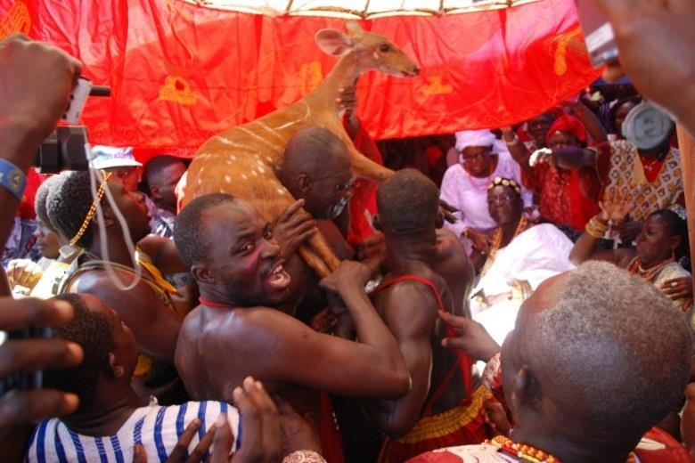
Plate 4.1.12 The Dentsefo No. 2 with a catch at the durbar grounds
Source: photograph by researcher
The victorious side then picks it up from the feet of the paramount chief and parades with it to Abosomba. At this strategic position, visitors who could not go to the durbar grounds also troop to catch a glimpse of the catch. After a while, the priest and some elders of the god Akyeampong (messenger god) all clad in white calico along the waist come with twigs, they spread them out to form a mat, lay the animal on them, and with the stem of a creeping plant as twine, the twigs
(“mpar”) and animal together are bound firm to enable it to be carried away. On their way, the senior member of the Prama (Akyeampong Ano) plays the gong requesting all to clear from their path. With a head pad as support, the catch is carried to the ceremonial Apa Sekum shrine at the ancestral market for the next day’s sacrifice. On their way back to the shrine, the person who led them in now wields an ancient cutlass in a fashion that is reminiscent of one clearing a bush path as if the animal is being brought from the bush to the shrine. An additional catch by any of the Asafo Companies is not material to the festival but only adds to the fun fare. In such situations all animals are carried by the people of Akyeampong Ano (Ano when used this way refers to the Prama) to the ancestral market but the one for the sacrifice is marked for easy identification.
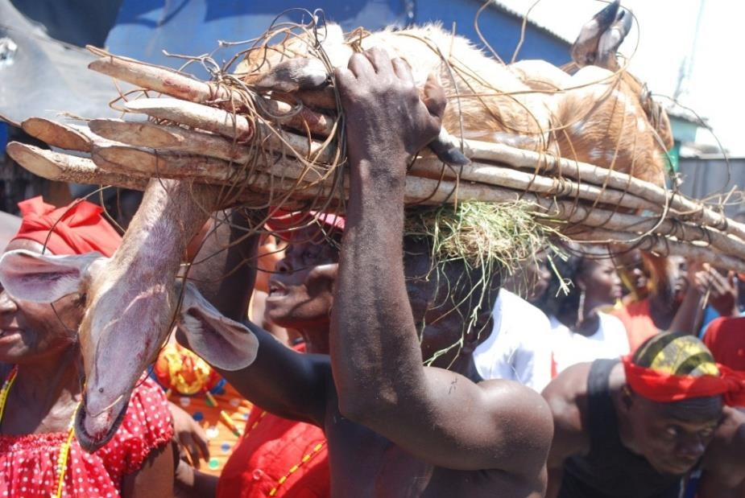
Plate 4.1.13 The deer laid on a mat made of twigs and tied with twines being carried to the shrine by a man from Akyeampong Ano
Source: photograph by researcher

Soon after noon it is time to take the king back home; to the Palace. This is the time for the afternoon procession. By 1.30 pm the Asafo now in full regalia; very colourfully decorated, start the procession from the Abasraba (suburb of the town). There is Asafo singing, drumming and dancing to Akosuadontoba and Owombir; a free for all dance time. The King rides in palanquin along the procession led by his chiefs in rich regalia. The victorious Asafo Company, i.e., the one that brought the first catch for that year leads in the procession followed by the paramount Chief and his entourage, and at the rear of the procession is the Asafo Company that returned last from the hunt. This procession ends at the Chief’s palace where libation is poured in prayer and a ram is slaughtered to thank all and sundry including the souls of the departed and the deity and then the Asafo is dismissed pending the Chief’s appreciation drinks; the ayekoo nsa which the Chief pays to the Asafo for honouring their vow to present to him with a live deer for the propitiation of the deity, Apa Sekum annually.
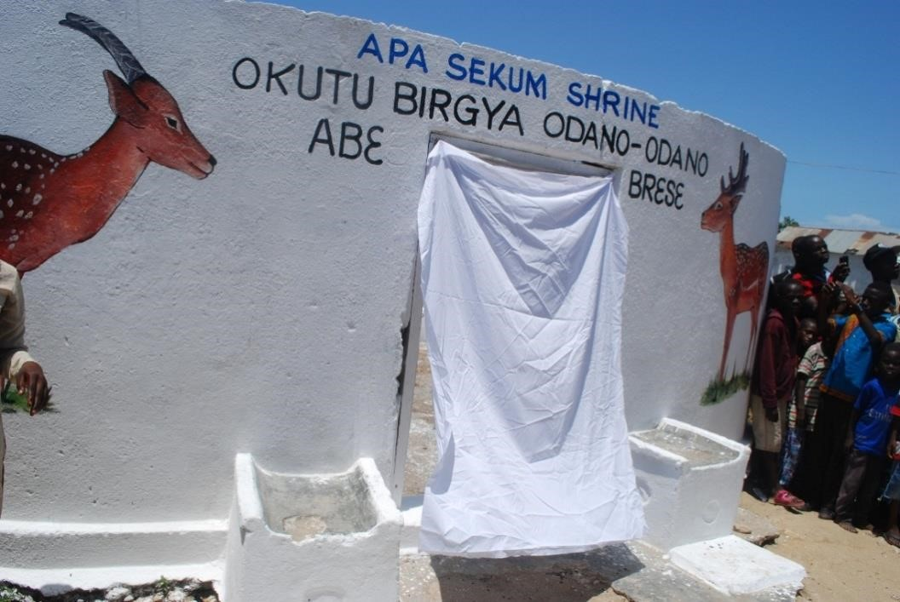
Plate 4.1.14 Apa Sekum shrine where the deer is fed to the deity

Source: photograph by researcher

The final stage of the festival is on the Sunday after the catch. This is called the “Ebisatsir” (casting of lot). This time is meant for inquisition from the oracle what the gods have in store for the new year they just entered. The chief priestess draws four parallel lines on the floor. One in white, another in red clay, the third charcoal and the final one is in salt. She places a pot upside down at the end of the lines. The fabric covering the deity Penkye Otu is then taken off and rolled into a carrying pad which the priestess places at the bottom of the pot. She picks up the little round stone that lies before the deity, puts it upon the pad and invokes the spirits of the 77 gods of the Effutu State to descend. She invokes Penkye Otu. The moment the priestess stops speaking, the stone rolls and rests upon one of the four lines drawn on the floor. She places the stone on the pad and leaves it to roll again. This is repeated a third time. She then announces the result to the people. If the stone falls upon the white clay, it signifies great drought during the year. On the other hand, if it rest upon the charcoal line, it implies heavy rains. If the stone stops on the salt, it indicates plenty of fish and food for all and if it settles upon the red line, it signifies war and strife (Ackom, 2005).
Today, the festival is celebrated with other additional events that are meant to entertain the tourists and other guests. The festival has been programmed to last a week long. The key entertaining events are:
- Open Marathon competition organized to help the youth unearth their sporting talents
- Regatta and Tug-of-war this event is meant to engage the fishermen who constitute the
Asafo to have their day.
- Football matches (gala) which engages the youths of the community to have fun
- Aboakyer tennis open (tennis tournament for the youths).
- Bicycle race to engage the youth in a form of competition to unearth sporting talents
- Mini trade fair to support entrepreneurs in the area to showcase their products. This lasts the length of the festivities.
- Musical concerts organized by sponsors to entertain indigenes and guests.
- The crowning of Miss Aboakyer after the Saturday procession of Asafo and Chiefs is to have further fun fare in a musical night programme with beauty pageants.

4.2 The Akomase Festival of the Effutus
Akomase (literally; k masa, means end of hunger) falls in the period between the second and third week of August but better marked on the 15th Sunday after the Aboakyer festival. It is said that the actual festival of the people of Simpa (Winneba) is Akomase but its popularity gave way to the Aboakyer because of its artistic, musical, competitive and sportive nature.
Penkye Otu feasts during this season and all shrines in Simpa feast this time. Whereas at Otu Ano, there is yam feasting for a week ending on the Akomase day, the 15th Sunday yam feasting is for a day at all shrines: Gyaaben Ano, Akyeampong Ano, Kweikum Prama and Alata Prama. During these days, all the left over’s and garbage from the cooking is not discarded but saved for the final day rites.
It is customary that Otu’s meal is cooked with fire made by its priestess and the slaughtering and cooking is done by the Os w and elders of Dawur Prama. It is also the practice that those other Prama and shrines that celebrate yam with Otu, do not make their own fire but come to Otu-Ano when Otu’s fire has been made to pick lit firewood to start theirs.
(Personal conversation with Neenyi Ghartey VII, April 29, 2014)

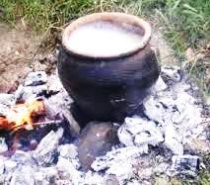
Plate 4.2.1 Penkye Otu’s yam being cooked

Source: photograph by researcher

At dawn on that final Sunday, the Akomase day, there is general weeping throughout the town. This is in remembrance of the dead. In the early hours of the day, family members congregate at clan houses, pour libation and then wait for the meal of the season. Members whose relations have died and been buried in the course of the year cook sumptuous meals to feed the whole family gathering. This is said to be the end of rites of remembrance of the dead for those persons.

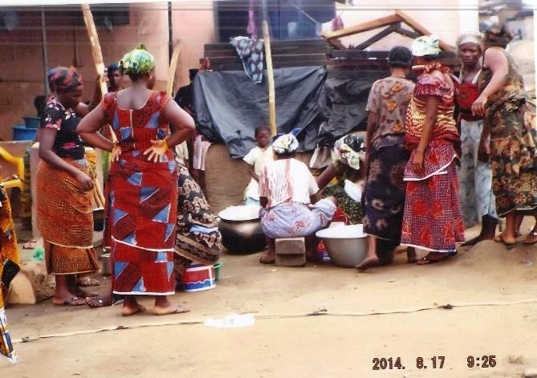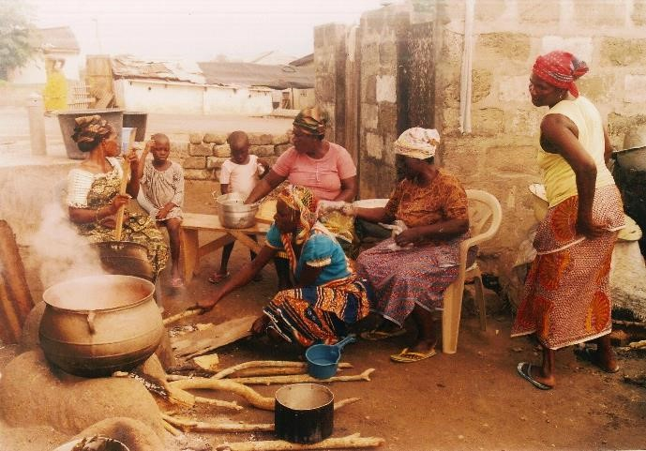

Plate 4.2.2a Plate 4.2.2b

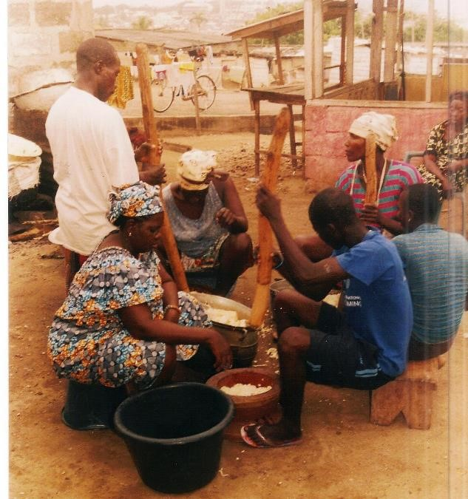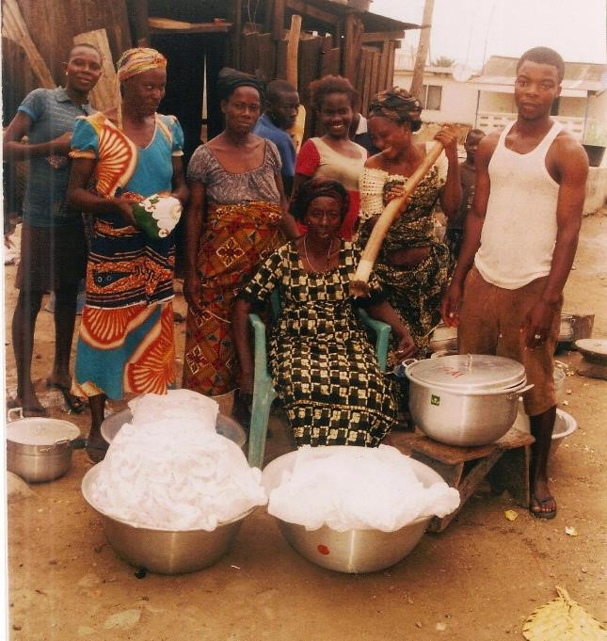

Plate 4.2.2c Plate 4.2.2d

Plate 4.2.2 Preparation of food to feed the families during the Akomase festival
Source: courtesy of Richard
In the afternoon, shrine houses that participated in the festival carry on flat wooden trays all the garbage from the rituals performed with the carriers clad in white calico along the waist. The assembly point is Nkwantanan ( twek nduase), road intersection where they are joined by those from Otuano. The Akyeampong Ano priest leads the procession wielding an ancient cutlass swinging it to the left and right in a manner reminiscent of path clearing to show that they are moving into the bush to throw the garbage. They follow a special path to a spot; a groove at Donkoryiem where the garbage is disposed off.
On the way to the garbage dumping site; a point within Donkoryiem, they sing the song;
EFFUTU ENGLISH
Otu oo oo Otu o oo (Penkye Otu – god of the Effutus)
Otu oo, oo Otu oo oo
Woowoo, woo woo Yeah yeah yeah yeah
W so no kwangya We are leading Otu’s garbage away
Literal meaning they are leading Otu’s garbage away.
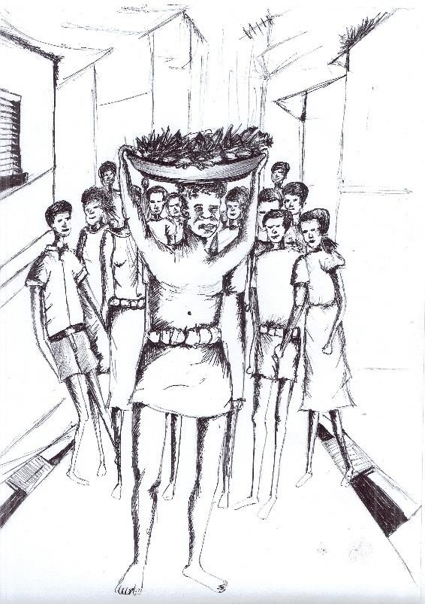
Plate 4.2.3 Members of the seven Prama carrying the garbage to the site
Source: Illustration by researcher

While in this procession, those carrying the garbage are in trance till the garbage if disposed at that special spot. This ends the celebration of Akomase and those who went along on arrival at the shrine are given some drink after a final libation is offered to the deity. There is singing and jubilation along the procession.
People who are standing by pick small pieces of stone, turn it around the head and body and throw it over the garbage, a gesture that signifies a request for the garbage to go away with any illness, bad luck and any other problems the individual might be troubled with. This is an expression of faith in the deity as a father, protector and deliverer and one that has the ability to bring prosperity. The Artistic Elements in the Festivals of the Effutus
The Effutus can boast of lots of artefacts linked to their festivals thus Aboakyer, Akomase,
Masquerading Festival, Tuafo Fida (Twins Yam Feasting), Dentsefo Memenda, Fantse Fantse Firing of Musketry, Eyipey Otu Yam Feasting and Ash Wednesday (Festival of the gourd). To them art is an integral part of their culture and without art they do not have any form of identity. They are identified through their emblem, black stool, royal stool, festivals, rites of passage and certain customs and beliefs. These are all coupled with lots of artefacts ranging from textiles, sculpture, paintings, jewellery, body arts, verbal arts, installations and performing arts.

4.3 Visual Arts in the Aboakyer Festival
Visual art works in the celebration of the Aboakyer festival play an integral role and its benefits are enormous. Effutus are noted for their aesthetic impact in their celebrations. They have a great sense of beauty and this reflects in their culture and traditions.

4.3.1 Beads (Jewellery)

“Nsise” and “Ehuma”
“Nsise” and “Ehuma” beads are ornaments made with glass, stone, paper or similar material that is threaded with others to make a necklace won during the Aboakyer Festival. Categories of groups or individuals wear beads according to their status and also for identification. The Dentsefo No. 2 uses the “Nsise” thus the red and yellow beads and the Tuafo No. 1 uses the “Ehuma” beads thus the black and white or blue and white as parts of the ornaments worn during the festival. The beads are worn around the neck or the wrist during the Aboakyer festival. The “Nsise” and “Ehuma” serve as identification for the Asafo Company during the festival. In the culture of the Effutus, Asafo affiliation is inherited from the paternal home (Prama). The choice of bead is guided by the patrilineal affiliation.
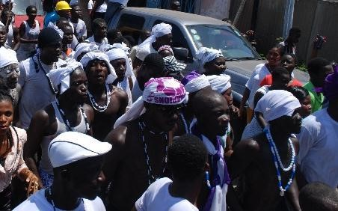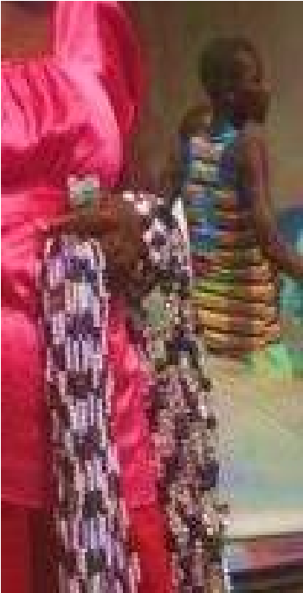

Plate 4.3.1 “Ehuma” beads used by Tuafo No. 1 Asafo Group for identification Source: photograph by researcher

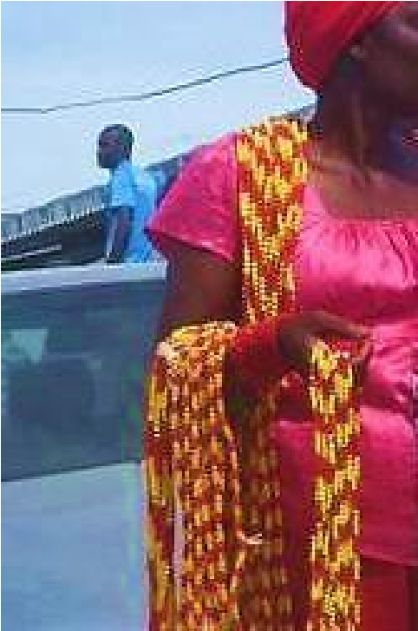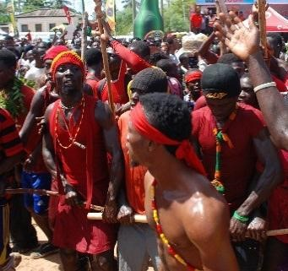
Plate 4.3.2 Dentsefo Asafo youths wearing “Nsise” beads for identification Source: photograph by researcher

There are other forms of beads worn during the Aboakyer festival. Queen mothers, chiefs, traditional priests and priestesses wear special type of beads for medicinal, identification, and protective purposes. Dignitaries and visitors wear beads for aesthetic purposes. Beads are won around the neck, arms and ankles.
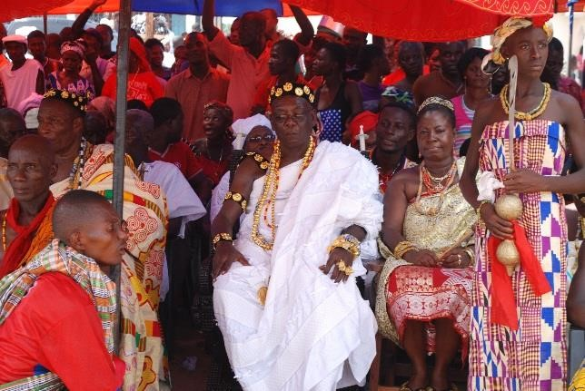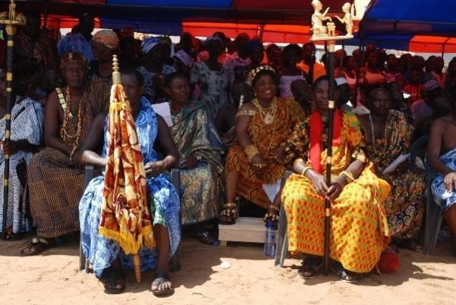

Plate 4.3.3a Plate 4.3.3b
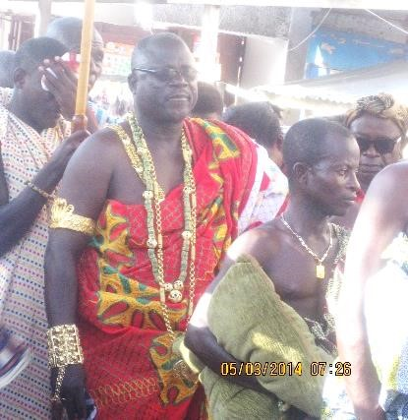
Plate 4.3.3 Beads (Jewellery) worn by the Chiefs and Queen Mothers during Aboakyer
Source: photograph by researcher

Plate 4.3.3c

4.3.2 Textiles (Costume)
The Effutu festivals are noted for colourful and fanciful costume finishing. The Dentsefo No. 2 and Tuafo No. 1 have respective colours assigned to them and this is manifested in their choice of costumes for the celebration. The costumes of the Asafo Companies for the Aboakyer festival are taken to the paramount chief’s court for inspection and approval before they are used on the Saturday of the festival. This is done to avoid rivalry and conflict during the Aboakyer festival. Costumes are used during the festival to show identity and classification, class, historical purposes and aesthetics. They are used by individuals and groups. The various Asafo groups sew special costumes for the celebrations. The women groups also do same for the festival.
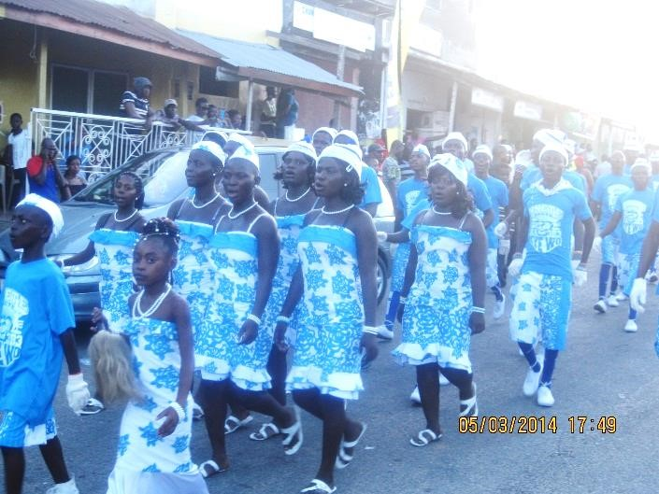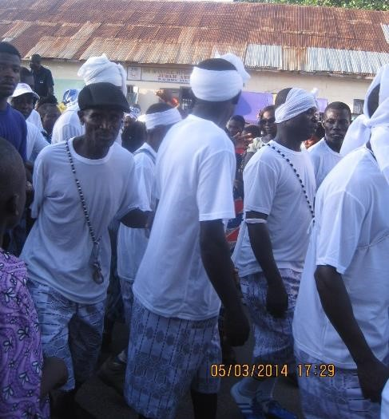

Plate 4.3.4 The Tuafo No. 1 female and male groups in their costume
Source: photograph by researcher

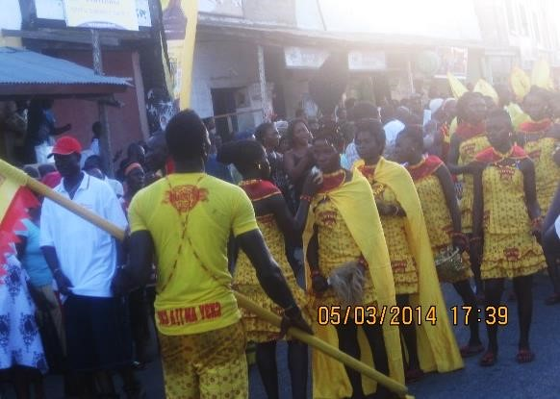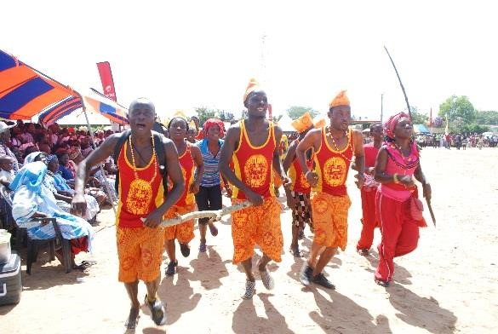

Plate 4.3.5 the Dentsefo No. 2 female and male groups in their costume

Source: photograph by researcher

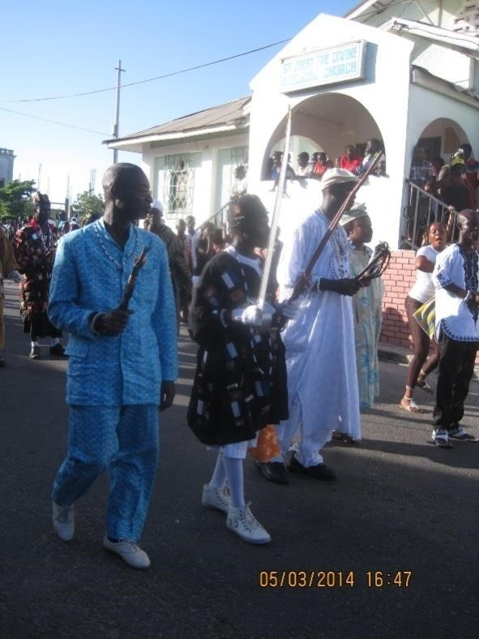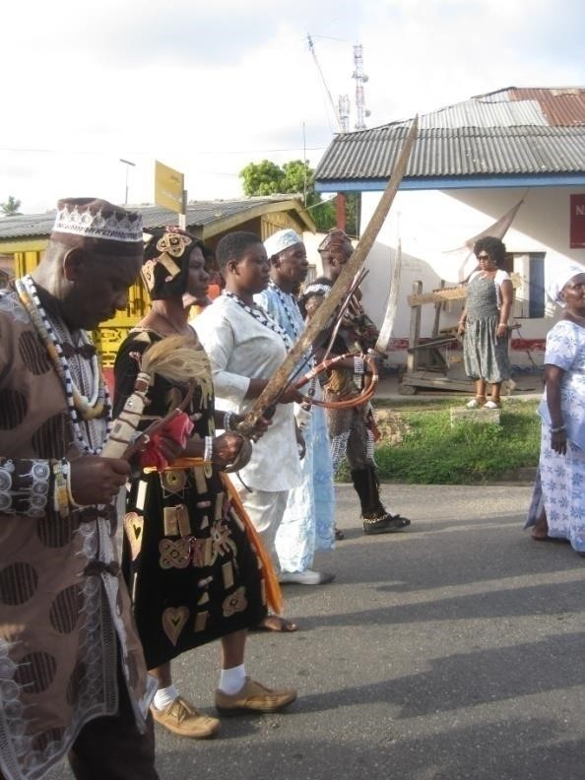

Plate 4.3.6 The Tuafo No. 1 Supis in their costume during the afternoon procession

Source: photograph by researcher

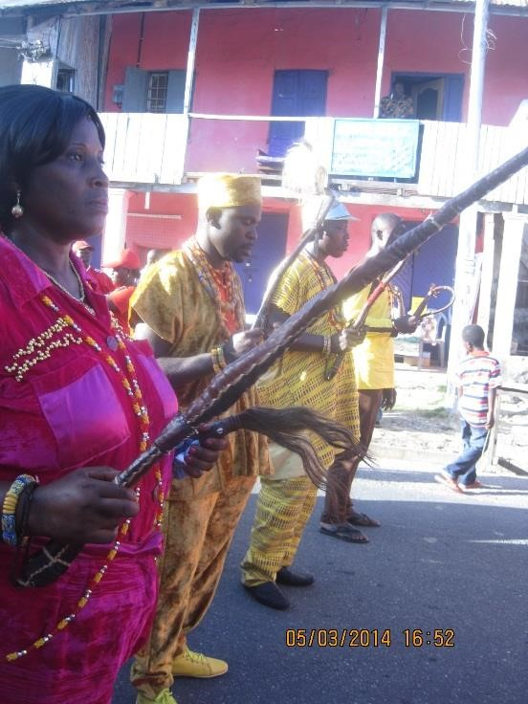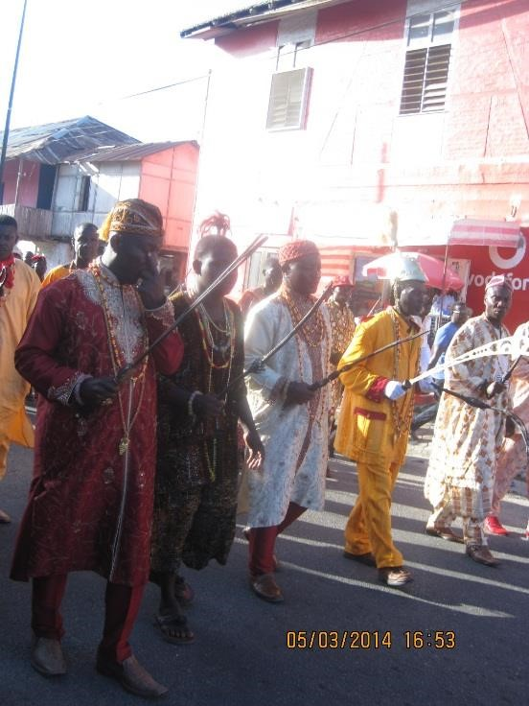

Plate 4.3.7 The Dentsefo No. 2 Supis in their costume during the afternoon procession

Source: photograph by researcher
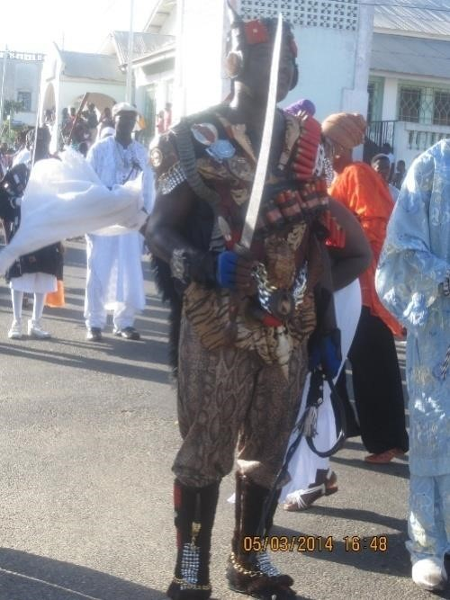
Plate 4.3.8 Tuafo No. 1 “Nmbo” (amulet) worn during the
festival
Source: photograph by researcher

The “Nmbo” (amulets) is worn by the Supi from the Tuafo No. 1 Asafo Company for protection. It is believed to have certain spiritual and medicinal powers. It was used during war in the history of the Tuafo No.1 Asafo Company.

Iron Helmet
The iron helmet is a free standing sculpture (sculpture in the round). The media used is metal and the technique used for producing it is casting. The artist who produced it is anonymous. The elements of art seen in the work are colour, texture, shape, space and line. The piece has a golden colour as a finish and has a rough and smooth texture. The rough texture is seen in the whisk fixed at the top of the helmet whiles the metallic part is smooth in appearance. Line is seen at the base of the helmet. The piece has a semi oval shape and also the motifs infront of the helmets has some regular and irregular shapes. It has a positive and negative space. The positive space is the area where the work occupies whiles the negative space is the surroundings around the work.
The elements used in the execution of the iron helmet was guided by certain principles. These are balance, proprtion, variety, unity and harmony. The artwork is semetrically balanced thus equally distributed weight. Proportion is also exhibited in the work; this is seen in the relative parts. The artist also used different elements (line, colour, shape, space and texture) in the work which portrays variety. Again, there is the use of unity and harmony; this is seen in how the elements were used.
The Iron helmets style was copied from the early Portuguese traders and settlers. This is worn by the captains of the Dentsefo No. 2 Asafo Company. The iron helmets was a protective gear worn by the Asafo during war and still wear it even though there are no longer wars in recent time but serves as a symbolic piece (artworks) during the celebration of the Aboakyer festival. It is used for identification and also to show class, status and authority.
The helmet is a successful piece of art considering the finishing, technique used and the media. Judging it using the aesthetic theories, the work is successful to the imitationalist. It resembles an helmet and can be worn on the head. Again, to the aesthetic instrumentalist, the work is successful.
It plays specific functions therefore makes it “art for life sake”. The aesthetic contextualist also sees the work as a successful piece of art. It has some history and cultural origin attached to it aside it physical beauty.
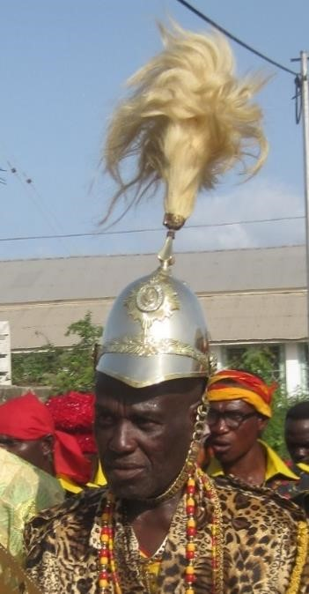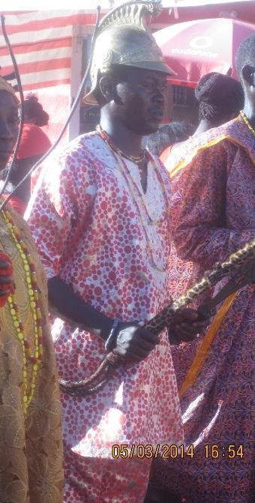

Plate 4.3.9 Dentsefo No. 2 Roman iron helmet worn during the festival
Source: photograph by researcher

“Fokyw”
“Foky[w” is a three dimensional piece of art. The artist who manufactured it is anonymous. The media used is mixed media and the technique used is assemblage. The height is 35cm long whiles the base is 21cm wide. The elements seen in the work are line, colour, shape, space and texture. Line is seen in the patterns created with cowries and leather. Colour is seen in the leather as brown, hide or skin of animal as black and cowries as white. Also, the work has a positive space and negative space. The positive space is where the work occupies whiles the negative space is the area surrounding the work. The “foky[w” is conical in shape. The texture is rough and smooth. The animal skin is rough and fluffy whiles the cowries have a smooth surface. The leather also has a smooth surface.
The “Foky[w” is symmetrically balanced, that is when divided into two equal parts, one side will be a mirror of the other part. The art work shows rhythm that is, the use of cowries to produce patterns repeatedly. Design elements such as colour, line, texture, shape and space employed by the artist brings variety in the “Foky[w” art piece.
“Fo” in the Effutu language literally means hairs of an animal and “ky[w” also refers to a hat.
“Foky[w” is a hat made of animal skin (hide) and cowries in a conical shape. It is believed that this hat was brought from a war with the northerners and because of the colour black with white cowries, it was not supposed to be used by the Dentsefo, instead the Tuafo because of the colours assigned to them.
Before the celebration of the festival, the Asafo Companies take their costume to court to be accessed. That particular year the hat (“Foky[w”) was not accepted by the court so the Dentsefo decided to stay aside. The Tuafo were the only group that went. As at 12 noon, there was no catch, the king at that time Nana Ayirebi Acquah III later agreed they wear the foky[w and when they eventually went for the catch, they caught five deer that year. Since that time the “foky[w” was agreed upon to be used by the “Asomfo”, a sub group of the Dentsefo No. 2 although it has the black and white colour. The “Foky[w” now gives the Asafo some psychological toughness, guarantee of a catch and also imbues their confidence. It is a symbol and a badge of achievement to the Asafo group.
The “Foky[w” ( three dimensional realistic Asafo hat) is a successful artefact. The work resembles a hat which makes it successful to the aesthetic imitationalist. It has the characteristic of a hat and also serve the intended purpose. Again, to the aesthetic instrumentalist/functionalist, the art work is successful. It perform specific task thus, functional. It identifies the Asomfo of the Dentsefo No.
2 Asafo Company and also imbues their confidence for a successful catch. Also, to the aesthetic contextualist the artefact is a successful piece of art. It has some history, philosophy and canons attached to it.
(Papa Kodwo Owranye, Personal communication 14th June, 2014)

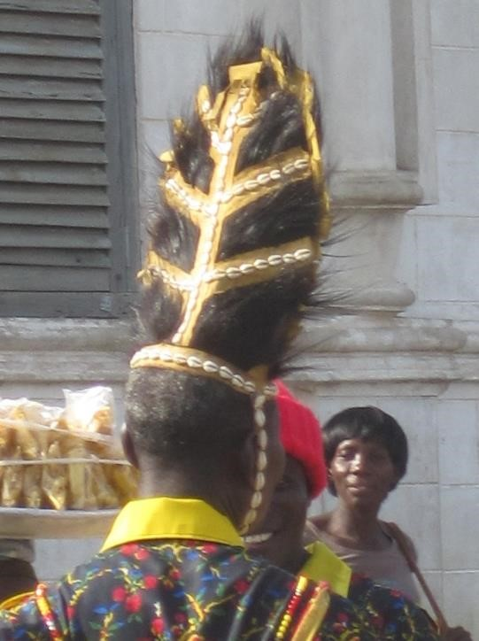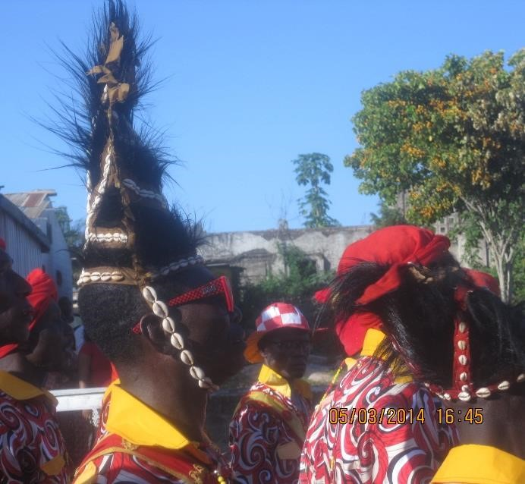

Plate 4. 3.10 Dentsefo No. 2 Asafo men wearing “Foky w” during the afternoon procession
Source: photograph by researcher

4.3.3 Body Arts
Body arts refers to the art forms or ornaments worn on the body or using the body as an art form for aesthetics, protection, medicinal or healing purposes. It comes in two forms thus the body as a platform on which art forms are displayed on (carrier of arts) and the body as the art work through paintings, tattoos and scarifications. A body art changes the wearer into an object shaped by colour, movement, texture, patterns and designs. It uses the human as a way to express an individual status, spiritual beliefs and ethnic affiliation. It can be created for wear on the body in the form of garments or jewellery, coiffure for example Tekuwa/Dansikran. Tattoos, scarifications, body paintings, jewelleries, hair styles, and piercing are the main body arts. The body art is seen on the Asafo
Companies, traditional priests, priestesses, the youths, queen mothers, chiefs and the indigenes.
The zeal and enthusiasm exhibited by the indigenes makes the festivals more colourful and joyous.

Body Painting
Body painting is a temporary act of applying pigment onto the body for protection, aesthetics and religious purposes. It only lasts for some hours or days or weeks. Body paint can involve just the face or some body parts or it can be a full-body design. The Effutus during the Aboakyer festival paint their skin for identification and protection. The two Asafo Companies use different coloured pigment on their bodies before setting off to the hunting grounds (“P w mu”). “Ntwema” is a solution made up of a mixture of red clay and grounded terracotta. The Asafo No. 2 youths
(Dentsefo) bath with the “Ntwema” three times before they set off for the catch on Saturday morning. This is meant for identification and also protects them from thorns in the bush. The youths wear shorts without shirts and paint themselves with the “Ntwema” solution. Some youths from the Dentsefo group also paint themselves with yellow paint (pigment) mixed with water.
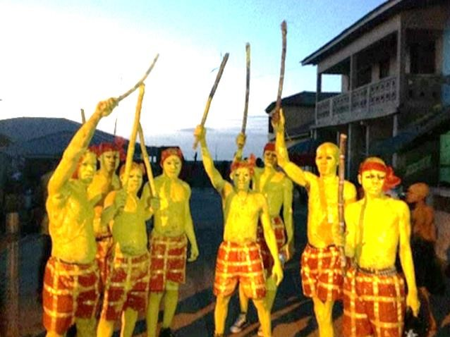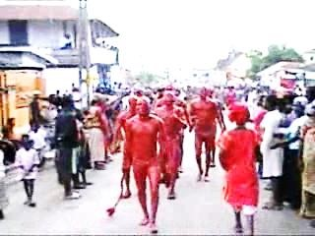

Plate 4.3.11 Dentsefo youths painted with Plate 4.3.12 Dentsefo youths painted with yellow pigments for the hunting “Ntwema” solution for the hunting
Source of photograph: researcher Source of photograph: researcher

The Tuafo No. 1 youths paint themselves with “Hyirew” (grounded kaolin) mixed with water for protection, identification and aesthetic purposes. Some also grind charcoal and mix it with water to paint themselves for the catch. Others also apply blue paints on their body. This is due to their assigned and approved colours used over the years. The body paintings are removed when they return from the hunting grounds. They change into their respective group costumes for the afternoon session.
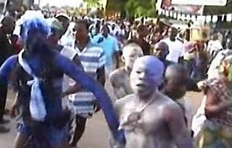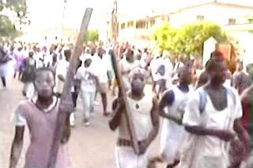

Plate 4.3.13 Tuafo no. 1 youths painted with white clay and blue pigment for hunting

Source of photograph: researcher
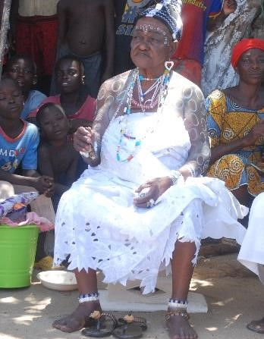
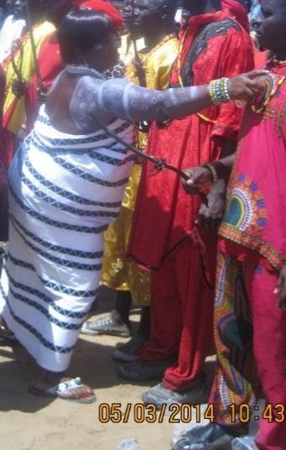
Plate 4.3.14 Body markings seen

on the priestesses during the Aboakyer
Source: photograph by researcher

Coiffure (Hairdo)
It is the art done to the human hair. It involves the art of twisting, dyeing, plaiting or treating the hair with cosmetics. The human hair to the Effutus is also a medium for making art works. They have variety of hairstyles paraded during the celebration of the Aboakyer festival and these are made for religious and aesthetic purposes.
The queen mothers wear a special hair do to show class and status, the priestesses wear special hair do for identification, protection and religious purposes. The princesses also wear special hair do during the celebration for identification and aesthetic purposes. The messengers and servants in the shrines also wear a special hair do for religious purposes.
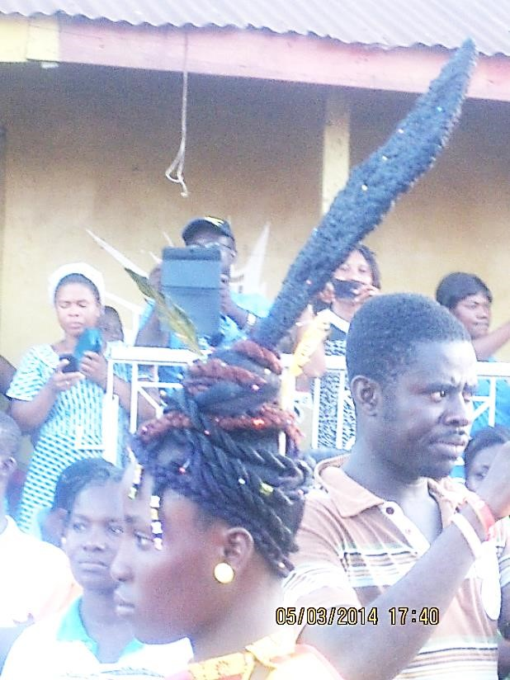
Plate 4.3.15 Hairdo seen during the Aboakyer festival
Source: photograph by researcher

“Mporba Hair”
The “Mporba” hairstyle is a traditional hair of the Effutus. It is used by the traditional priesthood for identification, spirtual and also aesthetic purposes. The hair is divided into five conical or circular shapes and golden or silver pebbles fixed on each shape. Some are decorated with strings and small wooden shaped motifs.
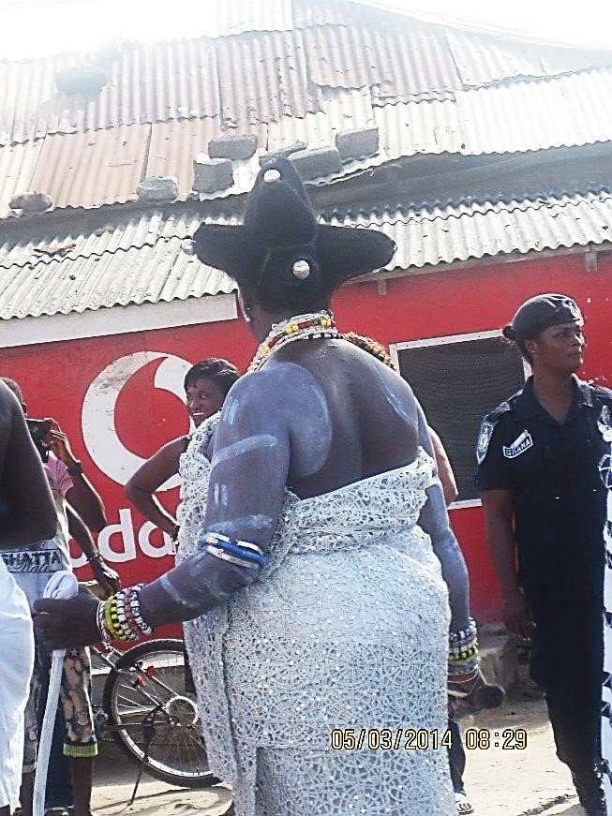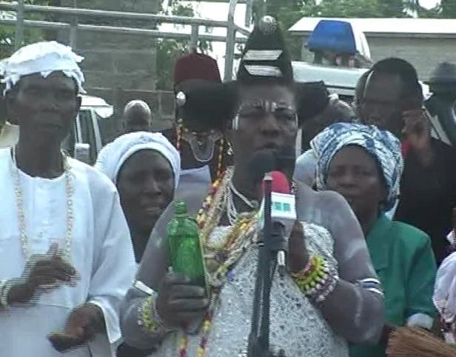

Plate 4.3.16 “Mporba” hairstyle of Okomfo Ansa (Chief priestess) during the Aboakyer festival
Source: photograph by researcher

Okomfo Ansa is the chief priestess in charge of sacrificing the deer to Apa Sekum (war god). She opens the durbar with a libation prayer inviting all the seventy seven gods of the town. Okomfo Ansa has a special hair style (“Mporba”) with some silver ornaments fixed in the hair. The hairstyle is meant for identification and also spiritual purposes. She keeps the natural hair without any form of cream applied to it. She performs the Ebisatsir (casting of lot) on the Aboakyer Sunday. The festival is not over for her after the Aboakyer festival. She sleeps in the open at the shrine till the first rainfall. To the priestess it is a happy moment for those waiting to sow the new crops. She washes the items (pots and utensils) used for the celebration and returns to her house.

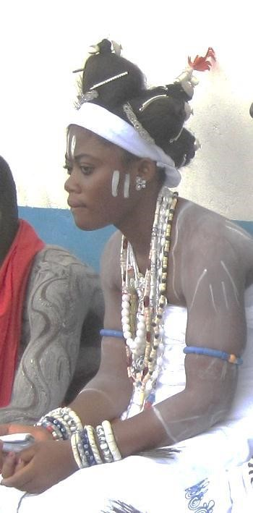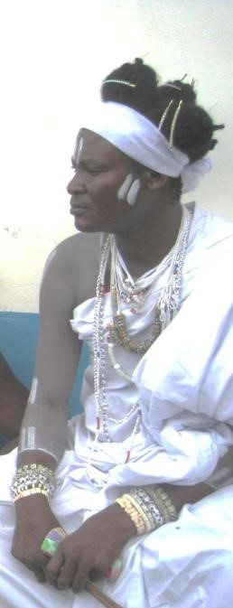

Plate 4.3.17 “Mporba” hairstyle used by the priesthood during the
Aboakyer festival
Source: photograph by researcher

4.3.4. Sculpture
The celebration of Aboakyer festival encompasses variety of three dimensional artefacts either in the round or relief from materials such as wood, stone, clay, metal etc. These figures and art forms are created by carving, modelling, casting, assemblage or construction.
Most of the sculptures used perform specific functions thus “art for life sake” thus, produced purposely to perform specific functions or roles and not for aesthetic purpose. Some sculpture works used in the celebration of the Aboakyer festival are the ceremonial seat of Oma Odefe, palanquin, linguist staff, stools, wooden horse, rings, statues, wooden ship (steamer), umbrella tops, chiefs’ sword, rattle (kakrade), drums, nkodwo (bell) canoes etc.

Ceremonial Seat of Oma Odefe
The ceremonial seat of the Effutus is the most valued and cherished royal insagnia used by the paramount chief (Oma Odefe). It serves as a symbol of authority. The seat is made up of wood and fabric. The dear as a symbol of the effutus is carved on it representing the identity of the people. The paramount Chief sits on it at the durbar grounds and places his feet on the skin of a deer to await the live deer from the hunting grounds.
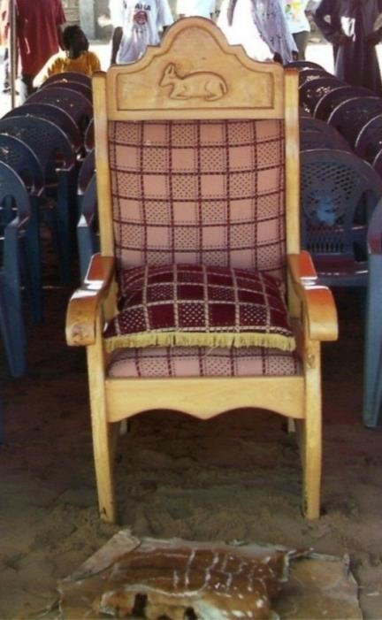
Plate 4.3.18 The Ceremonial Seat of Oma Odefe
Source: Oma Odefe’s palace

Palanquin of Oma Odefe of Effutu Traditional Area
During the procession in the afternoon (Akosuadontoba dance and Owombir), the Oma Odefe is carried in a palanquin through the principal streets of Winneba. This is a covered seat carried on poles held parallel to the ground on shoulders of four or more people. It has foam around it covered with velvet and a carved emblem of the Effutus on it. The paramount Chief dances in the palanquin signifying his authority and supremacy over the state and the indigenes.
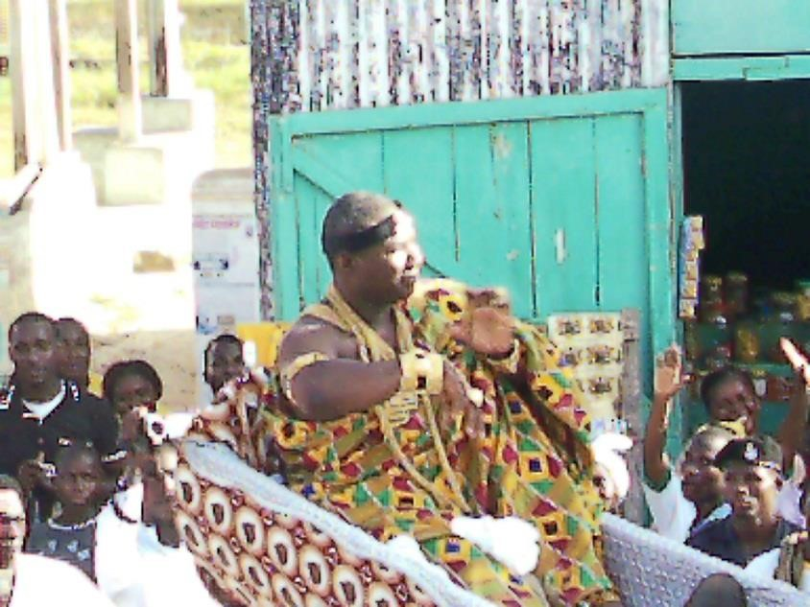
Plate 4.3.19 Oma Odefe dancing in his palanquin during the afternoon
procession through the principal street

Source: palace of Oma Odefe

Wooden Horse
“Wooden Horse” is a free standing sculpture that is sculpture in the round. The production technique used is construction and carving of which the base is made up of a case with four wheels under it. The artist who made it is anonymous. Elements seen in the work are line, texture, shape, space and colour. Lines are seen on the head, legs, shoulder, flank, neck and the base of the horse.
The head is conical in shape, the neck is cylindrical, the shoulder and flank are cylindrical, the leg is rectangular in shape and the hoof is triangular in shape. The “Wooden Horse” has a positive and negative space that is, the positive space is where the work occupies and the negative space is the surrounding or the environment where the work is located. The texture of the work is smooth and rough. Smooth texture is seen in the skin because it is covered with a fabric as the finishing. Rough texture is shown in the hair (crest) and the mane of the horse.The colour in the work is as a result of the fabric covering that is white (assigned colour for the Tuafo No. 1 Asafo Company) and the base construction is also blue and white.
The artist depicted movement (rhythm) in the work through the position of the four legs that is the right back leg in a contraposto pose (a figure that poses with the body slightly twisted and its weight resting mainly on one leg giving the impression of movement). The work manifests symmetrical balance meaning that when the work is divided into two, what will be on the left will be a reflection of what is on the right. The use of smooth and rough texture brings contrast in the work. Also, the use of lines, shapes, space brings variety in the work. The unity and harmony in the work is seen in how the parts are positioned. Proportion is exhibited in the relative parts of the horse and the height. Emphasis is laid on the right back leg showing the horse is in motion. The focal point is at the upper front of the horse.
The white horse is made up of wood and has several parts assembled together. It is constructed with horse parts which is separated after use and reassembled the following year. The horse stands in a wooden case which has four wheels under it that enables it to move.
The second part of the celebration on Saturday afternoon parades a wooden horse which belongs to the Tuafo No. 1 Asafo Company. The reigning Safohen rides on the horse during the procession through the principal streets of Winneba during the Aboakyer festival.
The horse is a symbolic piece representing the land as a means of transport by the Tuafo Asafo Company for war outside their territory. The Effutu land is made up of the sea and the land. The horse was the vehicle for transportation of the Safohen when going for war. This symbolic piece concur to the definition of festival by Hall (2000) as a means of celebrating the social, symbolic, historical continuity and physical survival related to the culture and ideology of the people.

The piece is a successful sculpture work because although the work is in wood, it is not rigid but manifests flexibility, movement and is proportional in relating the various parts of the body to the work in totality. He was able to get the anatomy right.
Using the aesthetic theories to judge the work, the work is successful from an aesthetic imitationalist point of view because it depicts a true resemblance of a horse. To the instrumentalist, the work is successful because it was able to carry the Safohen of the Tuafo No. 1 Asafo Company during the afternoon procession. It will make an exotic and elegant addition to many styles of an environmental [an outdoor sculpture] and also indoor sculpture. Then again, to the aesthetic contextualist the sculpture piece is also successful because it has some cultural origin, history and canons attached to it. The work is a symbolic piece representing the means by which Safohen of the Tuafo Asafo Company was transported for war and also to show class and status.
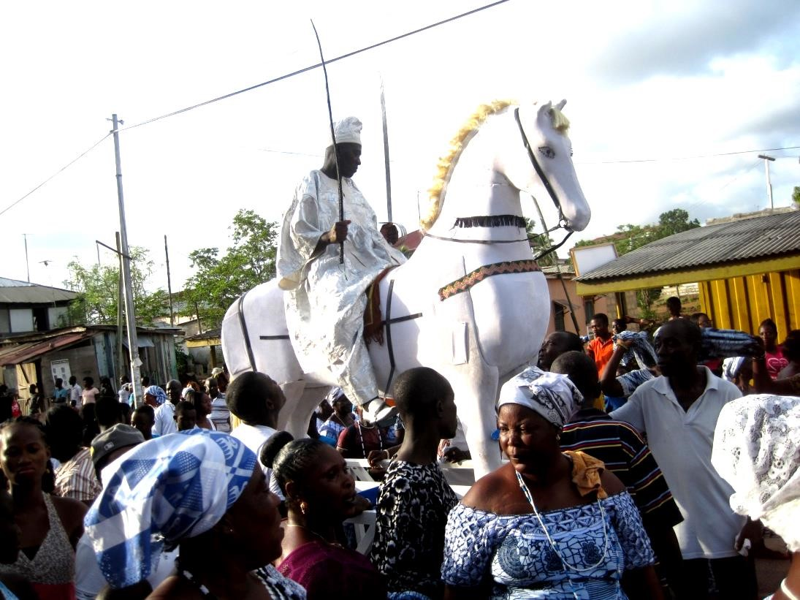
Plate 4.3.20 A captain of Tuafo No. 1 Asafo Company (Safohen) riding on a wooden horse during the celebration of Aboakyer

Source: photograph by researcher

Wooden Ship (Steamer)
The “Steamer” is also free standing sculpture (sculpture in the round). The technique used is construction and fabrication. It was hand made with metallic plates and poles welded together to form the steamer. The front is fixed with glass making it transparent for effective mobility. The stand (base) is made up of four wheels. The artist who designed and constructed it is anonymous and the size of the work is about 12ft tall and 14ft wide.
The elements seen in the work are line, shape, texture, space and colour. Lines are seen in the front of the steamer, the staircase and poles on it. Shape is also seen in the work that is, the lower part has an irregular quadrilateral shape, and the top has a parallelogram shape with a slanted top towards the right. Colour seen in the work is yellow and red; this is as a result of the assigned colours of the Dentsefo No. 2 Asafo Company. The texture is smooth because of the spray finishing giving it a glossy effect. The glass windscreen is also smooth in texture. The sculpture is made up of positive and negative space. The positive space is the area the work occupies while the negative space is the surrounding around the work.
The artist was able to achieve balance as a principle in the work. This is symmetrically balance (when divided into two equal part, the half will be the same as the other half). The proportion is manifested in the relative parts of the steamer. There is variety as a principle of art in the artwork. This is as a result of the use of different elements in the work.
The Dentsefo No. 2 is also attributed by their custom of carrying their leaders in a wooden ship (steamer) followed by drummers who played the “Owombir” tune. The wooden ship also has four wheels under it which enables it to move on the land. It serves as a carrier of the Safohen to show class, status and identity as well. The steamer is also a symbolic piece signifying the sea as a means of transport for war by the Dentsefo Asafo Company outside their comfort zone (territory).
This realistic piece of sculpture which depicts a “Steamer” is “art for life sake” (which means functional apart from the physical beauty). It is used to carry the Safohen during the afternoon procession on the Aboakyer Saturday. Although the work is in metal, the artist was able to achieve the principles; balance, proportion, unity and variety.
Judging the work using the aesthetic theories, the work is successful from an aesthetic instrumentalist point of view because it was able to move and carry the Safohen and some Asafo members through a procession during the Owombir dance on the Aboakyer Saturday.
Then again, to the aesthetic imitationalist, the sculpture work is successful. It portrays the true replica of a ship hence the title “Steamer”. The artist was able to design and produce the ship even with a stiff media (metal). Furthermore, to the aesthetic contextualist the sculpture piece is successful. It is a symbolic piece representing the means of transport on the sea by the Dentsefo Asafo Company when going for war during the early days of the Effutus. The work has some cultural relation to the history of the Effutus.
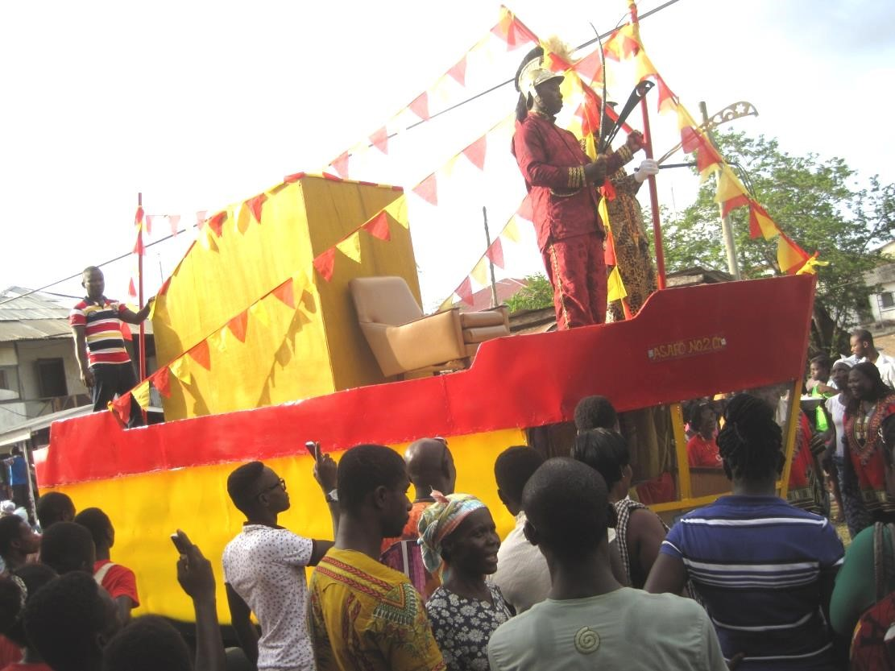
Plate 4.3.21 A captain of Dentsefo No. 2 being carried in a wooden ship during the Aboakyer festival

Source: photograph by researcher

Stools
Stools are simple seats with two to four legs made up of wood with no back or arm rest. Some are created by carving and others are constructed. There were several stools used during the Aboakyer festival. The traditional priests and priestesses sit on stools at the durbar grounds on the Aboakyer
Saturday. Some queen mothers and divisional chiefs also sit on stools during the Aboakyer festival.
Symbols are carved on the stools giving identity and status to the persons who sit on them. In the culture of the Effutus, stools symbolize the soul of the society, families (clan) and they play significant roles in the Aboakyer festival. Edusei (2004) stated in the introduction of his article that “stools stand out as the most important single art object of the southern Ghanaian Chief’s or King’s state regalia”. This can be seen in the Emblem of the Effutus in Plate 3. They are symbols of authority to the chiefs, queen mothers, priests, priestesses and clan leader
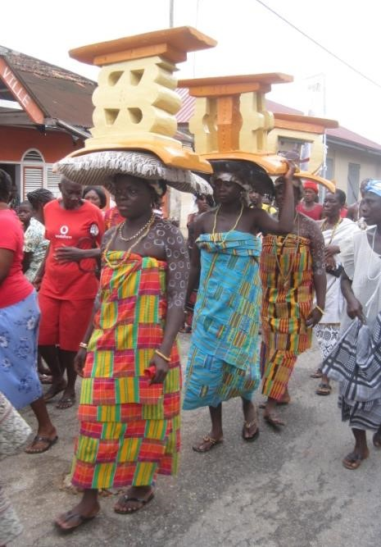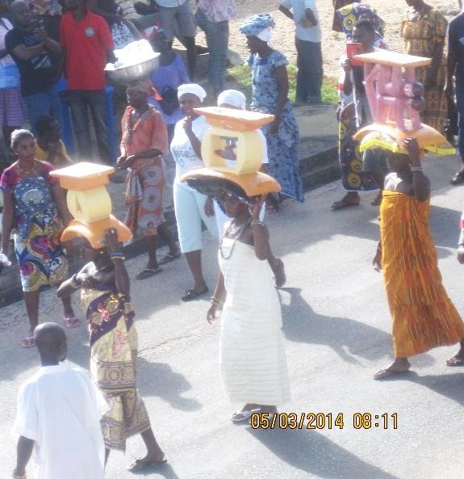

Umbrella Tops
Marfo (2007) defines an umbrella as a “collapsible canopy that protects a person from rain or sunshine”. Chiefs in the Effutu traditional area are taken to the durbar grounds during the Aboakyer festival on foot through a procession on the principal street. They process under umbrellas. The size of the umbrella determines the status of the chief. The umbrella tops are decorated with carvings made from wood and sprayed with spray paint giving it a golden or bronze effect. The symbols on the umbrella tops identify the chiefs and the authority or power they possess, philosophy of stool and moral lesson. It also shows the families the chiefs emerged from and has symbolic meanings attached to them.

“An na” Ebusua (family) Umbrella Top
The symbol for the “An na” umbrella top is a parrot eating a palm fruit. The appellation for their members is “abanakron” and the attribute is “okusubentsir”. The totem on the umbrella top identifies the chief as a descendant of that family (Anna). The“An na Ebusua”is known to be out spoken and brave hence their symbol the parrot. The Twafohen Neenyi Annobil VI belongs to the An na family of the Effutu Traditional Area and the umbrella with the totem belongs to him.
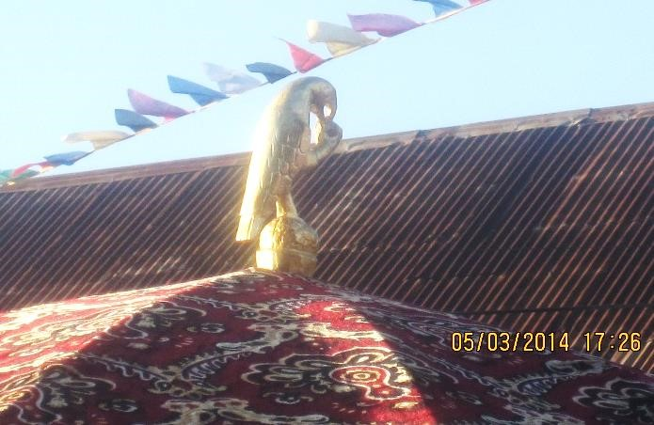
Plate 4.3.23 “An na Ebusua” umbrella top seen during the procession of chiefs to the durbar grounds
Source: photograph by researcher

“Twidan Ebusua” Umbrella Top
The “twidan Ebusua” totem is made up of a lion. This is a carved piece of a lion with wood and sprayed to give it a golden finish. Their appellation is “aban akron” and their attribute is “twi-aodzii-amon”. The lion signifies strenght, power and might. It serves as a symbol of identification to the chief and the family he emerged from.
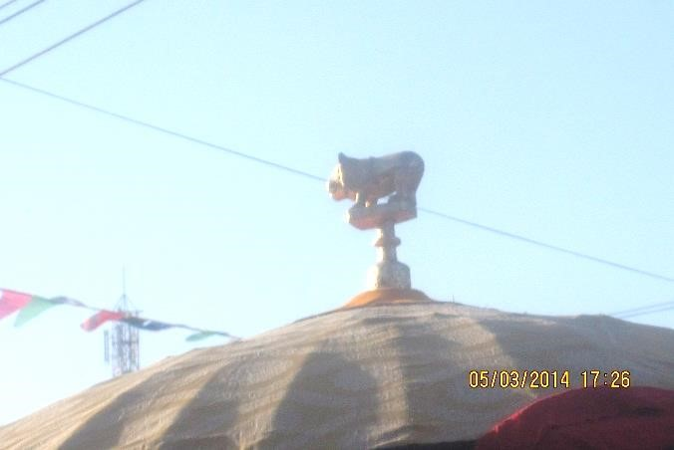
Plate 4.3.24 “Twidan Ebusua” umbrella top seen during the Aboakyer festival
Source: photograph by researcher

Tufuhen’s Umbrella Top
The totem is made up of the hand holding a gun (weapon). It symbolizes the power and the authority of the Tufuhen of the Effutu Traditional Area. It belongs to Neenyi Otubua Siripi II (
Tufuhen of Effutu Traditional Area). The tufuhen is the commander and chief of security and war. He works hand in hand with the Supis of the two Asafo Companies (military wing of the state) and answerable to the police and law courts in the traditional set up.
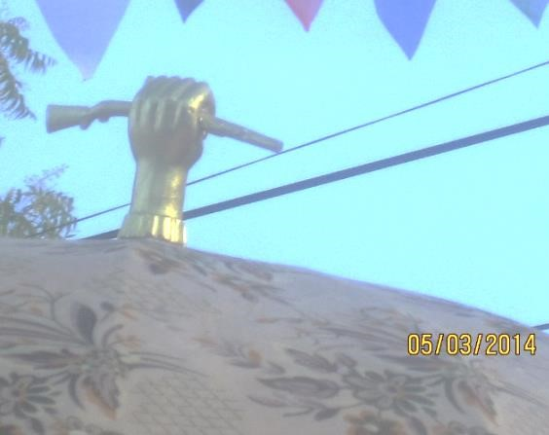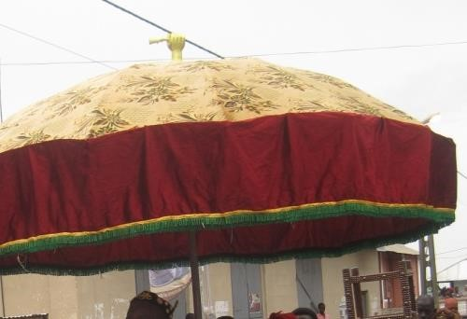

Plate 4.3.25 Tufuhen’s umbrella top seen during the procession of chiefs at the Aboakyer festival
Source: photograph by researcher

Spokesman’s Staff
The spokesman’s staff is the official insignia of the Okyeame (spokesman), and the symbol of the Okyeame’s status as spokesperson, counsellor and advisor to the chief (Okai – Anti, 2010). The staff is a large heavy stick, rod, or pole with a carved figure(s) used as a symbol of authority in ceremonies. It is made up of wood and sprayed with black, gold or bronze spray paint. The Okyeame serves as a mediator between the chief and whoever wants to speak to the chief. Due to the status and authority of the chief, no one speaks to him directly unless through the Okyeame. During the Saturday morning procession of the paramount chief and the divisional chiefs, they are accompanied with the spokesmen and elders. There are several spokesmen staff paraded during the Aboakyer festival. They have different symbols which serve as totems to represent the clan or family the chief emerged from.

“Nkyid mhen’s ” Staff
The “Nkyidmhen” staff is made up of a male and female sitting on a stool while the man is eating. This identifies the chief as the care taker of the land when the rest leave for war and a protector of the citizens left behind. It is a symbol of authority for the chief. The staff belongs to the Nsuekyir chief Neenyi Tawiah Ababio V.
‘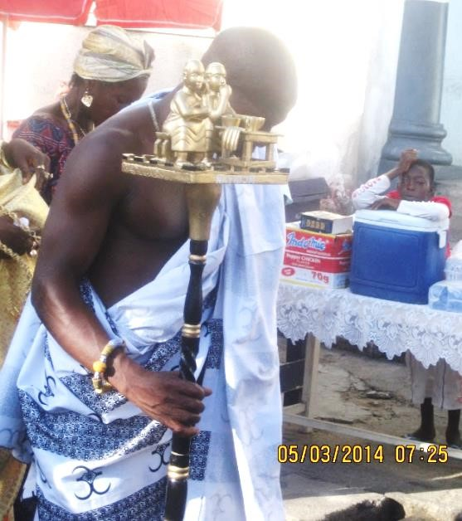
Plate 4.3.26 Spokesperson holding “Nkyid mhen’s”
staff during the Aboakyer festival
Source: photograph by researcher

“Ns na” Ebusua Staff
The staff with the crow is a staff for the Ns na Ebusua of the people of Winneba. The staff seen during the procession of chiefs to the durbar grounds identify the chief as a descendant of the
Ns na Ebusua (family). The staff belongs to Neenyi Takyi IV, Nyimfahen of the Effutu
Traditional Area. The totem is made up of a stool with two swords (“nkonfona”) infront with two crows standing at both sides of the stool. Behind it is a crow standing on top of an umbrella with a man and woman sitting under it.
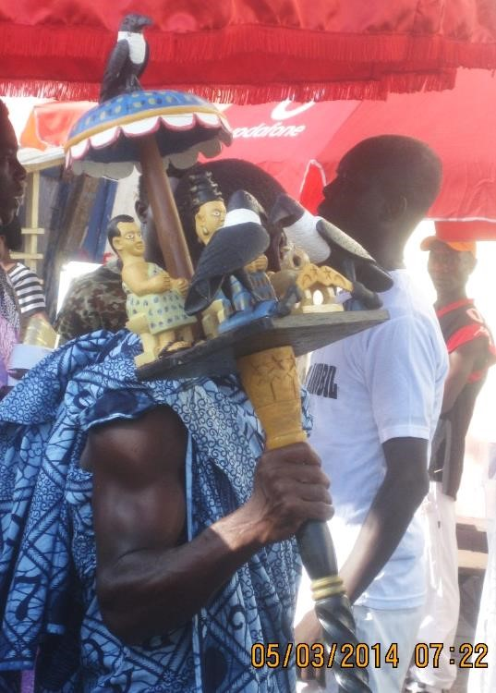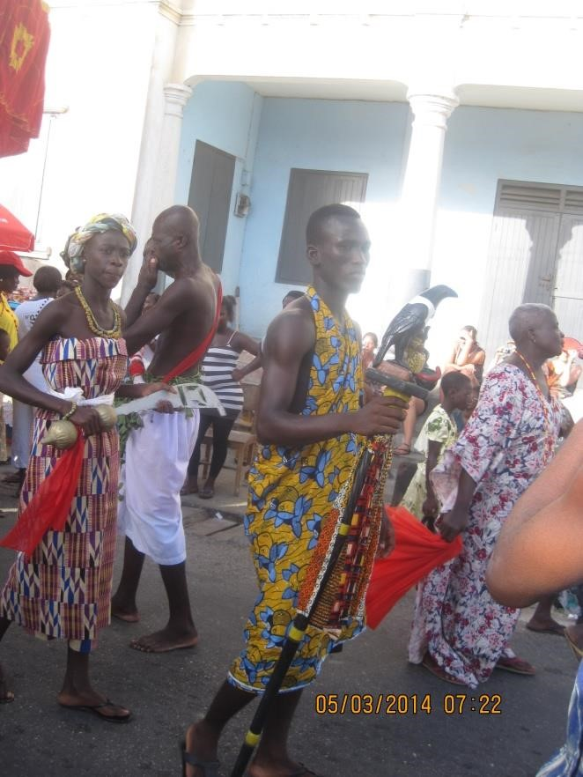

Plate 4.3.27 the linguists holding “Ns na” Ebusua (family)
staff during the procession of chiefs at the Aboakyer festival
Source: photograph by researcher

Adwinadze Ebusua Staff
This is a staff which signifies total ownership and the need to adapt one self to diverse situations.
It is a staff for the Adwinadze Ebusua of the Effutu Traditional Area.The staff identifies the Osubonpanyin chief Nana Ackon Egyeefi V as a member of the adwinadze family and shares their ideology and philosophy. It is a symbol of authority of the chief and also a means of identification among other chiefs.
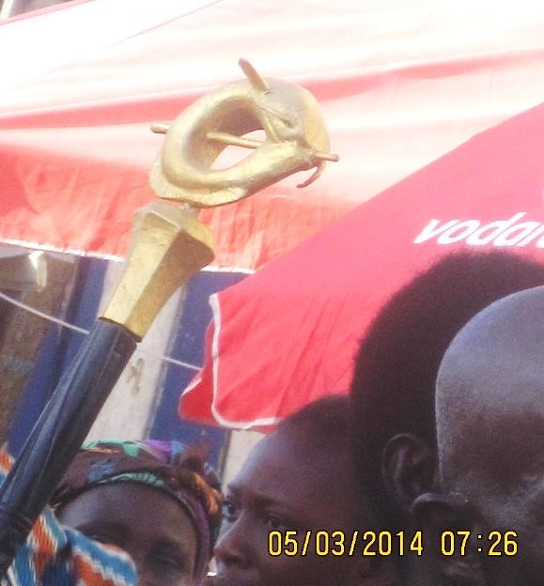
Plate 4.3.28 Edwinadze Ebusua staff seen during the Aboakyer festival
Source: photograph by researcher

Oma Odefe’s Staff
The Oma Odefe’s staff is a three dimensional sculpture which is produced by a technique called carving and sprayed with spray paint giving it a golden finish. The artist who made it is anonymous. The media used for making the artwork is wood. The elements seen in the work are lines, colour, texture, space and shape. Lines are seen in the handle and the head of the staff. The staff has a golden colour and also made up of rough and smooth textures. It has a positive space and the negative space. The positive space is the area the staff occupies while the negative is the environment or surrounding of the staff. There are several shapes in the composition of the staff.
The padlock has a square shape and semi-circle. The key has an oval shape and cylindrical shape.
The Oma Odefe’s staff is symmetrically balance that is, when divided into two, the half is a
reflection of the other half. There is variety in the work. This is seen in the use of different elements (line, colour, shape, space and texture) in the work. Emphasis is seen in the work of art; this can be seen in the head thus the padlock and the key.
Oma Odefe’s staff is golden in colour signifying royalty. The padlock represents the gateway to the Effutu State and the key represents the opener to the Effutu State. The Oma Odefe (Paramount Chief) is in possession of the staff because he is the number one gentleman and the traditional leader of the town and holds the key to the Effutu State. The staff leads Oma Odefe’s entourage during the procession.
The Oma Odefe’s staff is a successful piece of sculpture. To the aesthetic imitationalist, the work is successful; the padlock and key resembles the real ones. Again, the work is a successful piece to the aesthetic contextualist. This is so because the work has some cultural origin attached to it. The aesthetic instrumentalist/functionalist also see the work as a successful piece. This is so because the work serves specific functions that is, a symbol of authority to the Paramount Chief and also a form of identification.
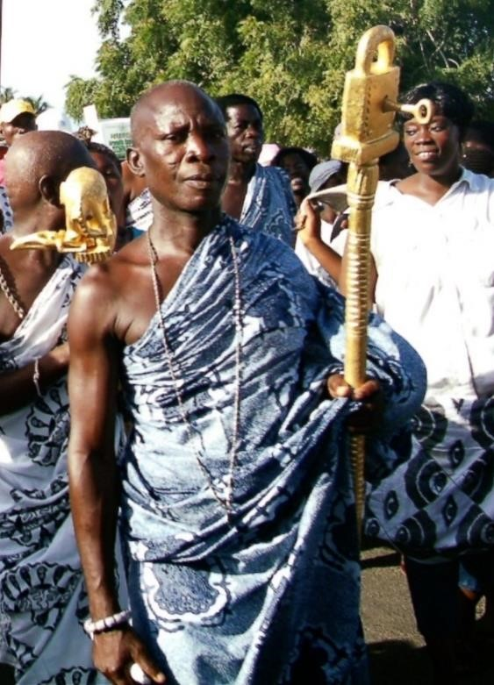
Plate 4.3.29 Okyeame holding Oma Odefe’s staff during the procession to the durbar grounds
Source: Oma Odefe’s palace

Tufuhen’s Staff
The Tufuhen’s staff is a symbol of power to wage war. It belongs to Neenyi Otubua Siripi II (Tufuhen for the Effutu Traditional Area). This is seen when the chiefs assemble to see the asafo groups set off to the hunting grounds before the procession to the durbar grounds. The staff identifies the chief as Tufuhen and also a symbol of authority. He is the leader of the Asafo groups and leads them to war hence” iturfo h n hen” meaning the chief of arms. The Tufuhen is responsible for sharing firearms for them.
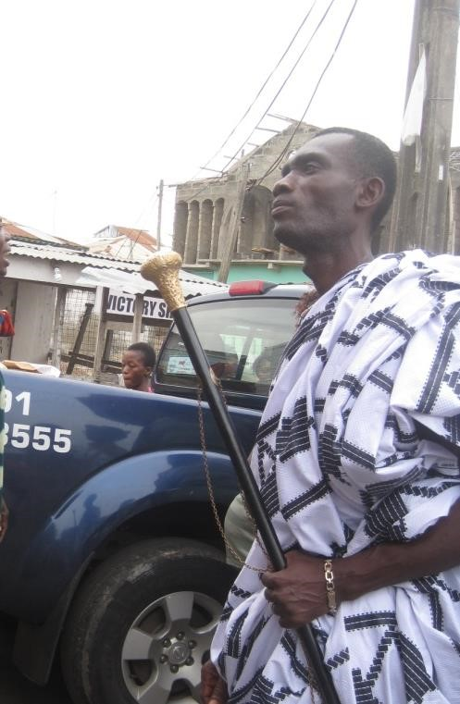
Plate 4.3.30 The linguist holding Tufuhen’s staff during the
Aboakyer festival
Source: photograph by researcher

Apofohen’s Staff (Chief Fisherman)
The staff is a carved piece made of the canoe, fishermen paddling a canoe supported with a carved wooden prop and a Ghana flag on it. This is a symbol of authority for Neenyi Monyi Kaiko II, the Chief fisherman of the Effutu Traditional Area. It is a symbol of authority and identification for the chief. This was seen during the procession of chiefs to the durbar grounds.
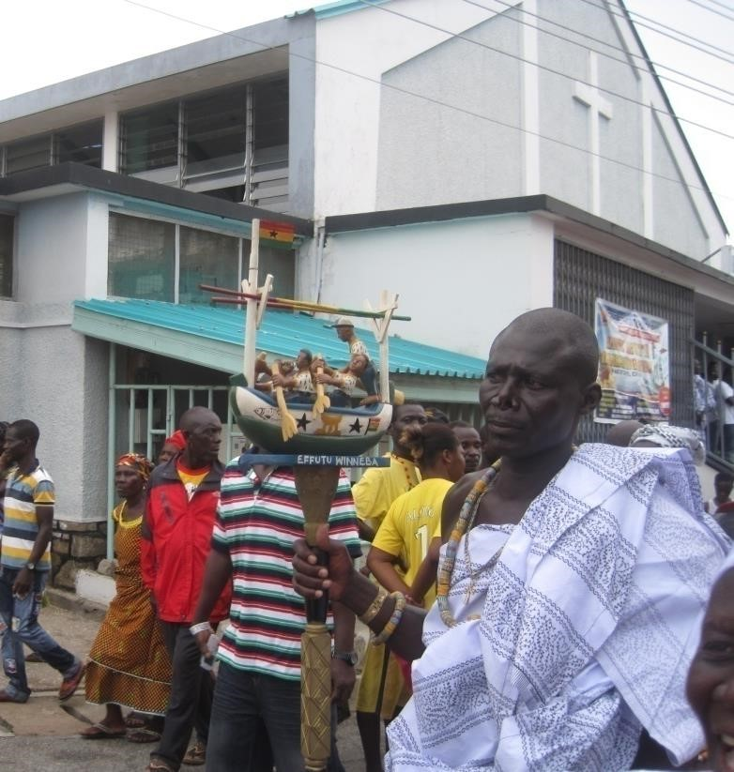
Plate 4.3.31 The linguist holding the Apofohen’s staff during the

procession of chiefs to the durbar grounds
Source: photograph by researcher

Sword (Akonfena)
Sword is a handled weapon with a long blade that is sharp on one or both edges and sometimes carved handle. It serves as a weapon (fighting sword) and also symbolizes the state authority and the authority of the supis of the Asafo Companies. It is made up of the handle and a blade with motifs and symbols incised in them.
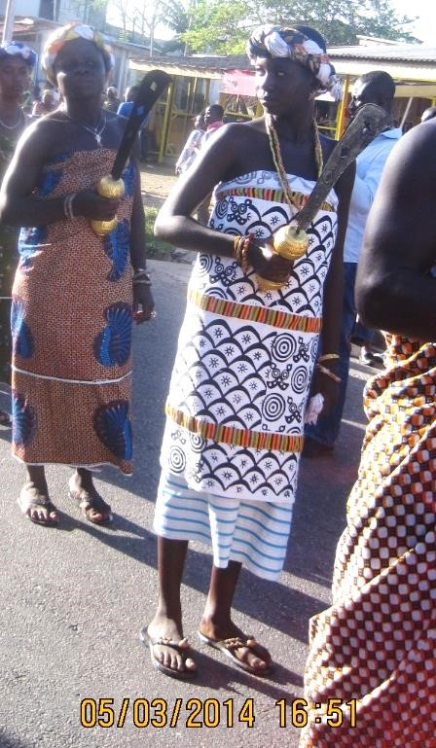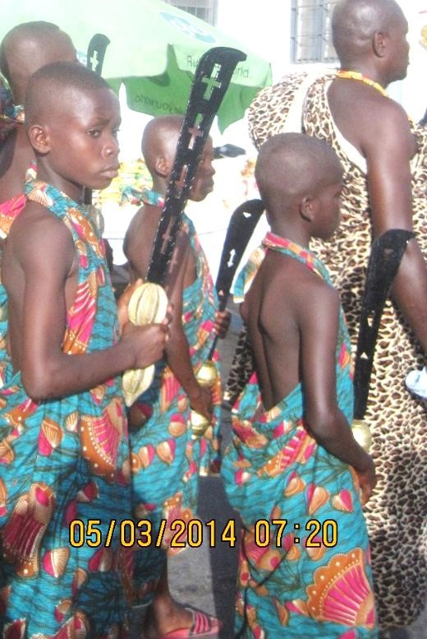
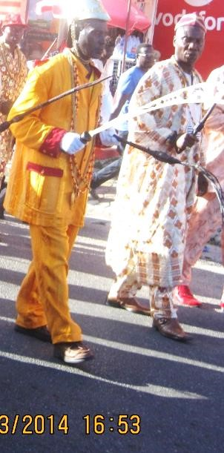
Plate 4.3.32 The Akonfena (sword) used during the Aboakyer festival
Source: photograph by researcher

Drums
The drum is a musical instrument consisting of a skin or hide stretched across a hollow frame and played by striking the stretched skin. The drums are used by the royal house to communicate and for a tune for the chief as a talking drum (Atunpan). The drums for the royal families have some relief carvings of adinkra symbols on them. Example is the fromtomfrom.
The Asafo Companies also use drums as a medium of communication. Each sub group of the Asafo Company whether Dentsefo or Tuafo has a single drum. Six drums for the Dentsefo No. 2 and six for Tuafo No. 1. Each drum communicates to its members. The drum is played to assemble the
Asafo sub groups early in the morning before they set off to the hunting grounds. (Personal Communication, Supi Samuel Donsu – Petufo Supi for Dentsefo No.2, 17th August, 2014)
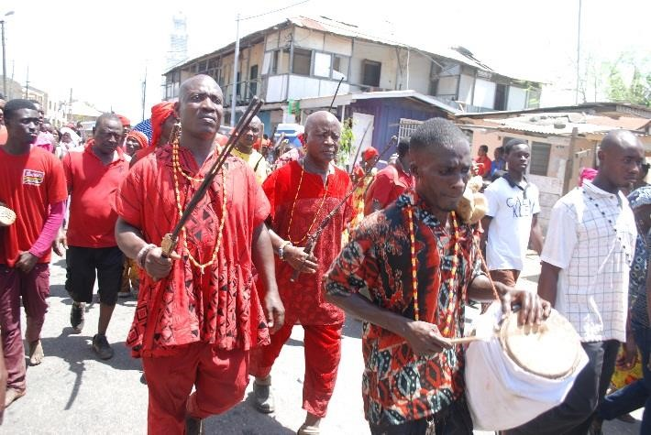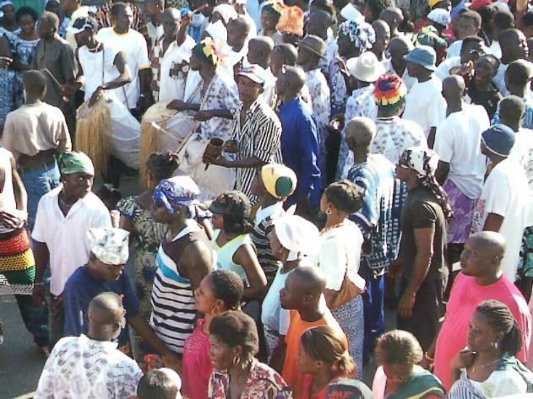

Plate 4.3.33 Drum played by the sub groups of the Asafo Companies to communicate with them

Source: photograph by researcher
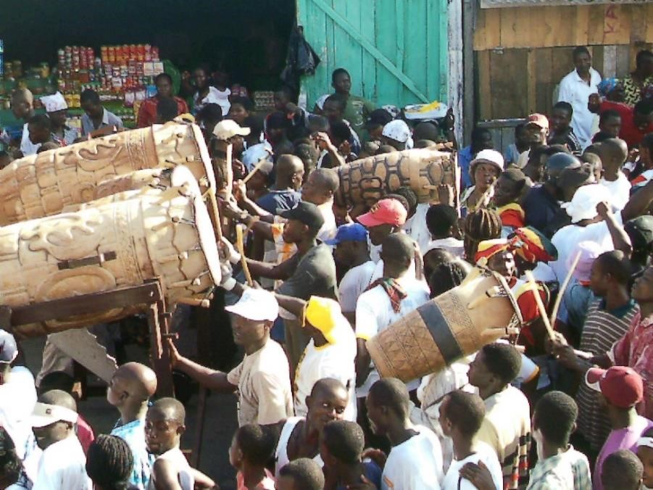
Plate 4.3.34 The Fromtomfrom drum played during the Aboakyer festival
Source: Oma Odefe’s palace

Rings
Rings are durable circular bands of gold, alloy, abyssinia especially a small band worn for decorative, spiritual and medicinal purpose. This is made by casting of heated metals using a mould.
Chiefs and queen mothers of the Effutu Traditional Area during procession to the durbar grounds in the morning and Owombir and Akosuadontoba in the afternoon put on rings as part of the royal regalia. Every ring has a unique symbol on it which has its own meaning attached to it. The rings differ from one chief or queen mother to the other. The rings are for aesthetic purposes, to show class and status and also symbolic in nature.
(Personal Communication, Nana Frimpongmaa III Queen mother for Nyimfahen, 17th August, 2014)
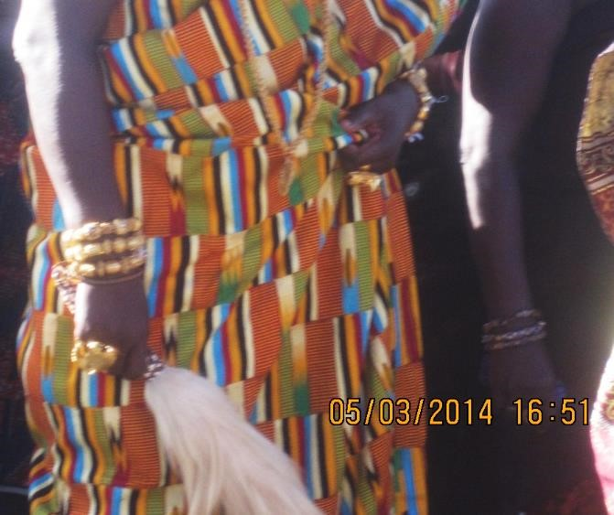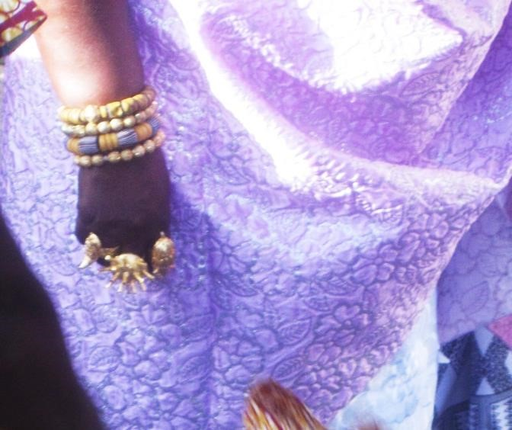

Plate 4.3.35 Rings worn by the Chiefs and Queen Mothers during the Aboakyer festival

Source: photograph by researcher “Abosomba” Statue
The “Abosomba” statue is a three dimensional sculpture (in the round) made from cement. The artist who made it is anonymous. The base /stand of the work is about 2.8ft in height and the actual statue is about 3.5ft tall and 1.8ft wide. The technique used for the production of the sculpture piece is casting and the media used is cement. The elements seen in the work are line, dot, texture, shape, space and colour. Line is seen in the painting of the statue and also the muscles on the hand. The eye of the deer is represented by a dot. The colour in the work is brown and some white textures on the skin of the deer. The statue has a positive and negative space; the positive space is the image area or where the statue occupies whiles the negative area is the surrounding around the work. Shape is also seen in the work; the head of the deer looks triangular in shape, the neck is cylindrical in shape and the middle part of the deer is conical.
The “Abosomba” statue is balance. It is asymmetrical balance and this is due to the position of the hand and the neck and head of the deer. The work is proportionally correct relating the various parts thus the head and neck of the deer and the arm and hand of the human figure. There is unity and harmony between the hand and the head of the deer. There is emphasis on the hand and the horn signifying the catch. Also, there is variety in the work, this is so because the artist made use of different elements (line, texture, colour, shape, space) in the work.
The sculpture work is found at “Abosomba” formerly the main taxi rank in Winneba. It is a symbolic piece which identifies the place as the killing grounds for the deer during the Aboakyer festival. The deer is taken from the durbar grounds through the principal streets amidst music and dance to the
“Abosomba” where the deer is killed by striking it with a wooden club three times and the Akyeampong Ano priest makes libation prayer before taking the deer to the Apa Sekum shrine. The deer is then laid on a mat made of props and tied with twigs. The deer is kept there for some hours so that the public who were not at the durbar grounds will have a glimpse of the animal before it will be taken to the shrine.
The realistic statue is a successful piece of art. To the aesthetic instrumentalist/functionalist, the work is successful because it identifies the place as the killing ground of the animal and also the animal kept there for the public to catch a glimpse of the animal. The aesthetic imitationalist sees the work as a success because of the true resemblance of the hand and the deer that is, realistic. The hand is real and resembles the human hand as in nature and the arm and hand is a replica of the human arm and hand in nature. Again, to the aesthetic contextualist the work is a successful piece of art. It has some cultural origin and value attached to it part from the physical beauty.
(Personal communication, Nana Kwansah Panyin – PRO Effutu Youth Association, 31st March 2015)
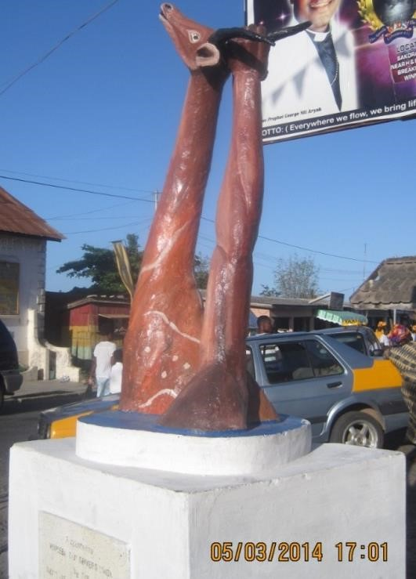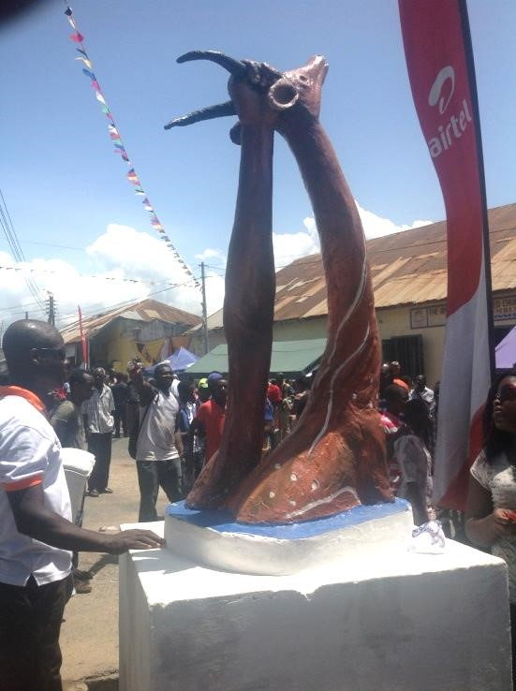

Plate 4.3.36 “Abosomba” statue seen during the Aboakyer festival

Source: photograph by researcher

Canoe
Sayour (2010) defines canoe as “a boat in which a person sits down on a seat with his or her legs on the floor underneath them and uses a single-bladed paddle to propel the boat through the water” (Walden, 2012). Canoes in Ghana are made through an artistic process thus carving of timber logs to come out with the narrow and pointed ends. They are decorated with colourful paintings, text and symbols.
Canoes are used during the Aboakyer festival on the Tuesday afternoon immediately after the ”tug of peace” for a canoe race (regatta) between the youth of Dentsefo and Tuafo Asafo Companies. The role of the canoe is to serve as a vehicle to help the Asafo to move on the sea. The choice of canoe is to engage the fishermen in the activities of the Aboakyer festival since fishing is the major occupation of the people of Winneba (Effutus).
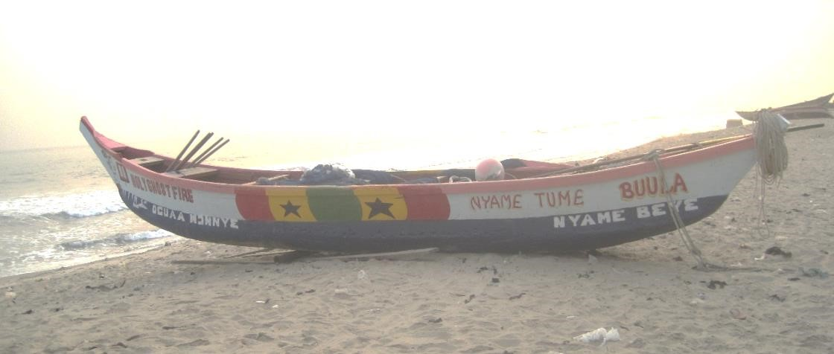
Plate 4.3.37 Canoe used for a race during the Aboakyer festival

Source: photograph by researcher

Rattle (kakrade)
A rattle is a carved wooden sculpture with a handle, two metallic plates and a large bolt locked on it. It serves as a musical instrument in the celebration of the Aboakyer festival and this is peculiar to the Tuafo No.1 asafo company. Although it is a sculpture piece, it produces sound which is unique and aids in the singing of the asafo songs.
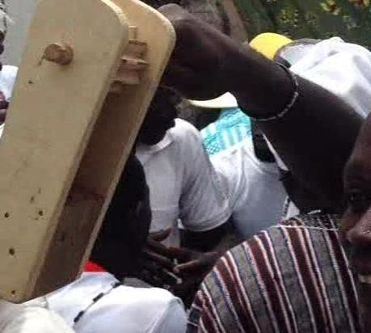
Plate 4.3.38 Rattle used by the Tuafo No.1 during the Aboakyer festival
Source: photograph by researcher

Dawur-nta (gong gong)
This is a metallic casted sculpture piece forged like a gong – gong with two of them created in one unit. It is used as a musical instrument and it is used by the Dentsefo No. 2 asafo company. The priest and priestesses use it also during certain performances of ritual and incantations.

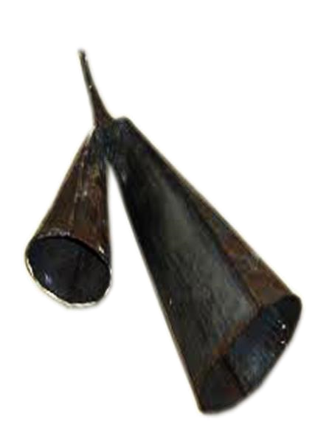
Plate 4.3.39 Dawur – nta (gong gong) used during the Aboakyer festival
Source: researcher

Bells (“Nkodwo”)
Bells are hollow open – ended metallic instrument with a rounded top that produces a ringing sound when struck. Traditionally, they are used for sending signals and summonses. They serve as a musical instrument assigned to the Dentsefo No. 2 asafo company. The Dentsefo use the bell when outdooring their deities through the principal streets during the Aboakyer festival and also for the hunt on Saturday. They are part of the instruments used by the Asafo for their various music and dance forms.
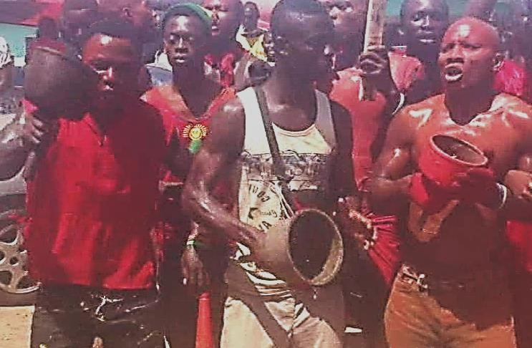
Plate 4.3.40 Bell (“nkodwo”) used by the Dentsefo during the Aboakyer
Source: photograph by researcher

4.3.5 Graphic Design
This is a branch of visual arts which concerns itself with the text and illustration for the purpose of communication. There were several graphic design items found during the celebration of Aboakyer festival. Examples of graphic design products or items seen during the celebration are printed t-shirts, banners, flags and buntings.

Union Jack (British Flag)
This is a decorated piece of fabric composed of red, blue and white fabrics. The flag combines the flag of England, Scotland and Ireland. The inclusion of this flag was dated back during the reign of Nana Ayirebi Acquah II (Kow Mbir Sackey) 1919 - 1941. It was a prize for the eventual group that will catch the deer that year. It was mounted at the durbar grounds (Advance Park) formerly known as Humphreys Park. This is because it happened during the Gold Coast era now Ghana where the political structure was such that the British were ruling over Ghana. The Dentsefo No. 2 were the successful group that year and caught five deer, the Chief gave them the flag as a prize for winning the competition. Since that time, the Dentsefo No. 2 Asafo Company have been using the flag even though the assigned colours for them conflict with the flag. This is an exception seen during the festival. Till date, when the Dentsefo catch a deer, a delegation is sent from “P w mu” (hunting ground) to the durbar ground with the Union Jack. They wave it at the durbar grounds signalling the people around about the catch before the deer is brought. (Personal Communication, Papa Kodwo Owrenye, 15th August 2014)
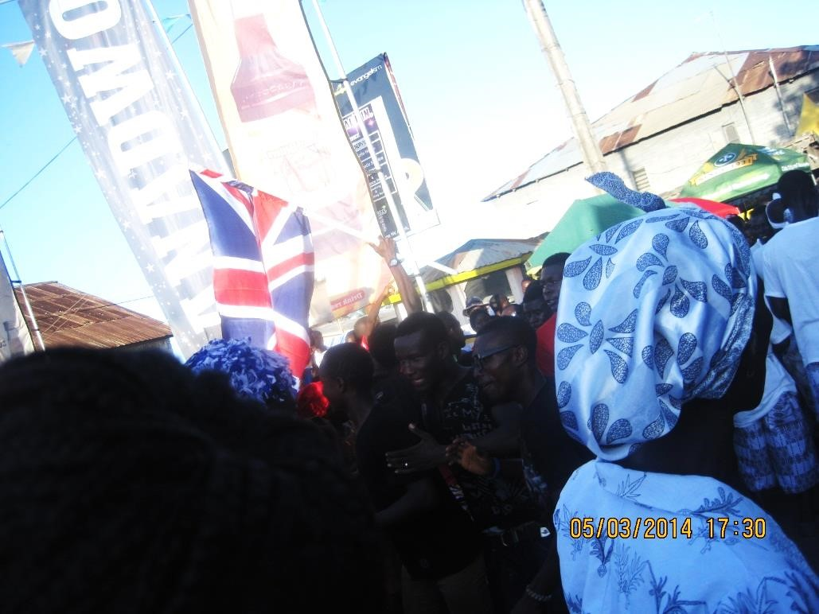
Plate 4.3.41 Union jack (British flag) used by the Dentsefo during the Aboakyer festival

Source: Photograph by researcher

Asafo Flags
A flag is a piece of fabric often rectangular or triangular and hanged on a pole with a design used as an emblem. The sub groups in the Asafo Company example Akonful, Kyeremfo and Apagyafo of Tuafo No.1 Company and Petufo, Asomfo and Etsiwafo of Dentsefo No. 2 carry separate flags during the procession or to the hunting ground. The symbols in the asafo flags serve as an identity for the group. It also tells history about the group thereby including the events, loses in war, achievements and victories of the group in the wars they fought.
The Asafo Companies also have different flags which are symbolic and are outdoored during special events such as funerals of their great leaders and members.
(Personal Communication, Supi Kojo Sakyi (Etsiwafo) 17th August, 2014)
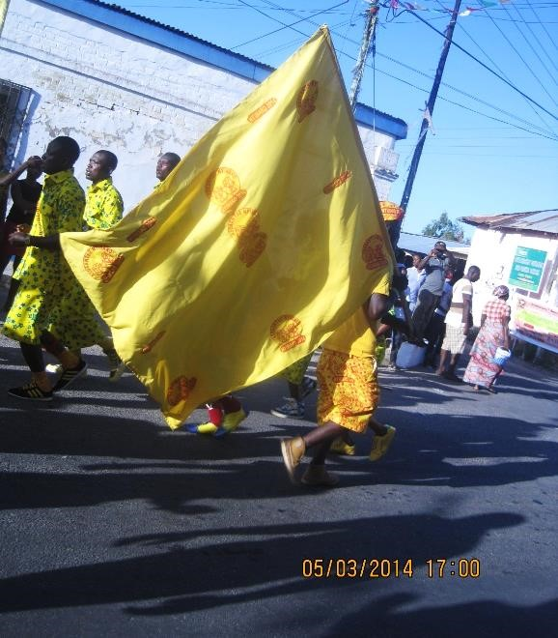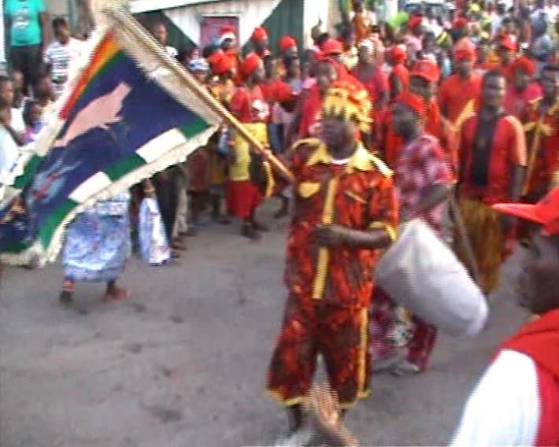

Plate 4.3.42 Asafo flags for Dentsefo No. 2 Company seen during the festival

Source: photograph by researcher
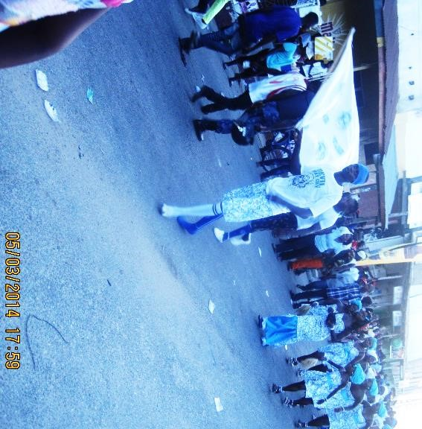
Plate 4.3.43 Asafo flag for Tuafo No. 1 group seen during the Aboakyer festival
Source: photograph by researcher

Buntings
Buntings are small coloured triangular flags or streamers chained together and hanged in rooms or outside during an occasion to herald events. They were hanged in the principal streets of the town for decorative purposes and also for awareness creation about the upcoming event to the general public.
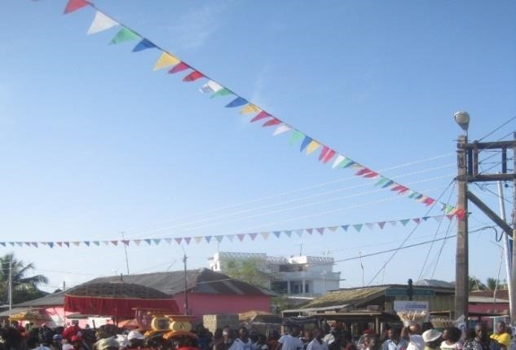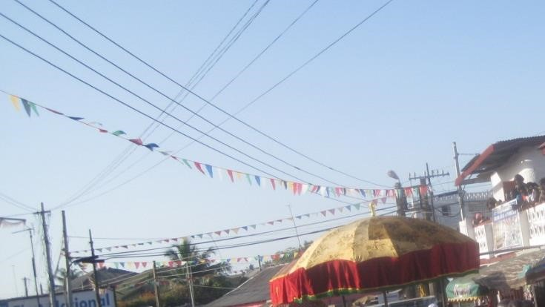

Plate 4.3.44 Buntings used during the Aboakyer festival
Source: photograph by researcher

Printed T-shirts
T – Shirt refers to a type of shirt shaped like the letter “T” plain or with inscriptions printed on them. During the Aboakyer festival t-shirts are printed to identify the Asafo groups. For example yellow and red t – shirts with the inscription “Aboakyer 2014” is printed at the back and the name or logo of a sponsor printed in front of them belongs to the Dentsefo No. 2 Asafo Company. Blue and white t – shirts also belongs to the Tuafo No.1 Asafo Company.
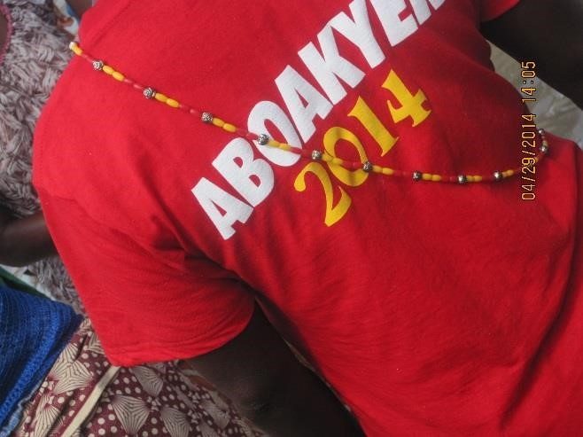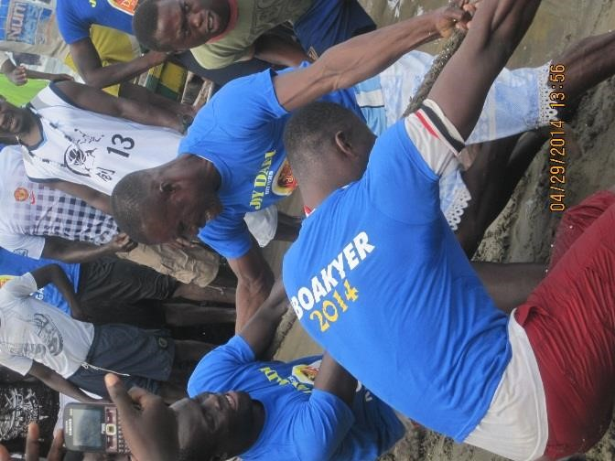

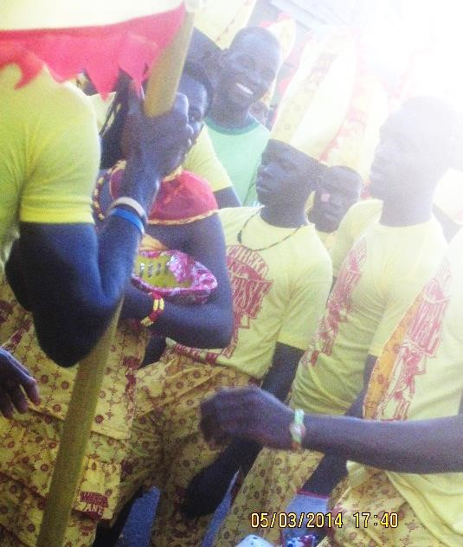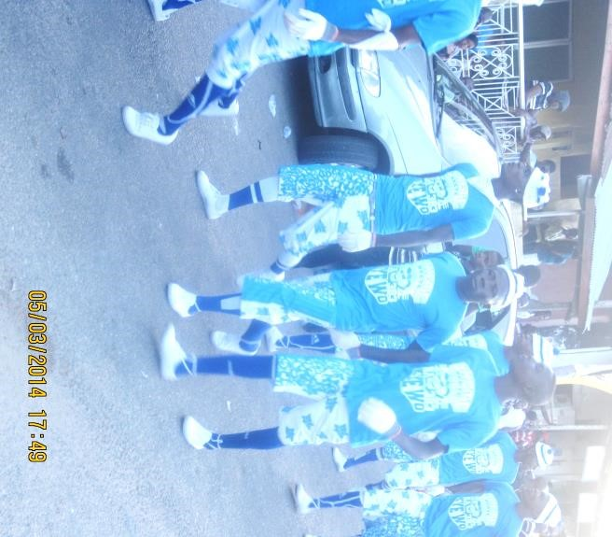

Plate 4.3.45 Printed T – Shirts identifying the Dentsefo and Tuafo Asafo Company
Source: photograph by researcher

Banner
A banner is a printed or written message on a piece of fabric displayed to communicate with the public. Prior to the Aboakyer festival, a pictorial banner is printed and hanged at a vantage point to create awareness of the impending festival. It is composed of text and illustration. The banner bears information such as the date, venue, theme and weekly activities.
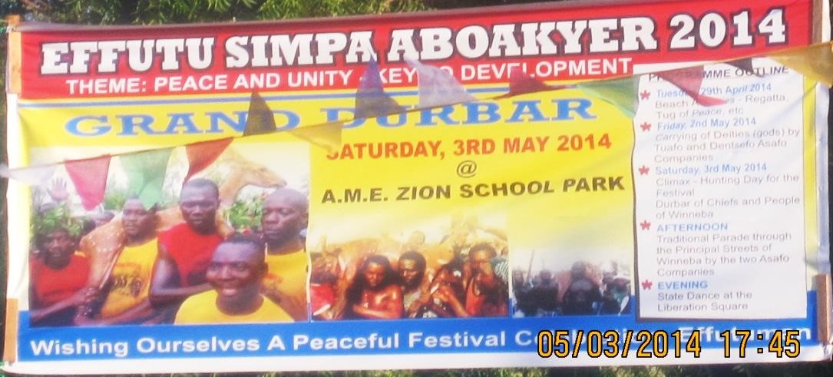
Plate 4.3.46 Banner displayed during the Aboakyer festival
Source: photograph by researcher

4.3.6 Leather work
Leather work is the art of preparing animal skins and hides into leather and using appropriate tools and materials to produce leather articles. Leather can be used for state umbrella, swords, pouffe, whisk, mats, drums, leather-plaited stools, talisman, amulets, bows, arrows, hats, belts, footwear etc. These items mentioned are seen during the celebration of the festival. They are used for religious or magical purposes, aesthetics, body items, defence and protective purposes.

Whips of Office (Asafo Abe)
The “Asafo Ab[e” is a three dimensional leatherwork. The artist who made it is anonymous and the media used is leather. The technique used is assembling and joining. The “Asafo Ab[e” has variety of sizes and the elements of design seen in the leatherwork are line, texture, colour, space and shape. The line is seen in the height of the horse riding cane. Some are vertical whiles others are curved. The leatherwork is greyish in colour. The texture is rough and smooth. The handle and hairs are rough in appearance whiles the top getting to the head is smooth. It has positive and negative space. Positive area is the space it occupies whiles the negative area is the surrounding or environment around it. The horse riding cane is oval in shape when folded.
The artefact is asymmetrically balance; when divided into two, one part will be slightly bigger than the other part. There is variety in the artefact; the use of different elements of art portrays variety. There is unity and harmony in the work. This is seen in how the parts are brought together as a whole.
Whip of office is a leather, horse riding cane, metal or cloth held by the Supis and Asafohen as a symbol of power and authority. Before a Supi is ordained, a power is invoked in an object and fixed in the rod or whip and later gone through spiritual purification. A god is invoked in the whip of office before given to the bearer. The rod is passed on from one generation to the other. It serves as a disciplinary medium for checking the Asafo members and also the general public in time of war or confusion. In the culture of the Effutus, anyone who has the Asafo ab[e (whips of office) possess some authority and power over his Asafo mba (men).
The horse riding cane (Asafo ab[e) is a successful piece. To the aesthetic instrumentalist, it is successful because of it functionality. It serves a particular purpose aside the physical appearance. The artwork gives authority and power to the bearers. It is also used as a symbol of identification for the bearers. Again, to the aesthetic imitationalist, the artwork is successful. This is so because it has a true resemblance of a horse riding cane. Also, the aesthetic contextualist see the artwork as successful. This is as a result of the cultural origin and history attached to it.
(Personal communication, Safohen Ghartey Tagoe, 17th August, 2014)
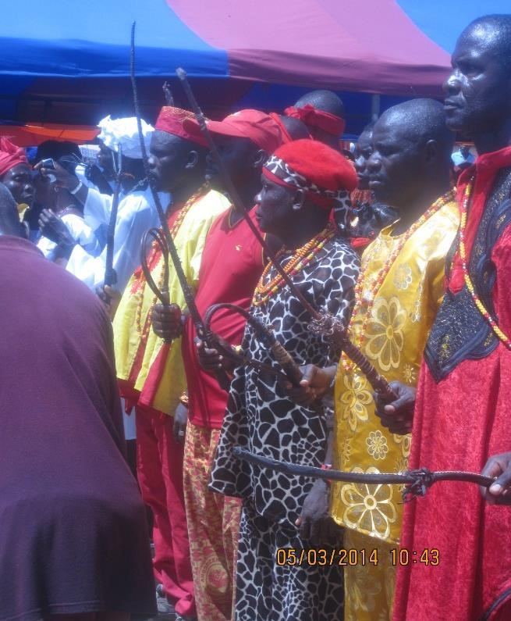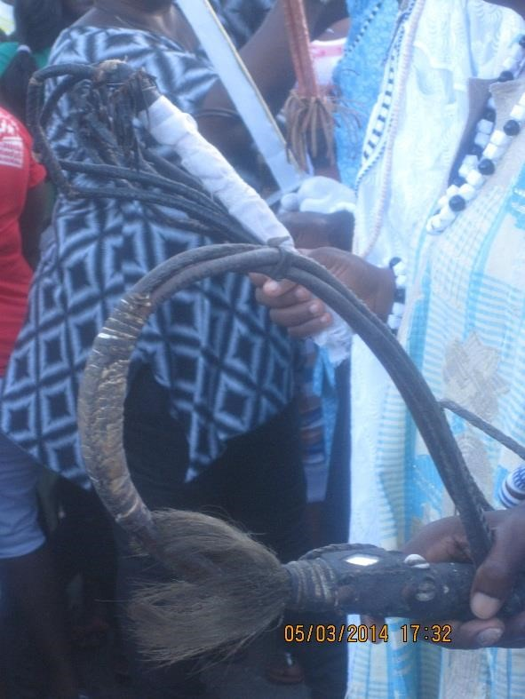

Plate 4.3.47 Supis from the Dentsefo Plate 4.3.48 Supis from the Tuafo Asafo
Asafo Company with their whips of office Company with their whips of office
Source: photograph by researcher Source: photograph by researcher

Traditional Sandals
The traditional sandals are made from leather, wooden base, upper part covered by shiny foil with variety of symbols on it. These symbols are proverbial in nature and they carry a message across. They are motifs carved or casted and sprayed with gold, silver and bronze spray paint. The chiefs and queen mothers wear them during the Aboakyer festival as a protective wear to the durbar grounds since they process on foot to the durbar grounds. They are also used to show identity, class and status during the festival.
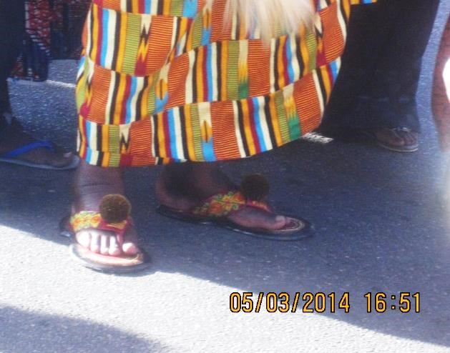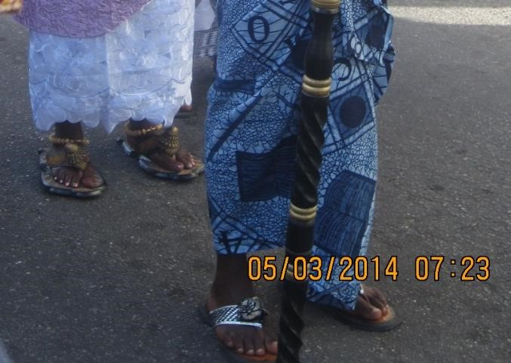

Plate 4.3.49 Examples of Traditional sandals seen during Aboakyer festival
Source: photograph by researcher

4.3.7 Pottery/Ceramics
Ceramics is the art and science of making clay objects and subjecting them to heat to make them permanents. One of the examples of ceramic wares seen during the Aboakyer festival is the pot for cooking the meal for the deity and the pot used for Ebisatsir on the Sunday afternoon. During the Ebisatsir (casting of lot), the pot symbolises or represents the Effutu land and also serves as the center or meeting point for the four convergent lines drawn by the chief priestess using white clay, red clay, charcoal and salt. It helps give clear distinctions to the lines making it possible to identify which line the small stone or pebble will fall on giving them the clear picture of what will happen in the new year they just entered.
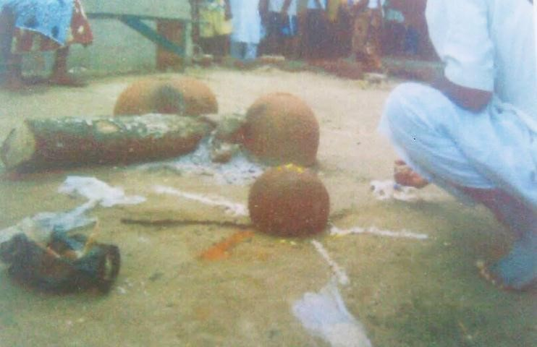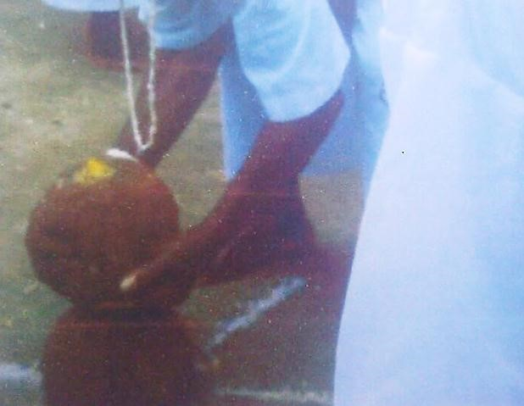

Plate 4.3.50 Ceramic pot used for the Ebisatsir during the Aboakyer sunday
Source: courtesy of Okai-Anti (2010)

4.4 Performing Arts in the Aboakyer Festival
This section of this chapter is made up of the various performing arts associated in the celebration of the festival. Performing arts involve performative realities of space, facial expressions, voice, and body language to communicate a creative idea or message. The glamorous Aboakyer festival is embodied with a lot of music, dance, drama, speech, and drumming. It runs through the various phases of the celebration thus the beginning to the end.

4.4.1 Music
Munyaradzi and Zimidzi (2012) as cited in Aiello et al (1994) defined music as “the art that expresses feelings and meanings through the qualities of sound and the relationship between sounds”. Music spread through the celebration of Aboakyer Festival. It plays vitally important role in the celebration. It is as old as the festival. Before the festival begins, the Asafo Companies meet secretly to learn and rehearse their songs for the celebration. These songs are composed of the past achievements, victory of battles and also provocative lyrics in a form of rivalry to their opponent. There are also forms of songs sung by the women and youths. When the Asafo Company and the youths get to the hunting grounds, they surround the mountain, sing and chant asafo songs to confuse the animals so they come out to be caught. When the animal is caught too they sing victory songs to the durbar ground. Asafo songs serve as ‘charging’ song for the group. It prepares them for action and also a means of entertaining themselves. Its contents (lyrics) reminds them of victories in wars they fought in the past, loses and achievements thereby serving as a bridge between the indigenous and contemporary asafo. Below is an example of the victory song sung by the Asafo Company:
Oyiwa eeeee
Aboa no resu  Mbaa mbaa la  Oyiwa eeee  Aboa no resu  Mbaa mbaa la | There it is  The animal is crying  Mbaa mbaa la  There it is  The animal is crying  Mbaa mbaa la
Literal meaning oyiwa eeee the animal is crying mbaa mbaa la.
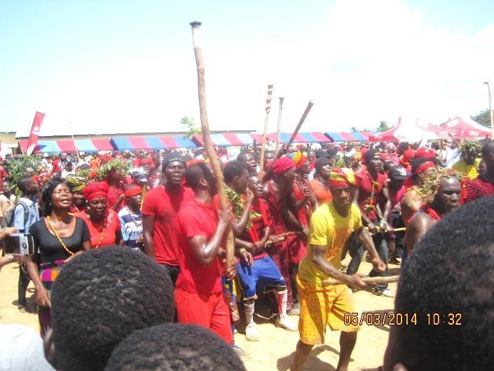
Plate 4.4.1 The Dentsefo youths singing and making merry
after a successful catch
Source: photograph by researcher

During the procession of the chiefs, queen mothers, linguists, traditional priests and priestesses to the durbar grounds in the morning, the “akoben” (horn) is blown to sing praises and appellations to the chiefs. It is a means to give recognition to the chiefs and also make their presence felt.
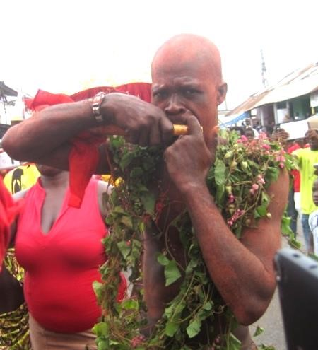
Plate 4.4.2 Horn blower using the Akoben (horn) to sing praises to the chiefs during the Aboakyer festival
Source: photograph by researcher

The afternoon procession sees a special form of adzewa (adzeba), Effutu version of adzewa music.
This is performed by the women. Adzewa is strictly women music and dance group. The ontology
behind this performance is that, during the early days of the Effutus, when the asafo goes for war, the women gather and perform adzewa to await them. The National Commission on Culture, however, informs us that the two Adzewa groups in Winneba were formed in 1958. This does not really tell us which group was the first to be formed but it may be deduced that the two groups were formed about the same time (Ampomah, 2014).

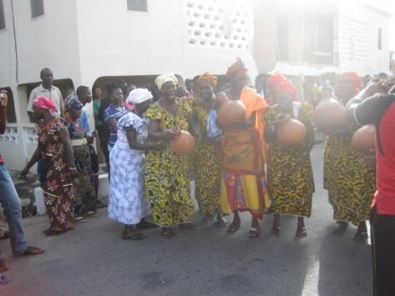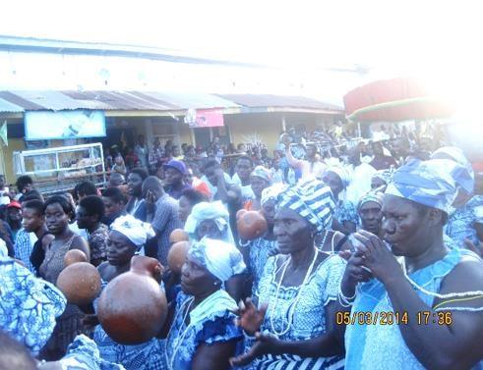

Plate 4.4.3 The Dentsefo women singing Plate 4.4.4 The Tuafo women singing their their native songs (Adzewa music) during native songs (Adzewa music) during the the afternoon procession. afternoon procession.
Source: photograph by researcher Source: photograph by researcher

4.4.2 Drama
Drama in the Aboakyer festival is a real – life event or situation that is particularly exciting or emotionally involving. It is an important part of the celebration. Drama overspread through the activities of the Aboakyer festival. It is manifested in the invoking and outdooring of the deities through the selected routes of the town.
Since the Aboakyer is a festival for the Asafo companies, they rehearse several songs and performances and display during the festival. These performances are seen throughout the festival.
During the grand durbar, there are several drama displays by a cultural troupe and the Islamic community displays are not left out. These performances add up to the artistic elements and also sell out the rich culture of the Effutus. The performance entertains the guests and the people present at the durbar grounds as they await the asafo groups for the catch.
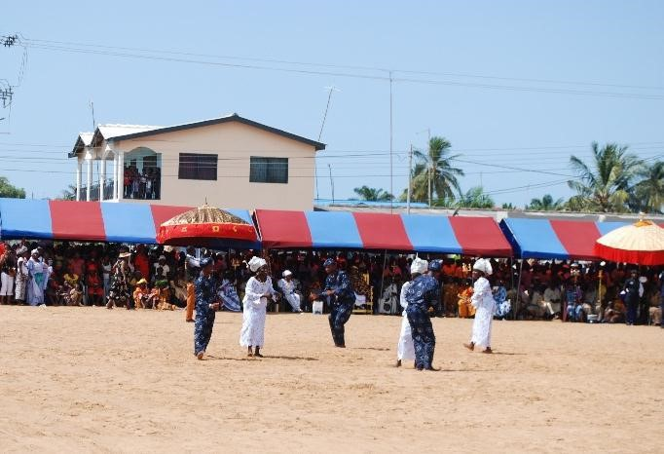
Plate 4.4.5 Drama performance at the durbar grounds
Source: photograph by researcher

4.4.3 Drumming
Drumming also plays key role in the celebration of the Aboakyer festival. This goes on saturday morning before the asafo leaves for the hunting grounds. The leaders of both parties in the early hours of saturday meet the groups and make libation prayer for them before setting off. One important observation is that, they fortify the drums of the sub cohorts before they go for hunting. The drum tunes are used to communicate to the asafo as to what they are supposed to do at every point in time.
The durbar also sees great drumming from the cultural troupe as a way of entertaining the guests, Chiefs, Queen mothers, traditional priests and priestesses as they await the Asafo from the hunting grounds. While the cultural troupe performs and are supposed to exit the durbar grounds, the master drummer plays the exit tune as a drum language to lead the dancers off the place. An example is transcribed in the Twi language below:
TWI ENGLISH
Yɛnkɔ, yɛnkɔ, yɛnkɔ, yɛnkɔ Let’s go, let’s go, let’s go, let’s go
Yɛnkɔ, yɛnkɔ, yɛnkɔ, yɛnkɔ Let’s go, let’s go, let’s go, let’s go Yɛnkɔ,agodifoɔ , yɛnkɔ Let’s go, performers, let’s go.
(Source: Ampomah, 2014)
An example of the Asafo drum language of the Effutus is transcribed in Fantse below and also interpreted in English below:
FANTSE ENGLISH
Dɔ m - Yɛ wɔ hɔ Asafo (group members) – we are here
Dɔ m bi botumi hom Can any group match you
Dɔ m biara re ntum hɛ n No group can match us
Hom ntwe mpin 2x Get closer to each other 2x
Hom nantsew pegya pegya Walk briskly
Ndɛ yɛ enyiber da Today is an action day
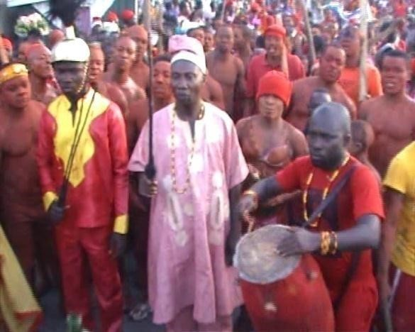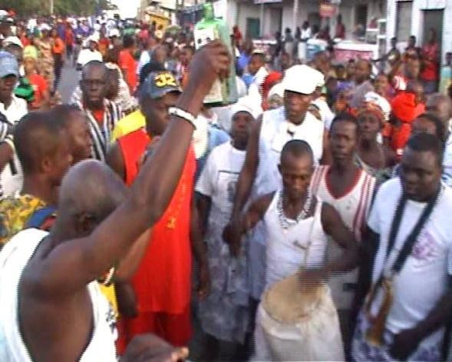

Plate 4.4.6 Dentsefo No. 2 Asafo Plate 4.4.7 Tuafo No. 1 Asafo drumming as a medium of drumming as a medium of communication communication
Source: photograph by researcher Source: photograph by researcher
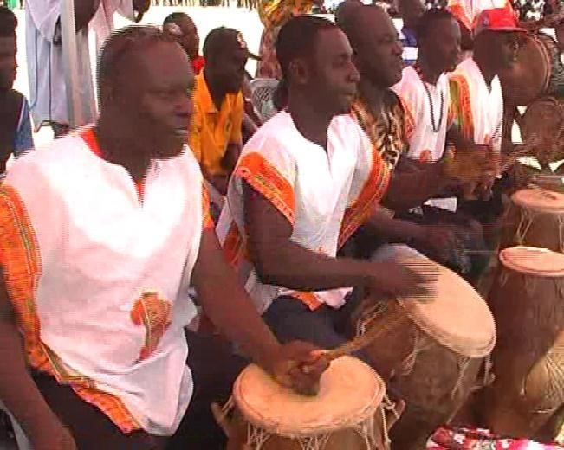
Plate 4.4.8 Drumming by the cultural troupe at the durbar grounds
Source: photograph by researcher

4.4.4 Dance
The Asafo dance is performed with three drums and gong gong beating to keep the rhythm. Each Asafo Company uses three drums thus making it six for both. Tuafo No.1 has three and Dentsefo No.2 also has three. The males do most of the singing and clapping to maintain the tempo but the dancing is not restrictive. When it is an all-female affair, they perform a version of the Asafo dance music but drum sounds are produced from “mfoba” (gourd enmeshed with beads) playing; this is the Effutu version of adzewa. The main asafo dance form is rather masculine and fierce in nature. For entertainment and other social functions the people of Winneba have developed a number of musical dance forms.
There is a dance performance also by the cultural troupe at the durbar. The dance moves accompanied with music entertains the people at the durbar grounds. The afternoon procession also sees special dance forms called the Owombir by the Dentsefo No.2 and Akosuadontoba by the Tuafo No. 1 Asafo Company.

Akosuadontoba and Owombir Dance
These are dance forms performed during the afternoon procession. The group that won the competition with the catch leads the procession followed by the other group. The Akosuadontoba is performed by the Tuafo No. 1 Asafo Company whiles the Owombir is performed by the Dentsefo No. 2 Asafo Company. The dance is between middle aged men and women. The left thumb is placed on the forehead whiles the other hand is placed at the back (dance gestures and moves). The middle aged men dance glued to the back of the women. The women bend down a little shaking their waist and buttocks. They move forward four steps and move backwards two steps. It is repeated till the end of the procession. The dance form attracts lots of young men and women due to the nature and also add lots of excitement to the celebration. The Owombir is accompanied with drumming, Asafo songs, dawur and the sound of the bell (nkodwo). The
Akosuadontoba is also accompanied with drumming, asafo songs and the sound of the rattle.
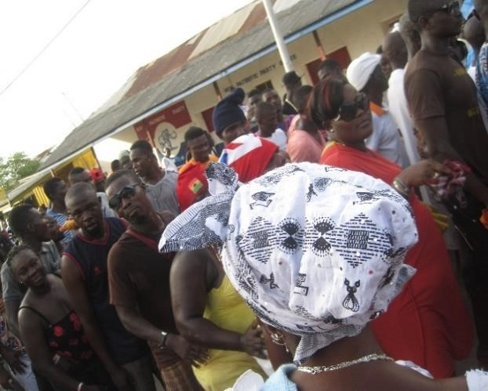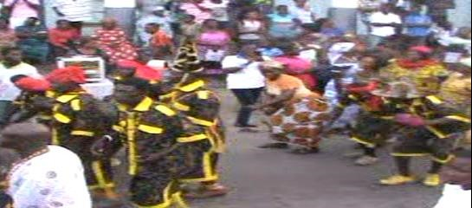
Plate 4.4.9 The Tuafo Asafo dancing the Plate 4.4.10 The Dentsefo Asafo dancing Akosuadontoba during the afternoon the Owombir during the afternoon
procession procession
Source: photograph by researcher Source: photograph by researcher
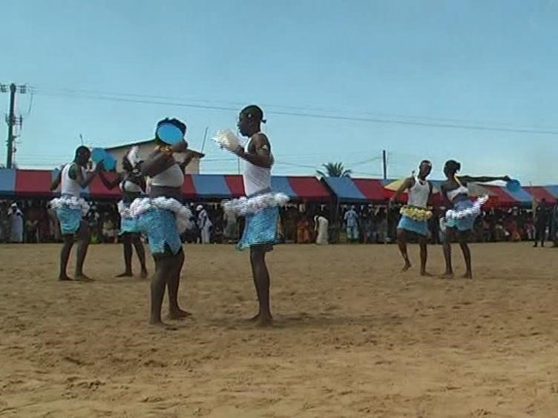
Plate 4.4.11 The cultural group dancing at the durbar grounds
during the Aboakyer festival
Source: photograph by researcher

4.4.5 Verbal Art
This is the art of talking. It involves all sort of speech - making processes such as recitation, libations prayer, incantations etc. During the Aboakyer festival, lot of verbal arts go on; from the beginning till the end of the festival. It takes place at the fishing beach where the regatta and tug of peace took place, outdooring of the deities, speeches by the chiefs and other dignitaries at the durbar grounds. Prayer by the chief priestess, traditional priests and priestesses are all form of verbal arts. The traditional priest pours a traditional drink (Schnapp) into a container created by the horn of the cow. He raises it up giving reverence to the Supreme Being, and brings it down and invites all the seventy gods of the land. He informs the messenger god (Akyeampong) to send the message to Apa Sekum (war god) about the catch and that they are taking the animal to the shrine. He then seeks for their presence to clear the path to the shrine.
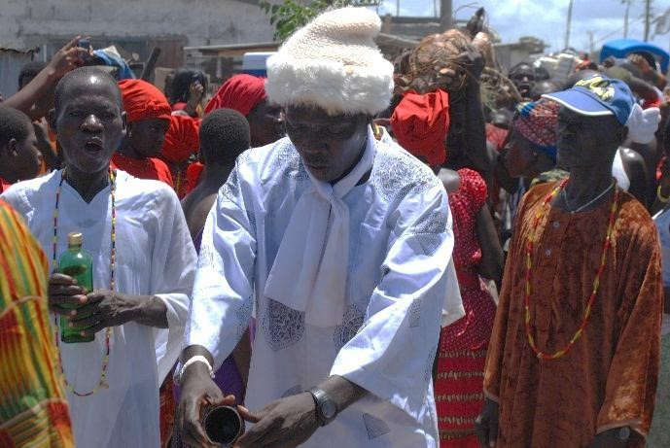
Plate 4.4.12 Priest of Akyeampong Ano making

libation prayer to receive the deer at Abosomba.
Source: photograph by researcher

4.5 Visual Arts in the Akomase Festival
The Akomase festival celebrated by the Effutus in the month of August each year also has some artistic elements in the celebration. The celebration is made up of visual or environmental, verbal and performing arts. Examples of art forms seen in the celebration are “Ap npowa” (flat wooden tray), earthenware bowls, ceramic pots, cutlass etc.

“Ap npowa” (Flat Wooden Tray/Panel)
This is a flat panel or tray made from wood using the subtractive method in sculpture known as carving. This is used to carry Penkye Otu’s garbage from the yam meal and also meals from the seven paternal homes (Prama) prepared for the celebration through selected route in the town to Donkoryiem where the refuse will be burnt. This is in agreement to what Ododo (2001) pointed out about the functionality of arts in festivals thus “art for life sake”. The art performs specific task aside the physical beauty.
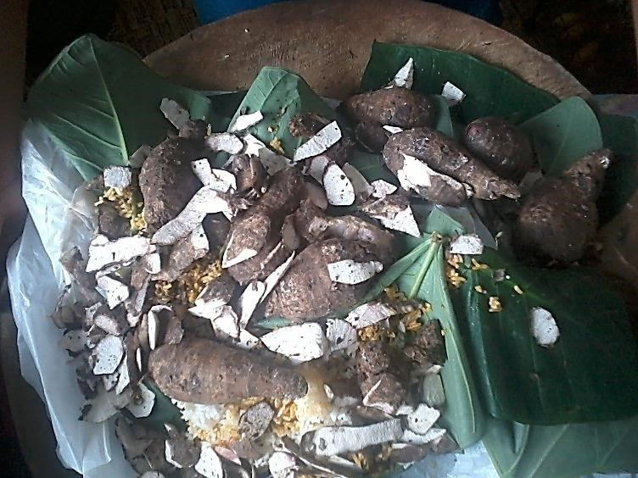
Plate 4.5.1 “Ap npowa” (Flat wooden tray) used to carry garbage from Penkye Otu’s meal and the seven paternal homes to the garbage site during the Akomase festival

Source: courtesy of Papa Kodwo Owrenye

Ceramic Pot
This is a container made with clay using a hand built method or the potter’s wheel and fired afterwards to make it permanent. The pot was used by the priestess in cooking Penkye Otu’s meal and the priestesses for the other gods also use the ceramic pot during the Akomase festival to cook for their gods.
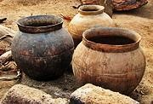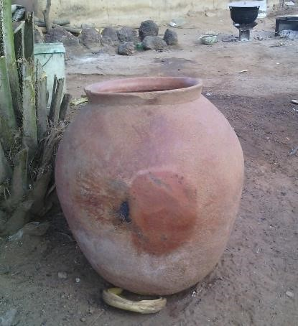

Plate 4.5.2 ceramic pots for cooking Penkye Otu’s meal and other

gods during the Akomase festival

Source: photograph by researcher

Earthenware Bowl
Earthenware bowl is a native bowl used for grinding, mashing and dishing out food. The bowl is used to dish out Penkye Otu’s yam meal (mashed yam with red oil) during the yam feast on the Akomase sunday. In the traditional setting, things or items in the shrine related to the deities are sacred. The earthenware bowl has been the dishing out bowl for the deity since the genesis of the Effutus and anything apart from that, the deities will not eat the served food. This is an important artefact in the shrine.

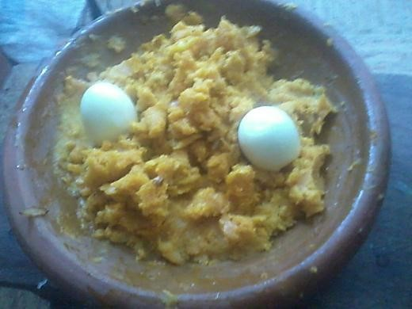
Plate 4.5.4 Earthenware bowl used for dishing out Penkye Otu’s meal during the
Akomase yam feasting.
Source: photograph by researcher

Matchet/Cutlass
Matchet/cutlass is a tool made up of a metallic blade and wooden handle used for weeding. It is classified as an artwork here because it went through an artistic process before arriving at the final product. The matchet/cutlass in the Akomase is used by the Akyeampong Ano priest swinging it to the left and right in a manner reminiscent of path clearing to show that they are moving into the bush to throw and burn Otu’s garbage away. It is used symbolically for clearing the path to the garbage site.
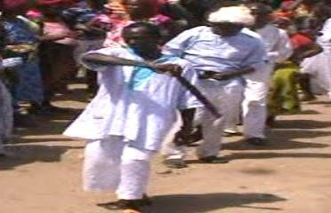
Plate 4.5.3 Cutlass used by the priest to clear the path to the garbage site during the Akomase festival
Source: courtesy of Papa Kodwo Owrenye

4.6 Performing Arts in the Akomase Festival
The Akomase festival was also celebrated with couple of performing arts. These include music, dance, drama and verbal arts.

4.6.1 Music
The Akomase festival also uses music like any other festival in the country. There are songs sung by the followers accompanying the Akyeampong Ano and Otu Ano priests and priestesses to the garbage site. This is done through a procession to a spot in Donkoryiem where the garbage site is located. They sing this song on their way to the garbage site in the Effutu language as translated in English below:
EFFUTU ENGLISH
Otu oo oo Otu oo oo (god of the Effutus)
Otu oo, oo Otu oo oo
Woowoo, woo woo Yeah yeah, yeah yeah
W so no kwangya We are taking your garbage away
Literally meaning they are leading Otu’s garbage away.

4.6.2 Drama
There are series of Drama during the Akomase festival. These are not rehearsed form of acts in front of audience but happen as part of the activities during the celebration. This can be seen during the making of libation prayers to the ancestors by the family heads to invite them to dine with them. This can also be seen when the priest swings cutlass from left to right signifying clearing of the path to the garbage site where Otu’s garbage will be burnt.
Again, observations made by the priests at the garbage site before the burning is done are also a form of drama.
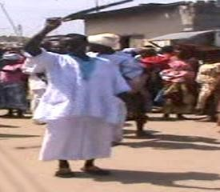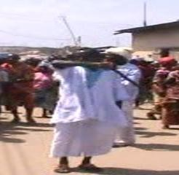

Plate 4.6.1 The priest swinging cutlass left right clearing the path to the
garbage site
Source: courtesy of Papa Kodwo Owrenye

CHAPTER FIVE SUMMARY, CONCLUSIONS AND RECOMMENDATIONS Overview
The previous chapter discussed how the Aboakyer and Akomase festival of the Effutus are celebrated and the various artistic elements involved in the celebration in relation to their culture.
This chapter expounds the summary, conclusions and recommendations. It recaps the entire study, giving it conclusions and making applicable and constructive recommendations.

5.1 Summary
The celebration of Aboakyer festival is an evidence of the festival as a feast for the Asafo Companies to feed their war god Apa Sekum; the colourful nature and high level of participation cannot be overemphasized.
The Akomase festival is the festival for the entire citizens but has lost its popularity to the Aboakyer festival due to its nature and the artistic elements in the celebration. Aboakyer has now become a festival for all even those who have aligned themselves with Islam and Christianity do participate in their activities.
The Aboakyer festival displays lots of artistic elements ranging from visual or environmental arts, performing arts and verbal arts. The Effutus’ culture, history and traditions are all inculcated in their arts. Due to the competitive nature of the Aboakyer festival between the Asafo Companies (Tuafo No. 1 and Dentsefo No. 2), their choice of arts differ from each cohort. They have specific colours assigned to each cohort and they do not use anything in common. This has increased the number of artworks used in the celebration.
The nature of Akomase has affected the artistic elements seen during the celebration. It cannot boast of lots of artworks as compared to the Aboakyer festival. The artworks used were to perform specific functions and not for aesthetic purposes. Some were symbolic in their usage.
The use of arts in the festivals are necessity rather than liability in the culture of the Effutus. They form major part and play significant roles in the celebrations. This confirms the saying “Art is life”. The existence of the Effutus is traced through their arts.
Their history or the origin, philosophies, values, culture and traditions are seen in their arts. The visual, verbal and performing arts serve as an identity to them and leaving them out makes them ordinary and a common place. The arts in the festivals transform the serene town into a flamboyant and vibrant milieu with lots of artefacts, music, drama, merry making and noise.
The art forms used during the festivals were not “art for art sake” but “art for life sake” thus, functional. They play significant roles in the celebration and their benefits are enormous.

5.2 Conclusions
It is a testimony through this thesis that the artistic elements in the festival of the Effutus are substantial especially the Aboakyer festival. Some of the visual arts involved in the celebration are discarded after the festivals. The study concentrated more on the permanent artefacts which are reused annually during the festival.
The relation of the arts to the culture of the Effutus which has been the findings of the study revealed that without the cultural relation to arts in festivals, the arts are seen as ordinary and discussing them becomes straightforward thereby considering only the physical beauty. This is evidence to the fact that the culture of a particular group of people cannot be complete without art forms. It is evident that art plays significant role in the Effutu culture.
The arts involved in the Effutu festivals are most significant phenomenon which combine “art for art sake” and “art for life sake” and without it the festival will be monotonous.
Some of the key art forms used by the Asafo Companies have been destroyed and others perished due to the conflicts in the celebrations some years back. Some are now expensive to produce example is the wooden ship (steamer) for the Dentsefo No. 2 Asafo Company.
The artistic elements served as a bridge between the traditional celebration and contemporary celebration. The indigenous works are the ones with some histories behind them. Some of the contemporary works are discarded after use and new ones are made for the next celebration.

5.3 Recommendations
It is recommended that the Effutu Traditional Council should have a museum or gallery for keeping the artworks used in their festivals and train personnel to educate people about the role they play in the festival and artistic elements in relation to their culture. This will go a long way to avoid distortions and alterations of their history, customs and traditions.
The National Commission for Culture and Tourism should create a digital repository for all these artistic elements in their festivals which will serve as evidence and also a supplement for the artworks in case the actual works perish.
The culture, history, customs and traditions of the Effutus should be introduced to the indigenes right from infancy. Elite parents should stop shying away from the festival and discouraging their wards from participating in the celebration. They should stop seeing the arts and festivals as fetish.
This will increase a great sense of belongingness and patriotism in the natives.
The planning committee of the festivals should include photo exhibitions as part of the activities during the festivals and premiere of the origin of the festivals in the form of a documentary or movie. This will be of great impact in the socio economic life of the Effutus and the nation as a whole. It will help project the culture of the Effutus and also African arts.
The various stakeholders (Effutu Traditional Council, National Commission for Culture and
Tourism, Ministry of Education, Ghana Art Teachers Association and Ghana Association of Visual Artist) should help promote the art of the Effutus in relation to their culture.
The Effutu Traditional Council should put in place pragmatic measures to prevent conflicts during their festivals.

REFERENCES
Ackom, N. (2005). History of the Effutus. Banahene Publishing and Printing: Accra.
Akintan, O. A. (2013). Traditional Religious Festivals and Modernity : A Case Study of Female-Oriented Cults Annual Festivals in Ijebuland of South Western Nigeria, 3(4), 1035– 1046.

Amate, P. (2011). Visual representation of selected akan proverbs in Ghana: their philosophical and socio-cultural values, M.A. Thesis. KNUST: Kumasi.
Ampomah, K. (2014). An Investigation into Adowa and Adzewa Music and Dance of the Akan
People of Ghana. International Journal of Humanities and Social Science. USA. www.ijhssnet.com (retrieved 02/04/2015).

Asihene, E.V. (1978). Understanding the Traditional Art of Ghana. New Jersey, Cranbury: Associate University Press Inc.

Bailey, K.D. (1994). Methods of Social Research. (Fourth Edition). New York: Free Press

Brewer, J. (2004). Ethnography In D. Cassell and G. Symon Ed. Essential Guide to Qualitative Methods on Organizational Research. London: Sage Publications.
Brown, K.E. (2005). Social Conflicts In Contemporary Effutu Festivals. U.S.A : Bowling Green State University.
Cohen, L. (2008). Research Methods in Education. (Sixth Edition). New York: Routledge.
Cole, H. (1975), The Arts of Africa, UCLA James S. Coleman African Studies Center, pp.12, 6061.

Cooper, D.C. & Schindler, P.S. (2001). Business Research Methods (Seventh Edition). New York: McGraw - Hill.

Crayner, J.B. (1975). Yeehyiahyia oo!. Accra: Bureau of Ghana Languages.

Creswell, J. W. (2008). Research design: Qualitative, Quantitative, and Mixed Methods Approaches (5th Ed.). Thousand Oaks, CA: Sage.

Dampson, D.E & Mensah, D.K.D (2012). Practical Guide to Action and Case Study Research.
Kumasi: Payless Publication Limited.
Duran, M. D., Fernando, F.& Bogotá, U. E. A. N. (2014). Economic and Social Affects in the Culture and Arts Industries : The Case of Colombian Festivals. School of Postgraduate Studies Universidad EAN, 3(2), 35–43.

Edusei, K. (2004). Art Forms in Ghana: The Stool as a Socio-Politico-Religious Symbol. Journal of Science and Technology, Vol. 24, No. 1.

Ephirim‐Donkor, A. (2009).The Making of African King: Patrilineal and Matrilineal Struggle Among the Effutu of Ghana. Trenton, NJ: Africa World Press.

Feldman E. B. (1993) Practical Art Criticism. USA: Prentice Hall PTR

Gbadegbe, R.S. (2009). The Role of Art in Asogli Yam Festival. PHD thesis. KNUST: Kumasi.
Gbadegbe, R.S & Mensah, C. (2013). The Role of Art Forms in the Celebration of Festivals: A Case Study of Asogli Yam Festival, Volta Region, Ghana. Vol. 12 www.iiste.org (retrieved 13/12/2014).

Given L. M. (2008). The Sage Encyclopedia of Qualitative Research Methods. Sage: Thousand Oaks, CA, Vol.2, pp.697‐698.
Guetzkow, J. (2002). How the Arts Impact Communities. U.S.A : Princeton University.
Hall, M (2000).The future of tourism: a personal speculation. Tourism recreation research Vol 25(1): 85-95.

http://en.wikipedia.org/wiki/Winneba(retrieved 10/02/14). http://www.transafrica.biz/en/festivals-togo.php(retrieved 05/09/2014). http://www.transafrica.biz/en/festivals.php(retrieved 05/09/2014).
Janeczko, B. B., Mules, T., & Ritchie, B. (n.d.). Estimating The Economic Impacts Of Festivals And Events : A Research Guide. www.crctourism.com.au (retrieved 14/06/2014).

Kabutey, E.A. (2011). A Study of the Arts in the Ada Asafotufiami Festival. M.A thesis. KNUST. Kumasi: Department of General Art Studies.
Kiwewa, F. (n.d.). Contribution Of Arts Festivals And Events To National And Regional Economies. Uganda: Bayimba Cultural Foundation.
Kumah, D. (2009). Stools in Ashanti Culture. M.A. thesis. KNUST. Kumasi: Department of General Art Studies.
Larbi, K.A. (2009). Reading the Intangible Heritage in Tangible Akan Art. International Journal of Intangible Heritage. Vol. 4 (retrieved 8/03/2014).
Marfo, S. (2007). Educational Value of Boaman Stool Regalia. M.A. thesis. KNUST. Kumasi: Department of General Art Studies.
Moore, T. (2012). Economic Impact of Events and Festivals on local regions The Economics of Sustainability. United Kingdom: Bucks New University.
Munyaradzi, G., & Zimidzi, W. (2012). Comparison of Western Music and African Music. Creative Education, 3, 193.
Nkansah, P.K. (2008). Documentation of Queen Mothers' Regalia in the Kwawu Traditional Area. M.A. thesis. KNUST. Kumasi: Department of General Art Studies.
Nortey, S. (2009). The H m w Festival in Accra: Artistic and other Cultural Aspects. PhD Dissertation. KNUST. Kumasi: Department of General Art Studies.
Nortey, S. (2012). Artistic Evolutions of the Ga Mashie Twins Yam Festival and Its cultural Implications. Art and Design Studies. Vol. 2 http://www.iiste.org (retrieved11/04/2014).
Ododo, S. E. (2001). Theatrical Aesthetics And Functional Values Of Ekuechi Masquerade Ensemble Of The Ebira People In Nigeria, 22(May), 1–36.
Okai -Anti, E(2010) Educational Significance of the Visual Arts in the Aboakyer Festival of the Effutu People of Winneba. M.A. thesis. KNUST. Kumasi: Department of General Art Studies.
Robson, C. (2002) Real World Research (Second Edition). Oxford: Blackwell.
Turkson, E. (2001) Student Research Project. Takoradi: TM Global Logistics.
Vrettos, A. (2006). The Economic Value of Arts & Culture Festivals/ A Comparison of four European Economic Impact Studies. University of Maastricht. UK: unpublished thesis.

Walden, P. (2012). The Socio-cultural Significance of Canoe Decoration among the people of the Effutu Traditional Area in the Central Region of Ghana. M.A. thesis. KNUST. Kumasi: Department of General Art Studies.
Wyllie, R.W. (1994). Gods, Locals and Strangers: The Effutu Aboakyer as Visitor Attraction. U.S.A: The University of Chicago Press.

APPENDIX I
Interview guide used by the researcher during the Aboakyer and Akomase festival.
- How is the Aboakyer festival celebrated?
- When was the youth deity introduced in the celebration?
- What led to the introduction of the youth deity?
- What is the composition of the deity?
- What are the art forms used in the celebration?
- What informs the choice of certain art forms in the celebration?
- What is the name of the special beads used by the Denstefo and Tuafo Asafo company?
- Why are they used during the celebration?
- Why do the Dentsefo use the Union Jack during the Aboakyer festival?
- When was it introduced in the celebration?
- Why do the Dentsefo Asafo company use the foky w during the Aboakyer festival despite the colour?
- When was it introduced in the celebration and under whose reign?
- What is used in painting the body of the Asafo youth before going to the hunting grounds?
- Why do they paint their bodies?
- What are some of the art works seen during the procession to the durbar ground?
- Why are some umbrellas of the chiefs bigger than others?
- Why do they have different symbols at the top of the umbrella?
- What are the roles of the symbols?
- Why does the Safohen of Dentsefo No. 2 sit in the wooden ship (steamer) during the afternoon procession?
- Why does the Safohen of Tuafo No. 1 ride on a wooden horse during the afternoon procession?
- Why do the Asafo flags have symbols in them?
- What role do the symbols play?
- What is the role of the beads on the queen mother?
- What informs her choice of beads during the Aboakyer festival?
- What is the purpose of the rings on the queen mother’s hand?
- What differentiate a queen mother from the other?
- What does the queen mother sit on during the Aboakyer festival?
- What is the Asafo abe (whip or rod) made up of?
- What is the function of the whip of office?
- What functions do the drums play in the festival?
- Which among the deities is the deer fed during the festival?
- Who are the custodians of the musical instruments used during the celebration of the
Aboakyer festival?
- How is the Akomase festival celebrated?
- What are the art forms used in the celebration?
- What is the role of the wooden tray in the celebration of Akomase?
- What is the role of the cutlass in the celebration of Akomase?
- What is the use of the ceramic pot during the celebration?
- What is the role of earthenware bowl during the celebration?
- Why is the Akomase festival not as popular as the Aboakyer festival?
- Can the festivals be celebrated without the art forms?
- What are some of the performing arts seen during the festival?
- What roles do they play in the celebration of the festivals?

APPENDIX II
Observation checklist used by the researcher for data collection.
Aboakyer festival
- Observing the regatta (tug of peace) and canoe race between the Dentsefo and Tuafo youth at the fishing beach on Tuesday afternoon
- Outdooring of the Tuafo youth deity through selected routes in the town on Tuesday afternoon
- Outdooring the Dentsefo youth deity through selected route in the town on Thursday afternoon
- Outdooring of the Tuafo Asafo company deity “Gyemisi” through selected route in the town on Friday afternoon
- Outdooring of the Dentsefo Asafo company deity “Asikama” through the selected route
in the town on late Friday afternoon
- Asafo companies setting off to the hunting grounds on Saturday dawn
- Procession of the chiefs through the principal streets to the durbar grounds
- Activities at the hunting grounds
- The Asafo companies return to the durbar grounds with the catch
- Activities at the durbar
- Carrying of the deer shoulder high to Abosomba for certain observations and libation prayer
- Taking of the deer to Apa Sekum shrine
- Afternoon procession, Akosuadontoba and Owombir dance through the principal street
- Casting of lot (Ebisatsir) on the Sunday afternoon
Akomase festival
- Preparation of Penkye Otu’s meal and the meal for the other gods
- Preparation of the ancestral meals
- General weeping throughout the town on Sunday dawn
- Libation prayer by the various family heads to invite the ancestors for dinning with the family
- Procession of priests, priestesses, chiefs and indigenes and carrying of garbage from the food prepaid to the garbage site (Donkoyiem)
- Observations and libation prayer at the garbage site
- Procession of priests, priestesses and indigenes back from the garbage site

