KWAME NKRUMAH UNIVERSITY OF SCIENCE AND TECHNOLOGY,
KUMASI
COLLEGE OF SCIENCE

DEPARTMENT OF FOOD SCIENCE AND TECHNOLOGY

EFFECTS OF DRYING ON QUALITY AND DRYING CHARACTERISTICS
OF AERIAL YAM (DIOSCOREA BULBIFERA)

BY
RITA ELSIE SANFUL

A Thesis submitted to the Department of Food Science and Technology, College of
Science in partial fulfilment of the requirements for the degree of
DOCTOR OF PHILOSOPHY IN FOOD SCIENCE AND TECHNOLOGY

JUNE, 2017
DECLARATION
I hereby declare that this submission is my own work towards the PhD and that, to the best of my knowledge, it contains no material previously published by another person, nor material which has been accepted for the award of any other degree of the University, except where due acknowledgement has been made in the text.

Rita Elsie Sanful | ………………………… | ………………………
(PG3888209)  Student Name & ID  Certified by: | Signature | Date
Prof Ibok Oduro | ………………………… | ………………………
(Supervisor) | Signature | Date
Prof. William Otoo Ellis | ………………………… | ………………………
(Supervisor) | Signature | Date
Prof, Ahmad Addo | ………………………… | ………………………
(Supervisor)  Certified by: | Signature | Date
Mr. John Barimah | ………………………… | ………………………
(Head of Department) | Signature | Date
ACKNOWLEDGEMENTS
My foremost acknowledgement goes to the Almighty God for his Grace and Mercies throughout my study period.
I am extremely grateful to my supervisors, Prof. Ibok Oduro, Prof. William O. Ellis and Prof. Ahmad Addo for their patience in mentoring me. I wish to acknowledge their guidance, invaluable contributions and the opportunity they gave me to learn outside my core specialty, I am extremely grateful. My greatest gratitude goes to Prof. Robert Kwame Nkum for his steady encouragement to take up this challenge.
I would like to express my gratitude in no mean words to Nana Baah Peprah Ameyaw for his enormous help thank you so much Nana!
Finally, I appreciate all who contributed in one way or the other in making this journey of mine successful.
ABSTRACT
The preference for Dioscorea rotunda and other yams to the aerial yam, by consumers has led to its underutilisation and post-harvest losses. The quality attributes of the aerial yam processed into flour using various processing techniques (boiling, steaming, solar and oven drying) were determined. Drying characteristics of the aerial yam bulbis slabs were determined and fitted to twelve different drying models. Flour yields for the boiled flours were high (32.5%, 31.25%) for solar and oven drying methods. Protein content was high in steamed flour and low in boiled flour for solar drying and high in the fresh flours for the oven drying method. All the processed flours were significantly high in fat content which ranged from 0.96 to 1.40%. Oven dried flours were also high in ash content (0.24-0.51). Results suggested that aerial yam was a good source of calcium, iron, sodium and potassium. Oven drying did not significantly change P, K and Na contents relative to the other methods. The values of water binding capacity were different between boiled solar dried flour (303%) and all oven dried flours (241.05% -235.11%). Solubility was high in the solar dried flours with a range of 15.98% -22.01%. No significant differences occurred between drying methods for swelling power. For the drying methods, solar dried flours had the highest pH values of 5.90-7.25. Although the drying methods and pre-treatment showed no significant differences in the breakdown, final and setback viscosities of the aerial yam flours, pre-treatment of boiling and steaming and the two drying methods resulted in low peak and holding strength viscosities. The aerial yam flour, however, required higher temperature and time to cook with the exception of the boiled solar dried yam flour. Low final viscosity values of 0.50-46.00 BU indicated the inability of the aerial yam flour to form a firm gel after cooking and cooling making it appropriate for infant baby food formulation. Oven dried flours had lower pasting properties in all the pre-treated flour except for the breakdown and setback viscosities. Solar drying, boiling and steaming methods showed slight decreases in the amylose content of the yam flour while oven drying showed slight increases in the amylose content. Oven dried flours showed increases in yellowness whiles solar dried flours exhibited increased redness indicating a high potential for enzymatic browning. High temperatures resulted in shorter drying times, which increased with increasing thickness. Boiling decreased the rate of moisture movement which resulted in increased drying time. Midilli et al., 2002; Verma et al., (Dadali et al., 2007); Diffusion Approach, (Yaldiz and Ertekin, 2001), Wang and Singh, (Demir et al., 2007); Parabolic (Sharma and Prasad, 2001) and Simplified Ficks Diffusion (Babalis et al., 2004) models best described the thin-layer drying characteristics of aerial yam slabs. The effective moisture diffusivity values of aerial yam, varied between 1.401 ×10⁻¹⁰ m²/s to 6.720 x 10⁻¹⁰ m²/s for the fresh samples and 7.223 x 10⁻¹¹ m²/s and 2.306 x 10⁻¹⁰ m²/s for the boiled samples over the temperature range of 50–70°C. Moisture diffusivity increased with increasing temperature. From the result aerial yam could be utilised in the food industry for baby food formulation and the above selected drying models will facilitate the design and manufacture of a suitable dryer for the aerial yam in the food industry.

Contribution to Science
From this study, the following have been established and therefore add onto the scientific knowledge on aerial yam:
- The mineral content of D. bulbifera flour after processing.
- The pasting characteristics of the D. bulbifera flour.
- The best fit models for predicting the drying characteristics of the D. bulbifera bulbis.
These models will be beneficial to the food industry in the optimisation of the processing methods for the aerial yam.

PUBLICATIONS FROM RESEARCH
- Sanful, R.E., Addo, A., Oduro, I. and Ellis, W.O. (2013). Influence of Boiling, Temperature and Thickness on Drying Time of Aerial Yam
(Dioscorea bulbifera). Scholars Journal of Engineering and Technology 3(8):701-706
- Sanful, R.E., Oduro, I. and Ellis, W.O. (2013). Proximate and Functional Properties of Five Local Varieties of Aerial Yam (Dioscorea bulbifera) in Ghana, Middle East Journal of Scientific Research 14(7):947-951
- Sanful, R.E., Oduro, I. and Ellis, W.O. (2013). Effect of Pre-treatment and drying on the Functional Properties of Dioscorea bulbifera flour. Sky journal of Food Science 2(4): 27-34
- Sanful, R.E., Oduro, I. and Ellis, W.O. (2013). Effect of Pre-treatment and drying on the Nutritional and Mineral Composition of Dioscorea bulbifera Flour. Journal of Biological and Food Science Research 2(4):37-44
- Sanful, R.E., Oduro, I. and Ellis, W.O. (2017). The Influence of Pre-treatment and Drying Methods on the Pasting Characteristics, Amylose Content and Colour of Aerial yam (Dioscorea bulbifera) Flour, Accepted for publication in International Food Research.
- Sanful, R.E., Oduro, I., Addo, A. and Ellis, W.O. (2016). Air Drying Characteristics of Aerial Yam (Dioscorea bulbifera). Scholars Journal of
Engineering and Technology 3(8): 693-700
TABLE OF CONTENTS
DECLARATION.......................................................................................................... ii
ACKNOWLEDGEMENTS ...................................................................................... iii
ABSTRACT ................................................................................................................. iv
PUBLICATIONS FROM RESEARCH ................................................................... vii
TABLE OF CONTENTS ........................................................................................ viii
LIST OF TABLES ..................................................................................................... xv
LIST OF FIGURES .................................................................................................. xvi LIST OF PLATES ................................................................................................. xviii

CHAPTER 1: INTRODUCTION ............................................................................... 1
1.1 Statement of the Problem ......................................................................................... 2
1.2 Justification .............................................................................................................. 2
1.3 Main Objective......................................................................................................... 3
1.3.1 Specific Objectives ............................................................................................... 3

CHAPTER 2: LITERATURE REVIEW .................................................................. 5
2.1 Yam ................................................................................................................... 5
2.2 Aerial yam (Dioscorea bulbifera L) ......................................................................... 5
2.2.1 Origin and distribution of aerial yam .................................................................... 7
2.2.2 Cultivation conditions ........................................................................................... 8
2.2.3 Harvesting, handling and storage of Aerial Yam................................................ 10
2.2.4 Composition of aerial yam (Dioscorea bulbifera) .............................................. 11
2.2.4.1 Proximate composition .................................................................................... 11
2.2.4.2 Mineral Content of aerial yam (Dioscorea bulbifera) ..................................... 12
2.2.4.3 Anti–nutritional factors of aerial yam (Dioscorea bulbifera) .......................... 13

2.2.5 Uses of yam.........................................................................................................14
2.2.5.1 Domestic Uses of Aerial Yam (Dioscorea bulbifera) ..................................... 14
2.2.5.2 Potential industrial uses of aerial yam (Dioscorea bulbifera) ......................... 15
2.3 Processing of Roots and Tubers ............................................................................. 16
2.3.1 Processing of Aerial Yam (Dioscorea bulbifera) ............................................... 17
2.3.2 Effect of processing on some functional properties of food ............................... 19
2.3.2.1 Water binding capacity .................................................................................... 20
2.3.2.2 Swelling power and solubility ......................................................................... 20
2.3.3 Effect of processing on nutritional value of food ............................................... 21
2.4 Pasting properties of the aerial yam flour and starch ............................................. 22
2.5 Drying of foods ...................................................................................................... 23
2.5.1 Effects of drying on foods................................................................................... 24
2.5.2 Pre-treatments in drying ...................................................................................... 26
2.5.2.1 Blanching ......................................................................................................... 26
2.5.2.1.1 Effects of blanching on food quality ............................................................. 27
2.5.2.2 Other pre-treatment methods ........................................................................... 29
2.6 Modelling of Thin- Layer Drying of Agricultural Produce ................................... 29
2.7 Mathematical Model Equations used for Drying of Agricultural Products ........... 31
2.8 Effective moisture diffusivity and activation energy ............................................. 34
2.9 Chemical Properties of Flour and Starches ............................................................ 37
2.9.1 Amylose .............................................................................................................. 37
2.9.2 Amylopectin ........................................................................................................ 38 CHAPTER 3 ............................................................................................................... 39

EFFECTS OF PRE-TREATMENTS (BOILING AND STEAMING) AND DRYING (OVEN AND SOLAR) ON THE PROXIMATE, MINERAL, FUNCTIONAL, PASTING, COLOUR AND AMYLOSE PROPERTIES OF THE AERIAL YAM FLOUR ................................................................................... 39
3.1 Introduction ............................................................................................................ 39
3.2 Materials and Methods ........................................................................................... 40
3.2.1 Source of plant materials .................................................................................... 40
3.2.2 Sample preparation ............................................................................................. 41
3.2.2.1 Preparation of aerial yam flour from pre-treated yam ..................................... 41
3.3 Analysis of Yam Flour ........................................................................................... 43
3.3.1 Determination of flour yield ............................................................................... 43
3.3.2 Determination of moisture content ..................................................................... 43
3.3.3 Determination of crude protein content .............................................................. 44
3.3.4 Determination of crude fibre content .................................................................. 45
3.3.5 Determination of crude fat content ..................................................................... 45
3.3.6 Determination of ash content .............................................................................. 46
3.3.7 Determination of pH ........................................................................................... 46
3.3.8 Determination of swelling power and solubility index ....................................... 46
3.3.9 Determination of water binding capacity ............................................................ 47
3.3.10 Determination of pasting characteristics ........................................................... 48
3.3.11 Determination of amylose and amylopectin contents ....................................... 49
3.3.12 Determination of mineral content ..................................................................... 49
3.3.13 Preparation of standard ascorbic acid and indophenol solutions ...................... 50
3.3.14 Determination of vitamin C (ascorbic acid)...................................................... 50
3.3.15 Determination of total carbohydrate content .................................................... 51
3.3.16 Colour measurement ......................................................................................... 51
3.4 Statistical Analysis .................................................................................................52
3.5 Results and Discussion .......................................................................................... 52
3.5.1 Aerial yam flour yield ......................................................................................... 52
3.5.2 Effect of pre-treatments, processing (boiling, steaming) and drying on the
proximate composition of the aerial yam flour ................................................... 53
3.5.3 Effect of pre-treatment and drying on mineral and ascorbic acid content of aerial yam flour ............................................................................................................. 60
3.5.3.1 Correlation between pre-treatments, drying methods and mineral composition
of aerial yam ................................................................................................... 65
3.5.4 The effect of pre-treatment and drying on the functional properties of
D.bulbifera flour ................................................................................................. 66
3.5.4.1 Correlation between pre-treatments, drying methods and functional properties
of Aerial yam .................................................................................................. 69
3.5.5 Effect of pre-treatment and drying on pasting properties of Aerial yam flour ... 70
3.7.5.1 Correlation between pre-treatments, drying methods and pasting properties of
aerial yam ....................................................................................................... 76
3.5.6 Effect of pre-treatment and drying on amylose and amylopectin content of aerial yam flour ............................................................................................................. 77
3.5.7 Effect of pre-treatment and drying on the colour of the Dioscorea bulbifera flour
............................................................................................................................. 79
3.6 Conclusion ............................................................................................................. 81

CHAPTER 4 ............................................................................................................... 82

SIZE AND TEMPERATURE EEFECT ON THE DRYING CHARACTERISTICS OF AERIAL YAM ............................................................. 82
4.1 Introduction ............................................................................................................ 82
4.2 Materials and Methods ........................................................................................... 82
4.2.1 Materials ............................................................................................................. 82
4.2.2 Drying equipment and drying process ................................................................83
4.2.3 Experimental Design and Statistical Analysis .................................................... 84
4.2.4 Drying characteristics expressed in terms of empirical models.......................... 84
4.3 Results and Discussion .......................................................................................... 85
4.3.1 Influence of thickness and temperature on the drying characteristics of the
Aerial yam ........................................................................................................... 85
4.3.1.1 The influence of different thickness and boiling on drying time of aerial yam
at 70°C ............................................................................................................ 85
4.3.1.2 The influence of thickness and boiling on drying time of aerial yam at 60°C 87
4.3.1.3 The influence of thickness and boiling on drying time of D. bulbifera at 50°C
........................................................................................................................ 89
4.3.2 The influence of temperature on drying time of aerial yam at different thickness
............................................................................................................................. 90
4.3.2.1 The influence of temperature on drying time of aerial yam at 0.5cm thickness
........................................................................................................................ 90
4.4 Conclusion ............................................................................................................. 93

CHAPTER 5 ............................................................................................................... 94

MODELLING OF THE DRYING CHARACTERISTICS OF THE AERIAL YAM ............................................................................................................................ 94
5.1 Introduction ............................................................................................................ 94
5.2 Materials and Methods ........................................................................................... 95
5.2.1 Materials ............................................................................................................. 95
5.2.2 Modelling of the experimental data .................................................................... 95
5.2.3 Determination of effective moisture diffusivity and activation energy .............. 97
5.2.4 Statistical analysis ............................................................................................... 98
5.3 Results and Discussion .......................................................................................... 98
5.3.1 Modelling of the Drying Curves .........................................................................98
5.3.1.1 Validation of established models ................................................................... 104
5.3.2 Effective moisture diffusivity of the Aerial yam .............................................. 107
5.3.3 Activation energy of aerial yam ........................................................................ 111
5.4 Conclusion ........................................................................................................... 114

CHAPTER 6 ............................................................................................................. 115

GENERAL CONCLUSION AND RECOMMENDATIONS .............................. 115
6.1 Conclusions .......................................................................................................... 115
6.2 Recommendations ................................................................................................ 116

REFERENCES ......................................................................................................... 118

APPENDICES .......................................................................................................... 149
Appendix 1: Regression analysis and fitting of experimental data to drying models for the fresh D. bulbifera 0.5cm slab at 50°C ............................................. 149
Appendix 2: Regression analysis and fitting of experimental data to drying models for the fresh D. bulbifera 0.5cm slab at 60°C ............................................. 150
Appendix 3: Regression analysis and fitting to experimental data to drying models for the fresh D. bulbifera 0.5cm slab at 70°C ............................................. 151
Appendix 4: Regression analysis and fitting to experimental data to drying models for the fresh D. bulbifera 1cm slab at 50°C ................................................ 152
Appendix 5: Regression analysis and fitting to experimental data to drying models for the fresh D. bulbifera 1cm slab at 60°C ................................................ 153
Appendix 6: Regression analysis and fitting to experimental data to drying models for the fresh D. bulbifera 1cm slab at 70°C ................................................ 154
Appendix 7: Regression analysis and fitting to experimental data to drying models for the boiled D. bulbifera 0.5cm slab at 50°C ........................................... 155
Appendix 8: Regression analysis and fitting to experimental data to drying models for the boiled D. bulbifera 0.5cm slab at 60°C ........................................... 156
Appendix 9: Regression analysis and fitting to experimental data to drying models for
the boiled D. bulbifera 0.5cm slab at 70°C ........................................... 157
Appendix 10: Regression analysis and fitting to experimental data to drying models for the boiled D. bulbifera 1cm slab at 50°C ........................................ 158
Appendix 11: Regression analysis and fitting to experimental data to drying models for the boiled D. bulbifera 1cm slab at 60°C ........................................ 159
Appendix 12: Regression analysis and fitting to experimental data to drying models
for the boiled D. bulbifera 1cm slab at 70°C ........................................ 160
Appendix 13: Moisture content and moisture ratios of fresh 0.5 and 1cm D. bulbifera
dried at 50ºC ......................................................................................... 161
Appendix 14: Moisture content and moisture ratios of boiled 0.5and 1cm D. bulbifera
dried at 50ºC ......................................................................................... 162
Appendix 15: Moisture content and moisture ratios of fresh 0.5and 1cm D. bulbifera
dried at 60ºC ......................................................................................... 163
Appendix 16: Moisture content and moisture ratios of boiled 0.5and 1cm D. bulbifera
dried at 60ºC ......................................................................................... 164
Appendix 17: Moisture content and moisture ratios of fresh 0.5and 1cm D. bulbifera
dried at 70ºC ......................................................................................... 165
Appendix 18: Moisture content and moisture ratios of boiled 0.5and 1cm D. bulbifera
dried at 70ºC ......................................................................................... 166
LIST OF TABLES
Table 2.1: The main aerial yam producing regions and districts in Ghana ................... 9
Table 2.2: Mathematical models for drying characteristics of products ...................... 32
Table 3.1: Flour yield from pre-treated oven and solar dried aerial yam samples ...... 52
Table 3.2: Effect of pre-treatment, oven and sun drying on proximate composition of aerial yam (Dry Basis) ............................................................................ 56
Table 3.3: Effect of pre-treatment and drying on mineral and Ascorbic Acid
Composition of Aerial yam (mg/100g) ................................................... 61
Table 3.4: Correlation between pre-treatments, drying methods and mineral
composition of D. bulbifera .................................................................... 66
Table 3.5: Effect of Pre-treatment and drying on functional properties of aerial yam 67
Table 3.6: Correlation between pre-treatments, drying methods and functional
properties of Aerial yam ......................................................................... 70
Table 3.7: Effect of pre-treatment and drying on pasting properties of D. bulbifera . 71
Table 3.8: Correlation between pre-treatments, drying methods and pasting properties
of D. bulbifera ......................................................................................... 77
Table: 3.9: Amylose and Amylopectin content (%) of flours from D. bulbifera ........ 78
Table 3.10: Effect of pre-treatment and drying on the colour of the Dioscorea
bulbifera flour (%) .................................................................................. 80 Table 5.1 Mathematical Models applied to the Experimental data ............................. 97
Table 5.2: Summary of values of the drying constants and coefficients of best fit
models ................................................................................................... 100 Table 5.3: Moisture diffusivity for fresh and boiled samples .................................... 109
Table 5.4: Activation energy for boiled and fresh samples ....................................... 113
LIST OF FIGURES
Figure 2.1: Distribution of Dioscorea bulbifera sampled areas in Ghana ................... 10
Figure 3.1: Flowchart of aerial yam flour preparation ................................................. 42
Figure 4.1: Moisture ratio as a function of drying time for boiled and fresh samples of
0.5cm and 1cm thickness at 70°C .............................................................. 86
Figure 4.2: Moisture ratio as a function of drying time for boiled and fresh samples of
0.5cm and 1cm thickness at 60°C .............................................................. 88
Figure 4.3: Moisture ratio as a function of drying time for boiled and fresh samples of
0.5cm and 1cm tickness at 50°C ................................................................ 89
Figure 4.4: Drying curve of 0.5cm thickness of boiled and fresh D. bulbifera at various drying air temperatures. ................................................................ 91
Figure 4.5: Moisture ratio as a function of drying time of 1 cm thickness of boiled and fresh D. bulbifera at various drying air temperatures ................................ 92
Figure 5.1: Variation of experimental and predicted moisture ratio with drying time by the Diffusion approach and Wang and Singh models for fresh 0.5cm at
various temperatures ................................................................................ 101
Figure 5.2: Variation of experimental and predicted moisture ratio with drying time by the Simplified Ficks Diffusion, Wang and Singh, Parabolic and Midilli et al models for the fresh slab thickness of 1cm dried at various
temperatures. ............................................................................................ 102
Figure 5.3: Variation of experimental and predicted moisture ratio with drying time by the Midilli et al, Verma et al and Diffusion Approach models for the boiled slab thickness of 0.5 cm dried at various temperatures ................ 103
Figure 5.4: Variation of experimental and predicted moisture ratio with drying time by the Simplified Ficks Diffusion, Verma et al., Modified Page I and Midilli et al models for the boiled slab thickness of 1cm dried at various
temperatures. ............................................................................................ 104
Figures 5.5 (A-D) Relationship between Experimental and predicted moisture ratio
data ........................................................................................................... 105
Figure 5.5 (E-H) Relationship between Experimental and predicted moisture ratio
data ........................................................................................................... 106
Figure 5.5 (I-L) Relationship between Experimental and predicted moisture ratio data
.................................................................................................................. 107
Figure 5.6-5.9: Change ln MR over time in seconds ................................................. 110
Figure 5.10: Influence of drying temperature on moisture diffusivity for fresh yam
(0.5cm) ..................................................................................................... 111
Figure 5.11: Influence of drying temperature on moisture diffusivity for fresh yam
(1cm) ........................................................................................................ 112
Figure 5.12 Influence of drying temperature on moisture diffusivity for boiled yam
(0.5cm) ..................................................................................................... 112
Figure 5.13 Influence of drying temperature on moisture diffusivity for boiled yam
(1cm) ........................................................................................................ 113
LIST OF PLATES
Plate 1.1: Aerial yam...................................................................................................... 6
Plate 3.1: Yam samples in solar dryer ......................................................................... 41
Plate 4.1: Fixed bed dryer or tray dryer (static dryer).................................................. 84

CHAPTER 1: INTRODUCTION
Food processing is the conversion of raw materials into edible forms with the main aim of adding value and extending the shelf life of an agricultural produce. The processing of food brings many benefits to small-scale farmers as it slows down the natural decay of foods, preserves them for extended periods and acts as a reserve against times of shortage, thus increasing food security (Fellows, 2011). Whiles processing of foods ensures security; it has been reported to affect the nutritional value and quality of the food (Morris and Olive- Jean, 2006). It is therefore imperative that, whiles considering expanding the use of underutilised crops, consideration is given to the processes that will best maintain the quality of the food.
Dioscorea bulbifera, which is also known as air potatoes or aerial yam, is a member of the yam species. Often considered as wild species of yam native to Africa and Asia, they can also be found in other areas of the world. In many tropical areas however, this specie of yam is regarded as an invasive species or a pest plant. Aerial yam is amongst the underutilized crops in Ghana, Nigeria and Ivory Coast where it grows and appears in both the wild and edible forms. Unlike other yam species, aerial yam has a long vine and it produces tubers (bulbis). The bulbis are about the size of potatoes and are irregularly shaped. This specie of yam is not popular among farmers or consumers and does not enjoy the patronage that some of the other edible yam species enjoy. Despite its underutilization, aerial yam has been shown to possess a myriad of compounds that have also been attributed to several health benefits (Azeem et al., 2013; Panduraju et al., 2010; Suriyavathana and Indupriya, 2011). As more studies seek to find alternative food sources and cash crops as well as develop novel and functional foods, researchers have sought to characterize aerial yam in a number of ways. This specie of yam has certain advantages that go beyond its health conferring abilities. It is very easy to grow under even harsh conditions and this presents an opportunity to have a reliable food source all year round. This study recognises the potential of modern food technological advancements particularly the application of different processing methods like drying and milling into flour as a means of promoting the utilization of aerial yam.

1.1 Statement of the Problem
Aerial yam has been applied greatly in the pharmaceutical industry as drug and a tablet binder, due to its functional properties and beneficial health conferring compounds (Subhash et al., 2012). However, it is unable to find its way into food product development due to the dearth of information on its potential food use as well as limited diversity in existing food products resulting in its underutilization. There is therefore, the looming potential loss of a viable crop for the local food industry through post-harvest losses in Ghana and other developing countries.
To reduce the post-harvest losses and ensure maximum utilization of the aerial yam there is the need to explore the food potential, benefits and contribution of this specie to the overall food systems.

1.2 Justification
The bulbifera, has high levels of phenolics but also a high rate of post-harvest losses compared to other yam species in Ghana. The antioxidant elements in plants have been found to be very important in protecting the body against cardiovascular diseases. This has generated interest among food producers, scientists and consumers, as the desire for functional foods with well-defined health benefits is on the Increase.
(Kahkonen et al., 1999 in Bhandari and Kawabata, 2003).
Investigating the influence of different processing methods of Dioscorea bulbifera will enhance knowledge on the potential food uses of the yam and provide information on alternate food uses for subsequent industrial uptake by food processors. In the long term, the enhanced utilization will reduce the postharvest losses due to underutilization and thereby contribute to sustainable food and nutrition security measures.
This study therefore sought to unearth the effect of different processing methods on the nutritional properties of the aerial yam and describe the characteristics of the yam under different drying conditions. This will provide food processors with the knowledge to determine the best processing conditions for the yam and eliminate potential waste that may lead to sustenance of food security and nutrition.

1.3 Main Objective
The purpose of this study was to evaluate the effect of different processing techniques on the quality of aerial yam products and to model the drying characteristics of the bulbis under various drying conditions. To achieve the above, the study sought to address the following specific objectives.

1.3.1 Specific Objectives
- Evaluate the effects of pre-treatments (boiling, steaming) and drying (oven and solar) on the proximate, mineral, functional, colour, amylose and pasting properties of the aerial yam (D. Bulbifera).
- Determine the combined influence of size, boiling and drying temperature (50,
60 and 70ºC) on the drying characteristics of aerial yam.
- To establish the models that best describe the drying behaviour of aerial yam under the above conditions.
CHAPTER 2: LITERATURE REVIEW

2.1 Yam
Yam is known to be an economically useful plant which belongs to the genus Dioscorea (family dioscoreacea). They are widely grown in three parts of the world, namely: West Africa, the Caribbean Islands and Southeast Asia. The largest acreage and greatest amount of yam is produced in West Africa, where over 95 per cent of the total world production takes place. In West Africa, production of yam is limited to the region stretching from the Ivory Coast to Cameroun. The major yam producing countries in this region are Nigeria, the Ivory Coast, Ghana and Togo in order of importance (Asiedu, 2010).
Yam consists of over 600 species and ten of these species are commonly cultivated for food whiles a number of them are harvested from the wild in times of famine
(Bhandari et al., 2003; Coursey, 1983). Six are widely cultivated in West Africa and Central Africa and these are D. alata, D. bulbifera, D. dumetorum (pax), D. esculenta (lour), D. cayenensis Lamk and D. rotundata (Poir) (Tetteh and Saakwa, 1994). The tuber of yam is believed to be economically the most important part of the plant (Asiedu, 2010) and many wild yam species are believed to contain toxic or bioactive chemicals, and some of these are cultivated for pharmaceutical products (Coursey, 1967 as quoted by O‟Sullivan, 2010).

2.2 Aerial yam (Dioscorea bulbifera L)
Dioscorea bulbifera L. is commonly called aerial yam, air potato or bitter yam (Plate 1.1). A member of the yam family (Dioscoreacea), aerial yam, produces large number of aerial tubers and potato-like growths from the leaf axils (Morisawa, 1999). The genus Dioscorea (true yam) is economically important worldwide as a food crop particularly in West Africa where their edible underground tubers are important commodities. According to Morisawa (1999), two-thirds of worldwide yam is grown in West Africa.
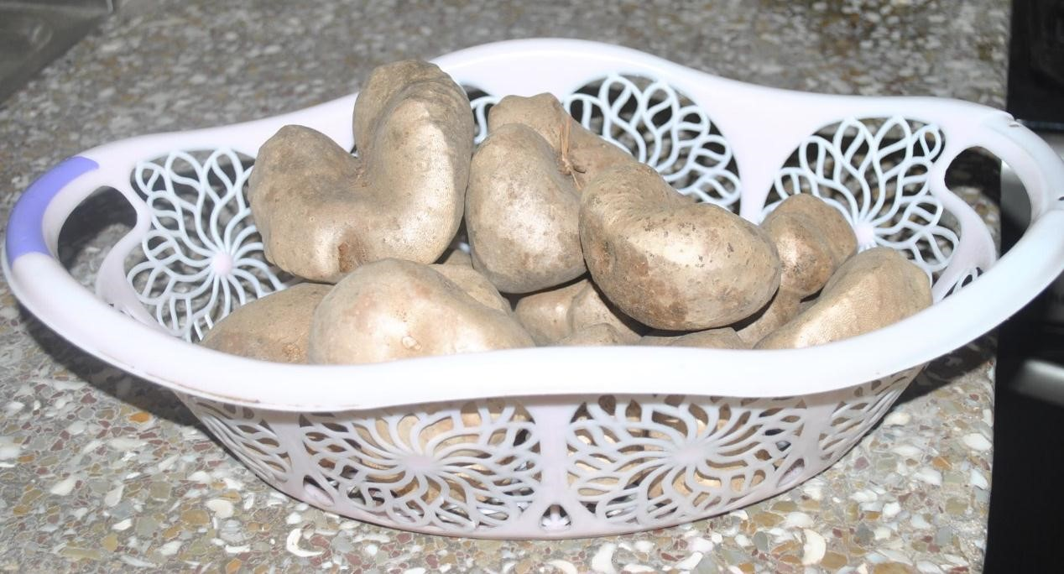
Plate 1.1: Aerial yam
In Ghana, Dioscorea bulbifera L. is referred to as “Firigima” in Dagbani, “akam”, “sowaba”, “bosor bofamu” in Akan and “dundunbisa” in some of the northern communities (personal communication). Dioscorea bulbifera is identified by its aggressively high-climbing annual twining stems, large ovate leaves with distinct veins, and aerial tubers that looks like potatoes (Morton, 1974; Long and Lakela, 1976). Production of large numbers of aerial tubers allows for quick proliferation and colonization. The presence of the sun facilitates its rapid growth which leads to destruction of native flora (Schultz, 1993). According to Morisawa (1999), it can grow as quickly as 20 cm per day, quickly spiralling up to tree tops to form dense masses that shade out trees and kill them in the event.
D. bulbifera is a vigorous climber plant commonly found in West Africa (Hamon et al., 1995) which produces large numbers of edible bulbis and serves as both food and medicinal purposes due to its high content of diosgenin, a saponin and dioscorine, an alkaloid (Okezie, 2003). It has its stem twining in clockwise direction and is reported to measure up to 39.37 feet (Berthaud et al., 1997), with shiny green leaves. The flesh of D. bulbifera has a colour ranging from yellow to purple, and even though it possesses a distinctive flavour, it does not have the same appeal compared to D. alata L. and D. rotundata Poir (Martin, 1967).
In Ghana, the aerial yam („Firigima yam‟) is so important to the people in the north such that one can speak of a „Firigima‟ yam culture. The cultivation of the yam is associated with magic so much so that, the best one must always be given to the chief in the community and a farmer gains prestige by cultivating the largest „Firigima‟ farm within a community. Commercial development of aerial yam is almost nonexistent and this is due to the plant being known only in remote and normally povertystricken areas. Even though there are limitations on the quantities of aerial yam produced, they easily grow through “wild” propagation without cultivation. One advantage is that the bulbis have long shelf life and thus can be kept almost indefinitely for later utilisation (Mbaya et al., 2013). The bulbis have a hard back or thick skin that is peeled off after cooking and prior to eating.

2.2.1 Origin and distribution of aerial yam
„Firigima‟ was first found in Southern Asia. Though it is not cultivated on a large scale as the African yam, it is largely distributed worldwide than any yam cultivated in Asia, the Pacific Islands, Africa, and the West Indies (Mignouna et al., 2003). The distribution of aerial yam in Africa has never been sufficiently charted. Its origin is however uncertain and is believed to originate from both Asia and Africa (Tanzania,
Uganda, Cameroon, Ghana, Burkina Faso, Ivory Coast, Guinea, Liberia, Nigeria, Senegal, and Sierra Leone). Yayock et al. (1988) reported that it originated from tropical Asia and West Africa whiles others reported that it is native to Asia and was later introduced into Africa (Hammer, 1998). Aerial yam was widely introduced to most parts of the world, where it is currently found through human activities (Asiedu, 2010).
Coursey (1967) also reported that, the aerial yam was introduced to the Americas from Africa during the slave trade, and specifically into Florida in 1905 for scientific study (Morton, 1976) and now forms one of the most aggressive weeds ever introduced to Florida (Hammer, 1998). According to Langeland and Burks (1998), it is found throughout the State of Florida. It can now be found also in Mississippi,
Louisiana, Texas, Hawaii and Puerto Rico (Overholt et al., 2006).

2.2.2 Cultivation conditions
Martin (1974) reported that although the conditions for cultivation are similar to other yams, they are different in practice because the roots of the aerial yam stay in the soil, and is cropped every year without replanting. In most parts of West Africa, the vine is allowed to creep up a tree which serves as natural stake and the withered leaves at its base serves as moisture traps facilitating the germination of fallen bulbis. It does well in drained sandy loamy soils that are rich in organic matter.
According to Adewole et al. (2011), aerial yam grows in a wide range of soil and most types require long rainy seasons. They further reiterated that, in Nigeria, planting procedure include planting the bulbis or tubers either whole or in small pieces. It has been reported that its underground tubers can be enormously toxic, for this reason they are considered inedible. However, improved varieties are known to be less toxic relative to the wild ones (Martin, 1974).
In Ghana, planting begins in November at the onset of the dry season or between March and April at the onset of the rainy season. The process involves the burying of the bulbis in the mound about 10 to 15 cm below the apex and capping the apex of the mound with mulch to protect the setts from overheating from the sun. Cultivation also involves the application of mulching especially in frequently cropped soils. Mulching application involves the use of organic manure mainly from green manure. In the absence of organic manure, the inorganic fertilizer mainly NPK; 10:10:20 at a rate of 250kg/ ha is applied three weeks after emergence. The main aerial yam producing areas in Ghana are presented in Table 2.1 and Figure 2.1.

Table 2.1: The main aerial yam producing regions and districts in Ghana
REGION | DISTRICT
Northern Region | Salaga  Nanumba  Yendi  Saboba-Chereponi  Savelugu
Ashanti Region | Ejura  Sekyeredumase  Sekyere East  Sekyere West

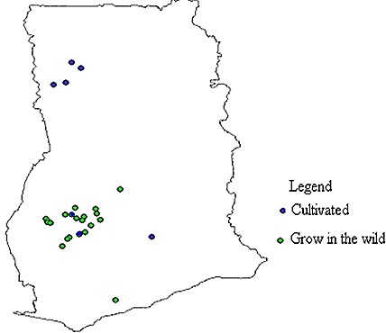
Figure 2.1: Distribution of Dioscorea bulbifera sampled areas in Ghana

2.2.3 Harvesting, handling and storage of Aerial Yam
Harvesting of immature bulbis can be done within three to four months after planting and may continue up to 24 months of the life of the plant. The underground tubers of the aerial yam can be harvested after 15 to 24 months when the vine dies. Immature bulbis are handpicked like fruits while the mature ones are allowed to fall to the ground. The harvested yams may be stored in barns, raised platform or left in the ground for several months until they are needed.
The tubers and bulbis are known to be resistant to fungal infections, and harvest wounds have been reported to heal quickly. For moderate storage life, bulbis need to be well aerated and shaded away from sunlight to keep them relatively cool. There is the need to frequently inspect and remove the rotten ones from the lot (personal communication) (Asiedu).

2.2.4 Composition of aerial yam (Dioscorea bulbifera)

2.2.4.1 Proximate composition
Studies on the proximate composition of aerial yam have provided different values. Studies by Abara (2011) had the following results; 62.50%, 2.55%, 1.68%, 0.20%, 34.60% and 1.50% for moisture, protein, crude fibre, fat, carbohydrate and ash respectively on wet weight basis. Igyor et al. (2004) reported values of 63.17%, 0.49%, 1.20%, 0.87% and 34.35% for moisture, fat, protein, ash and carbohydrate respectively. The chemical composition of aerial yam obtained in two localities (A and B) in Nigeria revealed moisture content of 68.54% and 67.46% in samples B and A respectively with a mean dry matter of 32.00%. There was an average of 3.61% crude protein (CP), 3.06% ether extract (EE) or fat, 8.65% crude fibre (CF) and 1.33% ash. Nitrogen free extract (NFE) or soluble carbohydrate was slightly higher in sample B (83.88%) than in sample A (83.24%) giving a mean value of 83.56% (Mbaya et al., 2013). The differences may be due to specie variation and environmental changes.
However, the aerial yam is generally reported to be low in fat and fibre content with high carbohydrate and energy content (Polycarp et al., 2012). The low protein levels of the yam imply that, products from this yam should be accompanied with sauces of high protein. Other studies have reported higher values of protein, up to 10% of the dry matter, however the sulphur-bearing amino acids were found to be low, limiting the nutritional value. The xanthophyll of D. bulbifera denoted by the yellow pigments are of no nutritional importance (Coursey, 1967; Martin, 1974). The variations in some of the values could be attributed to the fact that the compositions of yam tubers are affected by differences in farming environment, stage of maturity, method and duration of storage and the specie type (Asiedu, 2010; Afoakwa and Sefa-Dedeh, 2012).
Whiles different authors have reported on proximate composition of the aerial yam, there is little or no studies done on the processing effects on proximate composition of the aerial yam. This is necessary to ascertain the best processing methods to employ that will eventually result in good quality finished products. Aerial yam is a crop that has great potential to serve as source of essential nutrients and so can be utilised in the food industry. According to Mbaya et al. (2013), the nutritional value of aerial yam suggests that it can be fully incorporated into the cropping system by farmers in areas where it is found. There is however the need for more research on its chemical properties for possible commercial development.

2.2.4.2 Mineral Content of aerial yam (Dioscorea bulbifera)
Mineral components usually reported in literature on roots and tubers are calcium, phosphorous and iron and sometimes potassium and sodium (Abara, 2011). Potassium content of yam is relatively high and forms about 0.3% of the tuber on wet basis. Sodium content have been found to be generally low and forms about 120 ppm of the tuber dry matter (Abara, 2011). The magnesium content of yam was found to be between 40-85mg/100g on wet basis and other minerals like zinc, copper and manganese in trace amounts (Abara, 2011). Irrespective of these available data, there are generally limited studies on the mineral content of aerial yam (Okwu and Ndu, 2006; Ogbuagu, 2008; Abara, 2011 and Polycarp et al., 2012).
Okwu and Ndu (2006) reported values of 0.85mg/100g, 1.80mg/100g, 1.00mg/100g, 0.22mg/100g and 0.36mg/100g for magnesium, calcium, potassium, sodium and phosphorous respectively for aerial yam. Polycarp et al. (2012) also reported values of
76.5mg/100g, 116.50gm/100g, 1250mg/100g, 92.5mg/100g, 224.5gm/100g and 6.50mg/100g, for potassium, sodium, calcium, magnesium, phosphorous and iron respectively. There is also a paucity of data on the effect of processing on the mineral content of the aerial yam.

2.2.4.3 Anti–nutritional factors of aerial yam (Dioscorea bulbifera)
The tubers and bulbis of some varieties of the D. bulbifera are poisonous and are often considered to be inedible even though they possess all the food nutrients within acceptable levels for root and tuber crops (Ogbuagu, 2008). This is as a result of the presence of anti-nutritional compounds such as alkaloids, oxalates and saponin in such concentrations that affect animals and human health adversely (Mas-Yamaguchi, 1983; Ogbuagu, 2008). The matured edible yams do not possess bitter compounds which are found to be present in immature tuber tissues. The bitter compounds of the aerial yam induce a 3–furanosidenorditerpene called diosbulbin which causes paralysis. Extracts of the yam are utilised in the immobilization of fish. In Malaysia, the yam has been reported to have been used in poisoning tigers and the extracts are also used in preparing arrow poison in Indonesia (Subhash et al., 2012). Alkaloids are used as poison and steroid derivatives. For instance, diosgenin extracts are useful in the pharmaceutical industry (Ihekoronye and Ngody, 1985).
Few researchers have reported on anti-nutritional properties of the aerial yam. The alkaloid, oxalate and saponin content of the aerial and bitter yams were found to decrease considerably after cooking. It is therefore assumed that, aerial yam with higher oxalate content (0.69 mg/100g) can be rendered edible after series of processing to reduce the concentration of oxalate and alkaloid (Ashajiyothi et al.,
2012; Polycarp et al., 2012; Ogbuagu, 2008). Polycarp et al. (2012) recommended that since aerial yam had low levels of oxalates (0.58mg/100g), tannins (10.98mg/100g) and phytate (2.24mg/100g) (<15 mg/100g) it could be safely recommended for food processing applications.

2.2.5 Uses of yam
Yam tubers have been diversely utilized and still have more potential usage. A great amount of yam in West Africa is eaten boiled, roasted, fried, and pounded yam as in “Amala” a stiff glutinous dough. Yam has also found its way in industrial uses as a thickener in soup and other bakery products (Iwuoha, 2004). They may therefore be processed into various forms for domestic and industrial applications.

2.2.5.1 Domestic Uses of Aerial Yam (Dioscorea bulbifera)
The aerial yam has been used domestically in various forms. It is boiled, roasted or fried like potatoes and any other starchy root crop. They are also pounded as fufu in some parts of the Northern region of Ghana (Asiedu, 2011). In the Philippines, it is taken as a dessert called „halaya‟, and is also an ingredient for a Filipino sweet, „halo halo‟ (Asiedu, 2003). The peels of aerial yam have been reported to be a good source of food for animals when the toxicity has been minimised through processing. Many varieties found in Africa need detoxification either by immersing in water or by boiling for a long period before consumption. Some are succulent and may be eaten raw even though they can be bitter and have a flavour inferior to that of most of the regular yams and are usually eaten during famine. The yellow fleshed variety darkens during cooking.
Nevertheless, the bulbis have gained some acceptance because of its convenient size for domestic use (Martin et al., 1974). D. bulbifera has not been thoroughly investigated especially in the area of value addition and its full potential may still be undiscovered. Presently, it seems to have potential in the backyard gardens than large- scale production. However, the edible types are easy to cook and can be harvested for a 20 month duration after 4 months of planting (Martin et al., 1974).

2.2.5.2 Potential industrial uses of aerial yam (Dioscorea bulbifera)
Apart from being served directly as food, the yam has many potential industrial uses but regrettably has not been processed to any significant extent commercially (Asiedu: personal communication, 2011). Dehydrated flours and flakes can be produced through Sun or oven drying and milling of the tubers. These have potential for both the local and international markets. It has been reported that the bulbis and tubers are frequently processed into flour (Igyor et al., 2004; Nwosu, 2014). In Africa, it has also been reported that the inedible types may be cultivated amongst the edible to ward off thieves, whiles poisons for fish are made from the bulbis of the inedible varieties in Indonesia. The pulp prepared from the tuber is administered as treatment for snake bites and scorpion stings in India and Jamaica respectively (Kay, 1998).
Subhash et al. (2012) studied the nutritional profile and phytochemical screening of the aerial yam and found that the aerial yam possesses profound therapeutic potential. They suggested the need for more detailed study to be done for further isolation leading to the production of the pure compounds. Kuete et al. (2012) reported on antibacterial activities of the extracts, fractions and compounds from Dioscorea bulbifera and concluded that, the crude extract of the aerial yam as well as some of the compounds and mostly compound C3 bafoudiosbulbins could be considered as potential antimicrobial drugs to fight against multi- drug resistant bacterial. Adewole et al. (2011) investigated the rheological properties of wild yam and aerial yam and concluded that, aerial yam starches can be useful in the pharmaceutical industries as a tablet binder and as a thickening agent and stabilizer when modified.

2.3 Processing of Roots and Tubers
Roots and tubers are consumed in various forms, such as boiled, chunks, pounded or slices. These are obtained through cooking, moisture reduction, fermentation and milling (Morris et al., 2006). Yam (Dioscorea spp) is a member of the semi perishable group of crops owing to its relatively high moisture content. In the absence of good storage facilities, yam tubers are disposed to a steady physiological deterioration after harvesting. Yams can however, be processed into flour through various processing methods to prolong its shelf life and later be reconstituted with hot water to form paste or dough. The reconstituted flour (known as “Kokonte” in Ghana and Amala in Nigeria) is popular as food for both adults and children, and forms an essential source of carbohydrate for many people in the yam zone of West Africa (Akissoe et al., 2003; Otunsanya and Jeger, 1996; Afoakwa and Sefa-Dedeh, 2001).
In Africa, yam processing is a long established practice. Traditionally and culturally, tubers and bulbis of yams are prepared in several ways for ingestion. They may be boiled, roasted, pounded or fried according to an individual‟s desire. It is reported that several factors do influence the nutritional content of food and level of losses during processing. These factors may include the genetic make-up of the plant, the soil in which it is grown, the use or non-use of fertilizer, prevailing environmental conditions, maturity at harvest, packaging and storage conditions and method of preparation for processing (Morris et al., 2006).
Post processing handling and storage conditions are very essential for the maintenance of the nutritional content of food (Morris et al., 2006).Varying amounts
of nutrients are lost when roots and tubers are subjected to different treatments such as boiling in water and slicing during processing (Lamptey et al., 2008). In their study, Lamptey et al. (2008) observed high protein content in the flour produced from the sliced yam. Whichever processing method is chosen, retention of these nutrient decrease with longer processing time, high processing temperatures, and cutting or maceration of the food. Processing food offers many benefits including enhancement of preservation, and reduction of food safety risks and creation of variety in the food supply chain.

2.3.1 Processing of Aerial Yam (Dioscorea bulbifera)
Aerial yam may be processed in different ways for both commercial and industrial use. The main use of D. bulbifera involves its preparation and processing into edible food by boiling, frying or roasting, or eaten as cooked vegetables as the case may be. Aerial yam can be made into paste after boiling and eaten with soup or can as well be processed into various forms such as crisps and chips or flakes. It is easy to convert this yam specie into shelf stable and convenient forms such as flours which can be used as human and animal feed (Nwosu, 2014). Few authors have reported on processing of aerial yam into Amala and biscuits (Igyor et al., 2004; Nwosu, 2014).
There are few studies on processing of aerial yam, which is very important in the development of products. Nwosu, (2014) studied the proximate and sensory properties of aerial yam and wheat flour composite biscuits and concluded that the biscuit produced with wheat flour, substituted with aerial yam flour, at different levels of composition, were significantly different (P≤0.05) in terms of the proximate and sensory properties. It was recommended that up to 50% substitution of aerial yam with wheat flour was acceptable in biscuit production and other related products.
Aerial yam flour was found to be a good energy food source and a good substitution for wheat flour, especially in baking, considering the high cost of wheat flour.
Igyor et al. (2004) studied the food potential of potato yam (D. bulbifera) and concluded that, the chemical composition of aerial yam is similar to that of other yam species commonly consumed in Nigeria and also Amala prepared from aerial yam is quite acceptable and compared favourably with other yams. Therefore, aerial yam is a good energy food source and substitute for white yam. Examples of processed traditional foods from aerial yam are listed below:
Boiled yam: Yam tubers or bulbis are washed, peeled, washed and cut into slices and for smaller tubers/bulbis cooked with the peels to conserve the ascorbic acid content. The time allowed for boiling will depend on the specie, variety and maturity of the yam. Coursey (1967) intimated that boiling with the peels conserves the vitamin content where 95% of ascorbic acid is retained. In Ghana Boiled yams can be eaten with green leafy stews, tomato sauce, soups and palm oil to form a traditional dish called „eto‟ eaten with groundnuts, and avocado pear if preferred with boiled eggs. However, in Ghana, the boiled aerial bulbis have incisions made on them and filled with pepper sauce (Ayensu, 2011: Personal communication).
Fufu: Fufu which is a popular dish in most of the West African countries is prepared by peeling the yams, removing all inedible parts, cutting them into desirable shapes and boiling in water until it is soft to the touch. The boiled yam pieces are drained and pounded with a wooden mortar and pestle until the starch granule structure is broken down to form stiff glutinous dough. Depending on the quantity and texture of boiled yams, pounding can take between 20-60 minutes. The fufu is then moulded by hand into spherical shapes and eaten with palm nut soup, garden eggs soup, peanut butter soup or any soup as desired (personal communication, 2011; Nwosu, 2014).
Roasted yam: Sliced or whole yam is roasted by placing on a wire mesh over fire. In Ghana this is often eaten with a piece of roasted fish (Ayensu, 2011: Personal communication) whereas in other West Africa countries they are eaten with red palm
oil.
Yam flour: In Nigeria, flour is prepared from aerial yam by washing and slicing the peeled bulbis to 1cm thick and dried in the sun until moisture has been reduced to about 10 per cent. In some instances, the bulbis are parboiled before sun drying which softens the tissues significantly and gives a palatable finished product (Igyor, 2004).
Even though few authors have reported on processing of aerial yam (Igyor, 2004; Nwosu, 2014), no comprehensive studies have been conducted on processing of either the yam or the effects of different processing techniques on the final quality of the aerial yam products. This has resulted in the underutilisation of the aerial yam.

2.3.2 Effect of processing on some functional properties of food
Functional properties as defined by Matil (1971) are those characteristics that govern the behaviour of nutrients in food during processing and storage as they affect food quality and acceptability. Functionality of a raw material according to Brennan (2006) is the combination of properties which define product quality and process effectiveness. These properties vary greatly for different raw materials and processes, and maybe measured by chemical analysis or product testing. Some of the important functional properties that influence the utility of most starchy staples, such as yam, include the drying characteristics, water binding capacity, swelling power and
solubility.

2.3.2.1 Water binding capacity
Water binding capacity (WBC) is used to determine if a particular type of flour would be useful in the food system such as bakery items that require hydration to improve handling characteristics. High WBC is attributed to loose structure of starch polymers whiles low values indicate the compactness of the structure (Oladipo and Nwokocha, 2011). WBC is an essential parameter in the production of baked products, extruded snacks and mash. High water binding capacity is essential for making mashes whiles lower water binding capacity is ideal for thinner gruels. It is also a very important parameter to be considered in the development of ready to eat foods. It has been reported that foods with high WBC will assure product cohesiveness (Houson and Ayenor, 2002).
Ogunlakin et al. (2012) studied the effect of drying on physico-chemical properties of cocoyam flour and observed that the water absorption capacity ranged between 125.4130.3 %. In the study, sundried samples had the highest value while cabinet dried samples the lowest value. They concluded that acceptable cocoyam flour can be produced by different drying methods depending on intended use and that drying affected the water absorption capacity of the flour. Igyor et al. (2004) also reported water absorption capacity of 3.50 g/g for the aerial yam whiles Nwosu, (2014) reported that functional property determination for aerial yam flour showed low water absorption value of 3.86 g. However, there is little information on the effect of processing on water binding capacity of aerial yam flour.

2.3.2.2 Swelling power and solubility
Swelling power of starch granules is an indication of the extent of associate forces within the granules and it is related to the water absorption index of the starch based flour during heating (Moorthy et al., 1981). Generally, swelling is reported to be related to the water absorption index of starch based flours during heating (Loos et al., 1981). High swelling power is said to constitute better thickening as well as a bulking agent (Iwuoha and Nwakanma, 1998).
Solubility is a measure of the ease with which the flour particles are able to dissolve in cooking water, thereby reflecting the extent of starch degradation (Diosady et al., 1985). It permits rapid and extensive dispersion of flour particles in solution. This leads to a finely dispersed colloidal system, with homogenous macroscopic structure and a smooth texture (Akinwande et al., 2012). Few authors reported values on solubility and swelling capacity of the aerial yam flour. Igyor et al. (2004) and
Nwosu, (2014) from their studies, reported a value of 5.90 ml/g.

2.3.3 Effect of processing on nutritional value of food
The effect of food processing on nutritive value of food depends on the sensitivity of the nutrient to the different conditions prevailing at the time of processing, such as heat, oxygen, pH and light. The properties and level of nutrients in a particular food being processed may influence mineral retention. For example, sensitivity of vitamin C to heat varies with pH. Macronutrient and vitamin contents of foods are more likely to be affected by processing than the mineral content. In considering the effects of processing on nutrient content of particular foods, the loss of protein (amino acid) during blanching of green vegetables, for instance, might be of more relevance to the diet than that of vitamin C from the same source (Morris et al., 2006). Various authors have reported effect of processing on nutritional composition of some roots and tubers
(Hsu et al., 2003; Agoreyo et al., 2011; Adegunwa et al., 2011; Aasa et al., 2012; Oyewole and Oyewole, 2013); however there is a paucity of information on the effect of processing on dioscorea bulbifera bulbis and its flour.

2.4 Pasting properties of the aerial yam flour and starch
According to Maziya–Dixon et al. (2005), when heat is applied to starchy foods, series of changes occur that constitute pasting and gelatinisation. During this process, if heating continues, more granules become swollen and accompanied by the increase in leaching of amylose and amylopectin from granule as well as the increase of viscosity. When most granules have undergone this process, the starch is considered to be pasting and peak viscosity is reached (Thomas and Atwell, 1997). Therefore, a starch paste can be defined as a two phase system composed of a disperse phase of swollen granules and a continuous phase of leached amylose. During cooling, aggregation of amylose phase with linear segments of amylopectin will result in a strong gel (Ring, 1985). The ability of starch to form paste is useful as starch forms an ingredient to improve food texture. Rheological properties of starch play important roles in food and industrial processing application. Heating and shearing treatment that is usually applied during processing might cause rheological changes of the paste and subsequently might affect the final product (Katayama, 2002).
Pasting viscosity may be recorded using Brabender Viscoamylograph, Rapid Visco Analyzer (RVA) or other viscometers which record continuously the viscosity of pastes as a function of heating, holding and cooling temperatures. When starch granule is heated up to gelatinisation temperature in excess of water, the granule swells and viscosity increases rapidly with the rise of temperature. Temperature at the onset of this rise in viscosity is called pasting temperature (PT). With increase in temperature, a lot more of the starch granules gelatinise. With the increasing temperature, the starch granules begin to breakdown and at peak viscosity this breakdown gets better. With the continuous stirring and increase in temperature, the granules rupture causing an increase in the release of amylose and amylopectin. This process causes a decrease in viscosity of the paste (Zaidul et al., 2007).
Few authors have reported on the pasting and rheological properties of the aerial yam. Adewole et al. (2011) studied the rheological properties of wild yam (dioscorea villosa) and aerial yam (Dioscorea bulbifera) and observed high peak viscosity for aerial yam (390.92 RVU), pasting time of 86.50 min, and breakdown viscosity of
20.50 RVU and setback viscosity of 128.83 RVU. Peak time of aerial yam was 5.60 RVU lower than that of wild yam (Dioscorea villosa). The trough for aerial yam was reported as 262.08 RVU. The pasting time for aerial yam was higher than that of the wild yam. The high breakdown observed in the wild yam implied that the starch is highly stable. They further concluded that, starches of aerial yam can be applicable in the pharmaceutical industries as a tablet binder and when modified, can be used as a thickening agent and stabilizer.

2.5 Drying of foods
Drying of food is one of the oldest approaches to food preservation and a very essential phase of food processing. It is one of the methods that are applied in the perseveration of perishable agricultural produce in order to ensure their availability all year round, reduce post-harvest losses and achieve food security. It allows foods to be preserved by the removal of moisture to prevent or inhibit the growth of microorganisms that cause deterioration (Agoreyo et al., 2011; Mukhatar, 2009). The most commonly used drying methods include sun drying, convectional air drying, vacuum drying and osmotic drying (Krokida and Maroulis, 2001). The convectional air drying is the process where heat from hot air is transferred to the food material by convection to evaporate moisture to the surrounding air. Drying by convection involves the exposure of food materials to high temperatures which normally results in thermal damage to vitamins, colour, flavour, and other quality attributes in dried agricultural produce (Jayas, 2007).
Drying of agricultural produce as a means of improving shelf life has been practised for many centuries. As compared to fresh produce which can be kept for a short time under ambient conditions; dry products can be stored for months or even years without appreciable loss of nutrients. Drying also reduces bulk weight thus facilitating ease of transportation. In some cases drying may lead to a considerable reduction in volume and hence reduction in storage space requirements (Agoreyo et al., 2011). Various researchers have conducted a number of studies on the drying of agricultural produce, including, yam so that the moisture content can be reduced and allow for further development of value-added products (Hsu et al., 2003; Agoreyo et al., 2011; Adegunwa et al., 2011; Aasa et al., 2012; Oyewole and Oyewole, 2013). It has been reported that fresh yams are difficult to store and prone to spoilage. Because they are considered as health foods and not staple foods in oriental countries, it is feasible to develop a stable form of yam products to satisfy the health food market. Since yam flour products are easily stored for long periods and conveniently used in producing formulated foods for consumption, dried yam flour is worth producing (Hsu et al.,
2003).

2.5.1 Effects of drying on foods
One aspect of product quality is usually to control product moisture content at the dryer outlet to lower chemical degradation reactions, maintain product structure and texture. It is also to acquire the desired colour, control the product density and porosity and develop a flexible drying process that can yield products of different structures for different uses (Krokida and Maroulis, 2001). Drying and processing conditions affect the quality properties of the dehydrated products, specifically; the colour, texture, and density, porosity and sorption characteristics of the materials. Therefore the fresh material may end up as a different product depending on the type of drying method and conditions applied relative to the final product (Krokida and Maroulis, 2001).
Two processes do occur during drying, the transfer of heat to the food and removal of moisture from the food. Heating can be both beneficial and damaging to nutritional content of foods. It usually improves the digestibility of foods, making certain nutrients more available. Typical example is the protein in legumes, which is made more digestible by heating because of the inactivation of anti-nutrients such as trypsin inhibitors. Loss of nutrients during drying is more due to the application of heat than to the removal of moisture. Usually, except for thiamine, removal of moisture results in increased concentration of nutrients (Morris et al., 2006). It has been reported that, almost any method of processing raw food will have an adverse effect on some of its nutrients. The quality changes that may occur in any product during the process of drying are changes in optical properties (colour and appearance), sensory properties (odour, taste and flavour), structural properties (density, porosity, rehydration and specific volume), textural properties, rehydration properties (rehydration rate, and rehydration capacity) and nutritional characteristics (vitamin loss and protein denaturation) (Krokida and Maroulis, 2001). In the literature, there is little information on the effect of drying on aerial yam, however some researchers have reported on the effect of drying methods on cocoyam flour (Ogunlakin et al., 2012) and white yam (Oyewole and Oyewole, 2013). There is therefore the need to investigate the effects of drying on D. bulbifera to determine the suitable drying method that will ensure a quality product during processing.

2.5.2 Pre-treatments in drying
Pre-treatments have been used commercially to assure product quality and prevent microbial attack during drying. Dipping fruits for several seconds in pre-treatment solutions also greatly reduces the drying time (Radler, 1964; Bolin et al., 1975). Agricultural produce that are to be dried are pre-treated to prevent discolouration by oxidation, maintain its colour, have a more flexible texture, facilitate the retention of vitamins A and C, and in most cases to accelerate the rate of drying. Improvement of dried food quality can be achieved by applying various pre-treatments before drying (Doymaz, 2003). One of the most widely used pre-treatment in the drying of agricultural produce is blanching due to its ability to inactivate enzymes, change tissue structure, facilitate shorter drying time and increase drying rate (Doymaz,
2003).

2.5.2.1 Blanching
Blanching is a pre-treatment widely used prior to freezing, canning or drying roots and tubers for the purpose of inactivating enzymes. Blanching involves heat treatment for a short while either by steam or hot water (Morris et al., 2006). The main aim is to achieve certain favourable effects on processed foods such as the inactivation of enzymes, removal of trapped air, reduction of initial infection, removal of undesirable flavours and aromas and preservation of colour and nutritional value (Krokida and
Maroulis, 2001; Morris et al., 2006).
Hot water and steam are the most common heating media in industry (Reyes et al., 2004). Loss of nutrients in blanching is due to thermal degradation, oxidation and leaching. Nutrient losses due to thermal degradation and oxidation are similar for steam and hot water blanching. Hot water blanching, however, results in greater losses due to leaching of water soluble vitamins, minerals and amino acids (Morris et al., 2006). Water blanching is done in hot water at temperatures between 70°C to 100°C. Hot water blanching is known to result in a more uniform treatment allowing processing at lower temperatures. Water blanching requires longer processing duration leading to increased leaching of minerals and nutrients such as vitamins (Reyes et al., 2004). Steam blanching is mostly used for cut and small products, which requires less time compared with water blanching due to the fact that, the heat transfer coefficient of condensing steam is greater than that of hot water. However, due to the high-temperature gradients between the surface and the centre of the product, bigger products or pieces of products can be over blanched close to the surface and under blanched at the centre. Steam blanching is more energy-efficient as compared to water blanching and has reduced nutrient leaching (Reyes et al., 2004).

2.5.2.1.1 Effects of blanching on food quality
The quality of food is significantly affected by the type and degree of blanching. The quality parameters that are normally evaluated for fresh produce just after blanching are flavour, texture and colour. This helps in determining the efficacy of the process in retaining or improving the food quality depending on each process (Reyes et al., 2004; Morris et al., 2006). The flavour of many products is directly and indirectly affected by inactivation of enzymes responsible for off-flavour development. The compound notably responsible for this is epoxygenase in vegetables (Reyes et al., 2004; Morris et al., 2006). Blanching sometimes increases flavour retention, and sometimes removes unwanted bitter flavours from the product. Undesirable softening in agricultural produce do occur in blanching and this can be reduced by the addition of calcium. Combination of low-temperature blanching and calcium has been reported to be effective in firming canned food crops (Reyes et al., 2004; Morris et al., 2006). This is due to the activity of pectin with a reduced degree of methylesterase that produces pectin with reduced level of methylation that readily interacts with calcium.
However et al. (2008) reported that blanching leads to structure softening and hence facilitate removal of moisture.
Just as blanching can directly or indirectly affect colour, it is also characterised by the destruction of chlorophyll. In potato processing, reducing sugar content maybe adjusted by water blanching resulting in colour development during further and more intensive heating where Maillard reaction then takes place (Reyes et al., 2004; Morris et al., 2006; Malomo et al., 2013). In the food industry, colour evaluation is performed by comparing to standards. It is known that blanching leads to decrease in nutritional value of foods. During blanching, nutrients leach out of the product. Vitamins are degraded by heat, however, ascorbic acid (vitamin C) is the most commonly assayed nutrient in blanching probably due to its high solubility and heat susceptibility that makes it a conservative indicator of nutrient retention (Reyes et al., 2004; Morris et al., 2006). Blanching facilitates peeling and dicing and is accompanied by microbial load reduction (Malomo et al., 2013).
Some studies have shown considerable decreases in drying times when hot water blanching was employed as pre-treatment technique in drying various agricultural crops (Doymaz, 2006; Abioye, 2012; Oyewole and Olaoye 2013). The effect of steaming on properties of yam flour was studied by Akinwande et al. (2012), and they reported that increase in steaming time of 10, 20, and 30 min at specified temperature improves the functional properties of the yam flour.

2.5.2.2 Other pre-treatment methods
One potential challenge in yam flour production is the discolouration and darkening of the final product (Akubor, 2013). This has been attributed to enzymatic reactions due to the presence of water soluble phenolic substances in yam (Onimawo and Akubor, 2012). One challenge for food processors is how to achieve a flour of superior quality exhibiting the natural colour of the raw material. Many approaches have been utilised in preventing the discolouration during processing of flour. Some of these are lowering of pH and use of antioxidants like ascorbic acid and sulphur dioxide. Sulphites are added to foods as antioxidants to inhibit browning, this however results in the loss of thiamine (Onimawo and Akubor, 2012).

2.6 Modelling of Thin- Layer Drying of Agricultural Produce
Drying of food crops with high moisture content is a complex process, which includes simultaneous heat and mass transfer. The food materials are dried making use of several methods however, thin layer - drying has gained popularity owing to its faster rate in comparison to others in the minimum loss of nutrients. Thin-layer drying is used to describe the process of drying a single layer of sample particles. There are three types of thin-layer drying models used to describe the drying phenomenon of agricultural produce. The theoretical model considers only the internal resistance to moisture transfer between product and heating air whiles semi theoretical and empirical models consider only the external resistance (Midilli et al., 2002).
Demirtas et al. (1998); Ece and Cihan (1993) reported that theoretical model needs assumptions of geometry of a typical food, mass diffusivity and the conductivity Empirical model neglects the fundamentals of drying process and presents a direct relationship between average moisture and drying time by means of regression analysis (Ozdemir and Devres, 1999; Wang and Singh, 1978). The semi theoretical model is a trade-off between the theoretical and empirical ones derived from simplification of Fick‟s second law of diffusion or modification of the simplified model, which are widely used, such as the Lewis, Page, Modified Page, Henderson and Pabis, Logarithmic, Two term, Approximation of diffusion, Verma and Midilli Kucuk models ((Midilli et al., 2002; Panchariya et al., 2002).
Lopez et al. (2000) studied models for the kinetics of hot air drying of 2.5 mm thick potato slices. They observed two different drying rates; the first was a constant rate period during the initial period of 70 min, for which equations correlating to air flow rate and heat transfer coefficient were derived, followed by a falling rate period which could be described by Fick's equation. Dependence of moisture diffusivity on temperature followed the Arrhenius relationship.
Drying temperature, pre-treatment method, relative humidity, and product sizes are some of the factors that affect the drying kinetics of agricultural produce (Kudra, 2004; Ade-Omowaye et al., 2002) and are specific to a particular crop. Several researchers have carried out studies on the drying characteristics and kinetics of various food crops (Sacilik et al., 2006; Doymaz, 2007; Vengaiah and Pandey, 2007; Goyal et al., 2008; Therdthai and Zhou, 2009). Physical and thermal properties of agricultural products such as heat and mass transfer, moisture diffusion, energy of activation, and energy consumption are required for ideal dryer design. According to Sobukola et al. (2008), knowledge of drying kinetics of biological materials is important to the design, optimisation and control of the drying process.
Several researchers reported the moisture diffusion and energy activation of agricultural products and evaluated the effect of the drying conditions in thin-layer drying (Akpinar et al., 2003; Babalis and Belessiotis, 2004; Goyal and Bhargava, 2007). However, no study on the drying characteristics of aerial yam has been
reported in the literature.
2.7 Mathematical Model Equations used for Drying of Agricultural Products A number of drying models have been reported in the literature. Table 2.2 presents some of the mathematical models for thin- layer drying of food materials.

Table 2.2: Mathematical models for drying characteristics of products
No. | Model name | Model equation | Food product | Source
1 | Newton | MR = exp (-kt)
2 | Logarithmi  c | MR = aexp (-kt)+c | Corn Grains | Ajala et al.  (2012)
3 | Henderson and Pabis | MR = aexp (-kt)+c | Grapes | Roberts et al. (2008)
4 | Modified Henderson and Pabis | MR= aexp (-kt) +  bexp(-gt)+cexp(-ht) | Citric acid pretreated potato | Doymaz (2012)
5 | Approxima tion of  Diffusion | MR = aexp (-kt) +  (1-a) exp(-kbt) | Organic Tomato | Sacilik et al.  (2006)
6 | Page | MR = exp (-ktn) | Buckwheat | Tabatabaee et al. (2004)
7 | Modified Page 1 | MR = aexp (-(kt)n) | Sweet potatoes | Dinrifo ( 2012)
8 | Two Term Exponentia  l | MR = aexp (-kt) + (1-a)exp(-kat | Blanched potato | Doymaz (2012)
9 | Wang and  Singh | MR = 1+at+bt² | Strawberry dried at 65°C | Doymaz (2007)
10 | Midilli  Kucuk  &Yapar | MR = aexp (-ktn) +bt | Tomato | Taheri-Garvand et al. (2011)
Moisture ratio during drying experiment is usually calculated using equation (1):
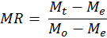
(1)
where, M_{e} is equilibrium moisture content, kg water/kg dry matter; Mo: initial moisture content (kg water/kg dry matter); M_{t} is moisture content at any time t.
When the equilibrium moisture is very small compared to the values of M_{t} and M_{o}, the value can be neglected and the dimensionless moisture ratio can be written as M_{t}/M_{o} only.
The drying rate is calculated by using the following equation:

(2)
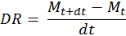

where, DR is drying rate; M_{t} is as introduced earlier and Mt+dt is Mt after some incremental time dt; dt is the elapsed drying time.
Coefficient of determination (R²) is the primary criterion for selecting the best equation to describe drying curve. Reduced chi square (χ²) is the mean square of the deviation between the experimental and the predicted values for the models. The root mean square error (RMSE) is used to determine the goodness of fit. The higher the values of R², and the lower the value of x² and the RMSE the better the goodness of fit
(Yaldiz and Ertekin, 2001; Akpinar et al., 2003; Gunhan et al., 2005)
These parameters are calculated as follows
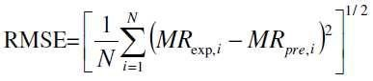 (3)

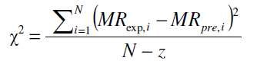
(4)

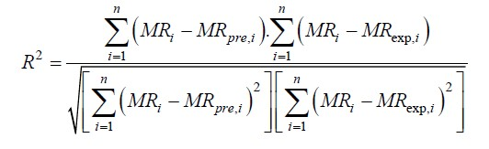
(5)

where MR exp, i is the ith experimental moisture ratio, MR pre, i is the ith predicted moisture ratio, N is the number of observations, and z is the number of constants in the drying model.

2.8 Effective moisture diffusivity and activation energy
Drying of most food materials occurs in the falling rate period, and moisture transfer during drying is controlled by internal diffusion. Effective moisture diffusivity is used to represent an overall mass transport property of water in food materials (Dadali et al., 2007b). For most biological materials, Fick‟s second law of (equation 6) has been widely used to describe the drying process during the falling rate period as follows:

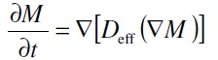
(6)

where, M is moisture content (kg water/kg dry matter); t is the time s; D_{eff} is the effective moisture diffusivity, m²/s; Δ is the differential operator.
The solution of Fick‟s second law in slab geometry was caused by diffusion, negligible shrinkage, constant diffusion coefficient and temperature and was given by Crank (1975) as follows:
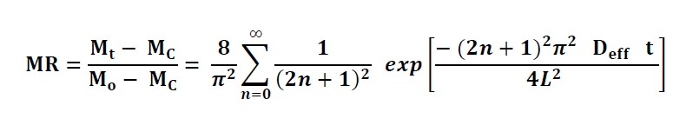 (7)

where, L is the half thickness of the slab in m, t is the drying time.
Many researches have shown that equation (7) may be simplified to a straight line equation (8) (Lopez et al., 2000; Doymaz, 2004):
(8)
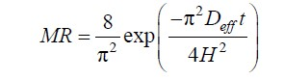
The effective moisture diffusivity can be determined from the slope of the normalized plot of the unaccomplished moisture ratio, In (MR) versus time, using the following equation:
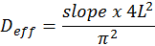
(9)

Effective moisture diffusion which is influenced by the composition of the food, its moisture content, temperature and porosity is used due to limited knowledge on the mechanism of moisture movement during drying and complexity of the process (Afzal and Abe, 1998).
Falade et al. (2007) reported that moisture diffusivities for D. alata and D. rotundata varied with pre-treatment. Generally, effective moisture diffusivity increased with increased drying air temperature, whiles D_{eff} increased with increased thickness of yam slices (Falade et al., 2007). They further reported lower D_{eff} values for blanched D. alata yams as compared to the sulphited and untreated yam samples. Several authors have reported on effective moisture diffusivity for many agricultural produce (Xiao et al., 2011; Olawale and Omole, 2012; Abano et al., 2013).
Activation energy is obtained by plotting the natural logarithm of D_{eff} against the reciprocal absolute temperature. The temperature dependence of the effective diffusivity has been shown to be represented by the Arrhenius relationship. Lopez et al. (2000) and Simal et al. (1996) related temperature with the Arrhenius expression as follows:
(10)
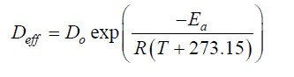
where, D_{o} is the constant in the Arrhenius equation, m²s⁻¹; E_{a} is the activation energy
(kJ/mol); T is the temperature of air, ºC; R is the universal gas constant, kJ/ (mol.K).
Rearranging Equation (10) gives Equation (11):
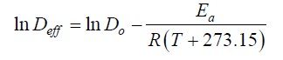 (11)

Activation energy can be calculated from Equation (11). The plot of InD versus 1/ (T+273.15) gives a straight line (slope of K_{L} = E_{a}/R). Falade et al. (2007) reported activation energy values ranging from 25.26 to 46.46 and 41.75 to 72.47 kJ/mol for D. alata and D. rotundata respectively, depending on pre-treatment and thickness of slices. Even though several authors (Xiao et al., 2011; Olawale and Omole, 2012; Abano et al., 2013) have reported activation energies and moisture diffusivities for different agricultural produce, there is a paucity of data on the aerial yam.

2.9 Chemical Properties of Flour and Starches

2.9.1 Amylose
Amylose and amylopectin are the major starch fractions. Amylose comprises between 23-31% of starch dry weight basis, while amylopectin comprises of 69-73%. In amylose, long chains of glucose units are joined together by α-1, 4 linkages. Amylose can be shown as either a straight chain or a helix. The interior or the helix contains hydrogen atoms that allow amylose to form complex with free fatty acids, alcohols, lipids, or iodine. The proportion of amylose in starch could be determined using several methods, including blue value, potentiometric, and amperometric titration. These methods are based on the formation of amylose-iodine complex that gives a blue colour, characterized by a maximum absorption wavelength above 620 nm. This iodine reaction is the most commonly used in determining amylose content due to its specificity, sensitivity and ease. Amylose content estimated using methods based on iodine complex formation is considered as apparent amylose content (Cui, 2005).
On the other hand, potentiometric method gives an estimate of amylose content that is considered as absolute amylose content if the sample is defatted before titration. Iodometric method may also be used to measure the content of medium to long chain of α-(1→4)-glucan. Measurement of amylose content can be influenced by certain factors such as starch source, sample preparation and molecular structure of starch. Adewole et al. (2011) observed that the high stability of the wild yam could be attributed to loss of amylose. There is little information on the effect of processing on amylose content of aerial yam.

2.9.2 Amylopectin
Amylopectin is a highly branched polysaccharide, which consists of α-Dglucopyranose residues linked mainly by several (1→4)-linkages and many nonrandom (1→6)-linkages to give a highly branched structure (Thomas and Atwell, 1977; Galliard and Bowler, 1987). According to their chain length and branching points, amylopectin can be categorized into three types, namely A, B, and C chains. The A chains are the shortest and carry no branch chains. The B chains are branched by A chains or other B chains (B1, B2, B3) while the C chain carries B chains and contains the sole reducing terminal residue. There is little available literature on the amylopectin content of the aerial yam.
The literature review has revealed the extensive application of the aerial yam in the pharmaceutical industries, however, its application in product development is practically non-existent. The need to explore its food potentials is very important to ensure the maximum utilization of this crop that is able to grow under harsh conditions, this presents an opportunity to have a reliable food source all year round.
CHAPTER 3
EFFECTS OF PRE-TREATMENTS (BOILING AND STEAMING) AND
DRYING (OVEN AND SOLAR) ON THE PROXIMATE, MINERAL,
FUNCTIONAL, PASTING, COLOUR AND AMYLOSE PROPERTIES OF
THE AERIAL YAM FLOUR

3.1 Introduction
Yam which belongs to the Dioscorea genus is a good source of carbohydrate for a large number of natives of the sub-Sahara region most especially in West Africa
(Akissoe et al., 2003). It is reported to be a major contributor to food security in West Africa (Zannon, 2006), however of the 600 known species, only seven are mostly utilised (Jayakody et al., 2007). The seven most commonly consumed yams are Dioscorea rotundata, Poir (white yam), Dioscorea cayensis (yellow yam), Dioscorea
Alata (water yam), Dioscorea bulbifera (potato/aerial yam), Dioscorea esculenta,
Dioscorea dumetorum (bitter yam) and Dioscorea praehensalis (bush yam). According to Otoo and Asiedu (2008), D. Rotundata is the most important specie grown and utilised in Ghana in relation to the area planted and quantity produced.
Yams are cultivated in three main areas: West Africa, parts of East, Central and Southern Africa. (FAO, 1999) and are the main producing areas cultivating 95% of the world‟s yam production. Yams are reported to be high in starch and possess alpha amylase which is responsible for the conversion of starch to sugars as the tuber matures in storage. (Ravindran and Wanasundera, 1992).
D. bulbifera known as potato yam or aerial yam and in Ghana, locally called Firigima,
Akam and Bosoro bofamu is one of the most common and widespread yams of the Tropics. The aerial yam is the only yam species which is common to both Asia and Africa and are so distinct from each other (Martin, 1975). In Ghana, the bulbifera is found in various regions of Ghana (Volta, Ashanti, Central, Brong Ahafo, Upper East and North) but predominately in the Northern and Upper East regions. They are commonly boiled and eaten with pepper sauce or pounded into fufu and eaten with soup. Even though the flavour of D. bulbifera is distinctive, and has lots of potential as a functional food, the bulbis do not have the same appeal as compared to other perceived best varieties of D. Rotundata and D. alata L. Preference for the best varieties is rapidly resulting in huge post-harvest losses of aerial yam and eventual loss of income to the farmers. There is therefore the need to develop appropriate processes to manage these losses and also produce stable products from the dioscorea bulbifera.
This study therefore sought to identify the best processing methods to be used in preserving the nutritional content and quality characteristics of the yam. This will be achieved by evaluating the effect of different drying methods on the nutritional, functional, pasting, colour and amylose properties of the aerial yam flour. This will enhance good health; and potentially reduce post-harvest losses to ensure food security and nutrition.

3.2 Materials and Methods

3.2.1 Source of plant materials
Samples of aerial yam were obtained from farmers in the Northern Region of Ghana at the end of January 2012 six months after planting.

3.2.2 Sample preparation

3.2.2.1 Preparation of aerial yam flour from pre-treated yam
The flow diagram for flour production is shown in Figure 3.1. Aerial yam samples were randomly selected, washed, peeled and cut into 2 cm thick slices and divided into 3 parts of 3200 grams each. One part was boiled, after which it was further divided into two batches of 1600 g, one part was solar and the other oven dried. The second portion was steamed and treated as for the boiled samples. The third part which served as control was left fresh, divided into two, one part was solar dried and the other oven dried. (Plate 3.1)
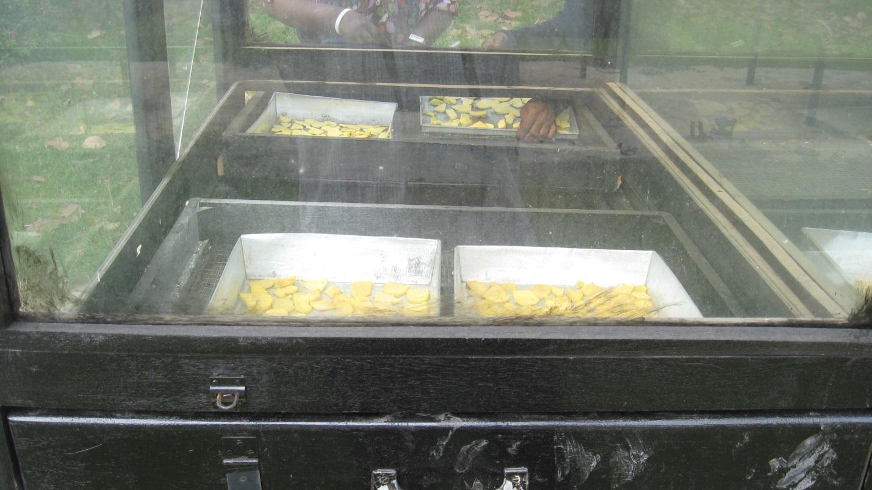
Plate 3.1: Yam samples in solar dryer
Boiling: The process involved placing the yam slices into a rice cooker containing boiling water at 100 ºC for 20 min. after which they were removed for solar drying or oven drying depending on the process flow under consideration.
Steaming: The process involved placing the slices in a colander suspended over boiling water which served as the source of steam and steamed at 100 ºC for 25 min. after which they were removed for solar or oven drying.

Yam

Wash

Slice

)
(2
cm

Boil

Steam

Fresh

Solar Drying

Oven Drying

days
5

4
days

60
o
C

(75
hrs
)

60
o
C

hrs
(48
)

Mill

Sieve

0.25
µm

Store

Dried
samples

Figure 3.1: Flowchart of aerial yam flour preparation

3.3 Analysis of Yam Flour

3.3.1 Determination of flour yield
The processed samples after drying were milled with a hammer mill (Retsch Adda Antriebstechnik, GMBH 63322 Rodermark) with a 0.25µm sieve to obtain the yam flour. The resultant flour was weighed and flour yield was determined as the percentage flour after drying and milling from a weighed sample of aerial yam. The percentage flour yield was prepared using equation (12).
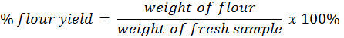
(12)

3.3.2 Determination of moisture content
The moisture content on fresh weight basis was determined according to the procedure of AOAC (1990). Two grams (2 g) each of samples (peeled and steamed or boiled) were weighed into a previously dried and weighed glass crucible. They were then dried in a thermostatically controlled forced convection oven (Gallenkamp, England) at 105C overnight to a constant weight. The glass crucibles were removed and transferred into a desiccator for cooling after which they were weighed. Moisture content was determined by difference in mass and expressed as a percentage using equation (13).

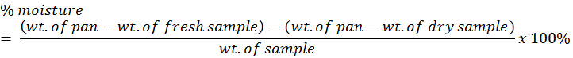
(13)

3.3.3 Determination of crude protein content
The Kjeldahl method (AOAC, 2004) was used for the determination of crude protein content. Two grams (2 g) of sample was placed in a Kjeldahl digestion tube together with half tablet of a selenium-based catalyst and a few anti-bumping granules. 25 ml of concentrated H₂SO₄ was added and the tube shaken until the entire sample was thoroughly wet. The flask was placed on a digestion burner in a fume chamber and heated to approximately 410 C until the rest of the solution was clear. It was then cooled to room temperature and the digested sample solution transferred into a 100 ml volumetric flask and made up to the mark with distilled water.
The distillation apparatus was flushed with distilled water for about 10 minutes. 25 ml of 2% boric acid was poured into a 250 ml conical flask and 3 drops of mixed indicator added and the solution turned pink. The conical flask and its contents were placed under the condenser with the tip of the condenser completely immersed in the boric acid solution. 10ml of the digested sample solution and 20 ml of 40% NaOH solution were transferred into the decomposition flask and the funnel stopcock well closed. Ammonia (NH₃) liberated during the distillation was collected by the boric acid solution, which changed its colour from pink to bluish-green. The distillate was titrated against 0.1N hydrochloric acid (HCI) solution and changed colour from bluish-green to pink. The end point was recorded and the titre values obtained were used to calculate the total nitrogen and the percentage crude protein content. A conversion factor of 6.25 was used to convert from total nitrogen to percentage crude protein (AOAC, 2004).

3.3.4 Determination of crude fibre content
The crude fibre content of samples was determined according to the official method analysis of AOAC (1990). The defatted sample was transferred into a 750 ml
Erlenmeyer flask and 0.5 g of asbestos added. 200 ml of boiling 1.25% sulphuric acid (H₂SO₄) was added to the flask and immediately transferred onto a hot plate. And a cold finger condenser was attached to it. The sample was boiled for 30 min during which the entire sample was allowed to become thoroughly immersed and wetted during the boiling period. After 30 min, the flask was removed; its contents filtered through linen cloth in a funnel and washed with boiling water until the washings were no longer acidic. The sample with asbestos was washed back into the flask with 200 ml boiling 1.25% NaOH solution. The flask was reconnected to the condenser and boiled for 30 min. The contents were again filtered through linen cloth in a funnel and washed thoroughly with boiling water and thereafter with 15 ml alcohol. The residue was transferred into a previously dried and weighed porcelain crucible which was dried in an oven at 100 C for 1 h, cooled in a desiccator and weighed. The crucible and its contents were ignited in an electric furnace at 600 C for 30 min. It was cooled and reweighed and the loss in weight was reported as percentage crude fibre.

3.3.5 Determination of crude fat content
Two grams (2 g) of the dried sample from the moisture determination was transferred into a paper thimble plugged at the opening with glass wool and placed into a thimble holder. 200 ml of petroleum ether was measured into a previously dried and weighed round-bottom flask and this was assembled together with the thimble holder and its contents. The Quick fit condenser was connected to the Soxhlet Extractor and refluxed for 16 hours on low heat on a heating mantle. The flask was then removed and the solvent evaporated on a steam bath. The flask containing the fat was heated at 105 C in an oven for 30 min, cooled in a desiccator and the weight of the fat collected determined and expressed as percentage crude fat (AOAC, 1990).

3.3.6 Determination of ash content
Two grams (2.0 g) of sample was accurately weighed into a porcelain crucible placed in a muffle furnace (Gallenkamp, England) and ignited for 2 h at 600 C. After ashing, the crucibles were cooled to about 105 C in a forced convection oven before further cooling to room temperature in a desiccator. The crucibles and their contents were weighed and the weight reported as percentage ash content (AOAC, 1990) using equation (14)

(14)

3.3.7 Determination of pH
Ten grams (10 g) of flour sample was weighed and dissolved in a beaker containing 25 ml of distilled water to form slurry. It was continuously stirred for 10 min and pH meter (Model HI 9017, Hanna Instruments, U.S.A) was used to measure the pH as described by Kamenan et al. (1987).

3.3.8 Determination of swelling power and solubility index
Solubility and Swelling power determinations were carried out based on a modification of the method of Leach et al. (1959). One gram of yam flour was dissolved in distilled water to a total volume of 40 ml using a weighed 50 ml graduated centrifuge tube. The suspension was stirred just sufficiently and uniformly to avoid excessive speed which might cause fragmentation of the starch granules. The slurry in the tube was heated at 85ºC in a thermostatically regulated temperature water bath for 30 min with constant gentle stirring. The tube was then removed, wiped dry on the outside and cooled to room temperature. It was then centrifuged at 2200 rpm for 15 min. The supernatant was decanted into a pre-weighed moisture can. The solubility was determined by evaporating the supernatant in a thermostatically controlled drying oven at 105 ºC and the residue weighed. The sediment paste was weighed and swelling power was calculated as the weight of sediment paste per gram of flour used. (Equation 15).
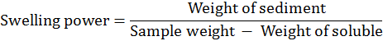 (15)

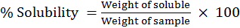% (16)

3.3.9 Determination of water binding capacity
Water binding capacity of yam flour was determined according to the method of Yamazaki (1953) as modified by Medcalf and Gilles (1965). Two grams (dry weight) of yam flour was dissolved in 40ml distilled water to make an aqueous suspension. The suspension was agitated for 1 hour in a Griffin flask shaker and centrifuged at 2200 rpm for 10 min. The free water (supernatant) was decanted from the wet flour, drained for 10 minutes and the wet flour was then weighed. The water binding capacity was calculated by difference using equation (17).
(17)

3.3.10 Determination of pasting characteristics
The pasting characteristic of the flour samples were determined using the Brabender Viscograph instrument (802526 versions 2.3.16). The moisture content of each flour sample was determined with an electronic moisture analyser (Sartorius MA 45). The moisture value obtained was inputted into the software of the Brabender Viscograph, which automatically indicates the weight of flour sample to use and the amount of distilled water to be added to form the slurry. Forty grams of flour (10% moisture level) were mixed with 420ml of distilled water in a sample canister. The sample was thoroughly mixed and the slurry set into a stainless steel canister of the instrument and heated at a rate of 1.5 ºC/min by means of a thermo-regulator at a speed of 75 rpm. The initial temperature was 50 ºC and when the suspension attained 95 ºC, the suspension was held constant for 15 min (first holding period) as stirring continued. The paste was then cooled to 50 ºC at a rate of 1.5 ºC/ min and held for another 15 min (second holding period). The process lasted for 90 min and the following parameters were read from the print out of the Brabender Viscograph. Corresponding values for pasting temperature, pasting time, peak viscosity (Brabender Units-BU), peak temperature, peak time, viscosity at 95 ºC (BU), viscosity after 15 minutes at 95 ºC (BU), viscosity at 50 ºC (BU), viscosity after 15 minute at 50 ºC (BU), paste stability at 50 ºC (BU), paste stability at 95ºC (BU), setback viscosity (BU) and breakdown viscosity (BU). Paste stability at 95 ºC and paste stability at 50 ºC were calculated as the difference between viscosity at 95 ºC and viscosity after 15 min at 95 ºC and the difference between viscosity at 50 ºC and viscosity after 15 min at 50 ºC respectively.

3.3.11 Determination of amylose and amylopectin contents
The method of Williams et al. (1958) and Juliano and Hicks (1996) was used. It is a colorimetric method in which amylose forms starch iodine complex (dark blue colour) due to its high affinity for iodine. 0.1 g of the flour sample was solubilized with 1 ml of 95% ethanol and 9 ml of 1 N NaOH, and heated in a boiling water bath for 10 min; 1 ml of the extract was made up to 10 ml with distilled water. 0.5 ml of the diluted extract was added to 0.1 ml 1N acetic acid and 0.2 ml iodine solution (0.2 g I +2.0 g 2 KI in 100 ml of distilled water) to develop a dark blue colour. The coloured solution was made up to 10 ml with distilled water and allowed to stand for 20 min for complete colour development. The solution was vortexed and its absorbance was read using a spectrophotometer (Milton Roy Spectronic 601) at 620 nm. Absorbance of standard corn amylose with known amylose concentration was used as reference to estimate the amylose content in the sample using equation (18).
(18)

3.3.12 Determination of mineral content
Mineral analysis was done according to the method of Hunter et al. (1984) and Benton et al. (1990). The flour sample (0.48–0.52 g) was weighed into a clean ceramic crucible. An empty crucible was included as a blank. These were then placed
o in a muffle furnace and heated to 500 C over a period of 2 h. The sample was allowed to turn to ash for another 2 h and cooled. The ashed sample was transferred into 50 ml centrifuge tube and the crucible was subsequently rinsed 3 times with 5 ml distilled water and 5 ml of aqua 62 regia making a total added volume of 20 ml. The sample was vortexed to mix the contents thoroughly and centrifuged at 3000 rpm for 10 min. The supernatant was decanted into micro-vials. Ca, Mg, K, Na, Zn, Cu, Mn, P and Fe were determined using the flame atomic absorption spectrophotometer (Buck
Scientific, Model Buck 205, U.S.A).
3.3.13 Preparation of standard ascorbic acid and indophenol solutions Ascorbic acid was determined according to the method of AOAC 1990. Standard ascorbic acid solution was prepared by weighing fifty milligrams of ascorbic acid into a 50 ml volumetric flask and diluted to volume immediately before use with metaphosphoric acid –acetic acid solution. Metaphosphoric acid –acetic acid solution was prepared by adding 20 ml of acetic acid to 100 ml distilled water in 250 ml beaker. 75g of metaphosphoric acid was then added, and allowed to dissolve. The volume was made up to 250 ml. The Mixture was filtered using fluted filter paper and stored in the refrigerator.
The indophenol solution was also prepared by adding 42 mg of sodium bicarbonate to 50 ml distilled water in a 200 ml beaker and stirred to dissolve completely. Fifty milligram of 2, 6-dichloroindophenol sodium salt was weighed and added to the dissolved solution in the beaker. The mixture was diluted to the 200 ml volume with distilled water. The final solution was then filtered using a filter paper (whatman paper) into an amber bottle and tightly stoppered and stored in the refrigerator.

3.3.14 Determination of vitamin C (ascorbic acid)
Vitamin C content was determined using the Indophenols titration method (AOAC, 1990). Metaphosphoric acid-acetic acid solution (5 ml) was pipetted and added to 2 ml ascorbic acid standard solution in 50 ml Erlenmeyer flasks in triplicates. A burette filled with indophenols solution was titrated against the standard ascorbic solution (V₁ ml) in the Erlenmeyer flask until a distinct rose- pink colour was formed and persisted for more than 5sec. The initial and final readings of the burette were recorded. Blanks were prepared in the same way and the average titre of the indophenol dye used was calculated. 2 g yam sample was added to 5 ml Metaphosphoric acid – acetic acid solution in a 50 ml Erlenmeyer flask and was titrated with the indophenol dye solution (V₂) until a distinct rose-pink colour persisted for more than 5 seconds. This was done in triplicates and the initial and final readings of the burette was taken and used to calculate the average titre of dye used. The ascorbic acid content was calculated using equation (19).
Vitamin C (mg/100 g) = Titre×0.606×100
Wt of sample (19)

3.3.15 Determination of total carbohydrate content
Total carbohydrate was calculated by the difference between 100 and the sum of % moisture, % ash, % crude fat, % crude protein and % crude fibre (Kirk and Sawyer,
1981).

3.3.16 Colour measurement
The colour of the fresh and pre-treated yam flours was measured using a Minolta portable Chroma meter (Minolta Co. Ltd., Model CR 310, Japan). The Hunter Lab colour brightness coordinates, L* measures the lightness value of a colour and ranges from dark at 0 to light at 100. The chromaticity coordinates, a*, measures the red when positive and green when negative, and the chromaticity coordinate, b*, measures yellow when positive and blue when negative (Abano, 2013).

3.4 Statistical Analysis
The data obtained for the various determinations were subjected to a One -way Analysis of Variance (ANOVA) using the Stat Graphics software package (Centurion version XVI). Significant differences were reported at 95% confidence level using Duncan multiple range test. The relationship between drying methods and pretreatment of the aerial yam was determined by the use of Pearson correlation.

3.5 Results and Discussion

3.5.1 Aerial yam flour yield
The flour yield from the oven dried samples ranged between 15.63% and 32.5% with the boiled dried sample obtaining the highest yield (Appendix A). Solar dried samples had a yield, ranging between 12.55% and 31.25%. The boiled samples had the highest yield and the lowest yield was observed on the fresh samples. Boiled samples from the oven and solar drying had the highest yields in each case while the lowest yields were observed for the fresh solar dried sample.

Table 3.1: Flour yield from pre-treated oven and solar dried aerial yam samples
Oven dried Samples | Yield (%) | Solar dried Samples | Yield (%)
Boiled | 32.5 | Boiled | 31.25
Steamed | 18.8 | Steamed | 15.63
Fresh | 20.0 | Fresh | 12.5

The low yield from the steamed sample was in agreement with the findings of Harijiono et al. (2013). They reported similar values in flour yield for blanched purple water yam. They attributed this to the possible evaporation of high moisture content of the tubers during the drying process. They observed that, blanching reduced nutritional values of foods due to leaching of nutrients and degradation by heat. Boiling as a pre-treatment, is recommended for aerial yam flour production due to its highest yield of flour. However consideration should be given to how best the processing method employed is able to maintain the nutritional, mineral and functional properties of the flour. Starch properties may be altered during heating (Kouassi et al., 2010).
The high flour yield of the boiled yam in relation to the other flours (Harijiono et al., 2013) may be attributed to the fact that the yam samples may have absorbed water to increase its bulk via cross-linking reaction probably induced by heat generated by boiling (Table 3.1). This may have increased the stability of the carbohydrates thereby enhancing its resistance to further heat (Nzewi and Egbuonu, 2011). Generally, the percentage flour yields were low and this may be attributed to the high moisture content of aerial yam and the milling method used.
Production of flour is indispensable to the utilization of many root and tuber crops.
This prepares the crops for further processing into various consumer ready products. As a result, the yield of flour produced is very important as it provides a measure of how much end product can be obtained after processing. This information is vital for industrial applications and scaling up of production as it ensures the economic utilization of resources.

3.5.2 Effect of pre-treatments, processing (boiling, steaming) and drying on the proximate composition of the aerial yam flour
The effect of pre-treatment and drying on the quality of aerial yam flour were determined. The proximate composition of the flour was determined after steaming, boiling, and subsequently drying with solar and oven methods. The percentage compositions of the various samples are presented in Table 3.2.
Drying reduced moisture content significantly with the oven dried samples having the lowest moisture content ranging between 8.77 and 9.90% for the fresh (control) and steamed respectively, while the moisture content for the solar dried flours ranged between 10.03 and 10.94% for the steamed and boiled respectively. There was no significant difference between the steamed flours for both drying methods while differences existed between the flours for steamed oven dried and fresh oven dried flour. The observed differences between the oven dried and solar dried flours in general could be as a result of the high and constant temperature (60 °C) in the oven than was for the solar dryer (32 °C). Oven drying significantly (p < 0.05) affected the moisture content of the yam flour. Pierre (1989) reported that, the lower the moisture content of a sample, the better the efficiency of the drying method. There were significant differences between the moisture contents of the pre-treated samples and the fresh samples under both drying methods. This observation agrees with the findings of Greve et al. (1994) and Waldron et al. (2003) who reported that cells lose their wall integrity when blanched with steam and thus bound water is lost faster than in un-blanched samples.
Moisture contents of the pre-treated yam flours were below 11.00% which implies it can be stored for longer periods. Moisture level is essential for storage of flour and values higher than 12% facilitate microbial growth. Therefore low levels are favourable and give a relatively longer shelf life (Aryee et al., 2006). The pre-treated flours were significantly higher in moisture content than the fresh yam flour. This trend was confirmed in studies by Adepoju (2012) who reported higher moisture content values for boiled D. rotundata flour (62.3%) and lower values for fresh D.
Rotundata flour (58.8%).

Table 3.2: Effect of pre-treatment, oven and sun drying on proximate composition of aerial yam (Dry Basis)
Sample | Moisture (%)  Wet Dry Basis |  | Ash (%) | Protein (%) | Fat (%) | Fibre (%) | Carbohydrate (%)
DBBS | - | 10.94±0.16^{b} | 3.23±0.04^{c} | 1.17±0.12^{bc} | 1.17±0.25^{bc} | 2.17±0.14ª | 81.31±0.23^{d}
DBFS | - | 10.57±0.31^{b} | 3.43±0.15^{b} | 1.28±0.03^{b} | 0.96±0.08^{c} | 0.94±0.07e | 82.81±0.31^{bc}
DBSS | - | 10.03±0.08^{c} | 3.72±0.02ª | 1.91±0.51ª | 1.40±0.28^{b} | 2.17±0.05ª | 80.77±0.65^{d}
DBSO | 68.79±0.89^{b} | 9.90±0.06^{c} | 3.23±0.09^{c} | 1.31±0.25^{b} | 1.77±0.24ª | 1.49±0.12^{c} | 82.30±0.65^{c}
DBBO | 72.46±2.33ª | 9.36±0.17^{d} | 3.06±0.14^{cd} | 1.17±0.02^{bc} | 0.49±0.13^{d} | 1.87±0.17^{b} | 84.06±0.27ª
DBFO | 68.92±0.74^{b} | 8.77±0.51e | 2.97±0.04^{d} | 1.33±0.04^{b} | 1.45±0.18^{ab} | 1.25±0.07^{d} | 84.23±0.62ª
Samples with same letters are not significantly different (p<0.05) DBBS= boiled solar dried, DBSS, = steamed solar dried, DBFS= fresh (control) solar dried, DBBO= boiled oven dried, DBSO= steamed oven dried and DBFO= fresh oven (control) dried.

56

The moisture content on wet basis ranged between 68.92% and 72.46% with the boiled flour having the highest value and the fresh the lowest. This observation may be due to the boiled samples imbibing water during the boiling process.
The ash content reflects the total minerals present in the samples. The results showed the solar dried yam flours to be significantly (p<0.05) higher (2.97–3.27%) than the oven dried yam flours (3.23-3.72%) with the exception of boiled solar dried and steamed oven dried yam flours which had the same value of 3.23%. The values obtained for the pre-treated yam flours were all significantly different (p<0.05) and higher than the fresh yam flour. The values observed in this study for the fresh yam flour (0.96 %) are lower than 2.23 % reported by Ezeocha and Ojimelukwe, (2012) for fresh D. dumetorum flour. The observed low values in ash content after boiling may be due to leaching of minerals and thus lowering the amount of essential minerals available in the sample (Ezeocha and Ojimelukwe, 2012). Again, the values obtained for the oven dried yam flour (2.97-3.72%) were higher than the values for D. rotundata and cocoyam as reported in literature (1.105, 1.60%, Agoreyo et al., 2011).
However, the values obtained compared favourably with the value for cocoyam (2.47%) as reported by Ogunlakin et al. (2012).
The results in Table 3.2 showed that solar dried yam flours had relatively higher protein contents (1.17-1.91%) than the oven dried yam flours (1.17-1.33%). The protein content was significantly high (p<0.05) in the steamed solar dried yam flour (1.91%) than the steamed oven dried yam flour (1.31%). With the exception of the boiled yam flours, the steamed flours were found to be comparatively higher in protein content than the fresh yam flour. Among the pre-treatment methods applied, steaming had the least effect while boiling had the highest effect. There were significant differences (p<0.05) between the pre-treated yam flours with steaming exhibiting the least effect. The observation in this study was similar to the observation made by Ezeocha and Ojimelukwe, 2012 for trifoliate yam flour. The trend in both studies showed higher protein values for fresh yam flours than boiled yam flours. The differences observed between the boiled and steamed yam flours may be due to the fact that the steamed yam did not have direct contact with the boiling water so there may be minimal loss of free amino acids as reported (Ezeocha et al., 2012). However, results of both study are contrary to claims made by Onu et al. (2001) that cooking breaks down tannin which is well known to form complexes with protein thereby hindering protein availability and increasing level of proteins after cooking. The variations observed in the different studies could be attributed to differences in species and environmental conditions. Generally with the exception of the steamed solar dried yam flour, there were no significant differences between the protein contents of the yam flours under the two drying methods.
Fats are very necessary to the structure and biological functions of cells and are used as alternative energy source. Yams are generally known to have low fat content
(Ezeocha et al., 2012). The steamed yam flours were found to be significantly (p<0.05) high in fat content than all the other yam flour samples with the steamed oven dried flour being high in fat content than the steamed solar dried flour. The solar dried pre-treated flour samples were significantly higher in fat content (p<0.05) than the fresh yam flour. Fresh yams are generally known to be low in lipid compared with processed flours.
The boiled oven dried yam flour had the least fat content compared with the steamed oven dried and fresh oven dried yam flours. This observation may be explained by the fact that some of the nutrients become soluble in the boiled water which is later discarded reducing their content in the sample (Ezeocha et al., 2012). There is also the possibility of chemical changes resulting in lipid oxidation (Savage et al., 2002). The value obtained for the fresh (0.96 – 1.45%), was however, higher than that reported for D. rotundata (0.60%, Agoreyo et al., 2011) and D. dumetorum (0.71%, Ezeocha et al., 2012). Again, the results of the high fat contents of the oven dried steamed and fresh yam flours are contrary to the results reported by Ofosu (2012) that fat in solar dried yam flours are significantly higher than oven dried yam flour. This observation was only confirmed in the boiled yam flour which recorded fat content of 0.49 and 1.17% for oven and solar dried yam flours respectively.
Crude fibre which constitutes up to half the total dietary fibre represents the portion of food not used up by the body nutritionally, but mainly made up of cellulose. This provides an idea of the dietary fibre which together with lignin is reported to increase bulk stool (Eleazu et al., 2011). All the pre-treated flours were significantly higher (p<0.05) in crude fibre content than the fresh yam flour. Results from this study indicate that aerial yam flour has higher fibre content than those of sweet potato and red cocoyam flours of 0.75 % and 0.50% respectively as reported by Oladebeye et al. (2008). This observation is very important because crude fibre has a useful role in providing roughage that aids digestion (Eva, 1983). Generally, solar dried pre-treated flours exhibited high fibre content values.
Carbohydrate content of the yam flours ranged between 80.77- 82.30 and 81.31 – 84.06% for steamed and boiled flours respectively. However, there was no significant difference (p<0.05) between the fresh yam flour, the steamed and boiled yam flours. Ezeocha et al. (2012) and Onu et al. (2001) in their studies on D. dumetorum reported an increase in carbohydrate levels after boiling. A similar observation was made in this study even though the level of increase was not significant.
Steaming was found to have the least effect on moisture, protein, crude fibre and fat contents of the yam flour while boiling had the highest effect on protein and fat content of the yam flour. The values obtained for crude protein, crude fat, ash and crude fibre for fresh D. bulbifera flour were in close agreement with that reported by other authors (Ezeocha et al., 2012; Osagie, 1992). Fresh yam is low in crude lipid, fibre and protein, moderate in ash content, and high in moisture, carbohydrate and gross energy content. Pre-treatment and processing enhances nutrient availability in processed foods as compared to the fresh (Adejumo et al., 2013).This assertion is in agreement with the observation made by Adejumo et al. (2013) that blanching (pretreatment) resulted in D. rotundata yam flour with better quality attributes than fresh yam flour in terms of its functional properties.

3.5.3 Effect of pre-treatment and drying on mineral and ascorbic acid content of aerial yam flour
The effect of pre-treatment and drying on the aerial yam flour was assessed by evaluating the mineral and ascorbic acid contents of the sample. Mineral content is a measure of the amount of specific inorganic components present within a food material. The concentrations of minerals in tubers in general are influenced by several factors that include environmental, processing methods and genetic factors (White and Broadley, 2005). With respect to environmental factors the mineral content may be influenced by the degree or extent of availability of these minerals in the soil. It is estimated that humans require at least 22 mineral elements for a healthy life (White and Broadley, 2005). Studies have also shown that over 60% of the world‟s population are iron (Fe)-deficient and over 30% are zinc (Zn) deficient (White and
Broadley, 2005; Welch and Graham, 2002). Deficiencies of calcium (Ca), magnesium
(Mg) and copper (Cu) is common in both developed and developing countries (White and Broadley, 2005). These deficiencies may be attributed to the consumption of products with low mineral availability, and more refined foods.
The data in Table 3.3 shows the mineral content for aerial yam. Generally, it implies that aerial yam is a good source of minerals such as calcium, iron, sodium and potassium. The variation in mineral content between the different samples gives general information on the mineral distribution in aerial yam after processing.

Table 3.3: Effect of pre-treatment and drying on mineral and Ascorbic Acid Composition of Aerial yam (mg/100g)
Sample Code | Ascorbic Acid | Phosphorus | Calcium | Iron | Sodium | Potassium
DBBS | 79.33±0.01^{c} | 34.2±0.0173^{d} | 124.6±0.03^{c} | 10.5±0.01ª | 51.7±0.01 d | 1270.8±0.03^{d}
DBSS | 77.78±0.01^{d} | 42.3±0.0040ª | 100.1±0.02^{d} | 8.3±0.00^{d} | 54.4±0.01^{c} | 1358.7±0.05ª
DBFS | 93.55±0.01^{b} | 39.4±0.0023^{b} | 240.2±0.03ª | 9.5±0.00^{bc} | 66.9±0.00ª | 1305.9.0±0.0  5^{c}
DBBO | 105.78±0.0  1 a | 37.10±0.005  2^{c} | 96.6±0.03^{d} | 10.2±0.00ª | 50.0±0.00e | 1314.7±0.03^{b}
DBSO | 79.44±0.01^{c} | 35.8±0.0075^{d} | 149.0±0.03^{b} | 10.2±0.01ª | 55.7±0.01 b | 1026.6±0.05^{f}
DBFO | 53.33±0.01e | 35.7±0.00^{d} | 96.5±0.03^{d} | 9.0±0.01^{c} | 66.9±0.00ª | 1255.0±0.03e
Samples with same letters are not significantly different (p<0.05) DBBS= boiled solar dried, DBSS = steamed solar dried, DBFS= fresh (control) solar dried, DBBO= boiled oven dried, DBSO= steamed oven dried and DBFO= fresh oven (control) dried.

Ascorbic acid is an antioxidant that activates the function of all the cells. It is known to facilitate the absorption of iron in the intestines, provide protection against infections and instrumental in the healing of wounds (Roger, 1999). The results show that the oven dried yam flours had higher ascorbic acid content than the solar dried yam flours. However, there was statistically no difference between the steamed oven dried yam flour (79.44mg/100g) and the boiled solar dried yam flour (79.33mg/100g). The values of ascorbic acid content of the pre-treated yam flours ranged between
77.78–79.44mg/100g (steaming) and 79.33 – 105.78mg/100g (boiling). The study values were higher than the values reported by Okwu and Ndu (2003) for aerial yam. There appears to be an increase in the ascorbic acid content of all the pre-treated yam flours relative to the fresh yam flour, which is surprising as ascorbic acid as well as minerals in general, are known to be water soluble so leaching through boiling was expected to have affected the ascorbic acid content of the yam flours (Adepoju et al., 2010). So far similar observation has not been reported in the literature to support the trend observed in the aerial yam.
Phosphorus is very vital in the production and maintenance of bones and teeth. It also strengthens cell wall and is used to regulate the acid/base balance in the body (FAO, 1987). The phosphorous (P) content of the pre-treated yam flours ranged from 34.2 – 37.10mg/100g (boiling) to 35.8- 42.3mg/100g (steaming). The oven dried yam flours had relatively high P content (35.7 - 42.2mg/100g) than the solar dried yam flours (34.2-42.3mg/100g). The values obtained in this study fall within the range of values reported by Adepoju et al. (2012) for white yam. The P content of the steamed yam flours was high relative to the fresh yam flour (35.7 – 39.4). The P levels in fresh yam flour reported in this study were however lower than those reported by Abara (2011) for fresh tissue of D. bulbifera (64.40 and 150.00 mg/100 g) on wet and dry basis respectively and those from other authors (37.00 and 62.15 mg/100g) (Polycarp et al., 2013). The low P content of the boiled solar dried yam flour is in agreement with the assertion by Adepoju et al. (2010) that leaching of minerals occur during boiling.
Calcium is a very important element necessary in building and maintaining bones and teeth. It also plays a role in blood clotting, nerve conduction and muscle contraction
(FAO/WHO, 2002). Calcium (Ca) content from the study ranged from 96.6 –
124.6mg/100g and 100.1 – 149.0mg/100g for boiled and steamed flours respectively.
The fresh solar dried yam flour was significantly (p<0.05) higher in Ca content than all the pre-treated solar dried yam flours. The significant differences (p<0.05) observed showed steamed and boiled solar dried flours to have low Ca content relative to the fresh solar dried flour. This trend agrees with Adepoju et al. (2010) report. However, the values observed in this study were found to be higher than those reported by Abara (2011) and Abara (2003) for fresh D. bulbifera on wet and dry basis respectively (35.30 mg /100g and 205.60mg/100g and 209.00 mg/100g). The solar dried yam flours showed higher calcium content than the oven dried yam flours except for the steamed oven dried yam flour (149.9mg/100g). Similar trend was reported by Agoreyo et al. (2011) where the calcium content of the solar dried white yam flour was higher than the oven dried yam flour. The variations observed in the calcium content in this study relative to other studies may be due to differences in species, soil composition in which it was grown, planting period and water availability (Abara, 2011). Calcium is important for proper bone and teeth formation however; its presence does not guarantee its availability as its absorption depends on the presence of vitamin D, oxalic and phytic acid (White and Broadley, 2005).
Iron (Fe) has been reported to play an important role as a transport medium for electrons within cells and as an integrated part of important enzyme. Fe content ranged from 8.3 – 10.2mg/100g and 10.2 – 10.5mg/100g for steaming and boiling in that order. The results showed the boiled yam flours have higher Fe content than the steamed and fresh yam flours for both drying methods except for the steamed oven dried yam flour which had the same value as the boiled oven dried yam flour (10.2mg/100g) The Fe content of 8.2 to 10.2 mg/100 g obtained in this study for dry tissue is higher relative to reports from other studies. FAO (1968); (FAO 1972);
Adepoju et al. (2010) (4.1-4.6mg/100g); Eka (1978) and Egbe and Treche (1984) reported levels of 2.00, 1.68 and 1.30 mg/100 g respectively of Fe content in the tissue of D. bulbifera on fresh weight basis. Barquar and Oke (1977) reported 3.46 ppm of iron on dry weight basis in the tissues of aerial yam. The results of this study show the pre-treated yam flours to be higher in Fe content than the fresh yam flour except for the steamed solar dried yam flour with a value of 8.3mg/100g. The Fe values observed in this study fall within the recommended daily allowance of about 10mg/100g for both adults and children (WHO, 2002). These findings therefore suggest that aerial yam may be a major source of dietary iron.
Sodium (Na) content for the pre-treated yam flour was found to be in the range of
50.0 – 51.7 mg/100g and 54.4 – 55.7 mg/100g in the order of boiling and steaming. Significant differences (p<0.05) existed between the pre-treated yam flours and the fresh yam flour. All the pre-treated yam flours had low Na values relative to the fresh yam flour. This indicates that boiling and steaming did affect the Na content of the yam flour. However the difference between the two drying methods for the various flours was minimal. Values within the ranges of 51.7 – 68.4mg/100g and 50.0 – 89.1mg/100g were observed for solar and oven drying respectively. Adepoju (2012) reported higher values of 340.0mg/100g for oven dried yam flour. The Na content observed in this study was low compared to values reported by other authors. Abara (2011) reported a range of 220.00 and 550.00mg/100 g on wet and dry weight basis respectively for the tissue, while Adepoju et al. (2010) reported a range of 270.0 – 510.0mg/100 for D. rotundata. Barquar and Oke (1977) also reported 126.00 mg/100g. Generally, the Na content of yams including aerial yam is low, thus the observed low values obtained in this study. The differences observed in the various samples may be attributed to environmental and soil differences. The recommended daily intake of sodium is 500 mg for adults and 400 mg for children (WHO, 1973). About 700 g of aerial yam is needed to achieve the recommended daily intake of Na.
The potassium (K) content determined range between 1026.6 – 1358.7 mg/100g and 1270.8 – 1314.7 mg/100g in steamed and boiled yam flours respectively. All the pretreatment and drying methods had varying effect on the K content of the various yam flour relative to the fresh yam flour (1255.0 – 1305.9 mg/g). The Boiled oven dried flour was high in the K content while steamed oven dried flour was low. Furthermore, K content was high in the steamed solar dried yam flour and low in the boiled solar dried yam flour, this could be attributed to leaching of nutrients in boiling. From the results, aerial yam is high in potassium and is not adversely affected by the treatments in this study. Lower values have been reported by other authors
(390mg/100g, Adepoju et al., 2010 for white yam; 500.97mg/100g and
611.83mg/100g for boiled and fresh yam flour respectively (Kouassi et al., 2010). The WHO recommended daily intake of potassium is 2000 mg for adult and 1600 mg for children (Abara, 2011). This suggests an intake of a little over 100g yam to achieve the recommended daily requirement. Pre-treatment had varying effects on the mineral content of the dried yam flours.
Generally, with the exception of calcium, iron and potassium oven drying had the least effect on ascorbic acid, phosphorus, and sodium contents of the dried yam flours while solar drying had the least effect on calcium, iron and potassium content of the dried yam flours.

3.5.3.1 Correlation between pre-treatments, drying methods and mineral composition of aerial yam
The result from Table 3.4 indicates that a relationship exist amongst some pretreatment and drying methods against mineral properties of aerial yam. There was a strong positive correlation between fresh solar dried (DBFS) and calcium (Ca) (r
=0.760, P<0.05), DBFS and iron (Fe) (r = 0.760, p<0.05) and steamed solar dried and Potassium (K) (r =0.859, p < 0.05). Implications deduced from the above are that, steaming and solar drying greatly affect the content variations of these minerals during flour production. Steam blanching is reported to result in nutritional losses due to leaching of water soluble vitamins, minerals and amino acids (Morris et al., 2006).

Table 3.4: Correlation between pre-treatments, drying methods and mineral composition of D. bulbifera
 | Vit. C | P | Ca | Fe | Na | K
DBBS | -.213 | -.521 | -.071 | -.130 | -.350 | -.081
Sig | .613 | .186 | .866 | -.759 | .395 | .849
DBSS | -.235 | .446 | -.249 | -.249 | -.266 | .199
Sig | .570 | .268 | .553 | .553 | .524 | .636
DBFS | -.003 | .146 | .760 | .760 | .126 | .031
Sig | .995 | .729 | .028 | .028 | .767 | .941
DBBO | .177 | -.140 | -.274 | -.274 | -.404 | .059
Sig | (0.676) | .742 | .512 | .512 | .321 | .889
DBSO | .211 | -.344 | .104 | .104 | -.225 | .859
Sig | (.616) | .404 | .807 | .807 | .592 | .006
DBFO | .596 | -.412 | -.275 | -.275 | .126 | -.131
Sig | (.119) | .311 | .510 | .510 | .767 | .757
*. Correlation is significant at the 0.05 level (2-tailed). **. Correlation is significant at the 0.01 level (2-tailed).

3.5.4 The effect of pre-treatment and drying on the functional properties of D.bulbifera flour
The functional properties which included swelling power, solubility and water binding capacity were determined from the pre-treated aerial yam flour which was dried using the oven and solar drying methods. The data obtained from these determinations are presented in Table 3.5. The ranges of water binding capacity
(WBC) in the yam flours from fresh, steaming and boiling were 200.41 – 235.11%, 241.03 – 262.10 and 252.43 – 303%. Among the pre-treatment methods used, boiling had the least effect on the WBC of the yam flour relative to the fresh flour but not statistically different (p<0.05) from the other dried yam flours except for the boiled solar dried yam flours. The solar dried yam flours were significantly (p<0.05) high in water binding capacity than the oven dried yam flours.

Table 3.5: Effect of Pre-treatment and drying on functional properties of aerial yam
Sample | Water binding | Solubility | Swelling power | pH
DBBS | 303±47.40ª | 16.54±0.62^{c} | 9.55±0.20^{b} | 5.90±0.01^{c}
DBFS | 200.41±14.57^{c} | 22.01±0.75ª | 10.09±0.06ª | 6.25±0.01^{b}
DBSS | 263.10±9.17^{b} | 19.60±1.83^{b} | 9.87±0.23ª | 5.95±0.01^{c}
DBSO | 241.03±10.86^{b} | 16.25±1.12^{cd} | 9.55±0.17^{b} | 5.93±0.01^{c}
DBBO | 252.43±12.22^{b} | 14.82±0.20^{d} | 9.34±0.17^{b} | 6.04±0.02^{c}
DBFO | 235.11±18.42^{bc} | 20.96±0.33^{ab} | 9.92±0.07ª | 5.90±0.08^{c}
Samples with same letters are not significantly different (p<0.05) DBBS= boiled solar dried, dbss, = steamed solar dried, DBFS= fresh (control) solar dried, DBBO= boiled oven dried, DBSO= steamed oven dried and DBFO= fresh oven (control) dried.
The effect of the pre-treatment methods might have accounted for the differences in the WBC of the various flours. Water binding capacity is very essential in the development of ready to eat foods and so foods with high WBC will assure product cohesiveness (Houson and Ayenor, 2002). High WBC determined for the boiled and steamed flours indicates that cooked samples have higher WBC and implies they can be used in bakery products. This is because higher values increase the unit yield of products. Pomeranz (1991) reported that the higher the WBC, the greater the amount of water needed to make dough of desired quality. According to Baah (2009), differences observed in the various samples may be due to differences in species, ecological effect and tuber maturity.
The swelling power values ranged between 9.34 - 9.55% and 9.55–9.87% for boiling and steaming respectively. The fresh yam samples had a value of 9.92 – 10.09% with solubility index between 20.96 – 22.01%. The swelling power of flour granules is an indication of the extent of associative forces within the granule (Addy, 2012). It is also related to the water absorption index of the starch-based flour during heating (Loss et al., 1981). Like the water binding capacity, solar dried yam flours exhibited high swelling power with the highest values in the fresh dried yam flours and lowest in the boiled dried yam flours. With the exception of the steamed solar dried flour, significant differences existed between all the yam flours. Furthermore there were significant differences between both steamed flours. The pre-treatment and drying methods had varying effects on the swelling power of the yam flours.
The water solubility index reflects the extent of starch degradation (Diosady et al., 1985). The solubility index values ranged between 14.82 – 16.54% and 16.25 – 19.60% for boiling and steaming respectively. Solubility values were relatively higher in the solar dried flours with the highest in the fresh flours and lowest in the boiled flours. Steaming had the least effect on the solubility of the yam flours while differences existed between the two steamed flours. High solubility has been associated with high amylose content which is believed to leach out easily during the swelling process (Soni et al., 1993). This agrees with the findings in this study as most of the yam flour samples that had high solubility values also recorded high amylose content (Tables 3.5 and 3.10).
From the pH determined, both boiling and steaming had high effects. The range of pH in the order fresh, boiled and steamed were 5.90 – 6.25, 5.90 – 6.04 and 5.93 – 5.95 respectively. Solar dried flours were high in pH though not statistically different. All the pre-treatments and drying methods did not have any significant effect on the pH of the flours. The high pH values observed indicates a low level of acidity in the yam flour samples. This implies fermentation was reduced during drying and processing since the pH of the flour ranged from 5.90 – 7.25. The results indicates that, the solar dried, fresh oven dried and boiled solar dried flours are all of good quality with pH in the acceptable wheat flour pH range (6.0 to 6.80). pH of roots and tubers such as cassava and yam of 4 or less indicates appreciable level of fermentation and hence starch breakdown (Jeromy, 2002). Fermentation also gives characteristic aroma; flavour and sour taste to the flour and this makes it less preferred for use in the baking industry.
In conclusion solar drying had the least effect on the functional properties of the various flours while steaming least affected the solubility, swelling power and pH of the flours.

3.5.4.1 Correlation between pre-treatments, drying methods and functional properties of Aerial yam
Correlation analysis (Table 3.6) showed a relationship between some pre-treatment methods, drying methods and functional properties of aerial yam. The results showed a strong positive relationship between boiled solar dried (DBBS) and water binding capacity of D. bulbifera (r = 0.733, p < 0.05). Boiling and solar drying methods resulted in increased water binding capacity of the yam flour. Boiling as stated earlier in 3.7.1, improved the functional properties of the yam flour.

Table 3.6: Correlation between pre-treatments, drying methods and functional properties of Aerial yam
Sample | Water binding | Swelling power | solubility | pH
DBBS | .733* | -.225 | -.271 | -.241
Sig | .039 | .593 | .516 | .565
DBSS | .250 | .208 | .154 | -.204
Sig | .551 | .622 | .716 | .628
DBFS | -.510 | .505 | .489 | .018
Sig | .196 | .202 | .219 | .967
DBBO | .120 | -.508 | -.511 | -.138
Sig | .777 | .198 | .196 | .745
DBSO | -.018 | -.225 | -.312 | -.219
Sig | .966 | .593 | .452 | .603
DBFO | -.090 | .275 | .343 | -.241
Sig | .833 | .509 | .406 | .565
*. Correlation is significant at the 0.05 level (2-tailed). **. Correlation is significant at the 0.01 level (2-tailed).

3.5.5 Effect of pre-treatment and drying on pasting properties of Aerial yam flour
The results of the effect of pre-treatment and drying on the pasting properties of aerial yam flour is presented in Table 3.7. Pasting properties of flour are reported to be essential indices in predicting the pasting behaviour during and after cooking (Richard, 1991 cited by Ogunlankin et al., 2012). They are the most commonly assessed set of quality characteristics possibly because the methods are well established and have been proven to be a reliable predictor of flour quality (Eke-
Ejiofor and Owuno, 2012).

Table 3.7: Effect of pre-treatment and drying on pasting properties of D. bulbifera
Samples | Pasting  Temperature  (ºC) | Pasting  Time  (min) | Peak  Viscosity(PV)  (BU) | Final  Viscosity(FV)  (BU) | Holding  Strength(HS)  (BU) | Break down  Viscosity(BV)  (BU) | Setback  Viscosity(SV)  (BU)
DBBO  DBFO  DBSO  DBBS  DBFS  DBSS | 86.20ª  85.50ª  94.80ª  53.0^{b}  90.90ª  74.80^{c} | 25.33^{ab}  24.30^{b}  32.00ª  2.20^{d}  27.85^{ab}  17.10^{c} | 25.00^{c}  57.00^{f}  13.00^{b}  6.50ª  45.50e  35.00^{d} | 0.50ª  46.00^{c}  1.00ª  9.50^{b}  44.50^{c}  5.00ª | 11.50^{b}  57.00e  14.00^{b}  6.50ª  45.50^{d}  23.00^{c} | 13.50^{b}  0.00ª  -1.00ª  0.00ª  0.00ª  12.00^{b} | -11.00ª  -11.00ª  -13.00ª  3.00^{c}  -1.00^{bc}  -18.00ª
Means on the same column sharing the same superscript are not significantly different (P<0.05) BU- Brabender Unit Samples with same letters are not significantly different (p<0.05) DBBS= boiled solar dried, DBSS, = steamed solar dried, DBFS= fresh (control) solar dried, DBBO= boiled oven dried, DBSO= steamed oven dried and DBFO= fresh oven (control) dried.

The pasting temperature is the temperature at which the viscosity starts to rise (Swinkels, 1985; Liang and King, 2003). The pasting temperatures of pre-treated yam flours in this study varied significantly at p<0.05, and ranged from 53.0 to 86.20 °C, 89.50 to 91.25 °C and 74.80 to 94.80 °C with boiling pre-treatment having the lowest range and steaming the highest. The pasting temperature was predominantly higher in the oven dried samples with the steamed flour having the highest temperature (94.80 °C) though not significantly (p<0.05) different from the oven dried fresh yam flour with the temperature of 85.50 °C. Boiling was found to have the most effect on the pasting temperature of the yam flour amongst the solar dried samples. This could be due to the initial gelatinization that took place during boiling so the boiled flour did not require high temperature to form a paste. The pasting temperature for all the solar dried samples were statistically different at p<0.05.
Pasting time provides an indication of the minimum time required to cook a given food sample. The boiled solar dried yam flour were cooked for a duration of 2 mm.20 s whereas all the other samples took a longer period Pasting time values ranged between 2.20 to 25.33 min for the boiled yam samples and 17.10 to 32.00 min for steamed yam flour. High values were observed for the oven dried yam flours with the highest in the steamed flour (32.00 min) and lowest value of 24 min 30 s for the fresh flour. There were Significant differences between all the solar dried yam flours, however, no differences were observed between the oven dried flours. The boiled solar dried yam flours had the lowest pasting time of 25.33 min and pasting temperature of 53.0 °C; (initial gelatinisation has taken place therefore pasting time is expected to be shorter than the other flours). This implies it would be most suitable for the production of foods that require shorter processing time.
Peak viscosity indicates the water binding capacity of starch (Moorthy, 2002; Mahasukhonthachat, 2010 in Oke et al., 2013), that is its ability to form a paste. It is measured as the highest value of viscosity attained by the paste during the heating cycle (25-95 °C). The peak viscosity of the flours showed significant differences at p<0.05 with the oven dried flours which had the highest values of 13.00 -57.00 °C. Peak temperature ranged between 6.50 to 25.00 and 13.00 to 35.00 °C were observed for boiled and steamed yam flours respectively and were low relative to the fresh flours for both drying methods. The values observed in this study were lower than the values of 112.38 to 284.82 °C for fresh and cooked trifoliate yam flour as reported by Abiodun et al. (2013) and 79.58 for Dioscorea dumetorum by Eke- Ejiofor and Owuno, (2012).
Peak viscosity observed for the fresh yam flour in this study ranged between 45.50 to 57.00 °C. Increase in viscosity of gelatinised food is said to be more dependent on the starch content of the product (Adeyemi and Beckley, 1986). The differences observed between the study samples and reports by other authors could be due to differences in variety. Aerial yam a known bulbis even though a dioscoreacea is neither a root nor tuber and so may not exhibit the same characteristics as a typical root and tuber. The low starch content reported for the study samples (Table 3.8) indicates that they may not be suitable for products requiring high gel strength and elasticity as high viscosity is an indicator that a sample is high in starch and suitable for high gel strength products (Adebowale et al., 2005).
Final viscosity indicates the ability of the flour to form a firm, visco-elastic paste or gel after cooking and cooling due to re-association of starch molecules (Newport Scientific Applications Manual, 1998). It is the common parameter used to determine the quality of starch-based samples and is the viscosity after cooling cooked paste to 50 °C. Steaming (1.00 to 5.00 BU) had the least effect on the final viscosity of the flour followed by boiling (0.50 to 9.50 BU). The low final viscosities recorded for the study samples indicate their low resistance to shear stress during cooking and cooling. No differences were observed between the two steamed flours though they were significantly different from the fresh yam flours for both drying methods. The treated flours were all different from the fresh flours.
Holding strength measures the ability of starch to remain undisrupted when yam paste is subjected to a long duration of high constant temperature during the process of cooking (Jimoh et al., 2010). Lower holding strength was observed in the boiled (6.50 to 11.50 BU) and steamed (14.00 to 23.00 BU) flours indicating high cooking loss and inferior eating quality whiles higher values were observed for the fresh (46.50 to 57.00 BU) samples indicating low cooking loss and good eating quality (Bhattacharya et al., 1999). Values observed in this study agree with findings of Abiodun et al. (2005), who reported lower holding strength in boiled white trifoliate yam. Samples were subjected to a period of constant high temperature and mechanical shear stress during the holding period which disrupted the starch granules. It has been reported that the capacity of flour samples to withstand heating and shear stress is an important factor for many processes (Newport Scientific manual, 1998). Significant differences (p<0.05) were observed between the pre-treated yam flours in relation to the fresh yam flour. Boiling, steaming and solar drying resulted in lower holding strength of the flours, this could be attributed to gelatinisation.
Breakdown is a measure of susceptibility of cooked starch granules to disintegrate and affect the stability of flour products. This means that, it is able to measure the ability of starch to break down during cooling. The flour samples in this study exhibited low breakdown in viscosity. Significant differences existed in breakdown viscosities of all the pre-treated flours. Boiling had the highest (0.00 to 13.50 BU) and was found to be within the range of 5.85 -78.10 RVU reported for pre-cooked white trifoliate yam flour (Abiodun et al., 2009). However, the values observed in this study for fresh flour samples were lower than values of 21.64 RVU and 69.17- 257.36 RVU reported by Abiodun et al. (2009; 2013) for fresh white trifoliate yam. Low breakdown values in the samples indicate high stability of the yam flour under hot conditions. Adebowale et al. (2005) reported that the higher the breakdown in viscosity, the lower the ability of the sample to withstand heating and shear stress during cooking. This is an important factor for most food processing operations and a factor in describing the quality of starch gels.
Setback is an index of the tendency of the cooked flour to harden on cooling due to amylose retrogradation (Aribisala and Olorunfemi, 1989). It measures the reassociation of starch. The higher the setback value, the higher the retrogradation during cooling. The flour samples in this study exhibited lower setback in viscosity with the least observed in the steamed yam flour for both drying methods. This is indicative of the flours usefulness in the food processing industry as high retrogradation leads to staling in bread quick precipitation and loss of viscosity in sauces (Ikegwu et al., 2010).
Higher values of setback have been reported by other researchers (Abiodun et al., 2013; Eke-Ejiofor and Owuno, 2012). Low setback values observed in the study samples indicate minimal amylose retrogradation as the paste is cooled and indicates its flour is more stable when cooked. The low set back values obtained for D.bulbifera may not make it suitable for pounded fufu that require high cohesive pastes. Conversely, the flours may be useful for products such as weaning foods, which require low viscosity and paste stability at low temperatures (Oduro et al., 2001), It has been reported that pre-cooked flours have lower tendency to retrograde than fresh flours (Abiodun et al., 2013).
Steaming had the least effect on pasting temperature and pasting time and the highest effect on the final viscosity, breakdown and setback. Boiling on the other hand had the least effect on breakdown and setback and the highest effect on pasting temperature, pasting time, peak viscosity and holding strength.
The two drying methods, oven and solar had varying effects on the pasting properties of the yam flours. With the exception of setback viscosity (-13.00 to 5.50 BU), oven drying was observed to have the least effect on temperature (85.50 to 94.80°C) and pasting time (24.30 to 32.00 min), holding strength (11.50 to 57.00 BU), peak (13.00 to 57.00 BU), final (0.50 to 46.00 BU) and breakdown (-1.00 to 13.50 BU) viscosities Conversely, solar drying had the least effect on temperature (53.0 to 90.90°C) and pasting time (17.10 to 27.85 min), holding strength (6.50 to 45.50 BU), peak (6.50 to 45.00 Bu), final (5.00 to 44.5 BU) and breakdown (0.00 to 12.00 BU) viscosities and the highest effect on setback viscosity (-18.00 TO 3.00 BU). Solar drying exhibited lower pasting time and enabled the yam flour to swell faster. Overall solar dried samples required lower temperature and time to cook in relation to the oven dried samples. This implies it would be most suitable for the production of foods that require shorter processing time. In all the pasting parameters measured, solar drying had lower values for all the pre-treated samples except for the breakdown and setback viscosities.

3.7.5.1 Correlation between pre-treatments, drying methods and pasting properties of aerial yam
At the bivariate level, the relationship between pre-treatment, drying and pasting properties were measured using spearman correlation coefficient and its significance was tested using the two tailed test. The result indicated a negative, yet significant relationship between steaming, oven drying and pasting temperature (r= - 0.970, p< 0.000) and steaming, oven drying and Pasting time (r=-0.899, p< 0.002). This may imply that when the yam samples are steamed and oven dried, it requires high temperature and longer time to cook.

Table 3.8: Correlation between pre-treatments, drying methods and pasting properties of D. bulbifera
 | PT | PTi | PV | FV | HS | BV | SV
DBBO | .018 | .101 | -.205 | -.436 | -.406 | .703 | -.152
 | .966 | .811 | .627 | .280 | .318 | .052 | .720
DBFO | -.002 | .059 | .528 | .469 | .547 | -.206 | -.152
 | .997 | .890 | .178 | .242 | .160 | .624 | .720
DBSO | .264 | .377 | -.480 | -.426 | -.354 | -.273 | -.270
 | .528 | .357 | .229 | .292 | .390 | .512 | .518
DBBS | -.970** | -.899** | -.629 | -.257 | -.511 | -.206 | .676
 | .000 | .002 | .095 | .538 | .196 | .624 | .065
DBFS | .152 | .206 | .265 | .439 | .306 | -.206 | .440
 | .719 | .625 | .526 | .277 | .460 | .624 | .275
DBSS | .264 | -.239 | .024 | -.347 | -.165 | .602 | -.566
 | .528 | .569 | .954 | .400 | .696 | .115 | .144

3.5.6 Effect of pre-treatment and drying on amylose and amylopectin content of aerial yam flour
The results of amylose and amylopectin contents of the yam flour are presented in Table 3.9. The pre-treatment methods had different effect on the amylose and amylopectin contents of the yam flour. While fresh yam flour had the highest amylose content (29.5-30.0 %), steamed solar dried flour had the lowest (25.0 %). Fresh yam had the highest amylose content followed by the boiled and steamed yam samples respectively. Lower amylose contents were observed for both boiled and steamed flours. The results agreed with observation by Harijono et al. (2013) in water yam, that blanched yam had lower amylose content than the unblanched. Blanching in tuber processing in general, is reported to decrease water soluble content such as starch due to leaching (Harijono et al., 2013). The amylopectin content ranged from
72.0 to 73.5% and 71.5 to 75.0% for the boiled and steamed yam samples
respectively.
Yam flours generally have higher amylose contents than those from other root and tuber crops (Baah et al., 2009). Amylose values of between 27.6 and 39.4% for D. alata have been reported by other researchers (Hoover, 2001; Peroni, Rocha et al., 2006). Sahorè et al. (2005) obtained amylose content of 2.32 and more than 25% for wild yam species.

Table: 3.9: Amylose and Amylopectin content (%) of flours from D. bulbifera
Sample | Amylose (%) | Amylopectin (%) | Amylose/Amylopectin Ratio
DBFO | 30.0 | 70.0 | 0.43
DBBO | 26.5 | 73.5 | 0.36
DBSO | 28.5 | 71.5 | 0.40
DBFS | 29.5 | 70.5 | 0.42
DBBS | 28.0 | 72.0 | 0.39
DBSS | 25.0 | 75.0 | 0.33
DBBS= Dioscorea Bulbifera boiled solar dried, DBSS, = steamed solar dried, DBFS= fresh (control) solar dried, DBBO= boiled oven dried, DBSO= steamed oven dried and DBFO= fresh oven (control)
dried.
Amylose content of starch affects its swelling and hot paste viscosities (Shimelis et al., 2006). As the amylose content increases, the swelling tends to be restricted and hot paste viscosity stabilizes (Schoch and Maywald, 1968). Ikegwu et al. (2010) reported that amylose content of flour and other component present has a bearing on pasting properties. Amylose content of yam starch is reported to be between 14-30% depending on the species. Moorthy (2002) reported amylose content of 21.25% for D. rotundata, 21-25% for D. cayenensis, and 21-30% for D. alata. The amylose contents are in good agreement with values reported by other authors. The study has shown that the drying methods had effect on the chemical composition of the dried yam due to the disruption of the cellular/granular structure within the amorphous and crystalline domain by the different drying methods and these may have caused the differences in amylose and amylopectin content of the yam samples. This effect might have enhanced strong bond formation and increased the interaction between the water molecules thus facilitating the release of amylose.

3.5.7 Effect of pre-treatment and drying on the colour of the Dioscorea bulbifera flour
Colour is an important standard for starch quality especially for utilisation in the textile industries. It is one of the most important criteria of food and brightness, an essential indicator for many powders. Brightness of powder may be an indicator of its freshness or purity (Abano et al., 2011). The development of colour due to enzymatic and non-enzymatic browning is one of the major problems that occur during processing of food materials.
The results of the colour parameters obtained from the oven and solar drying processes of various pre-treatments are presented in Table 3.10. The pre-treatments had varying effects on the colour of the flour. Boiling and steaming pre-treatments, had significant effect on the brightness of the flour as indicated by the high L* values. While steaming had the least effect maintaining a more whitish colour of the flour, boiling had the highest effect. This implies that, steamed yam flour had a higher white intensity compared to the other samples with the exception of the fresh yam flour which showed a higher L value than all the samples. The range of colour (L*) values in the order of fresh, boiling and steaming were, 75.71 – 77.69 %, 66.67 – 76.78 % and 70.85 – 73.10 %. The boiled yam flour exhibited the highest yellowness as indicated by the b value (16.45 – 20.14%). The pre-treatment methods had significant effect (P < 0.05) on the L values of all the yam flour samples. The a* and b* values varied significantly (P < 0.05) among the samples under the different pre-treatment methods. Steamed (70.85-73.10%) and boiled flours (66.67-76.78%) showed lower L* values relative to the fresh flour 75.3-77.69%). The light/white colour or appearance of the yam flour samples may be due to the effect of the pre-treatment methods on enzymatic/microbial activity. The various pre-treatment methods had significant (p < 0.05) effects on the colour of the yam flour samples.

Table 3.10: Effect of pre-treatment and drying on the colour of the Dioscorea bulbifera flour (%)
Oven | L* | a* | b* | Solar | L* | a* | b*
Fresh | 77.69  ΔL= 1.82 | -0.45 ΔL= 0.16 | +19.14  ΔL=-17.24 | Fresh | 75.71 ΔL=+2.18 | +1.22 ΔL=-  0.93 | +18.30  ΔL=-16.4
Boiled | 76.78 ΔL=+20.73 | -2.71 ΔL=2.42 | +20.14  ΔL=-18.24 | Boiled | 66.67 ΔL=+30.84 | +1.75 ΔL=-  1.46 | +16.45  ΔL=-14.55
Steamed | 73.10 ΔL=+24.41 | -1.38 ΔL=1.09 | +17.91  ΔL=-16.01 | Steamed | 70.85 ΔL=+26.66 | +1.01 ΔL=-  0.72 | +17.08  ΔL=-15.18
L axis indicates Lightness/darkness on a scale of 100/0, a axis indicates Red (+values)/green (-values), b axis indicates Yellow (+values)/blue (-values) -ΔL: standard is lighter than sample +Δa: sample is redder than standard +Δb: sample is yellower than standard. Calibration (standards): L=97.51, a=+0.29 and b=+1.90.

The oven dried flours showed high L* and b* values than the solar dried flours while it had low b values relative to the solar dried flours.

3.6 Conclusion
Pre-treatment(boiling and steaming) and drying methods (oven and solar) had varying effects on the proximate, mineral, ascorbic acid, functional and pasting properties of the aerial yam flour. The oven and solar drying methods showed significant effects on the amylose and colour attributes of the yam flour. Oven drying significantly affected the brightness of the flour as indicated by the higher L* value for the oven dried samples. The positive a* and b * values obtained for solar dried flours indicated a reddish and yellowish colour respectively. The b values for the oven and solar dried flours were significantly different (p< 0.05).
None of the flour samples had L* values comparable to commercial flours (L* value of 92.5). However it is important to note that the aerial yam has a characteristic yellow colour and any reduction in its b value (yellow intensity) could be attributed to bleaching as in the case of the steamed and boiled yam flour samples.
CHAPTER 4
SIZE AND TEMPERATURE EEFECT ON THE DRYING
CHARACTERISTICS OF AERIAL YAM

4.1 Introduction
Preliminary studies in Chapter Three has established that pre-treatment and type of drying method used affected the yield, nutritional and functional characteristics of the aerial yam flour production. The findings from the pasting characteristic study have also shown the potential usage of the flour in food product development. Thus, it is clear from this initial study that value addition and shelf life of the aerial yam can be done through flour production which becomes one of the first steps in the commercialization of this yam since it is one of the highly underutilised food crops.
Aerial yam as observed has the tendency to discolour during drying; this may be attributed to the action of polyphenol oxidase (Ayim et al., 2012). There are a number of pre-treatments to mitigate this action some of which include sulphating, blanching and boiling (Ayim et al., 2012). These pre-treatments do have influence on drying time and energy requirements of the products during drying (Falade et al., 2007). To be able to transform the yam into a commercial flour product, it is essential to establish optimum conditions necessary for effective flour production. This requires investigation into the drying characteristics of this yam.

4.2 Materials and Methods

4.2.1 Materials
Aerial yams were obtained from farmers in the Northern Region of Ghana from which bulbis were randomly selected for analysis. Yams (20grams) were washed with 4L of distilled water, and manually peeled and cut with a sharp stainless steel knife into slabs having dimensions of 0.5cm×1cm×2cm, and 1cm×1cm×2cm. The slabs of the different dimensions were divided into two parts with one part each boiled at 100 °C for 10 min. They were quickly cooled with cold water and the surface moisture allowed to drain off in a colander. The other portions were kept fresh and used as control. Two grams each of the boiled and fresh samples of different thickness were arranged in stainless steel mesh trays of dimension of 10cm × 7cm and transferred into the fixed bed dryer (Plate 4.1).

4.2.2 Drying equipment and drying process
The fixed bed dryer designed and fabricated at the Department of Agricultural
Engineering, Kwame Nkrumah University of Science and Technology, Kumasi, Ghana. It has an electric fan that blows air over a 1800 w heating element. Prior to start of experiment it was switched on and allowed to run for approximately one hour prior to loading of samples to allow the heated air to stabilize at desired temperatures of 50, 60 and 70 °C respectively. The loaded pre-weighed yam samples were removed and weighed with an electronic balance; Sartorius model CPA 6235 to 0.01g precision at 30 min intervals until three consecutive constant readings were obtained. The process was conducted in triplicates and average values recorded. The average moisture ratio was used to plot the drying characteristics curves for the temperature range studied with dimensionless moisture ratio against drying time.
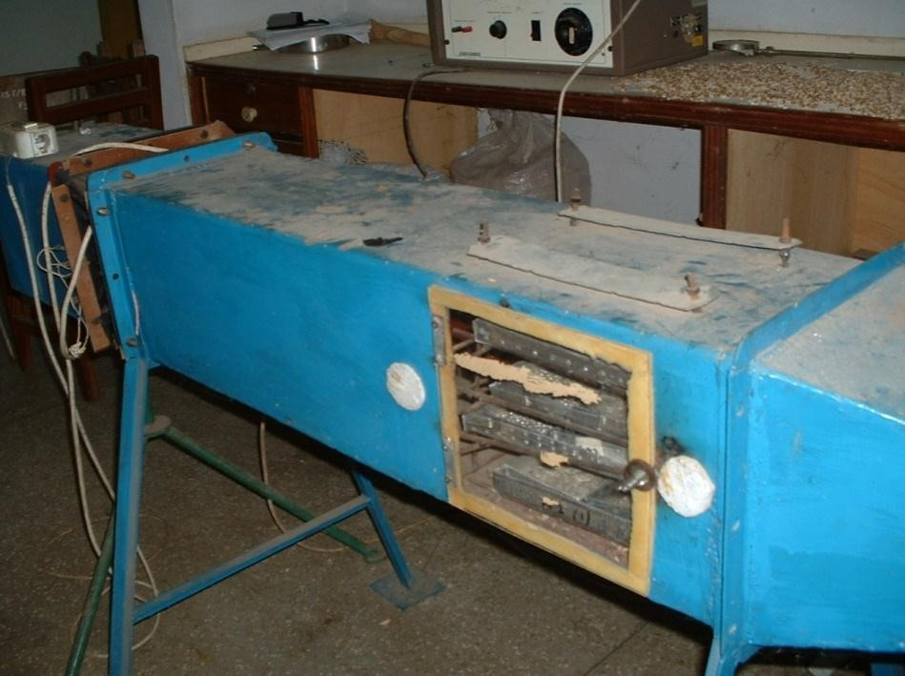
Plate 4.1: Fixed bed dryer or tray dryer (static dryer)

4.2.3 Experimental Design and Statistical Analysis
A 2×2×3 full factorial design was used to design the drying experiments. In this study, two levels of sample thickness (0.5 and 1.0 cm), two levels of treatment (boiled and fresh) and three levels of air drying temperature (50, 60, 70 ºC) were generated. The data generated was analysed using the statistical package programme, QtiPlot 0.9.8.8 Svn 2255 (2004-2011) and Curve Expert Professional 2.0. (Hyams, 2010).
Significance was accepted at P <0.05. Analysis was carried out in three replicates.

4.2.4 Drying characteristics expressed in terms of empirical models
The drying characteristics of the yam slabs was expressed in terms of empirical models, where the experimental data obtained for the three different temperatures (50, 60 and 70°C) were plotted in the form of dimensionless moisture ratio (MR) against drying time expressed in minutes. The equations used to establish drying
characteristics are shown in 20 to 21:
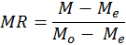 (20)

where, MR is the moisture ratio (-), is the equilibrium moisture content (-), and M_{o} is the initial moisture content (%)
The drying rate of the yam slabs were calculated using Eq. 4.2 (Doymaz, 2010), where
M_{t + dt} is the moisture content (kg water kg dry matter) at t + dt, and t is the drying time (min).
(21)

4.3 Results and Discussion

4.3.1 Influence of thickness and temperature on the drying characteristics of the Aerial yam

4.3.1.1 The influence of different thickness and boiling on drying time of aerial yam at 70°C
The aerial yam was dried at 10°C intervals from 50°C to 70°C to investigate the effect of thickness and temperature on the drying characteristics of D. bulbifera. The effect of temperature and thickness (0.5cm, 1.0cm) on drying time presented in Fig.4.1 showed that decreasing thickness resulted in increase in the rate of mass loss. The total drying time was reduced with decrease in thickness.
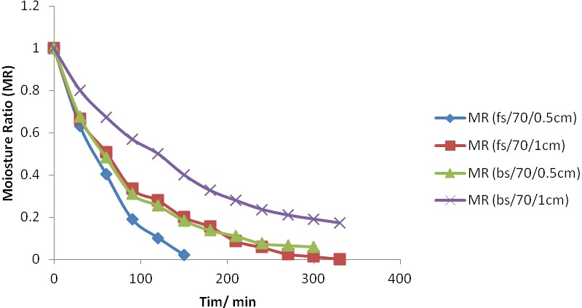

Figure 4.1: Moisture ratio as a function of drying time for boiled and fresh
samples of 0.5cm and 1cm thickness at 70°C
Fs/70/0.5cm= 0.5cm thick fresh yam dried at70°C, Fs/70/1cm=1cm thick fresh yam dried at 70°C, Bs/70/0.5cm= 0.5cm thick boiled yam dried @70°C and Bs/70/1cm= 1cm thick boiled yam dried at70°C

The moisture ratio versus pre-treatment (boiling) and drying time at various thicknesses of the fresh samples at 70°C are shown in fig. 4.1 Sample thickness of 0.5cm took a shorter time to dry than the sample of 1cm thickness. From the drying curve, the results indicated that, the thickness of the pre-treated (boiled) samples influenced drying time for both the boiled and fresh samples. The boiled sample of
0.5cm thickness took a shorter time to dry as compared with the fresh sample of 0.5cm thickness. The same trend was observed for 1cm thickness. For both boiled and fresh samples, dried at 70°C, thickness greatly influenced drying time.
At drying temperature 70°C, boiling had great influence on drying time. The boiled samples of both thicknesses of 0.5cm and 1cm had longer drying times compared with the fresh samples at the same thicknesses. This is to be expected as pre-treatment increases the resistance to moisture transport thereby increasing the drying time (Dinrifo, 2012). Boiling and blanching cause gelatinization of yam starches which results in decreased rate of moisture transport from within the material to the surface during air drying (Falade et al., 2007). This result agrees with the findings of Alzamora and Chirife (1980) who reported that blanching of potato decreased the rate of drying due to starch gelatinisation resulting in reduced porosity (Mate et al., 1998).

4.3.1.2 The influence of thickness and boiling on drying time of aerial yam at 60°C
Figure 4.2 shows the drying curves for fresh and boiled yam slices dried at 60°C. Drying time increased with increase in thickness of the fresh samples. The same trend was observed in the boiled samples, increase in thickness influenced drying time which resulted in high moisture ratio for sample thickness of 1cm. This situation implies that increase in thickness will require more time to reduce moisture ratio to the required 10%.
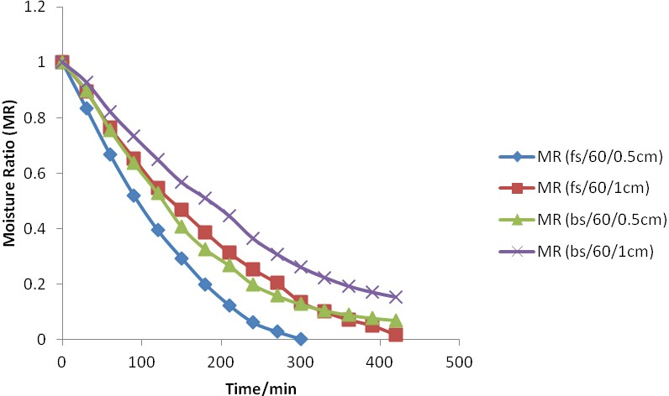

Figure 4.2: Moisture ratio as a function of drying time for boiled and fresh
samples of 0.5cm and 1cm thickness at 60°C
Fs/60/0.5cm= 0.5cm thick fresh yam dried at °C, Fs/60/1cm=1cm thick fresh yam dried at 60°C, Bs/60/0.5cm= 0.5cm thick boiled yam dried at 60°C and Bs/60/1cm= 1cm thick boiled yam dried at 60°C

This trend could be attributed to the fact that boiling increases the drying time due to gelatinisation of the yam starch. From fig. 4.2, it is obvious that increase in thickness of sample size resulted in increase in moisture ratio for the boiled samples thereby drying time is increased.
From the drying curve, sample with 0.5 and 1cm thicknesses exhibited the same drying time of 420 min and moisture ratio range between 7-18%. This result is contrary to that reported by Falade et al. (2007) for Dioscorea rotundata and alata. They reported a decrease in moisture ratio and drying rate as the thickness of the yam slices increased. They attributed it to the effect of larger exposed surface area resulting in increased diffusion path of the yam slices. The variations could be attributed to difference in specie and thickness.

4.3.1.3 The influence of thickness and boiling on drying time of D. bulbifera at 50°C
The influence of thickness and boiling on drying rate of D. bulbifera are presented in Fig. 4.3. It is observed from the drying curve that fresh samples of 0.5cm thickness had faster drying time than the fresh samples of 1cm thickness. Similar trend was observed in the boiled samples. On the other hand, fresh samples of 0.5cm had faster drying time than boiled samples of the same thickness, the same trend observed for sample thickness of 1cm. The time required to dry yam slabs to specific moisture is influenced by the thickness being fastest with the 0.5cm and longest with 1cm. Moreover, drying time increased with increased thickness of yam slabs. The results indicated that boiling decreased the rate of moisture movement which resulted in increased drying time as observed in the treatment.
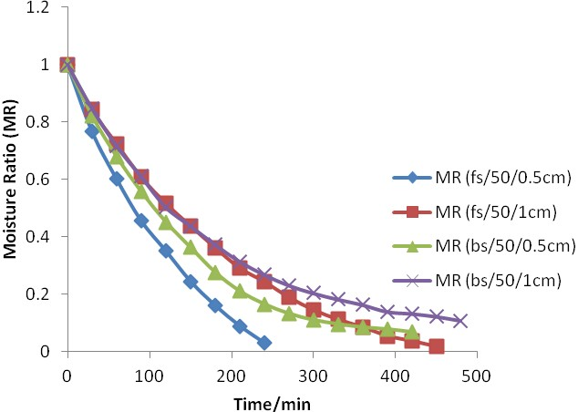
Figure 4.3: Moisture ratio as a function of drying time for boiled and fresh
samples of 0.5cm and 1cm tickness at 50°C

4.3.2 The influence of temperature on drying time of aerial yam at different thickness

4.3.2.1 The influence of temperature on drying time of aerial yam at 0.5cm thickness
The influence of different temperatures 50, 60 and 70°C on drying time is shown in Figure 4.4. Increasing temperature resulted in improvement of the rate of moisture loss and significant decrease in total drying time. The drying time of the fresh aerial yam slabs at 70°C was twice as fast as that at 60°C and five times compared to 50°C. Decreasing drying time of around 150 min with increasing 10°C was observed within this temperature range except for the slightly lower difference for the case of drying at 50°C. The drying time was lower for 50°C compared to 60°C. This phenomenon could be attributed to surface or case hardening due to quicker initial rate of evaporation of moisture from the sample surface. Case hardening may have slowed down drying rates of yam slabs at higher dry air temperature than at the lower temperature of 50°C.
It was observed from figure 4.4 for boiled yam slabs that, as the temperature increases, the drying time decreased. The drying time of the boiled yam slabs at 70°C was shorter by 120 min compared to yam slabs dried at 60°C and 50°C temperatures. The same drying time recorded for both yam slabs dried at 50°C and 60°C may be attributed to the case hardening effect as observed for the fresh yam slabs. In the falling rate period, the concentration gradient in the food matrix controls the drying rate and is temperature dependent (Falade et al., 2007). This may account for the difference in drying time between the boiled and fresh yam slabs and between 70°C and the two lower temperatures of 60 and 50°C. From the figure, it is obvious that differences of drying rate between 70 and the two lower temperatures occurred in the early stage of drying within the first thirty minutes. The differences especially between 60°C and 50°C then gradually decreased to the point when the drying times were equal. Drying time to obtain equal moisture ratio for all the yam slabs decreased with increasing temperatures most evident with 70°C drying air temperature.
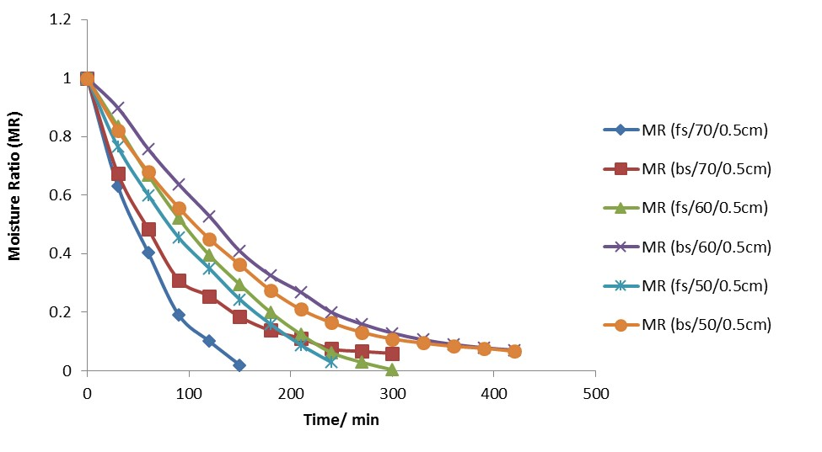

Figure 4.4: Drying curve of 0.5cm thickness of boiled and fresh D. bulbifera at
various drying air temperatures.
From figure 4.5, the influence of drying temperature on drying time can be clearly observed. The fresh yam slabs dried at 70°C took 210mins to reach a moisture ratio of 8.7% on dry basis. Whiles it took the yam slabs dried at 60°C 330min to reach a moisture ratio of 10% (d.b) and 360mins for slabs dried at 50°C to reach a moisture ratio of 10% (d..b).
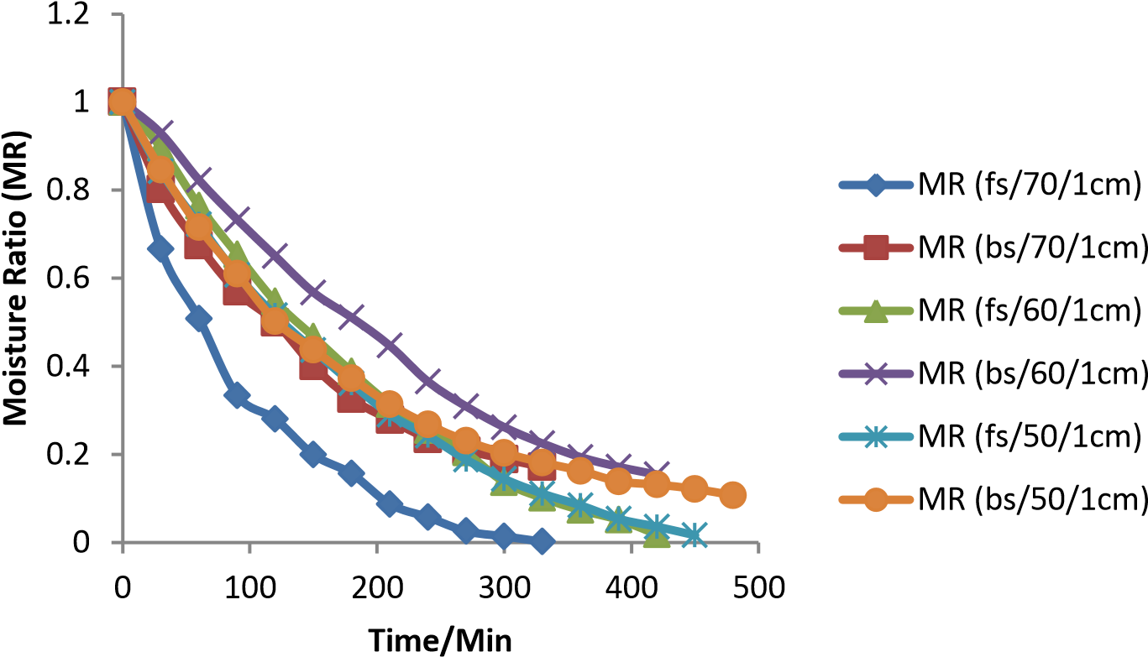

Figure 4.5: Moisture ratio as a function of drying time of 1 cm thickness of boiled
and fresh D. bulbifera at various drying air temperatures
The same trend was observed in the boiled yam slabs where higher temperatures resulted in shorter drying times though the moisture ratio for 70 and 60°C were higher than 10% required moisture content for roots and tubers. This may be attributed to gelatinisation of the starch molecules thereby inhibiting the free movement of moisture from the sample. However, the yam slabs dried at 50°C had moisture ratio of 10% (d.b) when it was dried for 480 min. This could imply that if the boiled slabs dried at 70 and 60°C had been dried further, it may have resulted in 10% moisture
ratio.
A slight constant rate period was observed for all the graphs, generally, drying took place in the falling rate period as have been recorded in literature for different crops (Hii et al., 2008; Taheri-Garvand, 2011). These results will provide food processors with information to determine the best processing conditions for the dioscorea bulbifera and finally eliminate wastage.

4.4 Conclusion
The study showed that short constant rate period was observed for all the drying curves. Generally, drying took place in the falling rate period as have been recorded in literature for different crops (Hii et al., 2008; Taheri-Garvand, 2011). Increasing slab thickness influenced drying time for both the boiled and fresh samples at all temperatures, whiles boiling as a pre-treatment decreased the rate of moisture movement which also resulted in increased drying time.
CHAPTER 5
MODELLING OF THE DRYING CHARACTERISTICS OF THE AERIAL
YAM

5.1 Introduction
Aerial yam which is also known as air potatoes is a member of the yam species often considered as a wild species of yam native to Africa and Asia. It is among one of the most underutilized food crops in Ghana and other parts of the world where it grows and appears in both the wild and edible forms. Unlike the other yam species, aerial yam has a long vine and produces tubers (bulbis) which grow at the base of its leaves. This species of yam is not popular among farmers or consumers and does not enjoy the patronage that some of the other edible yam species enjoy. Despite it underutilization, aerial yam has been shown to possess a myriad of compounds that have also been attributed to several health benefits (Azeem et al., 2013; Panduraju et al., 2010; Suriyavathana and Indupriya, 2011).This species of yam has certain advantages that go beyond its health conferring abilities. It is very easy to grow under even harsh conditions and this presents an opportunity to have a reliable food source all year round.
Drying is a highly energy intensive unit operation in the food industry, where it is necessary to maintain food product quality during drying in addition to reducing cost. Some products can be very high valued such as mango, strawberry and some marine products; even highly expensive freeze drying can also be used for these products with enough profit margins. However, products such as roots and tubers and vegetables cannot be dried using such expensive drying process. It has therefore become very necessary to develop cost-effective and innovative drying methods in the food industry (Jangam et al., 2010).
Drying kinetics of food crops are generally affected by factors including drying temperature, pre-treatment method, relative humidity, and product sizes (Kudra, 2004; Ade-Omowaye et al., 2002) and are crop specific.
The flesh of aerial yam is usually white but the colour of the flour ranges from cream to brown due to enzymatic browning. Pre-treatment like boiling which can be used to minimise enzymatic browning have been shown to influence drying characteristics and energy requirements during drying (Falade et al., 2007). So far, there are no studies on the influence of pre-treatment on the energy requirements during drying of the aerial yam. Many authors studied the air drying characteristics and calculated the moisture diffusion and activation energy of agricultural produce (Akpinar et al., 2003; Babalis and Belessiotis, 2004; Goyal et al., 2007). The objective of this study therefore was to investigate the modelling and effects of boiling on the activation energy and moisture diffusivity of the aerial yam.

5.2 Materials and Methods

5.2.1 Materials
The aerial yam used in this study was obtained from a farmer in the Northern region of Ghana. The samples were prepared as described in section 4.2.1.

5.2.2 Modelling of the experimental data
To determine the drying model, the experimental moisture ratio data were fitted to 12 thin – layer drying models widely used in scientific literature as represented in Table 5.1 to describe the drying rate of the yam slabs. The non-linear regression analysis was performed with the statistical package program, QtiPlot and professional curve expert version 2.0 (Hyams, 2010). According to Erbay and Icier (2008), regression and correlation analysis are very useful tools in modelling the drying behaviour of biological materials. Determination of the best fit was done using higher values of coefficient of determination (R²), and the lowest values of root mean square error
(RMSE) and the reduced chi square (χ²). The different statistical evaluation equations to describe the goodness of the fit of the dried yam slabs are as follows:
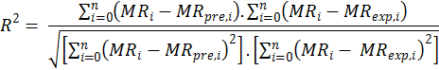 (21)

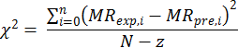
(22)

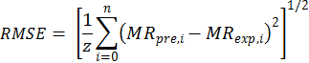 (23) Table 5.1 Mathematical Models applied to the Experimental data
Model name | Model expression | Reference
Verma et al | MR = a exp(-kt)+(1-a)exp(-gt) | Dadali et al. (2007)
Wang and Sing | MR = 1 +at+bt² | Demir et al. (2007)
Henderson and Pabis | MR = aexp(-kt)+c | Henderson and Pabis,  1961
Page | MR = exp (-kt)^{n} | Zhang and Litchfield  (1991)
Parabolic | MR =c + bt + at² | Sharma and Prasad (2001)
Diffusion Approach | MR=aexp(-kt)+(1-a)exp(-kbt) | Yaldiz and Ertekin, (2001)
Logarithmic | MR = aexp(-kt)+c | McMinn, (2006)
Midilli et al | MR = aexp(-kt^{n})+bt | Midilli et al. (2002)
SimplifiedFicks  Diffusion | MR=aexp(-kt)+c | Babalis et al. (2004)
Modified Page I | MR = aexp(-(kt)^{n}) | Akpinar and Bicer (2006
Modified Page II | MR=exp(-k(t/L²)^{n})
Newton | MR = exp(-kt) | Ayensu (1997)

5.2.3 Determination of effective moisture diffusivity and activation energy
The effective moisture diffusivity of the samples was estimated by using the simplified mathematical Fick‟s second diffusion model (Babalis et al., 2004)
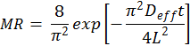
(24)

The activation energy of the samples was obtained by plotting the natural logarithm of D_{eff} against the reciprocal of absolute temperature, then determining the slope of the straight line by using the following equation 3.7 (Falade et al., 2007).
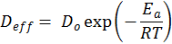
(25)

5.2.4 Statistical analysis
Non – linear regression analysis was performed to fit the models using QtiPlot and
Curve Expert Professional 2.0.

5.3 Results and Discussion

5.3.1 Modelling of the Drying Curves
The dimensionless moisture ratio against drying time for the experimental data at various air temperatures was fitted to the various models; Page, Midilli et al., Wang and Singh, Henderson and Pabis, Verma et al., Parabolic, Diffusion Approach, Logarithmic, Simplified Ficks Diffusion, Modified Page I, Modified Page II and Newton drying models available in literature. The coefficient of determination (R²), residual mean square error (RMSE), and Chi-square (χ²) were determined as the primary criteria for determining the goodness of the fit for the drying data. The coefficient of determination (R²) serves as a measure of the closeness of the relation to linearity, while the RMSE and χ² represent the deviation between the predicted and experimental values.
The residual sum of squares (RSS) is a measure of the discrepancy between the data and an estimated model. A small RSS indicates a tight fit of the model to the data.
Due to this, the best model shows the highest R², while the RMSE and χ² approaches zero (Berger, 1980; Panchariya et al., 2002).The results of such fitting of the experimental data for the fresh samples of 0.5 cm thickness dried at 50 °C, 60 °C and 70 °C are displayed in Table 5.2 which showed the values of the estimated constants with their corresponding statistical R², χ² and RMSE values characterising each fitting. In all cases the value of R² was greater than 0.90 indicating a good fit (Madamba et al., 1996; Erenturk et al., 2004).
From the results, it is evident that the experimental data fitted to all the models used in this study as the correlation coefficients are in the range of 0.972154 to 0.998631. The values for R² for all the models were above 0.97 but the diffusion approach model gave a comparatively higher R² and lower χ² (1.185821x10⁻⁴) and RMSE (0.0136316), therefore the diffusion approach best described the thin layer drying behaviour of the 0.5 cm fresh D.bulbifera yam slabs dried at 50 °C.
The correlation coefficients for 0.5 cm fresh D. bulbifera slab dried at 60 °C are in the range of 0.972154 to 0.998631 (Table 5.2). All the R² values were higher than 0.97 also indicating a good fit, however, the Wang and Sing model gave a comparatively higher R² value (0.999759) and lower ²(3.231043x10⁻⁵⁾ and RMSE (0.00568423) values. The Wang and Singh model may be assumed to represent the thin layer drying behaviour of the fresh 0.5 cm D. bulbifera slabs dried at 60 °C.
For the fresh 0.5 cm slabs dried at 70°C, the correlation coefficients are in the range of 0.972154 to 0.998631. The diffusion approach and Wang and Singh best predicted the thin layer drying behaviour of the fresh 0.5 cm slabs dried at 70 °C.

Table 5.2: Summary of values of the drying constants and coefficients of best fit models
Sample | Temperature | Model | χ² | RSME | R²
Fresh  0.5cm | 50°C | Diffusion approach | 1.185821x10⁻⁴ | 0.0136316 | 0.998631
 | 60°C | Wang and Singh | 3.231043x10⁻⁵ | 0.00568423 | 0.999759
 | 70°C | Diffusion approach | 1.426310x10⁻⁴ | 0.0119428 | 0.999149
Fresh  1cm | 50°C | Simplified  Fick‟s diffusion | 2.053277x10⁻⁵ | 0.00453131 | 0.999811
 | 60°C | Wang and Singh | 6.724053x10⁻⁵ | 0.00820003 | 0.999388
 | 60°C | Parabolic | 7.077015x10⁻⁵ | 0.0084125 | 0.999405
 | 70°C | Midilli et al | 2.401299x10⁻⁴ | 0.0154961 | 0.99816
Boiled  0.5cm | 50°C | Midilli et al | 1.030250x10⁻⁴ | 0.0101501 | 0.999101
 | 60°C | Midilli et al | 3.467910x10⁻⁵ | 0.0058889 | 0.999725
 | 70°C | Verna et al | 1.307015x10⁻⁴ | 0.0114325 | 0.998845
 | 70°C | Diffusion approach | 1.307015x10⁻⁴ | 0.0114325 | 0.998845
Boiled  1cm | 50°C | Midilli et al | 1.679551x10⁻⁵ | 0.00409823 | 0.999819
 | 60°C | Midilli et al | 9.948467x10⁻⁵ | 0.0099742 | 0.999031
 | 60°C | Modified page1 | 8.585458x10⁻⁵ | 0.00926577 | 0.999011
 | 70°C | Midilli et al | 1.769201x10⁻⁴ | 0.0133011 | 0.998206
 | 70°C | Simplified  Fick‟s diffusion | 1.707523x10⁻⁴ | 0.0130672 | 0.998052

The Figure 5.1 below gives further evidence of the fitness of the selected models
(Diffusion approach and Wang and Sing).
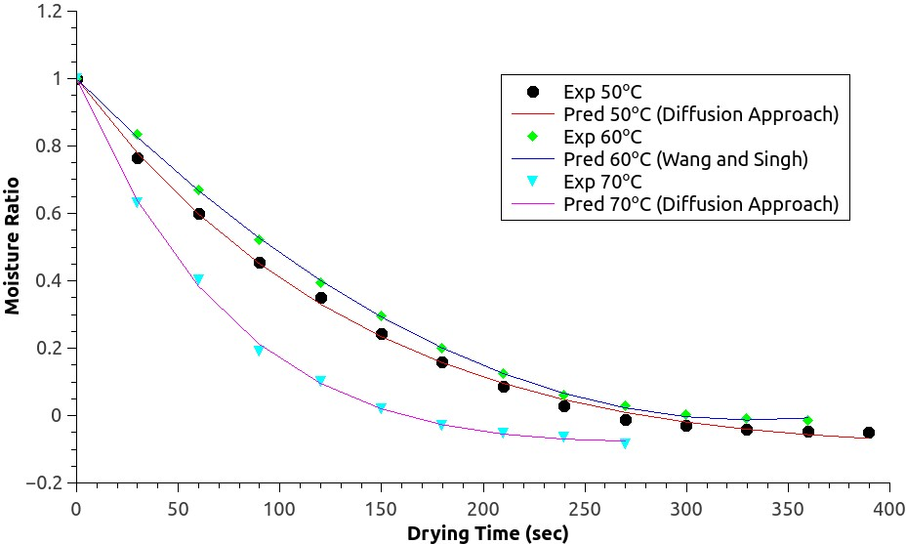
Figure 5.1: Variation of experimental and predicted moisture ratio with drying time by the Diffusion approach and Wang and Singh models for fresh 0.5cm at
various temperatures
The results of statistical analysis for the fresh samples of 1cm thickness dried at 50 °C, 60 °C and 70 °C showed in all instances that, the values of R² were greater than
0.97 indicating a good fit. The values of R², ² and RMSE for models ranged from 0.992463 to 0.999811, 2.053277x10⁻⁵ to 9.374781x10⁻⁴ and 0.00453131 to 0.02863 respectively.
The Simplified Ficks Diffusion, Wang and Singh and Parabolic, and Midilli et al models were found to be better models for describing the drying characteristics of 1cm fresh D. bulbifera dried at 50 °C, 60 °C and70 °C respectively.
Fig. 5.2 further confirms the fitness of the selected models for fresh samples at 1.0 cm thickness (Simplified Ficks diffusion, Wang and Sing, Parabolic and Midilli et al).
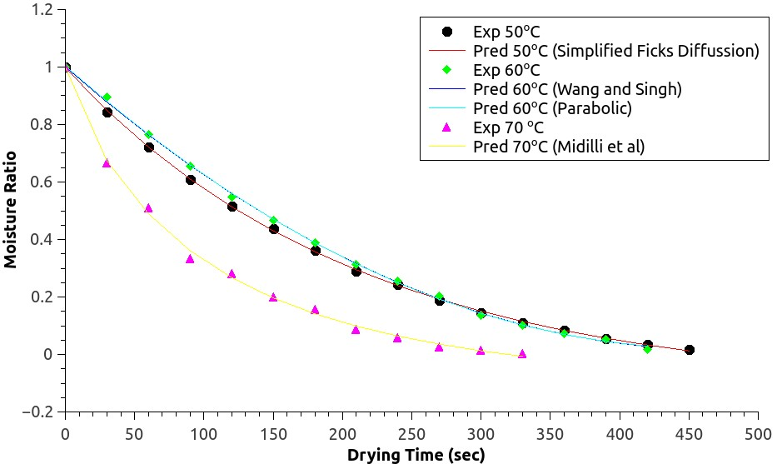
Figure 5.2: Variation of experimental and predicted moisture ratio with drying time by the Simplified Ficks Diffusion, Wang and Singh, Parabolic and Midilli et al models for the fresh slab thickness of 1cm dried at various temperatures.
The results for the boiled samples of 0.5 cm thickness dried at 50 °C 60 °C and 70 °C are shown in table 5.2. The results showed the correlation coefficients to be in the range of 0.9954 to 0.9991, for samples dried at 50 °C while the best fit model was found to be Midilli et al with the highest R² (0.9991) and lowest X² (1.0302×10⁴) and RMSE (0.01015). All the models used in this study fitted reasonably well with the drying data.
The results for the samples dried at 60 °C showed the correlation coefficients to be in the range of 0.986457 to 0.999725 which indicates that Midilli et al is the best model that describes the drying data of the 0.5 cm boiled yam slabs dried at 60 °C air temperature with the highest R² of 0.9992 and lowest RMSE, 0.0058889 and χ² of 3.467910x10^{-5.}. Midilli et al was found to fit both boiled samples dried at 50 °C and
60 °C with the exception of the sample dried at 70°C air temperature which was best fitted to both Midilli et al and Diffusion approach models with the same highest R² (0.998845), lowest X² (1.307015x10⁻⁴) and RMSE (0.0114325).
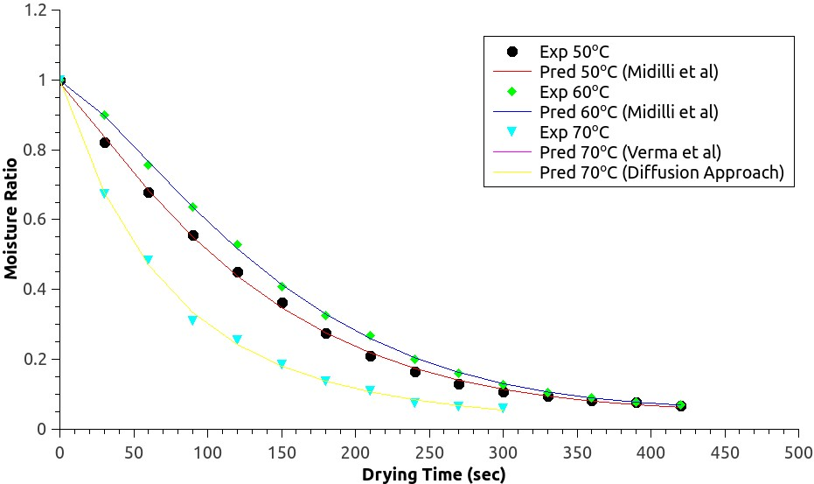
Figure 5.3: Variation of experimental and predicted moisture ratio with drying time by the Midilli et al, Verma et al and Diffusion Approach models for the boiled slab thickness of 0.5 cm dried at various temperatures
Figure 5.3 further confirms the fitness of the models selected for boiled sample with 0.5 cm thickness (Midilli et al., Verma et al and Diffusion approach). The results of such fitting of the experimental data for the boiled yam slabs of 1cm thickness dried at 50 °C, 60 °C and 70 °C are presented in Table 5.2.
The correlation coefficients are in the range of 0.9889 to 0.9998, 0.9922 to 0.9990and 0.9935-0.9980 for 50 °C, 60 °C and 70 °C dried samples respectively. Midilli et al model was found to fit all the samples except for the 60 °C and 70 °C samples that had Modified Page I and Simplified Ficks diffusion respectively fitting their drying data.
The drying curve in Figure 5.4 below confirms the fitness of the selected thin layer drying models (Midilli et al., Simplified Ficks diffusion and Modified Page I).
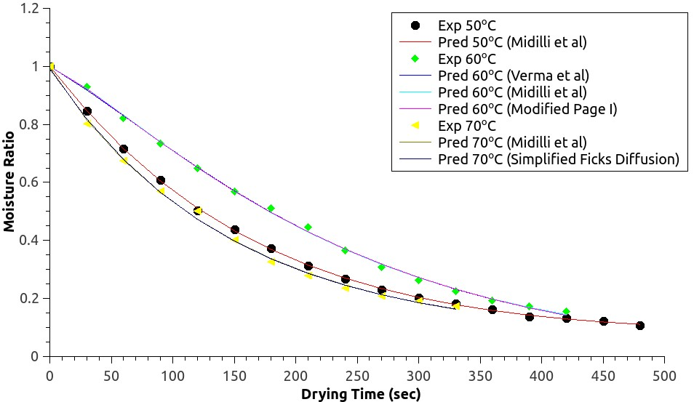
Figure 5.4: Variation of experimental and predicted moisture ratio with drying time by the Simplified Ficks Diffusion, Verma et al., Modified Page I and Midilli et al models for the boiled slab thickness of 1cm dried at various temperatures.

5.3.1.1 Validation of established models
The experimental and predicted moisture ratio values are compared in Figure 5.5. Validation of the established models was made by comparing experimental moisture ratio with the predicted moisture ratio. The established models provided satisfactorily a good conformity between the experimental and predicted moisture ratios. The predicted data generally banded around the straight line which indicates the suitability of the selected models in describing the drying behaviour of different thicknesses of aerial yam at varying temperatures.

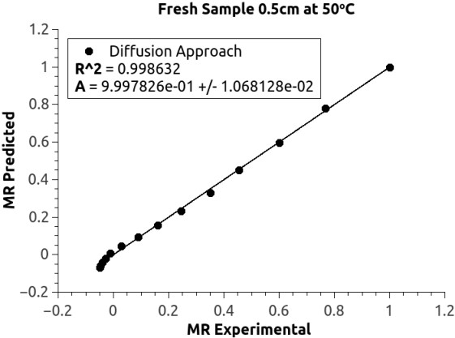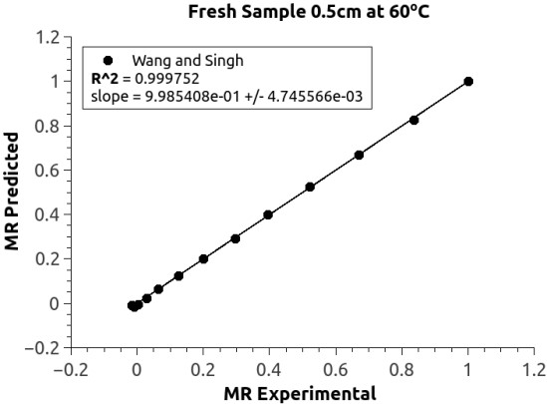
A B
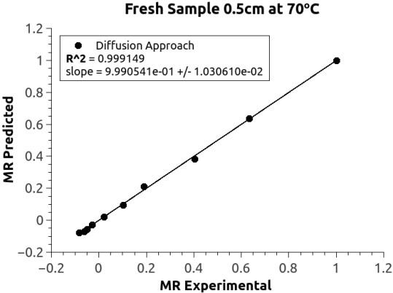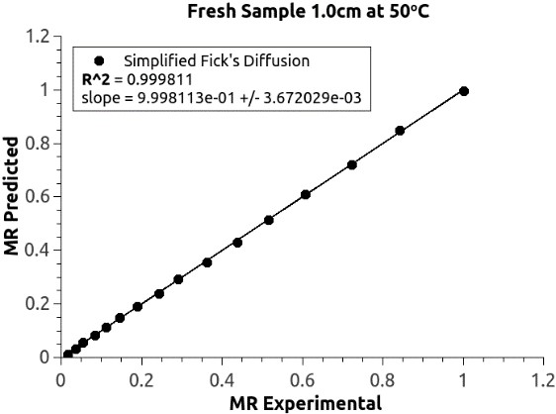
C D

Figures 5.5 (A-D) Relationship between Experimental and predicted moisture
ratio data

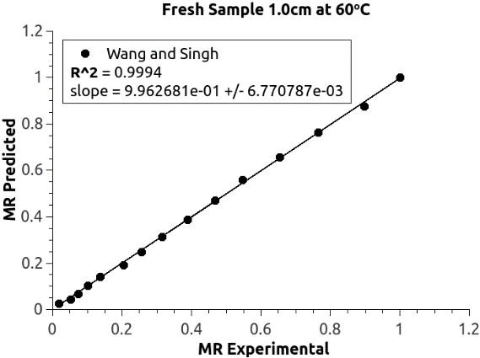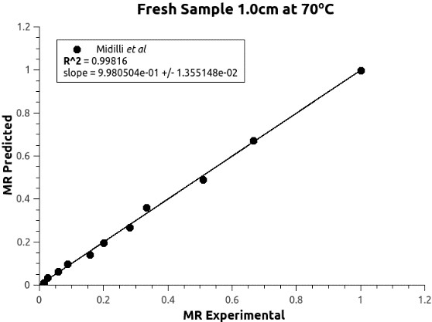

E F
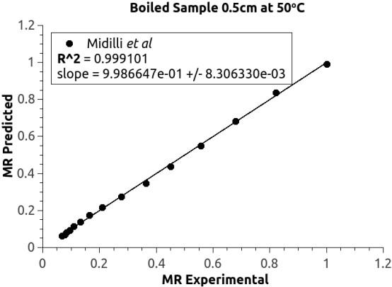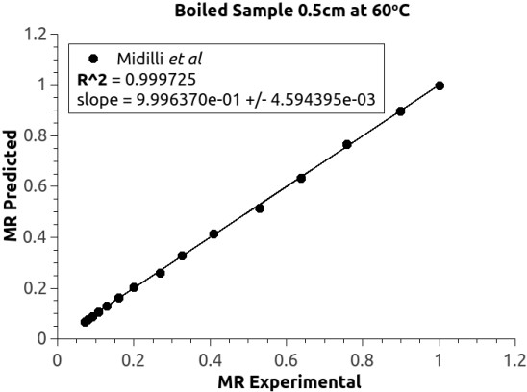

G H
Figure 5.5 (E-H) Relationship between Experimental and predicted moisture
ratio data
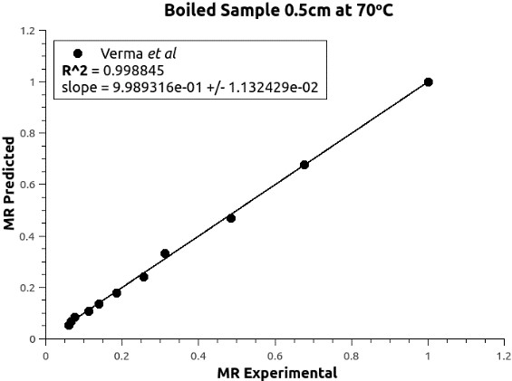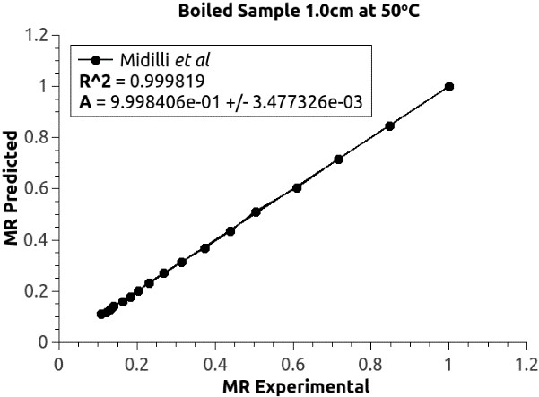

I J
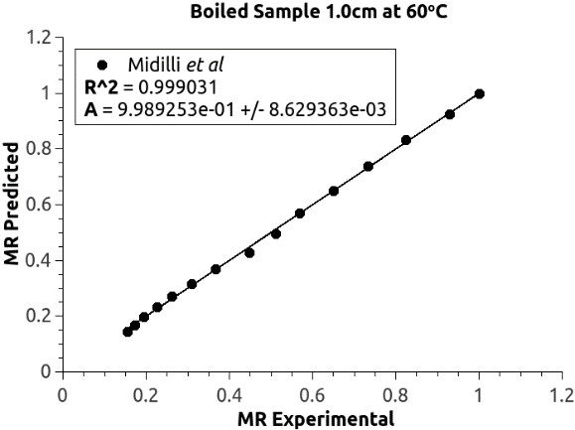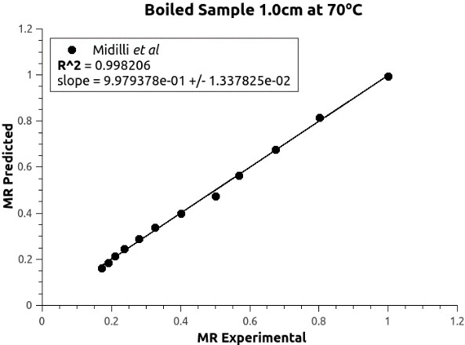

K L

Figure 5.5 (I-L) Relationship between Experimental and predicted moisture ratio
data

5.3.2 Effective moisture diffusivity of the Aerial yam
Drying of most food materials occurs in the falling rate period, and the moisture transfer during drying is controlled by internal diffusion. For most of such systems, Fick‟s second law of diffusion has been widely used to describe the drying process during the falling rate period. Equation 26
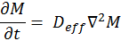 26 where, M is the moisture content, t is the time, D_{eff} is the effective moisture diffusivity,  is the differential operator. The solution of Fick‟s second law in slab geometry, with the assumption that moisture migration was caused by diffusion, negligible shrinkage, constant diffusion coefficient and temperature was given by Crank (1975) as follows:
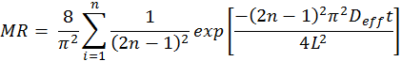 27
Where, L is the half thickness of the slab, and n = 1, 2, 3, the number of terms taken into consideration. In practice only the first term is used, yielding
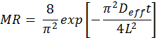 28
The above equation can be rewritten as
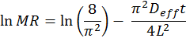 29
Thus a plot of ln MR against the time it gives a straight line with the slope given as
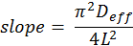 30
The calculated values of the effective moisture diffusivity are given in Table 5.1. These values were obtained from plots of ln MR against t for the samples studied in this work given in Figures 5.6 to 5.9. The effective moisture diffusivity values of dried samples were varied in the range of 1.401 x 10⁻¹⁰ m²/s to 6.720 x 10⁻¹⁰ m²/s for the fresh samples and 7.223 x 10⁻¹¹ m²/s to 2.306 x 10⁻¹⁰ m²/s for the boiled samples. The effective moisture diffusivity values obtained from the experimental data fall within the (10⁻¹¹ – 10⁻⁶ m²/s) range reported for most food products (Doymaz, 2007; Falade et al., 2007; Tunde-Akintunde, 2009).
Generally it was observed from the results, that at any temperature the fresh samples have higher diffusivity compared with the boiled samples.

Table 5.3: Moisture diffusivity for fresh and boiled samples
Pre-treatment Temperature (ºC) Moisture diffusivity (m²/s)
 |  | 0.5 cm | 1.0 cm
Fresh | 50 | 1.401 x 10⁻¹⁰ | 3.456 x 10⁻¹⁰
Fresh | 60 | 1.689 x 10⁻¹⁰ | 3.533 x 10⁻¹⁰
Fresh | 70 | 2.603 x 10⁻¹⁰ | 6.720 x 10⁻¹⁰
Boiled | 50 | 7.223 x 10⁻¹¹ | 1.987 x 10⁻¹⁰
Boiled | 60 | 7.223 x 10⁻¹¹ | 1.981 x 10⁻¹⁰
Boiled | 70 | 1.012 x 10⁻¹⁰ | 2.306 x 10⁻¹⁰

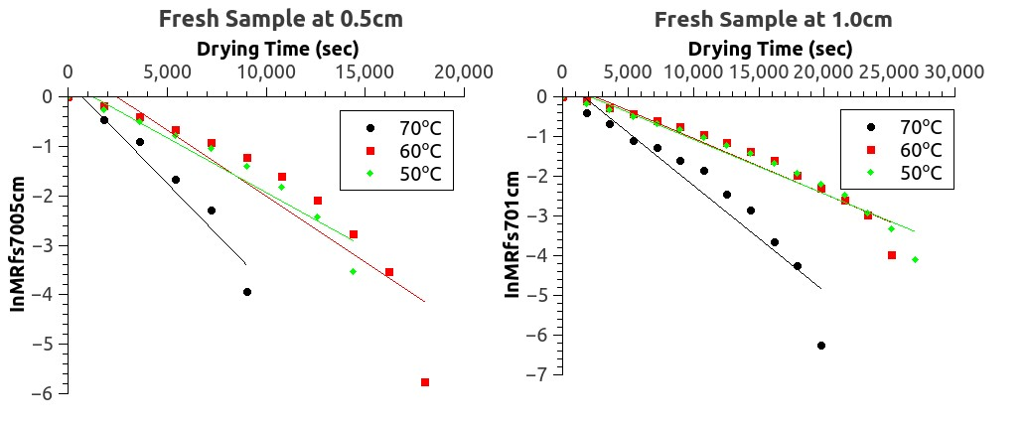
Figure 5.6 Figure 5.7
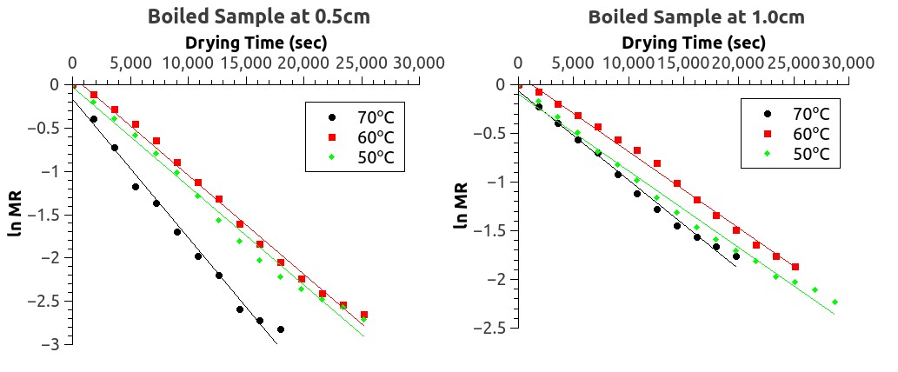
Figure 5.8 Figure 5.9

Figure 5.6-5.9: Change ln MR over time in seconds
Moisture diffusivity is related to the quantity of heat passing normally through a unit area per unit time. Moisture diffusivity is therefore affected by drying temperatures. It is observed from this work that for a particular sample, the moisture diffusivity increased considerably with increase in the drying temperature. Thus, energy consumption is expected to decrease as temperature increases. This result is similar to the results of other workers; (Kouchakzadeh, 2010; Moteval et al., 2012; Dinrifo,
2012).

5.3.3 Activation energy of aerial yam
The dependence of the effective moisture diffusivity on temperature may be described by an Arrhenius-type relation as follows (Simal et al., 1996; Doymaz, 2004; Lopez et al., 2000; Rafiee, Sharifi, Keyhani, Omid, Jafari, Mohtasebi and Mobli, 2010; Xiao et al., 2010)
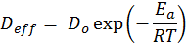 Equation 31
Where D_{o} is the constant in the Arrhenius equation, E_{a} is the activation energy, T is the absolute temperature and R is the Universal gas constant. The above equation can
be rewritten as 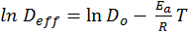. Table 5.2 gives the values of the activation
energy determined from the plots of ln D_{ef} against T (Fig 5.10 to 5.13).
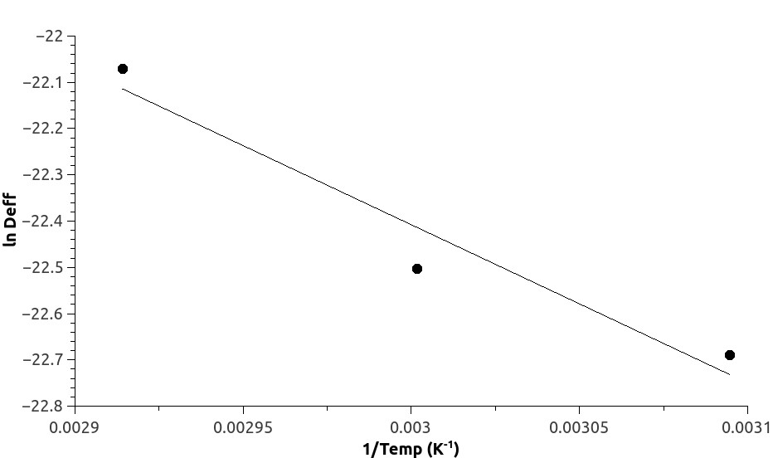

Figure 5.10: Influence of drying temperature on moisture diffusivity for fresh
yam (0.5cm)
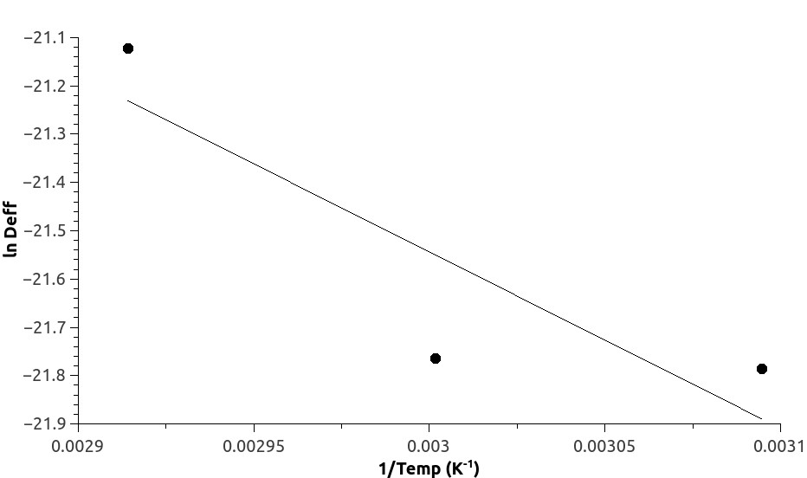

Figure 5.11: Influence of drying temperature on moisture diffusivity for fresh
yam (1cm)
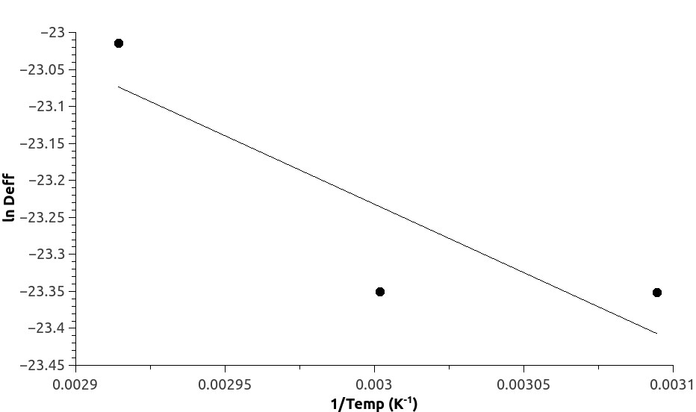

Figure 5.12 Influence of drying temperature on moisture diffusivity for boiled
yam (0.5cm)
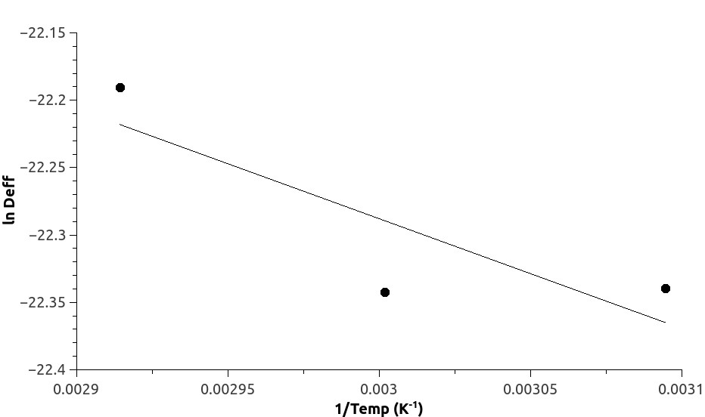

Figure 5.13 Influence of drying temperature on moisture diffusivity for boiled
yam (1cm)
From the Table 5.4, it is observed that the fresh samples have higher activation energies compared with the boiled samples, for samples of the same thickness. This indicates that it is easier to induce the water release process in the boiled samples than in the fresh samples. Lower E_{a} indicates higher temperature sensitivity of diffusion coefficient and therefore less energy required to remove moisture from the product. According to Falade et al. (2007), boiling and blanching does cause gelatinization of yam starches which results in decreased rate of moisture transport from within the material to the surface during air drying.

Table 5.4: Activation energy for boiled and fresh samples

Pre-treatment Activation energy (kJ/mole)
Fresh | 0.5cm | 1.0 cm
Fresh | 28.42 | 30.33
Boiled | 15.37 | 6.77
The values of activation energy obtained from this work lie within the general range of 12.7 – 110 kJ/mol for food materials (Aghbasho et al., 2008; Jangam et al., 2010) except for the 1.0-cm boiled sample which had activation energy of 6.77kJ/mol.

5.4 Conclusion
This study demonstrated that, among the twelve drying models, Midilli et al., Verma et al., Diffusion Approach, Wang and Singh, Parabolic and Simplified Fick‟s Diffusion models were found to be the best models to predict the moisture ratio values during the drying process with high capability for D.bulbifera.
It was observed that for a particular sample, the moisture diffusivity increased with increasing drying temperature. The fresh yam samples were found to have higher activation energy than the boiled samples of the same thickness,
Mathematical models for drying processes are used for designing new or improving existing drying systems and controlling of drying process (Ertekin and Yaldiz, 2010; Jangam et al., 2010). This study has provided information which will be beneficial to the food industry in the optimisation of processing method for the aerial yam.
CHAPTER 6
GENERAL CONCLUSION AND RECOMMENDATIONS

6.1 Conclusions
Dioscorea bulbifera L. commonly called aerial yam, air potato or bitter yam is a member of the yam family (Dioscoreacea). It produces large numbers of aerial tubers, potato-like growths from the leaf axils and is among one of the most underutilized food crops in Ghana due to the preference for the other yams. It has been shown to possess a myriad of compounds that have also been attributed to several health benefits.
On the whole the study established that aerial yam, Dioscorea bulbifera flour obtained by oven drying but pre-treated by boiling produced higher flour yields relative to that from solar drying. The different processing methods evaluated in the study (oven drying, solar drying, boiling and steaming) had significant effects on the nutritional quality of the flour samples. Flours produced using steam pre-treatment had slightly higher moisture, protein, crude fibre, and fat content compared with flours produced using boiling as a pre-treatment. However, the carbohydrate content of all the flours obtained was within acceptable limits.
Pre-treatment had significant (p<0.05) but varying effects on the mineral contents of the flours. The findings of the study showed that with the exception of Ca, Fe and K, the oven dried flours showed least variation for P and Na levels as well as for ascorbic acid whilst it is the inverse for the solar dried flour samples. The functional properties of the flours obtained after pre-treatment and using the drying methods showed significant variations. The solubility and swelling power of flours produced using the boiling pre-treatment technique showed significant variation compared with that pretreated with steam. However, pH levels of flours from the different processing methods gave values within relative acceptable levels using wheat flour as reference. Generally, pre-treatments prior to drying showed varying effects on the quality of the flours obtained. Data obtained on the pasting characteristics indicated that the different processing methods affected flour quality. On the whole, flours produced by solar drying after pre-treatment gave relatively lower values for all the pasting indicators measured except for breakdown and setback viscosities.
A degree of inter-relationship existed between the different processing methods and nutritional, functional and pasting properties of the flour from D. dioscorea. The results indicated that drying took place in the falling rate period as established by other researchers in their work (Hii et al. 2005; Taheri-Garvard, 2011). However, increasing slab thickness influenced drying time at all temperatures while boiling prior to drying decreased the rate of moisture movement thus increasing drying time. The drying characteristics for the production of D. bulbifera flour showed that moisture diffusivity increased with increasing drying temperature. The fresh samples had higher activation energy relative to the pre-treated boiled samples of the same thickness indicating an easier inducement of water release process in the boiled samples relative to the fresh samples.
Of the twelve (12) drying models evaluated Midilli et al., Verma et al., Diffusion
Approach, Wang and Singh, Parabolic and Simplified Fick‟s Diffusion were found to be the best models and are recommended for predicting the drying kinetics of the aerial yam. They will be useful in the design of a dryer for the food industry.

6.2 Recommendations
Based on the findings, there is the need to determine the moisture isotherm to predict suitable storage conditions for the yam flour and other derived products.
Explore the use of aerial yam composite flour in bakery products and
Research into the breeding, cultivation (agronomic practices) and storage of the aerial yam for commercial production.
REFERENCES
Aasa, S. A., Ajayi, O. O. and Omotosho, O. A (2012). Design optimisation of hot air dryer for yam flour chunks. Asian Journal of Science Research, 5(3): 143-152.
Abano, E.E. (2013). Influence of hot-air, microwave-vacuum and far-infrared catalytic drying on drying kinetics and quality of tomato slices. A Thesis submitted to the Department of Food Science and Engineering, Jiangsu University. China.
Abano, E.E., Haile, M.A., Owusu, J. and Engmann, F.N. (2013). Microwave –vacuum drying effects on drying kinetics, lycopene and ascorbic acid content of tomato slices. Journal of Stored Products and Post-harvest Research. 4(1)11-
22
Abano, E.E., Ma, H. and Qu, W. (2011). Effects of pre-treatments on the drying characteristics and chemical composition of garlic slices in a convective hot air dryer. Journal of Agriculture and Food Technology 1(5):50-58.
Abara, A. E. (2011). Proximate and mineral elements composition of the tissue and peel of Dioscorea bulbifera Tuber. Pakistan Journal of Nutrition, 10: 543551.
Abara, A. E., Tawo, E. N., Obi-Abang, M. E. and Obochi, G. O. (2011). Dietary fibre components of four common Nigerian Dioscorea species. Pakistan Journal of
Nutrition, 10(4): 383-387
Abara, A.E. (2003) Tannin content of Dioscorea bulbifera JSCN, 28: 55-56
Abiodun, O. A., Adegbite, J.A. and Oladipo, T.S. (2009). Effect of soaking time on the pasting properties of two cultivars of trifoliate yam (Dioscorea dumetorum) flours. Pakistan Journal of Nutrition, 8(10): 1537-1539.
Abiodun, O.A., Akinoso R., Oladapo A.S and Adepeju AB (2013). Influence of soaking method on the chemical and functional properties of trifoliate yam (Dioscorea dumetorum) flours. Journal of Root Crops 39 (1): 84-87.
Abioye, V. F. (2012). Effect of some processing variables on the quality attributes of yam flour. Journal of Agricultural Science and Technology, 2: 621-626.
Addy, R.N.A. (2012). Comparative Study on the Properties of Yam (Dioscorea Rotundata) Varieties in Ghana: A Case Study in Asante Mampong A thesis submitted to the Department of Food Science and Technology, Kwame Nkrumah University of Science and Technology.
Adebowale, A. A., Sanni, L. O. and Awonorin, S. O. (2005). Effects of texture modifiers on the physicochemical and sensory properties of dried fufu. Food Science and Technology International, 11(5): 373-382.
Adegunwa, M. O., Alamu, E. O. and Omitogun, L. A. (2011). Effect of processing on the nutritional contents of yam and cocoyam tubers. Journal of Applied Biosciences, 46: 3086–3092.
Adejumo, B. A., Okundare, R. O., Afolayan, O. I., and Balogun, S. A. (2013). Quality Attributes of Yam Flour (Elubo) as affected by blanching water temperature and soaking time. The International Journal of Engineering and Science
(IJES), 2(1): 216–221.
Ade-Omowaye, B.I.O., Rastogi, N.K., Angersbach, A. and Knorr, D. (2002). Osmotic dehydration behavior of red paprika (Capsicum annuum 400 L.). Journal of Food Science, 67(5): 1790–1796.
Adepoju, O.T. (2012). Effects of processing methods on nutrient retention and contribution of white yam (Dioscorea rotundata) products to nutritional intake of Nigerians. African Journal of Food Science, 6:163-167.
Adepoju, O.T., Adekola, Y.G., Mustapha, S.O, and Ogunola, S.I. (2010). Effect of processing methods on nutrient retention and contribution of local diets from cassava (Manihot spp) to nutrient intake of Nigerian consumers. African
Journal of Agriculture and Nutrition Development. (AJFAND) 10(@): 209920111.
Adewole, E., Ogunmodede, O.T., Adeniran, O.A., and Lagide, L. (2011). Rheological properties of wild yam (Dioscorea villosa) and aerial yam (Dioscorea bulbifera). Der Pharma Chemica, 3(5): 324-328.
Adeyemi, I.A., and Beckley, O., (1986). Effect of period of maize fermentation and souring on chemical properties and amylograph pasting viscosities of ogi. Cereal Science. 4: 353-360
Afoakwa E.O and Sefa-Dedeh S. (2001). Chemical composition and quality changes in Dioscorea dumetorum pax tubers after harvest. Food Chemistry, 75: 85-91.
Afoakwa, E. O. and Sefa-Dedeh, S. (2002). Viscoelastic properties and changes in pasting characteristics of trifoliate yam (Dioscorea dumetorum) starch after harvesting. Food Chemistry 77: 203-208
Afzal, T.M, and Abe. T. (1998). Diffusion potato during far infrared radiation drying.
Journal of Food Engineering 37(4):353-365 ·
Aghbashlo, M., Samimi-Akhijahani, H. (2008). Influence of drying conditions on the effective moisture diffusivity, energy of activation and energy consumption during the thin-layer drying of berberis fruit (Berberidaceae). Energy Conversion and Management, 49(10): 2865–2871.
Agoreyo, B.O., Akpiroroh O., Orukpe O.A, Osaweren O.R, and Owabor C.N. (2011). The effects of various drying methods on the nutritional composition of Musa paradisiaca, Dioscorea rotundata and Colocasia esculenta. Asian Journal of Biochemistry, 6(6): 458-464.
Akinwande, A. A., Fagbenro, O.A and Adebayo, O.T. (2012). Fertilization, hatch ability, survival and larval biometry in interspecific and intergeneric hybridization in heterobranchus longifilis, clarias gariepinus and clarias anguillaris under controlled hatchery conditions. Elixir Aquaculture 43: 6696-
6700
Akissoe, N., Joseph, H., Christian, M. and Nago, N. (2003). Effect of tuber storage and pre- and post-blanching treatments on the physicochemical and pasting properties of dry yam flour. Food Chemistry, 85: 1414 - 1419.
Akpinar, E. K. (2006a). Determination of suitable thin layer drying curve model for some vegetables and fruits. Journal of Food Engineering, 73(1): 75–84.
Akpinar, E. K. (2006b). Mathematical modelling of thin layer drying process under open sun of some aromatic plants. Journal of Food Engineering, 77(4): 864– 870.
Akpinar, E. K., Bicer, Y. and Yildiz, C. (2003). Thin layer drying of red pepper.
Journal of Food Engineering, 59(1): 99–104.
Akubor, P. I. (2013) Effect of ascorbic acid and citric acid treatments on the functional and sensory properties of yam flour. International Journal of Agricultural Policy and Research, 1(4): 103-108.
Alzamora, S. J. and Chirife, J. (1980). Some factors controlling the kinetics of moisture movement during avocado dehydration. Journal of Food Science, 45(6): 1645-1657.
AOAC (2000). Official Methods of Analysis, Association of Official
Analytical Chemists, Washington, DC, USA, 17th edition.
AOAC, (1990). Association of Official Analytical Chemists. Official Methods of Analysis. 15th Edn, Gaithersburg. AOAC Press, USA
AOAC, 2004. Official Methods of Analysis. Association of Official Analytical Chemists International Washington, DC, USA
Aribisala, O.A and Olorunfemi, B. N. (1989). Action Committee on Raw Materials. Abuja, Nigeria
Aryee, F, Oduro, I., Ellis, W. O. and Afoakwa, J. (2006). The physicochemical properties of flour samples from the roots of 31 varieties of cassava. Food Control, 17: 916-922.
Asaoka, M., Blanchard, J. M. V. and Richard, J. E. (1991).Seasonal effects on the physicochemical properties of starch from four cultivars of cassava. Starch/ Staerke 43: 455-459.
Ashajyothi, V., Pippalla, R.S., and Satyavati, D. (2012). Dioscorea bulbifera, A
Review. International Journal of Post-Harvest Technology, 4(2): 2157-2163).
Asiedu, J. J. (2010). Processing tropical crops; A Technological Approach. Mission
Press. Ndola, Zambia. Pp. 249.
Ayensu, A. (1997). Dehydration of food crops using a solar dryer with convective heat flow. Solar Energy, 59(4-6): 121-126.
Ayensu, E. S and Coursey D. G. (1972). Guinea yams: The botany, ethnobotany, use and possible future of yams in West Africa. Econ. Botany, 26: 301-318.
Ayim, I., Amankwah, E. A. and Dzisi, K. A. (2012). Effect of Pre-treatment and temperature on the air drying of French and False horn plantain slices.
Journal of Animal and Plant Sciences, 13(2):1771-1780.
Azeem, A. K., Rasheed, A., Dilip, C., Rasheed, S. P., and Prasanth, N. V. (2013).
Pharmacognistical Studies of Dioscorea bulbifera Linn. Tubers. American Journal of Pharmatech Research, 3(2).
Baah, F. D., Maziya-Dixon, B., Asiedu, R., Oduro, I. and Ellis, W. O. (2009). Physicochemical and pasting characteristics of water yam (Dioscorea spp) and relationship of eating quality of pounded yam. Journal of Food, Agriculture and Environment, 7(2):107-112.
Babalis, S. J. and Belessiotis, V. G. (2004). Influence of the drying conditions on the drying constants and moisture diffusivity during the thin-layer drying of figs.
Journal of Food Engineering, 65(3): 449–458.
Barquar, S. R. and Oke, O. L. (1977). Mineral constituents of Nigerian yams.
Nutritional. Rep. International, 15(3): 265-272.
Bencini, M. C. (1991). Post-harvest and processing technologies of African staple foods: a technical compendium. FAO Agricultural Service Bulletin 89. FAO, Rome.
Benton, J., Jones, J. R. and Vernon, W. C. (1990). Sampling, handling and analyzing plant tissue samples. In: Soil Testing and Plant Analysis (3rd Ed). R.L. Westerman (Ed). SSSA Book Series No. 3.
Berger, J. (1980). A Robust Generalised Bayes Estimator and Confidence Region for a Multivariate Normal Mean. The Annals of Statistics. 8(4): 716-761
Berthaud, J., Bricas, N. and Marchand, J.L. (1997). The yam plant and secular culture future. Proceedings of International Seminar 3 to 6 June 1997, Montpellier, France.
Bhandari, M. R., Kasai, T. and Kawabata, J. (2003). Nutritional evaluation of wild yam (Dioscorea spp.) Tubers of Nepal. Food Chemistry, 82(4): 619-623.
Bhattacharya, M., Zee, S. Y. and Corke, rs H. (1999). Physicochemical properties related to quality of rice noodles. Cereal Chemistry. 76:861-867
Bolin, H. R., Petrucci, V., and Fuller, G. (1975). Characteristics of mechanically harvested raisins produced by dehydration and by field drying. Journal of Food Science. 40:1036–1038
Brand–Miller, J., Burani, J. and Foster-Powell, K. (2003). The new glucose revolution, pocket guide to the top 100 low GI Foods.2nd ed. Marlowe and Company.
Brennan, J. G. (2006). Food processing handbook. Food processing handbook.
Weinheim: Wiley
Burkill, H. M. (1995). The Useful Plants of West Tropical Africa. (Vol. 3, Families JL) Royal Botanic Gardens, Kew.
Cogne, A. L. (2002). Phytochemical investigation of plants used in African medicine:
Dioscorea sylvatica (Dioscoreacea), Urginiaaltissima (Liliaceae), Jamesbrittiniafodina and Jamesbrittiniaelegantissima (Scrophulariaceae), M.S. thesis, University of Lausanne, Lausanne, Switzerland.
Coursey, D. G. (1967). Yams: An Account of the Nature, Cultivation and Utilization of the Useful Members of Dioscoreacea. Longmans: London, UK.
Coursey, D. G. (1983). Yams. In: Hand Book of Tropical Foods. Chan H. T. (Eds.). Marcel Dekker, New York, USA. pp 555-601.
Crank, J. (1975). The Mathematics of Diffusion. 2nd Edition, Oxford University
Press, England.
Cui, S. W. (2005). Understanding Starch and their Role in Foods. Food
Carbohydrates: Chemistry, Physical properties, and Applications. Florida. CRC Press, Pp. 310-349.
Dadali, G., Kılıc¸ Apar, D., and O¨ zbek, B. (2007b). Estimation of effective moisture diffusivity of okra for microwave drying. Drying Technology. 25:1445–1450.
Dadali, G., Kılıc¸, D., and O¨ zbek, B. (2007a). Microwave drying kinetics of okra. Drying Technology, 25: 917–924.
Demir, V., Gunhan, T. and Yagcioglu, A. K. (2007). Mathematical modelling of convection drying of green table olives. Biosystems Engineering, 98:47– 53.
Demirtas, C., Ayhan, T. and Kaygusuz, K. (1998). Drying behavior of hazelnuts.
Journal of the Science and Agriculture. 76:559–564.
Dinrifo, R. R (2012). Effects of pre-treatments on drying kinetics of sweet potato slices. Agric. Eng. Int. CIGR Journal, 14(3): 136-145.
Diosady, L.L., Patton, D., Rosen, N. and Rubin, L.J. (1985). Degradation of wheat starch. Journal of Food Science, 50: 1697-1706.
Doymaz, I. (2004). Convective air drying characteristics of thin layer carrots. Journal of Food Engineering, 61(3): 359–364.
Doymaz, I. (2006). Thin-layer drying behaviour of mint leaves. Journal of Food Engineering, 74:370–375
Doymaz, I. (2007). Air-drying characteristics of tomatoes. Journal of Food
Engineering, 78(4): 1291–1297.
Doymaz, I. 2010. Thin-layer drying characteristics of sweet potato slices and mathematical modelling. Heat and Mass Transfer doi:10.1007/s00231-010-
0722-3
Doymaz, I., and Pala, M. (2003).The thin-layer drying characteristics of corn. Journal of Food Engineering, 60(2): 125-130
Ece, M.C, and Cihan, A. (1993). A liquid diffusion model for drying rough rice. Transactions of American Society of Agricultural Engineers, 36: 837–840.
Egbe, T. A. and Treche, S. (1984). Variability in Chemical Composition of yams grown in Cameroon in: Tropical Root Crops: Production and uses in Africa. International Development Research Centre, Doula. Cameroon.
Egyesi, C. N., S., Ogunyemi, S., and Asiedu, R. (2005). Genotype x environment interaction in water yam (Dioscorea alata) yield trials in five yam growing states in Nigeria. Journal of Genetics and Breeding, 59: 81-88.
Ejoh, S. I., Obagtolu, V. A, Olanipekun, O. T, and Farinde, E. O. (2013) Extending the use of an underutilized I: Physico chemical and Pasting Properties of cocoyam (Xanthosoma sagittifolium) flour and its suitability for making biscuits. African Journal of Food Science, 7(9): 264-273.
Eka, O. U. (1978). Chemical Evaluation of the nutritive value of soya paps and porridges. The Nigerian Weaning Foods. Food Chemistry, 3:199-206.
Eka, O. U. (1998). Roots and Tubers In: Nutritional quality of plant foods. Macmillan
Press, London. Pp 1-31.
Eke-Ejiofor, J. and Owuno, F. (2012).Functional and Pasting Properties of Wheat/
Three leaved Yam (Dioscorea dumetorum) composite flour blend. Global Research Journal of Agricultural and Biological Sciences. 3 (4):330 –335
Eleazu, C.O., Amayor, J.U., Ikpeama, A.I and Awa, W. (2011). Studies on the nutrient composition, antioxidants activities, functional properties and microbial load of flours of 10 elite cassava (Manihot esculenta) varieties. Asian Journal of Clinical Nutrition 3:33-39.
Erbay, Z. and Icier, F. (2008). Thin-layer drying behaviours of Olive leaves (Okea europaca L). Journal of Food Process Engineering, 33:287-308.
Erenturk, K., Erenturk, S. and Tabil, L. G. (2004). A comparative study for the estimation of dynamical drying behavior of Echinacea angustifolia: regression analysis and neural network. Computers and Electronics in Agriculture, 45:71–90.
Eva, R. (1983). Food, Health and you. A book on Nutrition with Special Reference to
East Africa, McMillan Publishers, London, pp: 14-25.
Ezeocha, V.C and Ojimelukwe, P.C. (2012). The Impact of Cooking on the Proximate
Composition and anti-nutritional factors of water yam (Dioscorea Alata). Journal of Stored Products and Post-harvest Research. 3(13):172-176.
Ezeocha, V.C., Ojimelukwe, P.C. and Onwuka, G.I. (2012). Effect of cooking on Nutritional and Phytochemical Components of trifoliate yam (Dioscorea dumetorum) Journal of Biochemistry and Bioinform 1:26-30.
Falade, K. O and Onyeoziri, N. F. (2012).Effects of cultivar and drying method on colour, pasting and sensory attributes of instant yam (Dioscorea rotundata) flours. Food and Bioprocess Technology, 5(3), 879–887.
Falade, K. O., Olurin, T. O., Ike, E. A., and Aworh, O. C. (2007).Effect of pretreatment and temperature on air-drying of Dioscorea alata and Dioscorea rotundata slices. Journal of Food Engineering, 80(4): 1002–1010.
Famurewa, J.A.V., Oluwamukomi, M. O and Alaba J. O. (2013). Effect of different drying methods on the physicochemical characteristics of cassava flour
(“pupuru”) International Journal of Biological and. Chemical Sciences. 7(2): 832-839
FAO (1987). The Nutrition and Feeding of Farmed Fish and Shrimp –A Training Manual 1.he essential nutrients. Food and Agriculture Organization.
http://www.fao.org/3/contents/d66b3e1f-c059-50fa-9ba2-
717e9940b7f1/AB470E00.htm
FAO, (1968). Food Composition Table for Use in Africa. Food and Agricultural
Organisation. Rome, Italy.
FAO, (1972). Food Composition Table for Use in East Africa. Food and Agricultural
Organisation. Rome, Italy.
FAO, (1997). Food Production Year book. 50:160-168.
FAO, (2005). Production Year book, Vol. 55. Collection FAO statistics no. 170. FAO, Rome Italy
FAO/WHO (2002). Human vitamin and mineral requirements.
(ftp://ftp.fao.org/docrep/fao/004/y2809e/y2809e00.pdf
FAO/WHO. (1973). Energy and Protein Requirement (Vol. 52 pp 1-118) Technical Report Series. Switzerland, Geneva. WHO
Fellows, J. P. (2000). Food Processing Technology, Principles and Practice 2nd
Edition. CRC Press, Woodhead Publishing Limited.
Florida„s Natural Areas. University of Florida, Gainesville.165p, available from 1 –
800 – 226 – 1764.
Gedil, M., and Sartie, A. (2010).Perspectives on molecular breeding of Africa‟s main staple food crops – cassava and yams. Aspects of Applied Biology, 96: 123135.
Goyal, R. K., Kingsly, A. R. P., Manikantan, M. R. and Ilyas, S. M. (2006). Thin layer drying kinetics of raw mango slices. Biosystems Engineering 95(1):
43-49.
Goyal, R. K., Kingsly, A. R. P., Manikantan, M. R. and Ilyas, S. M. (2007). Mathematical modelling of thin layer drying kinetics of plum in a tunnel dryer. Journal of Food Engineering 79(1): 176-180.
Goyal, R.K., Mujjeb, O. and Bhargava, V.K. (2008). Mathematical modelling of thin layer drying kinetics of apple in tunnel dryer. Inter. J. Food Eng. 4(8):
Article 8
Gunhan, T., Demir, V., Hancioglu, E, and Hepbasli, A. (2005). Mathematical modelling of drying of bay leaves. Energy Conversion and Management. 46:1667–1679.
Gupta, D. and Singh, J. (1989). P-Hydroxyaceptophenone derivatives from Dioscorea bulbifera. Phytochemistry, 28(3): 947-949.
Hahn, S. K. (1995). Yams: Dioscorea species (Dioscoreacea) in Kambaska, K., Sahoo, S., and Prusti, A. (2008). Effect of plant growth regulator on in vitro micro propagation of „bitter yam‟ (Dioscorea hispida Dennst). International Journal of Integrative Biology, 4(1): 50-56.
Hahn, S. K., Osiru, D. S. O., Akorada, M. O., and Otoo, J. A. (1987).Yam production and its future prospect outlook in agriculture. 16: 109-118. IITA (1993). Crop Improvement
Hahn, S.K. (1995). Yams: Dioscorea spp. (Dioscoreacea). In: Smartt, J., and
Simmonds, N.W. (Eds). Evolution of Crop Plants. Longman Scientific and
Technical, UK. Pp.112-120.
Hammer, R. L. (1998). Diagnosis: Dioscorea. Wild land weeds: Pp. 8–10.
Hamon, P., Dumont, R., Zoundjihekpon, J., tio-Toure, B. and Hamon, S (1995).Wild
Yams of West Africa .Morphological characteristics. Ed. De I‟Orstom, Paris, pp.385-400.
Harijono, T.E., Saputri, D.S. and Kusnadi, J. (2013). Effect of Blanching on properties of water yam (Dioscorea Alata) flour. Advance Journal of Food
Science and Technology, 5(10): 1342-1350.
Henderson and Pabis, (1961) Henderson, S.M., and Pabis, S. (1961). Grain drying theory I: Temperature effect on drying coefficient. Journal of Agricultural Engineering Research, 6:169–174.
Hii, C.L., Law, C.L. and Cloke, M. (2008). Modeling of Thin layer drying kinetics of cocoa beans during artificial and natural drying. Journal of Engineering Science and Technology 3(1): 1 - 10
Hoover, R. (2001). Composition, molecular structure, and physicochemical properties of tuber and root starches: a review. Carbohydrates Polymers, 45, 253-267
Housson, P. and Ayernor, G. S. (2002). Appropriate processing and food functional properties of maize flour. African Journal of Science and Technology, Science and Engineering series, 3 (1): 126-131.
Hsu, CL, Chen, W, Weng, Y-M, and Tseng, C-Y (2003). Chemical composition, physical properties, and antioxidant activities of yam flours as affected by different drying methods Food Chemistry, 83: 85-92.
Hunter, R. C., Halverson, T. L. and Anderson, R. D. (1984). Quality Assurance for Plant tissue analysis by ICP-AES Commun. In: Soil Science. Plant Anal. 15(11): 12851322.
Igyor, M. A., Ikyo, S. M., and Gernah, D. I. (2004).The food potential of potato yam
(Dioscorea Bulbifera). Nigerian Food Journal, 22: 209-215.
Ihekoronye, A.I. and P.O. Ngoddy, 1985. Integrated Food Science and Technology for the Tropics. Macmillan Publishers, London and Basingstoke, pp: 283-289.
Ikegwu O.J., Okechukwu P.E, and Ekumankana, E.O. (2010). Physico-chemical and pasting characteristics of flour and starch from achi Brachystegia eurycoma seed. Journal of Food Technology, 8(2): 58-65.
Ile, E. I., Craufurd, P. Q., Battey, N. H., and Asiedu, R. (2006).Phases of dormancy in yam tubers (Dioscorea Rotundata). Annals of Botany. (1) 97:497-504.
Iwuoha, C. I. (2004). Comparative evaluation of physicochemical qualities of flours from steam-processed yam tubers. Food Chemistry 85:541-551.
Iwuoha, C. I. and Nwakanma, M. I. (1998). Density and viscosity of flour yam paste of cassava (Manihot esculenta Grantz), sweet potato (Ipomea batata Lam) and white yam (Dioscorea rotundata Poir) tubers as affected by concentration and particle size. Carbohydrate Polymer; 37(1): 97-101.
Jangam, S. V., Law, C. I. and Mujumdar, A. S. (2010). Drying of Foods, Vegetables, and Fruits. N Nottingham University Press, Malaysia Campus.
Jayakody, L., Hoover, R., Liu, Q. and Donner, E. (2007). Studies on tuber starches. II.
Molecular structure, composition and physicochemical properties of yam
(Dioscorea sp.) starches grown in Sri Lanka. Carbohydrate Polymers, 69: 148–163.
Jayas, D.S., S. Cenkowski, S. Pabis and W.E. Muir. (1991). Review of Thin layer drying and rewetting equations. Drying Technology 9: 551-558
Jeromy, A. (2002).Yam Utilization in Food, Feed and Industry. Nwstuley Press. Ltd. South Africa. pp. 223-225.
Jimoh, K. O., Olurin, T. O., and Aina, J. O. (2010).Effect of drying methods on the rheological characteristics and colour of yam flours. African Journal of Biotechnology, 8(10): 2325-2328.
Juliano, B. O, and Hicks, P. A. (1996). Rice functional properties and rice food products.
Food Reviews International.12:71-103.
Kahkonen, M.P., Hopia, A.I., Vuorela, H.J., Rauha, J. P., Pihlaja. K., Kujala, T.S. and Heinonen, M. (1999). Antioxidant activity of plant extracts containing phenolic compounds. .Journal of Agricultural and Food Chemistry, 47, 39543962.
Kamenan, A., Beuchat, L.R., Chinan, M.S. and Heaton, E.K (1987). Composition and Physico-chemical properties of yam Dioscorea species flour prepared using different processes. Journal of Food Processing and Preservation. 11:299308.
Katayama, K., Komae, K., Kohyama, K., Kato, T., Tamiya, S, and Komaki, K. (2002). New sweetpotato line having low gelatinization temperature and alters starch structure. Starch, 54: 51 – 57.
Kay, D.E. (1987). Root crops. London: Tropical Development and Research Institute. pp. 343.
Keyon, L. and Fowler, M (2000). Final Technical report: Study of factors affecting the uptake and adoption of outputs of crop protection research on yams in Ghana, Natural Resources Institute, University of Greenwich.
Kirk, R. S. and Sawyer, R. (1981). Pearson„s Composition and Analysis of Foods. 9th
Ed. Longman Singapore Publishers (Pte) Limited. Singapore. Pp. 295.
Kouassi, A.M., Yao, K.A., Ahoussi, K.E., Seki, L.C., Yao, N.A, and Biémi, J. (2010).
Caractérisation hydrochimique des aquifères fissurés de la région du N‟ziComoé (Centre-Est de la Côte d‟Ivoire). International Journal of Biological and Chemical Sciences, 4(5): 1816-1838.
Kouchakzadeh, A. (2010). Moisture Diffusivity of Five Major Varieties of Iranian
Pistachios. American Journal of Food Tech., 6: 253-259
Krokida, M. K. and Maroulis, Z. (2001). Quality changes during drying of food materials. J. Food Science and Technology, 49(2): 33-39.
Kudra, T. (2004). Energy aspects in drying. Drying Technology, 22(5): 917–932.
Kuete, V., Tepono, R. M., Mbaveng, A. T., Tapondjou, L. A., Meyer, J. J. M., Barboni, L. and Lall, N. (2012).Antibacterial activities of the extracts, fractions and compounds from dioscorea bulbifera. BMC Complementary and Alternative Medicine. 12: 228-235
Lamptey, J. A., Sakyi-Dawson, E., Johnson, P.N.T and Amponsah Annor, G. (2008). Effects of processing methods on the nutritional composition and cyanogenic content of flour from new and promising cassava varieties in Ghana. Journal of Root Crops. 34(2): 157-163.
Langeland, K. A. and K. C. Burks. (1998). Identification and Biology of Non-native plants in Florida„s Natural Areas. University of Florida, Gainesville. 165p,
available from 1 – 800 – 226 – 1764
Leach, H. W., McCoven, L. D. and Scoch, T. J. (1959). Structure of the starch granule, swelling and solubility patterns of various starches. Cereal Chemistry, 36: 534-544
Leon, A.E., Barrera, G.N., Perez, G.T., Ribotta, P.D and Rosell, C.M. (2006). Effect of damaged starch levels on flour-thermal behavior and bread staling.
European Food Research Technology. 224: 187-192.
Liang, X. and King, J.M. (2003) Pasting and crystalline property differences of commercial and isolated rice starch with added amino acids. Journal of Food Science 68 (3):832–838.
Libra, M. A., Gonnety, A. P., Dabonne, E. D., Ahipo and Kouame, L.P. (2011). Physicochemical changes in bulbis of two cultivars of dioscorea bulbifera during ripening period. Advance journal of Food Science and Technology, 3(5): 327-331.
Liu, H., Gui-Xin, C., Tao, W., Yin-Long, G., Shun-Chun, W., Chang-Hong, W. and Zheng-Tao, W. (2009).Steroidal sapogenins and glycosides from the rhizomes of Dioscorea bulbifera. Journal of Natural Products, 72(11): 1964-1968.
Long, R. W. and O. Lakela. (1976). A Flora of Tropical Florida. Banyan Books.
Miami In: Schultz, G. E. 1993. The Nature Conservancy 4245 North Fairfax Drive, Arlington, Virginia 22203-1606 (703): 841-5300.
Loos, P. J., Hood, L. F. and Graham, A. J. (1981).Isolation and characterization of starch from breadfruit. Cereal Chemistry, 58:282-286.
Lopez, A., Iguaz, A., Esnoz, A. and Virsed, P. (2000). Thin-layer drying behaviour of vegetable waste from wholesale market. Drying Technology, 18:995-1006.
Madamba, P.S., Driscoll, R.H., and Buckle, K.A. (1996). Thin-layer drying characteristics of garlic slices. Journal of Food Engineering, 29:75–97.
Mahasukhonthachat, K., Sopade, P.A, and Gidley, M.J. (2010). Kinetics of starch digestion in sorghum as affected by particle size. Journal of Food
Engineering, 96:18- 28.
Malomo, S. A., Eleginmi, A. F. and Fashakin J. B. (2011). Chemical composition, rheological properties and bread making potential of composite flours from bread fruit, breads and wheat. African Journal of Food Science, 5(7): 400-410.
Martin, F. N. (1974). „Tropical Yams and their Potential, Part 2 Dioscorea bulbifera. Agricultural Handbook, No. 466. USDA: Washington, DC.
Martin, F. N. (1974). “Tropical Yam and their Potentials. Part 2. Dioscorea bulbifera”. Agricultural Handbook, No. 466. USDA: Washington, DC.
Martin, F. W. (1976). Tropical yams and their potential. Part 3, Dioscorea alata. USDA Agriculture Handbook no. 495, Pp. 40.
Martin, F. W., Telek, L. and Rubert, R. (1974). The yellow pigments of Dioscorea bulbifera. Journal of Agricultural and Food Chemistry, 22: 335-337.
Mate, J. I., Quartert, C., Meerdink, G and van‟t Riet, K (1998). Effect of blanching the structural quality of dried potato slices. Journal of Agriculture and Food Chemistry, 46(2): 676-681.
Matil, K.F. (1971). The functional requirements of protein foods. Journal of American Oil Chemistry Society. 48:477-480
Maziya-Dixon, B., Adebowale, A.A., Onabanjo, O.O. and Dixon, A.G.O. (2005). Effect of variety and drying methods on physic-chemical properties of high quality cassava flour from yellow cassava roots. African Crop Science Conference Proceedings, 7: 635-641.
Mbaya, Y. P., Hussaini, A. S. and Shehu, A. J. (2013). Acceptance of Aerial yam (Dioscorea bulbifera L.) for food in Biu Emirate Council, Borno State,
Nigeria. Journal of Biology, Agriculture and Healthcare, 3(10): 18-22.
Mbiantcha, M., Kamanyi, A., Teponno, R.B., Tapondjou, A.L., Watcho, P. and Nguelefack, T. B. (2010). Analgesic and anti-inflammatory properties of extracts from the bulbis of Dioscorea bulbifera L. Varsativa (Dioscoreacea) in Mice and Rats .Evidence-Based Complementary and Alternative Medicine. 2011:1-10
McMinn, W.A.M. (2006). Thin-layer modelling of the convective, microwave, microwave-convective and microwave-vacuum drying of lactose powder.
Journal of Food Engineering. 72:113–123.
Medcalf, D. G and Gilles, K. A. (1965). Wheat Starches 1. Comparison of Physico- chemical properties. Cereal Chemistry, 42:538-568.
Midilli, A., Kucuk, H., and Yapar, Z. (2002). A new model for single-layer drying. Drying Technology, 20: 1503–1513.
Mignouna H. D., Abang, M. M., and Asiedu, R. (2003). Harnessing modern biotechnology for tropical tuber crop improvement: Yam (Dioscorea spp) Molecular breeding. McGraw Hill Book Company, New York. pp. 45.
Moorthy, S. N. (2002). Physicochemical and functional properties of tropical tuber starches. Starch/Starke, 54: 559-592.
Moorthy, S. N. and Ramanujan, T. (1986).Variation in properties of in cassava varieties in relation to age of the crop. Starch/Staerke, 38(20): 58-61.
Morisawa, T. (1999). Weed Notes: Dioscorea bulbifera, D. alata and D.
sansibarensis; The Nature Conservancy Wild land Invasive Species Program.
(http://tncweeds.ucdavis.edu). Accessed in June 2012.
Morris, A., Audia, B. and Olive- Jean, B. (2006). Effects of processing on nutrient content of foods. Cajarticles, 37(3): 160-165.
Morton, J. F. (1976). Pestiferous Spread of Many Ornamental and Fruit Species in South Florida. Proceedings of Florida State Horticultural Society, 89: 348-353.
Morton, J. F. (1981). 500 plants of South Florida. 2nd ed. Fairchild Tropical Garden,
Miami, FL. p. 163.
Motevali, A., Abbaszadeh, A., Minaei, S., Khostaghaza, M.H, and Ghobadian, B.
(2012). Effective moisture diffusivity, Activation Energy consumption in
Thin-layer drying of jujube (Zizyphus) Journal of Agricultural Science and Technology. 14: 523-532.
Mukhatar, F.B. (2009). Effect of storage temperature on post-harvest deterioration of banana and plantain (Musa spp.). International Journal of Physics and Applied Science, 3: 28-38.
Murray RDH, Jorge ZD, Khan NH, Shahjahan M, Quaisuddin M. Diosbulbin d and 8epidiosbulbin e acetate, norclerodane diterpenoids from Dioscorea bulbifera tubers. Phytochemistry. 23(3):623–625.
Newport Scientific (1998). Applications manual for the Rapid viscoTM analyzer Using thermocline for windows. Newport Scientific Pty Ltd. Australia. pp. 2-26.
Nkum Associates (1994). Report on workshop on post-harvest systems of yams and cassava and its potential improvements. Accra: Ghanaian German Technical
Co-operation project (MOFA – GTZ).
Nwosu, J. N. (2014). Evaluation of the proximate and sensory properties of biscuits produced from aerial yam (Dioscorea bulbifera) flour. American Journal of Research Communication 2(3): 119-126.
Nzewi, D. E. ACC (2011). Effect of boiling and roasting on the proximate properties of asparagus bean (Vigna sesquipedalis). African Journal of Biotechnology, 10(54): 11239-11244.
O‟Sullivan, J. N. (2010). Yam Nutrition: Nutrient Disorders and Soil Fertility
Management. Australian Centre for International Agricultural Research.
Oduro, I., Ellis, W.O, Nyarko, L., Koomson, G, and Otoo, J.A.
(2001).Physicochemical and pasting properties of flour from four sweet potato varieties in Ghana. Proceedings of the Eigth Triennial Symposium of the
International Society for Tropical Root Crops (ISTRC-AB), Ibadan, Nigeria. 12-16 November, 2001.
Ofosu, S.A. (2012). Assessment of Three White Yam (Dioscorea rotundata) Varieties for Possible Development into Flour. Unpublished MPhil Thesis submitted to the Department of Food Science and Technology, Kwame Nkrumah University of Science and Technology, Kumasi, Ghana.
Ogbuagu, M. N. (2008). Nutritive and anti-nutritive composition of the wild (InEdible) Species of dioscorea bulbifera (potato yam) and Dioscorea dumetorum (bitter yam). Journal of Food Technology, 6(5): 224–226.
Ogunlakin, G. O. Oke, M. O., Babarinde, G. O. and Olatunbosun, D. G. (2012). Effect of drying methods on proximate composition and physico-chemical properties of cocoyam flour. American Journal of Food Technology, 7(4):
245-250.
Okezie, C. E. A. (2003). An efficient protocol for Medium-Term conservation of the Aerial yam, Dioscorea bulbifera L. In vitro. Journal of Biological Research and Biotechnology, 1(1): 43-52.
Okwu, D. E and Ndu, C. U (2006). Evaluation of the phytonutrients, minerals and vitamin contents of some varieties of yam (Dioscorea spp.). International Journal of Molecular Medicine and Advance Sciences, 2(2): 199-203.
Olabeye, A.O., Ohodi, A.A, and Olabeye, A.A (2008). Proceedings of International
Conference of Chemical Society of Nigeria.
Oladipo, F.Y. and Nwokocha, L.M. (2011). Effect of Sida acuta and Corchorus olitorius mucilage on the physicochemical properties of maize and sorghum starches. Asian Journal of Applied Science. 4: 514-525
Olawale, A. S and Omole, S. O (2012). Thin layer drying models for sweet potato in tray dryer. Agricultural Engineering International: CIGR Journal, 14(2): 131– 137.
Onimawo, I. and Akubor, P.I. (2012). Integrated Approach with Biochemical
Background. (2nd ed) Joytal Printing Press. Ibadan, Nigeria.
Onu, P.N., Madubuike, F.N., Esonu, B.O, and Onu, D.O, (2001). The effect of Wild cocoyam (Caladium bicolour) on the performance and internal organ weights of finisher broiler. Journal of Science, Agriculture, Food Technology and Environment, 1:19-24.
Onwueme, I. C (1978). The tropical tuber crops- yams, cassava, sweet potato, and cocoyam. John Wiley and sons. Chichester. p. 234.
Onwueme, I. C. (1982). The Tropical Tuber Crop John Wiley and sons, Chichester,
151: 189-191.
Osagie, A. U. (1992). The Yam in Storage. Postharvest Research Unit, University of
Benin, Nigeria.
Oslebe, H. O and Okporie, E. O. (2008). Evaluation of water yam (dioscorea alata L.) genotypes for yield and yield components in Abakaliki agro- ecological zone of Nigeria. Journal of Tropical Agriculture, Food, Environment and Extension, 7(3): 179-185.
Otoo, E. and Asiedu, R. 2008. GGE biplot analysis of Dioscorea rotundata cultivar
“DENTE” in Ghana. African Journal of Agricultural Research 3 (2): 115- 125.
Otunsanya, M. O. and Jeger, M.J. (1996). Effect of Aspergillus niger on shoot emergence and vine development in field-sown yams (Dioscorea spp) and rot development under long term storage conditions. International Biodegrade, 38(2): 89-100.
Overholt, W A., K. Langeland, E. C. Morgan, J. M and Gioeli K (2006). Air Potato in Florida. Indian River Research and Education Centre, University of Florida, Fort Pierce.
Ozedimir, M. and Devres, O. (1999). Turkish hazelnuts, the properties and the effects of microbiology and chemical changes on the quality. Food Review International. 15:309–333
Panchariya, P. C., Popovic, D. and Sharma, A. L. (2002). Thin-layer modelling of black tea drying process. Journal of Food Engineering, 52: 349–357.
Panduraju, T., Veera, R. B., Sateesh, K. V, and Prabhakar, R. V. (2010). Wound
Healing Activity of Dioscorea bulbifera Linn. Journal of Pharmacy Research, 3(12), 3138–3139
Pearson, D. (1970). The Chemical Analysis of Foods. 6th edition. J and A Churchill,
London.
Peroni, F. H. G. and Rocha, T. S. and Franco, C. M. L. (2006). Some structural and physicochemical characteristics of tuber of root starches. Journal of Food Science and Technology, 12(6): 505-513.
Pierre, S. (1989). Cassava. Macmillan Education Ltd. London. In Cooperation with the Technical Centre for Agriculture and Rural Cooperation Wageningen. The Netherlands, Pp: 1-76.
Polycarp, D, Afoakwa, E O, Buda, A S, and Otoo, E. (2012). Characterization of chemical composition and nutritional factors in seven species within the
Ghana yam (Dioscorea) germplasm. International Food Research Journal, 19(3): 985 – 992.
Pomeranz, Y. (1991). Wheat Chemistry and Technology. American Association of
Cereal Chemists Inc. New York.
Purseglove, J.W (1972). Dioscorea bulbifera L. Potato or aerial yam. Tropical crops, monocotyledons vol.1.Longman group, London .Pp: 102-104.
Quansah, J. K., Abbey, L., Annor, G. A. (2010). Performance of yam as an alternative to frozen potato French fries. Nature and Science, 8(12): 70-78.
Radler. (1964). The prevention of browning during drying by the cold dipping treatment of sultana grapes. Journal of the Science of Food and Agriculture. 15(12):864-869
Rafiee, S., Sharifi, M., Keyhani, A., Omid, M., Jafari, A., Mohtasebi, S. S., and
Mobli, H. (2010). Modeling effective moisture diffusivity of orange slice (Thompson Cv.). International Journal of Food Properties, 13(1): 32–40.
Reyes, S. J., Garcia, R.A., Chaplin, W.J, and Korzennik, S.G. (2004). On the Spatial of
Low-Degree Solar p-Mode Frequency Shifts from Full-Disk and Resolved-Sun
Observations Plant Physiology. (134): 1718–1732
Richard, J. (1991). Quality aspects of Tropical Root Crop Starches. In; proceeding of
9th symposium International Soc. Tropical Root Crops, 20-26 Oct; 1991 Accra Ghana. Pp. 89-93.
Riley, C. K., Wheatley, A. O., and Asemota, H. N. (2006). Isolation and
Characterisation of starches from eight Dioscorea alata cultivars grown in
Jamaica. African Journal of Biotechnology, 5(17):1528-1536.
Ring, S.G. (1985). Some studies on starch gelation. Starch. 37: 80-83.
Roger G.D.P. (1999). New Life Style, Enjoy it Editorial Safelic SL Saponin. pp. 75-
76.
Sacilik, K., Keskin, R. and Elicin, A. K. (2006). Mathematical modelling of solar tunnel drying of thin layer organic tomato. Journal of Food Engineering, 73: 231-238.
Sahoré, A. D. and Georges, A. N. (2013). Swelling and Solubility of Some Wild Yam
Species Starch Granules. Focusing on Modern Food Industry, 2(3):118-122
Sahore, D. A. and N. G. Amani (2005). Composition of wild yams of Cote ďIvoire, Tropical Science, 45(3): 110-113.
Sahoré, D. A., Amani, W. G. and Nemlin, G. J. (2005). The properties of starch form some Ivory Coast wild yam (Dioscorea) species. Tropical Science; 45(3):122125.
Sanful, R.E., Oduro, I, and Ellis, W.O. (2013). Effect of pre-treatment and drying on the nutritional and mineral composition of D. bulbifera flour. Journal of Biological Food Science Research. 2(4):37-44
Savage, G.P., Dutta, P.C. and Rodriguez-Estrada, M.T. (2002). Cholesterol oxides:
their occurrence and methods to prevent their generation in foods. Asia Pacific Journal of Clinical Nutrition. 11: 72-78.
Schoch, T. J. and Morrison, W. R. (1968). Preparation and properties of various legume starches. Cereal Chemistry 45:564-573.
Schultz, G. E. (1993a). Element Stewardship Abstract for Dioscorea Bulbifera, Air potato.
Schultz, G. E. (1993b). The Nature Conservancy - 4245 North Fairfax Drive,
Arlington, Virginia 22203- 1606 (700): 841 – 5300.
Sharma GP, Prasad S (2001) Drying of garlic (Allium sativum) cloves by microwavehot air combination. Journal of Food Engineering. 50: 99–105
Shimelis, E., Meaza, M. and Rakshit, S. (2006). Physico-chemical properties, pasting behaviour and functional characteristics of flour and starches from improved bean (Phaseolus vulgaris L.) varieties grown in East Africa. E.J. Agric. Eng.
Int., 8:1– 18.
Shirkande, A. J. (2000). Wine by products with health benefits. Food Research International 33:469- 474
Simal S., Femenia A., Garau, M.C. and Rosselló C. (2005). Use of exponential, Page's and diffusional models to simulate the drying kinetics of kiwi fruit. Journal of Food Engineering, 66(3), 323-328.
Sobukola, O. P., Dairo, O. U. and Odunewu, A. V. (2008). Convective hot air drying of blanched yam slices. International Journal of Food Science and Technology, 43(7): 1233–1238.
Soni, P. L., Sharma, H. W., Dobhal, N.P., Baisen, S.S., Srivasta, H.C., and Gharia,
M.M. (1985). The starches of Dioscorea Ballophylla and Amorphallus
Companulatus. Starch /Stearke 37: 6-9
Stone, H and Sidel, J. L. (2004). Sensory Evaluation Practices. 2nd Ed. Academic
Press: San Diego.
Subhash, C., Sarla, S., Abhay, M.P. and Anoop, B. (2012). Nutritional profile and phytochemical screening of Garwal Himilaya Medicinal Plant Dioscorea bulbifera. International Research Journal of Pharmacy, 3(5): 289-294 ISSN 2230-8407
Suriyavathana, M, and Indupriya, S. (2011). Screening of antioxidant potentials in Dioscorea bulbifera. International Journal of Pharmacy and Life Sciences. 2(4):661-664
Swinkels, J. J. M. (1985). Sources of Starch, its Chemistry and Physics. In: Starch conversion. G. M. A. Van Beynum, J. A. Roels, (ed). Marcel Dekker: Orlando,
FL, U. S. A. pp 15-46.
Tetteh, J. P., and Saakwa, C. (1991). “Prospects and constraints to yam production in Ghana”, In Ofori, F., and Hahn, S. (Eds) Proceedings of Ninth Symposium of the International Society for Tropical Root Crops. Accra: ISTRC.
The Nature Conservancy Wild land Invasive Species Program.
(http://tncweeds.ucdavis.edu).
Therdthai, N. and Zhou, W. (2009). Characterization of microwave vacuum drying and hot air drying of mint leaves (Mentha cordifolia opiz ex Fresen). Journal of Food Engineering, 91: 482-489.
Thomas, D.J. and Atwell, W. A. (1999). Starches. Eagan Press Handbook Series. Am. Assoc. Cereal Chemistry, St. Paul, M.N. pp. 12–15.
Trèche, S. and Agbor-Egbe, T. (1995). Evaluation of the chemical composition of
Cameroonian yam germplast. Journal of Food Composition and Analysis, 8:
274–283. Tropical Root Crops, October 1991. Accra: ISTRC.
Tunde-Akintunde, T., and Afon, A. A. (2009).Modelling of hot-air drying of pretreated cassava chips. Agricultural Engineering International: CIGR Journal, 12(2): 34–41.
Udensi, E. A., H. O. Oselebe and O. O. Iweala, (2008). The Investigation of Chemical Composition and Functional Properties of water yam (Dioscorea alata): Effect of Varietal differences. Pakistan Journal of Nutrition, 7(2): 342-344.
Vengaiah, P. C. and Pandey, J. P. (2007). Dehydration kinetics of sweet pepper,
(Capsicum annum L). Journal of Food Engineering, 81(2): 282–286.
Verma, L., Bucklin, R., Enda, J.Y., Wratten, F. (1985). Effects on drying air parameters on rice drying models. Transactions of the ASAE 28:296-301.
Waitt, A. W. (1963). Yams (Dioscorea species). Field Crop Abstracts, 16, 145-157.
Wang, C.Y., and Singh, R.P. (1978). A single layer drying equation for rough rice.
ASAE Paper No. 3001.
Wang, Z., Sun, J., Liao, X., Chen, F., Zhao, G., Wu, J., and Hu, X. (2007).
Mathematical modelling on hot air drying of thin layer apple pomace. Food Research International, 40:39–46
Ward, D.B. (1977), „Keys to the Flora of Florida _ 5, Dioscoreacea‟, Phytologia, 38, 151-154.
Welch, R.M. and Graham, R. D. (2002). Breeding crops for enhanced micronutrient content. Plant and Soil. 245, 205-214
White, P.J and Broadley M.R. (2005). Bio fortifying crops with essential mineral elements. Trends in Plant Science. 2:10(12):586-93.
WHO (1973). Trace elements in human nutrition. World Health Organization. WHO technical report series No 532. Geneva
WHO (2002). Keep fit for life: meeting the nutritional needs of older people. World
Health Organization, Geneva. pp. 1.
(www.who.int/entity/nutrition/publications/en/nut_ older_persons_1.pdf)
Williams, V. R., Wu, W. T., Tsai, H. Y. and Bates, H. G. (1985). Varietal difference in amylose contents of rice starch. Journal of Agriculture and Food Chemistry, 8: 47-48.
Xiao, H.-W., Pang, C.-L., Wang, L.-H., Bai, J.-W., Yang, W.-X., & Gao, Z.-J. (2010). Drying kinetics and quality of Monukka seedless grapes dried in an airimpingement jet dryer. Biosystems Engineering, 105(2): 233–240.
Xiao, X., White, P.E., Hooten, M.V, and Durham, S.L. (2011). On the use of logtransformation vs. nonlinear regression for analysing biological power laws. Ecology. 92(10): 1887–1894
Yaldiz, O, and Ertekin, C. (2001). Thin layer solar drying of some vegetables. Drying
Technology. 19:583–597.
Yamaguchi, M. (1983).World Vegetables. Avi. Publishing Company .Inc. Westport Connecticut.
Yamazaki, W.T. (1953). An alkaline water retention test for the evaluation of cookie baking potentialities of soft winter wheat flour. Cereal Chemistry, 30: 242- 246.
Yayock, J. Y., G. Lombin, J. J. Owonubi and O. C. Onazi. (1988). Crop Science and Production in Warm, Climates. McMillan Publishers, London. Pp. 133-138
Zabeer, A., Mohd, Z. C., Rakesh, K. J., and Asha, B. (2009). Antihyperglycemic and antidyslipidemic activity of aqueous extract of Dioscorea bulbifera Tubers. Diabetologia Croatia. 38:3.
Zaidul, I. S. M., Yamauchi, H., Kim, S. and Hashimoton, N. T. (2007). A study of mixtures of wheat flour and potato starches with different phosphorus contents. Food Chemistry, 102: 1105-1111.
Zannou, A. (2006). Socio-economic, agronomic and molecular analysis of yam and cowpea diversity in the Guinea-Sudan transition zone of Benin. PhD thesis, Wageningen University
Zhang, Q. and Litchfield, J. B. (1991). An optimization of intermittent corn drying in a laboratory scale thin layer dryer. Drying Technology, 9: 383-395.
APPENDICES

Appendix 1: Regression analysis and fitting of experimental data to drying models for the fresh D. bulbifera 0.5cm slab at 50°C
Model | Model constants | 2 | RMSE | RSS | R2
Verna et al | a=508.5205 g=0.01712625 k=0.01710330 | 1.965986x10⁻³ | 0.0443394 | 0.0216258 | 0.985514
Wang and  Singh | a=-0.0065386 b=0.00001011794 | 7.293723x10⁻⁴ | 0.0270069 | 0.00875247 | 0.994137
Henderson and Pabis | a=1.043540 k=0.01044539 | 3.227100x10⁻³ | 0.0568076 | 0.0387252 | 0.974061
Page | k=0.002544163 n=1;281334 | 1.735416x10⁻³ | 0.0416583 | 0.020825 | 0.986051
Parabolic | a=0.9561735 b=-0.006106732 c=0.00000922933 | 4.388016x10⁻⁴ | 0.0209476 | 0.00482682 | 0.996797
Diffusion  Approach | a=224.864 b=0.9964819 k=0.004539988 | 1.185821x10⁻⁴ | 0.0136316 | 0.00204403 | 0.998631
Logarithmic | a=1.043509 c=0.003058844 | 3.520472x10⁻³ | 0.0593336 | 0.0387252 | 0.974061
Midilli et al | a=0.9890888 b=-0.000239023 k=0.004796566 n=1.120087 | 3.380278x10⁻⁴ | 0.0183855 | 0.00338028 | 0.997736
Simplified  Ficks  Diffusion | a=1.142909 c=-0.1388226 k=0.007441228 | 2.945308x10⁻⁴ | 0.0171619 | 0.00323984 | 0.99783
Modified  PageI | k=0.009444931 n=1.281418 | 1.735416x10⁻³ | 0.0416583 | 0.020825 | 0.986051
Modified  PageII | k=0.00640015 n=0.2685597 | 3.779096x10⁻³ | 0.0614744 | 0.0415701 | 0.972155
Newton | k=0.01008611 | 3.197797x10⁻³ | 0.0565491 | 0.0415714 | 0.972154

Appendix 2: Regression analysis and fitting of experimental data to drying models for the fresh D. bulbifera 0.5cm slab at 60°C
Model | Model constants | 2 | RMSE | RSS | R2
Verna et al | a=211.4075 g=0.003674897 k=0.003690393 | 4.178181x10⁻⁴ | 0.0204406 | 0.00417818 | 0.997059
Wang and  Singh | a=-006084159 b=0.0000091307 | 3.231043x10⁻⁵ | 0.00568423 | 0.00035541  5 | 0.999759
Henderson and Pabis | a=1.065950 k=-0.009154773 | 2.882354x10⁻³ | 0.0536876 | 0.0317059 | 0.97768
Page | k=0.001387067 n=1.369096 | 5.446586x10⁻⁴ | 0.0233379 | 0.00599124 | 0.995782
Parabolic | a=1.001297 b=-0.006097953 c=0.0000091613  6 | 3.521596x10⁻⁵ | 0.00059343 | 0.00035216 | 0.999752
Diffusion  Approach | a=206.193 b=0.9956948 k=0.03690589 | 4.178181x10⁻⁴ | 0.0204406 | 0.00417818 | 0.997059
Logarithmic | a=0.1660826 c=0.0002525282 | 3.170589x10⁻³ | 0.056308 | 0.0317059 | 0.97768
Midilli et al | a=0.9934767 b=-0.0001657441 k=0.002190504 n=1.255035 | 1.255197x10⁻⁴ | 0.0112036 | 0.00112968 | 0.999205
Simplified  Ficks  Diffusion | a=1.197067 c=-0.1709514 k=0.006338155 | 4.568653x10⁻⁴ | 0.0213744 | 0.00456864 | 0.996784
Modified  PageI | k=0.008176340 n=1.369061 | 5.446586x10⁻⁴ | 0.0233379 | 0.00599124 | 0.995782
Modified  PageII | k=0-00119278 n=0.3969222 | 3.865614x10⁻³ | 0.0621741 | 0.0386561 | 0.972787
Newton | k=0.008643289 | 3.221384x10⁻³ | 0.0567572 | 0.0386566 | 0.972787

Appendix 3: Regression analysis and fitting to experimental data to drying models for the fresh D. bulbifera 0.5cm slab at 70°C
Model | Model constants | 2 | RMSE | RSS | R2
Verna et al | a=536.9169 g=0.03095801 k=0.03091656 | 2.922901x10⁻³ | 0.0540639 | 0.0204603 | 0.982568
Wang and  Singh | a=-0.01051960 b=0.00002505738 | 3.139689x10⁻³ | 0.0560329 | 0.0251175 | 0.9786
Henderson and Pabis | a=1.030961 k=0.01838252 | 4.012201x10⁻³ | 0.0633419 | 0.0320976 | 0.972653
Page | k=0.004878182 n=1.299532 | 2.459649x10⁻³ | 0.0495948 | 0.0196772 | 0.983235
Parabolic | a=0.9343103 b=-0.009601876 c=0.00002237397 | 2.591021x10⁻³ | 0.0509021 | 0.0181371 | 0.984547
Diffusion  Approach | a=2.981115 b=0.7288901 k=0.009365335 | 1.426310x10⁻⁴ | 0.0119428 | 0.000998417 | 0.999149
Logarithmic | a=1.030950 c=0.001231691 | 4.585373x10⁻³ | 0.0677154 | 0.0320976 | 0.972653
Midilli et al | a=0.9974213 b=-0.0003453303 k=0.009124974 n=1.125249 | 2.024935x10⁻⁴ | 0.01423 | 0.00121496 | 0.998965
Simplified  Ficks  Diffusion | a=1.121661 c=-0.115909 k=0.01367199 | 2.052797x10⁻⁴ | 0.0143276 | 0.00143696 | 0.998776
Modified  Page I | k=0.01664039 n=1.299505 | 2.459649x10⁻³ | 0.0495948 | 0.0196772 | 0.983235
Modified  Page II | k=0.001075333 n=1.276329 | 4.747543x10⁻³ | 0.0689024 | 0.0332328 | 0.971686
Newton | k=0.01796363 | 3.692544x10⁻³ | 0.0607663 | 0.0332329 | 0.971686

Appendix 4: Regression analysis and fitting to experimental data to drying models for the fresh D. bulbifera 1cm slab at 50°C
Model | Model constants | 2 | RMSE | RSS | R2
Verna et al | a=327.1227 g=0.009414352 k=0.009399452 | 2.708105x10⁻⁴ | 0.0164563 | 0.00352054 | 0.99751
Wang and  Singh | a=-0.004474571 b=0.0000052304 | 3.88777x10⁻⁴ | 0.0197175 | 0.00544289 | 0.99615
Henderson and Pabis | a=1.028154 k=0.006182394 | 7.611268x10⁻⁴ | 0.0275885 | 0.0106558 | 0.992463
Page | k=0.002781198 n=1.146170 | 3.097974x10⁻⁴ | 0.0176011 | 0.00433716 | 0.996932
Parabolic | a=0.9674817 b=-0.004195328 c=0.0000047299 | 2.348204x10⁻⁴ | 0.0153239 | 0.00305267 | 0.997841
Diffusion  Approach | a=1.19838382 b=0.1658169 k=0.004531436 | 2.127285x10⁻⁵ | 0.00461225 | 0.00027655 | 0.999804
Logarithmic | a=1.028148 c=0.002992839 | 8.196750x10⁻⁴ | 0.02863 | 0.0106558 | 0.992463
Midilli et al | a=0.9583406 b=-0.004866083 k=-0.000369865 n=1.266269 | 4.641004x10⁻⁴ | 0.021543 | 0.00556921 | 0.996061
Simplified  Ficks  Diffusion | a=1.118477 c=-0.1217597 k=0.004709730 | 2.053277x10⁻⁵ | 0.00453131 | 0.00026693 | 0.999811
Modified  Page I | k=0.005890679 n=1.146143 | 3.097974x10⁻⁴ | 0.0176011 | 0.00433716 | 0.996932
Modified  Page II | k=-0.03410735 n=-0.4080307 | 9.374781x10⁻⁴ | 0.0306183 | 0.0121872 | 0.99138
Newton | k=0.01148354 | 5.067829x10⁻⁴ | 0.0225118 | 0.00557461 | 0.99466

Appendix 5: Regression analysis and fitting to experimental data to drying models for the fresh D. bulbifera 1cm slab at 60°C
Model | Model constants | 2 | RMSE | RSS | R2
Verna et al | a=167.3185 g=0.002231750 k=0.002245684 | 1.353727x10⁻⁴ | 0.011635 | 0.00162447 | 0.998862
Wang and  Singh | a=-0.004205714 b=0.0000045030 | 6.724053x10⁻⁵ | 0.00820003 | 0.00087413 | 0.999388
Henderson and Pabis | a=1.131906 k=0.006421984 | 1.136064x10⁻³ | 0.0337056 | 0.0136328 | 0.986774
Page | k=0.001261112 n=1.284316 | 2.990875x10⁻⁴ | 0.0172841 | 0.00388814 | 0.997276
Parabolic | a=1.003401 b=-0.004236923 c=0.0000045628 | 7.077015x10⁻⁵ | 0.0084125 | 0.00084924 | 0.999405
Diffusion  Approach | a=140.8951 b=0.9926314 k=0.002246993 | 1.353728x10⁻⁴ | 0.011635 | 0.00162447 | 0.998862
Logarithmic | a=1.062533 c=0.001548189 | 1.816854x10⁻³ | 0.0426246 | 0.0218022 | 0.984726
Midilli et al | a=0.9994278 b=-0.004987698 k=-0.0003334045 n=1.279341 | 1.431072x10⁻⁴ | 0.0119627 | 0.00157418 | 0.998897
Simplified  Ficks  Diffusion | a=1.252300 c=-0.2336485 k=0.003902280 | 1.162617x10⁻⁴ | 0.0107825 | 0.00139514 | 0.999023
Modified  Page I | k=0.005528098 n=1.284306 | 2.990875x10⁻⁴ | 0.0172941 | 0.00388814 | 0.997276
Modified  Page II | k=0.006452241 n=0.2998578 | 2.463033x10⁻³ | 0.049629 | 0.0295564 | 0.979294
Newton | k=0.005667774 | 2.111175x10⁻³ | 0.0459475 | 0.0295565 | 0.979294

Appendix 6: Regression analysis and fitting to experimental data to drying models for the fresh D. bulbifera 1cm slab at 70°C
Model | Model constants | 2 | RMSE | RSS | R2
Verna et al | a=1.000055 g=-0.01868534 k=0.01136029 | 5.158688x10⁻⁴ | 0.0227127 | 0.00464282 | 0.995552
Wang and  Singh | a=-0.007656272 b=0.0000146492 | 4.426935x10⁻³ | 0.0665352 | 0.0442694 | 0.957592
Henderson and Pabis | a=0.9833699 k=0.01129702 | 5.204899x10⁻⁴ | 0.0228142 | 0.0052049 | 0.995014
Page | k=0.01434097 n=0.9529321 | 4.959277x10⁻⁴ | 0.0222694 | 0.00495928 | 0.995249
Parabolic | a=0.9016027 b=-0.006519017 c=0.0000119022 | 2.951059x10⁻³ | 0.0543236 | 0.0265595 | 0.974557
Diffusion  Approach | a=1.000055 b=-1.643682 k=0.01136021 | 5.158688x10⁻⁴ | 0.0227127 | 0.00464282 | 0.995552
Logarithmic | a=0.9833699 c=0.001525167 | 7.783222x10⁻⁴ | 0.0240483 | 0.0052049 | 0.995014
Midilli et al | a=0.9992028 b=-  0.0001892604 k=0.02223897 n=0.8393401 | 2.401299x10⁻⁴ | 0.0154961 | 0.00192104 | 0.99816
Simplified  Ficks  Diffusion | a=0.9943219 c=-0.01739092 k=0.01071520 | 5.212799x10⁻⁴ | 0.0228316 | 0.00469152 | 0.995506
Modified  Page I | k=0.0116286 n=0.9529161 | 4.959276x10⁻⁴ | 0.0222694 | 0.00495928 | 0.995249
Modified  Page II | k=0.01081221 n=0.3702107 | 6.194013x10⁻⁴ | 0.0248878 | 0.00557461 | 0.99466
Newton | k=0.01148354 | 5.067829x10⁻⁴ | 0.0225118 | 0.00557461 | 0.99466

Appendix 7: Regression analysis and fitting to experimental data to drying models for the boiled D. bulbifera 0.5cm slab at 50°C
Model | Model constants | 2 | RMSE | RSS | R2
Verma et al | a=1.110035 g=0.0240792 k=0.00757675 | 1.635022x10⁻⁴ | 0.0127868 | 0.00196203 | 0.998444
Wang and  Singh | a=-0.0053624 b=0.00000770 | 4.407567x10⁻⁴ | 0.0209942 | 0.00572984 | 0.995455
Henderson and Pabis | a=1.016492 k=0.00708236 | 2.379529x10⁻⁴ | 0.0154257 | 0.00309339 | 0.997546
Page | k=0.00502115 n=1.063939 | 1.655935x10⁻⁴ | 0.0128683 | 0.00215272 | 0.998293
Parabolic | a=0.9706134 b=-0.0050927 c=0.000007187 | 3.226265x10⁻⁴ | 0.0179618 | 0.00387152 | 0.996929
Diffusion  Approach | a=116.0216 b=0.9978277 k=0.005390602 | 2.493130x10⁻⁴ | 0.0157896 | 0.00299176 | 0.997627
Logarithmic | a=1.016483 c=0.0006655735 | 2.577823x10⁻⁴ | 0.0160556 | 0.00309339 | 0.997546
Midilli et al | a=0.9912970 b=0.0000797554 k=0.003454002 n=1.146773 | 1.030250x10⁻⁴ | 0.0101501 | 0.00113328 | 0.999101
Simplified  Ficks  Diffusion | a=1.021089 c=-0.006944489 k=0.006952723 | 2.526203x10⁻⁴ | 0.015894 | 0.00303144 | 0.997596
Modified  Page I | k=0.006902036 n=1.063943 | 1.655935x10⁻⁴ | 0.0128683 | 0.00215272 | 0.998293
Modified  Page II | k=0.005622128 n=0.1741262 | 2.970360x10⁻⁴ | 0.0172347 | 0.00356443 | 0.997173
Newton | k=0.006965902 | 2.546023x10⁻⁴ | 0.0159563 | 0.00356443 | 0.997173

Appendix 8: Regression analysis and fitting to experimental data to drying models for the boiled D. bulbifera 0.5cm slab at 60°C
Model | Model constants | 2 | RMSE | RSS | R2
Verna et al | a=1.323480 g=0.02478973 k=0.007622595 | 8.728083x10⁻⁵ | 0.00934242 | 0.00104737 | 0.999246
Wang and  Singh | a=-0.004735724 b=0.000006058247 | 2.313366x10⁻⁴ | 0.0152098 | 0.00300738 | 0.997836
Henderson and Pabis | a=1.061344 k=0.006418862 | 9.019304x10⁻⁴ | 0.0300322 | 0.0117251 | 0.991561
Page | k=0.001826761 n=1.229570 | 1.476003x10⁻⁴ | 0.0121491 | 0.0019188 | 0.998619
Parabolic | a=1.020017 b=-0.004919425 c=0.0000064102 | 1.787627x10⁻⁴ | 0.0133702 | 0.00214515 | 0.998456
Diffusion  Approach | a=153.4108 b=0.9960497 k=0.003344947 | 8.099735x10⁻⁴ | 0.02846 | 0.00971968 | 0.993005
Logarithmic | a=1.061342 c=0.0007244913 | 9.770913x10⁻⁴ | 0.0312585 | 0.0117251 | 0.991561
Midilli et al | a=0.9982290 b=0.00009797127 k=0.001213065 n=1.322347 | 3.467910x10⁻⁵ | 0.0058889 | 0.00038147 | 0.999725
Simplified  Ficks  Diffusion | a=1.113122 c=-0.06992355 k=0.005492351 | 6.563711x10⁻⁴ | 0.0256197 | 0.00787645 | 0.994331
Modified  Page I | k=0.005928497 n=1.229561 | 1.476003x10⁻⁴ | 0.0121491 | 0.0019188 | 0.998619
Modified  Page II | k=0.0004271155 n=0.4814277 | 1.568065x10⁻³ | 0.0395988 | 0.0188168 | 0.986457
Newton | k=0.00604444 | 1.344056x10⁻³ | 0.0366614 | 0.0188168 | 0.986457

Appendix 9: Regression analysis and fitting to experimental data to drying models for the boiled D. bulbifera 0.5cm slab at 70°C
Model | Model constants | 2 | RMSE | RSS | R2
Verna et al | a=0.2882667 g=0.01631547 k=0.005879123 | 1.307015x10⁻⁴ | 0.0114325 | 0.00104561 | 0.998845
Wang and  Singh | a=-0.008362948 b=0.00001818079 | 3.946702x10⁻³ | 0.0628228 | 0.0355203 | 0.960753
Henderson and Pabis | a=0.9783029 k=0.01145048 | 5.136438x10⁻⁴ | 0.0226637 | 0.00462279 | 0.994892
Page | k=0.02028130 n=0.8819531 | 1.761741x10⁻⁴ | 0.0132731 | 0.00158557 | 0.998248
Parabolic | a=0.9165992 b=-0.007307877 c=0.00001538959 | 2.942051x10⁻³ | 0.0542407 | 0,0235364 | 0.973994
Diffusion  Approach | a=0.7117334 b=0.3603404 k=0.01631546 | 1.307015x10⁻⁴ | 0.0114325 | 0.00104561 | 0.998845
Logarithmic | a=0.9783070 c=0.002181687 | 5.778493x10⁻⁴ | 0.0240385 | 0.00462279 | 0.994892
Midilli et al | a=1.000639 b=0.00008601244 k=0.0166414 n=0.9338001 | 1.577129x10⁻⁴ | 0.0125584 | 0.00110399 | 0.99878
Simplified  Ficks  Diffusion | a=0.9510729 c=0.04430189 k=0.01320884 | 1.593083x10⁻⁴ | 0.0126217 | 0.00127447 | 0.998592
Modified  Page I | k=0.01203664 n=0.8819529 | 1.761741x10⁻⁴ | 0.0132731 | 0.0058557 | 0.998248
Modified  Page II | k=0.005458582 n=0.0797092 | 6.535683x10⁻⁴ | 0.025565 | 0.00522855 | 0.994223
Newton | k=0.01171235 | 5.228553x10⁻⁴ | 0.022866 | 0.00522855 | 0.9924223

Appendix 10: Regression analysis and fitting to experimental data to drying models for the boiled D. bulbifera 1cm slab at 50°C
Model | Model constants | 2 | RMSE | RSS | R2
Verma et al | a=0.01036332 g=0.005745627 k=-0.003228825 | 1.818002x10⁻⁵ | 0.0042638 | 0.00025452 | 0.999789
Wang and  Singh | a=-0.004410212 b=0.0000055313 | 8.876220x10⁻⁴ | 0.029793 | 0.0133143 | 0.988938
Henderson and Pabis | a=0.9840707 k=0.005245609 | 2.577488x10⁻⁴ | 0.0160546 | 0.00386623 | 0.996788
Page | k=0.007824221 n=0.9284368 | 1.329739x10⁻⁴ | 0.0115314 | 0.00199461 | 0.998343
Parabolic | a=0.9549623 b=-0.004046827 c=0.00000491954 | 6.077623x10⁻⁴ | 0.0246528 | 0.0085067 | 0.992931
Diffusion  Approach | a=0.9896303 b=-0.5617406 k=0.005745707 | 1.818002x10⁻⁵ | 0.0042638 | 0.00025452 | 0.999789
Logarithmic | a=0.9840732 c=0.004778358 | 2.761595x10⁻⁴ | 0.016618 | 0.00386623 | 0.996788
Midilli et al | a=0.9999703 b=0.0001124547 k=0.005287667 n=1.019450 | 1.679551x10⁻⁵ | 0.00409823 | 0.000218342 | 0.999819
Simplified  Ficks  Diffusion | a=0.9480234 c=0.05709720 k=0.006159220 | 2.415777x10⁻⁵ | 0.00491506 | 0.00033821 | 0.999719
Modified  Page I | k=0.005384066 n=0.9288898 | 1.329651x10⁻⁴ | 0.011531 | 0.00199448 | 0.998343
Modified  Page II | k=-0.04490304 n=-0.3678389 | 3.12408x10⁻⁴ | 0.0176751 | 0.00437371 | 0.996366
Newton | k=0.005338187 | 2.733607x10⁻⁴ | 0.0165336 | 0.00437377 | 0.996366

Appendix 11: Regression analysis and fitting to experimental data to drying models for the boiled D. bulbifera 1cm slab at 60°C
Model | Model constants | 2 | RMSE | RSS | R2
Verma et al | a=1.760489 g=0.01020925 k=0.005816647 | 9.327588x10⁻⁵ | 0.00965794 | 0.00111931 | 0.999009
Wang and  Singh | a=-0.03326342 b=0.00000304517 | 1.577486x10⁻⁴ | 0.0125598 | 0.00205073 | 0.998184
Henderson and Pabis | a=1.050570 b=0.004343357 | 6.759523x10⁻⁴ | 0.0259991 | 0.00878738 | 0.992217
Page | k=0.01312166 n=1.2909404 | 8.585458x10⁻⁵ | 0.00926577 | 0.00111611 | 0.999011
Parabolic | a=1.018021 b=-0.003491720 c=0.00000331991 | 1.126601x10⁻⁴ | 0.0106141 | 0.00135192 | 0.998803
Diffusion  Approach | a=137.0788 b=0.9925692 k=0.001729632 | 3.078244x10⁻⁴ | 0.0175449 | 0.00369389 | 0.996728
Logarithmic | a=1.050576 c=0.001194816 | 7.322817x10⁻⁴ | 0.0270607 | 0.00878738 | 0.992217
Midilli et al | a=0.9984456 b=0.00002583754 k=0.001205654 n=1.228286 | 9.948467x10⁻⁵ | 0.0099742 | 0.00109433 | 0.999031
Simplified  Ficks  Diffusion | a=1.228213 c=-0.2045105 k=0.003095425 | 2.470953x10⁻⁴ | 0.0157193 | 0.00296514 | 0.996658
Modified  Page I | k=0.004139989 n=1.209404 | 8.585458x10⁻⁵ | 0.00926577 | 0.00111611 | 0.999011
Modified  Page II | k=0.004410`76 n=0.3119338 | 1.219622x10⁻³ | 0.0349231 | 0.0146355 | 0.987037
Newton | k=0.004094363 | 1.045390x10⁻³ | 0.0323325 | 0.0146355 | 0.987037

Appendix 12: Regression analysis and fitting to experimental data to drying models for the boiled D. bulbifera 1cm slab at 70°C
Model | Model constants | 2 | RMSE | RSS | R2
Verna et al | a=0.9392759 g=0.07160563 k=0.005571426 | 1.893249x10⁻⁴ | 0.0137595 | 0.00170392 | 0.99784
Wang and  Singh | a=-0.005352627 b=0.00000882054 | 5.114253x10⁻⁴ | 0.0226147 | 0.00511425 | 0.993517
Henderson and Pabis | a=0.9752835 k=0.005821756 | 3.077848x10⁻⁴ | 0.0175438 | 0.00307785 | 0.996099
Page | k=0.009573587 n0.9088016 | 1.588626x10⁻⁴ | 0.0126041 | 0.00158863 | 0.997986
Parabolic | a=0.9664106 b=-0.004964408 c=0.000007882812 | 3.38947x10⁻⁴ | 0.0184105 | 0.00305053 | 0.996133
Diffusion  Approach | a=0.9890681 b=-0.7450477 k=0.006503138 | 1.805918x10⁻⁴ | 0.0134384 | 0.00162533 | 0.99794
Logarithmic | a=0.4392443 c=0.001123226 | 3.419831x10⁻⁴ | 0.0184928 | 0.00307785 | 0.996099
Midilli et al | a=0.9950068 b=0.00009558733 k=0.007728276 n=0.9603266 | 1.769201x10⁻⁴ | 0.0133011 | 0.00141536 | 0.998206
Simplified  Ficks  Diffusion | a=0.9229721 c=0.06792550 k=0.006860205 | 1.707523x10⁻⁴ | 0.0130672 | 0.00153677 | 0.998052
Modified  Page I | k=0.006004481 n=0.9088074 | 1.588626x10⁻⁴ | 0.0126041 | 0.00158863 | 0.997539
Modified  Page II | k=0.009859646 n=0.2455072 | 4.634867x10⁻⁴ | 0.01215287 | 0.00417138 | 0.994712
Newton | k=0.005997758 | 3.792165x10⁻⁴ | 0.0194735 | 0.00417138 | 0.994712

Appendix 13: Moisture content and moisture ratios of fresh 0.5 and 1cm bulbifera dried at 50ºC
Time  (mins) | Moisture(dec.) at time T (0.5cm) | Moisture  (% db) | MR | Time  (mins) | Moisture(dec.) at time T  (1cm) | Moisture  (%db) | MR
0 | 3.21 | 3.212 | 1.00 | 0 | 3.21 | 3.212 | 1.00
30 | 2.46 | 2.461 | 0.76 | 30 | 2.70 | 2.705 | 0.84
60 | 1.93 | 1.929 | 0.60 | 60 | 2.32 | 2.322 | 0.72
90 | 1.46 | 1.460 | 0.45 | 90 | 1.95 | 1.951 | 0.60
120 | 1.12 | 1.124 | 0.35 | 120 | 1.65 | 1.655 | 0.51
150 | 0.78 | 0.784 | 0.24 | 150 | 1.40 | 1.404 | 0.43
180 | 0.51 | 0.513 | 0.16 | 180 | 1.16 | 1.161 | 0.36
210 | 0.28 | 0.284 | 0.09 | 210 | 0.93 | 0.933 | 0.29
240 | 0.09 | 0.093 | 0.03 | 240 | 0.77 | 0.779 | 0.24
270 |  |  |  | 270 | 0.60 | 0.604 | 0.18
300 |  |  |  | 300 | 0.46 | 0.463 | 0.14
330 |  |  |  | 330 | 0.35 | 0.356 | 0.11
360 |  |  |  | 360 | 0.27 | 0.271 | 0.08
390 |  |  |  | 390 | 0.17 | 0.172 | 0.05
420 |  |  |  | 420 | 0.11 | 0.115 | 0.03
450 |  |  |  | 450 | 0.05 | 0.053 | 0.01

Appendix 14: Moisture content and moisture ratios of boiled 0.5and 1cm bulbifera dried at 50ºC
Time  (mins) | Moisture(dec.) at time T  (0.5cm) | Moisture  (%db) | MR | Time  (mins) | Moisture(dec.) at time T  (1cm) | Moisture  (%db) | MR
0 | 5.76 | 5.768 | 1.00 | 0 | 5.76 | 5.768 | 1.00
30 | 4.73 | 4.737 | 0.82 | 30 | 4.88 | 4.884 | 0.84
60 | 3.91 | 3.917 | 0.67 | 60 | 4.12 | 4.129 | 0.71
90 | 3.21 | 3.210 | 0.55 | 90 | 3.51 | 3.517 | 0.60
120 | 2.60 | 2.600 | 0.45 | 120 | 2.90 | 2.901 | 0.50
150 | 2.09 | 2.090 | 0.36 | 150 | 2.52 | 2.526 | 0.43
180 | 1.59 | 1.590 | 0.27 | 180 | 2.15 | 2.152 | 0.37
210 | 1.21 | 1.210 | 0.20 | 210 | 1.81 | 1.811 | 0.31
240 | 0.94 | 0.947 | 0.16 | 240 | 1.54 | 1.545 | 0.26
270 | 0.75 | 0.757 | 0.13 | 270 | 1.33 | 1.330 | 0.23
300 | 0.62 | 0.627 | 0.10 | 300 | 1.17 | 1.172 | 0.20
330 | 0.54 | 0.546 | 0.09 | 330 | 1.04 | 1.047 | 0.18
360 | 0.48 | 0.482 | 0.08 | 360 | 0.93 | 0.939 | 0.16
390 | 0.44 | 0.443 | 0.07 | 390 | 0.80 | 0.800 | 0.13
420 | 0.38 | 0.385 | 0.06 | 420 | 0.75 | 0.759 | 0.13
450 |  |  |  | 450 | 0.70 | 0.703 | 0.12

Appendix 15: Moisture content and moisture ratios of fresh 0.5and 1cm bulbifera dried at 60ºC
Time  (mins) | Moisture  (dec.) at time T  (0.5cm) | Moisture  (% db) | MR | Time  (mins) | Moisture  (dec.) at time T  (1cm) | Moisture  (%db) | MR
0 | 3.21 | 3.212 | 1.00 | 0 | 3.21 | 3.212 | 1.00
30 | 2.68 | 2.682 | 0.83 | 30 | 2.87 | 2.878 | 0.89
60 | 2.14 | 2.146 | 0.66 | 60 | 2.45 | 2.456 | 0.76
90 | 1.67 | 1.671 | 0.52 | 90 | 2.10 | 2.100 | 0.65
120 | 1.26 | 1.268 | 0.39 | 120 | 1.75 | 1.757 | 0.54
150 | 0.94 | 0.946 | 0.29 | 150 | 1.50 | 1.501 | 0.46
180 | 0.64 | 0.643 | 0.20 | 180 | 1.24 | 1.246 | 0.38
210 | 0.39 | 0.399 | 0.12 | 210 | 1.00 | 1.009 | 0.31
240 | 0.19 | 0.199 | 0.06 | 240 | 0.81 | 0.818 | 0.25
270 | 0.09 | 0.093 | 0.03 | 270 | 0.65 | 0.654 | 0.20
300 | 0.01 | 0.010 | 0.00 | 300 | 0.44 | 0.440 | 0.13
330 |  |  |  | 330 | 0.32 | 0.325 | 0.10
360 |  |  |  | 360 | 0.23 | 0.236 | 0.07
390 |  |  |  | 390 | 0.16 | 0.165 | 0.05
420 |  |  |  | 420 | 0.06 | 0.060 | 0.02
450 |  |  |  | 450

Appendix 16: Moisture content and moisture ratios of boiled 0.5and 1cm bulbifera dried at 60ºC
Time  (mins) | Moisture(dec.) at time T  (0.5cm) | Moisture  (%db) | MR | Time  (mins) | Moisture(dec.) at time T  (1cm) | Moisture  (%db) | MR
0 | 5.77 | 5.768 | 1.00 | 0 | 5.77 | 5.768 | 1.00
30 | 5.18 | 5.185 | 0.90 | 30 | 5.36 | 5.359 | 0.92
60 | 4.37 | 4.368 | 0.76 | 60 | 4.75 | 4.746 | 0.82
90 | 3.67 | 3.674 | 0.64 | 90 | 4.23 | 4.230 | 0.73
120 | 3.05 | 3.050 | 0.53 | 120 | 3.75 | 3.749 | 0.65
150 | 2.36 | 2.358 | 0.41 | 150 | 3.27 | 3.274 | 0.56
180 | 1.88 | 1.883 | 0.33 | 180 | 2.95 | 2.947 | 0.51
210 | 1.55 | 1.549 | 0.27 | 210 | 2.58 | 2.578 | 0.44
240 | 1.15 | 1.154 | 0.20 | 240 | 2.11 | 2.107 | 0.36
270 | 0.92 | 0.921 | 0.16 | 270 | 1.78 | 1.782 | 0.30
300 | 0.74 | 0.743 | 0.13 | 300 | 1.51 | 1.510 | 0.26
330 | 0.61 | 0.613 | 0.11 | 330 | 1.30 | 1.297 | 0.22
360 | 0.52 | 0.519 | 0.09 | 360 | 1.12 | 1.118 | 0.19
390 | 0.45 | 0.454 | 0.08 | 390 | 0.99 | 0.990 | 0.17
420 | 0.41 | 0.408 | 0.07 | 420 | 0.89 | 0.890 | 0.15
450 |  |  |  | 450

Appendix 17: Moisture content and moisture ratios of fresh 0.5and 1cm bulbifera dried at 70ºC
Time  (mins) | Moisture(dec.) at time T  (0.5cm) | Moisture  (%db) | MR | Time  (mins) | Moisture(d) at time T  (1cm) | Moisture  (%db) | MR
0 | 3.21 | 3.212 | 1.00 | 0 | 3.21 | 3.212 | 1.00
30 | 2.03 | 2.029 | 0.631743 | 30 | 2.14 | 2.141 | 0.67
60 | 1.30 | 1.295 | 0.403285 | 60 | 1.63 | 1.634 | 0.51
90 | 0.61 | 0.611 | 0.190299 | 90 | 1.07 | 1.072 | 0.33
120 | 0.33 | 0.325 | 0.101065 | 120 | 0.90 | 0.901 | 0.28
150 | 0.06 | 0.063 | 0.019567 | 150 | 0.64 | 0.640 | 0.20
180 |  |  |  | 180 | 0.50 | 0.502 | 0.16
210 |  |  |  | 210 | 0.28 | 0.280 | 0.09
240 |  |  |  | 240 | 0.19 | 0.185 | 0.06
270 |  |  |  | 270 | 0.08 | 0.083 | 0.03
300 |  |  |  | 300 | 0.05 | 0.045 | 0.01
330 |  |  |  | 330 | 0.00 | 0.006 | 0.00

Appendix 18: Moisture content and moisture ratios of boiled 0.5and 1cm bulbifera dried at 70ºC
Time  (mins) | Moisture(dec.) at time T  (0.5cm) | Moisture  (%db) | MR | Time (mins) | Moisture(dec.) at time T  (1cm) | Moisture  (%db) | MR
0 | 5.77 | 5.768 | 1.00 |  | 5.83 | 5.830 | 1.00
30 | 3.89 | 3.894 | 0.68 |  | 4.67 | 4.672 | 0.80
60 | 2.79 | 2.790 | 0.48 |  | 3.93 | 3.931 | 0.67
90 | 1.79 | 1.789 | 0.31 |  | 3.32 | 3.318 | 0.57
120 | 1.47 | 1.470 | 0.25 |  | 2.92 | 2.912 | 0.50
150 | 1.06 | 1.063 | 0.18 |  | 2.33 | 2.333 | 0.40
180 | 0.80 | 0.795 | 0.14 |  | 1.90 | 1.901 | 0.33
210 | 0.64 | 0.638 | 0.11 |  | 1.62 | 1.624 | 0.28
240 | 0.43 | 0.431 | 0.07 |  | 1.38 | 1.377 | 0.24
270 | 0.38 | 0.381 | 0.07 |  | 1.22 | 1.219 | 0.21
300 | 0.34 | 0.345 | 0.06 |  | 1.11 | 1.107 | 0.19
330 |  |  |  |  | 1.00 | 1.001 | 0.17

