KWAME NKRUMAH UNIVERSITY OF SCIENCE AND TECHNOLOGY
KUMASI
COLLEGE OF SCIENCE
DEPARTMENT OF FOOD SCIENCE AND TECHNOLOGY

ANTINUTRIENT CONTENTS OF ACKEE (BLIGHIA SAPIDA)
ARILS AS INFLUENCED BY SOME PROCESSING METHODS

BY
SETH GEORGE ASIAMAH

JUNE, 2017

i

KWAME NKRUMAH UNIVERSITY OF SCIENCE AND TECHNOLOGY, KUMASI
COLLEGE OF SCIENCE
DEPARTMENT OF FOOD SCIENCE AND TECHNOLOGY

ANTINUTRIENT CONTENTS OF ACKEE (BLIGHIA SAPIDA)
ARILS AS INFLUENCED BY SOME PROCESSING METHODS

THIS DISSERTATION IS PRESENTED IN PARTIAL FULFILLMENT OF THE
REQUIREMENTS FOR THE AWARD OF MSc. DEGREE IN FOOD SCIENCE AND
TECHNOLOGY

BY
SETH GEORGE ASIAMAH

JUNE, 2017
ii

DECLARATION
I hereby declare that this submission is my own work towards the M.Sc. Food Science degree and that to the best of my knowledge it contains no material previously published by another person nor material which has been accepted for the award of any other degree of the university, except where due acknowledgement has been made in the text.

…………………………………….. …………………………………
(Signature) Date
Seth George Asiamah
…………………………………….. …………………………………
(Signature) Date
Jacob K. Agbenorhevi (PhD)
Supervisor
……………………………………... ………………………………...
(Signature) Date
Mr. John Barimah
Head of Department

ACKNOWLEDGEMENT
Foremost gratitude goes to God for the good health and spiritual directions that were necessary to complete this book.
I wish to express my sincere thanks to Dr. Jacob Agbenorhevi my supervisor, for providing me with his sincere, valuable guidance and encouragement, you were an inspiration.
To my head of department may God richly bless you for the encouragement you gave me when times were that difficult during the writing of this thesis.
I am also grateful to Mr. Barimah lecturer of the department whose contribution really helped me.
I take this opportunity to express my gratitude to all members of the faculty especially Damie for his willingness to help at all times whenever l call upon him.
To the staff at the pharmacy department laboratory (KNUST) l say thanks a lot for your support.
Special gratitude to Miss Sarah Jonfiah , am extremely thankful and indebted to you for your support during the good and bad times of writing these thesis.
Lastly but not the least many thanks and God’s blessings to my parents Mr and Mrs Asiamah and to my wife Mrs Joyce Asiamah and children who were always supporting me with their prayers.

ABSTRACT
Ackee (Blighia sapida) is a good source of food nutrients but the presence of anti-nutrients in it reduces its nutritional potential. To improve its nutritional potential the effects of moist heat treatments (boiling and steaming) at varying times (20 minutes, 30 minutes and 40 minutes) and soaking at varying times (1hr, 2hrs and 3hrs) on the levels of anti-nutrients (phytates, oxalates and tannins) were investigated. Standard methods were employed for the analysis of anti-nutrients. The phytate, oxalate and tannin content of raw ackee arils in this study were found to be 0.08175%, 0.3075% and 136.18 mg/100g, respectively. The processing methods employed; boiling, steaming and soaking had an effect on the anti-nutrients in the ackee arils. Boiling was the most effective method at reducing phytate content. It was able to reduce it by 80% after 40 minutes. Again, for oxalate boiling was able to reduce it by 67.07% in the ackee arils and was the most effective method amongst the selected methods; steaming and soaking. Tannin content was reduced by both boiling and steaming processes up to 68.71% and 67.08% after 40 minutes. Reduction of the antinutrients by the selected processing methods was time-dependent. Employing the use of these processing methods in the utilization of ackee arils will help improve their nutrients availability and make it more nutritious.

TABLES OF CONTENTS
DECLARATION i
ACKNOWLEDGEMENT ii
ABSTRACT iii
CHAPTER ONE 1
1.0 INTRODUCTION 1
1.1 BACKGROUND 1
1.2 PROBLEM STATEMENT 3
1.3 JUSTIFICATION 4
1.4 MAIN OBJECTIVE 4
CHAPTER TWO 5
2.0 LITERATURE REVIEW 5
2.1THE PLANT ACKEE 5
2.2. MEDICINAL PROPERTIES 12
2.3 TOXICITY 13
2.4 CHEMICAL AND NUTRITIONAL COMPOSITION OF ACKEE 15
2.6 ANTI-NUTRIENTS 17
2.7 SOME ANTI-NUTRIENTS IN FOODS 20
2.9 PHYTATES 25
2.10 OXALATES 27
CHAPTER THREE 30
3.0 MATERIALS AND METHODS 30
3.1 SOURCE OF RESEARCH MATERIALS 30
3.3 SAMPLE PREPARATION 30
3.4 TREATMENTS 31
3.6 DATA ANALYSIS 36
CHAPTER FOUR 37
4.0 RESULTS AND DISCUSSIONS 37
4.1 Boiling effect on antinutrient content of the ackee arils 37
4.1.1 Effect of boiling on the phytate content of ackee arils 37
4.2 STEAMING EFFECT ON THE PHYTATE LEVELS IN ACKEE ARILS 43
4.3 Soaking effect on antinutrient content of ackee arils 46
4.3.2 Effect of soaking on oxalate levels in ackee arils 48
CHAPTER FIVE 52
CONCLUSIONS 52
REFERENCES 54

LIST OF TABLES
Table 2.1 Nutritional Composition Of Ackee Arils ...................................................................... 16
Table 2.2 Mineral Composition Of Ackee Arils ........................................................................... 17
Table 2. 3: Fatty Acid Profile Of Mature Arils Of Cheese And Butter Ackee Varieties ............. 17

LIST OF FIGURES
Fig 2.1 (The Ackee Fruits) .............................................................................................................. 5
Fig 2.2 ( The Ackee Tree ) .............................................................................................................. 8
Fig 2.3 (Mature Splitted Ackee Exposing Glossy Seeds) …………………………….…………..9
Fig 2.4 Leaves Of Ackee Plant ..................................................................................................... 10
Fig 3.1 Drying of ackee arils in an oven ....................................................................................... 30
Fig 3.2 Ackee Arils Being Steamed In A Colander ...................................................................... 32
Fig 3.3 Ackee Arils In A Colander ............................................................................................... 33
Fig 3.4: Soaking Of Ackee Arils................................................................................................... 33
Fig 4.1. Effect of processing methods on Phytates ....................................................................... 39
Fig 4.2: Effect of processing method on oxalate content.............................................................. 41
Fig 4.3: Effect of Processing On Tannin Content…………………………….………………….43
Fig 4.4 Effect of soaking on phytate content ................................................................................ 48
Fig 4.5 effect of soaking on oxalate……………………………………………………………...50
Fig 4.6: Effect of soaking on tannin content ................................................................................. 51

CHAPTER ONE

1.0 INTRODUCTION

1.1 BACKGROUND
Hundreds of locally wild plant species and domesticated species rich in nutrients which require minimum management have been neglected and underutilized (Padulori et al., 2006). The livelihoods of millions of farmers in the tropical developing countries who are poor depend on many indigenous plant species. The local community also uses them as essential elements in their diets as well as in their food culture and rituals, however some of these species are part of the threatened biological assets representing a huge wealth of agro biodiversity that has the capacity to income improvement, food security, and nutrition.
There are over 7000 of plant species that can be used for food (Golden, Williams, and BaileyShaw, 2002), but the world today relies on just a few for its energy requirements. In developing countries this has been attributed to the promotion of Green Revolution high yielding varieties which displaced many local landrace (Thies, 2000). Whiles it is known that the Green Revolution made significant contributions to hunger and poverty alleviation in many settings its technology were too expensive or inappropriate for much of Africa countries (IFPRI, 2002).The overdependence on a few species was emphasized by Ekue et al., (2010) who reported that food security is a challenge and a major concern as a result of overdependence on few plant species for food in the world.
In most developing tropical countries, the food situation is worsening owing to increasing population, shortage of fertile land, high prices of fertile lands and high prices of available staples
(Nwosu, 2011, as cited by Iwuchukwu et al., 2013). Despite the fact that measures are being taken to boost production of food by agriculture conventionally, currently a lot is being focused on exploiting possible vast number of less familiar food plant resources.
Over the last two decades in a context of much stronger awareness of the interaction between agriculture and environment, the limitation of the Green Revolution, rapid climate change, a realization for the need for a highly diversified diet rich in fruits , for good health benefits, has necessitated the need for those neglected and under-utilized fruits or species to attract considerable interest in their under benefits in the regions or areas of nutrition and food security, income generation and medicinal value (Jeneiche et al., 2006 ). Such plants have been identified but lack of data on their chemical composition has limited their prospects for their broad utilization (Viano et al., 1995).
Commercialization of these species can help in so many ways such as providing income opportunities and traditional pharmacology information. However Shanthankumari et al.,(2008) also report that a major limiting factor when it comes to the utilization of many tropical plants is the presence of a wide range of natural compounds capable of causing effects which are deleterious to man, and reduction in nutrients utilization. Panhwar (2005) also reported that antinutritional factors also called anti nutrients were poisonous substances found in most food and were able to limit nutrient availability to the body.
Deleterious effects of anti-nutrients are mostly caused by the raw plant materials. It has however been found that majority of these anti-nutrients become ineffective upon putting in measures such as heating, soaking and autoclaving (Kassie, et al., 1999).
Ackee fruit (Blighia sapida) is one such plant that requires extensive research for potential and domestic utilizations in Ghana. Rashford (2001), Bowen (2005), and Goldson (2007), reported that Ackee (Blighia sapida) in Africa is not a major food crop though Africa is its land of origin. However, in Jamaica it is the national fruit and Ackee cooked with salt fish is so well liked and hence called the national dish. Since the time of slavery Ackee has provided food for Jamaicans. Njoki (2014), has reported that bioavailability of nutrients level can be enhanced by decreasing anti-nutrients in the diet before eating.
Calls have been made to investigate other food sources throughout the world. Hunger reduction, improved health and nutrition can be achieved through domestication, conservation and utilization of indigenous vegetables and wild fruit species (Ekue et al., 2010).
Efforts should therefore be made to evaluate different processing methods that can help increase absorption and bioavailability of nutrients. Some methods that have been developed include blanching, extrusion methods, roasting, boiling etc.
Research to increase the value of the Ackee would broaden its Agriculture resource base and increase livelihood options for the rural communities in Ghana.

1.2 PROBLEM STATEMENT
One of nature’s gifts to mankind are fruits and they are very good and rich sources of vitamins, protein, carbohydrates, and minerals which are very essential for maintaining our health status and physiological well being (Jain and Bal, 1997). However Shanthankumari et al., (2008) reported that a major limiting factor when it comes to the utilization of many tropical plant is the presence of a wide range of natural compounds capable of causing effects which are deleterious to man and reduction in nutrients utilization. Panhwar (2005) also reported that antinutritional factors also called anti-nutrients were poisonous substances found in most foods were able to limit nutrients availability to the body. This makes it imperative to check the anti-nutrients factors to ascertain whether they contain rights amounts of anti-nutrional factors.

1.3 JUSTIFICATION
Deleterious effects of anti-nutrients are mostly caused by the raw plant materials. It has however been found that majority of these anti-nutrients become ineffective upon putting in measures such as heating, soaking and autoclaving (Watzl and Leitzman, 1995 as cited by Kassie, et al., 1999).
Aril of the Ackee fruit are good sources of nutrients, but the presence of anti-nutrients in them make these nutrients not readily available, hence there is the need to find out processing methods that can be employed to either if not eliminate completely or remove these anti nutrients to their barest limit so as to get the maximum benefit of the fruit in terms of its nutrients in our diets.

1.4 MAIN OBJECTIVE
To evaluate some selected antinutrient contents of Ackee aril and determine the effect of some moist cooking methods on these anti nutrients.

1.4.1 Specific Objectives
- To determine contents of tannins, oxalates and phytates in the fresh Ackee aril.
- To study the effects of different processing methods (Boiling, steaming and soaking) on antinutrient content.

CHAPTER TWO

2.0 LITERATURE REVIEW

2.1THE PLANT ACKEE
Family name: Sapindaceae
Scientific name: Blighia sapida KD Koenig
Common names: Ackee Guinep, Akyefufo,Ankye
Height: 7 – 25 m
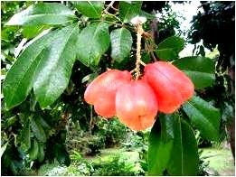
Fig 2.1 (The Ackee Fruits)

Fruit: red and yellow 7.5 -10 cm long

In Africa Ackee (Blighia sapida) is not a major food crop though Africa is its land of origin. However, in Jamaica it is the national fruit and Ackee cooked with salt fish is so well liked and hence called the national dish (Rashford, 2001; Bowen, 2005; Goldson, 2007).
In West Africa growth of wild Ackee is in the forest where they are seen as and admired as ornamental plants, shade and as wood but not as a major food source (Rashford 2001; Lancashire (2006). Ekume (2010) reported that it is distributed widely across Coted’Ivoire, Ghana, Liberia, Guinea, Senegal, Cameroun, Benin, Nigeria and Togo with very little cultural
significance.”Ackee” is a word derived from the Twi language “Ankye” (Akintayo et al., 2002). In West Africa it is also called Insin ( Nitchel et al.,2001) .
Geographically they are in the tropical and temperate regions of the globe with a majority of the species as native of Asia with a few in Africa and South America (APG II 2003). Esuoro and Odetokun (2005) reported that the plant can also be found in the drier forest of these savannah regions. In Nigeria it is commonly known as Ackee and called Gwanja Kwa (Hausa), Insin (Yoruba ) and Okpu (Igbo ) ( Morton, 1987 ). It is also known as arbo de seso and sesovegetal by name in Spanish, Panquesito (Columbia), aki (Costa Rica,Castanheiro de Africa (Portuguese) (Micheal et al., 1998). (Rashford, 2001) reported that in Jamaica it is referred to as the ‘Big Ackee’.
It is on record that Thomas Clarke introduced Ackee to the Eastern parishes in 1778, however it was captain Bligh who took the unnamed tree to Kew Garden in the year 1793 and got named as Blighia Sapida in his honor by Koenig (Koenig, 1806; Rashford 2001; Lancashire (2006).
Lancashire et al., (2004) reported Thomas Clarke was Jamaica’s first botanist. In Jamaica Ackee has become a major economic crop, despite the numerous reports of its poisoning nature at least since the 1880 named the Jamaica vomiting sickness which was found to be caused by Ackee,
Jamaicans held onto the fruit and has been home to Ackee research dating back to the 1950s.
Ackee was outlawed In Trinidad in 1900 after it had caused some fatalities and banned from the
US for 27 years until 2000 when it was allowed to be imported again. It does not thrive in the West Indies except in Jamaica. (Morton, 1987).
Research did include identifying natural toxic chemicals in the Ackee and how maturity changes these chemicals in various parts of the Ackee fruit. How these natural chemicals changes with cooking and identifying other natural chemicals with medicinal potential (Golden et al., 2002, 2006; Webster et al., 2006).

2.1.1 Botany and Agriculture
Ackee presents as shrubs and trees and tendrils bearing vines with about 140 to 150 genera and a total of 1400 to 2000 species worldwide (Adeyemi, 2011 )
Ackee is an evergreen tree and grows to a height of 7- 25 m high (fig 2.2). When young the Ackee fruit is green turning red or yellow on maturation. The portion that can be eaten is called the aril and is found in the mature opened pod. Arils must be separated completely from the seed and the red membrane attached to it be removed. Three pegs are found in an average Ackee pod, less frequently 2 or 4 and rarely 5 pegs.
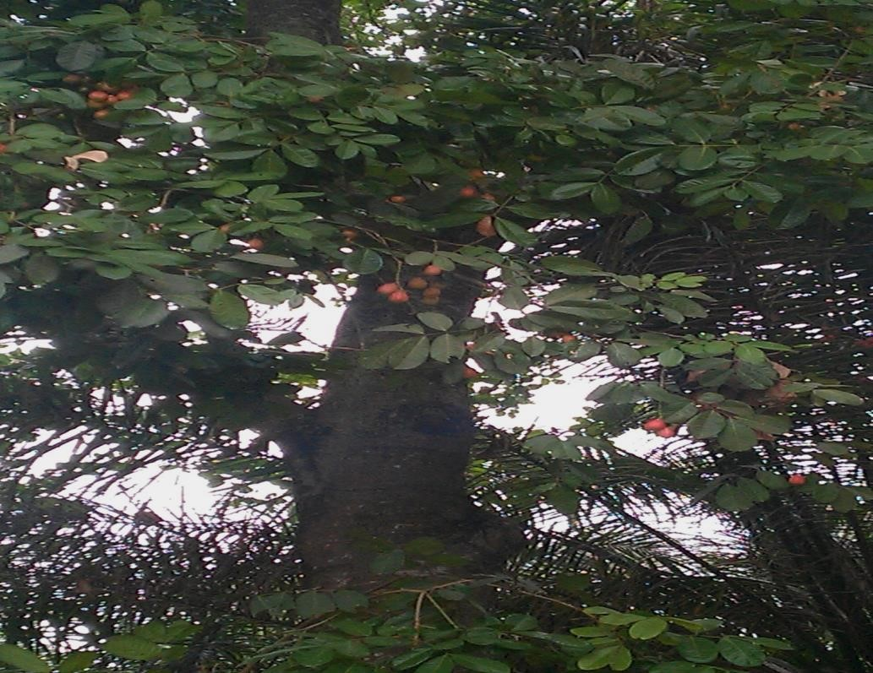

Fig 2.2 (The Ackee Tree )

The fruit is pear shape and splits open on maturation into 3 cream or butter colored fleshy,and glossy arils which are nutty- flavoured and are attached to a black nearly round smooth ,hard shinny seeds (Janick, and Pauli 2006). This was supported by Akintayo et al.,(2000 ) who reported that fruit color of the Ackee ranges from straw to bright red and that the fruits whilst on the tree split open to expose 3 blade glossy seeds surrounded by arils which is thick ,oily and yellow in colour (fig 2.3).The fruits also have fatty acids , vitamin A and protein in abundance (Shama et al., 2009)
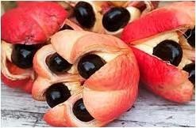

Fig 2.3 (Mature Splitted Ackee Exposing Glossy Seeds)

The “cheese” and “butter” are 2 types of Ackee recognized in Jamaica. The “butter” aril is yellow in color and soft and during cooking loses it shape easily. The “cheese” aril is creamy and hard, when cooked it retains its shape. Mitchell et al., (2008) reported that the cheese variety is preferred by processors for export because it retains its shape during cooking.

2.1.2 Leaves
Leaves of the Ackee are compound with 3 to 5 pairs of oblong, ovate –oblong ,or elliptical leaflets which are 1.5 – 3.0 cm long (Aderinola et al., 2000). Leaves of the Ackee tree as reported by
Akintayo et al.,(2002 ) are pinnate shape of about 10cm wide (fig 2.4).
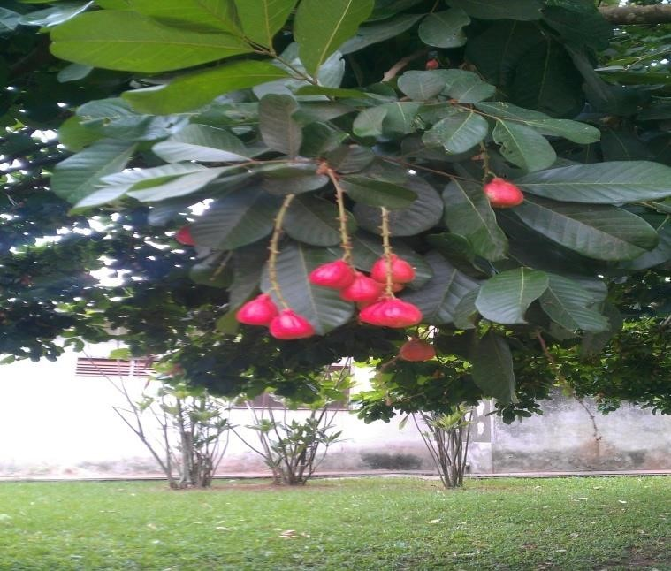

Fig 2.4 Leaves Of Ackee Plant

2.1.3 Propagation and culture
The Ackee fruit tree can be propagated in 3 principal ways (a) cuttings (b) grafting and (c) seeds. It is a plant that grows fast and little attention is required in its cultivation (Moya 2001). This was collaborated by RADA (2006), that Ackee can be propagated vegetatively by stem, cuttings, grafting and air layering; however, they can easily be propagated from seeds directly in the field.
At four years of age seedlings begin fruiting and the grafted trees do so in 1 to 2 years. For most parts of the year fruiting can be achieved but in the Northern parts fruiting is normally within December to May (Moya 2001).

2.1.4 Uses of the Ackee
Ekume et al., (2004) and Dossou et al., (2014) reported that Blighia sapida (Ackee) is a multipurpose woody perennial fruit tree species and is native to the Guinea forest of West Africa.
Different parts of the Ackee have been used for several purposes such as medicine, food construction, and cosmetics ( Ekue et al.,2000 ). The ripe Ackee fruit aril can be eaten dried, roasted, fried or used as soup in some parts of West Africa ( Ekume et al., 2010 ).
Some Ackee recipes with the aril
- Ackee and salt fish and other recipes (Grace Foods, 2007 )
- Ripe opened Ackee eaten raw and dipped in sugar (Rashford, 2001)
- Ackee and salt fish, fried Ackee , Ackee and rice, roasted Ackee ,Ackee stuffed breadfruit
(Rashford, 2001 )
- Ackee pudding and rum sauce (Gleaner, 2004 )
Akintayo, (2002) reported that the proximate analysis of Ackee arils is comparable to many seed oils and legumes.

2.1.5 Fresh and canned Ackee
Ackee is harvested when the mature pod is opened or unopened. However only Ackee that opens within 3 days of picking should be used. In the canning of Ackee, processors first receive the raw mature fruits from the suppliers either as open or unopened pods for ripening or mature opened pods from the tree. Unlike the opened mature pods, the mature opened ones are used immediately whiles the unopened mature pods are rack – ripened (Mitchell et al., 2008). This system of ripening is documented and controlled as part of the entire production process by the Bureau of standard as stipulated in the processed food Act of 1959 (RADA 2006b).
Jamaica and US exports of canned Ackee earned them US 4.3 million for 1,507,635 kg of Ackee in 1999 and US 8.5 million in 2002 (observer 2004, as cited by Mitchell et al., 2008 ). Blighia sapida widely cultivated in Jamaica had an annual turnover of US 400 million in the Ackee aril trade. Fresh or dried arils are traded also in Benin regional markets providing huge amounts of revenue for farmers especially women (Pen, 2006). Blake et al., (2006), reported that several tonnes of canned “Ackee in brine” are produced in Jamaica and exported to the United Kingdom and Canada. This generates revenue of 13 million US dollars per year.

2.1.6 Other Uses
The Ackee tree can also be used for other things such as construction and made into oars and paddles all these are made possible due to the durable and hard nature and resistance of the Ackee tree to termites. It has also be used for washing as the green fruits can produce soapy suds in water. Pods extract have also been used in cosmetics, whereas in Cuba cologne has been made from an extract of the flowers (Bowen, 2005). Khan and Gumbs (2003), reported that Ackee is also a repellant when it comes to the fruit component against insect pest of stored products. Seed oil of the Ackee has pesticidal properties and crushed fruits can be used to poison fish. Rashford (2001) and Ekue et al., (2001) also reported that the seeds and capsules are used to poison fish by sprinkling it in water bodies surfaces to anesthetize them for easy catching.

2.2. MEDICINAL PROPERTIES
The Ackee plant is a very good remedy for cold and pain and has insecticidal properties (Mitchell and Ahmad, 2007). The bark of the Ackee species can be used as ointments to relieve pains. Ripe arils together with sugar and cinnamon have been used in dysentery treatment .Fresh leaves when crushed can relieve severe headache when applied to the forehead whereas an application of leaves crushed with salt has helped in ulcer treatments. Ackee pods poutice has been used to treat ringworm, liver spots and skin infections (Rashford 2001; Bowen 2005). Lancachire, 2006; Goldson, 2007). In the treatment of diseases of the eye such as conjunctivitis and opthalmia, the juice of the leaves has been employed as well as the treatment of certain conditions such as dysentery, yellow fever, and epilepsy (Kean and Hare 1980). Gbolade (2009) has also reported its use in the management and treatment of diabetes.
The roots are used in conjunction with xylopia aethiopica to terminate pregnancy (Abolaji, et al., 2007). The capsules, seeds, roots, bark and leaves have been identified in the treatment of twenty two diseases in Benin. The Ackee tree has various parts used in preparation of traditional medicine for the treatment of malaria, fever, intestinal hemorrhage, dysentery, diabetes, yellow fever and constipation in West Africa (Ekue et al.,2010). Extracts from Ackee roots bark have a significant hypoglycemia effect on the normoglycemic albino rats (Saidu, et al., 2012). Antwi et al.,(2009) reported Pharmacological screening carried out on some constituents of the plant extracts and the anti– diarrhea activity of some constituents of the plant extracts.

2.3 TOXICITY
Goldson (2007) reported in the year 1880 an illness of unknown cause was found in Jamaica and it is now known as the hypoglycemic syndrome.The disease was formerly called Jamaica vomiting sickness (JVS). Although ackee was first implicated as the causative agent of the disease, it was unclear how it caused this disease because it was safely widely eaten. In 1948 the UWI was established and JVS was one of the diseases that it did research on. This research resulted in the discovery of two unusual amino acid components Hypoglcin A and B. These two amino acids were found to have similar toxicity as that of the JVS. Hassal and Reyle (1954, 1955). Morton et al., (1987) also reported that it was initially thought that the toxicity of the Ackee fruit was from the membranes attaching the arils or in the overripe and decomposing arils, but it was now known that the cause is the hypoglcin A contained in the unripe arils and as jackets of the fruit split open and gets exposed to light, the toxicity levels reduce. Arils still contain about one out of twelve of the amount of this toxin in the unripe fruit.
Clinical and chemical studies in Ackee fruit have indicated that it contains toxic substances called Hypoglcin A and Hypoglycin B (HGB). Hypoglcin A is (alpha-amino-beta-2 methylene cyclopropyl) propionic acid (Kean and Hare 1980; Orane et al.,2006 ). Golden,(2002) reported that the content of hypoglycin A in the ripe fruit to be 100 times lower than that of the unripe fruit.
The hypoglycin A is believed to be destroyed by light as the mature fruit splits open (Barennes et al., 2004). Bowen (2005), also reported that levels of hypoglycin A reduces 13 fold in the arils of the fruit whiles the level of hypoglycin B increases 7 fold in the seed during maturation. For the aril and membrane of the Ackee fruit the concentration of hypoglycin A in them is equal as the fruit matures and membranes contain about 40 ppm of hypoglycin A even at the edible stage (Brown et al., 1992). Hypoglcin B is only found in the seed and is of a lesser toxicity as compared to hypoglycin A, hypoglycin A is found in the aril of the Ackee and is water soluble hence should not be cooked with any other food and the water used in cooking should always be discarded. Golden et al., (2002) also reported that the arils become edible when the fruits ripen and that hypoglycin A is efficiently removed from the edible aril when the Ackee fruit is boiled in water for approximately 30 minutes.

Symptoms of Jamaica vomiting diseases
It was reported by Goldson (2007) that eating of the unripe Ackee aril results in symptoms which include vomiting, drowsiness, muscle and mental exhaustation, hypoglycemia and nausea. Young children on ingestion of the unripe Ackee die within a few hours. Treatments of these symptoms have to be fast and early administration of sugar and glucose is recommended although there is no standard treatment method.
Incidence of Jamaica vomiting sickness fatalities are rare now due to increased awareness that only ripe opened Ackee should be eaten ( Lancashire, 2006). However Mogya (2001), and Joskow et al., (2006) reports that outbreaks still occur, especially in young malnourished children ,recently in Haiti and West Africa. Therefore Ackee must “smile” before being picked off the tree is a traditional saying (Rashford, 2001).
Ocran et al., (2004) also reported that younger children in the lower socioeconomic ladder are most prone to hypoglycin toxicity when it occurs.
One or two distinct types of hypoglycin poisoning can be observed. In one form it is characterized by vomiting followed by a period of remission of about 8-10 hrs, convulsion and coma. In the other type it starts with convulsions and coma at the beginning, elevated liver function, and cholestatic jaundice has been found to be associated with chronic fruit ingestion (Larson et al.,1994).

2.4 CHEMICAL AND NUTRITIONAL COMPOSITION OF ACKEE
Extracts of Ackee has also indicated the presence of certain phytochemicals as saponins, reducing sugars, phytosterols and polyamide through phytochemical investigations (Antwi et al.,2009). The oils of the Ackee seeds are less dense than, cotton seed and canola oils. It has a specific gravity of less than 1 and iodine value of 90-94.5, this is lower than that of olive oil and soya bean (Howele et al., 2010 ; Anderson-Forster et al 2012; Adepoju et al.,2013; Oyeleke et al., 2013).

Table 2.1 Nutritional composition of Ackee arils
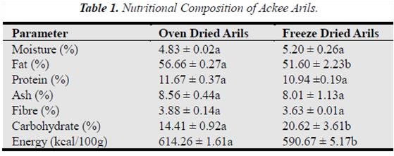
(Dossou, 2014)

2.5.1 Mineral composition
Howele et al., (2010), reported that there was more Zinc in Ackee fruits aril than roasted peanuts making the arils of Ackee a good source of Zinc. Zinc can serve as a major mineral for pregnant women. Akintayo et al.,(2002), Howele et al., (2010) and Oyeleke et al., (2013) all reported arils to be rich source of magnesium, calcium, potassium and sodium, with potassium being the most predominant mineral.

Table 2.2 mineral composition of Ackee Arils
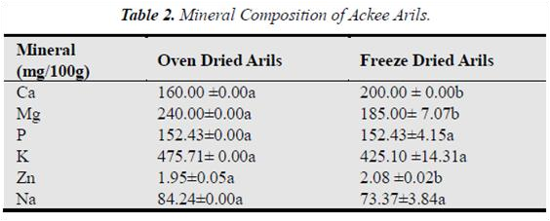
(Dossou, 2014)
Anderson et al., (2012), reported that Oleic, Palmitic,Linoleic and Stearic fatty acids are acids known to reduce diseases such as coronary heart diseases are abundant in Ackee aril oils .

Table 2. 3: Fatty Acid profile of Mature Arils of Cheese and Butter Ackee Varieties
Fatty Acid | Cheese Variety | Butter Variety (mg/ g)
Oleic Acid ( 18:1) | 143.5 +41.3a | 146.2 +4.3 a
Linoleic Acid (18:2) | 11.4 +2.8a | 7.2 + 1.7a
Palmitic Acid (16:0) | 80.2 + 15.6 a | 42.2 +9.0 a
Stearic Acid (18:0) | 47.0 + 9.7a | 36.7 +9.4 a
Linolenic (18:3) | 1.7 + 0.4 a | 9.9 +2.3a
Adapted from (Emmanuel et al., 2013 )

2.6 ANTI-NUTRIENTS
Anti-nutrients are natural or artificial compounds that interfere with the absorption of nutrients in the body. Anti-nutrients or anti-nutritional factors may be defined as those substances generated in natural feedstuffs affecting the normal metabolism of animal species and by different mechanisms (for example inactivation of some nutrients, and diminution of the digestive process or metabolic utilization of feed) which exerts effect contrary to optimum nutrition (Alobo, 2003).
Panhwar (2005), also reported that anti-nutritional factors are poisonous substances, found in most food which are able to limit availability of nutrients to the body. Controlled case and epidemiology studies conducted recently has indicated that majority of the anti-nutrients have beneficial effects example prevention of coronary and cancer diseases, if present in low levels in the food of humans (Redden et al., 2005).
Being an anti-nutrient is not an intrinsic characteristic of a compound but depends on the digestive process of the ingesting animal or humans (Alobo, 2003).
The negative effects of ingestion of anti-nutrients have been extensively reported. Anti-nutrients factors such as trypsin inhibitors affect protein utilization and digestion, phytic acids and tannins affect utilization of minerals, whereas lectins causes morphological damage to the villi of the small intestines and disruption of the small intestinal metabolism ( Francis et al., 2001).
The bioavailability of the essential nutrients in foods could be decreased in the presence of some antinutritional factors such as oxalates and cyanogenic glycosides (Akindahunsi and Salawu, 2005).

2.6.1 Classifications
Antinutritional factors (ANF) are structurally different compounds and are broadly divided into 2 categories.
Proteins such as (lectins and protease inhibitors and others such as tannins, phytic acids, saponins, oligosaccharides and alkaloids (Martin – Cabrejas et al.,2009). Francis et al., (2001), also reported that the antinutritional factors can also be classified based on their ability to withstand thermal processing which is the most common employed treatment to destroy them. Heat liable factors include lectins and heat stable factors include saponins.
Aletor (2005), classified antinutritional factors into groups based on their chemical structure, specific action brought by them or their biosynthetic origin. However Soetan and Oyewole (2009), reported that despite the fact that these classifications do not include all known groups of antinutritional factors, it represents the list of the frequently found anti-nutrients in food for humans.They also reported that anti-nutrients can also be divided into two broad categories , the proteins e.g. lectins and protease inhibitors which are heat sensitive to the normal processing temperatures and other anti-nutrients which are not heat sensitive to these processing temperatures example condensed tannins, non-proteins amino acids, galactomannan gums, polyphenolic compounds among others.

2.6.2 Effects of processing methods on anti-nutrients
Most anti-nutrients effects in plants can be removed by several processing methods, and they include soaking, germination, boiling, autoclaving and other processing methods (Soetan, 2008). Other people have collaborated these findings and have also made other findings. These include reports by Habiba (2002), Wang et al.,(2008) and Embaby (2010), that Levels of phytic acid, lectins and tannins were found to decrease considerably when heated especially with the moist heating methods like cooking, microwaving, autoclaving. Roasting was found to decrease phytic acid and tannins considerably (Frontela et al., 2008; Fagbemi et al., 2005).

2.7 SOME ANTIN-NUTRIENTS IN FOODS

2.7.1 Tannins
Tannins are flavonoids or polyphenol compounds which inhibit digestive enzymes and may also precipitate proteins (Beechen, 2003).
Tannins are astringent, or bitter polyphenol compounds found in plants that bind onto proteins and also precipitates it; it also binds other organic compounds including amino acids and alkaloids (Katie et al., 2006; McGee and Harold 2004). Astringent nature of tannins has been related to their affinity to proteins, when in the mouth they bind with saliva proteins or oral mucosal proteins to give this feeling. (Kallithraka, et al., 1998)
Tannin is a french word used for a range of natural polyphenols (Khanbabaee and Van Ree 2001). Tannins have traditionally been considered as an antinutrient but currently it is now known that their beneficial or antinutritional properties depend on their chemical structure and dosage.
Schofield et al.,(2001), also stated that originally the name “ tannins “ was used to describe extracts from vegetables used in the conversion of animal skin into stable leather and tannins from oak used in the tanning of animal hides into leather hence the use of the words ‘tan’ and ‘tanning’ when it comes to the treatment of leather . The word ‘tanning’ is very old and it reflects a traditional technology. This assertion was also made strong by Mueller ( 2001 ), that ‘tannins’ was a word used to describe the transformation of raw animal hides into durable leather in scientific literature from plants extracts such as fruits, wood, leaves and fruit pods .
Tannins are sometimes also called plant polyphenols (Haslam et al., 1989). The name ‘tannins’ originally were given to the extract of the plant without knowing their chemical structure although it was known to exhibit astringency. It was differentiated from other plant polyphenols types mainly due to their unique ability to bind proteins, pigments, large molecular compounds, metallic ions and antioxidants (Okuda 1985). This explains why in the quantitative analysis of tannins unlike other polyphenols in general it is based on their binding capacity activity.
Hernes and Hedges (2002), reported that tannins which are polyphenols of plants are estimated to be the fourth most abundant biochemical in terrestrial biomass following cellulose, hemicelluloses and lignin.
Majority of early reports relating to the antinutritional effects of tannins were centered on tannic acid and other hydrolysable tannins. Hydrolysable tannins are present only in trace amounts in commonly consumed foods; the more predominant condensed tannins are of more concern reason being due to their antinutritional effects. The implication of food tannins on health is one of public concern. However they have also been considered to be anti-carcinogenic and anti-mutagenic. These protective effects are related to their capacity to act as free radicals scavengers and activate antioxidant enzymes.
Some benefits of tannins
- Tannins exhibit significant biological functions such as protection from degenerative diseases and oxidative stress. Oxidative stress plays a pivotal role in the pathogenesis of degenerative diseases and aging results in oxidative alteration of biological macromolecules such as proteins, lipids and nucleic acids. (Becker et al., 2004 )
- Tannins enhance glucose uptake through mediators of insulin –signaling pathways. The reduction in blood glucose level caused by phenolic compounds has been attributed to such actions as a reduction in the absorption of nutrients (Shimizum et al., 2000)

2.7.1.1 Occurrence
Tannins are found in all plants and world climates all over. They play roles which include growth regulations. Quantities of tannins in lower plants such as algae, fungi and mosses are low. This indicates that the percentage of tannins in plants vary (Stephane, 2004). It has been reported by Jacobs (2011), that around 180 families of dicotyledons and 44 families of monocotyledons are distributed widely in different geographical regions and they have varying concentration of tannins in different composition and complexities status. Reports are that, in terms of the human diet they constitute the most abundant antioxidants, and the major dietary sources of tannins include vegetables, fruits and non-edible plants (Han et al., 2007).
Tannins are found in the following plant tissues
- Seed tissues – mainly in a layer between the outer integument and the aleurone layer. They have been associated with the maintenance of plant dormancy
- Stem –found in the active growth area of the trees, such as the secondary phloem and xylem and the layer between epidermis and cortex. Tannins may have a role in the growth regulation of these tissues. They are also found in the heartwood of conifers and may contribute to the natural durability of wood by inhibiting microbial activity
- bud tissues –most common in the outer part of the bud, probably as protection against freezing
- Root tissues –most common in the hypodermis they probably act as a chemical barrier to penetration and colonization of roots by plant pathogens
- Leaf tissues – most common in the upper epidermis. However, in evergreen plants, tannins are evenly distributed in all leaves. They serve to reduce palatability and thus protect against predators.
Tannins have also been found in certain parts of the plant which include barks, flowers, fruits as reported by (Puupponen-Pimia et al., 2001). Some plant based products as documented by Vottem et al., (2005) containing tannins include chocolate, ice creams, peanut, and fruit juices.

2.7.1.2 Chemical structure and classification
Tannins are large molecules and their molecular weight is between the regions of 3000Da and more than 50 KDa. Structure-wise they are made up of aromatic rings and have OH groups that bind to protein proline sites through hydrogen bonding and hydrophobic interaction (Jobst et al., 2004).
Loggerenberg, 2004 reported that the enormous structural variations among tannins have made it difficult to develop models which allow accurate predictions of the effect of tannins in any system.
Tannins was first classified into two groups Catechol type or catechin type tannins and pyrogall type tannins in accordance to the polyphenol groups in their molecules. Improvements in tannins chemistry however led to the renaming of these two groups to hydrolysable tannins and condensed tannins. In terms of structure, Santos et al., (2000) stated that the tannins have 12 – 16 phenolic groups and 5 -7 aromatic rings for every 1000 units of relative molecular mass (fig) with molecular masses ranging from 300 – 5000 Da as reported by (Rawel et al., 2007; Kulling et al., 2008).

2.7.1.4.1 Hydrolysable tannins
The hydrolysable tannins have a lower molecular weight of 500-3000 and are polysters of gallic acid (gallotannins) and hexahydroxy-diphenic (ellagitannins) with a central polyol such as glucose and phenolic such as catechin (Crespy and Willamson2004). This assertion was also collaborated by Khanbabaec and Ree (2001), who also reported that hydrolysable tannins are present in plants as gallotannins or ellagitannins .The hydrolysable tannins can be hydrolyzed when heated with tannases or hot water. They reported that tannins also contain a central core of polyhydric alcohol such as hydroxyl and glucose groups. They can be esterified partially or wholly by gallotannins (gallic acid) (Khanbabaee and Van Ree 2001). This was also confirmed by Santos et al., (2000) who reported that hydrolysable tannins are esters of phenolic acids (usually gallic acid as in gallotannins or other phenolic acids obtained from oxidation of galloyl residues as in
ellagitannins).
Hexahydroxydiphenic acids ( ellagitannins ) are also made up of at least two galloyl units that are C- C coupled to each other and do not contain a glycosiodically liked catechin unit Gallotannins yield glucose and gallic acids on hydrolysis with bases , acids or certain enzymes . Hydrolysable tannins have less complex structure than condensed tannins and they can be oligomeric and polymeric proanthocyanidins formed by linkage of C-4 of one catechin with C-8 or C-6 of the next monomeric catechin (Khanbabaee and Van Ree 2001). Hydrolysable tannins can be found in Rice, oat, and strawberries.

2.7.1.4.2 Condensed tannins
Molecular weight of condensed tannins are in the range of (1900 – 28000) and have no carbohydrate core but are made up of a group of polyhydroxy-flavan-3-ol oligomers and polymers linked by carbon- carbon between flavanol subunits (Crespy and Wlliamson, 2004). Condensed tannins reactivity with molecules of biological importance such as metals, ions, proteins and polysaccharides has important physiological and nutritional implications hence the importance of determination of condensed tannins amounts in plant material (Shofield et al., 2001). Polyphenols that are abundant in nature are the condensed tannins and are found in almost all plants families.
They inhibit digestion by binding to the proteins in the plant consumed (Adeparusi, 2001).
Condensed tannins can be found in Coffee, tea, wine grapes, strawberries, apples, apricots, and dry fruits.Condensed tannins are more resistant to microbial decomposition than the hydrolysable tannins .

2.9 PHYTATES
According to history phytates were discovered in 1903 (Mullaneyet al., 2012; Klopfensten et al., 2002). Phytates (myo-inositol hexaphosphate) are presented as salts of mono and divalent cations such as Mg²⁺,Ca²⁺ and K⁺ which accumulates mostly in the seeds during ripening of fruits . They serve as a reservoir for cations and, phosphoryl groups of high energy ( Loewus, 2002 ). Weaver and Kannan (2002 ), reported phytates works in a broad pH range as a highly negatively charged ion, making their presence in the diet a disadvantage due to their negative impart on the bioavailability of divalent and trivalent mineral ions such as Zn^{2, +}Fe²⁺, Ca²⁺, Mg²⁺ Mn²⁺ and Cu²⁺. However high levels of phytates in diets causing mineral deficiencies will be dependent on what else are being eaten. For parts of the world where cereals are a major dietary factor associated phytates intake is a cause for alarm (IUFST 2008). Aberoumon (2009), also mentioned that phytates are a major component of storage organs of plants and they act as a source of phosphate for the process of germination and growth .
Weaver and kannan (2002), reported that consumption of phytates in ruminants is not a problem or matter for concern due to an enzyme in their first chamber which is able to separate phosphorus in the phytates. Mullaney et al., (2012) and Klopfenstein et al., (2002) reported that phytates cannot be digested by humans or non ruminants hence not a source of either inositol or phosphate if eaten directly. Phytates are a saturated cyclic acids and they are the principal form in which phosphorus are stored in plants.
Tubers which include potatoes, cassava and yams on a wet weight basis contain approximately 0.05 %- 0.10 % phytates (Phillippy et al., 2003).On dry basis roots and tubers contain as much phytates as in seeds. Seeds contain phytates in the range of 0.5 -1.0 % (Phillipy, 2003)

2.9.2 Detrimental effects and interactions on food
Levels of phytates in foods have been found to depend on growing conditions, harvesting techniques, processing method and test method. Food grown using modern phosphate levels tend to have high levels of phytic acid in them as compared to those growing in natural compost. Weawer and Kannan (2002), reported that phytates can decrease the bioavailability of critical nutrients such as Fe, Zn, Ca and Mg in food such as nuts, wholegrain, and legumes due to its ability to chelate and precipitate minerals. It was explained by AdeniyI et al., (2009), that absorption of the soluble calcium ions in the diet was prevented due to too much soluble oxalate in the body as the phytates bind the calcium ions to form insoluble calcium oxalates complexes. Benefits of

phytates
Phytates also can exhibit positive effects on glucose and cholesterol level in the blood (Lee et al.,
2007). Phytates play beneficial roles as an antioxidant and anticarcinogen (Jenab and Thompson, 2002).

2.9.3 Detrimental effects on humans
For a good health , levels of phytates should be very low .The optimum it should be is 25mg or </100G or to about 0.3% of the phytates containing food eaten .It has been established that phosphorus retention decreases when phytates in the diet is 30-40 % or more of total phosphorous.
Ellis et al .,(2001) reported that intake of phytates exceeding 800mg /day is a cause for concern. Researchers have indicated that humans will approximately absorb 20 % of more Zn and 60 % Mg from our diets in the absence of phytates in the diet.
Phytates can be produced in humans but far less than those produced in mice making mice not affected by high phytates rich diet. This means humans cannot safely consume large quantities of diets rich in phytates on a daily basis however because probiotic lactobacilli and other digestive micro flora can produce phytases which is an enzyme that can breakdown phytic acid to release phosphorous, individuals who tend to have high level of this flora in their intestines can have an easier time with foods rich in phytic (Layrisse 2000).
The seriousness of phytates effects can be appreciated from a report on Malaysia by Norhaizan and Faizadatul (2009 ), that Malaysia mineral deficiency was due to its low bioavailability in diet and that phytates was one of the factors that acted for that, anemia due to deficiency of Fe was around 969,645 and osteoporosis due to Ca deficiency was 2,421,432 cases.
People with the tendency to form kidney stones are advice to avoid oxalate rich diets as oxalates bind calcium to form complexes (Adeniyi et al., 2009)

2.10 OXALATES
Oxalates are anti-nutrients found in plants. They are derived from oxalic acid (HOOC-COOH). An example is calcium oxalate which is widely found widely distributed in plants (Liebman, 2002). Under normal conditions oxalates as anti-nutrients are stored in different compartments but upon processing of food or digestion it gets into contact with the nutrients in the gastrointestinal tract (
GIT) (Liebman et al., 2011). Upon releasing its acid form oxalic acid binds with nutrients in the gut decreasing their bioavailability to the body. Consuming foods with excess amounts of oxalic acid can cause nutritional deficiencies as well as severe irritation to the lining of the gut (Reyersand Naude, 2012).
Poeydomenge et al., (2007), also reported that oxalates can be found as free oxalic acid or as soluble and insoluble oxalates in plants. The soluble forms are salts of oxalic acid and sodium, magnesium, or potassium with magnesium oxalate being less soluble than potassium, and sodium salts. The insoluble forms occur when oxalates bind with calcium and iron.
Oxalates distribution in plants is not even. It is highest in leaves followed by seeds and the lowest in the stems. It is also known that oxalic acid quantity in animal products is lower than in plant products making meat an option when planning low oxalate diets (Horrocks et al., 2008).
When it comes to humans majority of the oxalates in the diet are absorbed at the proximal portion of the GIT through passive and active uptake processes. Oxalates absorption rates vary from food to food and it is in the region of 2% to 15 % and this mechanism or process is dependent on certain factors like presence of divalent cations such as calcium and magnesium which bind oxalates in the GIT, and the presence of oxalate – degrading bacteria in the gut (Massey et al 2001). Liebman et al., (2011), also made an interesting report by stating that when it comes to humans they lack the enzymes necessary to metabolize dietary and endogenous oxalates, and that little oxalate catabolism has been reported to occur after absorption by humans and the oxalate concentration absorbed more than 90 % can be recovered within 24 -36 hrs in the urine after ingestion. Oxalobacter formigenes which is an anaerobic bacterium however can degrade 40 % of Oxalates to substances which are non-toxic.
Further reports from Umaru et al., (2007) indicated that oxalic acids and oxalates excretion from the human body depending on the chemical form and metabolic processes available differs, example whereas circulating oxalate can be excreted through the urine, excretion of insoluble calcium oxalate produced in the gut is by degradation by gastrointestinal bacteria example Oxalobacter formigenes before elimination through feaces.

CHAPTER THREE

3.1 MATERIALS AND METHODS

3.2 SOURCE OF RESEARCH MATERIALS
Materials investigated was the fresh arils of ripened Ackee fruit (Blighia sapida), obtained from Boadi farms in Kumasi. Fruits were carefully harvested in September 2014, with a sickle.

3.3 SAMPLE PREPARATION
Fresh arils were removed from the seeds with a sharp knife and put into a clean bowl and the red thin lining membrane (Raphe) was also removed. Samples were then washed with clean water and unwanted materials sorted from it. The arils were then cut into small pieces to facilitate easy drying. Samples were thoroughly mixed together. Grouped samples were then given different cooking treatments after which all samples were then dried at 60 ˚C for 18 hours.
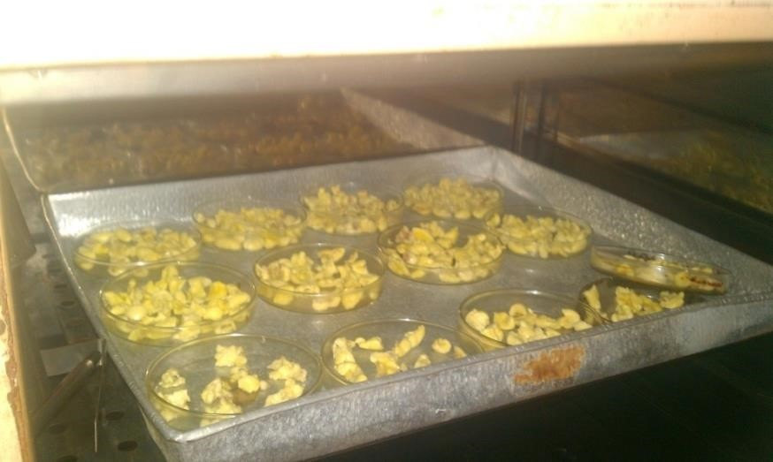
Fig 3.1 Drying of ackee arils in an oven

3.4 TREATMENTS

3.4.1 Boiling
About 30g of clean fresh aril samples about 30g was divided into three of 10g each. These were boiled after adding distilled water in a ratio of 1:10 (w/v). The first portion was boiled for 20 minuites while the second and third portions were boiled for 30 and 40 minutes respectively in a hot water bath. The water was drained off after boiling and each sample dried in the oven dried at 60ºC for 18 hours. The dried samples were then put in a desiccator to cool well and weighed (fig
3.3). Samples were then milled with a blender into flour to obtain particle size of 1mm mesh size.
The period of cooking was started from time of boiling.

3.4.2 Steaming
About 30g of clean fresh aril samples was divided into three portions of 10g each were steamed with water at a temperature of 100˚C. The samples were in a colander and covered with plastic sheet and suspended over boiling water for 20, 30 and 40 minutes (fig 3.4). Temperature was monitored with a laboratory cooking thermometer.
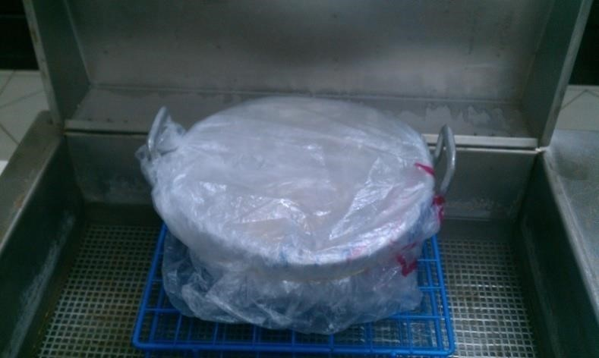

Fig 3.2 Ackee Arils Being Steamed In A Colander

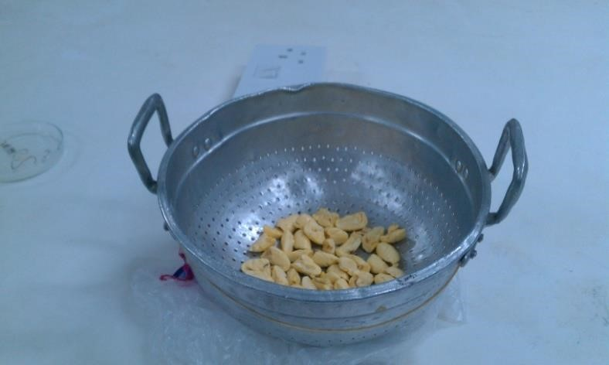

Fig 3.3 Ackee Arils In A Colander

3.4.3 Soaking
About 30g of clean fresh aril samples was divided into three portions of 10g each. Portions were soaked in distilled water at 1, 2 and 3 hours (fig 3.6).
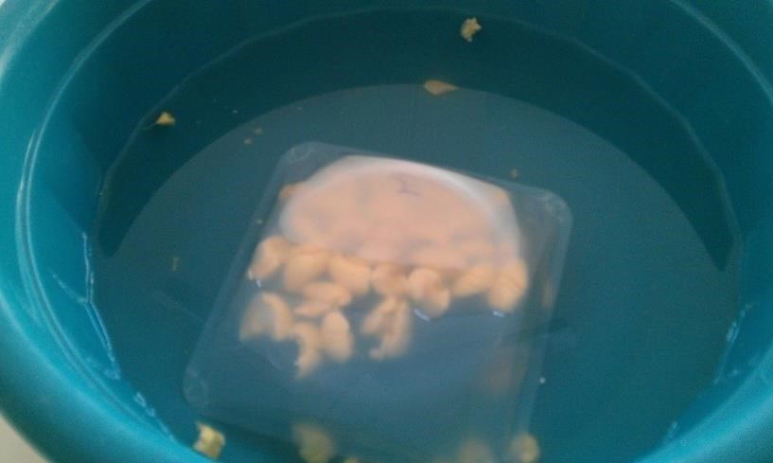s

Fig 3.4: Soaking Of Ackee Arils

3.4.4 Tannins determination
Tannins content was determined using the Ramirez and Roa (2003).
Preparation of standard tannic solution and standard curve
100g of tannic acid was dissolved in 100 ml distilled water to prepare standard tannic acid solution.

Preparation of standard curve
Ten millilitres (10 mls) of standard solution was made up to 100 ml. 1 -10 ml aliquots were taken in clear test tubes, 0.5 ml of Folin - Ciocalteu reagent and 1ml of sodium carbonate solution was added to each tube. Each tube was made up to 10 ml with distilled water. All the reagents in each tube were mixed well and kept undisturbed for 30 minutes and absorbance read at 760 nm against reagent blank.

Determination of tannic content
Powdered sample weighing 0.5 ml was transferred into 250 ml conical flask, and 75 ml of water added, the flask was gently boiled for 30 minutes. This was centrifugated at 2000 rpm for 20 minutes and the supernatant collected in a 100ml volumetric flask and the volume made up with distilled water. 1 ml of the sample extract was transferred into a 100 ml volumetric flask containing 75 ml water. 5 ml of Folin – Ciocalteu was then added followed by 10 ml sodium carbonate solution and diluted to 100 ml with water and shaken well. Absorbance was read at 760 nm after 30 minutes.

3.4.5 Phytates determination
Determination was done using Reddy and Love (1998) method
Four grammes (4.0 g) of the powdered sample was weighed into a conical flask, hundred millilitres (100 mls) of 2 % hydrochloric acid (HCL) was added to it to digest the samples for 3 hours and filtered using a filter paper. 25 ml of the filtrates was measured into a 250 ml conical flask and 5 ml of 0.3 % ammonium thiocyanate (NH4SCN) solution added. The mixture was then titrated against 0.1M ferrous chloride (Fecl₃) until a brownish-yellow color end point that persisted for 5 minutes was obtained. The phytates content was calculated as percentage phytates:
Titre value x constant (0.1635)

Oxalate determination
Oxalate was determine using the Iwuoha and Akalu (1994)
Two grammes (2 g) of the powdered sample was weighed into a 250 ml conical flask, 100 ml of distilled water was added and 5 ml of 6 M hydrochloric acid (HCl) was added. The mixtures were digested by heating in a water bath at 100˚C for an hour. Mixture was cooled and filtered using a filter paper and 2 drops of methyl red indicator added. Concentrated ammonium hydroxide (NH₄OH) was added drop wise until a faint yellow color was obtained. The mixture was then heated to 90 ºC in a water bath, cooled and filtered to remove ferrous ion precipitates. The filtrate was again heated to 90 ºC and 10 ml of 5 % calcium chloride (CaCL₂) solution was added with constant stirring. The mixture was then allowed to cool and then refrigerated at 5˚C overnight. It was then centrifuged at 2500 rpm for 5 minutes. The supernatants was decanted and the precipitates dissolved in 10 ml of 20 % sulphuric acid ( H₂SO₄) .The solution was made up to 100 ml with distilled water and titrated against KMNO₄ solution to a faint pink color which persisted for 30 seconds
The oxalate content was given by the relationship that 1 ml of 0.05 N Potassium permanganate (KMnO4) = 0.00225 g oxalate. The oxalate content was calculated using the formula:
% oxalate = 100 / W x titre value x 0.00225 where, W = weight of sample used (2g)

3.6 DATA ANALYSIS
The two-way Analysis of variance (ANOVA) was used to compare mean results.

CHAPTER FOUR

4.0 RESULTS AND DISCUSSIONS
The results obtained showed that the raw samples had the highest anti-nutrients when compared with the treated samples. The present study demonstrated reduction of the studied anti-nutrients in a time-dependent manner. This seems to suggest that increasing time may ensure complete elimination of these anti-nutrients in the ackee aril. The antinutrient reduction during the different heat treatments are also in agreement with other plant during heat processing as established by Ugwu and Orange (2006) and Jimoh et al., (2011).
In support to this present study Nwusu (2010) reported a time dependent reduction in phytates, tannins and trypsin content following cooking. The reductions in oxalate and phytates content during cooking could be advantageous for improving the health status of consumers, oxalates and phytates are anti-nutrients which chelate divalent cations such as Ca²⁺, Mg^{2+,} Zn²⁺ and Fe ²⁺ thereby reducing their bioavailability (Sandberg, 2002).

4.1 BOILING EFFECT ON ANTINUTRIENT CONTENT OF THE ACKEE ARILS
Boiling for 20, 30, and 40 minutes decreased antinutrient contents as shown in Figure 3.7. An indication that heating through boiling had an effect on anti-nutrient content. This observation has been confirmed by other researchers. Boiling is a thermal process hence resultant heat may inactivate these anti-nutrients (Akinyele, 1989). Boiling reduced trypsin inhibitor and other major anti-nutrients following perhaps their enhanced leaching into the heated water.

4.1.1 Effect of boiling on the phytate content of ackee arils
Increase in boiling time led to a decrease in phytate content. There was a percentage decrease of
66.67% in the phytate level after boiling for 20 min and after 30 min, the percentage decrease from the raw sample was 73.33%. After 40 min the phytate content of the ackee arils had reduced to 0.01635% (Fig 4.1) which represents 80% reduction from the control sample. This gave an indication that boiling for longer periods led to higher decrease in phytates levels in the ackee arils. Udensi et al. (2007) showed that thermal process has an effect on phytates in vegetable cowpea and also concluded that there is a reduction on phytic acid contents due to the thermal process. This reduction was attributed partly to the heat labile nature of the phytic acid and also the formation of insoluble complex between phytate and other components. This may have been the case for the ackee arils.
Reports from other plants source gave similar trend of reduction. Studies on chicken pea by researchers seem to suggest that heating decreased level of phytates as seen in the aril of ackee. Boiling of Indian chicken pea resulted in 12.3% loss in phytates (Mittal et al., 2012)
Levels of phytates when boiled at 20, 30 and 40 min were all significantly different from the levels in the raw ackee pulp. Boiling at 40 mins was also significantly different (p<0.05) from boiling at 20 mins with boiling at 40 mins having a lower (0.01635%) phytate level. Boiling at 30 mins gave a decrease in phytate level (0.0218 %) and this was significantly different from the levels in the raw ackee, as well (Fig 4.1).
Boiling for 40 minutes was the most effective for phytic acid reduction with 20 minutes of boiling being the least effective. Habiba (2002), Fagbemi et al. (2005) and Frontela et al. (2008) all also reported that phytic contents reduced similarly in other plant foodstuff. The apparent decrease in phytate content during boiling processes may partly be due to formation of insoluble complexes between phytates and other components such as phytates-protein and phytates -protein- mineral complexes or the inositol hexaphosphate may be hydrolysed to penta- and tetraphosphate (Siddhurajuand, 2001). Boiling is a thermal process hence resultant heat may inactivate these antinutrients. Akinyele (1989) reported that boiling reduced trypsin inhibitor and other major antinutrient following perhaps their enhanced leaching into the heated water (Ene and Obizoba, 1996). In general longer time of boiling resulted in lower levels of anti-nutrients; an indication that boiling for longer times has an effect on antinutrient content. This is a good observation as it increases digestibility of nutrients. Anigo et al. (2009) reported that phytates up to 1% could interfere with mineral bioavailability, including iron and calcium (Alonso et al., 2001). Thus the reduction of phytates level as observed in this study is indicative of improved safety and
bioavailability of nutrients in the ackee aril as a food source.
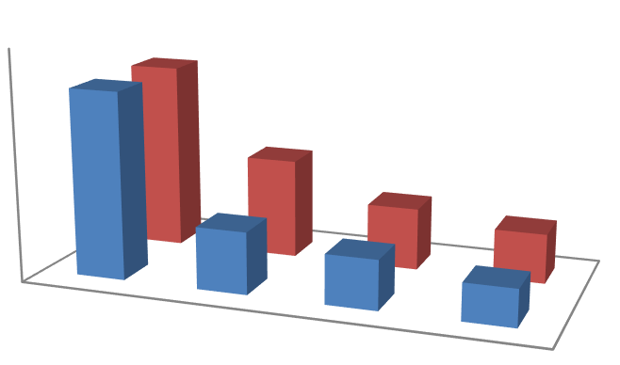

Boiling
steaming
0
0.05
0.1
control
20
min
30
min
40
min
0.08175
0.02725
0.0218
0.01635
0.08175

a

0.0436
b
0.02725

bc
0.0218

c
Phytate (%)
Treatments
Means with different letters are significantly different at 95 % confident interval

Fig 4.1. Effect of processing methods on Phytates

4.1.2 Effect of boiling on the Oxalates content of ackee arils
Oxalate content in ackee aril was influenced by boiling. Oxalates content decreased in the boiled ackee. Boiling for 20, 30, and 40 minutes significantly (p<0.05) reduced the oxalate content as boiling period increased. At 20 minutes of boiling the level of oxalate was 0.24375% and reduced to 0.1025% at 40 minutes of boiling (Fig 4.2). The percentage reduction of oxalate levels after 20 min of boiling was 20.7%. Boiling after 30 min was able to reduce the oxalate level by 51.22% while after 40 min, it was reduced by 67.07%. These reductions were all significant (Fig 4.2). This therefore implies that in order to reduce over half of oxalate levels in the ackee arils, boiling should take place for 40 min or more. From the significant reduction on oxalate levels in the arils, it could imply that increasing the boiling time could further reduce the oxalate levels by a greater percentage.
The decrease in oxalates as boiling time increased is confirmed in a study by Patricia et al. (2014) who reported a decrease in oxalates as boiling time increased from 15 minutes to 45 minutes in leafy vegetables. Ekop et al. (2005) also reported cooking of leafy vegetables as a detoxification procedure for removing these anti-nutrients. In the human body oxalic acid combines with divalent metallic cations such as calcium and iron. These oxalates can form larger kidney stones that can obstruct the tubules of the kidney. The ackee aril according to Dossou et al. (2014), contained appreciable amounts of calcium levels (160 mg/100g). Oyeleke et al. (2013) however reported 25.07 mg/100g, which is lower than what was reported by Dossou et al. (2014); and this could be attributed to the difference in climate conditions of growth of the crop, the soil quality and difference in variety. The iron content of the ackee arils according to Oyeleke et al. (2013) is 1.95 mg/100g; which is also appreciable. However, the presence of these oxalates in the ackee arils will prevent the absorption of calcium and iron into the body when consumed; since they chelate divalent metals like calcium and iron. Therefore the nutritive value of the arils in terms of minerals will reduce if the processing step such as boiling is not taken into consideration in the utilization of the ackee arils.
Effect of processing methods on oxalate content
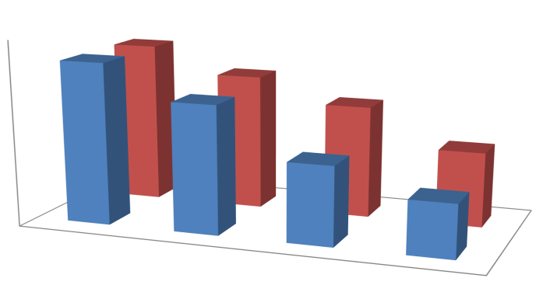
Boiling
Steaming
0
0.05
0.1
0.15
0.2
0.25
0.3
0.35
Control
20 min
30 min
40
min
0.3075
0.24375
0.15
0.10125
0.3075
0.25875
0.21375
0.1425
Oxalate (%)
Treatment
Boiling
Steaming
a
b
c
d
Means with different letters are significantly different at 95% confidence interval
21

Fig 4.2: Effect of processing method on oxalate content

4.1.3 Effect of boiling on the Tannin content in ackee arils
From the study there was a general decrease in tannin cotent as time of boiling increased. Tannin levels reduced from 136.38 mg/100g to 55.26 mg/100g after 20 min of boiling the ackee arils; which represented about 59.4% reduction. Therefore, after 20 min of boiling ackee arils more than half of the tannin level is eliminated. After 30 min of boiling tannin level had reduced to 48.57 mg/100g and then to 42.67 mg/100g after 40 min of boiling. Percentage decrease of oxalate levels in the ackee arils, from the control sample was 64.4% after 30 min of boiling and 68.71% after 40 min of boiling. This therefore implies that the reduction in tannin levels is drastic after the first 20 min of boiling but reduces steadily afterwards. This notwithstanding, there were significant differences (p<0.05) observed in all treatments; indicating that in order to greatly reduce tannin content in ackee aril, the boiling time would have to be greater than 40 min. Abeke et al. (2008) also reported a significant reduction in tannin content during the cooking of the Lablab pupurens beans. Mbah et al. (2012) reported that boiling reduces the tannin content of food when they reported a significant reduction of tannin levels in Moringa oleifera seeds.
The decrease in tannin content during boiling may be due to the fact that tannins are polyphenols and polyphenols are water soluble in nature (Kumar et al., 1979). This can imply that decrease in tannin content may be due to leaching out of phenols into the cooking medium under the influence of the concentration gradient (Vijayakumani et al., 1992).
Rakic et al. (2007) also reported that decrease in tannins occurs during boiling because they are heat labile and degrade upon heat treatment. Research done on chicken pea also revealed the same trend. Tannins however are fairly stable to heat as compared to the phytates and oxalates from the results which is in conformity with reports by Akinmutimi (2007) and Abeke et al., (2008). This could explain why percentage reduction in phyate and oxalate contents were higher than tannin content. The thermos-stability of tannins to heat has been explained by Akinmutim (2004) as due to extensive of intra-molecular forces within tannin. Tannins have been noted for their relative characteristic heat resistance (Jimoh, et al., 2011; Oladide, et al., 2011). Therefore in order to further reduce the tannin content in ackee arils a combination of soaking and boiling could help reduce it further, since tannins are water soluble.

Effect of processing methods on tannin content
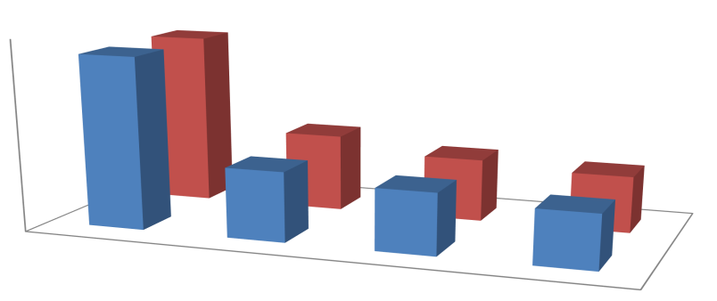
Boiling
Steaming
0
50
100
150
Control
20 min
30 min
40
min
136.18
55.26
48.57
42.67
136.18
61.35
49.75
44.83
Tannins (mg/100g)
Treatments
Boiling
Steaming
a
d
c
b
Means with different letters are significantly different at 95% confidence interval
23 Fig 4.3: Effect Of Processing On Tannin Content

4.2 STEAMING EFFECT ON THE PHYTATE LEVELS IN ACKEE ARILS
Ackee arils are very soft and melt easily if left in water for long. Another suggestion due to the soft nature of the ackee aril was to steam them. Steaming reduced the phytate content from 0.08175% to 0.0436% after 20 min. After 30 min the phytate level reduced to 0.02725% and after 40 min, 0.0218% (Fig 4.1). The reduction was not as high as boiling for the same time periods. After 20 min of steaming, the phytate content had reduced by 54.95% and after 30 min by 63.47%. The highest reduction of phytate in the arils occurred after 40 min of steaming; 67.08%. Despite these percentage reductions, no significant differences (p>0.05) were observed between the arils steamed at 20 and 30 min, and 30 and 40 min. Although increasing the steaming time may result in further decrease in the phytate levels, steaming up to 30 min will be ideal to reduce more than half of the phytate content in the ackee arils; since no significant difference (p>0.05) exists between 30 min and 40 min. There was however a significant difference (p<0.05) observed between the control ackee aril and the steam treated samples.
The decrease in phytate level during heating has been explained by Siddhuraju and Becker (2001) who reported that apparent decrease in phytate content during thermal treatment may be partly due to formation of insoluble complexes between phytates and other components example phytateprotein, phytate-protein-mineral complexes or to the inositol hexaphosphate hydrolysed to penta- and tetraphosphate. This is supported by other studies; heat processing specifically moist heat decreased to a substantial extent the levels of phytates (Habiba, 2002; Embaby 2010, 2011). Fagbemi et al. (2005) and Embaby (2011) also reported a decrease in phytate content after thermal treatment of samples; roasting. Thermal processing is one of the domestic technique which may reduce anti-nutrients, according to Hotz and Gibson (2007).

4.2.1 Effect steaming on oxalate levels in ackee arils
The steaming process also significantly reduced the oxalate content in the ackee arils (Fig 4.2) and this was time-dependent. The oxalate content reduced from 0.3075% in the raw ackee aril to
0.25875 after steaming for 20 min. After 30 min it reduced to 0.21375% and then to 0.1425% after 40 min of steaming, with reference to the control sample (raw ackee arils). The steaming process did not reduce the oxalate content as much as the boiling did but also had significant reductions (Fig 4.2). Percentage reduction of oxalate after 20 min of steaming was 15.85%, which was much lower than what was reported in the boiling process (Fig 4.2). After 30 min of steaming, the percentage decrease was 30.49% and after 40 min more than half of the oxalate content was eliminated (53.66%). A significant difference (p<0.05) in the mean oxalate content was observed amongst all the treatments including the control sample (raw ackee arils) (Fig 4.2).
The steaming process although helps to avoid the melting of ackee arils, it takes relatively so much time to reduce the oxalate levels in the ackee arils by half. The boiling therefore seems to be a better option for the elimination of oxalate content in ackee arils. While it takes the steaming process 40 min to reduce the oxalate content by half, the boiling process obtains this after 30 min.

4.2.2 Effect of steaming on the Tannins content in ackee arils
The tannin levels in ackee aril was found to be 136.18 mg/100g which reduced to 61.35 mg/100g after 20 min of steaming. After 30 min of steaming the tannin content had reduced to 49.75 mg/100g with reference to the control (raw ackee aril). The 40 min steaming resulted in reducing the tannin content to 44.83 mg/100g (Fig 4.3). Significant differences (p<0.05) were observed amongst all treated samples including the control sample (raw ackee aril). This implies that the reduction of tannins in ackee aril by the process of steaming is time dependent and increased time could result in more reduction of the tannin contents. Compared to the boiling process however, the steaming process may not be very effective at reducing tannin content in ackee arils. The tannin content was reduced up to 67.08% after 40 min of steaming, while the 30 min of steaming reduced it by 63.47% with reference to the control (raw ackee samples).
Other studies conducted gives credence to these assertions. Agunbiade et al. (2012) reported that tannins are highly heat sensitive and all contents of tannins of raw mature ackee was totally lost to ordinary steam cooking. More evidences are available in other works to prove the effect of heat decreasing tannins content; Abeke et al. (2008) reported several authors have also observed significant reduction in tannins content when Lablab pupurens beans was cooked.
The decrease could be related to the fact that antinutrient compounds are heat liable and degrade upon heat treatment (Rakic et al., 2007). Nithya et al. (2007) reported that reduction in tannin content during other thermal treatments like roasting might be due to the loss of compounds while treating at a higher temperature.

4.3 SOAKING EFFECT ON ANTINUTRIENT CONTENT OF ACKEE ARILS
There was a decrease in all the anti-nutrients investigated as time of soaking increased. This reduction may be attributed generally to leaching out of phytates, oxalates and tannins into the water. This was expected as other reports confirm this. Phillips and Abbey (1989), reported that steeping hydrates and induces leaching out of water soluble anti-nutrients such as phytates and tannins. Vidal-Valverde et al. (1992), reported that soaking could be one of the processes to remove soluble antinutrient factors which can be eliminated with the discarded soaking solution. Also some metabolic reactions can take place during soaking which affects some of the constituent compounds. However, Ackee arils cannot be soaked for longer periods especially overnight as with maize and beans as it dissipates into a liquid form. This observation was made during the trial stages of this studies. After a longer period of soaking, the arils melt and are difficult to pick up from the water being used for soaking. This therefore informed the choice of time intervals for the soaking of the ackee arils, used in this study.
However in all cases of the short periods of soaking there was decrease in the antinutrient content in all time durations of soaking, and this was time dependent, as the duration of soaking decreased antinutrient content in the ackee aril.

4.3.1 Effect of soaking on phytate levels in ackee arils
Soaking had an effect on levels of phytates and it was time dependent. Increasing the soaking time resulted in further decrease in phytate content. Ackee arils with phytate level of 0.08175% was reduced to 0.0545 after an hour of soaking, which further reduced to 0.03815% after 2 hours of soaking (Fig 4.4). After 3 hours of soaking the arils, the phytate content was 0.02725%. A significant difference (p<0.05) in phytate content was observed in the control sample and all treatments (Fig 4.4). However, there was no significant difference observed between 1 hour and 2 hours of soaking. While no significant difference (p>0.05) was observed between 2 hours and 3 hours of soaking, there was a significant difference (p<0.05) observed between the phytate content of ackee arils soaked at 1 hours and that soaked at 2 hours.
In terms of percentage decrease in phytate content of the ackee arils, the highest percentage reduction (66.67%) was seen in after 3 h of soaking the ackee arils. After an hour of soaking the ackee arils, the phytate content was reduced by 33.33% and after 2 h of soaking it was reduced to 53.33%. Although no significant difference (p>0.05), in terms of the mean phytate content was observed between 2 and 3 h of soaking, the percentage reductions 53.33% and 66.67%, respectively, indicate that it will be best to soak at 3 h to reduce a much higher proportion of the phytate content in the arils than to soak for only 2 h. As observed with the boiling effect on the anti-nutrients, the levels of anti-nutrients tend to reduce sharply after the first treatments but then tend to reduce steadily afterwards.
Reasons that can be ascribed to the decrease in phytate level could be due to hydration of phytates during soaking and the formation of insoluble complexes between phytate and other components of ackee pulp. Phytates decrease during soaking was good due to it deleterious effects as reported by Akande et al. (2010) and Agbaire and Oyewole (2012). According to them phytates decrease the protein digestibility and essential elements such as Ca, Mg, Zn, Fe and P by forming insoluble complexes which are not readily absorbed by the gastrointestinal tract. This claim is supported by other research studies. For instance, Frontela et al. (2008) reported phytate molecule is negatively charged at the physiological pH and it is reported to bind essential nutrients like Ca, Fe, Zn and Mg forming insoluble complexes making them unavailable for absorption. Again as reported by Dossou et al. (2014) and Oyeleke et al. (2013) ackee arils contain significant amounts of minerals such as Ca, Fe, Zn and Mg. The presence of phtates in the ackee arils will therefore reduce the micronutrient quality of the aril, since they will interfere with absorption.
Effect of soaking on phytate content
0.08175
545
0.0
0.0
3815
0.0
2725
0
0.01
0.02
0.03
0.04
0.05
0.06
0.07
0.08
0.09
control
1
h
h
2
3
h
Phytate (%)
Time of soaking
soaking
c
bc
a
b
Means with different letters are significantly different at 95% confidence interval
20

Fig 4.4 Effect of soaking on phytate content

4.3.2 Effect of soaking on oxalate levels in ackee arils
There was a general decrease in the levels of oxalate as time of soaking increased. However, unlike the phytate levels that decreased drastically, oxalate reduction was steadily. After an hour of soaking the oxalate content reduced from 0.3075% to 0.28875 and after 2 hours it reduced to 0.255% (Fig 4.5). The highest reduction of oxalate in the ackee arils occurred after 3 hours of soaking. No significant differences (p>0.05) occurred between the mean oxalate levels in the raw ackee arils and that soaked for an hour. Although there was a significant difference (p<0.05) between the mean oxalate levels in the raw ackee arils and that soaked after 2 hours, no significant differences (p>0.05) was observed between samples soaked at 1 h and 2 h, and between that soaked at 2 h and 3 h (Fig 4.5).
In terms of percentage reduction, after an hour, the oxalate content was only reduced by 6.10% which is very low compared to the reduction in phytate content by the process of soaking in ackee arils. After 2 h, the reduction was increased to 17.07% from the control sample and the reduction was highest after 3h of soaking at 25.61%. Therefore to achieve about a quarter of oxalate reduction in ackee arils, soaking has to be done for 3 h. This is not cost-effective and may not be a very good process for the reduction of oxalates in ackee arils. Exceeding 3 h will result in the melting of arils, therefore the boiling process compared to the soaking may be a better means of getting rid of oxalate in ackee arils. Boiling of ackee arils for 40 min resulted in a 67.07% reduction in oxalate content as reported earlier.
Although the reduction was very minimal the few reduction observed could be due to the leaching out of oxalate into the water. This decrease is good as Akande et al. (2010) reported that oxalates interfere with magnesium metabolism and react with proteins to form complexes which have an inhibitory effect in peptic digestion. Other researchers; Ladeji et al. (2004) and Agbaire (2012) reported that oxalate bind to Ca to form insoluble Ca oxalate crystals which prevent the absorption and utilization of Ca by the body thereby causing diseases such as rickets and osteomalacia. Ackee arils contain appreciable levels of calcium (Dossou et al., 2014; Oyeleke et al., 2013) and as a result the reduction of oxalate levels to increase bioavailability of the mineral is very important.
Calcium is required for bone formation in the body (Oyeleke et al., 2013).
Effect of soaking on oxalate
0.3075
0.28875
0.255
0.22875
0
0.05
0.1
0.15
0.2
0.25
0.3
0.35
control
1
h
2
h
3
h
Oxalate (%)
Time of soaking
a
ab
bc
c
Means with different letters are significantly different at 95% confidence interval
22

Fig 4.5 effect of soaking on oxalate

4.3.2 Effect of soaking on tannins levels in ackee arils
The tannin levels in the ackee arils drastically reduced after soaking for an hour, and then reduced further but steadily after 2 and 3 hours of soaking. After 1 hour of soaking, the tannin levels reduced from 136.18 mg/100g to 65.68 mg/100 and after 2 hours it reduced to 62.93 mg/100g. The least reduction occurred after 3 hours of soaking; 55.45 mg/100g. There was a significant difference (p<0.05) observed between the mean tannin content of the raw ackee arils and the treated samples. However amongst the treated samples, there were no significant differences (p>0.05) observed (Fig 4.6). More than half (51.77%) of the tannin content in the ackee arils was reduced after 1 h of soaking. After 2 h and 3 h, the tannin content had reduced by 53.79% and 59.28%, respectively, with reference to the control sample. This therefore implies that soaking at 1 h is enough to reduce more than half of the tannin levels in ackee arils; since there were no significant reduction of the tannins after 2 and 3 hours of soaking.
The trend of data obtained is in agreement with what was reported in a study by Onwuka (2006), who reported a decrease in tannin content of pigeon pea (Cajanus Cajan) and vegetable cowpea (Vigna unguiculata) after soaking. However, in their study, as the soaking time increased the tannin levels in the food samples reduced. The reduction in tannin levels after soaking could be explained or attributed to the solubility of tannins in water which results in it leaching into soaking water. Tannins are known to inhibit the activity of certain enzymes such as amylase, lipase, chymotrypsin and trypsin. They also contribute to the reduced bioavailability of protein by precipitating it (Mbah et al., 2012). The protein content of ackee arils according to Dossou et al. (2014) is 11.67%. Therefore their reduction in foods such as the ackee aril is very important to make the product highly nutritious.
Effect of soaking on tannin content
136.18
65.68
62.93
55.45
0
20
40
60
80
100
120
140
160
Control
1
h
2
h
3
h
Tannin content (mg/100g)
Time interval for soaking
a
b
b
b
Means with different letters are significantly different at 95% confidence interval
24
Fig 4.6: Effect of soaking on tannin content

CHAPTER FIVE

CONCLUSIONS
The phytate, oxalate and tannin content of ackee arils in this study were found to be 0.08175%, 0.3075% and 136.18 mg/100g, respectively. The processing methods employed; boiling, steaming and soaking had an effect on the anti-nutrients in the ackee arils. Boiling was the most effective method at reducing phytate content. It was able to reduce it by 80% after 40 min. Again, for oxalate boiling was able to reduce it by 67.07% in the ackee arils and was the most effective method amongst the selected methods; steaming and soaking. Tannin content was reduced by both boiling and steaming processes up to 68.71% and 67.08% after 40 min. Reduction of the anti-nutrients by the selected processing methods was time-dependent.
Since ackee has a good source of nutrients for human consumption any of the processing methods boiling, steaming and soaking is strongly advocated to be applied prior to consumption to ensure higher bioavailability levels of nutrients and quality.

RECOMMENDATIONS
- Further increase in times of boiling and steaming on phytates, oxalates and tannins should be done to see if there will be further decreases in the quantities of these anti-nutrients.

- Further studies should also be done to determine the effect of steaming , soaking and especially boiling on nutrient composition of the ackee aril.

.

REFERENCES

Abolaji, O.A., A.H. and Odesanmi O.S. (2007). Nutritional qualities of three medicinal plant parts xylopi aethiopica, Blighia sapida and parinari polyandra commonly used by pregnant women in the western part of Nigeria. Park .J .Nutr., 6, pp. 665-668.
Adeniyi, S.A., Orjiekwe, C. L. and Ehiagbonare, J.E. (2009 ). Determination of alkaloids and oxalates in some selected food samples in Nigeria. Afri.J. Biotechnol. 8 (1), pp. 110 – 112.
Adeparusi, E.O. (2001). Effect of processing on the nutrients and anti-nutrients of Lima bean
(Phaseolus lunatus L. )Flour .Nahrung/ Food, 4, pp. 94- 96.
Adeyemi, T.O. (2011 ). Molecular systematic and DNA bar coding of African Sapindaceae, unpublished Ph.D. Thesis submitted to the university of Lagos, Nigeria, pp. 345.
Agunbiade, S. O., Ighodaro, O. M., & Osinbola, I (2012). Effects of Maturation and Stem Cooking on Akee Apple Aril Nutritional and Phytochemical Properties. Advances In Bioresearch, 3 (1), pp 3-6.
Akande, A.O.(1989). Some nutritional and physiocochemical studies on Blighia sapida
.Bioscience Research Communication, 1 (2 ), pp. 131- 138.
Akindahunsi, A. A. and Salwu, S. O. (2005). Phytochemical screening and nutrient and anti – nutrient composition of selected tropical green leafy vegetables.Afr.J. Biotechnol. 4, pp.
497 – 501.
Akintayo, E.T., Adebayo, E.A. and Arogunde, L.A. (2002 ). Assessment of dietary exposure to the natural toxin hypoglycin in ackee (Blighia sapida ) by Jamaicans. Food Research International, 3, pp .833-838.
Aletor, V.A. (2005). Antinutritional factors as natures paradox in food and nutrition securities.
Inaugural lecture series 15 delivered at the Federal University of Technology , Akure (FUTA).
Alobo, A.P. (2003 ). Plant Food For Human Nutrition . 58 (3), pp. 1 – 9.
Antwi, S., O.N.K., Martey, K ., Nii - Ayitey D. and O.L .K. (2009 ). Anti- diarrhoeal activity of Blighia sapida (Sapindaceae) in rats and mice.J. Pharmacol. Toxicol.,4 (3), pp. 117 - 125. B.S.J. (2006 ). Ackee maturity index chart , Bureau Of Standards Jamaica.
Barennes, H., Valea, I., Boudat,A.M., Idle, J.R. and Nagot, N. (2004). Early glucose and methlene blue are effective against unripe ackee apple (Blighia sapida )poisoning in mice. Food And Chemical Toxicology 42, pp. 15 – 809.
Becker, L.B. (2004). New concepts in reactive O₂ species and cardiovascular reperfusion, physiology cardiovasc. Res.,61, pp. 461- 470.
Beecher, G.R. (2003). Overview of dietary flavanoids : nomenclature, occurrence and intake. J. Nutri.. 133 (10), pp. 54s - 3248s. PMID 14519822.
Blake ,O. A., Bennink M. R. and Jackson J.C. (2006 ). Ackee (Blighia sapida )hypoglycin A toxicity : Dose response assessment in laboratory rats . Food and chemical Toxicology, 44, pp. 207 – 213.
Bowen,C. (2005). Ackee – more than food . Gleaner Nov 24thhttp : // www. Jamaica – gleaner com/ gleaner/20051124/eye/eye 1.Html.
Brown, M., Bates, R.P. and McGowan, C.( 1992) . Influence of fruit maturity on the hypoglycin
A level in ackee ( Blighia sapida ) J. Food Safety . 12, pp.77- 167.
BSJ (2006).Ackee maturity index chart, Bereau of Standards, Jamaica.
Dossou, V.M., Agbenorhevi, J.K., Combey, S. and Afi-Koryoe, S. (2014) Ackee (Blighia sapida) fruit arils: Nutritional, phytochemicals and antioxidant properties, International Journal of Nutrition and Food Sciences, 3(6): 534-537.
Ekue , M.R.M., Sinsin, B., Eyog – Matig, O. and Finkeldey, R. ( 2010 ). Uses, traditional management, perception of variation and preferences in ackee (Blighia sapida K.D.
Koenig) fruits in Benin : implications for domestication and conservation,Journal Of Ethnobiology And Ethnomedicine, 6 (12 ), pp. 1 – 14.
Embasy, H. E. (2010 ). Effects of soaking, dehulling, and cooking methods on certain anti nutrients and in vitro protein digestibility of bitter and sweet lupin seeds .Food Sci. Biotechnol., 19, pp. 1055- 1062.
Francis, G., Makkar, H.P.S and Becker, K. (2001). Antinutritional factors present in plant – derieved alternate fish feed ingredients and their effects in fish .Aquaculture, 199, pp. 197 – 227.
Frontela, C., Garcia – Alonso, F. J., Ros, G., and Martinez, C. (2008 ). Phytic acid and inositol phosphates in raw flours and infant cereals : The effect of processing. J. Food Compos.
Anal., 21, pp. 343-350.
Gleaner, (2004). In the ackee. Gleaner, November 25, 2004 pp. E48.
Goel, G., Punlya, A. K., Aguliar, C.N. and Singh, K .(2005). Inferaction of gut microflora with tannins in feeds.Naturwissenschaften, Vol. 9, pp. 497 – 503.
Golden, A. (2007 ). The Ackee fruit (Blighia sapida) and its associated toxic effects.The science creative quarterly.2 : Jan – Mar 2007. http: // www. Seq .ubc , ca / ? p = 68.
Golden, K. D., Williams, O. J., & Bailey-Shaw, Y. (2002). High-performance liquid chromatographic analysis of amino acids in ackee fruit with emphasis on the toxic amino acid hypoglycin A. Journal of chromatographic science,40(8), 441-446.
Golden, K.D., Williams, O.J.and Bailey – Shaw Y. (2002 ). High performance liquid chromatographic analysis of amino acids in ackee fruit with emphasy on the toxic amino acids, hypoglycin A. Journal Of Chromatography Science 40, pp. (441 – 446).
Goldson A (2007) The ackee fruit (Blighia sapida) and its associated toxic effects. The Science
Creative Quarterly. 2: Jan-Mar 2007. http://www.scq.ubc.ca/?p=68.
Habiba, R.A. (2002) .Changes in anti- nutrients, proteins solubility, digestibility and HCL- extractability of ash and phosphorus in vegetable peas as affected by cooking methods.Food Chem., 77, pp. 187 – 192 .
Han, X., Shen, T.and Lou, H. (2007 ).Dietary polyphenols and their biological significance,
International Journal Of Molecular Sciences, 8, pp. 950 – 988.
Harold, M. (2004 ). On food and cooking ;the science care of the kitchen. New York : Scriber.
ISBN 0 – 684 – 80001 – 2, pp. 714.
Hernes, P.J. and Hedges, J.I. (2002). Determination of condensed tannin monomers in environmental samples by capillary gas chromatography of acid depolymerization extracts .Anal Chem. 72,S pp. 5115- 5124.
Horrocks, M., Grant – Mackie, J. and Matisoo- Smith, E. (2008) . Introduced taro ( Colocasia esculenta) and yams (Dioscorea spp ) in podtanean (2700 e 1800 years BP ) deposits from
Me Aure Cave (WND007 ), Moindou, New Caledonia. Journal Of Archaelogical Science, 35, pp. 169 - 180.
International Union of Food Science and Technology, IUFoST, (2008 ). Chemical hazards in food
.IUFoST , scientific information bulletin.
Iwuchukwu, J. C., Udoye, C. E., & Onwubuya, E. A. (2013). Training needs of pineapple farmers in Enugu State, Nigeria. Journal of Agricultural Extension, 17(1), 89-99.
Jacobs, J. (2011). What foods have tannic acid ?http :// www. Livestrong .com/ article/ 433531- what – foods – have – tannic – acid.
Jain, R. K., & Bal, S. (1997). Properties of pearl millet. Journal of Agricultural Engineering
Research, 66(2), 85-91.
Janick, J. and Pauli R.E. (2006) . Encyclopedia of fruit and nuts . CABI, Wallingford, UK, pp. 984.
Jobstl, E.O., Connell, J., Fairclough J.P.A.and Williamsom, M.P. (2004). Biomacromolecules vol
5, pp. 942 – 949.
Joskow,R., Belson, M., Vesper, H., Becker, L. and Rubin, C. (2006). Ackee fruit poisoning: An outbreak investigation in Haiti 2000-2001, and review of the literature, Clinical Toxicology 44 (3), pp. 267- 273.
Kallithraka S., Bakker, J. and Clifford, M.N. ( 1998 ).Evidence that salivary proteins are involved in astringency. J. Sens. study. 13, pp. 29 – 43.
Kassie, F., Pool-Zobel, B., Parzefall, W., & Knasmüller, S. (1999). Genotoxic effects of benzyl isothiocyanate, a natural chemopreventive agent.Mutagenesis, 14(6), 595-604.
Kean, E.A. and Hare, E.R. (1980). Gamma Glutamyl Trans peptidase of the Ackee plant Blighia sapida, Phytochemistry (Oxford) 19, pp.199- 204.
Khan, A., & Gumbs, F. A. (2003). Repellent effect-of ackee (Blighia sapida Koenig) component fruit parts against stored-product insect pests. Tropical agriculture, 80(1), 19-27.
Khanbabaee, K. and Van Ree T. (2001).Tannins; classification and definition. Natural Product
Reports 18, pp. 641- 649.
Koenig, K. D. (1806). Blighia sapidaAnn Bot (Konig and sims) 2:571, pp. 16 - 17.
Kulling, S.E. and Rawel, H.M. (2008). A review on the characteristics components and potential health effects.Plants Mel. 74, pp. 1625 – 1634.
Lancashire,R.J.(2006).JamaicanAckee(http://www.chem.uwimona.Edu.jm/lectures/ackee.html.re trieved Feb 2007.
Larson, J.,Vender, R. and Camuto, P. (1994). Cholestatic jaundice due to ackee fruit poisoning
.America Journal Of Gastroenterol 89, pp. 1577- 1578.
Liener, I.E. and Kakade, M. L. (1980). Protease inhibitors. In: Toxic constituents of plant food stuffs (Editor: I.E. Liener) Academic press, NewYork, pp. 7 – 71.
Loewus, F.A. (2002). Biosynthesis of phytate in food grains and seeds. In: Reddy, N.R., Sathe S. K. (Eds). Food phytates. C.R.C press, Boca raton Florida, pp. 53-1.
Martin – Cabrejas, M. A., Aguilera, Y., Pedrosa, M . M., Cuadrado, C., Hernandez, T. Diaz, S.
and Esteban, R.M. (2009). The impact of dehydration process on anti-nutrients and protein digestibility of some legume flours.Food Chem. 114, pp. 1063-1068.
Massey, l.k., Palmer, R.G. and Harner, H.T. (2001). Oxalate content of soybean seeds ( Glycine max: Leguminosae), Soya foods and other edible legumes . Journal Of Agriculture And Food Chemistry, 49, pp. 4262- 4266.
Mbah, B.O., and Eme, P.E. and Ogbusu, O.F. (2012), Effect of cooking methods (boiling and roasting) on nutrients and anti-nutrients content of Moringa oleifera seeds, Pakistan Journal of Nutrition, 11(3): 211-215.
Micheal , T.G., Williams, P. D. A., T.L.C., Fletcher, K., Singh, P.D.A. and Wharfe, G. Choo – Kang,E. (1998). Extracts from Blighia sapida (Koenig) produce neutropenia and thrombocytopenia in mice. Phytotherapy Research, Vol. 10 (8 ), pp. 689 – 691.
Mitchell, S. A., & Ahmad, M. H. (2007, March). Medicinal Plant Biotechnology Research in Jamaica-Challenges and Opportunities. InInternational Symposium on Medicinal and Nutraceutical Plants 756 (pp. 171-182).
Mitchell, S., Seymour, A. W., & Ahmad, M. (2008). Ackee, Jamaica’s top fruit. Jamaican Journal of Science and Technology, 31, 84-89.
Mitchell, S.A. and Ahmad, M.H. (2001).A Review Of Medicinal Plant Research At The University
Of The West Indies, Jamaica, pp. 254.
Mittal, R., Nagi, H. P. S., Sharma, P., & Sharma, S. (2012). Effect of processing on chemical composition and antinutritional factors in chickpea flour. Journal of Food Science and Engineering, 2(3), 180.
Morton, J. (1987). Ackee, in: fruits of warm climates. Julia, F. Morton, Miami, F.L. (http:// www. Hort. Purolue. Edu/ newcrop/ morton/ ackee. Html ) downloaded Feb 2007.
Morton, J. (2007).Fruits of warm climates ackee and saltfish.The Jamaica national dish, Montioso gardens.
Moya, J. (2001 ) . Ackee ( Blighia sapida ), poisoning in the northern province, Haiti epidemiol
bull. 22: pp. 8 – 9.
Moya, J.(2001), Ackee (Blighia sapida) poisoning in the northern province, Haiti, Epidemol Bull,
22 (2), pp. 8- 9.
Mueller, I. (2001). Analysis of hydrolysable tannins .Animal Feed Sci.Technol 99, pp. 3 – 20.
Njoki, J. W. (2014, May). IMPACT OF PROCESSING TECHNIQUES ON NUTRITIONAL
COMPOSITION AND ANTI-NUTRIENT CONTENT OF GRAIN AMARANTH.
In Scientific Conference Proceedings.
Okuda, T., Mori, K. and Hatano, T. (1985). Relationship of the structures of tannins to the binding activities with hemoglobin and methylene blue. Chem , pharm , Bull 1985 (33),pp. 1424 – 1433.
Oyeleke, G.O., Oyetade, O.A., Afolabi, F. and Adegoke, B .M. (2013). Nutrients, anti-nutrients and physiocochemical compositions of Blighia sapida pulp and pulp oil (ackee apple) Journal of Applied Chemistry, 4 (1), pp. 5- 8.
Padulosi, S., Hodgkin, T., Williams, J.T. and Haq, N. (2006). Underutilized crops:Trends, challenges and opportunities in the 21st century . International plant genetic resources (IPGRI), Rome, Italy, pp. 1- 14.
Panhwar, (2005). Anti nutritional factors in oil seeds as aflatoxin ingroundnut .Retrieved from www.chemlin. Com.
Patricia, D.O., and Lessoy, T. Z.( ) UFR , Biosciences, Universite Felix Houphourt- Biogny,
22 BP 582, Abidjan 22, Cote d’Ivoire.
Pen, M. (2006 ). Vaiable Ackee industry must be protected – BSJ Inspector. Jamaica information service [ http :// www. Jis. Gov. jm/agriculture/html/20060506T100000-0500-8777-jisviable – Ackee- Industry- Must – Be – Protected- BSJ- Inspector asp].
PuupponenPimiä, R., Nohynek, L., Meier, C., Kähkönen, M., Heinonen, M., Hopia, A., & OksmanCaldentey, K. M. (2001). Antimicrobial properties of phenolic compounds from berries. Journal of applied microbiology, 90(4), 494-507.
Rashford, J. (2001). Those that do not smile will kill me:The Ethnobotany Of The Ackee In
Jamaica. Economic Botany.55 (2), pp. 190 – 211.
Saidu, A.N., Mann, A. and Onuegbu, C. D . (2012 ). Phytochemical screening and hypoglycemic effect of aqeous Blighia sapida root bark extract on normoglycemic albino rats,British
Journal Of Pharmaceutical Research, 2(2), pp. 89 – 97.
Sandberg, A.S.(2002). Bioavailability of minerals in Legumes. Brit. J.Nutr.(88), pp 281-285.
Santos – Buelga, C., and Scalbert,A. (2000). Proanthocyanidins and tannin – like compounds – nature, occurrence, dietary intake and effects on nutrition and health .J. Sci. Food Agric.2000, pp. 1094 -1117.
Schofield, p., Mbugua, D.M. and Pell, A.N. (2001). Analysis of condensed tannins :A Review,
Animal Food Science Technology, 91, pp. 21- 40.
Shanthankumar, S., Mohan, V. and Britto, J. (2008). Nutritional evaluation and elimination of toxic principles in wild yam (Dioscorea spp).TropicalAnd Subtropical Agroecosystems,
(8), pp. 225- 319.
Sharma, S., Sharma, S., Yacavone, M. M., Cao, X., Sharma, S., Yacavone, M. M., ... & Cruickshank, K. (2009). Nutritional composition of commonly consumed composite dishes for Afro-Caribbeans (mainly Jamaicans) in the United Kingdom. International journal of food sciences and nutrition,60(sup7), 140-150.
Soetan , K.O. (2008 ). Pharmacological and orther beneficial effects of anti – nutritional factors in plants – A Review. Afr. J. Biotechno., 7 (25 ), pp. 4713 – 4721.
Soetan, K. and Oyewol, O. (2009). The need for adequate processing to reduce the antinutritional factors in plants used as human foods and animal feeds, a review, African Journal Of Food Science Vol. 3 (9), pp. 223 -232.
Stephane, (2004 ). Interaction of grape seed procyanidins with various proteins in relation to wine finig.J. Sci Food Agric 57, pp. 111- 125.
Thies, E. (2000). Incentive measures appropriate to enhance the conservation and sustainable use of agrobiodiversity. Deutsche Gesellschaft für Technische Zusammenarbeit (GTZ).
Udensi, E. A., Onwuka G.I and Oyewer C.R. ( 2005). Effects of autoclaving and boiling on some antinutritional factors in Mucum sloanie; Nig. Food J., 23,pp. 53 - 58.
Umaru, H.A., Adamu, R., Dahiru, D. and Nadro, M.S.(2007 ). Levels of antinutritional factors in some wild edible fruits of Northern Nigeria.African Journal Of Biotechnology, 6, pp . 1935- 1938.
Vattem, D.A., Ghaedian, R. and Shetty, K. (2005 ). Enhancing health beneficts of berries through phenolic antioxidant enrichment ; focus on cranberry , Asia Pacific Journal Of Clinical Nutrition , 14 (2), pp. 120 – 130.
Wang, N.D.W. and Gawalko, E .J . (2008 ). Effect of variety and processing on nutrients and certain anti – nutrients in field peas . (Piscum- sativum). Food chem., 111, pp. 132 – 138.
Weaver, C.M. and Kannan, S. (2002 ).Phytates and mineral bioavailability. In; Reddy, N.R., Sathe, S.K. (Eds ). Food phytates C. R .C press , Boca ration, FL, pp. 211- 223.
Webster, S.A., Mitchel, S .A., Reid, W. and Ahmad, M. H. (2006 ). Somatic embryogenesis from leaf and zygotic embryo explants of Blighia sapida “cheese” ackee. In vitro Cell .Dev. Bio.
– Plant. 42 (5), pp. 467 – 472.

APPENDIX

FORMULARS
Tannins determination
Absorbance was read at 760nm

Oxalate determination
1ml of 0.05N Potassium permanganate
(KMnO₄) = 0.00225g oxalate
Percentage Oxalate= 100/W x titre value x 0.00225
Where W = Weight of sample used (2g)

Phytate determination
Percentage Phytate = Titre value x constant (0.1635)

