KWAME NKRUMAH UNIVERSITY OF SCIENCE AND TECHNOLOGY
COLLEGE OF SCIENCE
DEPARTMENT OF FOOD SCIENCE AND TECHNOLOGY

Health Risk Assessment of some Environmental Pollutants through the consumption of
Cabbage and Lettuce Eaten Raw: A Probabilistic-based analysis.

By
Samuel Akomea-Frempong
BSc. (Hons.)

A thesis submitted to the Department of Food Science and Technology,
Kwame Nkrumah University of Science and Technology in partial Fulfilment of the requirements for the degree of

Master of Science
Food Science and Technology

August, 2016

CERTIFICATION
This is to certify that this thesis is the candidate’s own account of his research

Samuel Akomea-Frempong …................................ ……...........................

Student name Signature Date
(PG2476314)

Certified by Supervisors:
Mr. Isaac W. Ofosu ………......................... .....................................
Signature Date
Certified by Head of Department:

Mr. John Barimah …................................... .......................................
Signature Date

ABSTRACT
The exposure of inhabitants from Kumasi Metropolis, Ghana to arsenic (As), cadmium (Cd), lead (Pb), mercury (Hg) and polycyclic aromatic hydrocarbon (PAH) were estimated in a mixture of cabbage and lettuce. The purpose of the study was to estimate the risk associated with the consumption of cabbage and lettuce eaten raw for long term exposures. The samples were collected from farms, market, cafeterias and street food vending sites. Inductively coupled plasma – mass spectrometry (ICP-MS) was used to quantify the heavy metals whereas gas chromatography mass spectrometry (GC-MS) was used to quantify PAH in the samples. The study showed that the concentrations of As, Cd, Pb and Hg were below the acceptable levels in reference to the standard reference doses (R_{f}D). Monte Carlo Simulation of hazard data were performed using dataset of heavy metals and PAH concentrations, ingestion of raw cabbage and lettuce and consumer body mass. Carcinogenic risk was quantified for As, Pb and PAH as 7.90 × 10⁵, 6.42 × 10⁻⁷ and 4.33×10⁻⁵ respectively. Additionally, non-carcinogenic risk (HQ) of Cd and Hg also recorded 6.9 × 10⁻³ and 3 × 10⁻⁴ respectively. The assessments revealed that dietary exposure to the four heavy metals does not pose a health hazard threat to consumers of cabbage and lettuce. Unlike, the results of PAH which presented a high risk based on the 50th and 95th percentile (2.79 ×10⁻⁵ and 8.51 × 10⁻³ respectively) with respect to the acceptable level (1×10⁻⁵). It suggests that cabbage and lettuce consumed in the study area may pose a significant health risk with respect to PAH.

ACKNOWLEDGEMENTS
My profound gratitude goes to my Supervisor, Mr. Isaac W. Ofosu, Senior lecturer in the Food Science and Technology Department, for his invaluable contributions, discussions and guidance in making this project work a reality, and as well as his constructive criticisms. Your vast experiences in research during this study have made me better equipped in research than ever. I am so much humbled by your willingness to assist even in times I have even given you undue pressure. May God reward and give you a testimony to remember.
I would like to thank DANIDA for funding personal expenses involved in the project work. Financial support for this project was provided by DANIDA funds from the Safe
Water for Food project (SaWaFo). I wish to express my sincere appreciation to Professor
Anders Permin, the Director of SaWaFo project, Professor R. C. Abaidoo, Head of SaWaFo Project Ghana and also the Dean of Graduate School KNUST and the entire SaWaFo team.
I am grateful to all the Masters’ students of 2014/2015 Department of Food Science and Technology class especially John Lewis Zakuu for his help in writing the thesis. I wish to appreciate the cooperation of the Heads of Metallic and Pesticide laboratory of Ghana Standard Authority, Accra for their support in the determination of the hazard concentrations.
I wish to express my sincere appreciation to Dr. Emmanuel De-Graft Owusu-Ansah who introduced me to the SaWaFo project and his assistance in the use of Palisade software.
Also, to Dr Godfred Darko, Head of Chemistry Department KNUST. My special thanks go to Professor Joseph Sarkodie-Addo (Dean, Faculty of Agriculture, KNUST) and Dr. Owusu Amponsah, a lecturer in the Department of Planning for their encouragements.
Finally, I am grateful to my family, Mr. and Mrs Akomea, Anita, Justina and Philip without them I wouldn’t have been here. Thank you for your financial support, encouragements and prayers.

DEDICATION
I dedicate this work to my parents, Mr. and Mrs. Akomea.

TABLE OF CONTENT
Contents Page
CERTIFICATION ii
ABSTRACT iii
ACKNOWLEDGEMENTS iv
DEDICATION vi
TABLE OF CONTENT vii
LIST OF TABLES x
LIST OF FIGURES xi
LIST OF ABBREVIATIONS xii
CHAPTER ONE 1
INTRODUCTION 1
1.0 BACKGROUND 1
1.1 PROBLEM STATEMENT AND JUSTIFICATION 4
1.2 MAIN OBJECTIVE 5
1.2.1 Specific Objectives 5
CHAPTER TWO 6
LITERATURE REVIEW 6
2.1 VEGETABLES 6
2.2 SAFETY ASSESSMENT APPROACHES 7
2.3 RISK ASSESSMENT PROCESS 8
2.4 HAZARD IDENTIFICATION 9
2.4.1 Heavy Metals 9
2.4.2 Polycyclic Aromatic Hydrocarbons (PAHs) 14
2.5 HAZARD CHARACTERIZATION 16
2.5.1 Thresholds of chemical hazards 17
2.5.2 Reference Dose 19
2.5.3 Oral Cancer Slope Factors or Potency Factor 20
2.6 EXPOSURE ASSESSMENT 21
2.6.1 Exposure Pathway of Heavy Metals 21
2.6.2 Exposure Pathway of Polycyclic Aromatic Hydrocarbons 22
2.7 RISK CHARACTERIZATION 24
2.7.1 Risk Assessment for Heavy Metals 26
2.7.2 Risk Assessment for PAH 26
2.7.3 Risk Presentation 28
2.8 FUTURE OUTLOOK 29
CHAPTER 3 30
MATERIALS AND METHODS 30
3.1 STUDY AREA 30
3.2 RESEARCH DESIGN 32
3.3 SURVEY AND SAMPLING PROTOCOLS 32
3.4 HEAVY METALS QUANTIFICATION IN CABBAGE AND LETTUCE SAMPLES 33
3.4.1 Sample preparation 33
3.4.2 Determination of Heavy Metals by Inductively Coupled Plasma – Mass Spectrometry (ICP-MS) 33
3.5 POLYCYCLIC AROMATIC HYDROCARBON (PAH) QUANTIFICATION IN CABBAGE AND LETTUCE SAMPLES 34
3.5.1 Sample preparation 34
3.5.2 Determination of PAH by GC-MS 35
3.6 PROBABILISTIC RISK ASSESSMENT 36
3.6.1 Identification and documentation of decision variables 37
3.7 STATISTICAL METHODS 38
CHAPTER 4 42
RESULTS 42
4.1 HAZARD IDENTIFICATION 42
4.1.1 Identification of heavy metals in cabbage and lettuce samples 42
4.1.2 Identification of BaP_{eq} (PAH) in cabbage and lettuce samples 42
4.2 EXPOSURE ASSESSMENT 42
4.3 CHRONIC DAILY INTAKE 43
4.3. RISK ASSESSMENT 43
CHAPTER 5 48
DISCUSSION 48
5.1 HAZARD CONTENT IN CABBAGE AND LETTUCE 48
5.1.1 Heavy Metals Concentration 48
5.1.2. Polycyclic Aromatic Hydrocarbons Concentrations 49
5.2 EXPOSURE ASSESSMENT 50
5.3 CHRONIC DAILY INTAKE 51
5.3.1 CDI of Heavy Metals 51
5.3.2 CDI of PAH 52
5.4 HEALTH RISK ASSESSMENT 53
CHAPTER 6 55
CONCLUSION AND RECOMMENDATION 55
6.1. CONCLUSION 55
6.2. RECOMMENDATION 55
APPENDICIES 69
APPENDIX 1 69
APPENDIX 2 71

LIST OF TABLES
Table 2.1: Reference Dose of some chemical hazards…………………………………19 Table 2.2: Potency Factor of some chemical hazards………………………………….20
Table 3.1: Sampling areas of cabbage and lettuce samples……………..……...…...….31
Table 3.2: Shows the retention times of PAHs……………….…………………………36 Table 3.3: TEFs of some PAHs congeners…………..………………………………....38
Table 4.1: The distribution functions of hazard content of heavy metals in cabbage and
lettuce samples…………………..…….…………………………….………………….42
Table 4.2: The distribution functions of hazard content of BaP_{eq} (PAH) in cabbage and
lettuce samples………………...……………………………………….……………….42
Table 4.3: The distribution functions input factors obtained from the questionnaire administered in the study area as used in the risk assessment………………...……......43 Table 4.4: Chronic Daily Intake of As, Cd, Pb, Hg and BaP_{eq} via cabbage and lettuce
sample…………………………………………………………………………………..43
Table 4.5: The various risk percentiles in cabbage and lettuce samples in Kumasi.......44

LIST OF FIGURES
Figure 2.1: Chemical structure of some PAH congeners………….....……….......……14
Figure 3.1: Sampling areas of cabbage and lettuce or salads………….……….......…. 31
Figure 3.2: Flow charts showing risk assessment of As, Cd, Pb, Hg and BaPeq…..…..39
Figure 4.1: Carcinogenic risk distribution of arsenic intake via dietary intake of
salad…………………………………………………………………………………….45
Figure 4.2: Carcinogenic risk distribution of lead intake via dietary intake of
salad.................................................................................................................................45
Figure 4.3: Carcinogenic risk distribution of BaP intake via dietary intake of
salad………………………………………………………………………………….....46
Figure 4.4: Risk distribution (HQ) of cadmium intake via dietary intake of
salad……………………………………………………………………………….....…46
Figure 4.5: Risk distribution (HQ) of mercury intake via dietary intake of
salad……………………………………………………………………………..…...…47

LIST OF ABBREVIATIONS
ATSDR Agency for Toxic Substances and Disease Registry

BaP_{eq} Benzo(a)pyrene equivalent

BW Body weight

CalEPA California Environmental Protection Agency

ED Exposure duration

HI Hazard Index

HQ Hazard Quotient

IARC International Agency for Research on Cancer
ICP-MS Inductively Coupled Plasma – Mass Spectrometry
IRIS Integrated Risk Information System

LOAEL Lowest Observed Adverse Effect Level
mgkg⁻¹ milligrams per kilogram
mgkg⁻¹day⁻¹ milligram per kilogram per day concentration
NOAEL No Observed Adverse Effect Level

PAHs Polycyclic Aromatic Hydrocarbons
R_{f}D Reference dose
TEF Toxic equivalency factor
TEC Toxicity equivalent concentration
TTEC Total toxicity equivalent
USEPA U.S. Environmental Protection Agency

CHAPTER ONE

INTRODUCTION

1.0 BACKGROUND
Consumer interest in the health impact of their diets has become a growing concern across the globe. This is gaining ground particularly in Africa with its vast array of leafy foods. This highlights the need to tailor all attention towards food safety. Environmental contaminants such as Arsenic (As), Cadmium (Cd), Lead (Pb), Mercury (Hg) and Polycyclic Aromatic Hydrocarbons (PAH) have been reported to threaten food safety (Lente et al., 2014), with grave consequence on the health of consumers. Foods with nutritive and medicinal purpose are therefore widely preferred for their ability to promote good health. Major examples of such foods include fruits and vegetables.
Vegetable consumption is important for good health because it is rich in vitamins, minerals, phytochemicals, folate, potassium and fibers (Meng et al., 2014). Reports on vegetable consumption show that it helps in preventing diseases such as hypertension, diabetes, cardiovascular diseases and decrease risk of obesity (Florkowski et al., 2013). Also, they are known to possess protective effects against cancer of the stomach, colon, lung and oral cavity (Steinmetz and Potter, 1996).
There have however been reports suggesting that, increased consumption of contaminated vegetables could also increase concentration of PAH and certain heavy metals in humans: As, Cd, Pb and Hg. Exposure to significant amount of As, Cd, Pb, Hg and PAH can lead to life threatening complications. Heavy metals and PAH contamination may result during or after the vegetable cultivation due to negligence and unforeseen mistakes.
Again, heavy metals and PAH contamination of vegetables may be attributed to the prevalence of chemical hazards in the environment.
For the pre-harvest causes, manures and fertilizers application are sources of chemical hazard contamination in cultivated crops (Chopra et al., 2009). These mineral fertilizers have been found to contain arsenic, cadmium, lead, selenium, mercury and are released into the soil which are later absorbed by plants (Chopra et al., 2009). Also, mismanagement of industrial, households, workplace effluents, poor sanitation and urbanization infrastructure in developing countries has led to massive environmental pollution. These pollutants include waste water from domestic homes and effluents from industries, schools and sewage plants. These drain into gutters which eventually join streams and rivers. Farmers often use these water bodies as source of irrigation to their crops for rapid and cheap productions that usually yields more profit to sustain their livelihood (Seidu et al., 2008; Shackleton et al., 2009).
A study in Ghana revealed that, about 70 % of farmers used polluted rivers and streams as the main sources of water for irrigation in Kumasi, though none used (raw) effluent directly from a sewage treatment plant (Obuobie et al., 2006). Also, only 1 % of vegetable farmers in Kumasi used pipe water (assumed not to be polluted) for irrigation (Amoah et al., 2007). All these indicate that low quality water are used for cultivation of vegetables in Kumasi, Ghana. However, these low quality water have been reported to contain a lot of chemical hazards (Li et al., 2010) which eventually contaminates food crops when they come in contact.
Anthropogenic activities such as mining are also major contributing factors to high heavy metal concentrations on the surface soils where these vegetables are often cultivated. The crops absorb these contaminants through certain physiological activities. This intend leads to the high amounts of heavy metals in crops. Some post-harvest activities such as food processing and handling, and exhaust (fumes) may lead to cross contamination of vegetables too.
Most of these vegetables are used to prepare meals including salads. In Kumasi, salad preparation is mostly a mixture of cabbage ‘Brassica oleracea’ and lettuce Lactuca sativa’ (Fung et al., 2011). Very few use only cabbage or lettuce. According to Fung et al. (2011), a few add carrot ‘Daucus carota’, onion ‘Allium cepa’ and cucumber ‘Cucumis sativus’ at relatively smaller amounts with 75 % of the salad being a mixture of cabbage and lettuce.
These vegetables are mostly eaten raw, after washing with water only or water with a combination of one of the following; brine solution, vinegar and chlorine tablets (Fung et al., 2011). However, according to Drechsel and Seidu, (2011) the above procedures does little in reducing hazards concentrations. Hence cabbage and lettuce can be a source of food borne illness. Most consumers of cabbage and lettuce eaten raw especially farmers, prefer vegetables with good external morphology as they deem those ones to be healthier. Freshness or good morphology however, cannot be the only factors to guarantee the vegetable’s safety especially when dealing with chemical hazards like heavy metals and polycyclic aromatic hydrocarbons.
Cabbage and lettuce had elevated residue levels of cadmium and lead when irrigated with waste water as compared to ground water in a study conducted in Accra, Ghana (Lente et al., 2014). Also vegetables grown on waste dumping sites in Kumasi had high residue levels of cadmium (Odai et al., 2008). Moreover, vegetables grown in urban Romania indicated relatively higher PAH concentration to those cultivated in the rural areas (Soceanu et al., 2014). Even though, health risk of vegetable consumption is being assessed, there is not much emphasis on the hazards posed by the contaminants, As, Cd, Pb, Hg and PAH.

1.1 PROBLEM STATEMENT AND JUSTIFICATION
Farmers use low quality water to irrigate and produce leafy vegetables in order to meet the rapid population growth in Kumasi. However, low quality water is reported to contain high levels of microbial hazards, heavy metals such as Arsenic (As), Cadmium (Cd), Lead
(Pb), Mercury (Hg) and PAH which may have resulted from anthropogenic activities (Seidu et al., 2008). Atmospheric contaminants such as exhaust from vehicle and uncontrolled combustion of garbage materials in the open are also known to be major sources of environmental pollutants including Polycyclic Aromatic Hydrocarbons (PAH). Exposure to these chemical hazards are known to cause cancer and other health defects in humans (Deepali and Joshi, 2014; FAO/WHO, 1997). Nevertheless, efforts to control environmental pollutions are minimal, with much attention laid on better preparation before consumption. However, cabbage and lettuce presents a higher risk because they are not processed before consumption (they are eaten raw) in spite of their numerous nutritional benefits; contributing to food borne illness. Food borne illness is a major cause of hospital attendance in Ghana, although that of microbial origin has been documented to be high (Bruce et al., 2005). Statistical reports indicate 16,000 cases of cancer annually in Ghana; out of which 1,000 cases were children (TAR, 2012).
Paucity of information with regards to identifying the exact exposure pathways of these diseases has led to the persistence of this problem. Consequently, there is the need to ascertain whether the food we consume raw especially the cabbage and lettuce, is a medium through which consumers acquire endpoint diseases of heavy metals and PAH. So that interventions can be applied to stem the contamination of vegetables with these chemical hazards. This will strengthen food security in Ghana and increase healthy consumption of vegetables, required for good health.

1.2 MAIN OBJECTIVE
To determine the intake risk associated with some chemical hazards in cabbage and lettuce grown and sold in Kumasi.

1.2.1 Specific Objectives
To evaluate chronic daily intake of As, Cd, Pb, Hg and PAH via consumption of cabbage and lettuce and to quantify the probabilistic risk of consumers.

CHAPTER TWO

LITERATURE REVIEW

2.1 VEGETABLES
Vegetables are the second major food groups after cereals and their products in West
Africa (Stadlmayr et al., 2013). Different vegetables are eaten at various traditional African societies. The differences in these vegetables are as a result of cultural backgrounds, interaction with other cultures, consumer behaviours, socio-economic status and urbanization (Shackleton et al., 2009). The increased awareness of nutrients in vegetables through educational exposure has caused an upsurge of its consumption (Verma et al., 2015). Yet though, vegetable consumption in Ghana is lower than the recommended amount of 400 g per day (De Bruijn, 2010; Kpodo et al., 2015).
Kpodo et al., (2015) reported that out of 449 polytechnics students in Ghana, 59.3 % consume vegetables at least three times a day with majority purchasing from markets and a few from farms. They also reported majority of consumers use these vegetables in preparation of stews, with 19.7 % consuming it in a form of salad and 10.3 % as complements to other meals. Cabbage and lettuce were reported to be among the first seven vegetables preferred by consumers.
Cabbage is a vegetable in the family Cruciferae and is generally referred to as Brassicas with many varieties. The leaf is the edible part in some varieties such as the African leaf cabbage and Chinese cabbage whiles the heads are the edible parts in Savoy cabbage (Dupriez and De Leener, 1989). Before it was cultivated and used as food, it was mainly used for medicinal purposes for ailments such as headache, gout and remedy for consumption of poisonous mushrooms (Yamaguchi, 1983). The variety capitata of Brassica oleracea is a vegetable crop grown worldwide and it is a popular vegetable among urban and peri-urban dwellers in Ghana (Timbilla and Nyarko, 2004).
Lettuce is a vegetable crop of the family Compositae. It was both used for medicinal purposes and as food, as early as 4500 BC (Yamaguchi, 1983). There are various varieties but the high content of vitamin A and C in the leaf of lettuce according to Yamaguchi (1983) makes it more nutritious than the head type lettuce.
Most people consume these vegetables because of their nutritional components: Carbohydrates, proteins, minerals, vitamins and fiber are important nutrients found in vegetables (Chary et al., 2008; Sharma et al., 2009; Verma et al., 2015). However consumption of these vegetables might cause health problems to consumers because most of these vegetables have been reported to contain contaminants (Iqbal et al., 2016; Lente et al., 2014; Odai et al., 2008). Researchers have therefore adopted safety assessment approaches to help guarantee the quality of these foods.

2.2 SAFETY ASSESSMENT APPROACHES
There are various ways safety assessment of foods are achieved. In assessing food safety for humans and animals, hazard-based or risk assessment approaches are the most common methods used (Barlow et al., 2015). The former approach deals with the identification of hazards such as, chemicals, food allergens and pathogenic microorganisms in food. Food is therefore unsafe if hazards are detected in them. The absence or presence of these hazards makes communication of food safety easier to the consumer. Here, it does not require exposure assessments. This approach is perceived to be more precautionary and many have criticized the approach. This is because it could be misleading, since false conclusions could be drawn about food safety without potency or exposure consideration. But risk assessment adds potency, exposure and thresholds to the initial hazard identification (Barlow et al., 2015).

2.3 RISK ASSESSMENT PROCESS
Risk assessment is a well-structured systemic analysis for estimating the magnitude of a risk. Gerba, (2000) defined risk assessment as the process of estimating both the probability that an event will occur, and the probable magnitude of its adverse effects whether economic or health/safety-related over a specified time period. In this case, the risk assessment process is evaluating the probable magnitude of a hazard in a food and the probability of it causing an adverse effect on consumers can be calculated. Most of these risk assessment for hazards in foods are derivatives of the risk assessment developed by Nuclear Regulation Commission (NRC) and the WHO/FAO; which was purposely for environmental risk assessment (NRC, 1983; WHO, 1999).
Most of these risk studies of hazards in foods shows whether health risk is being implicated in a population or a study area. Nonetheless, probabilistic modelling of health effects helps to know the specific number of people in a study area or population expected to experience a particular risk in a given time period. In other words, the individual probability of experiencing a particular risk could be determined using probabilistic models. According to Van der Voet et al. (2007), a probabilistic model is the best approach when dealing with the individuals in a population. This is because most of these populations have heterogeneous consumption habits. There are four processes or steps in risk assessment. Hazard identification, Exposure assessment, Dose–response assessment and Risk characterization (Gerba, 2000) or Hazard identification, Hazard characterization, Exposure assessment and Risk characterization (Hammerling et al., 2009). This was adapted to suit a particular study such as the determination of the association between Polycyclic Aromatic Hydrocarbons (PAH) concentrations in drinking water with high Cancer incidence along Huai River in China (Sun et al., 2015).

2.4 HAZARD IDENTIFICATION
Some chemicals have been identified as hazards to human health through one of the following tests; animal test, epidemiology data and in vitro studies (Bridges and Bridges, 2007). The determination of the nature of these hazards whether biological, chemical or physical in the food is termed as hazard identification (Gerba, 2000; Hammerling et al., 2009). One of the major route to humans is through food. Food-borne illness caused by these hazards are becoming rampant and one major route is the consumption of contaminated cabbage and lettuce or salads (Fung et al., 2011).
Some chemical toxicants that contaminate food occur during processing (Acrylamide, Benzene, Furan and PAH) and during packaging with food-contact material, (Bisphenol A, Phthalates and Semicarbazide). Others are environmental pollutants (Dioxins and
PCBs, Heavy Metals and PAH) and agricultural residues (Antibiotics, Pesticides and Hormones) (Lawley et al., 2008). It is therefore not surprising to identify environmental contaminants like heavy metals and PAH in fresh vegetables (Cobb et al., 2000; Sharma et al., 2009; Soceanu et al., 2014).

2.4.1 Heavy Metals
One major factor used in defining heavy metals is density. Heavy metals are chemical elements with densities greater than 5 gcm⁻³. They are also elements with a specific gravity that is at least five times the specific gravity of water (1 at 4 °C), (Järup, 2003). Examples of heavy metals include; arsenic (As), cadmium (Cd), chromium (Cr), iron
(Fe), lead (Pb), mercury (Hg), nickel (Ni) and zinc (Zn). Heavy metals should be avoided in food especially in greater quantities. Smaller amounts have negligible chance of causing risk and these could be detected in food. Nevertheless, it should be avoided since they have the potential of bioaccumulating in the food chain and even in the body (Waalkes, 2003; Zhuang et al., 2009). This could be detrimental to human health although some heavy metals are of beneficial importance to humans.

2.4.1.1 Beneficial heavy metals
Some of these elements are found naturally in fruits and vegetables and are important to humans in their right doses. Others are found in various multivitamin products, examples of these are iron, copper, manganese, and zinc (IOSHIC, 1999). Some of these beneficial heavy metals help in the proper functioning of some critical enzymes in the human body (Suruchi and Khanna, 2011). Industrially, some heavy metals are used to manufacture pesticides, batteries, alloys, textile dyes and steel thus they improve the quality of life (IOSHIC, 1999).
However, if the function of a heavy metal is not known it is regarded as toxic in the body. Toxic heavy metals can replace vital body minerals and are known to have both carcinogenic and teratogenic effects on animals and humans (Wilson, 2011). According to ATSDR, (1990) arsenic, cadmium, lead and mercury are the most toxic heavy metals which are of great potential hazard to humans and the environment.

2.4.1.2 Poperties and toxicity of some heavy metals
Arsenic - Arsenic is regarded as a widely distributed poisonous chemical in the form of inorganic or organic compounds. Most of the inorganic compounds, example is arsenite, are water soluble which are the most toxic whiles the organic which are abundant in sea foods are less toxic (Lawley et al., 2008). It has an atomic mass and atomic number of
74.9216 g/mol and 33 respectively, density of 5.72 gcm⁻³ and classified in the metalloid group (Cai and Braids, 2002). It is semi-metal and has a solid phase at room temperature. Inorganic arsenic is classified as human carcinogen by EPA (EPA, 1993).
Several studies have indicated diseases such as skin lesions, keratosis, lung cancer and bladder cancer with arsenic (Wang et al., 2009; Ratnaike, 2003). Arsenic is also known to cause neonatal death when it gets into contact with and crosses the placenta. History of arsenic toxicity extends back into the ancient days, which was famously known as homicidal poison. Symptoms of arsenic poisoning such as skin pigmentation changes, keratosis and skin cancer were recorded in Taiwan, Minnesota (U.S.A.), Canada, North
Mexico and Argentina in the 1970’s as a result of well water contamination (Cebrian et al., 1983). Also, pathological nervous system in rats changed when exposed to Arsenic (Vahidnia et al., 2007).

Cadmium - Cadmium is a ubiquitous minor metallic element. It has an atomic mass and number of 112.4 g/mol and 48 respectively. It has a density of 8.7 gcm⁻³ and classified as a transition metal (Cai and Braids, 2002). It is soluble in acids but not in alkalis and tarnishes in air. Also the melting point of cadmium is known to be 321 °C and boiling point of 767 °C.
Cadmium is carcinogenic and teratogenic (IARC, 1993). The target area in humans is the kidney and lungs resulting into respiratory diseases (Asante-Duah, 2002). There were respiratory diseases recorded among cadmium workers in 1950s which resulted in 363 death of workers (Carmichael et al., 1982). Cadmium causes pulmonary edema, headaches, nausea, chills, weakness, and diarrhea. Moreover, recent evidence has shown a link between hypertension and cadmium. Long term exposure of cadmium may lead to kidney, prostate and testicular cancers and other diseases like lung damage, neurological disorders, possible damage to DNA and possible infertility (Lawley et al., 2008; Waalkes, 2003; Wang et al., 2009).

Lead - Lead is a shiny metal but very soft, highly malleable and ductile. It is very resistant to corrosion and tarnishes in air like cadmium. It has an atomic mass and number of 207.2 g/mol and 82 respectively. It has a density of 11.34 g/L and classified as a post-transition metal (Cai and Braids, 2002). Lead is found naturally in combination with other elements like oxygen (PbCO₃) or sulphur but not as a single element (USDHHS, 1999).
Lead is classified as a probable human carcinogen (IARC, 1983). Studies show that lead affect the central nervous system. Headaches, muscle tremor, hallucinations, loss of memory are signs of acute lead intoxications. There was an incidence of Cholic illness outbreak in Ulm, Germany; which was attributed to the lead base additive used in wine preparation in the late 1690’s (Needleman, 1999). But the case of lead poisoning is not a thing of the past. Recently, WHO estimated about 143, 000 deaths per year associated with lead, with the majority in the developing countries (WHO, 2015). Also several epidemiological studies of occupationally exposed workers to lead have shown carcinogenicity in humans. It is known to cause miscarriage and increase blood pressure in humans (Lawley et al., 2008).

Mercury - Mercury is a common natural element. It is a metal which is liquid at room or normal temperatures. It is a heavy metal which conducts electricity fairly but relatively poor conductor of heat. It has an atomic mass and number of 200.59 g/mol and 80 respectively. It has a density of 13.6 g/L and classified as a transition metal (Cai and Braids, 2002). Elemental mercury is not classified as a carcinogen due to inadequate data but mercuric chloride and methylmercury are classified as possible human carcinogens ( IARC, 1983).
Exposure to mercury could lead to loss of peripheral vision and walking muscle weakness. There is no connection of mercury exposure to cancer but there were tumors formation in rats and mice when exposed to high concentrations of mercury (EPA, 2002). Reports also indicates that mercury can damage the brain, DNA and chromosomes of humans which will eventually cause death (Lawley et al., 2008). As this was the case in fishing villages along Minamata Bay in Japan where 52 persons died from mercury poisoning as a result of consumption of contaminated shellfish in 1953 (Wang et al.,
2009).

2.4.1.3 Sources of Heavy Metals
Heavy metals are naturally occurring elements in the environment but largely from anthropogenic activities in recent times. Anthropogenic sources of metal contamination could be through mining and smelting, industry, atmospheric deposition, agriculture and waste disposal (Cobb et al., 2000; Järup, 2003).

2.4.2 Polycyclic Aromatic Hydrocarbons (PAHs)
These are a large group of stable, lipophilic organic chemicals, containing two or more fused benzene rings. They are classified as persistent organic pollutants (Asante-Duah,
2002). The fused benzene rings are either in linear, angular or cluster arrangements (Nyarko et al., 2011). PAHs are of great environmental concern because they are ubiquitous and widely reported to be carcinogenic in experimental animals. More than 100 congeners of PAH have been identified but human exposure and risk are commonly evaluated for 18 individual PAHs (Baird et al., 2007). Benzo(a)pyrene (BaP) is mostly used as a marker compound for all PAH in food, and environmental studies (Nisbet and Lagoy, 1992). Figure 2.1 below shows the chemical structure of some PAH congeners.
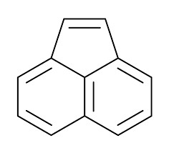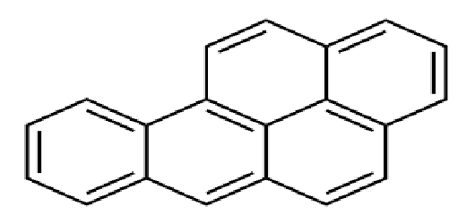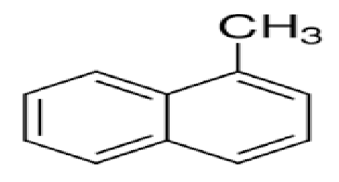

Acenaphthylene Benzo(a)pyrene 1 –Methylnaphthalene
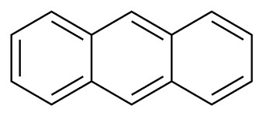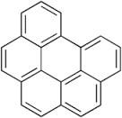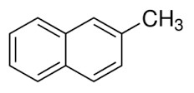

Anthracene Benzo(g,h,i)perylene 2- Methylnaphthalene
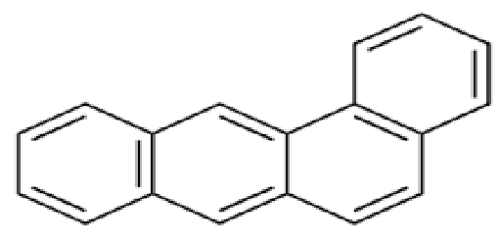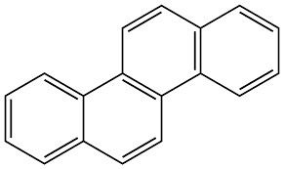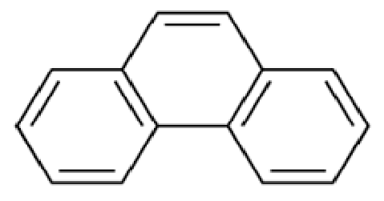

Benzo(a)anthracene Chrysene Phenanthrene
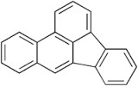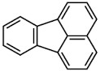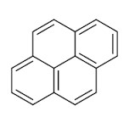

Benzo(b)fluoranthene Fluoranthene Pyrene
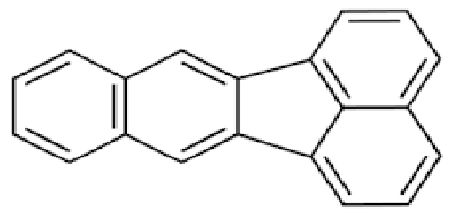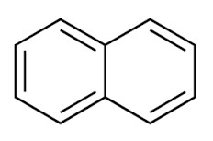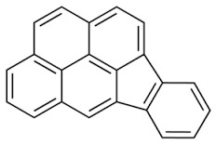
Benzo(k)fluoranthene Naphthalene Indenol(1,2,3-
c,d)pyrene

Figure 2.1: Chemical structures of some PAH congeners

2.4.2.1 Sources of Polycyclic Aromatic Hydrocarbons
Incineration of organic matter on land and discharge of industrial effluent into water bodies are known sources of PAH (Asante-Duah, 2002). These make them prevalent both on land and in water (Bouloubassi et al., 2001). They are also obtained from pyrolysis of fats and oils at higher temperatures and incomplete combustion of fuel. On the broader aspect, sources of PAHs are described as petrogenic if they are derived from petroleum source, e.g. natural oil seepage and oil spills or pyrogenic if the source is derived from the incomplete combustion of organic matter and fossil fuel (Asante-Duah, 2002). PAH congeners are used in products like dyes, plastics, preservatives, fertilizer and insecticides. When these products are used, PAH congeners are released into the environments. Example, if a fertilizer containing anthracene or benzo(a)pyrene is applied to crops, it is being released into the environment (ATSDR, 1990). Most of these attach strongly to soil and other solid matter, hence very stable in the environment which will later contaminate crop produce. Biodegradation of PAH occur at very lower rates because of its high stability increasing their concentration in the environment (Lauderdale et al., 2003).

2.4.2.2 Toxicities of PAH
According to King et al. (2002) PAHs was ranked 9th on the list of most threatening compounds to human health in 2001. Benzo(a)pyrene is mostly use as a marker for all PAH congeners because it has been extensively studied. BaP is part of the PAH congeners that are classified as potential human carcinogens (Group 2A) (IARC, 1983). Whiles congeners like chrysene, dibenzo[def,p]chrysene are classified as possible human carcinogen (Group 2B) (RAIS, 2009). PAH congeners such as benzo(a)anthracene, benzo(k)fluoranthene and benzo(b)fluoranthene produce tumors in mice when exposed to; also, there were formation of tumors in other animals such rabbits, monkeys and duck when dermal administration of benzo(a)pyrene was applied (Klein, 1963; U.S. EPA, 1991). PAH congeners such as 1-methylphenanthrene and fluoranthene are known to be systemic toxicants, as it causes liver toxicities in animal test (Lawley et al., 2008) and skin irritation in humans respectively (Le Marchand et al., 2002; U.S.DHHS, 2005). Moreover, PAHs have been reported to cause DNA damage including changes in long non-coding RNA (HOTAIR and MALAT1) in the peripheral blood lymphocytes among coke oven workers (Gao et al., 2016).

2.5 HAZARD CHARACTERIZATION
This is the qualitative and/or quantitative evaluation of the nature of the adverse health effects associated with the hazard that may be present in the food (Shephard, 2008). Also known as dose-response, many researchers use this model to characterize the hazard.
Therefore, the quantitative relationship that indicates the agent’s degree of toxicity to exposed species is expressed as hazard characterization (Gerba, 2000). Here the use of clinical studies, epidemiological and active surveillance studies, animal tests, in vitro test and expert opinions are used in determining and explaining the relationship between the dose and either the severity or the frequency of the effect. In hazard characterization, the highest dose level at which “no adverse effect is observed” (NOAEL) is established. They are established during a dose-response profile of laboratory animals. No adverse effect is observed is needed as a starting point to derive a guidance level at which no significant health risk should occur (Hammerling et al., 2009; Shephard, 2008). Agencies use the
NOAEL/LOAEL or adapt it to form various threshold concepts. Example is multiplying NOAEL with uncertainty factors to form the "acceptable daily intake (ADI)" for other species. Acceptable daily intake is the amount of a chemical to which a person can be exposed on a daily basis over an extended period of time (usually a lifetime) without suffering a deleterious effect (EPA, 1993). Other researchers are of the view that, benchmark dose (BMD) approach for carcinogenic chemicals, is more quantitative in dose-response profile than the NOAEL (Alexander et al., 2008). Based on these characterization, various thresholds for various hazards have been formulated.

2.5.1 Thresholds of chemical hazards
According to Nielsen et al., (2008), threshold is the dose or exposure concentration of a substance below which, a stated effect is not observed or expected to occur. The route of chemical administration gives the various unit to be used. For oral and dermal routes, it is normally mgkg⁻¹ body weight per day and mg/m³ for inhalation routes. Thresholds are derived from extrapolation from animal species to humans, duration of exposure in experimental studies, nature and severity of the effects and dose–response curve (Nielsen et al., 2008).
Different doses of toxicants have been used on different host to give different toxicological effects. Shuhaimi-Othman et al., (2015), worked on mortality of two varieties of fishes to determine the lethal concentration of cadmium and lead. The mean lethal concentration LC₅₀ of cadmium for Rasbora sumatrana were 1.44, 0.46, 0.39 and
0.10 mg/L at 24, 48, 72 and 96 hours respectively. That of Poecilia reticulate were 8.21,
2.83, 0.41 and 0.17 mg/L at the same time intervals. Other researchers reported different LC₅₀ of cadmium at 96 hours as 30.4 mg/L for Poecilia reticulate (Yilmaz et al., 2004) and 3.16 mg/L for juvenile Poecilia vimboides (Gomes et al., 2009). Again, the mean lethal concentration LC₅₀ of lead for Rasbora sumatrana were 4.99, 2.42, 1.10 and 0.63 mg/L at 24, 48, 72 and 96 hours respectively. And that of Poecilia reticulate were 13.31,
6.49, 3.99 and 1.99 mg/L at the same time intervals. Other researchers reported different LC₅₀ of lead at 96 hours as 7.57 mg/L for Capoeta fusca (Omidi et al., 2009) and 474.1 mg/L for adult Brachydanio rerio (Labrot et al., 1999). Upon these and other several animal tests, the LD₅₀ for cadmium and lead were set to be 890 mgkg⁻¹ (Tarasenko, 1978) and 450 mgkg⁻¹ (Takahasi, 1975) respectively for rats and humans orally. But that of mercury is believed to be within 10 to 100 mgkg⁻¹ (ATSDR, 1990).
Among the PAH congeners, Benzo(a)pyrene (BaP) is the most extensively studied congener. Therefore, it is used as a marker for PAH. Benzo(a)pyrene induced testicular toxicity in Swiss albino adult male rats when challenged with 50 mgkg⁻¹day⁻¹ BaP orally, for 10 consecutive days (Arafa et al., 2009). Other works with lesser doses such as 5 mgkg⁻¹ BaP induced tumors in 18 wild type C57BL/6, XPA–/– P53⁺/– mice when exposed to it (Steenhof et al., 2001). These and other experiments, helped established LD₅₀ of BaP in mice orally as >1600 mgkg⁻¹ (Awogi and Sato, 1989).
Based on these dose-response curves in animals and other epidemiological studies, thresholds such as oral cancer slope factors and reference dose for heavy metals and BaP have been deducted.

2.5.2 Reference Dose
Reference dose is maximum amount of a chemical (in mgkg⁻¹ body weight day⁻¹) that the human body can absorb without experiencing chronic health effects over a lifetime. Or an estimate of a daily exposure to the human population (including sensitive subgroups) that is likely to be without an appreciable risk of deleterious effects during a lifetime (Barnes and Dourson, 1988). R_{f}D of a chemical becomes a reference point to determine the potential effects of the chemical at other doses. Usually, doses less than the R_{f}D are not likely to be associated with adverse health risks, and are therefore less likely to be of regulatory concern (Barnes and Dourson, 1988). The R_{f}D of chemical hazards for the metals considered in this study are shown in the Table 2.1 below. This is important in assessing the risk of foods that are contaminated with these hazards.

Table 2.1: Reference Dose of some Chemical Hazards.
Chemical Hazard | R_{f}D (mgkg⁻¹day⁻¹) | Reference
Heavy metals Arsenic | 3 x 10⁻⁴ | USEPA (IRIS), 2007 ª
Cadmium | 5 x 10⁻⁴ | US EPA, 1992 ^{b}
Lead | 1.4 x 10⁻⁴ | Oak Ridge, 1997 ^{c}
Mercury | 3.0 x 10⁻⁴ | Oak Ridge, 1997 ^{c}
PAH  Benzo(a)pyrene | --- | USEPA (IRIS) 2014 ª
ªIRIS, U.S. EPA; ^{b}US EPA ^{c}Oak Ridge National Laboratory U.S.

Other researchers have reported different reference dose for these same hazards. As a result of that, different studies on risk assessment used different oral reference dose. For instance, Wang et al. (2005), used 1 × 10⁻³, 4 × 10⁻³ and 5 × 10⁻⁴ mgkg⁻¹day⁻¹ for Cd, Pb and Hg respectively. Also, Chen et al. (2014), used 3.6 × 10⁻³ for Pb and 5 × 10⁻³ mgkg¹day⁻¹ for Pb in another study (Khan et al., 2008).

2.5.3 Oral Cancer Slope Factors or Potency Factor
It is the risk produced by a lifetime average dose of 1 mgkg⁻¹day⁻¹ (Gerba, 2000). Potency factor is the slope of the dose–response curve at low doses. It expresses how potent a hazard is to a host organism.

Table 2.2: Potency factor of some chemical hazards
Chemical Hazard | Potency Factor (mgkg⁻¹day⁻¹) | Reference
Heavy metals Arsenic | 1.5 | US EPA, 2000a ª
Cadmium | 6.3 | US EPA, 1992
Lead | 0.0085 | OEHHA, 2009 ^{b}
Mercury | --
PAH  Benzo(a)pyrene | 1.7 | Cal-EPA, 2010 ^{c}
ªUS EPA. ^{b}Health Canada/US EPA. ^{c}Office of Environmental Health Hazard Assessment (OEHHA). ^{d}California EPA,

Different oral cancer slope factors are available due to the different outcomes from animal tests and opinions of experts. IRIS oral slope factor for BaP_{eq} is 7.3 (RAIS, 2009), whereas that of the California EPA is 1.7 (Cal-EPA, 2010). All these serves as baseline for further studies to obtain the ideal value for risk assessment.

2.6 EXPOSURE ASSESSMENT
Exposure assessment deals with how humans are expose to the various hazards. Or it could be the various ways contaminants are exposed to humans or animals. This can occur via inhalation, ingestion of water or food, or absorption through the skin upon dermal contact. Contaminant sources, release mechanisms, transport, and transformation characteristics are all important aspects of exposure assessment, so as the nature, location, and activity patterns of the exposed population. The exposure pathway of these hazards are critical in assessing the risk. Exposure pathway is the course that a hazardous agent takes from a source to a receptor e.g., human.

2.6.1 Exposure Pathway of Heavy Metals
Two main ways heavy metals are released into the environment, rock weathering and anthropogenic processes. Humans may be affected by heavy metals through food, water, air, or skin when they come into contact with it. This may occur during industrial, pharmaceutical and agricultural activities. According to Deepali and Joshi, (2014) industrial activities is the major route of exposure to adults, whiles playing in infected soils are to children.
Arsenic - Consumption of contaminated foods especially sea foods because they are known to contain high levels of arsenic (Lawley et al., 2008). Accidentally inhaling of herbicides, fungicides, wood preservatives may expose arsenic to the body since some varieties of them contain high levels of it (Cobb et al., 2000).
Cadmium - Food is the main source of cadmium intake (Lawley et al., 2008). When paint pigments, nickel-cadmium rechargeable batteries and PVC plastics are released into the environment (Deepali and Joshi, 2014) it becomes an exposure route to humans. Also when people inhale cigarette smoke and come into contact with industrial waste, they become exposed to cadmium (Hutton, 1983).
Lead - Humans are exposed to lead through inhalation, skin and ingestion. Acidic foods processed in cans with lead solder are more likely to get contaminated hence a possible source of lead poisoning when consumed (Romieu et al., 1994).
Mercury - Consumption of foods with high levels of mercury (Lanka et al., 1992). Concentration of mercury are higher in fishes before fruits and vegetables. They also accumulate in birds and mammals too. Most at times they are in the form of methylmercury in fish and shellfish, and the inorganic form in other food groups (Lawley et al., 2008).

2.6.2 Exposure Pathway of Polycyclic Aromatic Hydrocarbons
Generally, one can be affected by PAH through ingestion or dermal contact with contaminated sediments or consumption of contaminated finfish and shellfish (food) as a result of their exposure to sediments containing PAH (Baird et al., 2007). Some common
exposure pathways of acenaphthylene, anthracene, benzo(a)anthracene benzo(g,h,i)perylene, 1-methylphenanthrene and pyrene to humans is working in hazardous waste site where PAHs are disposed, eating or drinking contaminated food or water and breathing polluted air (ATSDR, 1990; Lauderdale et al., 2003). Apart from the above route humans are exposed to anthracene, benzo(b)fluoranthene and phenanthrene when they inhale tobacco smoke and dermal contact (ATSDR, 1990;
Lauderdale et al., 2003).
Exposure assessment helps to obtain a realistic estimate of total human exposure, expressed in terms of dose per unit weight, e.g. mg kg⁻¹. To determinate the amount of human exposure to a substance through ingestion of food, data of contamination levels in food should be collected as well as specific food intake (consumption) information (Gillespie et al., 2011). Food intake diaries, food balance sheet, 24 hours’ dietary recall, food frequency questionnaires (FFQs) and diet history survey are used to determine data on food intake (Hammerling et al., 2009; Shephard, 2008).

FFQs is mostly used among the above methods. It was used to determine the dietary intake and exposure of As, Cd, Pb and Hg from consumption of ready-to-eat locally milled tomato sauce in Tamale Metropolis, Ghana (Bonah, 2014). Again it was used to determine the exposure of gastrointestinal (GI) risks by microbial hazards via salads consumption in Kumasi, Ghana (Fung et al., 2011). Reproducibility becomes easier if periods of data collections are stated and bias were avoided during collection of data. The Average Daily Intake (ADI) of individuals are determined through FFQs, since it deals with individual survey and data. Whiles other methods such as food balance sheet determines the Estimated Daily Intake (EDI) of the individual, because it focuses on population survey and data.
EDI method used by Zhuang et al., (2009) in estimating the health risk of heavy metals in food crops in South China. In their work EDI was obtained from dividing the concentrations of the heavy metals by a national daily average consumption of the food crops and dividing it by the assumed body weight of consumers.
The national daily intakes and body weights are mostly assessed from literature and other databases. As in the experiments of Zhuang et al., (2009) in South China, Khan et al., (2008) in Beijing–China and Nyarko et al., (2011) in Ghana. But most at times, measurements of food intakes and weights of consumers are included into the FFQs. Heavy metal concentrations in foods are determined by the graphite furnace atomic absorption spectrometry (Zhuang et al., 2009). Heavy metals were also determined in other studies by the flame furnace atomic absorption spectrometry and inductively coupled plasma (Iqbal et al., 2016).
For PAH determination in food, GC-MS is mostly used (Bortey-Sam et al., 2014; Nyarko et al., 2011) but other methods such as HPLC system was used to detect PAH in vegetables (Voutsa and Samara, 1998).

2.7 RISK CHARACTERIZATION
Risk characterization is using the information obtained from hazard identification and exposure assessment to establish the danger to consumers at particular levels of intake of individual food contaminants (Bridges and Bridges, 2007). In addition to hazard characterization and exposure assessment, factors such as daily intake value, R_{f}D are needed for risk characterization. Also, specific data concerning the (sub) population exposed (e.g. body weight, consumption rate, etc.) absorption factors and residency time are needed to characterize the risk of a particular chemical to humans.
The level of exposure to the hazardous chemical associated with an increase in carcinogenic risk even if very small could be deducted from risk characterization.
Information deduced from risk characterization help all stakeholders to know about hazards whether they are in the acceptable or tolerable levels and how to curb them if above acceptable levels (Gillespie et al., 2011).
Carcinogenic risk is assessed for chemicals in food samples that are known to be human carcinogenic (Group 1), probable (Group 2A) or possible (Group 2B) cause of cancer (IARC, 1983). On the other hand, non-carcinogenic risk is assessed for chemicals that are not carcinogenic. These chemicals do not cause gene mutation but other diseases that affect the functioning of various organ systems. They are therefore known as toxic substances or systemic toxicants (Barnes and Dourson, 1988).
The risk is estimated by multiplying the Chronic Daily Intake (CDI) by the oral slope factor or potency factor of the chemical (Bempeh and Ewusi, 2015). Here, the averaging time or period of exposure is taken as seventy years but thirty years for systemic toxicants. For systemic toxicants or non-carcinogenic risk, the hazard quotient (HQ) is calculated as the risk (Bempeh and Ewusi, 2015). If risk is assessed for a group of hazards, then the Hazard Index (HI) is determined (Gerba, 2000).
The Hazard Quotient is calculated as ratio of CDI to Acceptable Daily Intake (ADI) or Reference Dose (R_{f}D) ( Gerba, 2000; Lente et al., 2014).
If the results of the HQ or HI are less than 1.0, it can be concluded with certainty that there is essentially no probability of adverse effect. However, if the ratio exceeds 1.0, then the potential for adverse effects is indicated but not demonstrated (Lente et al., 2014). If the hazards are more than one, the summation of the various hazard quotients will give the Hazard Index of all the hazards.

2.7.1 Risk Assessment for Heavy Metals
Most health risk assessment of heavy metals studied in various places were determined using hazard quotient or the target hazard quotient. The hazard quotient is a ratio of the pollutant concentration, duration and frequency of exposure and the body weight to the oral reference dose (R_{f}D) (Harmanescu et al., 2011; Khan et al., 2008). When Wang et al. (2005), assessed risk of heavy metals, correction factor was added to the above ratio when calculating for the HQ. The hazard concentration, duration and frequency of exposure and the body weight of consumers was multiplied by the correction factor of 10⁻³ before dividing with the R_{f}D.
The risk of heavy metals through the consumption of vegetables for both adults and children using the HQ approach were considered safe as they were below one in the experiment conducted in Beijing, China (Khan et al., 2008). Whiles THQ of Cd and Pb were not safe in vegetables in vicinity of Dabaoshan mine, South China as they recorded 2.61 to 6.25 for Cd and 1.43 to 1.99 for Pb (Zhaung et al., 2009). The THQ for heavy metals in fish and cabbage in an experiment conducted in Tiajin, China showed higher health risk of children in all four regions. The risk of heavy metals through the consumption of ready-to-eat locally milled tomato sauce were also safe for consumption since they were within the acceptable range (Bonah, 2014).

2.7.2 Risk Assessment for PAH
There are various approaches in estimating the risk caused by PAH. The appropriate approach is used depending on the researchers’ objectives. EPA (2002), described three approaches in assessing the health risk caused by PAH. These approaches include surrogate, comparative potency and relative potency approaches.
In the surrogate approach, any mixture of PAH in the atmosphere is a dilution of surrogate or potential mixtures of PAH. Where the PAH has been characterized chemically and toxicologically. Here, the risk of PAH is related to the extent of dilution. And the extent of dilution depends on the ratio of PAHs common to both the mixture of concern and that of the surrogate mixture (EPA, 2002). Because other PAH congeners were considered to be in other media which are not necessary in the atmosphere, EPA initiated the comparative potency approach to assess the health effects of diesel fuels. The assumption of this approach is that the relative potency of two PAH mixtures in an in vivo or in vitro bioassay is directly proportional to the relative potency in humans, represented by a scaling factor (k). For a mixture of interest of unknown potency considered to be a member of this group of similar mixtures, human cancer potency can be estimated by applying the scaling factor to short-term bioassay data.
Also most PAH congeners have not been extensively characterized, very few such as BaP have been extensively characterized. Here, the PAH congeners are determined in a mixture and the carcinogenic potencies of determined PAH congeners is calculated in terms of an index compound; which is mostly BaP. A summation of the carcinogenic potencies of the PAH congeners gives a cancer risk estimate for the whole mixture. This is known as a relative potency factor approach. This approach was used to assess risk of PAH in soils, and remediation of the soil was recommended (Ikhajiagbe et al., 2012). It has also been used to assess the risk of PAH in foods too (Cheung et al., 2007; Nyarko et al., 2011).
In order to determine the carcinogenic potencies of determined PAH congeners, the concentrations of the PAH congeners are multiplied with their corresponding “toxicity equivalency factor” (TEF). This gives the benzo(a)pyrene equivalent (BaP_{eq}). Summation of all the BaP_{eq} yields the “total toxicity equivalent concentration” (TTEC). The TTEC characterizes the risk for the entire PAH component in a mixture (EPA, 2002). TTEC is then compared to any of the cleanup level for benzo(a)pyrene values. The standard clean up levels for PAH are 0.33 mgkg⁻¹ (MDNR, 1993), 0.66 mgkg⁻¹ (New Jersey Register, 1992) and 0.1 mgkg⁻¹ (U.S. EPA, 1993). These clean-ups are mostly used in soils.
For most risk assessment of PAH in food, the screening value is used instead of the cleanup values. The screening value is obtained by multiplying the quotient of maximum acceptable risk level and the oral slope factor by body weight of consumers; before dividing it by the consumption rate or contact rate (Cheung et al., 2007; Nyarko et al., 2011). Here the TTEC are then compared with the screening values.

2.7.3 Risk Presentation
Hazards associated to health, safety and environmental risk is difficult to manage because of limited resources and unlimited number of risk. The most difficult step in risk management, is interpretation, acceptance and application of risk assessment, after risk characterization. This is because we moving from the world of facts to the world of values (Fiksel, 1988). Many approaches have been used in interpreting the risk assessment for better understanding. EPA uses the linearized multistage model (EPA, 1993), where for a lifetime risk of 1 mgkg⁻¹day⁻¹ of toxic chemical is 1 in 167,000 in a population could be affected. Some of the approaches are one-hit model (cancer formation goes through a single stage and that one molecule event induces cancer formation) also for a lifetime risk of 1 mgkg⁻¹day⁻¹ of toxic chemical in this model 1 in 17,000 of a population could be affected. Multi-Hit Model (cancer formation goes through a several stages) and probit model (log normal distribution); in these models 1 in 2.3 and 5.3 million persons in a population could be affected for a lifetime risk of 1 mgkg⁻¹day⁻¹ respectively (Gerba, 2000). Other researchers also uses the de-minimis approach (Fiksel, 1988).

2.8 FUTURE OUTLOOK
Most vegetables are assumed to be contaminated with many hazards because of the pre and post-harvest practices including low quality water irrigation. The major problem is when these vegetables are eaten raw without cooking. Most of these risk assessments have been done on individual vegetables at various places for various reasons, but this study seeks to find the risk hazard for cabbage and lettuce that are mostly used to prepare salads for consumers and are eaten raw by farmers even on the farm. There is therefore a need to estimate the risk of consumers to the endpoint diseases of As, Cd, Pb, Hg and PAH in the study area.
If we are aware of the problems it causes to population health, educating governmental authorities and citizens will be much easier, which is critical in mitigating this issue. Since we will all work together as stakeholders in palliating the problem.

CHAPTER 3

MATERIALS AND METHODS

MATERIALS
Fresh cabbages (Brassica oleracea) and lettuces (Lactuca sativa) were sampled from sixteen sites in Kumasi, Ghana. The sample sites consisted of four farms, four market centers, four street food vending sites and four cafeterias.
All reagents and solvents were obtained from Sigma Aldrich (St. Louis, Missouri, USA). All reagents were of analytical grade. Standard PAH congeners and heavy metals were obtained from US National Institute of Standards and Technology (Gaithersburg, USA).

3.1 STUDY AREA
The study was carried out in Kumasi, the capital of Ashanti Region. It covers an area of about 230 to 240 km² (Obuobie et al., 2006). Kumasi has an annual population growth rate of about 3.4 % in its current administrative boundary. Kumasi has an estimated population of 2.5 million (GSS, 2012). The study was carried out in Kumasi because 40 ha of lands are cultivated throughout the year with vegetables which mostly increases in the dry season (Amoah et al., 2007). Vegetables are mostly produced along streams or shallow wells dug out in farm lands in Kumasi. Cabbage and lettuce were sampled from the various categories along the food chain line. The table 3.1 and figure 3.1 shows the various sampling sites in Kumasi

Table 3.1: Sampling areas of cabbage and lettuce.
Categories of sites | Sampling sites | Global Positioning System (GPS)  Readings
Farm sites | Atonsu | 6° 39’ 42.23”N, 1° 35’ 12.32”W
 | Chirepatre | 6° 39’ 23.35”N, 1° 34’ 41.64”W
 | KNUST | 6° 40’ 0.68”N, 1° 34’ 54.90”W
 | Tanoso | 6° 41’ 54.02”N, 1° 40’ 42.23”W
Market centers | Ayigya | 6° 41’ 21.77”N, 1° 34’ 21.56”W
 | Kejetia | 6° 41’ 46.24”N, 1° 37’ 9.15”W
 | Kwadaso | 6° 41’ 54.67”N, 1° 38’ 57.04”W
 | Santasi | 6° 39’ 20.34”N, 1° 38’ 16.66”W
Street food vending sites | Aboabo | 6° 41’ 59.10”N, 1° 35’ 53.95”W
 | Asafo | 6° 41’ 18.82”N, 1° 36’ 55.89”W
 | Bantama | 6° 42’ 7.19”N, 1° 36’ 59.03”W
 | KNUST | 6° 40’ 37.57”N, 1° 34’ 27.37”W
Cafeterias & Restaurants | Adum | 6° 41’ 36.70”N, 1° 37’ 18.62”W
 | Airport  Roundabout | 6° 42’ 22.50”N, 1° 36’ 2.46”W
 | Fante New Town | 6° 41’ 27.66”N, 1° 36’ 47.94”W
 | Suame | 6° 42’ 46.27”N, 1° 37’ 44.67”W

However, selection of food vending sites and cafeteria represented a low to high income communities (Henseler, 2005) in Kumasi. The sampling areas of cabbages and lettuce in Kumasi, are shown graphically in figure 3.1.
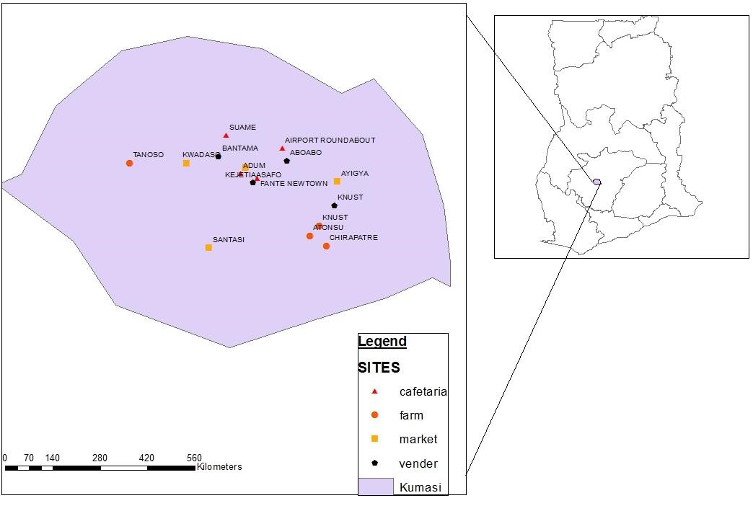
Figure 3.1: Sampling sites of cabbage and lettuce.

3.2 RESEARCH DESIGN
Probabilistic modelling was used, firstly to assess the chronic daily intake of As, Cd, Pb, Hg and PAH in cabbage and lettuce eaten raw. The research was contextualized to determine the uncertainty and the known inputs of the risk estimates.

3.3 SURVEY AND SAMPLING PROTOCOLS
Eight hundred grams (800 g) of lettuce and cabbage each were sampled from each farms and market centers. Eight hundred grams of a mixture of cabbage and lettuce (salad) each were also sampled from each street food vending sites and cafeteria over a period of three weeks.
A semi structured food frequency questionnaire (Appendix 1) was designed and administered to four hundred and six respondents including farmers, vegetable sellers, consumer (buyers), food vendors and restaurateurs. To prevent area bias and reduce heterogeneity, samples were selected from different places in Kumasi using the simple random sampling method. All respondents interviewed were selected using a simple random sampling method.
The questionnaires focused mainly on the daily intake of As, Cd, Pb, Hg and PAH via consumption of cabbage and lettuce eaten raw. Additional information on sociodemographic data and the body weight for each respondent given in the questionnaire were taken and recorded accordingly. Different quantities of salads in grams (5, 6.05, 10, 13, 15, 20, 25, 30 and 50) were weighed into zip bags (Appendix 2) and attached to the questionnaires to determine the amount of the mixture of cabbage and lettuce eaten by each respondent per meal.

3.4 HEAVY METALS QUANTIFICATION IN CABBAGE AND LETTUCE SAMPLES

3.4.1 Sample preparation
Five hundred grams (500 g) each of lettuce and cabbage from farms and market centers were weighed and blended together. The samples were blended together because most sellers use only lettuce and cabbage to prepare salad (Fung et al., 2011). Similarly, 500 g of already prepared salads (from food vendors and cafeterias) were blended. Ten grams (10 g) of each of the blended samples were taken, one for heavy metal analysis and the other for PAH analysis.

3.4.2 Determination of Heavy Metals by Inductively Coupled Plasma – Mass Spectrometry (ICP-MS)
Accurately, 1.5 g of each of the prepared samples was weighted directly into the PTFETFM vessels. This was followed by addition of 4 mL of nitric acid (HNO₃) and 2 mL of hydrogen peroxide (H₂O₂) before introducing them into the microwave digestion system. A ramp time of 25 min to reach 200 °C and a hold time of 25 min at 200 °C were used as operational conditions for the heating program. After digestion, the solution was diluted with 10 ml de-ionized water. A reagent blank digest was carried out in the same way. The samples were then introduced to the Inductively Coupled Plasma – Mass Spectrometry (ICP-MS) together with the digested Certified Reference Material (CRM).
Concentrations of As, Cd, Pb and Hg were measured in all samples and sequentially extracted fractions by Ultra Mass 700 ICP-MS (Varian, Australia). Mathematical equations that were built into the software were used for isobaric interference corrections. Quality control (QC) measures were taken to assess contamination and reliability of the data. Precision and accuracy of analysis were also ensured through repeated analysis of samples against CRMs for all metals. A Certified Reference Material (CRM) for vegetable sample was used for QC. The CRM was spiked with various standard solution of metals. The average recovery of CRMs values was in the range of 81.3% and 110%, otherwise analyses were repeated.

3.5 POLYCYCLIC AROMATIC HYDROCARBON (PAH) QUANTIFICATION IN CABBAGE AND LETTUCE SAMPLES

3.5.1 Sample preparation
Samples preparation and quantification were done according to method used by Akoto et al., (2015). Ten grams (10 g) each of the sixteen salad (cabbage and lettuce) homogenous sample were weighed into 50 mL centrifuge tube and 10 mL of distilled water added. The mixture was vortexed for 1 min and 10 g acetonitrile added to the mixture. It was then macerated for 1 min to give a uniform mixture. Salt mixture (4 g of magnesium sulphate anhydrous, 1 g of sodium chloride, 1 g of trisodium citrate dehydrate and 0.5 g disodium hydrogencitrate sesquihydrate) was added to the acetonitrile-based mixture. The resultant mixture was vigorously macerated for 1 min and centrifuged at 3000 rpm for 5 min.
Aliquots (6 mL) of the extract (organic phase) was transferred into centrifuge tube which contained 150 mg Purified Standardized Amine (PSA) and 900 mg Magnesium sulphate. The centrifuge tube containing the mixture was vortexed for 30 s and centrifuged for 5 min at 3000 rpm. Four milliliters of clean extract were transferred into a pear shaped flask and the pH of the extracts in the flask adjusted to 5 by adding 40 µL of 5% formic acid solution in acetonitrile (v/v). The filtrate was concentrated to dryness on a rotary evaporator (Rotary R-210). One milliliters of ethyl acetate and 20 µL of 1% glycol solution in ethyl acetate (v/v) was used to re-dissolve the concentrated filtrate before transferring the extract into 2 mL vial for quantification by GC/MS.

3.5.2 Determination of PAH by GC-MS
Gas Chromatography-Mass Spectrometry (GC-MS) was used for the quantification of PAH in the salad samples. Varian CP-3800 gas chromatograph interfaced to a HP5972 mass selective detector (Hewlett-Packard, Germany) with positive-ion electron ionization option was used in the selected ion monitoring mode. GC analysis was conducted on a fused on silica capillary column 30m × 0.25 mm internal diameter fused silica capillary column coated with VF-1701 ms (0.25 µm film) to detect 16 PAH components. The listed
PAH below were used for quantification: Acenaphthene, Anthracene, Benz(a)anthracene,
Benzo(b)fluoranthene, Benzo(a)pyrene, Benzo(g,h,i)perylene, Chrysene, Fluoranthene,
Fluorene, Naphthalene, 1-Methylnaphthalene, 2- Methylnaphthalene, Phenanthrene and Pyrene. The column oven temperature was set from 60 °C, held for 1 min and increased to 180 °C at a rate of 12 °C min⁻¹, 180 °C to 210 °C at a rate of 8 °C min⁻¹ and then from 210 °C to 340 °C at a rate of 5 °C min⁻¹ and held at 10 min. Purified nitrogen gas was used as carrier gas at the flow rate of 1.0 mL min⁻¹ and as the make-up gas of 29 mL min¹. The injector and detector temperatures were maintained at 210 °C and 340 °C, respectively. The injector volume of the gas chromatograph was 1.0 µL. For the mass spectrometer the following settings were used: ionization mode was electronic ionization
(EI) positive ion, closed EI for ion volume and 250 °C for ion source temperature. Emission current was 50 µA, full scan in range m/z 45-650 and SRM (selected reaction monitoring), with 0.15 as scan width. The collision gas (Ar) pressure was 0.5 mTorr and the scan times as 0.2 s for full scan and 0.05 for SRM. PAHs were quantified by MS within a single chromatographic run whiles simultaneously hydrocarbon profile is monitored in a full scan by the GC. Table 3.1 shows the retention times of PAHs analyzed in the various salad samples.
Reagent blanks used during the analysis were exposed to the same extraction procedures. Solvents used were run to verify any interfering substances within the runtime. In all batches, reagent blanks and spiked samples (sample fortified with mixed PAH standards) were added for quality control checks. Procedural recoveries were analyzed concurrently with each batch of analytical extracts. Fortification level of 0.05 mg kg⁻¹ was chosen based on the limit of determination. The limit of detection of PAHs using this method was approximately 0.3 ppb with about 75 % recovery.

Table 3.2: The retention times of PAHs
PAH (Peak Name) | Retention Time (RT) | PAH (Peak Name) | Retention Time
Acenaphthene | 5.655 | Fluoranthene | 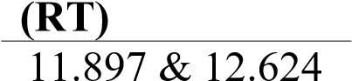
Anthracene | 8.591 | Fluorene | 6.643
Benz(a)anthracene | 17.453 | Naphthalene | 3.982
Benzo(b)fluoranthene | 22.073 | 1 -Methylnaphthalene | 4.734
Benzo(k)fluoranthene | 22.072 | 2- Methylnaphthalene | 4.734
Benzo(a)pyrene | 22.073 | Phenanthrene | 8.476
Benzo(g,h,i)perylene | 28.205 | Pyrene | 12.624
Chrysene | 17.604 | Indenol(1,2,3-c,d)pyrene | 27.632

3.6 PROBABILISTIC RISK ASSESSMENT
Probabilistic model was expressed as a function in excel to assess the risk (Appendix 3). The three distinct inputs required for the probabilistic model were known inputs, uncertainty variables and decision variables. The known inputs describe the averaging time of a hazard which should be imputed into the model, whether carcinogenic (70 years) or systemic toxicant (30 years). Hazard content (mg kg⁻¹), number of times of consumption of media, mass of medium (gram), exposure frequency and duration, contact rate and body weight (kg) of consumers constitute the uncertainty variables. These uncertainty variables were determined from the food consumption data obtained during administering of the food frequency questionnaire. For this research, the food consumption data had been determined with the probability that a consumer would be exposed to a certain mass of cabbage and lettuce that has As, Cd, Pb, Hg and PAH concentrations which would cause a disease. Additionally, decision variables such as oral cancer slope factors (mgkg⁻¹day⁻¹) and oral reference dose (R_{f}D) of the hazards are deducted from databases. The model uses distribution of uncertainty factors to represent these input variables in a function that computes a distribution of the output (chronic daily intake and risk).

3.6.1 Identification and documentation of decision variables
Uncertainty inputs are obtained from food consumption data (Table 3.2), whiles decision variables from database and other literatures.
Deduction of R_{f}D – The reference dose for many chemical hazards are derived from animal test or epidemiological studies. In this study the oral reference dose was used. The reference dose for arsenic, cadmium, lead and mercury were taken from various databases as 3 x 10⁻⁴, 1 x 10⁻³, 1.4 x 10⁻⁴ and 3.0 x 10⁻⁴ respectively (US EPA (IRIS), 2007, US EPA, 1992, Oak Ridge, 1997).
Deduction of Potency Factor – The oral cancer slope factor or potency factor for arsenic and lead were taken from various databases as 1.5 and 0.0085 (US EPA, 2000a; OEHHA,
2009). The oral cancer slope factor of BaP_{eq} for all PAH congeners was 1.7 (Cal-EPA, 2010). Where the oral slope factor or potency factor is not available the risk was quantified using the hazard quotient approach.
For the hazard content of the various PAH detected in the salads, the USEPA guideline was use in detecting the adverse health effect it causes using the BaP as a marker. All PAH congeners detected in salads were converted to BAP_{eq} using toxic equivalency factors (TEFs) derived from their cancer potencies (Nisbet and Lagoy, 1992). Table 3.3 shows TEFs of the detected PAH congeners in the experimental samples.

Table 3.3: TEFs of some PAHs congeners
PAH (Peak Name) | Toxic Equivalency Factors (TEFs)
Benzo(b)fluoranthene | 0.1
Benzo(k)fluoranthene | 0.1
Indenol(1,2,3-c,d)pyrene | 0.1
Benzo(g,h,i)perylene | 0.01
Source: (Nisbet and Lagoy, 1992).

Two methods were applied after this stage; firstly, a uniform distribution fit was used to determine a single concentration of all the BaP_{eq} known as the hazard concentration. The probabilistic model was then used to quantify risk of PAH (BaP_{eq}) in cabbage and lettuce eaten raw. Secondly, the corresponding BaP_{eq} were summed to give the total toxic equivalency concentration (TTEC) of the samples. The TTEC was then compared to the screening value to determine the risk of the hazards.

3.7 STATISTICAL METHODS
The compilation of consumption data and risk assessment for the various hazards were systematically analyzed as shown in the flow chart (Figures 3.2). The chart visualized the flow from imputation of As, Cd, Pb, Hg and BaPeq datasets (variables) obtained from food frequency questionnaire into Microsoft Excel 2013 (Step 1). The variables were subsequently fitted in Palisade@ risk software version 7.0 at appropriate excel cells (Step 2) and were fitted to distribution (Step 3) as shown in figure 3.2.
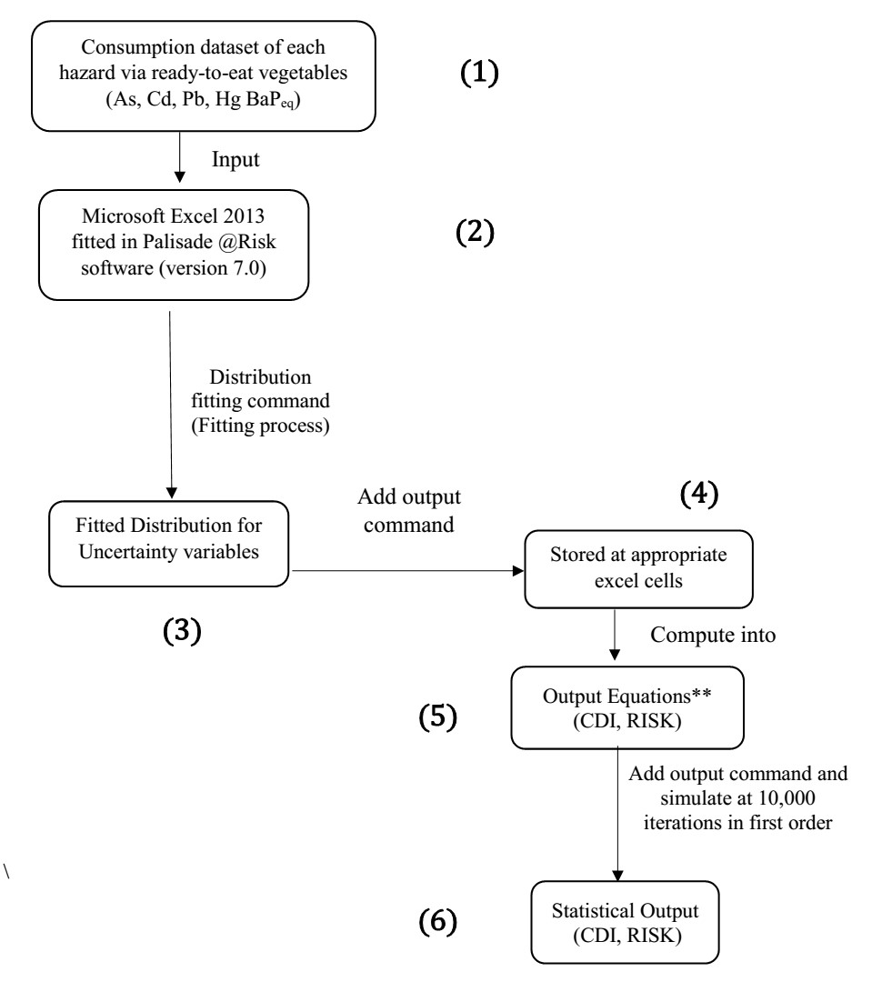
Figure 3.2: Flow charts showing risk assessment of As, Cd, Pb, Hg and BaP_{eq}.
Statistical output factors (Step 6) such as chronic daily intake (CDI) and risk were determined after computing their values into the output equations expressed in step 5
(Figure 3.2).
𝐂 × 𝐂𝐑 × 𝐄𝐅 × 𝐄𝐃 𝟏
𝐂𝐃𝐈 = × … … … … … … . (1)
𝐁𝐖 𝐀𝐓
Where; CDI is Chronic daily intake; the amount of chemical at the exchange boundary (mgkg¹day⁻¹), C is Concentration of Hazard, CR is the Contact rate (No. of times of consumption per day multiplied by mass of media consumed), EF is the Exposure frequency (No. of times of exposure within a year), and ED is exposure duration (years), BW is the Body weight, AT is the averaging time (days), for noncarcinogenic effects AV =ED (Gerba, 2000).

Carcinogenic risks of hazards were determined by multiplying the oral cancer slope factor (PF) by their corresponding CDI (Bempeh and Ewusi, 2015) as shown in the equation below.
𝐑𝐈𝐒𝐊 = 𝐏𝐅 × 𝐂𝐃𝐈 … … … … … … . (2)
Moreover, non-carcinogenic risks of hazards were determined using the hazard quotient
(HQ) method, expressed in equation 3 below (Bempeh and Ewusi, 2015).
𝐂𝐃𝐈
𝐇𝐚𝐳𝐚𝐫𝐝 𝐐𝐮𝐨𝐭𝐢𝐞𝐧𝐭 = … … … … … … . (3) 𝐑_{𝐟}𝐃
Where; CDI is Chronic daily intake; R_{f}D is reference dose

The mean, median, 5th and the 95th percentiles were determined as statistical outputs. Monte Carlo simulation is a common approach in estimating hazard exposure in a probability distribution because it handles variability and uncertainty in the dataset. This gives an advancement to probabilistic assessments over deterministic assessment of risk. As it provides an understanding of the degree of uncertainty and variability around a risk estimate that single-point estimates of risk cannot provide (EPA, 1994). However, variability or uncertainty still occurs in the output distribution, antecedent on the uncertainty or variability in the input variables. In this research, for the determination of CDI of cabbage and lettuce, and their risk (including hazard quotient), there were a number of input factors such as exposure frequency of hazard, body weight, concentration of hazard, etc. Again in this study, risk of PAHs in cabbage and lettuce were determined by comparing the total toxicity equivalent concentration (TTEC) value to the screening value of PAH in the samples (Cheung et al., 2007; Nyarko et al., 2011). The TTEC value was obtained by summing the products (BaP_{eq}) of all the PAH congeners by their corresponding toxicity equivalency factor (TEF) as expressed in equation 4.
𝐓𝐓𝐄𝐂 = 𝚺(𝐂𝐨𝐧𝐜𝐞𝐧𝐭𝐫𝐚𝐭𝐢𝐨𝐧𝐬 𝐨𝐟 𝐏𝐀𝐇 𝐜𝐨𝐧𝐠𝐞𝐧𝐞𝐫𝐬 × 𝐓𝐄𝐅) … … … … … … . (4)
Where, TTEC is the total toxicity equivalent concentration and TEF is the toxic equivalency factors (Nyarko et al., 2011).
If the TTEC was greater than the screening value (SV) then risk was implicated but if less than SV then, risk was significant negligible. The screening value were computed and expressed in excel as equation 5.

𝐑𝐋
𝐒𝐕 = ^{𝐒𝐅} × 𝐁𝐖 … … … … … … . (5) 𝐂𝐑
Where, SV is the screening value (µg/g); RL is the maximum acceptable risk level,
(dimensionless), SF is the oral slope factor (µg/g day), BW is the body weight (g) and CR is the consumption rate (g/day) (Nyarko et al., 2011).

CHAPTER 4

RESULTS

4.1 HAZARD IDENTIFICATION

4.1.1 Identification of heavy metals in cabbage and lettuce samples
Arsenic, cadmium, lead and mercury were identified in cabbage and lettuce samples eaten raw as hazard content; as shown in table 4.1.
Table 4.1: The distribution functions of hazard content of heavy metals in cabbage

and lettuce samples
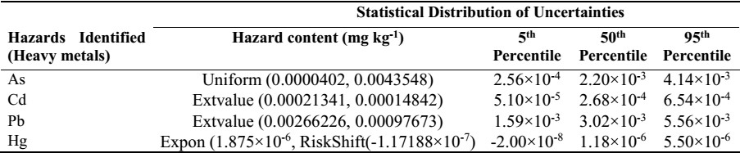
The concentrations of these hazards in cabbage and lettuce samples were in this order
Pb>As>Cu>Hg.

4.1.2 Identification of BaP_{eq} (PAH) in cabbage and lettuce samples
Table 4.2 shows the hazard content of BaPeq (PAH) identified in cabbage and lettuce samples eaten raw.

Table 4.2: The distribution functions of hazard content of BaP_{eq} (PAH) in cabbage and lettuce samples
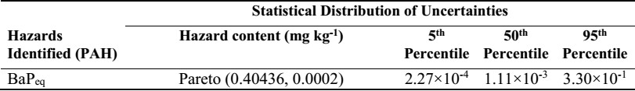

4.2 EXPOSURE ASSESSMENT
Out of the 406 respondents, 50.99 % were females and the majority (56.16 %) of the respondents were between the ages of 15 to 30 years. Ingestion dataset as well as the body weight of consumers of cabbage and lettuce eaten raw obtained from the questionnaires administered are shown in table 4.3 after loading according to their statistical distribution and defined accordingly in @ risk software.
Table 4.3: The distribution functions input factors obtained from the questionnaire administered in the study area as used in the risk assessment.
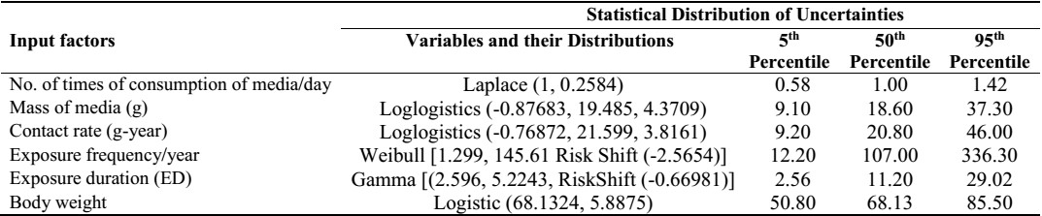

4.3 CHRONIC DAILY INTAKE
The chronic daily intake through consumption of cabbage and lettuce were subsequently determined by equation 1 (Chapter 3) and defining accordingly in @ risk software. Table 4.4 shows the daily intakes of As, Cd, Pb, Hg and BaP_{eq} via the consumption of cabbages and lettuce samples in this study.
Table 4.4: Chronic Daily Intake of As, Cd, Pb, Hg and BaP_{eq} via cabbage and lettuce samples.
 |  | Daily intake (mgkg⁻¹day⁻¹)
 | As | Cd | Pb | Hg | BaP_{eq}
Mean | 5.04 × 10⁻⁵ | 1.67. × 10⁻⁵ | 7.40× 10⁻⁵ | 9.41 × 10⁻⁸ | 2.55 × 10⁻⁵
Median | 2.19 × 10⁻⁵ | 6.98 × 10⁻⁶ | 3.74 × 10⁻⁵ | 2.81 × 10⁻⁸ | 1.64 × 10⁻⁵
5th percentile | 7.89 × 10⁻⁷ | 2.22 × 10⁻⁷ | 2.35 × 10⁻⁶ | 3.50 × 10⁻¹⁰ | 5.46 × 10⁻⁷
95th percentile | 1.99 × 10⁻⁴ | 6.28 × 10⁻⁵ | 2.73 × 10⁻⁴ | 3.90 × 10⁻⁷ | 5.15 × 10⁻³

4.3. RISK ASSESSMENT
Carcinogenic risk of As, Pb and BaP_{eq} via the consumption of cabbage and lettuce was determined using equation 2 (Chapter 3) and the values are shown in table 4.4 below.
Furthermore, risk assessment of BaP_{eq} using screening value was determined. Here, the total equivalency concentration (TTEC) of the detected PAH congeners in the cabbage and lettuce samples was 0.18671. The consumption rate of the cabbage and lettuce eaten raw in the study was 23.48 g/day. According to the USEPA, (2000b) the maximum acceptable risk level for BaP was 1×10⁻⁵. The body weight of salad consumers in the study area was recorded as 68.13 kg and the oral slope factor for BaP used as a marker for all PAHs was 1.7 µg/g day (Cal-EPA, 2010). These were computed into equation 5
(Chapter 3) to give a screening value of 0.0171 (less than the TTEC).

Table 4.5: The various risk percentiles in cabbage and lettuce samples in Kumasi.

RISK

RISK “HQ” (Non- RISK (Carcinogenic) carcinogenic)
Cd Hg As Pb BaP_{eq}
Mean | 1.64 × 10⁻² | 3.35 × 10⁻⁴ | 7.95 × 10⁻⁵ | 6.68 × 10⁻⁷ | 4.33 × 10⁻⁵
5th percentile | 2.20 × 10⁻⁴ | 1.28 × 10⁻⁶ | 1.22 × 10⁻⁶ | 1.90 × 10⁻⁸ | 9.99 × 10⁻⁷
50th percentile | 6.90 × 10⁻³ | 9.00 × 10 ⁻⁵ | 3.30 × 10⁻⁵ | 3.20 × 10⁻⁷ | 2.79 ×10 ⁻⁵
95th percentile | 6.30 × 10⁻² | 1.45 × 10⁻³ | 3.06 × 10⁻⁴ | 2.32 × 10⁻⁶ | 8.51 × 10⁻³

From equation 3 (Chapter 3), the hazard quotient (non-carcinogenic risk) of Cd and Hg were determined. It was observed that, Cd showed a higher mean HQ (1.64×10⁻²) in cabbage and lettuce samples than that of Hg (3.35×10⁻⁴). Thus, the hazard index of heavy metals (Cd and Hg) in the cabbage and lettuce samples eaten raw was 1.67×10⁻². The figures below show the graphical presentation of probabilistic risk of arsenic (fig. 4.1), lead (fig. 4.2), BaP_{eq} (fig. 4.3), cadmium (fig. 4.4) and mercury (fig. 4.5).
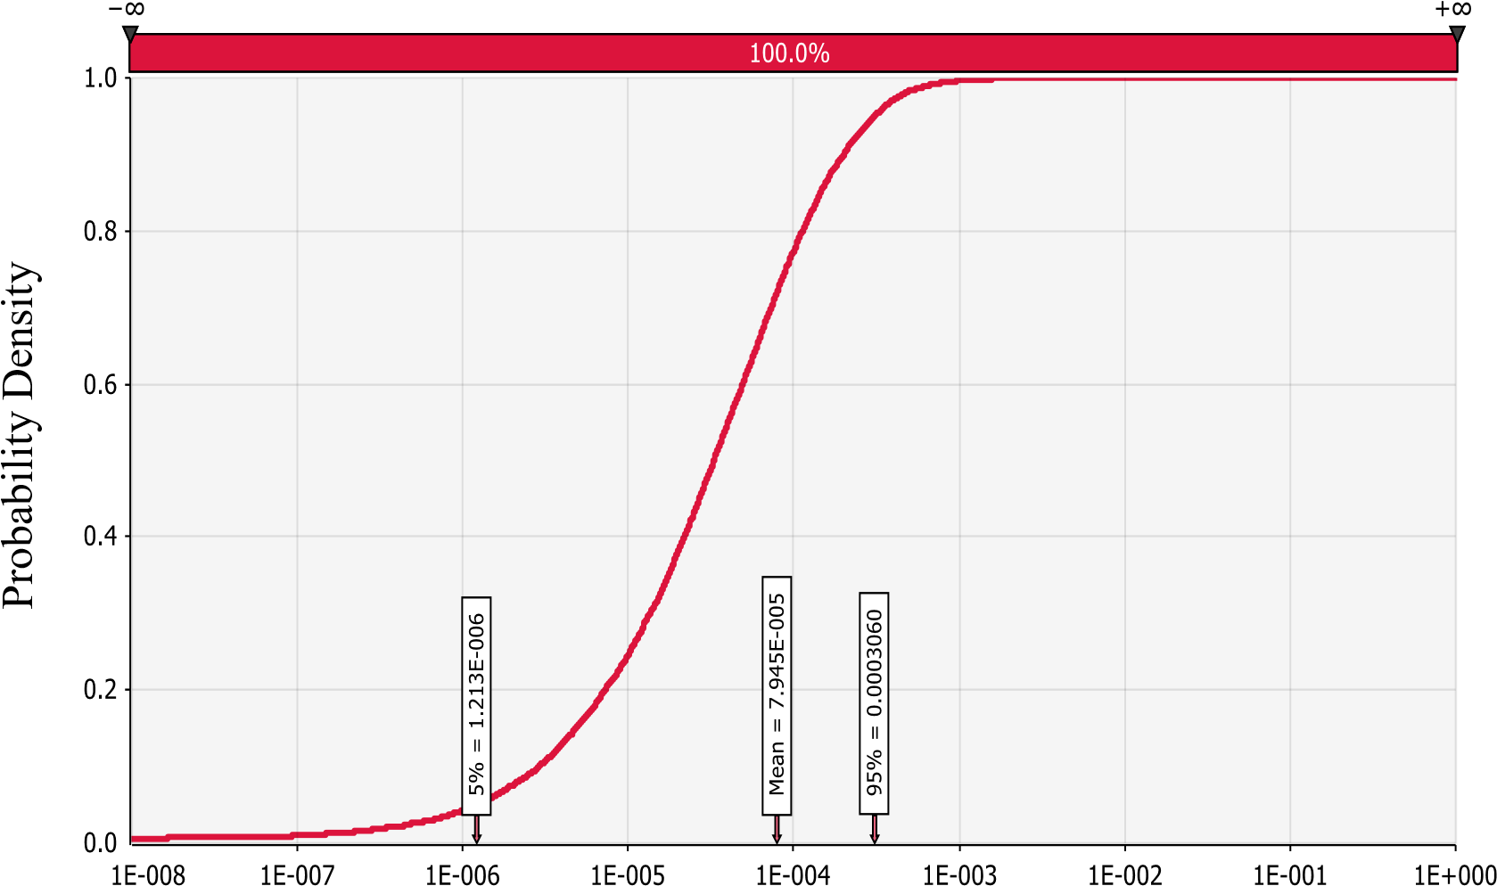
Figure 4.1: Risk distribution of Arsenic intake via dietary intake of salads.
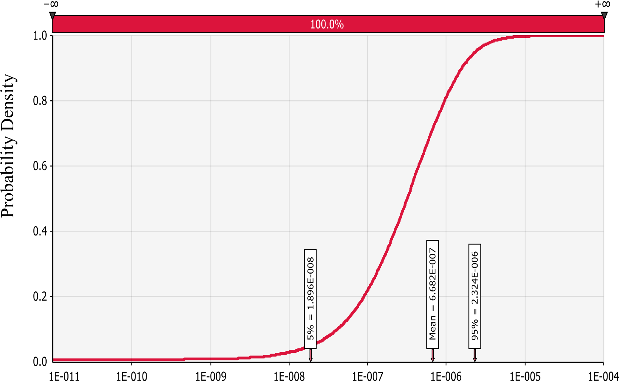
Figure 4.2: Risk distribution of lead intake via dietary intake of salads.
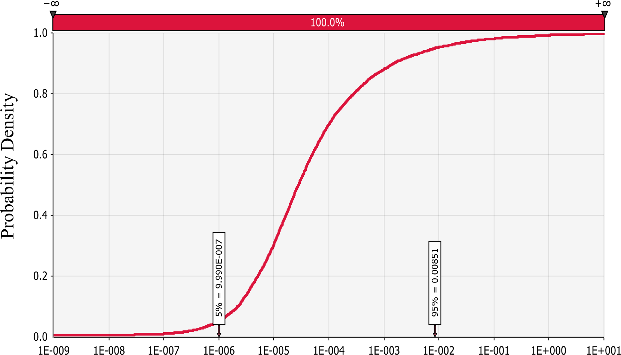
Figure 4.3: Risk distribution of BaP intake via dietary intake of salads.

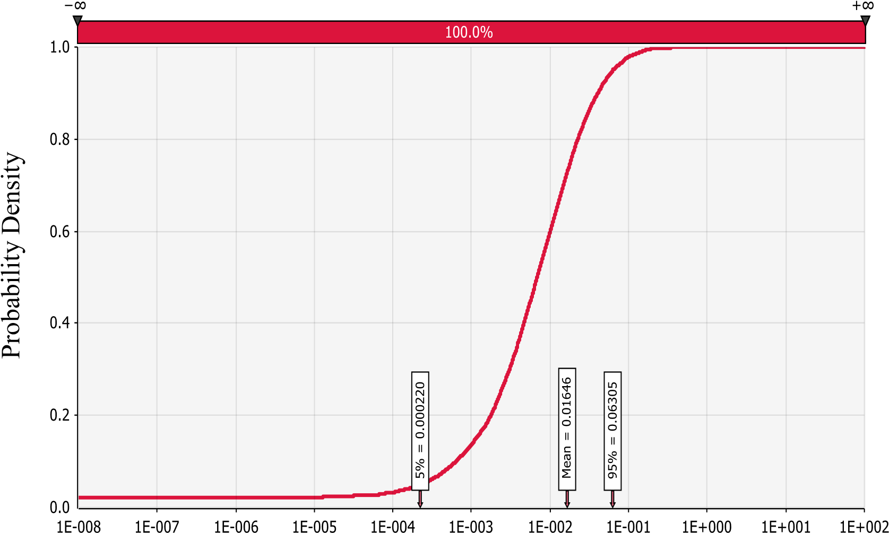
Figure 4.4: Risk (HQ) distribution of cadmium intake via dietary intake of salads.
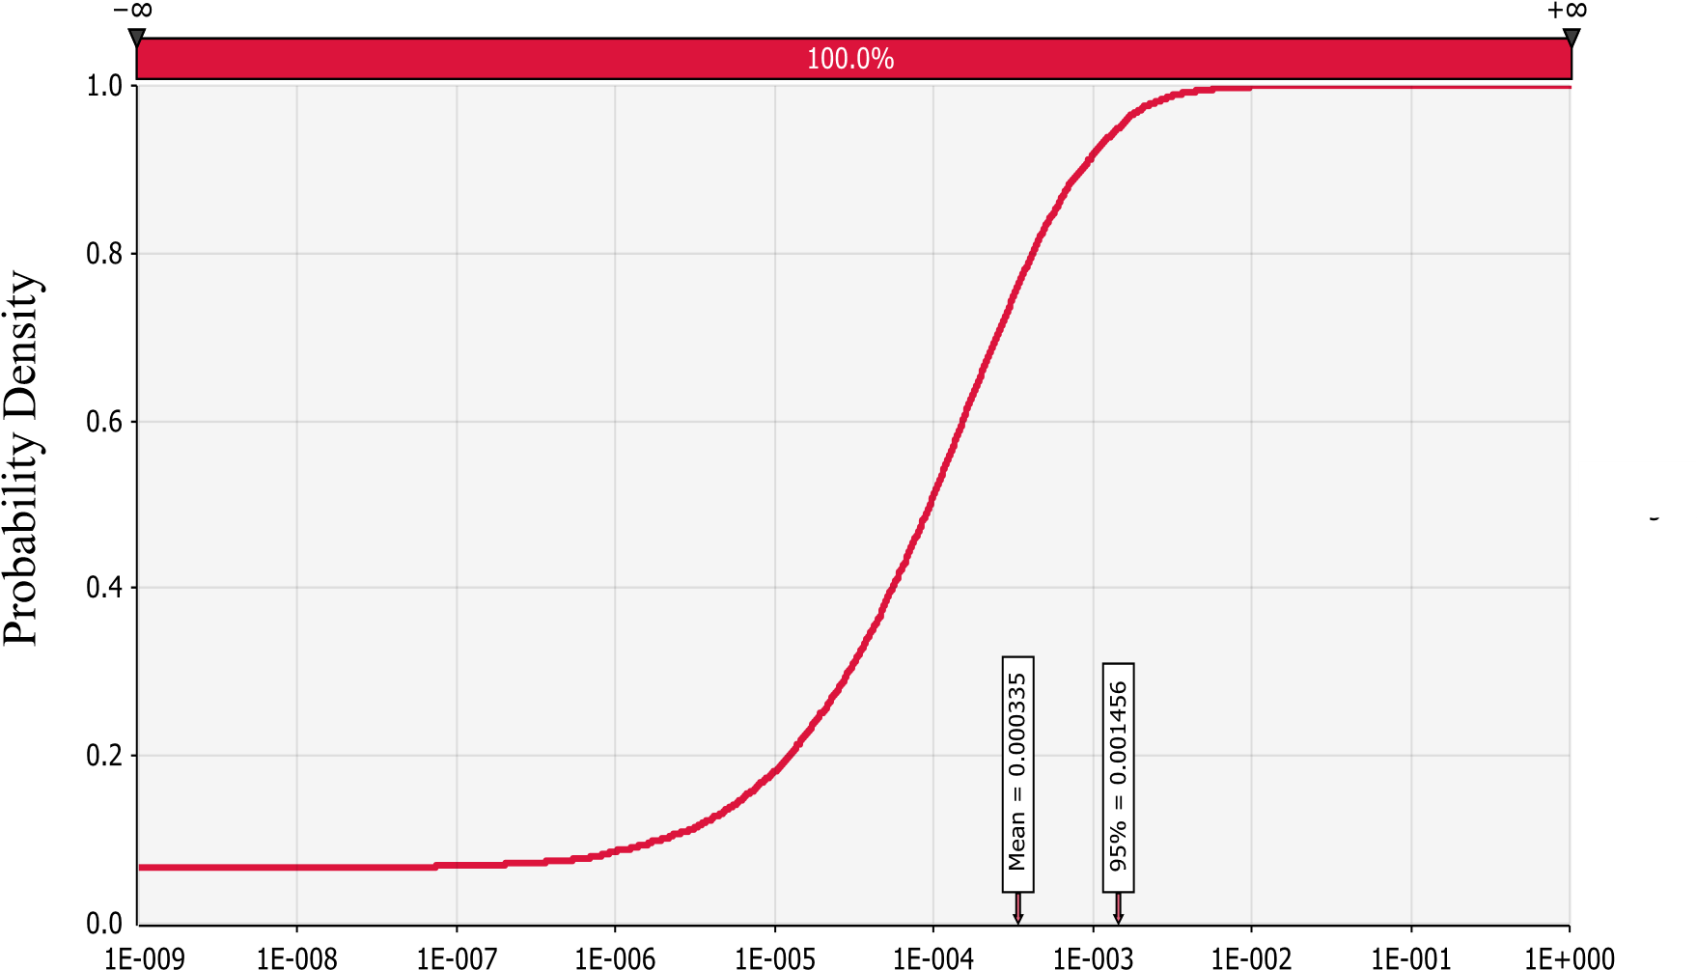
Figure 4.5: Risk (HQ) distribution of mercury intake via dietary intake of salads.

CHAPTER 5

DISCUSSION

5.1 HAZARD CONTENT IN CABBAGE AND LETTUCE

5.1.1 Heavy Metals Concentration
The 50th percentile of As, Cd, Pb and Hg concentration (2.20×10⁻³, 2.68×10⁻⁴, 3.02×10⁻³ and 1.18×10⁻⁶ mgkg⁻¹ respectively) in the mixture of cabbage and lettuce samples in this study (Table 4.1) were below the acceptable levels at 0.70, 0.20, 0.30 and 0.02 mgkg⁻¹ respectively (Asdeo and Loonker, 2011; Pan et al., 2016). Moreover, the excessive/higher content (95th percentile) of As, Cd, Pb and Hg concentration (4.14×10⁻³, 6.54×10⁻⁴,
5.56×10⁻³ and 5.50×10⁻⁶ mgkg⁻¹ respectively) were also within permissible levels (Table 4.1). These concentrations in the samples could be as a result of industrial pollution, pesticide application, hospital waste, irrigation with low quality water and atmospheric deposition ( Iqbal et al., 2016; Lawley et al., 2008; Obuobie et al., 2006). The vegetables are however, safe to consume since the heavy metal content were below the acceptable levels of As, Cd, Pb and Hg. Nevertheless, long term exposure to these heavy metals via vegetable consumption could pose serious health effects to humans as they accumulate in the receptor bodies (Zhuang et al., 2009). It is important to note also, that exposure to low concentrations of certain heavy metals especially arsenic can even cause nausea and headaches momentarily (RAIS, 2009).
Other researchers reported a range of 0.02 to 0.08 and 0.04 to 0.08 mg kg⁻¹ (Iqbal et al., 2016) and 0.39 to 0.93 and 2.55 to 4.50 mg kg⁻¹ (Khan et al., 2008) for Cd and Pb respectively in vegetables. The concentrations of Cd and Pb in vegetables were even greater than the 95th percentile of Cd (6.54×10⁻⁴ mgkg⁻¹) and Pb (5.56×10⁻³ mgkg⁻¹) concentrations (Table 4.1) determined in this study. The high residue levels in vegetables documented by Khan et al., (2008) were associated to waste land cultivation and low quality water irrigation. Also, median and higher bound of cadmium concentration (3.02×10⁻⁴ mgkg⁻¹ and 6.54×10⁻⁴ mgkg⁻¹) in this study (Table 4.1) were lower as compared to the high cadmium contamination of 0.68 to 1.78 mgkg⁻¹ that were observed in vegetables grown on waste dumping sites in Kumasi (Odai et al., 2008).
Among the four heavy metals investigated, lead (Pb) (3.02×10⁻³ mgkg⁻¹) had the highest concentration in the cabbage and lettuce samples as compared to 2.68×10⁻⁴, 2.20×10⁻³ and 1.18×10⁻⁶ mgkg⁻¹ of Cd, As and Hg respectively (Table 4.1). The outcome may be due to the use of PVC pipes farmers use to irrigate their vegetables in the study area (Amoah et al., 2007). As lead used as a stabilizer in PVC pipe production, could diffuse into the water (Asante-Duah, 2002).

5.1.2. Polycyclic Aromatic Hydrocarbons Concentrations
The BaP concentration recorded in cabbage (5.0×10⁻⁵ to 9.6×10⁻⁴ mgkg⁻¹) and lettuce
(9.0×10⁻⁵ to 2.2×10⁻⁴ mgkg⁻¹) in Greece (Voutsa and Samara, 1998) were lower than the 50th percentile of BaP_{eq} concentration in this study (1.11×10⁻³ mgkg⁻¹). It was even lower than the 5th percentile (lower bound) of BaP_{eq} concentration in this study, 2.27×10⁻⁴ mgkg¹, (Table 4.2) indicating high BaP_{eq} concentration in the samples of the current study.
The higher bound of BaP_{eq} concentration (95th percentile) in the mixture of cabbage and lettuce samples, 3.30×10⁻¹ mgkg⁻¹, (Table 4.2) were also lower than the values determined in cabbage grown at urban (10.062 mgkg⁻¹) and rural (8.131 mgkg⁻¹) areas in Romania
(Soceanu et al., 2014). Similarly, median of BaP_{eq} concentration, 1.11×10⁻³ mgkg⁻¹,
(Table 4.2) in this study were lower than median BaP_{eq} concentration observed in vegetables in Taiyuan, China (2.06×10⁻² mgkg⁻¹) and Catalonia-Spain (1.73×10⁻³ mgkg¹) (Xia et al., 2010). However, BaP_{eq} concentration in this study (1.11×10⁻³ mgkg⁻¹) was greater than that conducted on vegetables (3.1×10⁻⁴ mgkg⁻¹) in Korea (Li, 2007).
The relatively low concentrations of BaP_{eq} (1.11×10⁻³ mgkg⁻¹) in this study (Table 4.2) may be due to the fact that these vegetables are cultivated in soils with low PAH concentrations, since vegetables with high BaP_{eq} concentrations were attributed to high PAH in the soil (Kipopoulou, 1999).
The BaP_{eq} concentration (1.11×10⁻³ mgkg⁻¹) observed in the mixture of cabbage and lettuce samples were higher than the maximum level of BaP in oils and fat, and processed cereals (0.001 mgkg⁻¹) by the EU (EC Regulation 208/2005). However, it was lower than the maximum level for BaP in fish (0.002 mgkg⁻¹) (Nyarko et al., 2011).

5.2 EXPOSURE ASSESSMENT
Majority of vegetable consumers were within the ages 15 years and 30 years, which was similar to another study conducted in Kumasi among salad consumers (Fung et al., 2011). On the contrary, females consumed raw cabbage and lettuce more than that of males (Fung et al., 2011). This might be as a result of the variation in respondents. Respondents in the study included all the various people along the vegetable food chain (farmers, vegetable sellers, food vendors, buyers (consumers) and restauranteurs). Whereas only buyers (consumers) of salads at the cafeterias and street vending sites were interviewed in the study conducted by Fung et al. (2011). Cabbage and lettuce were averagely eaten once a day, with a mass of 18.6 grams (Table 4.3).

5.3 CHRONIC DAILY INTAKE

5.3.1 CDI of Heavy Metals
The mean intake of Cd, 1.67×10⁻⁵ mgkg⁻¹ (Table 4.4), via mixture of cabbage and lettuce samples in this study were lower than mean consumption of Cd via other leafy vegetables
(2.2×10⁻⁵ mgkg⁻¹) in Jiangsu, China (Zhang et al., 2016). The high cadmium intake in Jiangsu, China were as a result of consumption of various leafy vegetables unlike cabbage and lettuce only in this study. Similarly, Voutsa and Samara, (1998) recorded a median dietary intake (mgkg⁻¹) of As, Cd, Pb and Hg via consumption of cabbage as 7×10⁻⁵,
6×10⁻⁴, 1×10⁻³, 1.4×10⁻⁴ and lettuce also as 1.1×10⁻⁴, 5×10⁻⁴, 1×10⁻², 4×10⁻⁵ respectively.
These intakes were greater than the median chronic daily intakes of As, Cd, Pb and Hg (2.19×10⁻⁵, 6.98×10⁻⁶, 3.74×10⁻⁵ and 2.81×10⁻⁸ respectively) via mixture of cabbage and lettuce samples determined in this study (Table 4.4). This may be as a result of higher concentrations of heavy metals in the vegetables. Moreover, it could be the low consumption intake of vegetables in Ghana (Kpodo et al., 2015). The mean dietary intake of Cd in total diet studies was 0.21 ugkg⁻¹bwday⁻¹ for adults in Jinhu, China (Liu et al., 2010). Moreover, 50th and 95th percentile of dietary intake of Cd in total diets in Jiangsu, China were 0.375 and 0.952 ugkg⁻¹bwday⁻¹ respectively (Zhang et al., 2016). The above dietary intakes of Cd were all greater than the 50th and 95th percentile of Cd intake in the mixture of cabbage and lettuce samples (6.86×10⁻³ 6.98 × 10⁻⁶ ugkg⁻¹bwday⁻¹ and 6.28 × 10⁻⁵ ugkg⁻¹bwday⁻¹) in this study (Table 4.4). This could be attributed to the fact that Cd intake was determined via a mixture of cabbage and lettuce consumption only in this study whiles the other studies focused on the total diet (Liu et al., 2010; Zhang et al.,
2016). Dziubanek et al., (2015) also, recorded a higher dietary intake of Cd and Pb in
Brassica vegetables (5.20 and 3.46 mg/person/day respectively) than Cd and Pb intakes (6.98×10⁻⁶ and 3.74×10⁻⁵) in this study (Table 4.4). Their high intakes of Cd and Pb via Brassica vegetables might be as a result of the elevated heavy metal residues in the soil in which these vegetables were cultivated. Comparing the 50th percentile of chronic daily intakes of Cd (6.98 × 10⁻⁶) and Pb (3.74 × 10⁻⁵) in this study (Table 4.4) with LD₅₀ and
LC₅₀ of Cd and Pb that caused cancer in fishes and laboratory animals (890 and 450 mgkg¹) (Arafa et al., 2009; Shuhaimi-Othman et al., 2015), it could be suggested that, risk from Cd and Pb are not significant.
All the CDI of the various heavy metals (Table 4.4) were below their corresponding R_{f}D with the exception of the 95th percentile of Pb, which could implicate risk to consumers.

5.3.2 CDI of PAH
The daily intake of BaP_{eq} via vegetables was 1.0×10⁻⁵ mgkg⁻¹day⁻¹ in the UK (Dennis et al., 1983), and 2.0×10⁻⁶ to 1.5×10⁻⁵ mg day⁻¹ in Greece (Voutsa and Samara, 1998). These intakes were lower than the daily intake of BaP_{eq} (1.64 × 10⁻⁵ mg day⁻¹) in this study (Table 4.4). The relatively higher value of BaP_{eq} concentration (1.11×10⁻³ mg day⁻¹) in this study might be to the increased anthropogenic activities in the study area and rapid urbanization (Bortey-Sam et al., 2015; Essumang et al., 2006). However, the median CDI of BaP_{eq} in this study (1.64 × 10⁻⁵ mg day⁻¹; table 4.4) was within the range of BaP estimates via foods (2.0×10⁻⁶ to 1.1×10⁻³ mg) in Philipsburg, USA (Menzie et al., 1992) and that in the Netherlands of 7.0×10⁻⁶ to 1.7×10⁻⁵ mg day⁻¹ (de Vos et al., 1990). Nevertheless, direct comparison is not feasible because of differences in PAH congeners detected in each studies (Voutsa and Samara, 1998).

5.4 HEALTH RISK ASSESSMENT
The non-carcinogenic risk assessment of Cd and Hg showed low HQ (1.64×10⁻² and
3.35×10⁻⁴; Table 4.5) suggesting an acceptable level of adverse health risk. Moreover, the HI (1.67×10⁻²) was also lower than 1, signifying that consumers of cabbage and lettuce eaten raw in the study area will not be affected by a potential health risk from Cd and Hg. The results of Cd in this study (1.64×10⁻²) were in accordance with that of Khan et al., (2008) in Beijing, China (4.9×10⁻¹ to 2.0×10⁻¹); where there was no significant risk in consuming food produce grown even under waste water irrigation areas in relation to heavy metals. Since the HQ values were less than 1.0, it could be concluded with certainty that there is essentially no probability of adverse effect. (US EPA, 2000).
The carcinogenic risk of As and Pb (7.95×10⁻⁵ and 6.68×10⁻⁷; Table 4.5) through consumption of a mixture of cabbage and lettuce were below the acceptable risk for heavy metals (1×10⁻⁴) (Li et al., 2014). These threshold levels vary with chemical carcinogens from 10⁻⁴ to 10⁻⁶ depending on the population size (USEPA, 2011). Risks exceeding 1×10⁻⁴ are regarded as unacceptable; risks below 1×10⁻⁶ are considered to pose no significant adverse health effects; this is known as the de-minimis. Moreover, risk lying between unacceptable and the de-minimis are considered to be in an acceptable range, depending on circumstances of exposure (Li et al. 2014). Nevertheless, excessive exposure, 95th percentile risk (3.06 × 10⁻⁴; Table 4.5), of As in cabbage and lettuce samples in this study was higher than the acceptable level of 1×10⁻⁴ (Li et al. 2014) implicating risk to consumers.
Similarly, ingested PAH presented a probabilistic carcinogenic risk value of 4.33×10 ⁻⁵
(Table 4.5) was greater than USEPA’s maximum level of risk (threshold) of 1×10⁻⁵ for PAH over a lifetime of 70 years (USEPA, 2000b). Values that exceed the acceptable level (1×10⁻⁵), imply a significant cancer risk. The risk of PAH (4.33×10⁻⁵) therefore implies that, four, out of every hundred thousand people who consume a cabbage and lettuce raw, are at risk of getting cancer within a lifetime (70 years).
Considering the 95th percentile risk of BaP_{eq} (8.51 × 10⁻³; Table 4.5), consumption of a mixture of cabbage and lettuce, raw, should be highly prioritized as a cause to serious health problems. This is because, USEPA stated that a lifetime cancer risk of one in ten thousand or greater (1×10⁻⁴) must be considered serious and of high priority for causing health problem (Xia et al., 2010). Moreover, because the TTEC of PAH congeners detected in the mixture of cabbage and lettuce samples (0.18671) was higher than the screened value calculated for (0.0171), PAH in the samples may implicate health risk in
consumers of cabbage and lettuce.

CHAPTER 6

CONCLUSION AND RECOMMENDATION

6.1. CONCLUSION
The study evaluated the health risk of As, Cd, Pb, Hg and PAH in cabbage and lettuce consumed raw by inhabitants of Kumasi, Ghana. The median probabilistic chronic daily intake of As, Cd, Pb, Hg and BaP_{eq} in cabbage and lettuce in the study area were 2.19 × 10⁻⁵, 6.98 × 10⁻⁶, 3.74 × 10⁻⁵, 2.81 × 10⁻⁸ and 2.55×10⁻⁵ mgkg⁻¹day⁻¹, respectively. The probabilistic risk of As (7.84×10⁻⁵) and Pb (6.47×10⁻⁷) were below acceptable level of 1×10⁻⁴. Likewise, hazard quotient risks of Cd (1.64×10⁻²) and Hg (3.16×10⁻⁴) were lower than one, thus, indicating no significant adverse health effect. However, in contrast, probabilistic carcinogenic risk of BaP_{eq} (4.33×10⁻⁵) was higher than USEPA’s maximum level of risk (1×10⁻⁵). Thus, the consumption of a mixture of cabbage and lettuce (salad) over a long period of time may be harmful to human health in the study area.

6.2. RECOMMENDATION
It is important for all stakeholders to properly dispose waste materials and entreat industries to treat their effluents before disposing them since they eventually join these water bodies for irrigation. Vegetable farmers and other handlers should be educated on the best practices to reduce cross contamination which will enhance consumers’ safety. Water samples could be taken from the sources of irrigation and analyzed for the presence of the targets. This will help determine some of the sources of vegetable contamination in the study area.
The study may be repeated at other vegetable growing regions to study the influence of
soil diversity on the risk of consumption of these vegetables.
REFERENCES
Akoto, O., Gavor, S., Appah, M.K. and Apau, J. (2015). Estimation of human health risk associated with the consumption of pesticide-contaminated vegetables from Kumasi, Ghana. Environ. Monit. Assess. 187, 244. doi:10.1007/s10661-015-4471-0
Alexander, J., Benford, D., Cockburn, A., Cravedi, J., Dogliotti, E., et al., (2008). Polycyclic Aromatic Hydrocarbons in Food 1 Scientific Opinion of the Panel on Contaminants in the Food Chain. The EFSA Journal, (June), pp.1–114.
Amoah, P., Drechsel, P., Abaidoo, R. C. and Henseler, M. (2007). Irrigated urban vegetable production in Ghana: Microbiological contamination in farms and markets and associated consumer risk groups. Journal of Water and Health, 5(3), pp.455– 466.
Arafa, H.M.M., Aly, H.A.A., Abd-Ellah, M.F. and El-Refaey H.M. (2009). Hesperidin attenuates benzo[α] pyrene-induced testicular toxicity in rats via regulation of oxidant/antioxidant balance. Toxicology and Industrial Health; 25: 417–427
Asante-Duah, K. (2002). Public Health Risk Assessment for Human Exposure to Chemicals SPRINGER-SCIENCE+BUSINESS MEDIA, LLC. New York: Kluwer Academic Publishers. pp 162.
Asdeo, A. and Loonker S. (2011). A comparative analysis of trace metals in vegetables. Research Journal of Environmental Toxicology. 5(2), pp125-132.
ATSDR (Agency for Toxic Substances and Disease Registry). (1990). Toxicological Profile for Polycyclic Aromatic Hydrocarbons. Prepared by Clement International Corporation,
Awogi, T. and Sato, T. (1989). Micronucleus test with benzo(a)pyrene using a single peroral administration and intraperitoneal injection in males of the MS/Ae and CD1 mouse strains. Mutaiont. Research. 223(4): 353-6.
Baird, S.J.S., Bailey, E.A. and Vorhees, D.J. (2007). Evaluating Human Risk from Exposure to Alkylated PAHs in an Aquatic System. Human and Ecological Risk Assessment: An International Journal, 13(2), pp.322–338. Available at: http://www.tandfonline.com/doi/abs/10.1080/10807030701226277 [Accessed March 18, 2016].
Barlow, S.M., Boobis, A. R., Bridges, J., Cockburn, A., Dekant, W. and Nauta, M. J. (2015). The role of hazard- and risk-based approaches in ensuring food safety - Review. Trends in Food Science & Technology, 46(2015), pp.176–188.
Barnes, D.G. and Dourson, M. (1988). Reference Dose ( RfD ): Description and Use. REGULATORY TOXICOLOGY AND PHARMACOLOGY, 8, pp.471–486.
Bempah, C. K. and Ewusi, A. (2016). Heavy metals contamination and human health risk assessment around Obuasi gold mine in Ghana. Environmental Monitoring and Assessment, 188(261), pp. 1–13. http://doi.org/10.1007/s10661-016-5241-3
Bonah, E. (2014). Heavy Metal Health Risk Assessment And Microbial Quality Of Locally Milled Ready-To-Eat Tomato In Tamale, Ghana. Final Year Project Report
Submitted in Partial Fulfilment of the Requirements for the Degree of Master of Science Food Quality Management in the institute of distance learning, KNUSTGhana, pp.25-31.
Bortey-Sam, N., Ikenaka, Y., Nakayama, S. M. M., Akoto, O., Yohannes, Y. B., Baidoo, E., Mizukawa, H. and Ishizuka, M. (2014). Occurrence, distribution, sources and toxic potential of polycyclic aromatic hydrocarbons (PAHs) in surface soils from the Kumasi Metropolis, Ghana. Science of The Total Environment, 496, pp. 471–478. http://doi.org/10.1016/j.scitotenv.2014.07.07
Bortey-Sam, N., Ikenaka, Y., Nakayama, S. M. M., Akoto, O., Yohannes, Y. B., Baidoo, E., Mizukawa, H. and Ishizuka, M. (2015). Levels, potential sources and human health risk of polycyclic aromatic hydrocarbons (PAHs) in particulate matter (PM10) in Kumasi, Ghana. Environmental Science and Pollution Research, 22(13), pp. 9658–9667. http://doi.org/10.1007/s11356-014-4022-1
Bouloubassi, I., Fillaux, J. and Saliot, A. (2001). Hydrocarbons in surface sediments from Changjian (Yangtze River) estuary, East China Sea. Marine Pollution Bulletin, 42, pp.1335–13462.
Bridges, J. and Bridges, O. (2007). Risk assessment of food additives and contaminants. In Y. P. (Editor), ed. Food Toxicants Analysis. pp.33–51.
Bruce, J., Boschi-Pinto, C., Shibuya, K. and Black, R. (2005). WHO’s estimates of the causes of death in children. Lancet, 5(365), pp.1147–1152.
Cai, Y. and Braids, O.C. (Eds.), (2002). Biogeochemistry of Environmentally Important Trace Elements, ACS Symposium Series. American Chemical Society, Washington, DC. doi:10.1021/bk-2003-0835
Cal-EPA, OEHHA (2010). Public Health Goal for Benzo(a)pyrene in Drinking Water. Pesticide and Environmental Toxicology Branch
(http://www.oehha.ca.gov/water/phg/091610phgs.html).
Carmichael, N. G., Backhouse, B. L., Winder, C. and Lewis P. D. (1982). Teratogenicity, Toxicity and Perinatal Effects of Cadmium. Human Toxicology; 1: pp.159 – 186.
Cebrian, M. E., Albores, A., Aguilar, M. and Blakely, E. (1983). Chronic Arsenic Poisoning in the North of Mexico. Human Toxicology; 2: pp.121 – 133.
Chary, N.S., Kamala, C.T. and Raj, D.S.S. (2008). Assessing risk of heavy metals from consuming food grown on sewage irrigated soils and food chain transfer. Ecotoxicology and environmental safety, 69(3), pp.513–24. [Accessed February 17, 2016].
Cheung, K. C., Leung H. M., Kong K. Y. and Wong M. H. (2007). Residual levels of DDTs and PAHs in freshwater and marine fish from Hong Kong markets and their health risk assessment. Chemosphere 66: pp.460–468.
Chen, Y., Wu, P., Shao, Y. and Ying, Y. (2014). Health risk assessment of heavy metals in vegetables grown around battery production area. Scientia Agricola, 71(2), pp.126–132.
Chopra, A.K., Pathak, C. and Prasad, G. (2009). Scenario of heavy metal contamination in agricultural soil and its management. Journal of Applied and Natural Science, 1(1), pp.99–108.
Cobb, G.P., Sands, K., Waters, M., Wixson, B. G. and Dorward-Kingͦͦͦͦ , E. (2000). ACCUMULATION OF HEAVY METALS BY VEGETABLES GROWN IN
MINE WASTES. Environmental Toxicology and Chemistry, 19(3), pp.600–607.
Deepali, and Joshi, N. (2014). METALS AND THEIR IMPACTS ON HUMAN
BEINGS. Global journal of multidisciplinary and applied sciences, 2(2), pp.36–40.
Dennis, M.J., Massey, R.C., McWeeny, D.J., Knowles, M.E. and Watson, D. (1983). Analysis of polycyclic aromatic hydrocarbons in UK total diets. Food Chemical Toxicology 21: pp. 569-574.
De Bruijn, G. (2010). “Understanding college students’ fruit consumption- Integrating habit strength in the theory of planned behavior.” Appetite, 54, pp.16–22.
de Vos, R.H., van Dokkum, W., Schouten, A. and de Jong-Berkhout, P. (1990). Polycyclic aromatic hydrocarbons in Dutch total diet samples (1984 – 1986). Food Chemical Toxicology; 28: pp. 263-268.
Drechsel, P. and Seidu, R. (2011). Cost-effectiveness of options for reducing health risks in areas where food crops are irrigated with treated or untreated wastewater. Water International, 36(4), pp.535–548. Available at: http://www.tandfonline.com/loi/rwin20.
Dupriez, H. & De Leener P. (1989). African gardens and orchards. Growing vegetables and fruits. Macmillan Publishers in association with TERRES et VIE and CTA., pp.210-244.
Dziubanek, G., Piekut, A., Rusin, M., Baranowska, R. and Hajok, I. (2015). Contamination of food crops grown on soils with elevated heavy metals content. Ecotoxicology and Environmental Safety, 118(May), pp. 183–189.
http://doi.org/10.1016/j.ecoenv.2015.04.032
EPA. (1993). Integrated Risk Information System (IRIS). Cincinnati, OH, EnvironmentalCriteria and Assessment Office, U.S. Environmental Protection Agency.
EPA. (1994). Administrative Order on Consent, US EPA Docket No. 1093-02-093008(h).
January 19, 1994.
EPA (2002) Peer Consultation Workshop on Approaches to Polycyclic Aromatic Hydrocarbon (PAH) Health Assessment. National Center for Environmental Assessment Office of Research and Development U.S. Environmental Protection Agency Washington, DC. pp.4-6.
Essumang, D. K., Dodoo, D. K., Obiri, S. and Oduro, A. K. (2006). Analysis of Polycyclic Aromatic Hydrocarbons in Street Soil Dust in Kumasi Metropolis of Ghana. Environmental Monitoring and Assessment, 121(1-3), pp. 401–408. http://doi.org/10.1007/s10661-005-9137-x
FAO/WHO, (1997). Food consumption and exposure assessment of chemicals, Geneva, Switzerland.
Fiksel, J. (1988). CONTEMPORARY ISSUES IN RISK ANALYSIS 2 C. Wipple, ed., Springer US. Available at:
http://gen.lib.rus.ec/book/index.php?md5=8EE3F81D10C5C04AD07DC0DAC83 A9E97
Florkowski, W.J., Chinnan, M.S., Resurreccion, A.V.A. and Sarpong, D. (2013). Fruit and vegetable consumption frequency by urban households in Ghana - Implications for postharvest handling. Acta Horticulturae 1012: VII International Postharvest Symposium., 1012, pp.1387–1391.
Fung, J., Keraita, B., Konradsen, F., Moe, C. and Akple, M. (2011). Microbiological quality of urban-vended salad and its association with gastrointestinal diseases in Kumasi, Ghana. International Journal on Food Safety, Nutrition and Public Health, 4343(2-4), pp.152–166.
Gao, C., He, Z., Li, J., Li, X., Bai, Q., Zhang, Z., et al. (2016). Specific long non-coding RNAs response to occupational PAHs exposure in coke oven workers. Toxicological Reports, 3: pp.60-166.
Gerba, C.P. (2000). Risk assessment. In: Environmental Microbiology. In pp.213–234.
Ghana Statistical Service (GSS), (2012). SUMMARY REPORT OF FINAL RESULTS
Ghana Statistical Service.
Gillespie, Z., Pulido, O. and Vavasour, E. (2011). Risk Assessment Approaches for Carcinogenic Food Contaminants. International Food Risk Analysis Journal, 1(1), pp.1–18.
Gomes, L.C., Chippari-Gomes, A.R, Oss, R.N., Fernandes, L.F.L. and Magris R de A (2009). Acute toxicity of copper and cadmium for piaucu, Leporinus macrocephalus, and curimata ˜, Prochilodus vimboides. Acta Scientiarum Biological Sciences. 31(3): pp.313–315.
Hammerling, U., Tallsjo, A., Grafstrom, R. and Nils-Gunnar, I. (2009). Critical Reviews in Food Science and Nutrition Comparative Hazard Characterization in Food Toxicology Comparative Hazard Characterization in Food Toxicology. Critical Reviews in Food Science and Nutrition, 497(49), pp.626–669. Available at: http://www.tandfonline.com/action/journalInformation?journalCode=bfsn20.
Harmanescu, M., Alda, L.M., Bordean, D.M., Gogoasa, I. and Gergen, I. (2011). Heavy metals health risk assessment for population via consumption of vegetables grown in old mining area ; a case study : Banat County , Romania. Chemistry Central Journal, 5(64), pp.1–10.
Henseler, M. (2005). Lettuce Survey. Project Report; Lettuce Survey Component of CP51. IWMI, unpublished project report.,
Hutton, M. (1983). Sources of cadmium in the environment. Ecotoxicology and Environmental Safety, 7 (1), pp.9-24.
Ikhajiagbe, B., Anoliefo, G.O., Oshomoh, E.O., Ogedegbe, U.A. & Airhienbuwa, N. (2012). Changes in Polyaromatic Hydrocarbon Content of a Waste Engine Oil Polluted Soil Exposed to pH Adjustments. Annual Review & Research in Biology, 2(3), pp.66–82.
IARC (International Agency for Research on Cancer), (1983). IARC Monographs on the Evaluation of the Carcinogenic Risk of Chemicals to Humans. Polynuclear Aromatic Compounds, Part 1, Chemical, Environmental and Experimental Data, Vol. 32. World Health Organization, Lyon, France, pp. 33-224,405.
IARC, (1993). Monographs on the Evaluation of the carcinogenic Risks to Humans, Beryllium, Cadmium, mercury and Exposures in the Glass manufacturing Industry. In World Health Organization. Lyon, France.
International Occupational Safety and Health Information Centre “IOSHIC,” (1999).
Metals. In In Basics of Chemical Safety. Geneva:International Labour Organization.
Available at: www-ilomirro.cornell.edu/public/English/protection/safework/cis/products/metals.
Iqbal, H. H., Taseer, R., Anwar, S., Qadir, A. and Shahid, N. (2016). Human health risk assessment: Heavy metal contamination of vegetables in Bahawalpur, Pakistan. Bulletin of Environmental Studies, 1(1), pp. 10–17.
Järup, L. (2003). Hazards of heavy metal contamination. British medical bulletin, 68, pp.167–82. Available at: http://www.ncbi.nlm.nih.gov/pubmed/14757716 [Accessed March 2, 2016].
Khan, S., Cao, Q., Zheng, Y. M., Huang, Y. Z. and Zhu, Y. G. (2008). Health risks of heavy metals in contaminated soils and food crops irrigated with wastewater in Beijing, China. Environmental Pollution, 152, pp.686–692.
King, G., Murray, C. J. L.., Salomon, J. A. and Tandon, A. (2002). Enhancing the Validity of Cross cultural Comparability of Survey Research. Submitted for Publication. Downloadable from www.gking.harvard.edu/files/vign.pdf.
Kipopoulou, A.M., Manoli, E. and Samara, C. (1999). Bioconcentration of polycyclic aromatic hydrocarbons I vegetables grown in an industrial area. Environmental Pollution 106, pp.369–380
Klein, M. (1963). Susceptibility of strain B6AF/J hybrid infant mice to tumorigenesis with 1, 2-benzanthracene, deoxycholic acid, and 3- methylcholanthrene. Cancer Research 23, pp.1701-1707.
Kpodo, F.M., Mensah, C. and Dzah, C.S. (2015). Fruit and Vegetable Consumption Patterns and Preferences of Students in a Ghanaian Polytechnic. World Journal of Nutrition and Health., 3(3), pp.53–59.
Labrot, F., Narbonne, J.F., Ville, P., Saint Denis, M. and Ribera, D. (1999) Acute toxicity, toxicokinetics, and tissue target of lead and uranium in the clam Corbicula fluminea and the worm Eisenia fetida: Comparison with the fish Brachydanio rerio.
Archives of Environmental Contamination and Toxicology. 36(2): pp.167–178.
Lanka, M., Panda, K.K. & Panda, B.B. (1992). Monitoring and assessment of mercury pollution in the vicinity of chloralki plant. Bioconcentration of mercury in situ aquatic and terrestrial plants at Ganjam, India. Archives of Environmental Contamination and Toxicology, 22, pp.195–202.
Lauderdale, Ft., Okeechobee, F.L., Fort Meade, F.L. and Savannah, G.A. (2003). Spectrum Laboratories Inc U.S.A. EPA
Lawley, R., Curtis, L. and Davis, J. (2008). The Food Safety Hazard Guidebook, London, UK: The Royal Society of Chemistry.
Lente, I., Ofosu-Anim, J., Brimah, A. K. and Atiemo, S. (2014). Heavy Metal Pollution of Vegetable Crops Irrigated with Wastewater in Accra , Ghana. West African Journal of Applied Ecology, 22(1), pp.41–58.
Li, X.R (2007). Spatial distribution pattern of emission, dispersion and exposure of polycyclic aromatic hydrocarbons in Tianjin, China. Environmental geography, Doctor. Beijing, China: Peking University; 2007. p. 152.
Li, Y., Liu, J., Cao, Z., Lin, C. and Yang, Z. (2010). Spatial distribution and health risk of heavy metals and polycyclic aromatic hydrocarbons (PAHs) in the water of the Luanhe River Basin, China. Environmental monitoring and assessment, 163(1-4), pp.1–13. Available at: http://www.ncbi.nlm.nih.gov/pubmed/19255862 [Accessed March 18, 2016].
Li, Z., Ma, Z., Jan van der Kuijp, T., Yuan, Z. and Huang, L. (2014). A review of soil heavy metal pollution from mines in China: pollution and health risk assessment. Science of Total Environment, 468–469, pp. 843–853.
Liu, P., Wang, C.N., Song, X.Y., et al. (2010). Dietary intake of lead and cadmium by children and adults—Result calculated from dietary recall and available lead/cadmium level in food in comparison to result from food duplicate diet method. International Journal of Hygiene and Environmental Health. 213:4507
Meng, T., Florkowski, W.J., Sarpong, D. Chinnan, M. & Resurreccion, A.V.A. (2014). Expenditure on Fresh Vegetables, Fresh Fruits, and Peanut Products in Urban Ghana: Does Location Matter?.
Menzie, C.A, Potocki, B.B. and Santodonato J. (1992). Exposure to carcinogenic PAHs in the environment. Environmental Science Technology 26: pp. 1278-1284.
MDNR “Michigan Department of Natural Resources”. (1993). MERA Operational Memorandum #8, Revision 2. July 16.
National Research Council “NRC,” (1983). Risk Assessment in the Federal Government: Managing the Process.
Needleman, H.L. (1999) History of lead poisoning in the world. In: Lead poisoning prevention and treatment: implementing a national program in developing countries. George AM ed. The George Foundation, Bangalore. https://www.lead.org.au/history_of_lead_poisoning_in_the_world.htm
New Jersey Register. (1992). Site Remediation Program. Cleanup Standards for
Contaminated Sites. Proposed New Rules: NJAC 7:26D. C24:373. Monday, February 3.
Nielsen, E., Østergaard, G. and Larsen, J.C. (2008). Toxicological Risk Assessment of Chemicals: A Practical Guide, New York, NY 10017: Informa Healthcare USA,
Inc.
Nisbet, I.C.T. and Lagoy, P.K. (1992). Toxic Equivalency Factors ( TEFs ) for Polycyclic Aromatic Hydrocarbons ( PAHs ). Regulatory Toxicology and Pharmacology, 16, pp.290–300.
Nyarko, E., Botwe, B.O. and and Klubi, E., (2011). Polycyclic Aromatic Hydrocarbons (PAHs) Levels in Two. West African Journal of Applied Ecology, 19, pp.53–66.
Oak Ridge National Laboratory U.S. (1997).
http://web.ornl.gov/sci/env_rpt/aser2013/Appendix%2520F_Chemical.pdf.
Obuobie, E., Keraita, B., Danso, G., Amoah, P., Cofie, O. O., Raschid-Sally, L. and Drechsel, P. (2006) . Irrigated Urban Vegetable Production in Ghana: Characteristics Benefits and Risks. IWMI-RUAF-CPWF, Accra, Ghana. Available at: wwwruaforg/ node/1046.
Odai, S. N., Mensah E., Sipitey D., Ryo S. and Awuah E. (2008). Heavy Metals Uptake by Vegetables Cultivated on Urban Waste Dumpsites: Case Study of Kumasi, Ghana. Research Journal of Environmental Toxicology 2, pp.92–99.

Office of Environmental Health Hazard Assessment Cal-EPA “OEHHA,” (1999). Public Health Goal for Cadmium In Drinking Water,
Omidi, A., Sohrab, M. and Farhangfar, H. (2009). Preservative effect of quanats water to reduce lead acetate toxicity (LC50, 96 h) on Capoeta fusca. Journal of Fisheries and Aquatic Sciences. 4(1): pp.50–56.
Pan, X.-D., Wu, P.-G., Jiang, X.-G., (2016). Levels and potential health risk of heavy metals in marketed vegetables in Zhejiang, China. Scientific Reports 6, 20317. doi:10.1038/srep20317
Ratnaike, R N. (2003). Acute and chronic arsenic toxicity. Postgrad Medical Journal; 79: pp.391-396 doi:10.1136/pmj.79 pp.933.391
RAIS (2009). The Risk Assessment Information System. Available from http:// www.rais.ornl.gov/tox/profiles/arseni_c.html.
Romieu, I., Palazuelos E., Avila M. H., Rios C., Muñoz I., Jimenez, C. and Cahero, G. (1994). Sources of lead exposure in Mexico City. Environmental Health Perspective. 102(4), pp.384–389.
Seidu, R., Heistad, A., Amoah, P., Drechsel, P., Jenssen, P.D. and Stenstro¨m, T. (2008). Quantification of the health risk associated with wastewater reuse in Accra, Ghana: a contribution toward local guidelines Razak. Journal of Water and Health, 6(4), pp.461–471.
Shackleton, C., Pasquini, M. and Drescher, A. (2009). African Indigenous Vegetables in Urban Agriculture, London, EC1N 8XA, UK: Earthscan Dunstan House.
Sharma, R.K., Agrawal, M. and Marshall, F.M. (2009). Heavy metals in vegetables collected from production and market sites of a tropical urban area of India. Food and Chemical Toxicology. 47, pp.583-591.
Shephard, G.S. (2008). Risk assessment of aflatoxins in food in Africa. Food Additives & Contaminants: Part A, 25(10), pp.1246–1256. Available at: http://www.tandfonline.com/action/journalInformation?journalCode=tfac20.
Shuhaimi-Othman, M., Yakub, N., Ramle N., & Abas, A., (2015). Toxicology and Industrial Health: 31(9), pp.773–782.
Singh, V. and Garg, A. (2006). Availability of essential trace elements in Indian cereals, vegetables and spices using INAA and the contribution of spices to daily dietary intake. Food chemistry 94, pp. 81-89.
Soceanu, A., Dobrinas, S., Stanciu, G. and Popescu, V. (2014). Polycyclic aromatic hydrocarbons in vegetables grown in urban and rural areas. Environmental Engineering and Management Journal, 13(9), pp.2311–2315.
Stadlmayr, B., Charrondière, U.R. and Burlingame, B. (2013). Development of a regional food composition table for West Africa. Food Chemistry, 140(3), pp.443– 446. Available at: http://dx.doi.org/10.1016/j.foodchem.2012.09.107.
Steenhof, M., van der Meulen, J., van der Putten, S. G., van Esch, E., Tegelenbosch, M. and Joosten, H. (2001). The Carcinogenic Response of Transgenic XPA–/– and XPA– /– P53⁺/– Mice to Oral Administration of Estradiol-17ß. In: Appendix I: ILSI Alternatives Methods for Carcinogenicity Testing Workshop Poster Abstracts. Toxicologic Pathology; 29(Suppl.):198–322.
Steinmetz, K.A. and Potter, J.D. (1996). Vegetables, fruit, and cancer prevention: a review. Journal of the American Dietetic Association, 96(10), pp.1027–1039.
Sun, H., Zhang, Q. and Xu, Y. (2015). Polycyclic Aromatic Hydrocarbons Concentrations in Drinking Water in Villages along the Huai River in China and Their Association with High Cancer Incidence in Local Population. BioMed research international, 2015.
Suruchi, and Khanna, P. (2011). Assessment of Heavy Metal Contamination in Different Vegetables Grown in and Around Urban Areas. Research Journal of Environmental Toxicology, 5(3), pp.162–179.
Takahasi, A. (1975). Problems of hygiene maintenance for food coming into contact with rubber and plastics products. Nippon Gomu Kyokaishi 48(9):537 [Translated by Inglis EA(1976). Int Polymer Sci Tech 3(1):T/93-T/105.]
Tarasenko, N.Y, ed. (1978). Aktual’nye Problemy Gigieny Truda (Current Problems of Labour Hygiene) Moscow: Pervyi Moskovski Meditsinskii Institute, p.14 (in Russian).
TAR (The African Report) (2012). Ghana records 16,000 cancer cases annually, 1,000 childhood cases. The African Report. Available at:
http://www.theafricareport.com/West-Africa/ghana-records-16000-cancer-casesannually-1000-childhood-cases.html. [Accessed April 6, 2016].
Timbilla, J.A and Nyarko K.O. (2004). A survey of cabbage production and constraints in Ghana. Ghana Journal of Agricultral Science. 37, pp.93-101.
U.S. EPA (1991). Reference Dose (RfD): Description and Use in Health Risk Assessments (IRIS). https://www.epa.gov/iris/reference-dose-rfd-description-anduse-health-risk-assessments#1.1
US. EPA. (1992). Method 1311: Toxicity characteristic leaching procedure (TCLP), Revision 0. United States Environmental Protection Agency.
U.S. EPA. (1993). Risk-Based Concentration Table, Third Quarter. U.S. Environmental Protection Agency, Region III.
US EPA. (2000a). Risk-based concentration table. Philadelphia PA: United States Environmental Protection Agency, Washington DC.
USEPA (2000b). Guidance for assessing chemical contaminant, data for use in fish advisories, Vol. 1 Fish sampling and analysis, 3rd edn. EPAOffice of Water, Washington, DC.
USEPA, (2011). Exposure Factors Handbook 2011 Edition (Final), Office of Research and Development. National Center for Environmental Assessment, http://cfpub.epa.gov/ncea/ risk/recordisplay.cfm?deid=236252.
US Department of Health and Human Services, (US DHHS), (2005). P. H.S., ATSDR, Toxicological Profile for Polycyclic Aromatic Hydrocarbons (PAHs), Atlanta
Verma, P., Agrawal, M. and Sagar, R. (2015). Assessment of potential health risks due to heavy metals through vegetable consumption in a tropical area irrigated by treated wastewater. Environment Systems and Decisions, 35(3), pp.375–388.
Vahidnia, A., van der Voet, G.B and de Wolff, F.A (2007). Arsenic neurotoxicity – A review. Human & Experimental Toxicology 26: pp.823–832.
van der Voet, H., Mul, A.D. and Klaveren, J.D.V. (2007). A probabilistic model for simultaneous exposure to multiple compounds from food and its use for risk – benefit assessment. Food and Chemical Toxicology, 45(2007), pp.1496–1506.
Voutsa, D. and Samara, C. (1998). Dietary intake of trace elements and polycyclic aromatic hydrocarbons via vegetables grown in an industrial Greek area. Science of the Total Environment, 218(2-3), pp. 203–216. http://doi.org/10.1016/S00489697(98)00206-X
Waalkes, M.P. (2003). Cadmium carcinogenesis. Mutation Research, 533, pp.107–120.
Wang, X., Sato, T., Xing, B. and Tao, S. (2005). Health risks of heavy metals to the general public in Tianjin, China via consumption of vegetables and fish. Science of the Total Environment. 350(1): pp.28-37.
Wang, S., Jia, Y., Wang, S., Wang, X., Wang, H., Zhao, Z. and Liu, B. (2009). Total mercury and monomethylmercury in water, sediments, and hydrophytes from the rivers, estuary, and bay along the Bohai Sea coast, northeastern China. Applied Geochemistry. 24(9): pp.1702-1711.
Wilson, L. (2011). Toxic Metals and Human Health. The Centre for Development. Available at: http://drlwilson.com/articles/TOXIC METALS.htm. [Accessed January 3, 2016].
WHO, (1999). Principles and Guidelines for the Conduct of Microbiologic Assessment. CAC/GL-30.
WHO, (2015). Lead poisoning and health Fact sheet N°379. Reviewed August 2015. http://www.who.int/mediacentre/factsheets/fs379/en/. Assessed on 2 May 2016.
Xia, Z., Duan, X., Qiu, W., et al (2010). Health risk assessment on dietary exposure to polycyclic aromatic hydrocarbons (PAHs) in Taiyuan, China. Science of the Total Environment 408 (2010), pp.5331–5337.
Yamaguchi, M. (1983). World vegetables, principles, production and nutritive values. An avi book; published by Van Nostrand Reinhold, 115 fifth Avenue, New York 10003., pp.207 – 221.
Yılmaz, M., Gul, A. and Karakose, E. (2004). Investigation of acute toxicity and the effect of cadmium chloride metal salt on behavior of the guppy (Poecilia reticulata). Chemosphere 56: pp.375–380.
Zhang, Y., Liu, P., Jin, Y., Wang, C., Min, J. and Wu, Y. (2016). Dietary exposure and risk assessment to cadmium of the adult population of Jiangsu province, China: Comparing between semi-probabilistic and fully probabilistic approaches. Human and Ecological Risk Assessment: An International Journal, 22:1, pp. 226-240, DOI: 10.1080/10807039.2015.1057103
Zhuang, P., McBride, M. B., Xia, H., Li, N. and Li, Z. (2009). Health risk from heavy metals via consumption of food crops in the vicinity of Dabaoshan mine, South China. Science of the Total Environment. pp.1551-1561

APPENDICIES

APPENDIX 1
Kwame Nkrumah University of Science and Technology
Department of Food Science and Technology

Factors Associated with Low Quality Water Food Produce and Consumption Trends

Dear respondent (Farmers),
Thank you for participating in this study which seeks to assess the risk associated with consumers of low quality water food produce (cabbage and lettuce, “salad”). The success of this study will help determine the consequences of consuming contaminated salad on human health. The purpose of this questionnaire is purely for academic work, and any information provided will be treated with a high level of confidentiality. Please answer the questions below by ticking and writing short answers where necessary.

Section A: Demographic Characteristics

- Gender: Male [ ] Female [ ]
- Age: ……………………………………..

Section B: Risk Assessment of Contaminants
- How many times do you eat raw lettuce and cabbage a day:
Once [ ] twice [ ] thrice [ ] 1 or 2 [ ] 2 or 3 [ ] others
(specify)……………………………………..
- How do you eat them:
As salad only [ ] salad with other food [ ]
- Supposing you eat salad (with/out any food) four times a day,
  - What amount/mass (gram) do you eat at first meal ……………………
  - What amount/mass (gram) do you eat at second meal ……………………
  - What amount/mass (gram) do you eat at third meal ……………………
  - What amount/mass (gram) do you eat at fourth meal………………….
- How long have you been eating ready to eat vegetables (cabbage and lettuce) or salads throughout your lifetime? ……………………
- How many times do you eat ready to eat vegetables (cabbage and lettuce) or salads
in a week? ……………………..
- If not in a week how many times in a month? ......................................
- Body mass (kilogram) of the individual ……………………….

APPENDIX 2
Different weights of Salads or ready-to-eat vegetables (cabbage and lettuce).
