KWAME NKRUMAH UNIVERSITY OF SCIENCE AND TECHNOLOGY,
KUMASI, GHANA

EXPOSURE AND RISK ASSOCIATED WITH METALS IN COCOA BASED
PRODUCTS

BY
DANIEL SITSOFE YABANI

A THESIS SUBMITTED TO THE DEPARTMENT OF FOOD SCIENCE AND
TECHNOLOGY, KWAME NKRUMAH UNIVERSITY OF SCIENCE AND
TECHNOLOGY IN PARTIAL FULFILLMENT OF THE AWARD OF

MASTER OF SCIENCE DEGREE IN FOOD QUALITY MANAGEMENT

NOVEMBER, 2017

DECLARATION
I declare that I personally authored this work. As much as possible, all ideas and sources of information have been duly referenced in line with the ethics of academic honesty. I wish to declare emphatically that this work has not been published either in part or whole for the award of any academic degree. I am exclusively responsibility for any omissions, errors and weaknesses that might be found in thesis.

Daniel Sitsofe Yabani ………………………… ……………..……..
(PG 4370415) Signature Date

Certified By:
Mr. Isaac W. Ofosu ………………………… ……………..……..
(Supervisor) Signature Date

Certified By:
Dr. (Mrs) F.D. Wireko-Manu ………………………… ……………..……..
(Head Of Department) Signature Date

DEDICATION
This study is dedicated to Akorfa, Enam, Emefa and Sitsofe Jr.

ACKNOWLEDGEMENTS
I wish to express my profound acknowledgement to the almighty God for protecting me and granting me the ability to successfully undertake this study. I wish to also acknowledge the tremendous assistance received from the staff and management of Cocoa Research Institute of Ghana (CRIG) during the work.
I am highly indebted to my supervisor, Mr. Isaac W. Ofosu, for his immense support, technical advice and invaluable contribution throughout the course of this study. I also express my warmest thanks to my friend, Mr. Divine Addo, who was instrumental during the analyses of my samples.
To my boss, Dr. Esther Gyedu-Akoto, I owe her a debt of gratitude for her immense support and encouragement before and during this study.
My heartfelt appreciation goes to my wife, Cynthia Akorfa Yabani (Mrs) and my mum, Victoria Mawusi Akpabi for their love and prayers that sustained me throughout this study.

ABSTRACT
In recent years, the level of metals in food products has generated public concerns due to anthropogenic activities in the forest regions where most of the cash crops are harvested. This study evaluated the exposure and health risk of manganese (Mn), zinc (Zn), copper (Cu), iron (Fe) and lead (Pb) in both local and exotic cocoa products. Fifty products were sampled from the market and their metal contents digested and quantified by Atomic Absorption Spectrophotometry. Consumption data was collected from 300 consumers using a semi-structured questionnaire in October, 2016. Probabilistic exposure and risk were quantified using the recommended USEPA protocols based on Monte Carlo Simulations of hazard and cocoa consumption data. The 95th percentile chronic daily intake (CDI) estimates were above the recommended daily dietary limits for the metals. Similarly, the 95th percentile hazard quotients (HQ) of Mn, Zn and Cu in the products were above the acceptable limit of 1. Cancer risk from Pb intake was implicated at exposure levels of the 50th percentile (3.01 x 10⁻⁵ to
1.08 x 10⁻⁴) and 95th percentile (1.05 x 10⁻³ to 2.22 x 10⁻³) according to a deminimis of 10⁻⁶. The results suggested that chronic high consumption of cocoa products could result in lifetime adverse health effect.

TABLE OF CONTENTS
Contents Page
DECLARATION ii
DEDICATION iii
ACKNOWLEDGEMENTS iv
ABSTRACT v
TABLE OF CONTENTS vi
LIST OF TABLES viii
LIST OF FIGURES ix
LIST OF ABBREVIATIONS x

CHAPTER ONE ............................................................................................................. 1 INTRODUCTION .......................................................................................................... 1
1.1 Background ...................................................................................................... 1
1.2 Problem Statement and justification ................................................................ 2
1.3 Objective .......................................................................................................... 2

CHAPTER TWO ............................................................................................................ 3 LITERATURE REVIEW .............................................................................................. 3
2.1 Overview of Cocoa Products ........................................................................... 3
2.2 Dietary and Health Benefits of Cocoa ............................................................. 4
2.3 Metals............................................................................................................... 5
2.3.1 Health Benefits of Some Heavy Metals ........................................................... 6
2.4 Heavy Metals in Cocoa Products ..................................................................... 7
2.4.1 Possible Sources of Heavy Metals in Cocoa Products .................................... 8
2.4.1.1 Agricultural Sources ........................................................................................ 8
2.4.1.2 Processing Sources .......................................................................................... 9
2.4.1.3 Post-production sources ................................................................................. 12
2.5 Exposure and Risk Assessment ..................................................................... 13
2.5.1 Hazard Identification ..................................................................................... 13
2.5.2 Dose-Response Assessment ........................................................................... 15
2.5.3 Exposure Assessment .................................................................................... 16
2.5.4 Risk Characterization ..................................................................................... 18
2.5.4.1 Risk Characterization of Metals .................................................................... 19
2.5.5 Deterministic vs. Probabilistic Approach ...................................................... 20
2.5.5.1 Monte Carlo Simulation................................................................................. 21
2.6 Future Outlook ............................................................................................... 22

CHAPTER THREE ..................................................................................................... 23 MATERIALS AND METHODS ................................................................................. 23
3.1 Materials ........................................................................................................ 23
3.2 Methods ......................................................................................................... 23
3.2.1 Study Area ..................................................................................................... 23
3.2.2 Sample Collection .......................................................................................... 24
3.2.3 Digestion Procedure ....................................................................................... 25
3.2.4 Determination of Metals ................................................................................ 25
3.2.5 Quality Control and Assurance ...................................................................... 26
3.2.6 Determination of Dietary Intake .................................................................... 26
3.2.7 Data Processing.............................................................................................. 27

CHAPTER FOUR ........................................................................................................ 30 RESULTS AND DISCUSSION ................................................................................... 30
4.1 Results ............................................................................................................ 30
4.1.1 Levels of Heavy Metals in Cocoa Products ................................................... 30
4.1.2 Consumption Pattern...................................................................................... 30
4.1.2 Chronic Daily Intake ...................................................................................... 31
4.1.3 Risk Assessment ............................................................................................ 32
4.2 Discussion ...................................................................................................... 36

CHAPTER FIVE .......................................................................................................... 41 CONCLUSION AND RECOMMENDATION ......................................................... 41
5.1 Conclusion ..................................................................................................... 41
5.2 Recommendations .......................................................................................... 41

REFERENCES ............................................................................................................. 42 APPENDIX ................................................................................................................... 54

LIST OF TABLES
Table 2.1: USEPA’s carcinogenicity classification of substances .................................... 13
Table 3.1: Statistical distribution of metals used in risk computation .............................. 27
Table 3.2: Statistical distribution of uncertainty data for cocoa product .......................... 28
Table 4.1: Levels of heavy metals (µg/g) in cocoa products ............................................ 30
Table 4.2: Statistical distribution of survey data for imported product............................. 31
Table 4.3: Statistical distribution of survey data for local product ................................... 31
Table 4.4: Chronic Daily Intake of Mn, Zn, Cu, Fe and Pb via imported and local
cocoa products .................................................................................................. 32
Table 4.5: Lifetime carcinogenic and non-carcinogenic risks in cocoa products ............. 33

LIST OF FIGURES
Figure 2.1: Process flowchart for chocolate production. ............................................... 10
Figure 3.1: Map showing study area (Koforidua), ......................................................... 24
Figure 4.1: Risk (HQ) distribution of manganese from imported and local cocoa
products ....................................................................................................... 33
Figure 4.2: Risk (HQ) distribution of zinc from imported and local cocoa products .... 34
Figure 4.3: Risk (HQ) distribution of copper from imported and local cocoa products 34
Figure 4.4: Risk (HQ) distribution of iron from imported and local cocoa products..... 35
Figure 4.5: Risk distribution of lead from imported and local cocoa products .............. 35

LIST OF ABBREVIATIONS
AAS Atomic Absorption Spectroscopy
AT Averaging Time
BW Body Weight
CDI Chronic Daily Intake
COCOBOD Ghana Cocoa Board
CPC | Cocoa Processing Company
CR | Contact Rate
ED | Exposure Duration
EF | Exposure Frequency
EFSA | European Food Safety Authority
FNB/IOM | United States’ Food and Nutrition Board of the Institute of Medicine
HI | Hazard Index
HQ | Hazard Quotient
JECFA | Joint Food and Agriculture/World Health Organisation Expert  Committee on Food Additives
IOM | Institute of Medicine
MT | Metric tonne
PF | Potency Factor
PMTDI | Provisional Maximum Tolerable Daily Intake
PTWI | provisional tolerable weekly intake
RfD | Reference Dose
SF | Slope Factor
TDS | Total Diet Survey
UK | United Kingdom
U.S.A United States of America
USFDA United States Food and Drug Administration
WHO World Health Organisation

CHAPTER ONE
INTRODUCTION

1.1 Background
Contamination of food with metals poses a serious health concern for regulatory bodies in many countries. These metals become available in the environment via natural occurrences such as volcanic activity (WHO, 2010) and anthropogenic activities such as mining, smelting of metal ores, industrial production, use of leaded gasoline and applications of pesticides and fertilizers. They find their ways into food in various ways, ranging from the soil on which the plants grow to the conditions they are subjected to during pre-harvest, harvest and post-harvest periods (Alloway, 1994; Al
Othman, 2010).

Some metals such as lead are generally considered toxic to humans (ATSDR, 2007), however, others such as manganese, iron, zinc and copper are beneficial to the body for normal physiological and biochemical functions (Lee and Low, 1985). Manganese, for instance, is required for skeletal system development (ATSDR, 2000) and iron is needed in oxygen transport (Underwood, 1977). Zinc is required for protecting the skin and muscles against premature aging, and Copper is required in haemoglobin synthesis (Underwood, 1977). Above threshold levels, however, these essential metals could be toxic and may cause deleterious health effects (Bradl, 2005). High intake of manganese results in brain damage (ATSDR, 2000). Excessive intake of Zinc is implicated in obesity (Fairweather-Tait, 1998). Excessive iron and copper intake are causes of heart disease (Corbett, 1995) and liver cirrhosis (Graham and Cordano, 1976) respectively, while lead is reported to account for 0.6% of diseases globally (Al Othman, 2010).

1.2 Problem Statement and justification
Cocoa products are among some of the most widely consumed food products in the world (Rankin et al., 2005). In recent years, however, metals in cocoa products have generated public concern worldwide after several studies have reported alarmingly high level of metals in these products (Dahiya et al. 2005; Rankin et al., 2005; Giblin, 2010; Ochu et al., 2012; Fidler, 2016).
Many attributed this phenomenon to the source of the cocoa beans, the principle raw material (Lee and Low, 1985; Dahiya et al., 2005; Rankin et al., 2005) while others identified ingredients, production processes and equipment as possible sources of the contamination (Stahl et al. 2011).
The cocoa industry in Ghana has been bedeviled with increasing illegal mining activities and use of unauthorized agricultural chemicals in several cocoa growing communities (Ackah, 2012). These activities have been reported as major contributors of high levels of metals in cocoa beans (Lowor and Shiloh, 2013). ). Coupled with this, the local markets in the country have also seen an influx of various brands of cocoa products. Despite these occurrences, cocoa-based studies conducted in the country had only focused on metals in cocoa growing soils and the cocoa beans (Ackah, 2012; Lowor and Shiloh, 2013) leaving the cocoa products unstudied. It is therefore imperative that the metal contents of cocoa products in the country are assessed to assure consumer trust.

1.3 Objective
The objective of this work was to assess the dietary exposure and risk of lead, iron, copper, zinc and manganese in imported and locally produced cocoa-based products.
CHAPTER TWO
LITERATURE REVIEW

2.1 Overview of Cocoa Products
The use of cocoa beans as a raw material for product development has been in existence before 1000 BC as residues found in pottery vessels in ancient South America have a chemical compound found in chocolate (Pohlan and Perez, 2010). Subsequent archaeological evidence in Costa Rica indicates cocoa drink was drunk by Maya traders as early as 400 BC (Pohlan and Perez, 2010). The Mayas and Aztecs used their cocoa beans for the preparation of a brew called “chocolate” (bitter water) that was served at lavish banquets, buried with the dead, and used to anoint newborn babies (OECD, 2007; Pohlan and Perez, 2010). Perhaps, the spread of chocolate and production of other products from cocoa began after Hernando Cortes and his army brought cocoa beans they had received from Aztecs to Spain in 1524. The Spanish refined the recipes by adding sugar and heating the ingredients to improve the taste (Pohlan and Perez, 2010). Cocoa subsequently spread to other parts of the world due to colonization and demand for chocolates (OECD, 2007). In 1815, Van Houten, a Dutchman, set up the first chocolate factory and in 1819, Cailler, a Swiss, produced the first chocolate bar. The 19th and 20th century witnessed a massive enhancement in technologies to better process the cocoa beans into butter and powder and subsequent production of cocoabased confectioneries (OECD, 2007).

Generally, after fermentation, the beans are exported and/or further processed through sorting, cleaning and roasting (at temperature of 120 ºC to 149 ºC) to develop the needed colour and flavor (ICCO, 2012). The roasted beans are crushed to release the nib from the shell and then winnowed to separate the nib and shell. The nibs are then crushed into a liquor which is then pressed to release the butter (55 – 60%) leaving the butter-free mass or cake, which is converted to cocoa powder (FAO/WHO, 2015). The by-products of the cocoa beans (liquor, butter, cake and powder) are the chocolate industry’s raw materials. Other products such as biscuits, ice-creams, milk products, beverages, etc. are also produced from these by-products (OECD, 2007).

2.2 Dietary and Health Benefits of Cocoa
Cocoa has several health benefits which have long been acknowledged by the early consumers (Afoakwa, 2014). Epidemiological evidence suggested that, the Kuna Indian population of the islands of Panama, a population noted for their daily intake of cocoa, have low prevalence of atherosclerosis, type-2 diabetes and hypertension. However, when members of this population migrate to the urban areas on mainland Panama, they lost these health traits due to change in diet (i.e. consumption of less cocoa) (McCullough et al., 2006). Epidemiological evidence from a longitudinal study of the relationship between lifestyle and cardiovascular risk in older men also found that, cocoa intake is inversely related to blood pressure. They revealed that, the mean systolic blood pressure of the highest cocoa intake group was lower than the lowest intake group (Winson and Hurst, 2015). The aforementioned health benefits of cocoa are due to its antioxidant properties. Cocoa contains high concentrations of antioxidants such as flavonoids, epicatechin, catechin and procyanidins (Natsume et al., 2000). Its flavonoids content is greater than even tea and wine and it is also rich in procyanidin flavonoids, comparable with levels in procyanidin-rich apples (Lowor and Shiloh, 2013). Cocoa also contains nitrogenous compounds which include proteins, methylxanthines theobromine and caffeine, which are central nervous system stimulants, diuretics, and smooth muscle relaxants. Cocoa also contains valeric acid which acts as a stress reducer (Manton, 2006).

2.3 Metals
Metals are naturally occurring elements having metallic properties such as good thermal and electrical conductivity, and the capability of being permanently moulded or deformed at room room temperature (Kakani and Kakani, 2014). Although metals compose about three fourth of the known elements, the ones which have generated much attention in the food industry are generally classified as heavy metals (Kakani and Kakani, 2014). The term “heavy metals” has been inconsistently defined over the years leading to general confusion regarding the significance of the term. Some authors have defined the term on the basis of density (specific gravity) (Parker, 1989; Lozet, 1991; Morris, 1992; Thornton, 1995), however, at some point in the history of the term, some authors realized that the density is not of great significance in relation to the reactivity of the metal.
They, accordingly, formulated definitions in terms of atomic mass which brings us closer to the periodic table. These definitions based on mass criterion are, however, unclear and conflicting. For example, whilst Bennet (1986) and Lewis (1993) opted for atomic mass greater than that of sodium (i.e. greater than 23), thus starting with magnesium, Rand et al. (1995) prefer metals of atomic masses greater than 40, thus starting with scandium. Interestingly, Rand et al. (1995) went on, in what seems to be a contradiction to their earlier definition, to define the term as metals having atomic numbers above 20. Another group of definitions is based on the chemical properties, density for radiation screening, density of crystals, and reaction with dithizone (Hampel and Hawley, 1978; Bates and Jackson, 1987; Stevenson and Wyman, 1991). For the purpose of this study, the researcher would stick to Bennet (1986) and Lewis (1993)’s definition which also, somehow, agrees with Rand et al. (1995)’s second definition of the term.

2.3.1 Health Benefits of Some Heavy Metals
Some heavy metals, generally referred to as trace elements, are essential, in small quantities, for human health. For instance, manganese is essential for the development of skeletal system, enzymes activation, energy metabolism, nervous system, immunological system and reproductive hormone. It also serves as an antioxidant that protects cells from free radical attack (ATSDR, 2000; IOM, 2001). Zinc is reported to possess antioxidant properties which help protect the human body against premature aging of the skin and muscles (ATSDR, 2000). Despite being found in plant materials, zinc deficiency can occur as a result of poor diet, alcoholism and malabsorption. Symptoms of zinc deficiency include dwarfism, decline in sense of taste and smell, hypogonadism and dermatitis (Garrow and James, 1993; Dibley, 2001).
Copper is also essential for haemoglobin synthesis, catalysis of metabolic oxidation and some metalloenzymes activity in human (Schroeder, 1973; Underwood, 1977). Inadequate provision of copper to the human body can result in gastrointestinal disturbance, bone demineralization, depigmentation and depressed growth. Iron on the other hand forms an important component of many proteins and enzymes and is involved in oxygen transport (Dallman, 1987). It also plays a crucial role in the regulation of cell growth and differentiation (Andrews, 1997). Iron metabolism, however, is unusual; it differs from the metabolism of other metals in that, there is no physiological mechanism for iron excretion and almost 90% of the daily iron needs are obtained from endogenous sources, such as breakdown of red cells. The body also experiences iron losses notably through menstruation in women and injury (Hurrell and Egli, 2010). Deficiency of iron in the body affects oxygen delivery to the cells, resulting in fatigue and weakness, hair loss, decreased ability to concentrate, brittle nails, dizziness, headaches, apathy, depression and decreased immunity (Bhaskaram,
2001; Haas and Brownlie, 2001).

2.4 Heavy Metals in Cocoa Products
In recent years, heavy metals in cocoa products have generated public concern worldwide after several studies have found high levels of these metals in cocoa products. For example, the 1997/1998 New Zealand Total Diet Survey (TDS) stated lead level in chocolate biscuits (15 ng/g) was 3-fold greater than those of cracker (5.2 ng/g) and plain sweet biscuits (5.2 ng/g) (Rankin et al., 2005). Dahiya et al. (2005) also reported the average lead level in cocoa-based chocolates sold in India to be 1.92 µg/g (range: 0.05-8.3 µg/g). In 2006, a chocolate manufacturer in Oregon, United States of America (USA), recalled a range of organic chocolate bars as they contained high levels of lead. Quite recently as March 2010, chocolate products from Darrel Lea Chocolate Shops Pty Ltd were recalled in Australia, New Zealand, the United Kingdom (UK) and USA as a result of lead levels above the accepted Australian standard. Some of the top chocolate brands in the USA were found to have contained up to 9 times the daily amount of lead allowed in Califonia (Fidler, 2016). A recent study conducted in Nigeria by Rankin et al. (2005) revealed that whilst the average lead concentrations of cocoa beans was 0.5 ng/g, that of processed cocoa and chocolate products found in the local markets went as high as 230 ng/g. These findings were consistent with earlier studies by Onianwa et al. (1999) who reported the average lead content of cocoa powders in Nigeria to be 310 ng/g with a range of 80 - 880 ng/g. A recent study conducted by Ochu et al. (2012) on impounded chocolates and candies imported from overseas and sold in the Nigerian Market found rather high levels of copper (3.0 – 4.2 mg/g), manganese (40.0 – 55.7 mg/g), iron (102.5 mg/g) and zinc (42.5 mg/g) above the daily dietary recommended limits (Ochu et al., 2012).

2.4.1 Possible Sources of Heavy Metals in Cocoa Products
There have been several arguments about the sources of high levels of heavy metals in cocoa products. Whilst some studies pointed fingers at farming practices and manufacturing processes as the possible causes (Dahiya et al., 2005; Rankin et al., 2005; Lee and Low, 1985), manufacturers also absolve themselves of accusations by blaming the post-production handling of the finished cocoa products (Stahl et al., 2011). The possible sources of heavy metals in cocoa products can therefore be categorized into agricultural, processing and post-production sources.

2.4.1.1 Agricultural Sources
Cocoa cultivation is saddled with diverse pest infestations and notable among them is the brown cocoa mirid, Sahlbergella singularis, which is reported to be responsible for 25 to 30% loss in yield annually. Others are the cocoa pod borer, the shoot feeders, mealy bug and the fungus Phytophtora megakarya which account for 30 – 90% of economic losses in cocoa production (Afoakwa, 2014).

The most predominant means of controlling the menace of pest infestation in cocoa farms is by the use of copper-based fungicides of various brands. Usually, when pesticides are applied to crops, only 15% of the applied pesticide is taken by the target while the remaining finds its way into the soil and air. Studies have shown that, 11% of the total copper residue in cocoa beans was absorbed from the applied copper fungicide via the pod due to the ability of copper to easily permeate the cuticle of cocoa pods after application (Aikpokpodion et al., 2013). The copper based fungicides are produced using scrap copper which often contains lead as an impurity. Lead contamination of the soil can also result from the use of lead-acid batteries by some cocoa farmers to control termites on their plantations (Aikpokpodion et al., 2013). According to Mortvedt and Beaton (1995), phosphorus fertilizers are sources of heavy metals in the agricultural system. Similarly, soils that receive repeated applications of inorganic manures exhibit high level of extractable metals which causes an increase in heavy metal concentrations in runoffs (Moore et al., 1998). Some soils, depending on the parent material from which they are formed, may naturally contain some level of heavy metals. Cocoa farms which are also close to contaminated water-bodies as well as to where anthropogenic activities such as mining and smelting of metal ores, industrial production and use of leaded gasoline occur, may also have elevated levels of heavy metals in the soils (Alloway, 1994; Al Othman, 2010).

2.4.1.2 Processing Sources
For a very long time, cocoa processing technique was very basic: sun-drying of fresh beans and hand-grinding of the beans with a cylinder on a heated, slanting stone. This however changed considerably after the 18th century. Today, cocoa processing involves series of post-harvest activities until the final product is produced (Figure 2.1). The breaking of the cocoa pods and removal of the beans with the hands could be a critical stage in the contamination process, with pesticides getting transferred from the workers to the wet beans (Owusu-Manu, 1997).
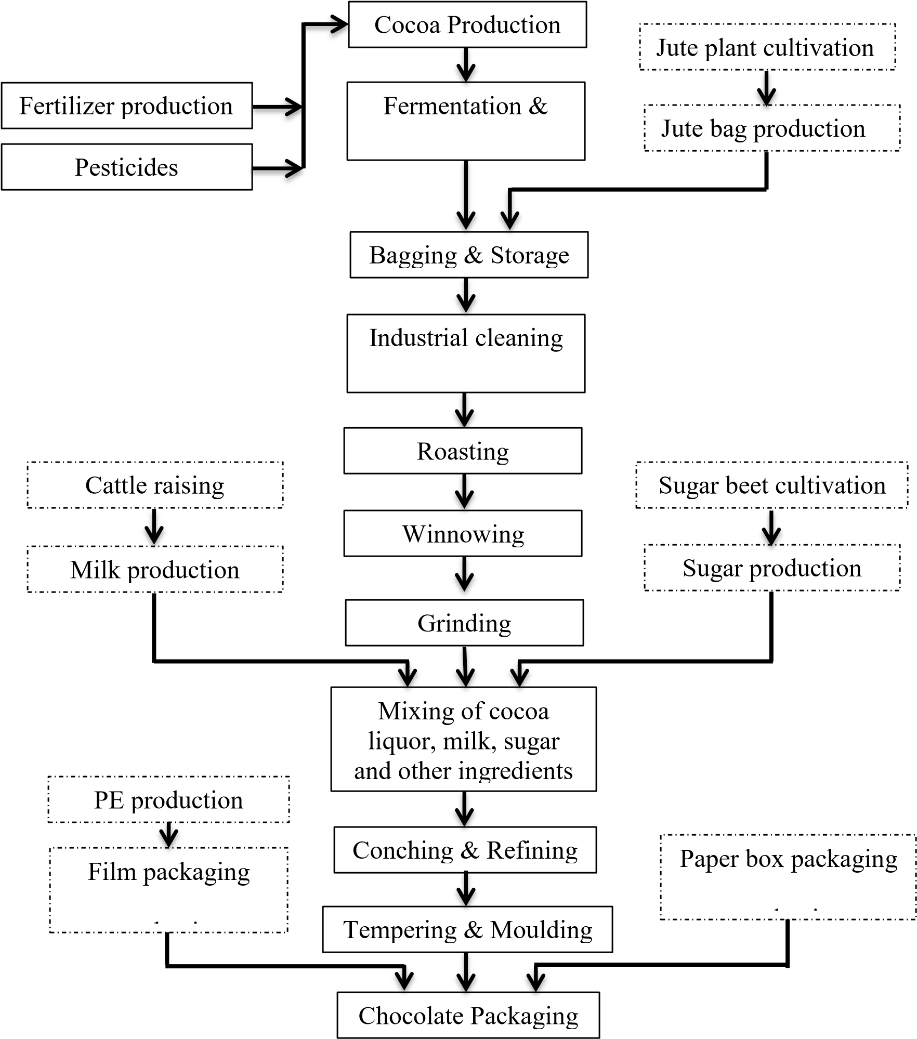
Figure 2.1: Process flowchart for chocolate production.
Source: Afrane and Ntiamoah (2011)

Subsequent fermentation, drying, transportation and storage may also expose the beans to metals in the air. Processing of the beans to butter, powder, chocolates and other confectionaries involve the use of highly sophisticated equipment. These equipment can be potential sources of heavy metal contamination (Morgan, 1999).
Another contamination source is the addition of ingredients. Since the year 2000, a European directive has authorised the use of up to a maximum of 5% of six fats (or oils) from plants to replace cocoa butter in chocolate production. These include: illipe, palm oil, sal, shea, kokum gurgi and mango kernels. While this directive has benefitted manufacturers due to the low cost of these products and ease of manufacture (OCED, 2007), it has come with other consequences, one of which is the introduction of heavy metal contaminants in the chocolates. Today, chocolates and other cocoa products are composed of solid constituents whose normal solid concentration is about 60 to 70% sugar, cocoa and milk. Beside these constituents, other ingredients like salts, hydrogenated vegetable oil, emulsifiers and buffering agents are present in cocoa products. All these ingredients could be sources of heavy metals in the products (Ciurea and Lipka, 1992).
Food additives, such as firming agent, carrier, colouring agent, anticaking agent, buffer, neutralizing agent, dough strengthener, emulsifying agent, stabilizer, thickener, curing agent, leavening agent and texturizer, also provide a significant percentage of daily heavy metal intake. These additives are used in milk, yogurt, preserves, baking soda, sugars, cereals and flours (Pennington, 1987) which often form part of the cocoa product recipes. It has been found that, cattle are often attracted to contaminated plants because of their sweet taste (Giblin, 2010). Thus, heavy metals such as Pb accumulate in cow milk and fatty tissues as cattle feed on grasses and plants which have grown on soils which has unusually high level of lead (Figueroa, 2008; Giblin, 2010). Such milks, when used as raw materials for chocolate and the other cocoa products, will end up contaminating the product. Water used at the plant in washing or rinsing operations as well that which is added as ingredient of the final food product could be another source of heavy metals. This is proven by studies which found incidents of high concentration of heavy metals in ground water (bore well/well water) and municipal water (Multani, 2010; Yokel, 2012).

The final packaging materials of cocoa products may also contribute to heavy metals contamination of the product. Cocoa-based candies which are likely to be consumed by children are often wrapped in colourful packages in order to induce children to purchase them. In a study conducted on candy packages available in South Korea, Kim et al. (2008) found lead, copper, manganese and zinc as high as 6394.1 mg/kg, 529.8 mg/kg, 8.3 mg/kg and 2579.5 mg/kg respectively in these materials. These metals can migrate from the printed surface to the food contact surface through four mechanisms: blocking, rubbing, peeling and diffusion (Bradley et al., 2005).

2.4.1.3 Post-production sources
Conditions under which cocoa products are transported and retailed are of paramount importance in dealing with product contamination. Elevated temperature, ultraviolet light exposure and lengthy storage time of the products affects the permeability of the packaging materials, thus resulting in the migration of contaminants such as heavy metals into the product (Meiron and Saguy, 2007). Products sold in areas close to possible source of heavy metals emission also stand the risk of being contaminated. Some of these areas include industrial regions where there are factories of batteries, soaps, paints, cosmetics, metal fabrication, plastics, corrugated iron sheets, pharmaceuticals, breweries, tanneries, copper melting plants as well as emissions from power stations (Lenntech, 2004). Heavy metal contamination can also occur when cocoa products are served or heated in any vessel which contains the metals – including vessels decorated with paint or poorly fired ceramic glaze which contains these metals (Giblin, 2010).

2.5 Exposure and Risk Assessment
Risk assessment is considered as the characterization of the potential harmful effects of humans as a result of exposure to contaminants (USEPA, 2012). This process entails evaluating toxicity data for substances which humans are exposed to and estimating the numeric potential exposure levels (Lushenko, 2010). There are four main steps involved in risk assessment which are: hazard identification, dose-response assessment, exposure assessment and risk characterization.

2.5.1 Hazard Identification
In this step, the various health problems the contaminant could cause are determined by examining the available scientific data about its effect on humans and laboratory animals. These health problems may either be carcinogenic or non-carcinogenic (USEPA, 1992). The USEPA used a weight-of-evidence approach to classify the likelihood of a substance of being a carcinogen and as a result, each substance is placed into one of the five categories presented in Table 2.1.

Table 2.1: USEPA’s carcinogenicity classification of substances
Group | Category
A | Human carcinogen
B | Probable human carcinogen
B | B1 - limited human evidence
B | B2 - sufficient evidence in animals, inadequate/no evidence in humans
C | Possible human carcinogen
D | Not classifiable as to human carcinogenicity
E | Evidence of non-carcinogenicity for humans
Source: USEPA (1992)
Lead, for instance, has been classified as a probable carcinogen (Group B2) (USEPA, 1988). Lead has a strong affinity for proteins, thus, it readily binds to haemoglobin and plasma protein which results in the inhibition of red blood cell synthesis. If the bonding capacity is exceeded, lead passes into the bone-marrow, kidneys and liver. Little is known about the excretion of lead once it has been absorbed. Thus, a large percentage of the metal accumulates in the body (ATSDR, 2000). According to Vitaosevic et al. (2007), chronic lead intoxication can adversely affect the central nervous system, kidney, reproductive organs and liver functions. Children, particularly, are more susceptible to the devastating effects of lead because of their more rapid growth rate and metabolism (Castro-Gonzalez and Mendez-Armenta, 2008). Both manganese and copper have not been classified as human carcinogens (Group D) (USEPA, 1988), however, manganese toxicity can damage the human respiratory tract and brain as confirmed through animals’ studies (ATSDR, 2000).
Similarly, excessive intake of copper can result in brain damage, liver cirrhosis, neurological disorders, demyelization, dermatitis and renal diseases (Lucas 1974; Graham and Cordano, 1976). While the USEPA (1992) could not assess the
carcinogenicity of zinc and iron due to inadequate information, studies have shown that these two essential elements are also toxic when consumed above threshold limits. Zinc is implicated in elecyrolyte imbalance, anaemia, nausea, birth defects and lethargy (Garrow and James, 1993; Dibley, 2001). Recent epidemiological study has also indicated a link between excessive intake of zinc and obesity and its associated diseases (Singh and Taneja, 2010). Iron toxicity can also result in fatty necrosis of the myocardium, increased capillary permeability, post-arteriolar dilatation, and reduced cardiac output (Greentree and Hall, 1995). Excess intake of iron, especially in men, has been found to be one of the major causes of heart disease and cancer (Corbett, 1995).

2.5.2 Dose-Response Assessment
Dose-response assessment determines the relationship between the magnitude of dose
(amount of substance) and a corresponding specific biological response (USEPA, 2005). In the case of carcinogenic substances, it is assumed that there is no reference dose (RfD), an estimate of daily exposure to human population that is likely to be without an appreciable risk of adverse effect during a life time (USEPA, 1992). This assumption agrees with the 73rd Joint Food and Agriculture/World Health Organisation Expert Committee on Food Additives (JECFA) findings when the committee reevaluated the previously established provisional tolerable weekly intake (PTWI) for lead through dose-response analyses. It was found that the 0.025 mg/kg body weight PTWI was associated with decrease of at least 3 IQ points in children and an increase in systolic blood pressure of approximately 3 mmHg (0.4 kPa) in adults. Subsequent doseresponse analyses could not indicate any threshold for the key effects of lead (JECFA, 2011).
In the case of non-carcinogens, it is assumed there is RfD. USEPA is also of the view that RfDs can also be derived for the non-carcinogenic health effects of substances that are also carcinogens (USEPA, 1992). As a result, the 1.4 x 10⁻⁴ (Oak Ridge, 1997), 4.0 x 10⁻², 3.0 x 10⁻¹, 7.0 x 10⁻¹ and 1.4 x 10⁻¹ mg/kg/day (USEPA, 2011) were estimated as the RfDs for lead, copper, zinc, iron and manganese respectively. While several studies have adopted the USEPA’s RfDs for copper, zinc, iron and manganese, there are quite a number of different RfDs reported for lead. As a result, different studies on risk assessment of lead used different RfDs. For instance, Khan et al. (2008), Wang et al. (2005) and Chen et al. (2014) used 3.5 x 10⁻³, 4 x 10⁻³ and 3.6 x 10⁻³ mg/kg/day respectively.

The United States’ Food and Nutrition Board of the Institute of Medicine (FNB/IOM) after evaluating the toxicity potential of manganese through dose-response studies has specified the upper intake levels for children with ages 1-3 years, 4-8 years, 9-13 years, 14-18 years and 19-30 years as 2 mg/day, 3 mg/day, 6 mg/day, 9 mg/day and 11 mg/day respectively. The FNB/IOM has also established upper manganese intake levels for pregnant and lactating women who are 14 to 18 years as 9 mg/day and adult men and women as 11 mg/day (FNB/IOM (2001). The WHO has equally estimated recommended dietary allowance for manganese as 2 to 5 mg/day/person (which is equivalent to 0.03-0.8 mg/kg/day) (Demirezen and Uruc, 2006). The recommended dietary allowance is the average daily level of intake sufficient to meet the nutrient requirements of nearly all (97%-98%) healthy human beings (Demirezen and Uruc,
2006). The JECFA also estimated the Provisional Maximum Tolerable Daily Intake
(PMTDI) of zinc, copper and iron as 1, 0.5 and 0.8 mg/kg body weight respectively (JECFA, 2011). The PMTDI represents the permissible human exposure due to the natural occurrence of the metal in food (JECFA, 2011).

The slope of the carcinogens dose-response curve is called the potency factor (PF) or the slope factor (SF) and it is defined as the cancer risk per unit dose (USEPA, 1992).
The SF of lead was determined as 0.0085 (OEHHA, 1997).

2.5.3 Exposure Assessment
This is a qualitative and quantitative assessment which helps to obtain a realistic estimate of total human exposure to a hazard, expressed in terms of dose per unit weight (USEPA, 1992). In order to determine the daily exposure of an individual metal, USEPA (1992) proposed, among others, the Chronic Daily Intake (CDI) as the exposure metric. This is calculated using the following equation:

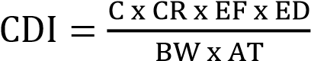 - (2.1)
Where CDI is the chronic daily intake (mg/kg/d), C is the metal concentration in the product (mg/g), CR is the contact rate (g/day), EF is the exposure frequency (days/year), ED is exposure duration (years), BW is body weight (kg) and AT is average of exposure duration (ED x 365 days/year)

Information required for the estimation of the CDI are usually obtained from food intake diaries, 24 hours’ recall, diet history survey and food frequency questionnaires (FFQs) (Hammerling et al., 2009; Shephard, 2008). Among the aforementioned methods, the most widely used is FFQs. It was used by Ogwok et al. (2014) to determine lead, copper and iron exposure from organ meats consumption in Nigeria.
Akomea-Frempong (2016) used it to estimate the exposure of inhabitants of Kumasi Metropolis, Ghana, to arsenic, cadmium, lead, mercury and polycyclic aromatic hydrocarbon from the consumption of cabbage and lettuce. Bonah (2014) also used it to estimate arsenic, cadmium, lead and mercury exposure from ready-to-eat locally milled tomato sauce in Ghana. The body weight is usually assessed from literature or an assumed weight of 70kg is used (Williams et al., 2002; Lee et al., 2004) for deterministic analyses. This, however, may result in over-estimating or underestimating the risk for the study population. Some studies, for the sake of accuracy, included the measurement of body weights in the FFQs (Ugwu, 2010).

Many studies determined the metal concentration using one or more of the following assays: Atomic Fluorescence Spectroscopy (AFS), Graphite Furnace Atomic
Absorption Spectroscopy (GFAAS), Inductively Coupled Plasma-Atomic Emission
Spectroscopy (ICP-AES) and Inductively Coupled Plasma-Mass Spectroscopy (ICP-
MS) (Melamed, 2005; Iqbal et al., 2016).

2.5.4 Risk Characterization
This is the last step in the risk assessment process and it involves bringing all the first three steps together to define an overall risk to a specific population. To determine the risk posed by the ingestion of carcinogen, the lifetime risk of cancer is calculated by the following equation (USEPA, 1999):
 - (2.2)
Where R is the probability of excess lifetime cancer, CDI is the chronic daily intake (mg/kg/d) and SF is the safety factor (mg/kg/d)⁻¹. Risk values higher than 10⁻⁶ (1 in a million, a deminimis) are generally considered unacceptable by the USEPA (2000). However, acceptable deminimis may change depending on the national standards and environmental policies and may be pegged as high as 10⁻⁴ (WHO, 2004).

To determine non-carcinogenic risk, the hazard quotient (HQ) is calculated when there is only one hazardous substance concerned. However, in the case of multiple hazardous substances in one product, the hazard index (HI), which is the sum of all HQ of the various hazards in the product, is used. Both HQ and HI are calculated using the following equations (USEPA, 1999):
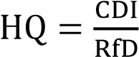 - (2.3)
- (2.4)
Where RfD is the reference dose (mg/kg/d) and HQ₁, HQ₂ and HQ_{n} are the hazard quotients of the hazardous substances in the product. In cases where the HQ and HI values exceed 1, it is assumed there is potential for adverse effect to occur or there is the need for further investigation. The conclusion drawn from risk characterization informs stakeholders about the hazard, whether its level is acceptable or tolerable and the control measures to put in place if it is above acceptable level (Gillespie et al.,
2011).

2.5.4.1 Risk Characterization of Metals
Several researchers have used the USEPA risk model to estimate risk of various metals in food products. For instance, Iwegbue et al. (2013) used the model to determine the HQ of cadmium in pudding (1.1), doughnut (1.0) and nickel in pudding (1.1), sausage roll (2.9), hot dog (1.0), chin-chin (1.1) and sponge cake (2.2). He also found the HI of these metals to range between 1.7 and 10.1. Similarly, Akomea-Frempong (2016) quantified the carcinogenic risk of arsenic, lead and polycyclic aromatic hydrocarbon (PAH) in raw lettuce and cabbage as 7.90 x 10⁻⁵, 6.42 x 10⁻⁷ and 4.33 x 10⁻⁵ respectively. By using an acceptable risk (deminimis) value of 10⁻⁶, he concluded the population was at risk of arsenic and PAH toxicity. He again used the model to estimate the HQ of cadmium and mercury as 6.9 x 10⁻³ and 3 x 10⁻⁴ respectively which were deemed acceptable as the values were less than 1. Wang et al. (2005), however, introduced a correction factor of 10⁻³ to the USEPA model when estimating the HQ of some heavy metals in vegetables. He multiplied the hazard concentration, duration and frequency of exposure and the body weight of consumers by the factor before dividing with RfD.

2.5.5 Deterministic vs. Probabilistic Approach
Depending on the risk assessment’s objectives, risk of exposure to heavy metals may be determined deterministically or probabilistically (stochastically). In the deterministic approach, the exposure and risk are calculated as point estimates (Kirchsteiger, 1999). This approach, however, does not allow the uncertainty associated with to the variables to be deduced. Hence, exposures may be underestimated or overestimated, resulting in an assessment that do not inform risk managers as to whether the population is
realistically at risk or not (Baugher, 2010).

The probabilistic approach, however, uses probability distributions to represent each variable in the exposure and risk equations. The probabilistic approach can enhance risk estimates by more holistically incorporating available information regarding the range of possible values that an input variable could take and weighing them by their probability of occurrence. More time and effort are required in this approach, hence, computer-based methods such as Monte Carlo simulation are needed (Kirchsteiger, 1999). Li et al. (2011) adopted both approaches when assessing arsenic cancer risk in Chinese food. They found that, the probabilistic approach was better in identifying the most relevant factors of cancer risk and uncertainty analysis and it gave comparatively lower risk values. Nonetheless, despite the limitations associated with the deterministic approach, few researchers still use it due to its relatively clear and simple analysis and decision making process (Kirchsteiger, 1999). For instance, in assessing the health risk of lead, cadmium, chromium, mercury and arsenic in soil-vegetable system in China, Lui et al. (2013) chose the deterministic approach. The results indicated that the soil in the study area was unsuitable for vegetable cultivation and while chromium and lead were the primary metals posing non-cancer risks, cadmium caused the greatest cancer
risk.

2.5.5.1 Monte Carlo Simulation
Monte Carlo simulation is a computer-based method of analysis which was developed in the 1940s. It has since become the preferred method for obtaining probabilistic approximation to the solution of a mathematical equations or model by using statistical sampling techniques (USEPA, 1997). Three inputs are required for this method, namely, known inputs (averaging time of hazard and exposure duration), uncertainty variables (hazard content, number of times of consumption of medium, mass of medium, exposure frequency, contact rate and body weight) and decision variables (reference dose or slope factor). The averaging time for carcinogens and noncarcinogens are 70 and 30 years respectively (USEPA, 1992). The exposure duration may be the actual event duration or be assumed to be 70 or 30 years for lifetime chronic consumption of carcinogen or non-carcinogen respectively (USEPA, 1992).
Kyei (2014), for instance, used the actual exposure duration of one year in his study on risk of acrylamide intake from “koose” consumption. Some researchers (e.g. AkomeahFrempong (2016)), however, classified the exposure duration as uncertainty factor. Uncertainty factors are usually obtained from the population understudy, however, some studies (Lui et al., 2013; Iwegbue et al., 2015) also obtained them from literature.
Some studies have used FFQ as a tool (Bonah, 2014; Ogwok et al., 2014 and Akomeah-Frempong, 2016) to obtain the uncertainty information from the population during their respective studies. Decision variables are obtained from databases. The distributions for each variable are used as the input distribution for the CDI determination model. During a single trial, values are selected randomly from the defined possibilities (the shape and range of the distribution) for each variable and then the outcome is calculated using the model. However, if a simulation is run for 10,000 trials, 10,000 possible outcomes are created. The probability distribution obtained for the CDI for each substance is used to estimate R, HQ and HI. The main advantage of the Monte Carlo approach is its applicability. There are no restrictions regarding the form of the input distributions and computations are also straightforward (USEPA, 1992).

2.6 Future Outlook
This chapter gave an overview of cocoa-based product developments and their health benefits. It went further to review the metals in cocoa products and the possible sources of these metals. The principles and methods underpinning the exposure and risk assessment of these metals were also reviewed. There are identifiable areas in which studies on metals in cocoa have been limited or non-existent. Because Ghana is the hub of cocoa production, most of the cocoa-based studies in the country have focused on metals in cocoa beans and the soils in the cocoa farms with the goal of ensuring the integrity of the beans that are made available to the world market. However, numerous food surveys conducted in other countries have shown high levels of metals such as lead, iron, copper, zinc and manganese in finished cocoa products. Considering the fact that Ghana’s local markets continuously see influxes of imported and locally produced cocoa products, one cannot help but be concerned with the safety of these products in the market. There is therefore the need to assess the dietary exposure of these metals in the cocoa products and estimate their corresponding risks. Findings from this study will provide basis for stakeholders to commit resources to identifying the source of the problem for subsequent mitigation.
CHAPTER THREE
MATERIALS AND METHODS

3.1 Materials
All reagents used for the study were of analytical grade. Nitric acid (Univar) was obtained from Ajax Finechem, Australia while perchloric acid (CDH) was obtained from Central Drug House Limited, New Delhi, India.

3.2 Methods

3.2.1 Study Area
The study area was in Koforidua which is an urban town and capital of Eastern Region, the third most populated region in Ghana with a projected settlement population of 3,028,597 by the year 2016 (Ghana Statistical Service, 2010). The town is located about 85 kilometers north-west of Accra and West of the foothills of the Obuotabiri
Mountains. Its immediate bordering towns include Effiduase, Ada, Densu Agya,
Okrase and Ntronan (Figure 3.1). It serves as a commercial centre for the Eastern Region and it is home to many businesses, most of which are into retailing of goods such as food, cosmetic, second-hand clothing and household equipment.
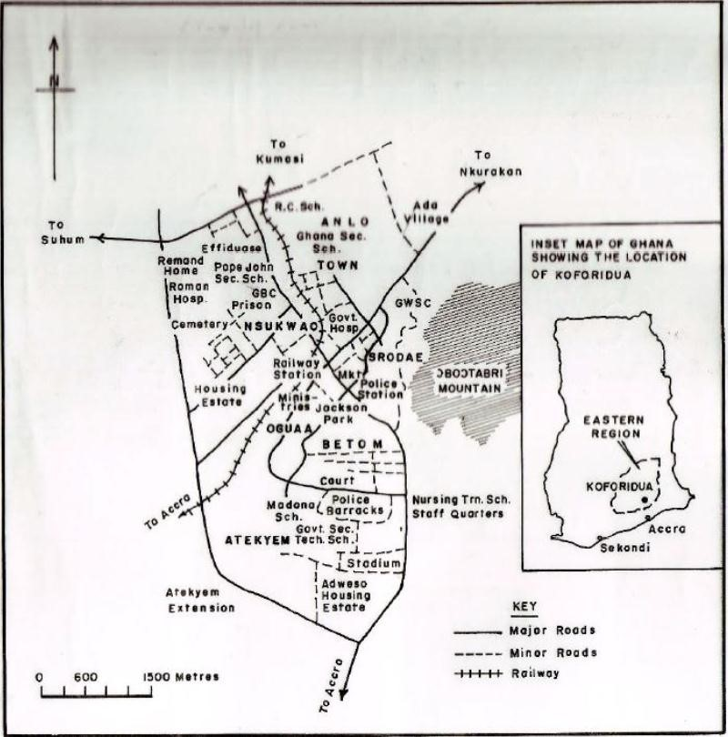

Figure 3.1: Map showing study area (Koforidua),
Source: Town and Country Planning Dept., Koforidua (2016)

3.2.2 Sample Collection
A total of 50 different brands of cocoa products, comprising of cookies, candies, icecreams and beverages, were randomly purchased from the open market in Koforidua. Each product was purchased in triplicates and replicates had different manufacturing dates and batch numbers. After acquisition, the ingredients, weight, manufacturer and country of origin of the products were recorded. The samples were stored under the manufacturer’s prescribed storage conditions until the time of analysis. The samples were categorized based on where they were produced. Those produced in the country were categorized as “local” while those imported into the country were categorized as
“imported”. In all, there were 21 local products and 29 imported products.

3.2.3 Digestion Procedure
The solid samples were each homogenized in a Christy and Norris stainless mill (Eco Pellet 120SP, England). Using the method described by Rehman and Husnain (2012) but with slight modification, 1.25 mg (1.25 ml for liquid samples) of each solid sample was weighed and transferred into 350 ml digestion flask. An amount of 12.5 ml of HNO₃ (70%^{v}/v) was added and the content which was placed in Tecator Digester (FOSS, Sweden) and heated at 70 oC for an hour after which the mixture was then allowed to cool at room temperature.. The mixture was then allowed to cool at room temperature after which 3.75 ml HClO₄ (70% ^{v}/v) was added and heating continued at 240 ºC until white fumes were produced. The resulting colourless solution was filtered through Whatman No. 42 (125 mm) into 25 ml volumetric flask and made up to the mark with deionized water.

3.2.4 Determination of Metals
The metals were analysed with Atomic Absorption Spectrometer (AAS) (Spectra AA 220FS, Australia) as described by Rehman and Husnain (2012). A working range of calibration standards (Fluka analytical, Sigma-Aldrich Chemie GmbH, Switzerland) of manganese (Mn), zinc (Zn), copper (Cu), iron (Fe) and lead (Pb) were prepared and used to optimize the response of the AAS. The calibration standards allowed concentration of the metals to be determined using linear regression. The metals; Mn,
Zn, Cu, Fe and Pb were determined at wavelength of 403.1 nm, 213.9 nm, 327.4 nm,
248.3 nm and 217 nm respectively using acetylene as fuel and air as the support gas. The detection limit for each element was determined and these were 0.005 µgMn/ml, 0.003 µgZn/ml, 0.01 µgCu/ml, 0.005 µgFe/ml and 0.01 µgPb/ml. The digest were aspirated into the spectrometer according to the manufacturer’s guidelines for each metal and each determination was done in triplicates.

3.2.5 Quality Control and Assurance
Quality assurance measures were employed during the analysis to validate the accuracy and reliability of the analytical results obtained. Reagent blanks were run to correct sample readings for any contamination of heavy metal in reagents or water used. Calibration standard solutions were analyzed at intervals (1 in every 10 samples) during analyses to monitor and control responses of the AAS. To check analytical precision, randomly chosen samples were measured in triplicate.

3.2.6 Determination of Dietary Intake
Consumption data was collected from 300 randomly selected respondents (112 males and 188 females) between the 2nd and 20th October, 2016 using questionnaires and interviews. The details of the study were explained to each respondent and a verbal consent obtained before questionnaires (Appendix A) were administered. Respondents who were proficient in English language filled the questionnaire on their own while the ones with poor literary skills responded to a questionnaire interview carried out in local dialects. Photographs of the products used in the study were attached to each questionnaire/interview schedule, to guide the respondents. Data were collected on quantity of product consumed, frequency of consumption, body weight and sociodemographic factors.

3.2.7 Data Processing
Metal content: The actual metal intakes were deduced from the consumption data and loaded into Palisade @Risk 7.5 software (Palisade Corporation, USA). These were fitted to their respective defined distribution (Table 3.1) and run by a first order Monte Carlo simulation at 10,000 iterations.

Table 3.1: Statistical distribution of metals used in risk computation
Variable | Product | Statistical Distribution
Manganese | Imported  Local | Lognorm(2.606,13.083,Shift(0.021243)  Expon(1.5198,Shift(0.016274)
Zinc | Imported  Local | Lognorm(1.6322,12.323,Shift(0.037707)  Expon(0.79169,Shift(0.041606)
Copper | Imported Local | Lognorm(0.48851,1.542,Shift(0.019048) Expon(0.59136,Shift(0.023906)
Iron | Imported  Local | Expon(0.41498,Shift(0.0068764)  Weibull(1.2037,0.66489,Shift(0.055594)
Lead | Imported | Invgauss(0.17151,0.052127,Shift(-  0.0034155)
 | Local | Expon(0.20987,Shift(0.0025839)

Other Uncertainty factors: The exposure frequency per year was extrapolated by multiplying the data on exposure frequency per week by 52. The result, together with the data on number of times of consumption per day, mass of product taken per day and body weight were simulated at first order Monte Carlo at 10,000 iterations. The various distributions fitted are presented in table 3.2. The contact rate was calculated as the product of the simulated values obtained for the number of times of consumption per day and the mass of product consumed per day.

Table 3.2: Statistical distribution of uncertainty data for cocoa product

Statistical Distribution of Uncertainties Input factors
 | Imported Products | Local Products
No. of times of consumption of  product/day | Binomial(3,0.36403) | Binomial(5,0.21541)
Mass of product (g) | Kumaraswamy  (0.46561,1.9765,0.05,168.92) | Expon(41.397,Shift(-0.034054)
Exposure frequency  (days/year) | Negbin(5,0.059169) | Negbin(5,0.054826)
Body weight (kg) | Kumaraswamy  (0.74659,1.6213,12.1,114.26) | Kumaraswamy  (0.77634,1.4851,12.1,121.63)

Chronic daily intake (CDI): The CDI was calculated according to the formula below (equation 2.1) (USEPA, 1992), using the distributions of each of the variables. For this study, the exposure duration was for a period of 30 years for non-carcinogens (USEPA,
1992) (Mn, Zn, Cu, Fe) and 70 years for the carcinogen (Pb) (USEPA, 1992). Similarly, the averaging time was 30 years x 365 (10,950 days) for non-carcinogens and 70 years x 365 (25,550 days) for the carcinogen (USEPA, 1992).
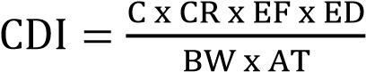 - (2.1)
Where C is the metal content (mg/g), CR is the contact rate (g/day), EF is the exposure frequency (days/year), ED is the exposure duration (year), BW is the body weight (kg) and AT is the averaging time (days). A Monte Carlo simulation was also run in favour of the CDI at 10,000 iterations.

Risk Calculation: The USEPA (1999)’s methods of risk assessment were used. The carcinogenic risk (R) was estimated by multiplying the CDI by a slope factor (cancer risk per unit dose) of 0.0085 (mg/kg/d)⁻¹ (OEHHA, 1997). The non-carcinogenic risk
(hazard quotient (HQ)) was estimated by dividing the CDI by oral reference dose (RfD). The RfD is an estimate of the daily exposure to the human population (including sensitive sub-groups) that is likely to be without an appreciable risk of deleterious effects during lifetime. In this study, RfD of 0.14 mg/kg/day (Mn), 0.3 mg/kg/day (Zn), 0.04 mg/kg/day (Cu) and 0.7 mg/kg/day (Fe) (USEPA, 2011) were used. Simulations were run for the risks at 10,000 iterations.

CHAPTER FOUR
RESULTS AND DISCUSSION

4.1 Results

4.1.1 Levels of Heavy Metals in Cocoa Products
Table 4.1 shows the mean concentration of metals in both imported and locally produced cocoa products. In all, Mn had the highest mean concentration in the imported (23.90 µg/g) and local (29.32 µg/g) products. Generally, the metal distributions in the products showed the order of Mn > Zn > Fe > Cu > Pb.

Table 4.1: Levels of heavy metals (µg/g) in cocoa products
Product | n | Mn | Zn | Cu | Fe | Pb
Imported | 29 | 23.90±16.54 | 11.47±2.05 | 5.90±2.13 | 7.90±3.17 | 2.13±0.90
 |  | 2.95-41.88 | 9.34-11.74 | 3.77-8.82 | 4.89-10.87 | 1.07-3.18
Local | 21 | 29.32±12.04 | 14.19±5.99 | 11.40±14.06 | 12.35±7.03 | 3.19±1.34
 |  | 15.37-45.66 | 8.44-26.49 | 2.61-42.29 | 3.57-25.04 | 1.22-4.16
Values are reported as mean ± standard deviation
Values in italics represent the range

4.1.2 Consumption Pattern
Tables 4.2 and 4.3 show the distribution of the survey data used in the CDI and risk estimation. Comparatively, the mean intake of the local products (41.36 g) was higher than that of the imported products (26.30 g). The local products were also consumed at higher frequencies than the imported ones. While the 5th, 50th and 95th percentile exposure frequencies (days/year) of the local products were 32, 80 and 160 respectively, those of the imported ones were 30, 74 and 148 respectively. The body weight distribution of respondents who consumed imported products ranged from 13.08 kg (5th percentile) to 93.28 kg (95th percentile) with a mean weight of 43.15 kg. The consumers of the local products also had body weights ranging from 12.27 kg (5th percentile) to 103.22 kg (95th percentile) with a mean weight of 48.82 kg.

Table 4.2: Statistical distribution of survey data for imported product
Input factors |  | Statistical Distribution of Uncertainties
Input factors | Mean | 5th Percentile | 50th Percentile | 95th Percentile
No. of times of consumption of product/day | 1.09 | 0.00 | 1.00 | 2.00
Mass of product (g) | 26.30 | 0.11 | 12.39 | 99.16
Exposure frequency (days/year) | 79.51 | 30.00 | 74.00 | 148.00
Body weight (kg) | 43.15 | 13.08 | 36.93 | 93.28

Table 4.3: Statistical distribution of survey data for local product
Input factors |  | Statistical Distribution of Uncertainties
Input factors | Mean | 5th Percentile | 50th Percentile | 95th Percentile
No. of times of consumption of product/day | 1.08 | 0.00 | 1.00 | 3.00
Mass of product (g) | 41.36 | 2.09 | 28.66 | 123.96
Exposure frequency  (days/year) | 86.20 | 32.00 | 80.00 | 160.00
Body weight (kg) | 48.82 | 12.27 | 42.84 | 103.22

4.1.2 Chronic Daily Intake
The Chronic Daily Intake (CDI) of Mn, Zn, Cu, Fe and Pb via imported and local products consumption are shown in Table 4.4. Generally, the CDI of all the studied metals were higher among consumers of local products and the highest ingested metal for the two product categories was Mn.

Table 4.4: Chronic Daily Intake of Mn, Zn, Cu, Fe and Pb via imported and local

cocoa products
Statistic |  | Chronic Daily Intake of Metals (x 10⁻³ mg/kg/day)
Statistic | Product | Mn | Zn | Cu | Fe | Pb
Mean | Imported | 451 | 322 | 96.1 | 83.1 | 29.6
 | Local | 458 | 245 | 183 | 199 | 55.9
5th Percentile | Imported | 0.192 | 0.121 | 0.0812 | 0.118 | 0.0248
 | Local | 3.74 | 2.74 | 1.85 | 3.09 | 0.127
50th Percentile | Imported | 29.8 | 15.9 | 10.1 | 14.5 | 3.37
 | Local | 127 | 72.2 | 53 | 66.8 | 12.5
95th Percentile | Imported | 1610 | 990 | 397 | 369 | 129
 | Local | 1890 | 1020 | 769 | 815 | 251

4.1.3 Risk Assessment
The estimated lifetime carcinogenic risks for Pb intake and non-carcinogenic (HQ) risks for Mn, Zn, Cu and Fe intake are shown in Table 4.5. The 50th percentile risk estimates for Pb intake from both imported (3.01 x 10⁻⁵) and local (1.08 x 10⁻⁴) products were above the acceptable limit of 10⁻⁶. Similarly, the 95th percentile risk estimates for Pb intake from both imported (1.05 x 10⁻³) and local (2.22 x 10⁻³) products were also above 10⁻⁶. In the case of the non-carcinogenic risks, the 95th percentile estimates for the intake of Mn (12.96), Zn (3.03) and Cu (9.93) from the imported products as well as the intakes from the local products (Mn (13.99), Zn (3.48), Cu (19.23) and Fe (1.16)) were above the acceptable limit of 1. A similar high estimate (>1) was observed for the 50th percentile estimate for Cu (1.33) intake from local products. Generally, Copper had the highest HQ values while Fe had the lowest HQ values. The graphical risk distribution of Mn, Zn, Cu, Fe and Pb are shown in
Figures 4.1 to 4.5 respectively.

Table 4.5: Lifetime carcinogenic and non-carcinogenic risks in cocoa products
Statistic |  | Risk “HQ” (Non-carcinogenic) (x 10⁻³) |  |  |  | Risk (Carcinogenic)
Statistic | Product | Mn | Zn | Cu | Fe | Pb
Mode | Imported  Local | 0.327  6.43 | 0.104  8.15 | 0.535  32.5 | 0.0133  2.95 | 5.76 x 10⁻⁸  5.60 x 10⁻⁸
5th Percentile | Imported  Local | 1.29  25.2 | 0.392 9 | 2.03  46.2 | 0.169  4.42 | 2.31 x 10⁻⁷  9.53 x 10⁻⁷
50th  Percentile | Imported  Local | 201  914 | 54.2 240 | 253  1330 | 20.7  95.4 | 3.01 x 10⁻⁵  1.08 x 10⁻⁴
95th  Percentile | Imported  Local | 12960  13990 | 3030  3480 | 9930  19230 | 530  1160 | 1.05 x 10⁻³  2.22 x 10⁻³

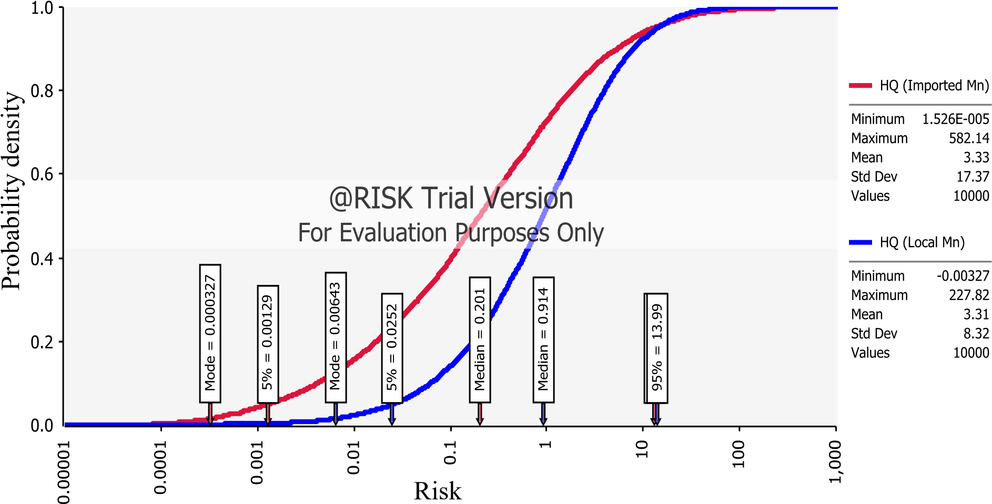
Figure 4.1: Risk (HQ) distribution of manganese from imported and local cocoa

products

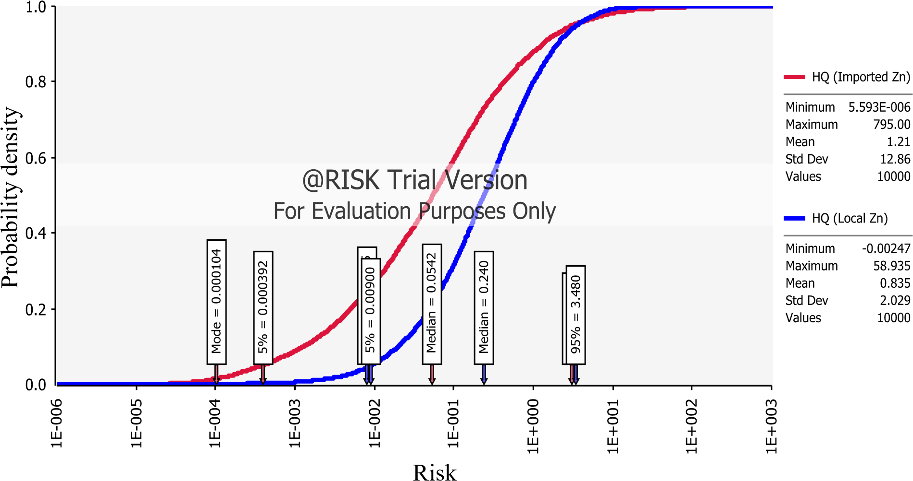

Figure 4.2: Risk (HQ) distribution of zinc from imported and local cocoa products

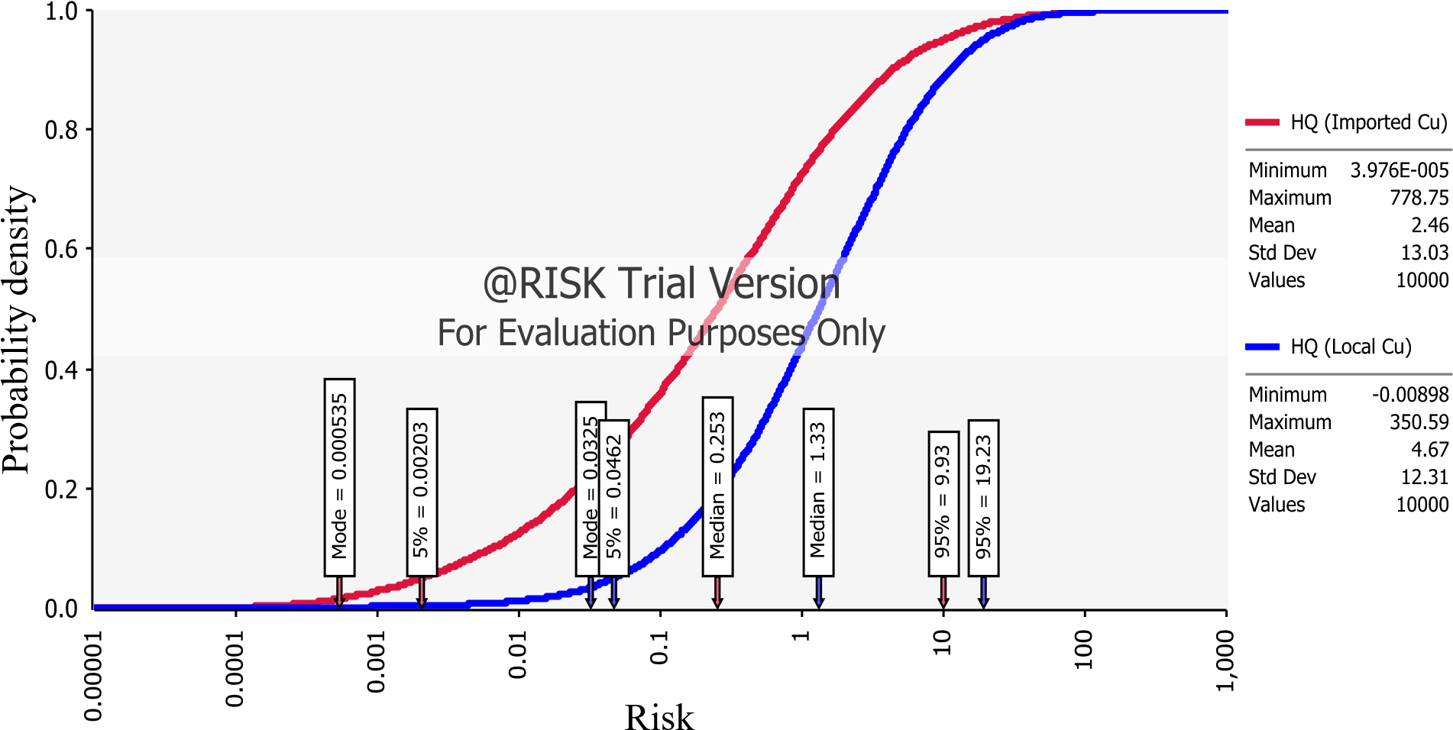
Figure 4.3: Risk (HQ) distribution of copper from imported and local cocoa

products
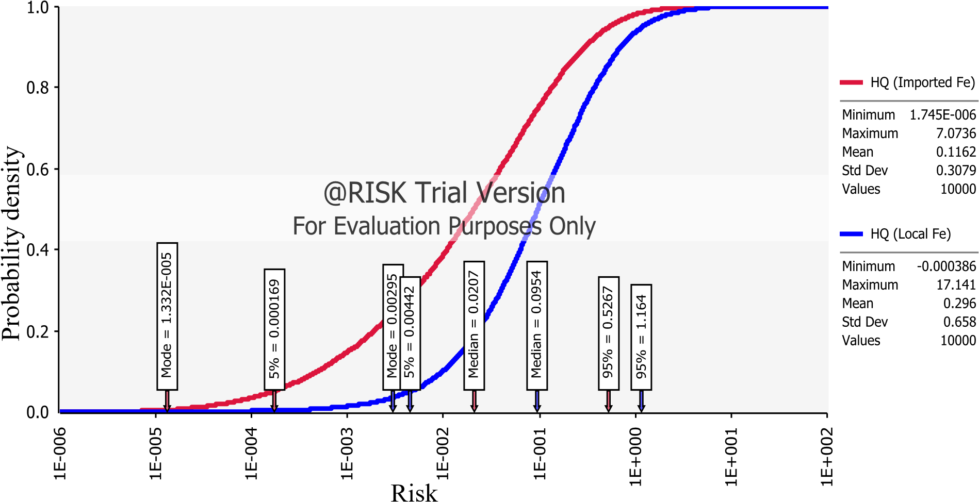

Figure 4.4: Risk (HQ) distribution of iron from imported and local cocoa products

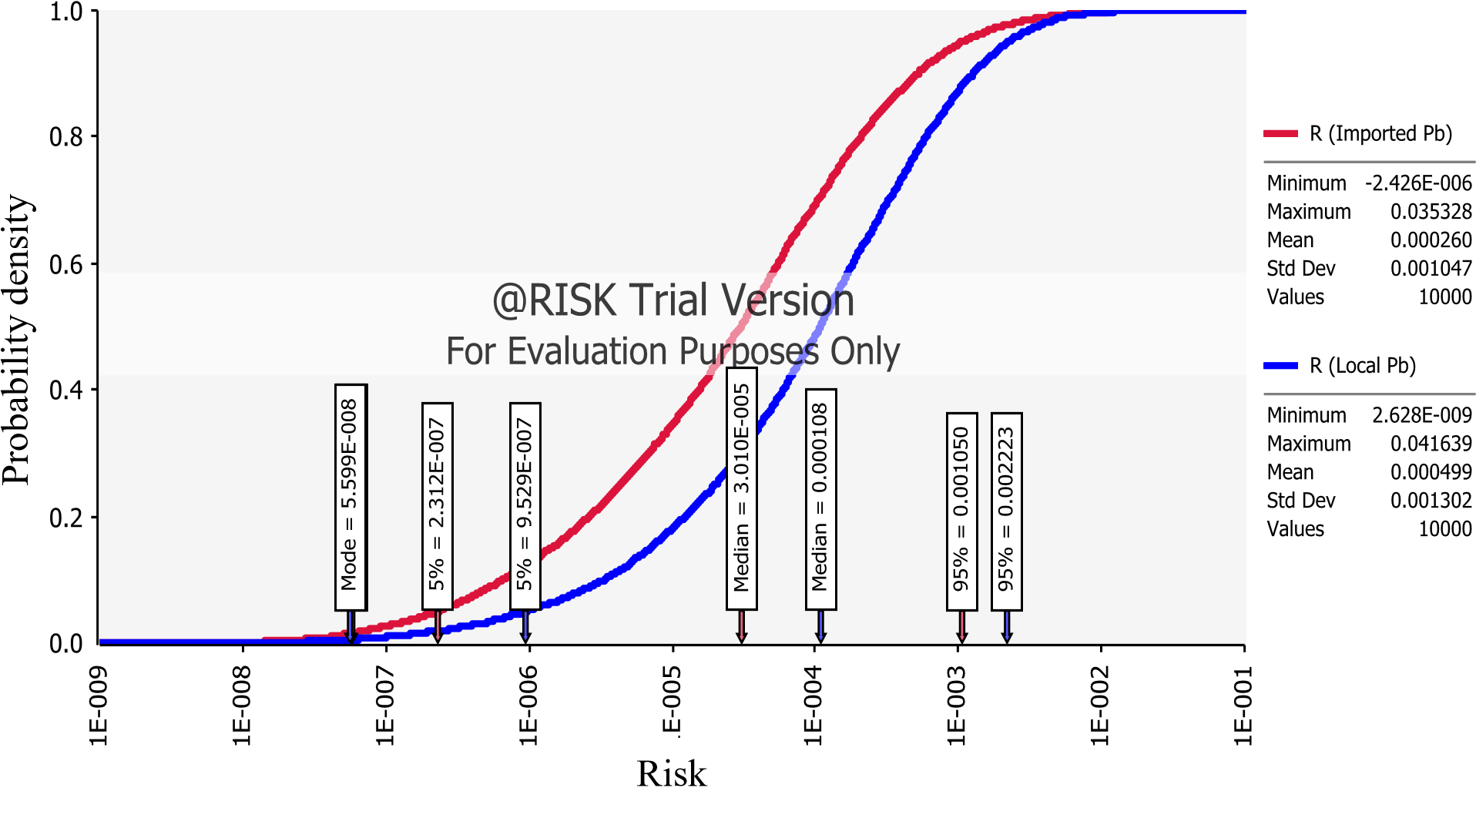

Figure 4.5: Risk distribution of lead from imported and local cocoa products

4.2 Discussion

Metals in Cocoa Products
High concentration of metals in food products have been implicated in numerous health issues such as obesity, brain damage, heart diseases, liver failure, neurological disorders, renal diseases and cancer (Lucas 1974; Graham and Cordano, 1976; Corbett, 1995; ATSDR, 2000; Singh and Taneja, 2010; Ackah, 2012). In this study, the mean levels of Mn in the cocoa products were the highest among all the five studied metals (Table 4.1). These Mn levels (23.90 and 29.32 µg/g for imported and local products respectively) were however, lower than those found in imported chocolates and candies sold in Nigeria (Ochu et al., 2012). While this study found Mn levels in imported and local cocoa products to be 23.90 and 29.32 µg/g respectively, Ochu et al. (2012) reported Mn level in imported chocolate and candy to range from 40,000 to 55,700 µg/g. The high level of Mn in the cocoa products may be due to a possible inclusion of ingredients in the products’ recipe which may be rich sources of Mn (Sager, 2012). Manganese levels in these products may also have been influenced by food processing because Mn is mostly used in alloys and cleansing agents for steel (Duran et al., 2009).

Generally, Mn, Zn, Cu, Fe and Pb levels in the cocoa products reported in this study were lower than those reported by other researchers. For instance, Danquah (2015) reported Cu (52.57 µg/g), Fe (375.03 µg/g) and Zn (83.68 µg/g) in cocoa powder produced in Ghana. Conversely, the Pb level in imported (2.13 µg/g) and local (3.19 µg/g) cocoa products in this study (Table 4.1) were higher than the 0.22 µg/g and 1.34 µg/g reported by Danquah (2015) and Lee and Low (1985) respectively. Similar high level of Pb (2.92 µg/g) in cookies consumed in Southern Nigeria had been reported by
Iwegbue (2012). Dahiya et al. (2005) had also reported a comparatively higher Pb level of 8.3 µg/g in chocolates sold in India. The source of metals in the cocoa products used in this study could be from the cocoa farms, ingredients or water used (Morgan, 1999; Naqvi et al., 2005). For instance, the municipal water used by most commercial entities in India were found to contain levels of Pb far exceeding the World Health Organisation (WHO) guideline value of 10 µg/L (Multani, 2010). Similar high content of Pb have been found by Multani (2010) in India’s bore wells where as high as 41% samples were unfit for drinking. Cobbina et al. (2015) also reported Pb levels as high as 31 to 250 µg/L in drinking water consumed in Nangodi and Tinga communities in northern Ghana. An ingredient used in most cocoa product recipe, cow milk, was reported to contain Pb as high as 23.1 µg/L (raw milk) and 19.6 µg/L (pasteurized milk) (Rodriguez et al., 1999). Some studies have also suggested processing equipment as possible contributors of metals in cocoa products (Morgan, 1999; Afoakwa, 2014). For instance, ball mills could add Fe to the product and this may be the reason why ball mills over a long period of time decrease in size (Afoakwa, 2014).

Consumption Pattern
In spite of the fact that this study found relatively higher consumption pattern among the consumers of local cocoa products compared to the imported ones (Tables 4.2 and 4.3), the general exposure to the two product categories was low. The highest exposure level (95th percentile) reported in this study revealed that, out of 365 days, only 5% of the population consumed imported and local products in 148 and 160 days respectively. This gives credence to the finding that, cocoa exporting countries such as Ghana have low consumption levels but process cocoa into byproducts for the industry, as well as importing countries, which process and consume a major share of the production
(OECD, 2007).

Chronic Daily Intake
The mean CDI found in this study (Table 4.4) were higher than those reported for some non-cocoa food products in the subregion. For instance, the intakes of 0.019 (Mn), 0.027 (Zn), 0.0069 (Cu), 0.072 (Fe) and 0.0043 (Pb) mg/kg/day reported among consumers of 80 g of ready-to-eat foods in Nigeria (Iwegbue, 2013) were lower than the intakes found from ingesting 26.30 g of imported and 41.36 g of local cocoa products in this study. The high intake of Mn observed in this study was expected as
Mn, generally, had the highest concentration in the cocoa products.

According to WHO, the recommended dietary allowance for Mn is 2 to 5 mg/day/person (which is equivalent to 0.033-0.083 mg/kg/day) (Demirezen and Uruc, 2006). The estimated 95th percentile intake of Mn for imported (1.61 mg/kg/day) and local (1.89 mg/kg/day) products were above the recommended dietary allowance and this suggest high Mn exposure among 5% of the population. The study also found the 95th percentile intake of Zn (1.02 mg/kg/day) from local products to be above the provisional maximum tolerable daily intake (PMTDI) of 1 mg/kg/day established by the Joint Food and Agriculture/World Health Organisation Expert Committee on Food Additives (JECFA) (JECFA, 2011). However, if the Safe Upper Level (SUL) Zn intake of 42 mg/day (equivalent to 0.7 mg/kg/day in a 60 kg adult) specified by the Expert Group on Vitamins and Minerals (EVM) (EVM, 2003) was used, the 95th percentile estimated for the imported products (0.99 mg/kg/day) may also be considered as above the recommended threshold limit. This again suggests 5% of the population may not be safe from Zn toxicity. JECFA’s PMTDI for Cu (0.5 mg/kg/day) was also found to be lower than the 95th percentile intake estimated for local products (0.77 mg/kg/day) while the 95th percentile estimate for the imported category was equally lower than the
EVM’s (2003) recommended SUL of 0.16 mg/kg/day.

A similar trend was observed in Fe intake where the 95th percentile intake (0.82 mg/kg/day) among local cocoa product consumers was marginally above JECFA’s recommended PMTDI of 0.8 mg/kg/day, thus, raising health concern among these consumers. Despite the fact that the provisional tolerable weekly intake (PTWI) for Pb (0.025 mg/kg/day) was withdrawn in 2010 by JECFA after dose-response assessments showed that it was associated with decrease of at least 3 IQ points in children and an increase in systolic blood pressure of approximately 3 mmHg (0.4 kPa) in adults, in this study, the 0.025 mg/kg/day value was used as an indicative value for comparing results. As observed in the intake of earlier-discussed metals, 5% of the study population for both product categories ingested Pb above the threshold limit. This is quite worrying since vulnerable groups, particularly children, are more susceptible to the devastating effect of Pb because of their more rapid growth rate and metabolism (ATSDR, 2007).

Health Risk Assessment
Non-cancer risk (HQ) values higher than 1 are generally considered unacceptable by the USEPA (2000). In this study, about 5% of the population may be at risk of noncancer adverse health effects from lifetime (30 years) consumption of the products judging from the high 95th percentile HQ estimates (>1) (Table 4.5). Generally, Cu, compared to Mn, Zn and Fe, presented higher potential for health risk due to its low RfD (0.04 mg/kg/day) (USEPA, 2011). Conversely, the potential health risk posed by of Fe intake was minimal compared to Mn, Zn and Cu due to its high RfD (0.7 mg/kg/day) (USEPA, 2011).
The USEPA (1999) prescribed a cancer risk threshold limit or deminimis of 10⁻⁶ (1 out of 1000,000 people). However, acceptable deminimis may change depending on the national standards and environmental policies (USEPA, 1999). Ghana did not establish any deminimis at the time of the study hence the USEPA’s threshold was used. Cancer risk was implicated at the 50th and 95th percentile exposures in the range of 3 out of 100,000 people to 2 out of 1,000 people who consumed either imported or local cocoa products. These estimates are higher than the deminimis thus deemed unacceptable. The modal risk estimates for both imported (5.76 x 10⁻⁸) and local (5.60 x 10⁻⁸) products, i.e. five out of hundred million lifetime product consumers were at risk of getting cancer, was deemed acceptable by USEPA (1999). The modal estimate suggested most of the Pb exposures via cocoa consumption in the study population were below the 5th percentile exposure and that majority of the population may be considered safe from the risk of getting cancer. However, since several dose-response analyses conducted by JECFA had still not indicate any threshold limit for Pb which would be considered health protective (JECFA, 2011), any level of Pb exposure must be considered dangerous.

CHAPTER FIVE
CONCLUSION AND RECOMMENDATION

5.1 Conclusion
In summary, the study found quite a substantial proportion (5%) of the population to be chronically exposed to the studied metals above their recommended daily dietary limits proposed by WHO, EVM and JECFA. These findings reflected in the non-carcinogenic risk assessment where risk values showed that 5% of the population might suffer adverse health effects from lifetime consumption of cocoa products. The carcinogenic risk assessment also indicated that, depending on exposure levels, 3 out of 100,000 consumers to 2 out of 1,000 consumers of the products have the probability of contracting cancer over a lifetime and this is considered unacceptable by USEPA standards. The presence of Pb in the cocoa products is quite worrying considering the fact that, there is no threshold limit for the metal. There is therefore the need to develop technologies that will ensure Pb is removed from the products during production stage. It is also recommended that, in making efforts to promote the consumption of cocoa products, authorities must also emphasize the need for people to consume the products in moderation.

5.2 Recommendations
Based on the findings from this study, the following recommendations are made:
i. Further studies should be carried out with the aim of developing technologies that will ensure Pb is removed from the products during production stage. ii. Similar studies should be conducted in other major cities in Ghana in order to arrive at a holistic picture of heavy metals exposure through the consumption of cocoa products in the country.
REFERENCES
Ackah, J.E. (2012). Distribution of heavy metals in cocoa farm soils in the western region of Ghana. Masters. University of Ghana.
Afoakwa, E.O. (2014). Cocoa Production and Processing Technology. Boca Raton: Taylor and Francis Group, CRC Press, pp. 48-50.
Afrane, G. and Ntiamoah, A. (2011). Use of pesticides in the cocoa industry and their impact on the environment and the food chain. In: M. Stoytcheva, ed., Pesticides in the Modern World - Risks and Benefits. InTech, pp. 51–68. Available at: http://www.intechopen.com/books/pesticides-in-the-modernworld-risks-and-benefits/use-of-pesticides-in-thecocoa-industry-and-theirimpact-on-the-environment-and-the-food-chain (Accessed: 1st July, 2016).
Aikpokpodion, P.E., Atewolara-Odule, O.C., Osobamiro, T., Oduwole, O.O. and Ademola, S.M. (2013). A survey of copper, lead, cadmium and zinc residues in cocoa beans obtained from selected plantations in Nigeria. Journal of Chemical and Pharmaceutical Research, 5(6), pp. 88–98.
Akomea-Frempong, S. (2016). Health Risk Assessment of some Environmental Pollutants through the consumption of Cabbage and Lettuce Eaten Raw: A Probabilistic-based analysis. Masters. Kwame Nkrumah University of Science and Technology.
Al Othman, Z.A. (2010). Lead contamination in selected foods from Riyadh City market and estimation of the daily intake. Molecules, 15, pp. 7482-7497.
Alloway, B.J. (1994). Toxic metals in soil-plant system. Chichester: John Wiley and Sons.
Andrews, N.C. (1999). Disorders of iron metabolism. The New England Journal of Medicine, 341, pp. 1986–1995.
ATSDR (Agency for Toxic Substance and Disease Registry). (2007). Toxicological profile for lead. Atlanta: U.S. Department of Health and Humans Services.
ATSDR (Agency for Toxic Substances and Disease Registry). (2000). Toxicological profile for manganese. Atlanta: US Department of Health and Human Services.
Bates, R.L. and Jackson, J.A. (1987). Glossary of Geology. 3rd ed. Alexandria: American Geological Institute.
Baugher, D.G. (2010). Comparison of deterministic and probabilistic approaches to modeling dermal exposure to pesticides during orchard airblast application. In: M.E. Krolski, C. Lunchick, eds. Non-Dietary Human Exposure and Risk Assessment, vol. 1047. USA: American Chemical Society, pp. 33–41. Available at: http://pubs.acs.org/doi/full/10.1021/bk-2010-1047.ch004 (Accessed: 1st July, 2016).
BBC NEWS., 2002. Chocolate makers dismiss toxic claims. [online]. Available at: http://news.bbc.co.uk/2/hi/business/1977780.stm (Accessed: 1st July, 2016).
Bennet, H. (1986). Concise Chemical and Technical Dictionary. 4th ed., London: Edward Arnold.
Bhasakram, P. (2001). Immunobiology of mild micronutrient deficiencies. Britain Journal of Nutrition, 85, pp. 75–80.
Bonah, E. (2014). Heavy Metal Health Risk Assessment And Microbial Quality Of Locally Milled Ready-To-Eat Tomato In Tamale, Ghana. Masters. Kwame Nkrumah University of Science and Technology.
Bradl, H. (2005). Heavy metals in the environment: Origin, interaction and remediation. Interface Science and Technology, 6, pp. 1–27.
Bradley, E.L., Castle, L., Dines, T.J., Fitzgerald, A.G., Gonzalez, T.P., and Jickells, S.M. (2005). Test method for measuring non-visible set-off from inks and lacquers on the food contact surface of printed packaging materials. Food Additives and Contaminants, 22(5), pp. 490-502.
Castro-González, M.I. and Méndez-Armenta, M. (2008). Heavy metals: Implications associated to fish consumption. Environmental Toxicology & Pharmacology, 26, pp. 263-271.
Chen, Y., Wu, P., Shao, Y. and Ying, Y. (2014). Health risk assessment of heavy metals in vegetables grown around battery production area. Scientia Agricola, 71(2), pp.126–132.
Ciurea, I.C., Lipka, Y.F. (1992). Occurrence of cadmium in cocoa and coffee. Mitt.
Geb. Lebensmittelunters Hyg, 83, pp. 197-199.
Cobbina, S.J., Duwiejuah, A.B., Quansah, R., Obiri, S. and Bakobie, N. (2015). Comparative assessment of heavy metals in drinking water sources in two small-scale mining communities in northern Ghana. Int. J. Environ. Res. Public Health, 12, pp. 10620-10634.
Corbett, J.V. (1995). Accidental poisoning with iron supplements. MCN, The American Journal of Maternal Child Nursing, 20, p. 234.
Dahiya, S., Karpe, R., Hegde, A.G. and Sharma, R.M. (2005). Lead, cadmium and nickel in chocolate and candies from suburban areas of Mumbai, India. Journal of Food Composition and Analysis, 18(6), pp. 517-522.
Dallman, P.R. (1986). Biochemical basis for the manifestations of iron deficiency. Annual Review of Nutrition, 6, pp. 13–40.
Danquah, J.O. (2015). Occurrence levels of heavy metals in fermented cocoa beans and cocoa derived products produced in Ghana. Masters. University of Ghana.
Dibley, M.J. (2001). Zinc. In: B.A. Bowman, R.M. Russell, eds. Present Knowledge in Nutrition, 8th ed. Washington DC: International Life Sciences Institute Press, p. 339.
Dimirezen, D. and Uruc, K. (2006). Comparative study of trace elements in certain fish, meat and meat products. Meat Science vol. 74, pp. 255–260.
Duran, A.A., Tuzen, M. and Soylak, M. (2009). Trace metal contents in chewing gums and candies marketed in Turkey. Environ. Monit. Assess. 149, pp. 283–289.
EVM. (2003). Safe upper levels for vitamins and minerals of the Export Group on
Vitamins and Minerals. [online]. Available at: http://www.food.gov.uk/multimedia/pdfs/ vitmin2003.pdf (Accessed 2nd November, 2016).
Fairweather-Tait, S.J. (1988). Zinc in human nutrition. Nutrition Research Review, 1, pp. 23–37.
FAO/WHO (2015). Establishment of maximum levels of cadmium in cocoa. In: Joint FAO/WHO Standards Programme CODEX Committee on Contaminants in Foods, 9th Session, New Delhi, India: Codex Alimentarius Commission.
Fidler, J. (2016). High levels of heavy metals found in popular chocolate brands. [online]. Available at: http://naturalsociety.com/high-levels-heavy-metalspopular-chocolate-brands-6983 (Accessed 2nd November, 2016).
Figueroa, E. (2008). Are more restrictive food cadmium standards justifiable health safety measures or opportunistic barriers to trade? An answer from economics and public health. Science of the Total Environment, 389, pp. 1-9.
FNB/IOM (Food and Nutrition Board Institute of Medicine). (2001). Dietary reference intakes for vitamin A, vitamin K, arsenic, boron, chromium, copper, iodine, iron, manganese, molybdenum, nickel, silicon, vanadium, and zinc.
Washington, D.C: National Academy Press, pp 394-415.
Garrow, J.S., and James, W.P.T. (1993). Human nutrition and dietetics. 9th ed.). Edinburgh: Churchill Livingstone.
Ghana Statistical Service. (2010). 2010 population projection by sex. Accra: Ghana Statistical Service.
Giblin, A. (2010). Lead contamination of food. LEAD Action News, 10(1), pp. 6-8.
Gillespie, Z., Pulido, O. and Vavasour, E. (2011). Risk assessment approaches for carcinogenic food contaminants. International Food Risk Analysis Journal, 1(1), pp. 1–18.
Graham, G.G. and Cordano, A. (1976). Copper deficiency in human subjects. In: A.S. Prasad, ed. The Nutrition Foundation. Trace elements in human health and diseases, vol. 1, New York: Academic Press.
Greentree, W.F. and Hall, J.O. (1995). Iron toxicosis. In: J.D. Bonagura, ed. Kirk’s current therapy XII: Small animal practice, Philadelphia, Pa: WB Saunders Co., p. 240–242.
Haas, J.D., and Brownlie, T. (2001). Iron deficiency and reduced work capacity: a critical review of the research to determine a causal relationship. Journal of Nutrition, 131, pp. 691–696.
Hammerling, U., Tallsjo, A., Grafstrom, R. and Nils-Gunnar, I. (2009). Critical Reviews in Food Science and Nutrition Comparative Hazard Characterization in Food Toxicology Comparative Hazard Characterization in Food Toxicology. Critical Reviews in Food Science and Nutrition, 497(49), pp. 626–669.
Hampel, C.A. and Hawley, G.G. (1976). Glossary of Chemical Terms, New York: Van Nostrand Reinhold.
Hurrell, R. and Egli, I. (2010). Iron bioavailability and dietary reference values. The American Journal of Clinical Nutrition, 91, pp. 1461S-7S.
ICCO (International Organization for Cocoa). (2012). The world cocoa economy: past and present. [online]. Available at: http://www.icco.org/ (Accessed: 19th September, 2016).
IOM (Institute of Medicine), Food and Nutrition Board (2001). Dietary reference intakes for vitamin A, vitamin K, arsenic, boron, chromium, copper, iodine, iron, manganese, molybdenum, nickel, silicon, vanadium and zinc. Washington DC: National Academy Press.
Iqbal, H.H., Taseer, R., Anwar, S., Qadir, A. and Shahid, N. (2016). Human health risk assessment: Heavy metal contamination of vegetables in Bahawalpur, Pakistan. Bulletin of Environmental Studies, 1(1), pp. 10–17.
Iwegbue, C.M.A. (2012). Metals in some brands of biscuits consumed in Southern Nigeria, American Journal of Food Technology, 7(3), pp. 160-167.
Iwegbue, C.M.A., Nwozo, S.O., Overah, C.L., Bassey, F.I. and Nwajei, G.E. (2013). Concentrations of selected metals in some ready-to-eat-foods consumed in Southern Nigeria: estimation of dietary intakes and target hazard quotients. Turkish Journal of Agriculture - Food Science and Technology, 1(1), pp. 1-7.
JECFA. (2011). Working document for information and use in discussions related to contaminants and toxins in the GSCTFF. In: Joint FAO/WHO Standards
Programme CODEX Committee on Contaminants in Foods, 5th session, The Hague, The Netherlands: Codex Alimentarius Commission.
Kakani, S.L. and Kakani, A. (2014). Engineering materials. 1st ed. New Delhi, India: New Age Publishers, p 2.
Khan, S., Cao, Q., Zheng, Y.M., Huang, Y.Z. and Zhu, Y.G. (2008). Health risks of heavy metals in contaminated soils and food crops irrigated with wastewater in Beijing, China. Environmental Pollution, 152, pp. 686-692.
Kim, K.C., Park, Y.B., Lee, M.J., Kim, J.B., Huh, J.W., Kim, D.H., Lee, J.B., Kim, J.C. (2008). Levels of heavy metals in candy packages and candies likely to be consumed by small children. Food Research International, 41, pp. 411–418.
Kirchsteiger, C. (1999). On the use of probabilistic and deterministic methods in risk analysis. Journal of Loss Prevention in the Process Industries, 12, pp. 399–419.
Kyei, S.O. (2014). Risk of dietary acrylamide exposure to an adult sub population of consumers of koose. Masters. Kwame Nkrumah University of Science and Technology.
Lee, C.K. and Low, K.S. (1985). Determination of cadmium, lead, copper and arsenic in raw cocoa, semi-finished and finished chocolate products. Pertanika, 8(2), pp. 243–248.
Lee, S.C., Guo, H., Lam, S.M.J. and Lau, S.L.A. (2004). Multipath-way risk assessmenton disinfection by-products of drinking water in Hong Kong. Environmental Research, 94, pp. 47-56.
Lenntech. (2004). Water treatment. [online]. Available at: www. lenntech.com (Accessed: 19th September, 2016).
Lewis Sr., R.J. (1993). Hawley’s Condensed Chemical Dictionary. 12th ed. New York:
Van Nostrand Reinhold.
Li, G., Sun, G.X., Williams, P.N., Nunes, L. and Zhu, Y.G. (2011). Inorganic arsenic in Chinese food and its cancer risk. Environ Int. 37(7), pp. 1219-25.
Liu, X., Song Q., Tang, Y., Li, W., Xu, J., Wu, J., Wang, F. and Brookes, P.C. (2013). Human health risk assessment of heavy metals in soil–vegetable system: A multi-medium analysis. Science of the Total Environment, 463, pp. 530–540.
Lowor, S.T. and Shiloh, O. (2013). Estimation of some metal and quality profile of cocoa beans in Ghana. Elixir Food Science, 59, pp. 15415–15420.
Lozet, J. and Mathieu, C. (1991). Dictionary of Soil Science. 2nd ed. Rotterdam: A. A. Balkema.
Lucas, J. (1974). Our polluted food: A survey of the risks. New York: John Wiley and Sons.
Lushenko, M.A. (2010). A risk assessment for ingestion of toxic chemicals in fish from Imperial beach. California: San Diego State University.
Manton, W. I. (2006). Sources of lead in cocoa and chocolate. Environmental Health Perspectives, 114(5), pp. 274–275.
McLaughlin, M.J., Hammon, R.E., Mclaren, R., Speir, G. and Rogers, T.W. (1999). A bioavailability-based rationale for controlling metal and metalloid contamination of agricultural land in Australian and New Zealand. Australian Journal of Soil Research, 38, pp. 1037–1086.
Meıron, T.S. and Saguy, I.S. (2007). Wetting properties of food packaging. Food Research International, 40(5), pp. 653-659.
Melamed, D. (2005). Monitoring arsenic in the environment: a review of science and technologies with the potential for field measurements. Analytica Chimica Acta, 532, pp. 1–13.
Moore, Jr. P.A., Daniel, T.C., Gilmour, J.T., Shreve, B.R., Edwards, D.R., and Wood, B.H. (1998). Decreasing metal runoff from poultry litter with aluminum sulfate. Journal Environment Quality, 27, pp. 92–95.
Morgan, J.N. (1999). Effects of processing on heavy metal content of foods. Adv. Exp.
Med. Biol., 459, pp. 195-211.
Morris, C. (1992). Academic Press Dictionary of Science and Technology. San Diego: Academic Press.
Mortvedt, J.J. and Beaton, J.D. (1995). Heavy metal and radionuclide contaminants in phosphate fertilizers. In: H. Tiessen, ed. Phosphorus in the global environment: transfer, cycles and management, New York: Wiley, pp. 93–106.
Multani, A. (2010). Lead contamination of drinking water in India due to PVC Pipes, LEAD Action News, 10(1), pp. 12- 15.
Naqvi, I.I., Saeed, Q. and Akhyar, F.M. (2005). Determination of trace metals (Co, Cu, Cd, Pb, Fe, Ni and Mn) in selected sweets of different shop of Karachi by atomic absorption spectroscopy. Pak. J. Biol. Sci. 7(8), pp. 1355–1359.
Natsume, M., Osakabe, N. and Yamagishi, M. (2000). Analyses of polyphenols in cacao liquor, cocoa, and chocolate by normal-phase and reversed phase HPLC.
Bioscience, Biotechnology and Biochemistry, 64, pp. 2581-7.
Oak Ridge National Laboratory U.S. (1997). Appendix 2520F. [online]. Available at:
http://web.ornl.gov/sci/env_rpt/aser2013/ Appendix %2520F_Chemical.pdf. (Accessed 12th January, 2016)
Ochu, J.O., Uzairu, A., Kagbu, J.A., Gimba, C.E. and Okunola, O.J. (2012). Evaluation of some heavy metals in imported chocolate and candies sold in Nigeria. Journal of Food Research; 1(3), pp. 169-177.
OECD. (2007). Cocoa. Atlas on Regional Intergration in West Africa- Economy Series, Available at: https://www.oecd.org/swac/publications/39596493.pdf (Accessed: 19th September, 2016).
OEHHA (Office of Environmental Health Hazard Assessment). (1997). Lead and lead compounds. [online]. Available at: https://oehha.ca.gov (Accessed: 21st March, 2017).
Ogwok, P., Bamuwamye, M., Apili, M. and Musalima, J.H. (2014). Health risk posed by lead, copper and iron via consumption of organ meats in Kampala city
(Uganda). Journal of Environment Pollution and Human Health, 2(3), pp. 69-
73.
Onianwa, P.C., Adetola, I.G., Iwegbue, C.M.A., Ojo, M.F. and Tella, O.O. (1999).
Trace heavy metals composition of some Nigerian beverages and food drinks.
Food Chem, 66, pp. 275–279.
Owusu-Manu, E. (1977) Insecticide residues and tainting in cocoa. In: D. Watson, ed.
Pesticide Management and Insecticide Resistance, London: Academic Press
Inc.
Parker, S.P. (1989). McGraw-Hill Dictionary of Scientific and Technical Terms. 4th ed. New York: McGraw-Hill.
Pennington, J.A.T. (1987). Aluminium content of foods and diets. Food Addit Contam 5 (2), pp. 161-232.
Pohlan, H.A.J. and Perez, V.A. (2010). Growth and production of cacao, in soils, plant growth and crop production. In: W.H. Verheye, ed., Encyclopedia of Life Support Systems, Oxford: Eolss Publishers.
Rand, G.M., Wells, P.G. and McCarty. L.S. (1995). Introduction to aquatic toxicology.
In: G.M. Rand, ed., Fundamentals of Aquatic Toxicology, Washington, DC: Taylor & Francis.
Rankin, C.W., Nriagu, J.O., Aggarwal, J.K., Arowolo, T.A., Adebayo, K. and Flegal A.R. (2005). Lead contamination in cocoa and cocoa products: Isotopic evidence of global contamination. Environmental Health Perspectives, 113(10), pp. 1344-8.
Rehman, S. and Husnain, S.M. (2012). Assessment of trace metal contents in chocolate samples by Atomic Absorption Spectrometry. Journal of Trace Element
Analysis, 1(1), pp. 1-11.
Rodríguez, E. M. R., E. D. Uretra and Romero, C. D. (1999). Concentrations of cadmium and lead in different types of milk. European Food Research & Technology, 208(3), pp. 162–168.
Sager, M. (2012). Chocolate and cocoa products as a source of essential elements in nutrition. J Nutr Food Sci., 2, p. 123.
Schroeder, H. A. (1973). The trace elements and nutrition. London: Faber and Faber, Inc.
Shephard, G.S. (2008). Risk assessment of aflatoxins in food in Africa. Food Additives & Contaminants: Part A, 25(10), pp.1246–1256.
Singh, K.B. and Tajena, S.K. (2010). Effect of long term excessive Zn supplementation on blood lipid profile and tissue mineral status in wistar Rat. J Experimental Sci. 1(3), pp. 4–9.
Stahl, T., Taschan, H. and Brunn, H. (2011). Aluminium content of selected foods and food Products, Environmental Sciences Europe, 23, p. 37.
Stevenson, L.H. and Wyman, B. (1991). The Facts on File Dictionary of Environmental Science. New York: Facts on File.
Thornton, I. (1996). Metals in the global environment - facts and misconceptions. Ottawa: ICME.
Ugwu, J.N. (2010). Assessment of levels of some heavy metals in the muscles and internal organs of cows consumed in enugu and nsukka, Enugu state, Nigeria. PhD. University of Nigeria.
Underwood, E.J. (1977). Trace elements in human and animal nutrition. 4th ed. New York: Academic Press.
USEPA. (1988). CASRN 7439-92-1, CASRN 7440-50-8, CASRN 7440-66-6, CASRN
7439-92-1, CASRN 7439-96-5. Available at: https://cfpub.epa.gov (Accessed: 12th November, 2016).
USEPA. (1992). Guidelines for exposure assessment, Risk Assessment Forum- EPA/600/Z-92/001. Washington, DC: USEPA.
USEPA. (1997). Guiding principles for Monte Carlo Analysis. Risk Assessment Forum- DC, EPA/630/R-97/001. Washington, DC: USEPA.
USEPA. (1999). Guidelines for carcinogen risk assessment. Risk Assessment Forum- NCEA-F-0644. Washington, DC: USEPA.
USEPA. (2000). Revisions to the methodology for deriving ambient water quality criteria for the protection of human health. [online] Available at:
http://www.epa.gov/EPA-WATER/2000/November/Day-03/w27924.htm (Accessed: 11th July, 2016).
USEPA. (2005). Guidelines for carcinogen risk assessment. Risk Assessment Forum- EPA/630/P-03/001F. Washington, DC: USEPA.
USEPA. (2011). USEPA regional screening level (RSL) summary table. [online] Available at: http://www.epa.gov/regshwmd/risk/human/Index.htm (Accessed:
19th September, 2016).
USEPA. (2012). Waste and cleanup risk assessment. [online]. Available at:
http://www2.epa.gov/risk/waste-and-cleanup-risk-assessment (Accessed: 19th September, 2016).
Vitošević, B., Samardžić, S., Antonijević, V. and Jakovljević, V. (2007). Heavy metals in some imported food products and their potential toxic implications. Medicus, 8(2), pp. 62–66.
Wang, X., Sato, T., Xing, B. and Tao, S. (2005). Health risks of heavy metals to the general public in Tianjin, China via consumption of vegetables and fish. Science of the Total Environment. 350(1), pp.28-37.
WHO. (2010). Exposure to cadmium: a major public health concern. [online].
Available at: http://www.who.int/ipcs/features/cadmium.pdf (Accessed: 19th September, 2016).
WHO. (2004). Guidelines for Drinking-water Quality. 3rd ed. Geneva: World Health Organization.
Williams, P., Benton, L., Warmerdam, J., Sheehan, P. (2002). Comparative Risk Analysis of Six Volatile Organic Compounds in California Drinking Water. Environmental Science and Technology, 36, pp 4721-4728.
Wison, P.K. and Hurst, W.J. (2015). Chocolate and health: chemistry, nutrition and therapy. Cambridge, UK: Royal Society of Chemistry, p 124.
Yokel, R.A. (2012). Aluminum in food – the nature and contribution of food additives. In: Y. El-Samragy, ed., Food Additive. InTech, Available at: http://www.intechopen.com/books/food-additive/aluminum-in-food-the-natureand-contribution-of-foodadditives (accessed: 27th March, 2016).

APPENDIX

APPENDIX-A FOOD FREQUENCY QUESTIONNAIRES
This questionnaire is to determine the consumption pattern of cocoa products among consumers in Koforidua.

INSTRUCTION: Please fill this form as honestly as possible. Thank you.

SECTION A: SOCIO-DEMOGRAPHIC INFORMATION
1. Sex
 Male  Female
2. Age (years)
 Under 10  10-20 |  |  21-30  31-40
 41-50  51-60  3. Physiological condition (if female) |  |  Above 60
 Pregnant  Not Pregnant |  |  Lactating
- Body weight (Kg) …………………………………….
- Educational Background:
 Non Formal |  Elementary/J.S.S/MSLC
 Vocational |  Secondary/Technical Training College
 Professional |  Tertiary

SECTION B: KNOWLEDGE OF COCOA PRODUCT CONSUMPTION
- Do you consume cocoa products?
 Yes  No
- Which of the cocoa products in SECTION D have you consumed before?
------------------------------------------------------------------------------------------------
------------------------------------------------------------------------------------------------ ------------------------------------------------------------------------------------------------

SECTION C: FREQUENCY OF COCOA PRODUCT CONSUMPTION
Name of Product | No. of times  consumption /day | of | Quantity /day | consumed | No. of times of consumption /week
SECTION D: COCOA PRODUCTS SAMPLED FROM KOFORIDUA
MARKETS

1. COOKIES
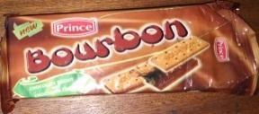

Brownie with
Hazelnut

Brownie (white
chocolate)

Bourbon (Prince)

TiO Dobi

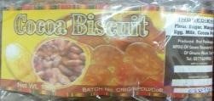

Tiffany Sugar Free Storm CRIG Biscuits

2. CANDIES
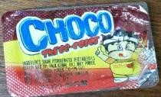    Choco Three Color Golden Tree Pebbles Chocolate + Biscuit Sweet Cup
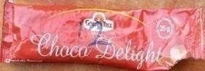

Hamlet

H&H Choco (3 Colors) Choco Delight

H&H Butterfly
Chocolate



Top Choco Maltesers Chocolate M&M’s TQ Bar


Kingsbite-Purple Kingsbite-Red Kitkat Chunky Starcup-P Starcup-G
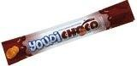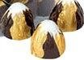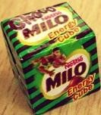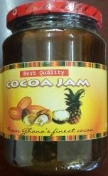

Youpichoco Bifa Raund Milo cube Cocoa Jam

Other Candies
Starch cup Chocolate | Starcup (Black foil)

3. ICE-CREAMS


Sandra Cremello Sandra Super Vinilla/Chocolate Fanice Chocolate

Frosty Bite
Chocolate


Sandra Chocolate Moments Sandra Super Chocolate FanChoco

4. BEVERAGES
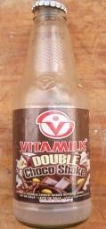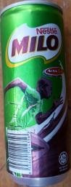

Cerealplus
Milo

Richoco Chocolim

Alltime
Milo

Vitamilk

Vitatop
ChocLate

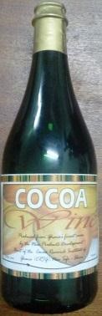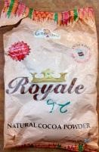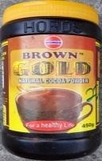
Cocoa Wine Royale Brown Gold Cocoa Vinegar

APPENDIX-B A SAMPLE FILLED QUESTIONNAIRE (SECTION C)
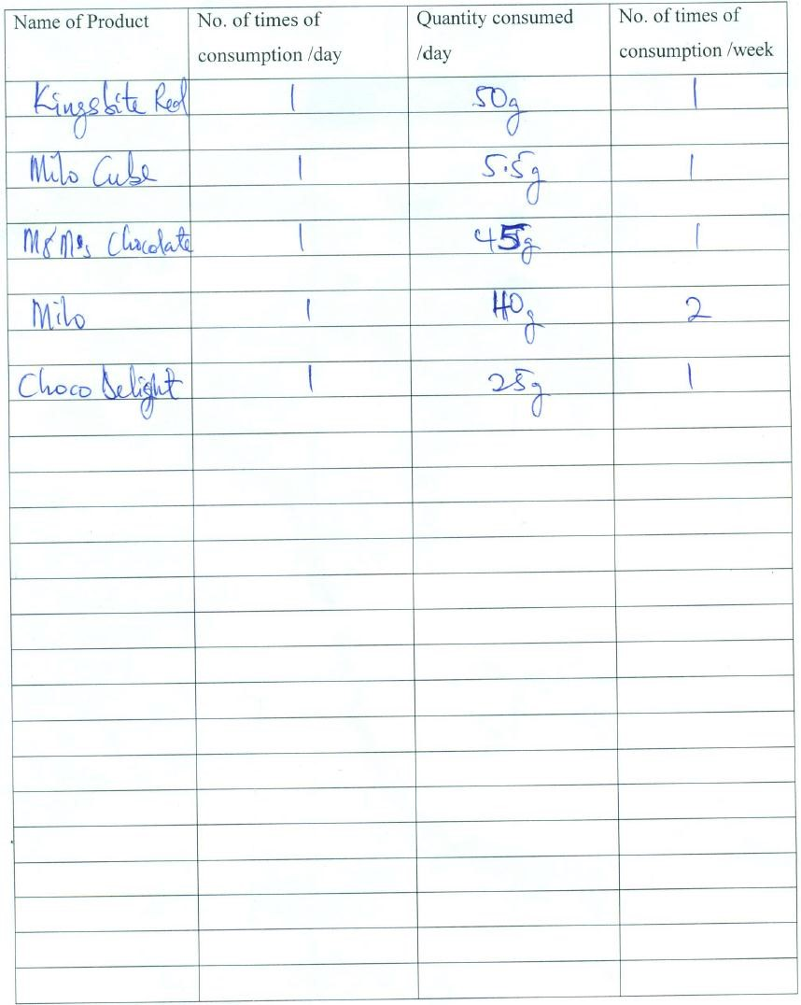

APPENDIX-B RESULTS OF METAL ANALYSIS IN COCOA PRODUCTS (P)

B-1 Levels of heavy metals (µg/g) in imported products
Sample | Mn | Zn | Cu | Pb | Fe
P1 | 2.69±1.27 | 8.22±0.10 | 3.63±0.34 | 1.33±0.05 | 13.05±0.62
P2 | 6.71±2.79 | 10.42±0.05 | 13.37±0.48 | 0.87±0.45 | 11.91±0.16
P3 | 2.28±0.65 | 10.33±0.10 | 3.66±0.50 | 1.41±0.25 | 6.85±0.02
P4 | 0.89±0.00 | 19.84±0.03 | 3.95±0.45 | 0.71±0.14 | 8.72±0.04
P5 | 3.32±1.38 | 6.24±0.14 | 2.49±0.79 | *BDL | 9.28±0.09
P6 | 1.80±0.00 | 8.68±0.11 | 8.07±0.13 | *BDL | 12.60±0.02
P8 | 13.78±5.48 | 18.07±0.06 | 9.50±0.77 | 1.80±0.33 | 15.53±0.41
P9 | 7.40±2.05 | 17.23±0.04 | 8.80±0.00 | 0.16±0.00 | 13.74±0.02
P10 | 22.14±4.70 | 7.94±0.17 | 9.44±0.37 | 6.30±0.45 | 16.82±0.08
P11 | 16.07±2.78 | 5.70±0.07 | 5.55±0.29 | 3.67±0.12 | 7.28±0.05
P12 | 8.98±1.56 | 10.70±0.05 | 6.42±0.45 | 1.68±0.29 | 11.81±0.07
P13 | 18.06±7.95 | 9.69±0.10 | 17.47±0.51 | 3.67±0.29 | 13.45±0.07
P14 | 16.74±8.06 | 11.84±0.11 | 16.35±0.27 | 1.60±0.44 | 14.58±0.10
P15 | 17.88±4.42 | 14.74±0.08 | 6.72±0.14 | 3.57±0.31 | 15.01±0.06
P16 | *BDL | 12.00±0.08 | 17.19±0.29 | 2.71±0.20 | 11.48±0.06
P17 | 5.83±3.07 | 13.00±0.05 | 8.59±0.46 | 2.30±0.16 | 12.65±0.04
P18 | 8.98±1.80 | 18.53±0.16 | 10.42±0.37 | 4.09±0.26 | 5.66±0.05
P19 | 57.31±3.53 | 23.14±0.18 | 5.87±0.45 | 4.09±0.48 | 8.57±0.20
P20 | 73.21±1.27 | 31.04±1.00 | 4.91±0.08 | 4.27±0.15 | 11.23±0.05
P21 | 64.14±3.34 | 11.34±0.06 | 4.39±0.28 | 3.83±0.04 | 4.44±0.03
P22 | 60.84±6.31 | 9.82±0.08 | 3.97±0.55 | 2.57±0.11 | 4.67±0.04
P23 | 67.29±8.08 | 12.00±0.03 | 5.52±0.12 | 4.52±0.17 | 7.08±0.06
P32 | 38.08±2.66 | 10.93±0.07 | 3.81±0.39 | 1.43±0.35 | 5.65±0.08
P33 | 40.74±0.95 | 14.54±0.23 | 3.83±0.73 | 2.94±0.11 | 9.81±0.04
P34 | 44.25±3.90 | 10.95±0.08 | 4.11±0.52 | 0.15±0.17 | 4.72±0.05
P35 | 44.43±2.28 | 10.54±0.12 | 3.35±0.49 | 2.61±0.54 | 1.55±0.02
P39 | 20.91±1.57 | 6.67±0.07 | 7.25±0.35 | 1.90±0.25 | 6.14±0.04
P40 | 25.45±4.81 | 14.25±0.20 | 5.41±0.50 | 2.20±0.08 | 3.81±0.04
P41 | 14.24±4.67 | 7.11±0.18 | 2.84±0.74 | 3.35±0.14 | 4.73±0.09
Values are reported as mean ± standard deviation
*BDL = Below detectable limit

B-2 Levels of heavy metals (µg/g) in local products
Levels of heavy metals (µg/g) in local products
Sample | Mn | Zn | Cu | Pb | Fe
P7 | *BDL | 13.50±0.12 | 3.84±0.47 | 4.66±0.08 | 8.46±0.07
P24 | 6.02±3.17 | 10.80±0.03 | 8.37±0.41 | 0.19±0.12 | 7.27±0.07
P25 | 16.73±2.93 | 18.78±0.23 | 10.64±0.30 | 8.17±0.20 | 10.80±0.10
P26 | 14.74±1.30 | 23.81±0.12 | 10.28±0.12 | 4.26±0.16 | 14.35±0.05
P27 | 10.14±3.71 | 19.46±0.34 | 9.27±0.47 | 0.58±0.18 | 15.30±0.04
P28 | 6.75±2.96 | 15.54±0.06 | 9.88±0.52 | 1.50±0.33 | 25.95±0.03
P29 | 12.43±1.13 | 10.39±0.01 | 4.95±0.13 | 4.48±2.77 | 13.12±0.07
P30 | 29.24±4.57 | 16.79±0.03 | 6.03±0.13 | 4.47±0.35 | 12.19±0.07
P31 | 26.91±3.47 | 7.49±0.03 | 7.33±0.05 | 2.38±0.14 | 7.78±0.09
P36 | 39.46±4.18 | 5.15±0.19 | 1.27±0.28 | *BDL | 2.79±0.04
P37 | 56.42±3.89 | 21.27±0.40 | 4.22±0.31 | 1.09±0.61 | 4.60±0.07
P38 | 29.05±2.35 | 6.42±0.08 | 1.61±0.15 | 1.87±0.09 | 3.31±0.00
P42 | 23.46±3.25 | 10.92±0.12 | 21.32±0.37 | 2.64±0.08 | 11.43±0.11
P43 | 20.15±3.30 | 20.71±0.20 | 12.02±0.43 | 3.99±0.14 | 11.58±0.03
P44 | 27.99±3.13 | 15.94±0.06 | 5.24±0.75 | 3.96±0.25 | 25.58±0.14
P45 | *BDL | 10.91±0.05 | 6.68±0.24 | 3.18±0.17 | 9.72±0.09
P46 | 11.52±5.55 | 9.85±0.15 | 8.09±0.24 | 3.29±0.26 | 7.77±0.05
P47 | 29.09±0.91 | 10.04±0.10 | 10.01±0.30 | 5.03±0.12 | 5.67±0.03
P48 | 57.76±6.92 | 26.74±0.84 | 47.68±0.41 | 4.02±0.14 | 17.70±0.09
P49 | 33.55±2.12 | 26.25±0.73 | 36.90±0.20 | 4.23±0.08 | 32.38±0.06
P50 | 29.09±1.57 | 8.44±0.09 | 2.61±0.18 | 1.22±0.65 | 14.76±1.21
Values are reported as mean ± standard deviation
*BDL = Below detectable limit

APPENDIX-D RISK INPUTS

@RISK Model Inputs for Local Products
Name | Graph |  | Min | Mean | Max

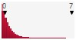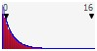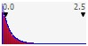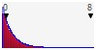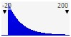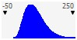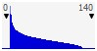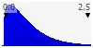
Mass of product consumed (g)

-
0.034054

41.36295

∞
+

Exposure freq per year

0

86.19761

∞
+

Body mass

12.1

48.81615

121.63

Iron mg
/g

0.055594

0.6805329

∞
+

Copper content

0.02391375

0.6152793

6.23576

Manganese mg/g

0.016321

1.536027

14.36524

Lead mg/g

0.002592757

0.2124465

2.016591

Zinc mg/g

0.0416467

0.833279

7.761521

@RISK Model Inputs for Imported Products
Name | Graph | Min | Mean | Max
Mass of product consumed (g) | 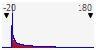 | 0.05000009 | 26.29698 | 167.3214
Exposure freq per year | 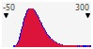 | 3 | 79.5094 | 291
Body mass | 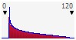 | 12.10015 | 43.15234 | 113.9539  4.20219
Iron mg/g | 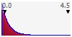 | 0.006890152 | 0.4218594 | 113.9539  4.20219
Copper mg/g | 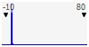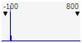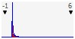 | 0.01940368 | 0.5073096 | 75.70419
Manganese (mg/g)  Lead mg/g |  | 0.02181946  -0.000307349 | 2.626452  0.167992 | 761.5621  5.239316

